**Spring Data JPA - A Quick Example**

1. Created a project using the given requirements .

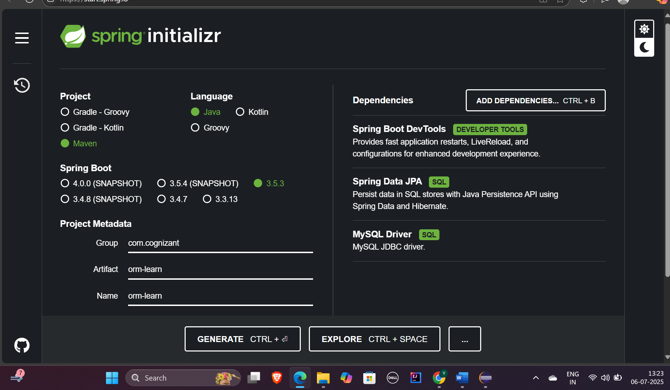

1. Imported the maven project into Eclipse workspace.

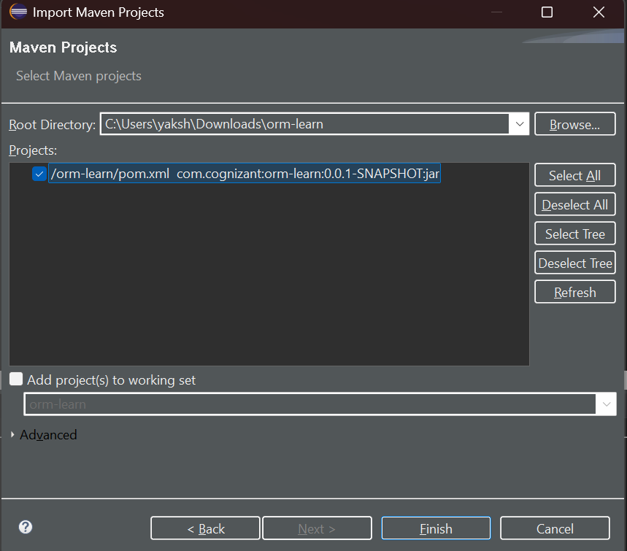

1. Created schema and inserted sample records in MySQL Workbench.

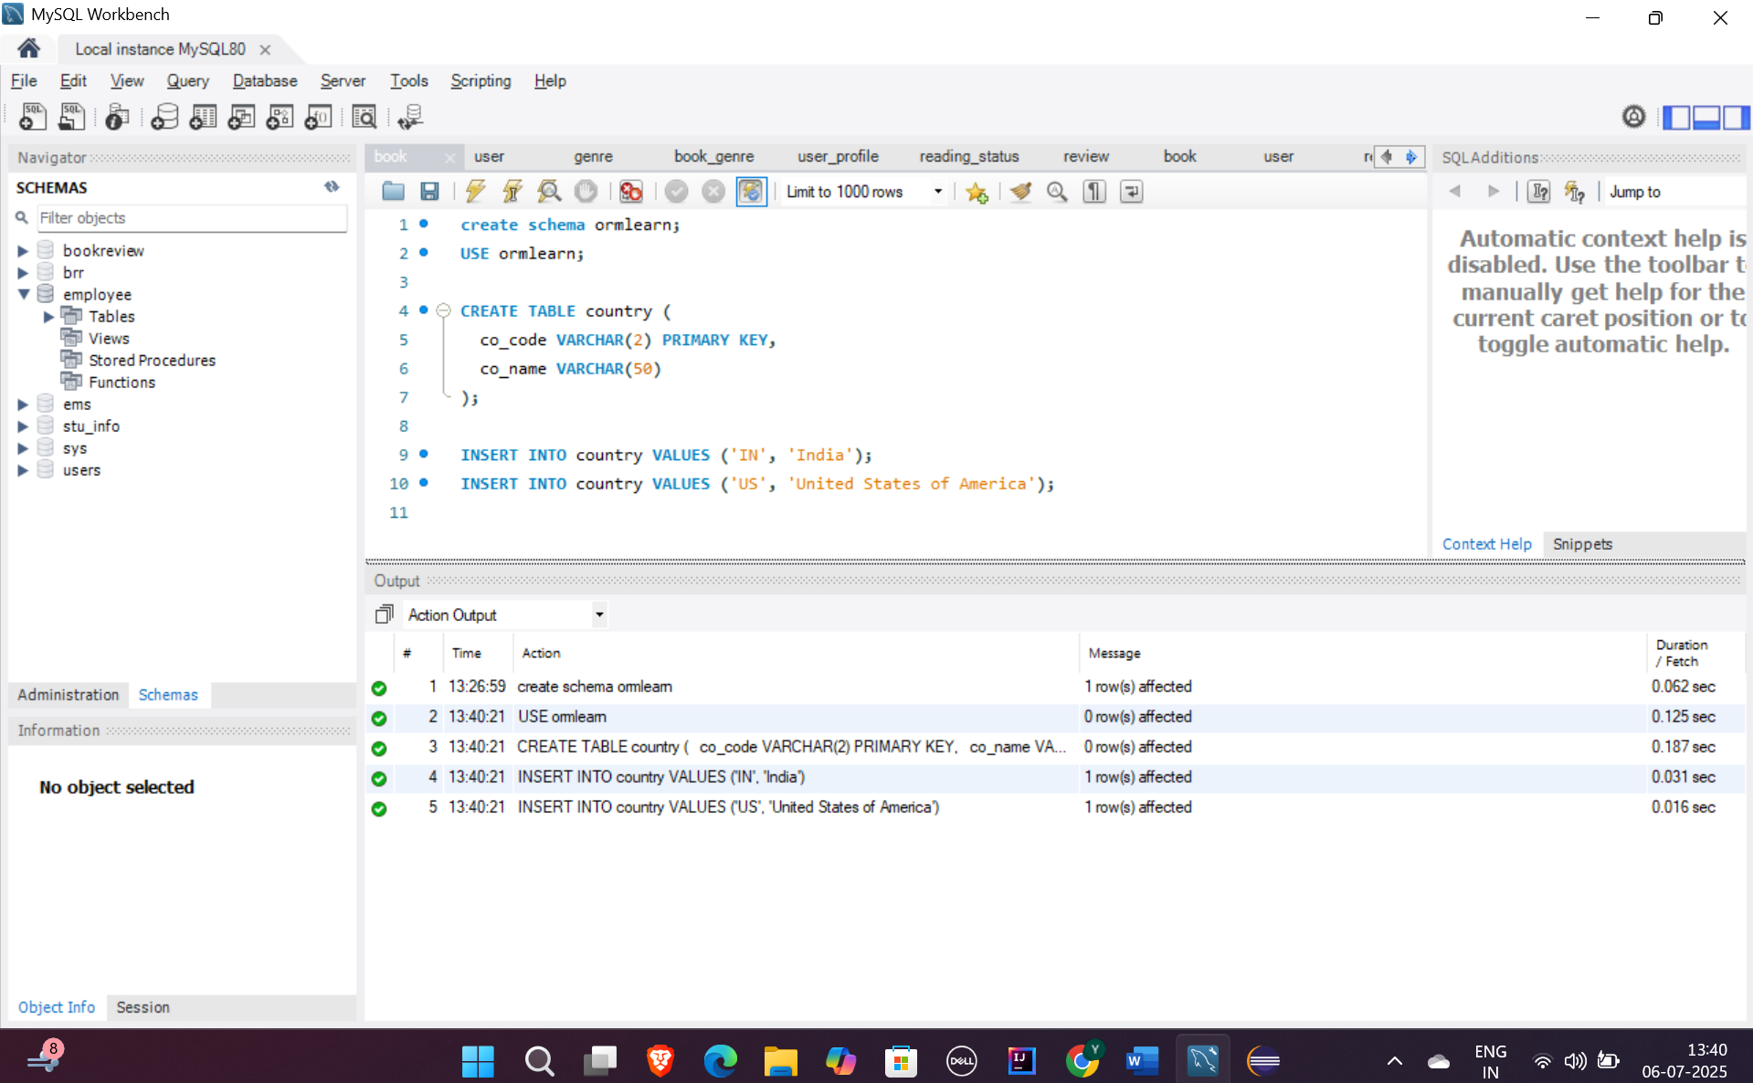

1. Configured application.properties to establish database connectivity and hibernate properties.

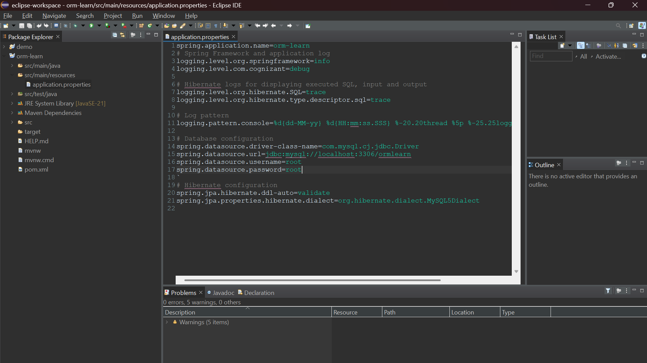

1. Created entity,service and repository classes within their respective packages.

**Country.java**

package com.cognizant.orm_learn.model;

import jakarta.persistence.Column;

import jakarta.persistence.Entity;

import jakarta.persistence.Id;

import jakarta.persistence.Table;

@Entity

@Table(name = "country")

public class Country {

@Id

@Column(name = "co_code")

private String code;

@Column(name = "co_name")

private String name;

public String getCode() {

return code;

}

public void setCode(String code) {

this.code = code;

}

public String getName() {

return name;

}

public void setName(String name) {

this.name = name;

}

@Override

public String toString() {

return "Country [code=" + code + ", name=" + name + "]";

}

}

**CountryRepository.java**

package com.cognizant.orm_learn.repository;

import java.util.List;

import org.springframework.data.jpa.repository.JpaRepository;

import org.springframework.stereotype.Repository;

import com.cognizant.orm_learn.model.Country;

*@Repository*

public interface CountryRepository extends JpaRepository<Country, String> {

List<Country> findAll();

}

**CountryService.java**

package com.cognizant.orm_learn.service;

import java.util.List;

import jakarta.transaction.Transactional;

import org.springframework.beans.factory.annotation.Autowired;

import org.springframework.stereotype.Service;

import com.cognizant.orm_learn.model.Country;

import com.cognizant.orm_learn.repository.CountryRepository;

*@Service*

public class CountryService {

*@Autowired*

private CountryRepository countryRepository;

*@Transactional*

public List<Country> getAllCountries() {

return countryRepository.findAll();

}

}

1. Performed testing in Main class using logger interface.

package com.cognizant.orm_learn;

import com.cognizant.orm_learn.model.Country;

import com.cognizant.orm_learn.service.CountryService;

import java.util.List;

import org.slf4j.Logger;

import org.slf4j.LoggerFactory;

import org.springframework.boot.SpringApplication;

import org.springframework.boot.autoconfigure.SpringBootApplication;

import org.springframework.context.ApplicationContext;

*@SpringBootApplication*

public class OrmLearnApplication {

private static final Logger ***LOGGER*** = LoggerFactory.*getLogger*(OrmLearnApplication.class);

private static CountryService *countryService*;

public static void main(String[] args) {

ApplicationContext context = SpringApplication.*run*(OrmLearnApplication.class, args);

*countryService* = context.getBean(CountryService.class);

***LOGGER***.info("Inside main");

*testGetAllCountries*();

}

private static void testGetAllCountries() {

***LOGGER***.info("Start");

List<Country> countries = *countryService*.getAllCountries();

***LOGGER***.debug("countries={}", countries);

***LOGGER***.info("End");

}

}

**Console output:**

