**Spring REST using Spring Boot3**

Ex 1 : Create a Spring Web Project using Maven

1. Created and configured a Spring Maven Project – “spring-learn” with Spring Web and Devtools dependencies.

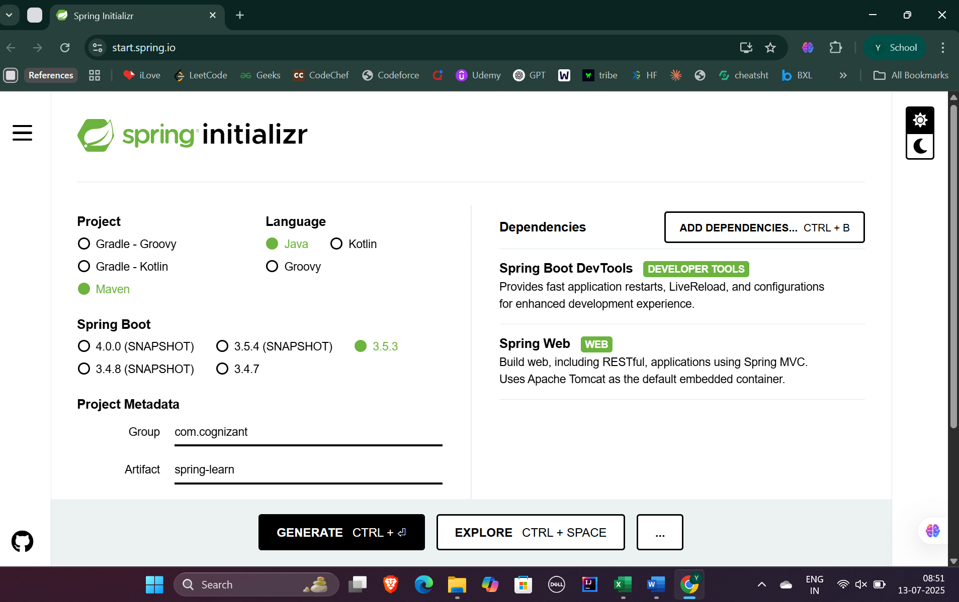

1. Built project using proxy settings and **mvn clean package** .

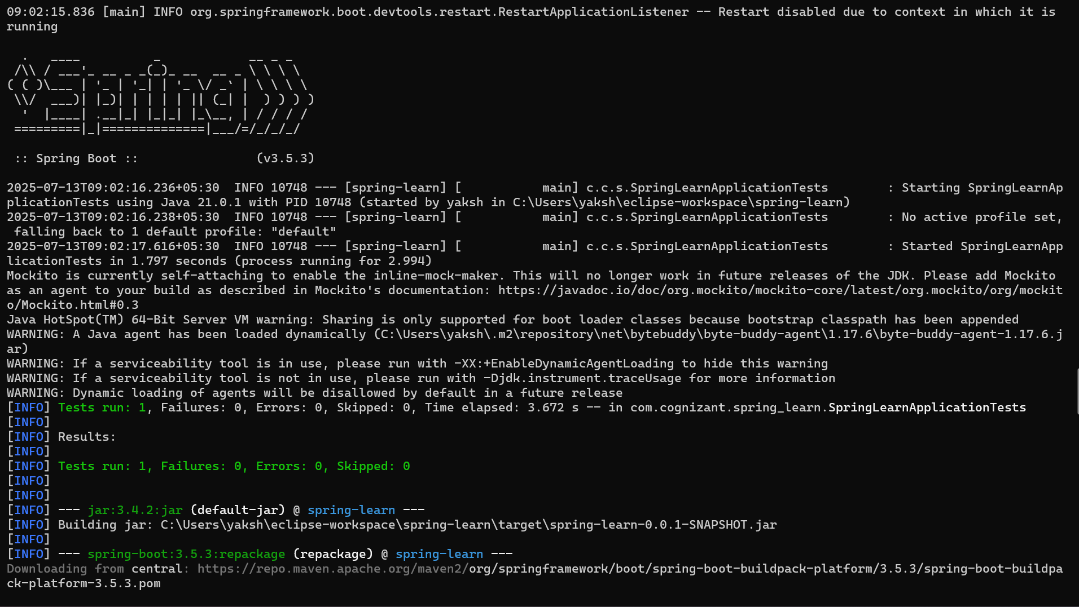

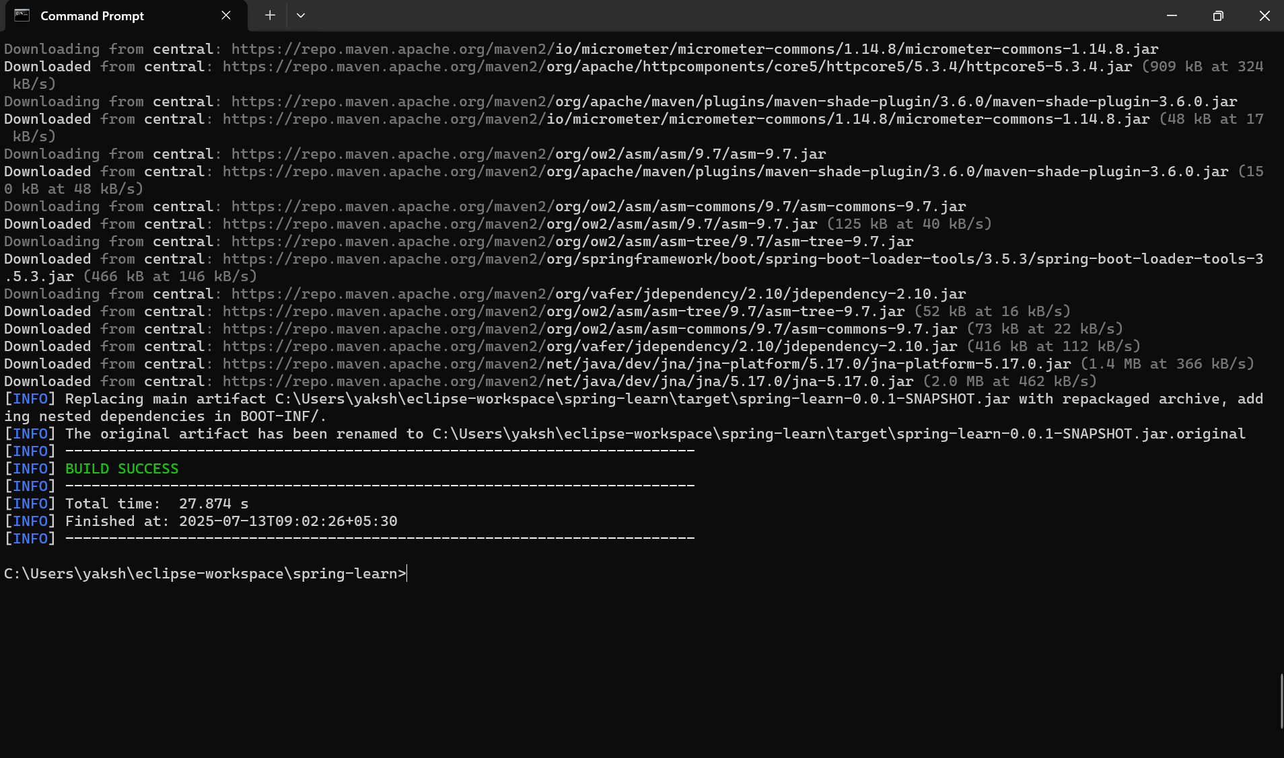

1. Imported project to Eclipse
   1. Added Logging in main() method.
   2. Ran the spring application and got the log output – “ Application started successfully”

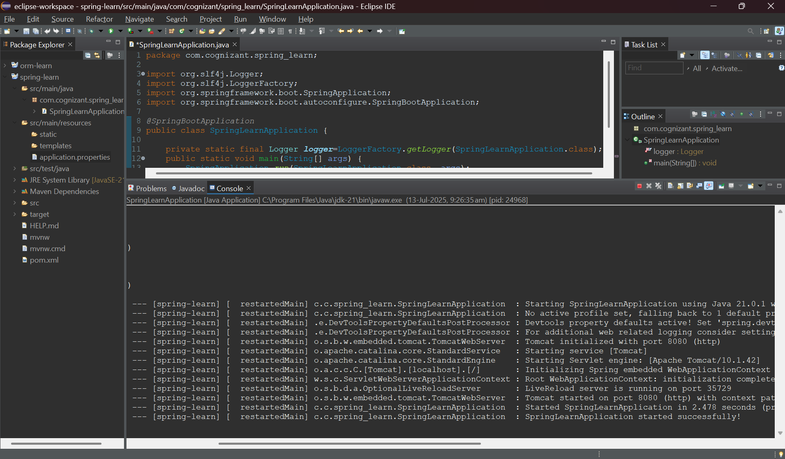

SME Walkthrough :

Purpose of each folder within project :

* Main/java – contains source code , main class of the Spring Boot app.
* Main/resources – contains configuration files like application.properties , static/ (for web assets) , templates/ (for thymeleaf templates)
* Test/java – holds unit and integration testcases (if any)

@SpringBootApplication serves as entry point for Spring Boot.

Opening pom.xml and clicking on Dependency Hierarchy gives a tree structure and shows transitive dependencies along with their versions.