**Spring REST using Spring Boot3**

Hello World RESTful Web Service

1. Created a controller class

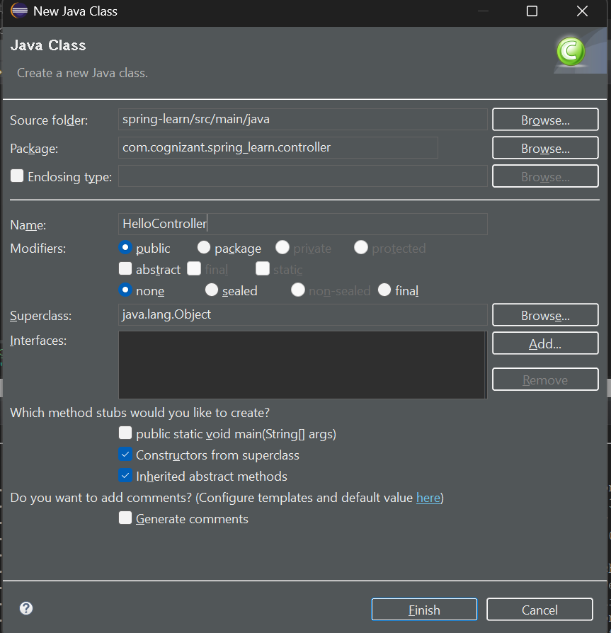

package com.cognizant.spring_learn.controller;

import org.slf4j.Logger;

import org.slf4j.LoggerFactory;

import org.springframework.web.bind.annotation.GetMapping;

import org.springframework.web.bind.annotation.RestController;

@RestController

public class HelloController {

private static final Logger LOGGER = LoggerFactory.getLogger(HelloController.class);

@GetMapping("/hello")

public String sayHello() {

LOGGER.info("START - sayHello()");

String message = "Hello World!!";

LOGGER.info("END - sayHello()");

return message;

}

}

1. Updated application.properties – change port number to 8083

server.port=8083

**OUTPUT:**

**In Chrome**

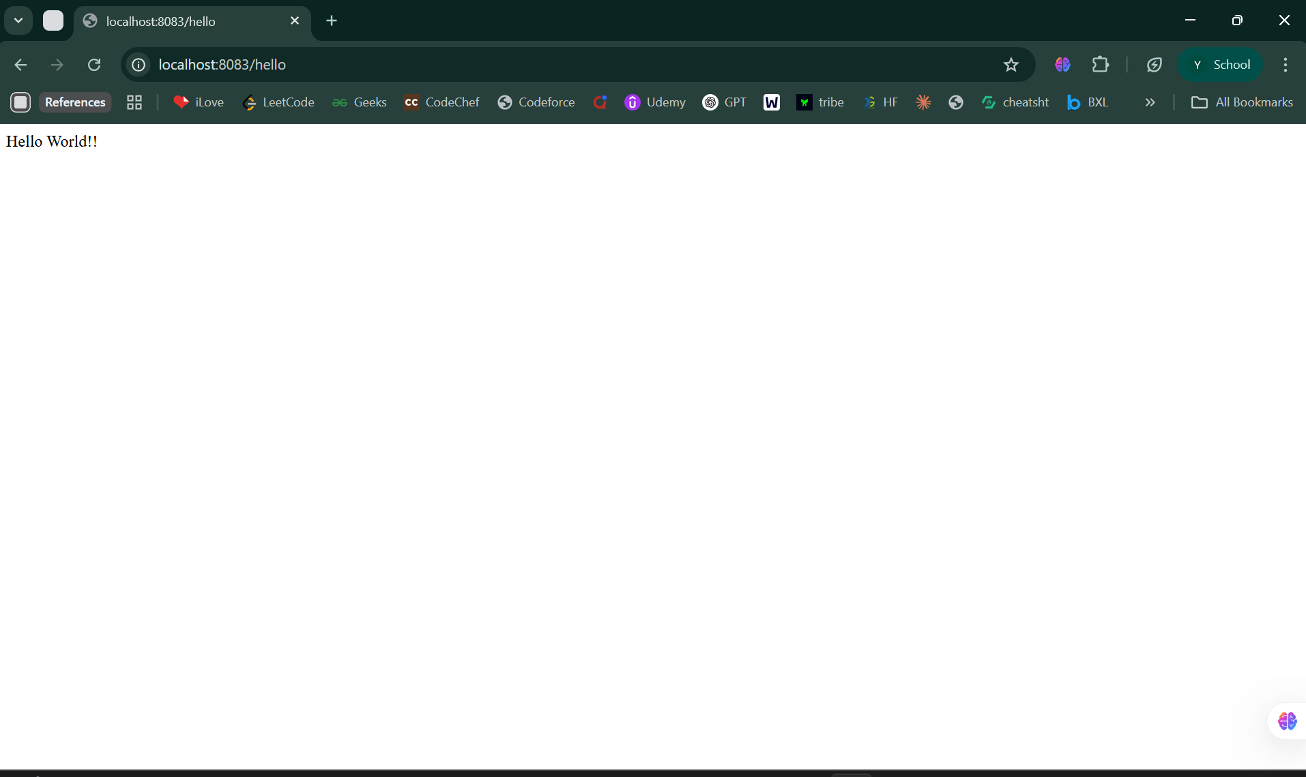

**In Postman:**

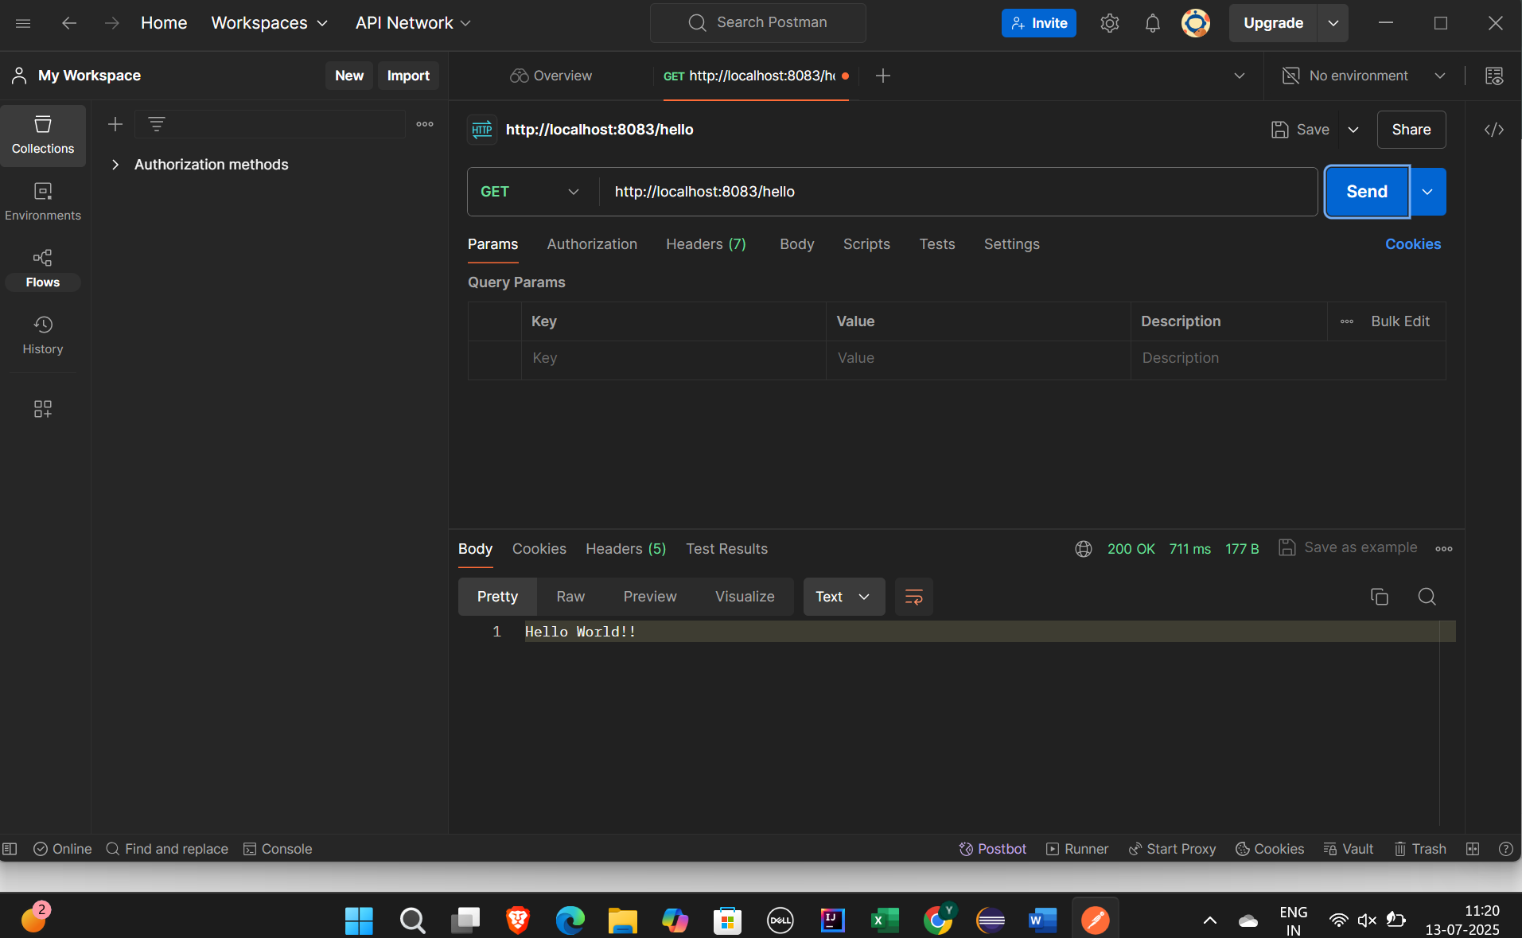

SME Walkthrough:

Inspecting the headers in Chrome and Postman for the /hello request.

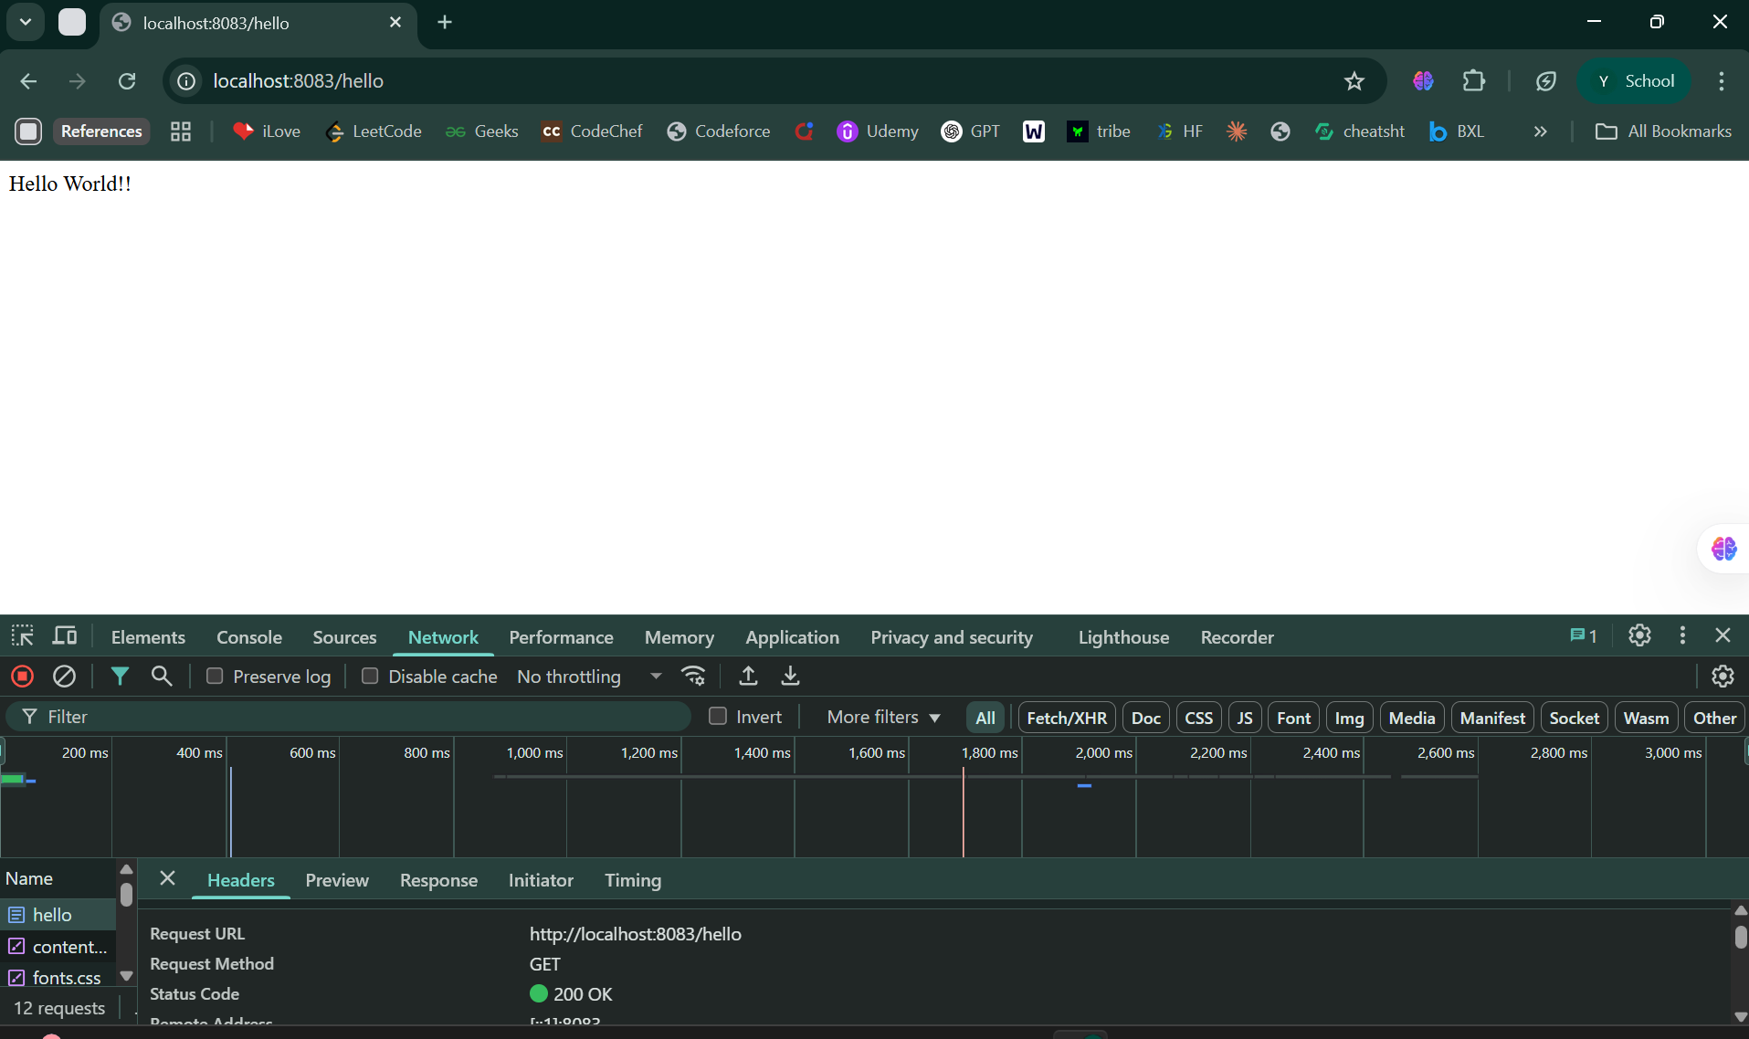

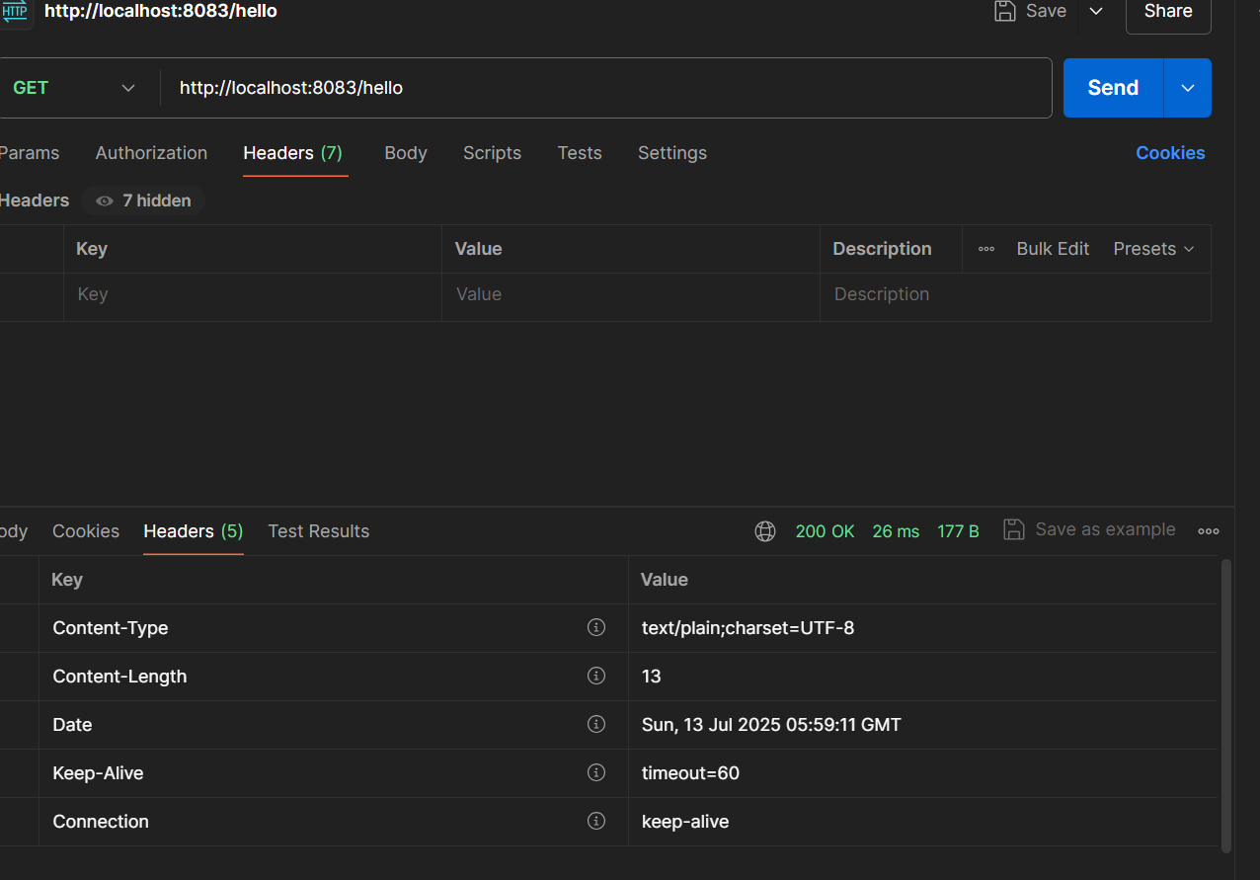

**Summarizing what I did :**

* Created REST controller under controller package
* Mapped GET /hello to return "Hello World!!"
* Added logging at start and end of method
* Changed port to 8083
* Verified in Chrome and Postman
* Understood header inspection in browser and Postman