**Spring REST using Spring Boot3**

**Ex: REST - Get country based on country code**

**IMPLEMENTATION :**

1. Updated countr.xml to have a list of countries :

<beans>

<bean id="countryList" class="java.util.ArrayList">

<constructor-arg>

<list>

<bean class="com.cognizant.springlearn.Country">

<property name="code" value="IN"/>

<property name="name" value="India"/>

</bean>

<bean class="com.cognizant.springlearn.Country">

<property name="code" value="US"/>

<property name="name" value="United States"/>

</bean>

<bean class="com.cognizant.springlearn.Country">

<property name="code" value="DE"/>

<property name="name" value="Germany"/>

</bean>

<bean class="com.cognizant.springlearn.Country">

<property name="code" value="JP"/>

<property name="name" value="Japan"/>

</bean>

</list>

</constructor-arg>

</bean>

</beans>

1. Created a CountryService class to load the countries from xml file and return the matching country:

package com.cognizant.spring_learn.service;

import java.util.List;

import org.springframework.context.ApplicationContext;

import org.springframework.context.support.ClassPathXmlApplicationContext;

import org.springframework.stereotype.Service;

import com.cognizant.springlearn.Country;

@Service

public class CountryService {

public Country getCountry(String code) {

ApplicationContext context = new ClassPathXmlApplicationContext("country.xml");

List<Country> countries = context.getBean("countryList", List.class);

return countries.stream()

.filter(c -> c.getCode().equalsIgnoreCase(code))

.findFirst(); }

}

1. Updated Controller to get the countrycode as path variable :

@RestController

public class CountryController {

private static final Logger LOGGER = LoggerFactory.getLogger(CountryController.class);

@Autowired

private CountryService countryService;

@GetMapping("/countries/{code}")

public Country getCountry(@PathVariable String code) {

LOGGER.info("START - getCountry({})", code);

Country country = countryService.getCountry(code);

LOGGER.info("END - getCountry({})", code);

return country;

}

}

**OUTPUT :**

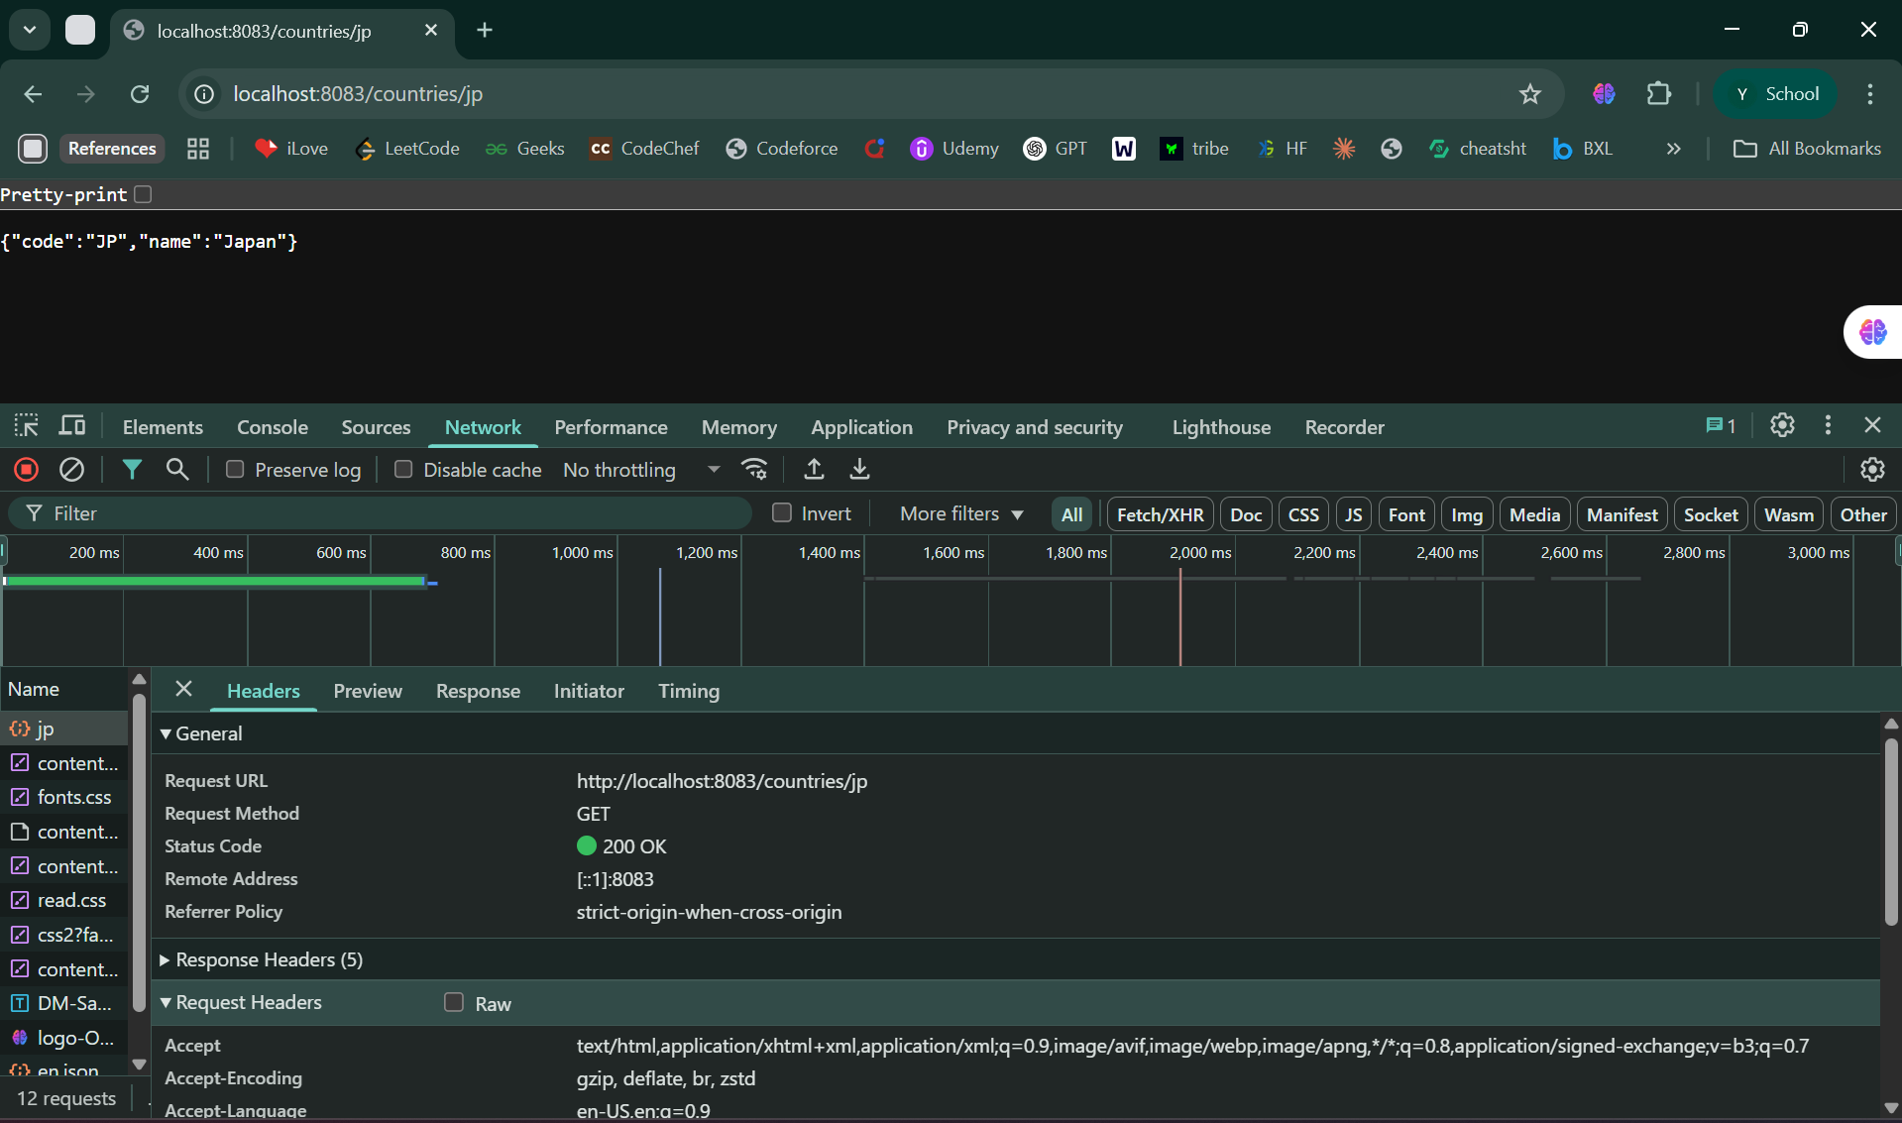

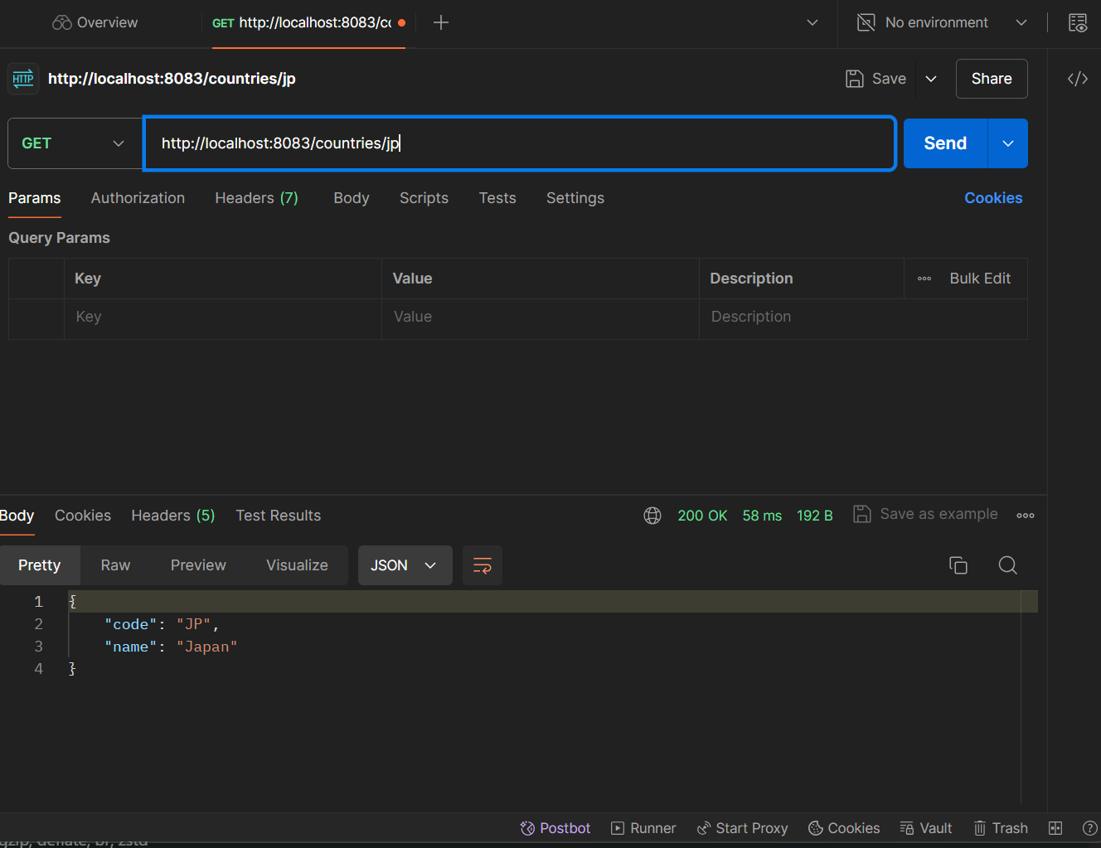

How it works :

1. When a GET request is made to /countries/{code}, the controller receives the country code as a path variable.
2. The service loads the list of countries from the country.xml Spring configuration file.
3. It filters the list ignoring the case to return the matching Country object.
4. Spring Boot converts the Country object to a JSON response.