**Welcome React Application – Setting up environment and using create-react-app**

**Step1 :** Install nodejs and npm.

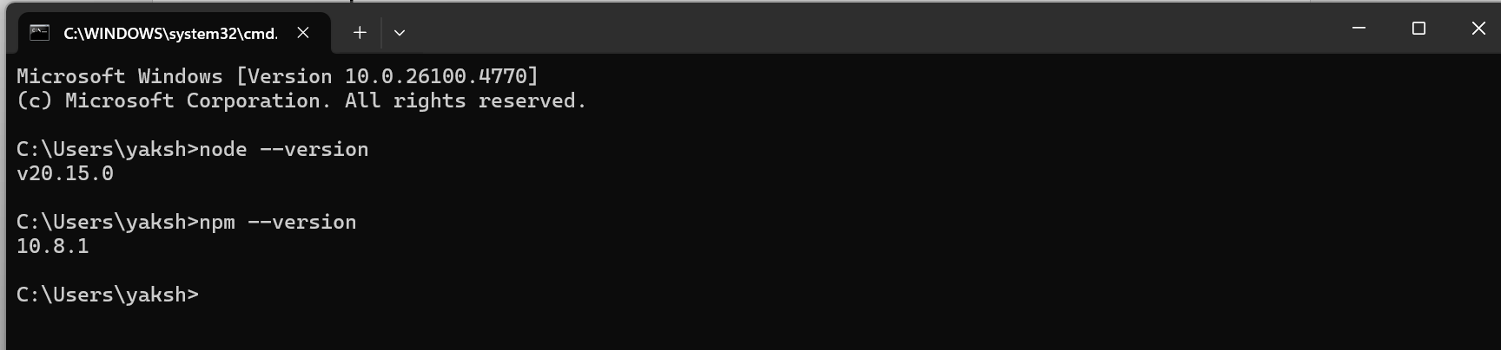

**Step2 :** Change the project directory and create a react application using the command  **npx create-react-app <appname>** in the command prompt.

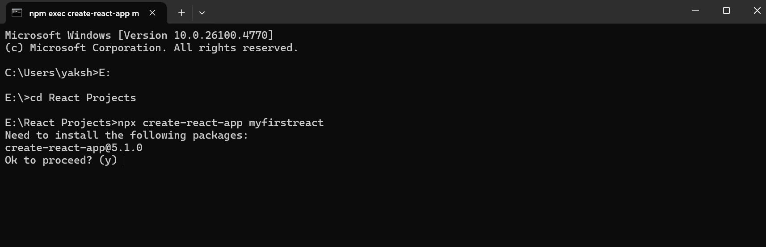

The ‘happy hacking’ at the end shows that the react app has been created successfully.

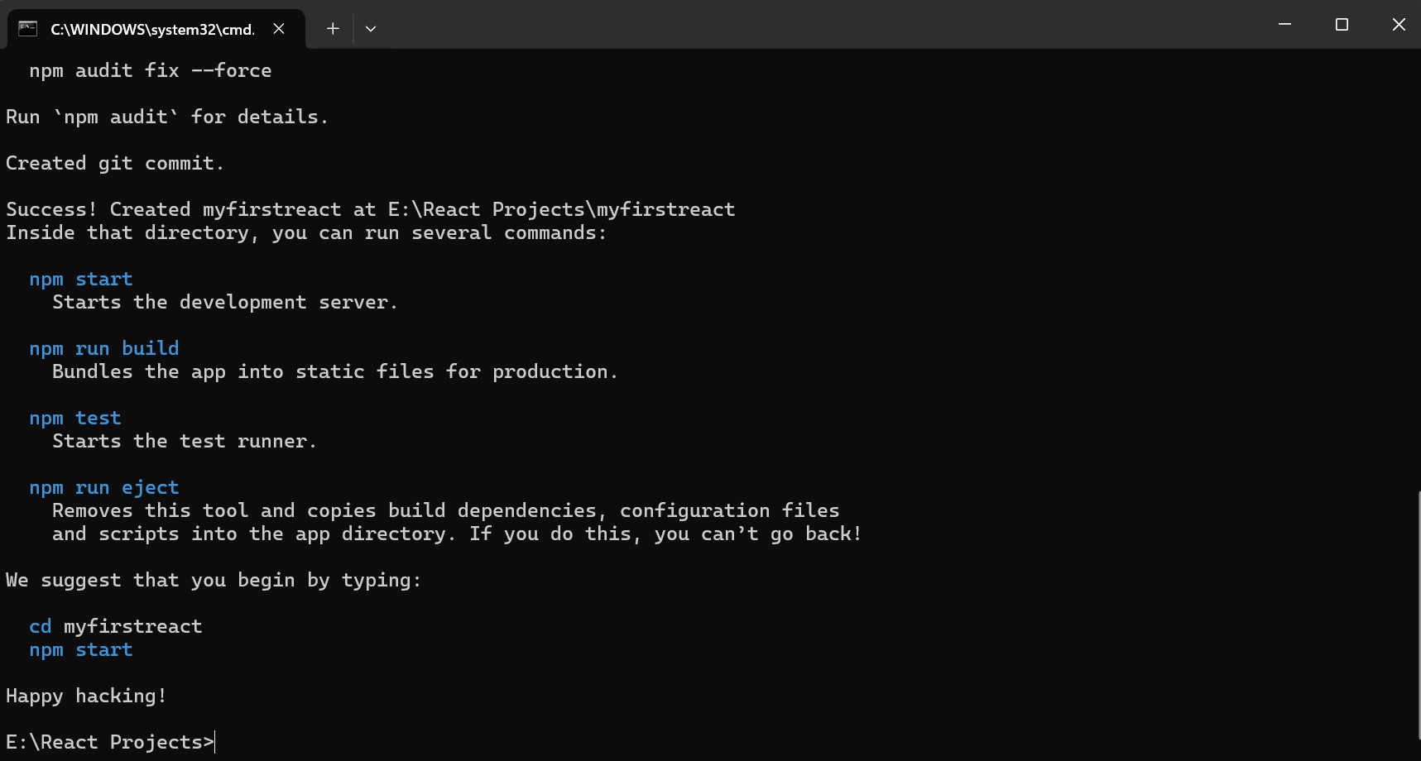

**Step3 :** Open the react project created in a code editor like VS Code.

File -> Open Folder -> Select Folder -> Open

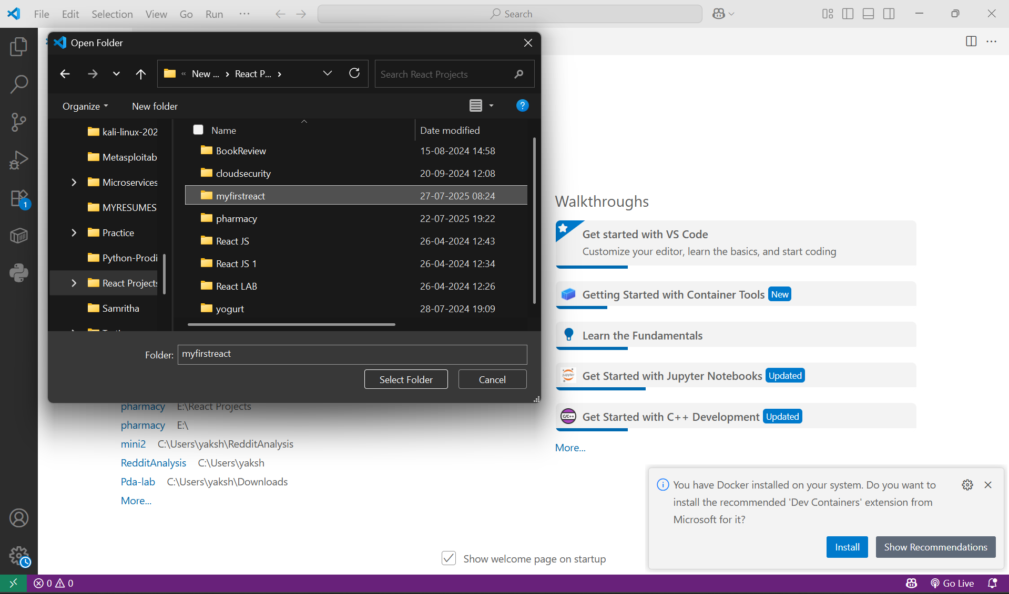

**Step4 :** Change the contents of App.js to render a header tag with the welcome message and in the project terminal , run the command **npm start** to execute the react app.

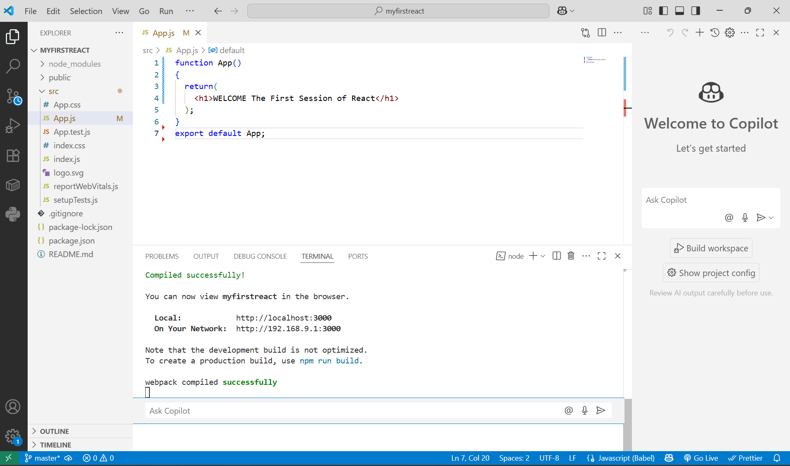

**Step 5 :** In the browser , the react app is up and running , configured in the localhost port 3000 by default.

