**React App for Student Management Portal**

**Step1 :** Change the directory to a desired one and create a react application using the command  **npx create-react-app studentapp** in the VS Code terminal.

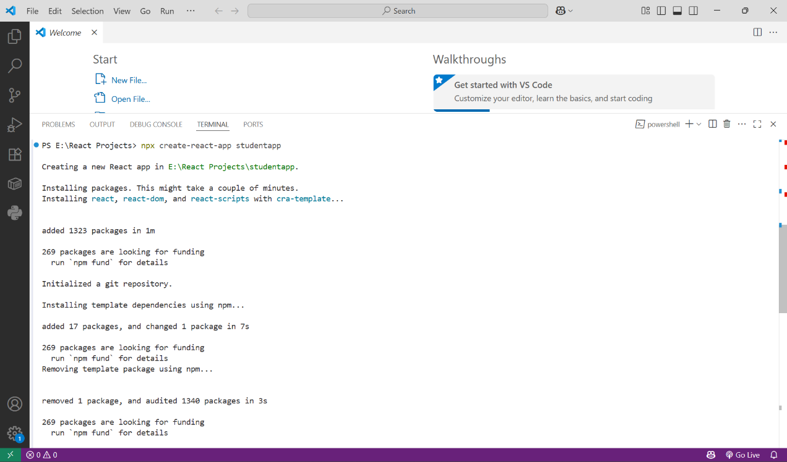

**Step2 :** Open the react project created in VS Code and create a folder Components which contains 3 more files namely

* Home.js
* About.js
* Contact.js

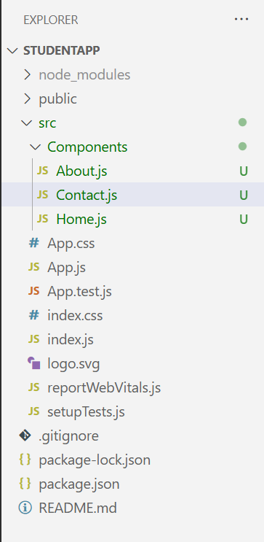

**Step3 :** Change the contents of the files created to render a header tag with the welcome message.

import React,{Component} from "react";

class Home extends Component{

    render()

    {

return (

        <div>

        <h3>Welcome to the homepage of Student Management Portal</h3>

        </div>

);

    }

}

export default Home;

Similarly edit the remaining files.

**Step 4 :** Edit the App.js to invoke the Home, About and Contact component.

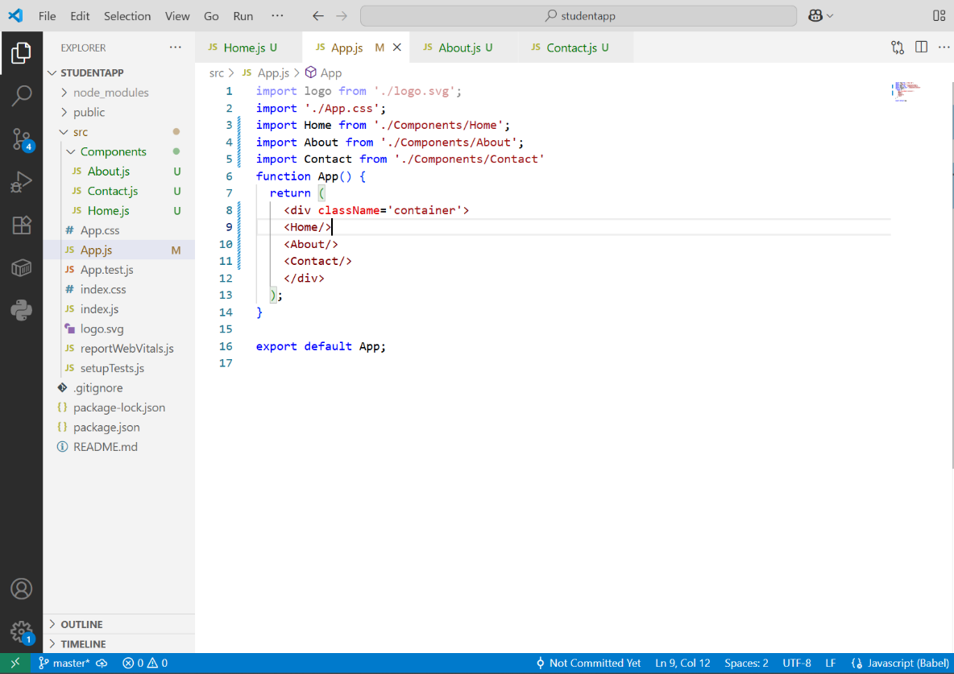

**Step 5 :** Run the project using **npm start** . In the browser , the react app is up and running , configured in the localhost port 3000 by default.

