**React App for Student Management Portal - ScoreCalculatorApp**

**Step1 :** Create a react application using the command  **npx create-react-app scorecalculatorapp** in the VS Code terminal.

**Step2 :** Open the project created in VS Code and create a folder **Components** and then a file named **CalculateScore.js** under it.

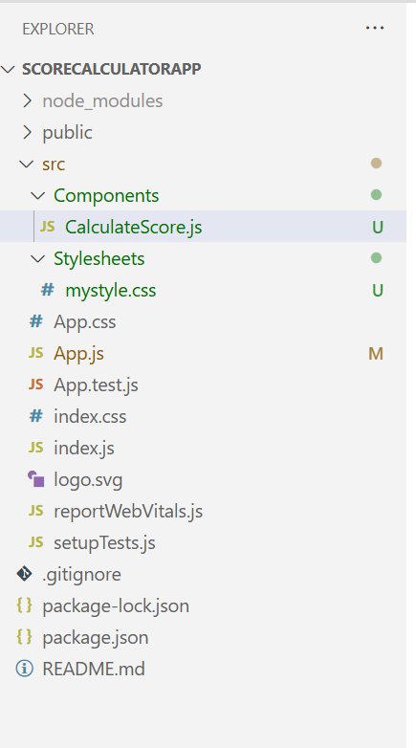

**Step3 :** Put the following code in **CalculateScore.js** :

import '../Stylesheets/mystyle.css'

const percentToDecimal=(decimal)=>{

    return(decimal.toFixed(2)+'%')

}

const calcScore=(total,goal)=>{

    return percentToDecimal(total/goal)

}

export const CalculateScore = ({ Name, School, total, goal }) => (

  <div className="formatstyle">

    <h1 style={{color="Brown"}}>Student Details:</h1>

    <div className="Name">

      <b><span> Name: </span></b>

      <span>{Name}</span>

    </div>

    <div className="School">

      <b><span> School: </span></b>

      <span>{School}</span>

    </div>

    <div className="Total">

      <b><span>Total:</span></b>

      <span>{total}</span>

      <span> Marks</span>

    </div>

    <div className="Score">

      <b>Score:</b>

      <span>

        {calcScore(total, goal)}

      </span>

    </div>

  </div>

);

**Step 4 :** Create a folder Stylesheets and a file mystyles.css within it and add the following :

.Name{

    font-weight: 300;

    color: blue;

}

.School

{

    color: crimson;

}

.Total

{

    color: darkmagenta;

}

.formatstyle

{

    text-align: center;

    font-size: large;

}

.Score

{

    color: forestgreen;

}

Step 5 : Edit the App.js to invoke the CalculateScore functional component as follows

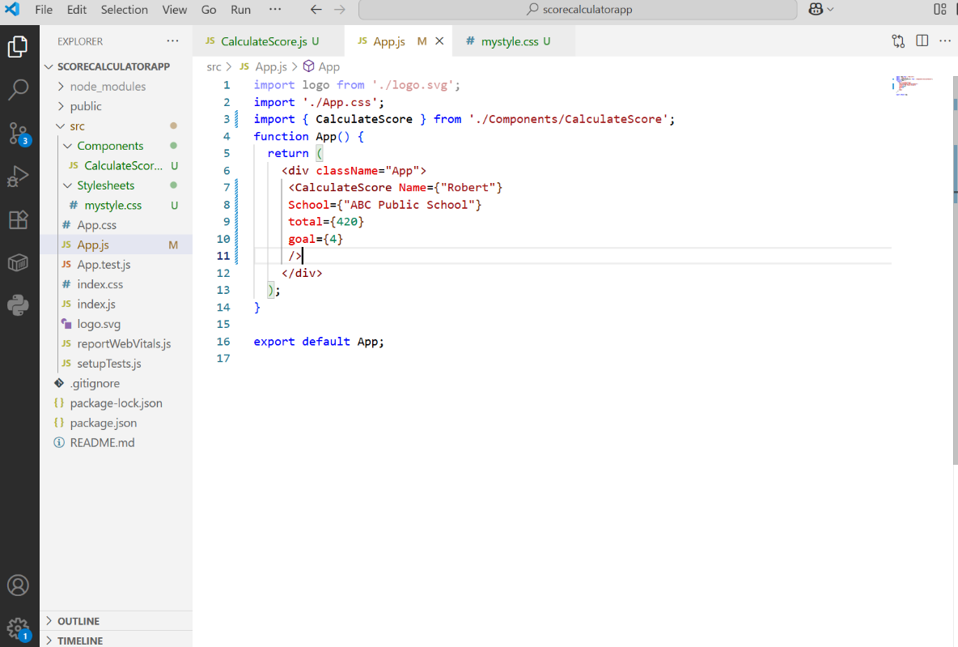

**Step 5 :** Run the project using **npm start** . In the browser , the react app is up and running , configured in the localhost port 3000 by default.

