**Dashboard for Ongoing and Completed Cohorts using React**

1. Unzip the react application in a folder

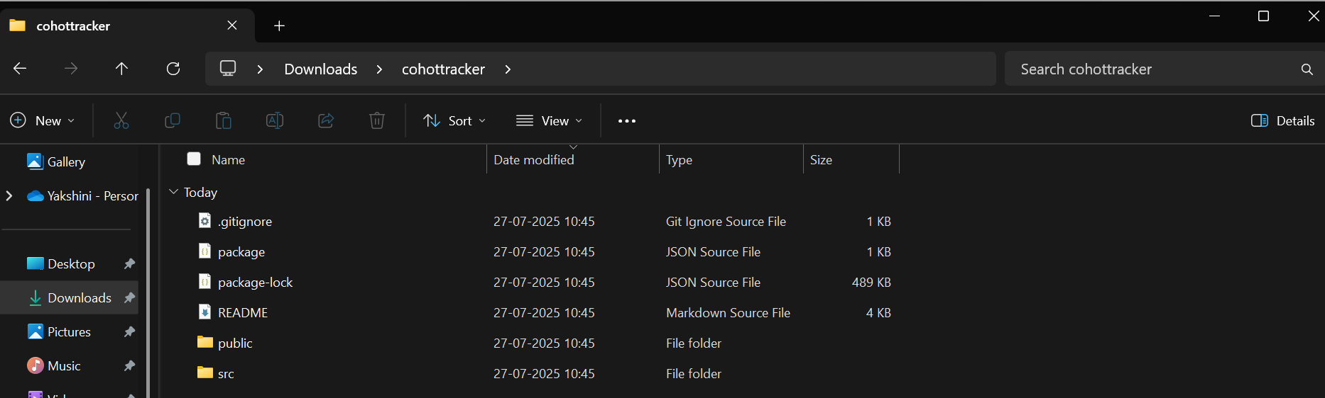

1. Open command prompt and switch to the react application folder using cd path\to\folder command.
2. Restore the node packages using npm install

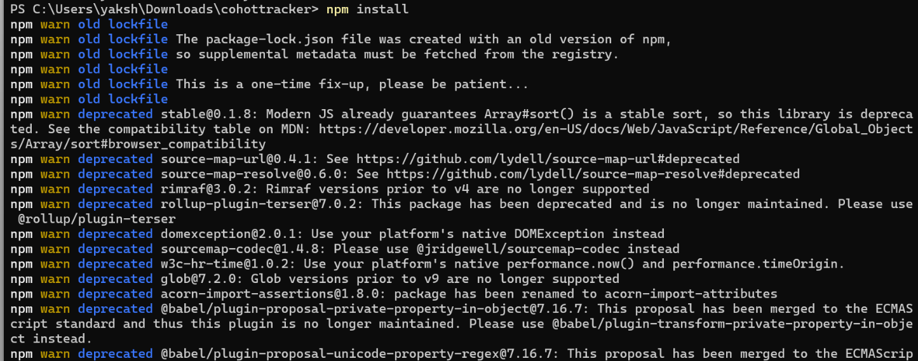

1. Open the application using VS Code using the command **code .**
2. Create a new CSS Module in a file called “CohortDetails.css”
3. Define .box class and and other styles.

.box {

width: 300px;

display: inline-block;

margin: 10px;

padding: 10px 20px;

border: 1px solid black;

border-radius: 10px;

}

dt {

font-weight: 500;

}

1. Open the cohort details component and import the CSS Module
2. Apply the box class to the container div

<div className=”box”>

{ /* other content */}

</div>

1. Define the style for <h3> element to use “green” color font when cohort status is “ongoing” and “blue” color in all other scenarios using

<h3 style={{color:props.cohort.currentStatus=== "Ongoing"? "green":"blue"}}>

1. **Final result :**

