**React Application - ticketbookingapp**

**Step1 :** Create the app:

**npx create-react-app ticketbookingapp**

**cd ticketbookingapp**

**Step 2 :** Separate component files with required logic

**GuestPage.js** (page to display before login)

function GuestPage() {

  return (

    <div>

      <h2>Welcome, Guest!</h2>

      <p>Please log in to book tickets.</p>

    </div>

  );

}

export default GuestPage;

**UserPage.js** (page to display after login)

import FlightList from "./FlightList";

function UserPage() {

  return (

    <div>

      <h2>Welcome, User!</h2>

      <p>You can now book your flight tickets.</p>

      <FlightList canBook={true} />

    </div>

  );

}

export default UserPage;

**FlightList.js** (component that lists available flights and option for booking flight )

const flights = [

  { id: 1, from: "Delhi", to: "Mumbai", time: "10:00 AM" },

  { id: 2, from: "Chennai", to: "Bangalore", time: "01:30 PM" },

  { id: 3, from: "Kolkata", to: "Hyderabad", time: "05:45 PM" },

];

function FlightList({ canBook }) {

  const handleBook = (flight) => {

    alert(`Ticket booked from ${flight.from} to ${flight.to} at ${flight.time}`);

  };

  return (

    <div>

      <h3>Available Flights</h3>

      <ul>

        {flights.map((flight) => (

          <li key={flight.id}>

            {flight.from} → {flight.to} at {flight.time}

            {canBook && (

              <button onClick={() => handleBook(flight)} style={{ marginLeft: "10px" }}>

                Book

              </button>

            )}

          </li>

        ))}

      </ul>

    </div>

  );

}

export default FlightList;

**Step 3 :** Edit the App.js to render the guest page or user page based on Login/Logout conditon.

import  {useState } from "react";

import GuestPage from "./GuestPage";

import UserPage from "./UserPage";

import "./App.css"; // Include this line for styling

function App() {

  const [isLoggedIn, setIsLoggedIn] = useState(false);

  const handleLogin = () => setIsLoggedIn(true);

  const handleLogout = () => setIsLoggedIn(false);

  return (

    <div className="app-container">

      <h1>✈️ Ticket Booking App</h1>

      <div className="top-bar">

        {!isLoggedIn ? (

          <button className="login-btn" onClick={handleLogin}>Login</button>

        ) : (

          <button className="logout-btn" onClick={handleLogout}>Logout</button>

        )}

      </div>

      <div className="content-area">

        {!isLoggedIn ? <GuestPage /> : <UserPage />}

      </div>

    </div>

  );

}

export default App;

**Step 4 :** Run the project using **npm start** . In the browser , the react app is up and running , configured in the localhost port 3000 by default.

When isLoggedIn == false

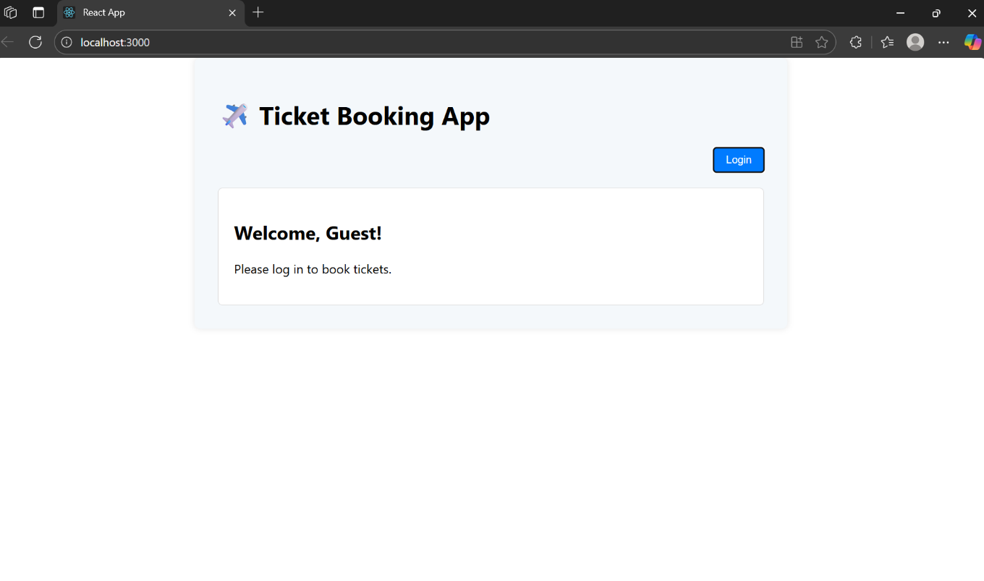

When isLoggedIn == true

