**React Application - cricketapp**

**Step1 :** Create a react application using the command  **npx create-react-app cricketapp** and navigate to the project folder using cd cricketapp.

**Step2 :** Following the component structure , create the required files.

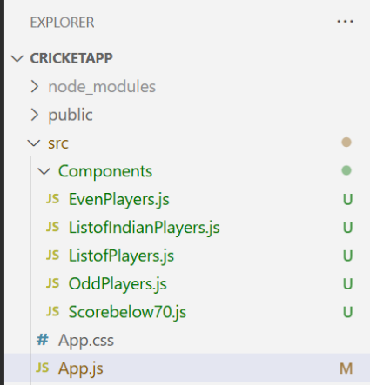

**Step3 : Separate component files with required logic**

**ListofPlayers.js**

const ListofPlayers = ({ players }) => {

  return (

    <ul>

      {players.map((player, index) => (

        <li key={index}>{player.name} - {player.score}</li>

      ))}

    </ul>

  );

};

export default ListofPlayers;

**Scorebelow70.js**

const Scorebelow70 = ({ players }) => {

  const below70 = players.filter(player => player.score < 70);

  return (

    <ul>

      {below70.map((player, index) => (

        <li key={index}>{player.name} - {player.score}</li>

      ))}

    </ul>

  );

};

export default Scorebelow70;

**OddPlayers.js**

const OddPlayers = ({ players }) => {

  return (

    <ul>

      {players.filter((_, index) => index % 2 === 0).map((player, idx) => (

        <li key={idx}>{player}</li>

      ))}

    </ul>

  );

};

export default OddPlayers;

**EvenPlayers.js**

const EvenPlayers = ({ players }) => {

  return (

    <ul>

      {players.filter((_, index) => index % 2 !== 0).map((player, idx) => (

        <li key={idx}>{player}</li>

      ))}

    </ul>

  );

};

export default EvenPlayers;

**ListofIndianPlayers.js**

const ListofIndianPlayers = ({ IndianPlayers }) => {

  return (

    <ul>

      {IndianPlayers.map((player, idx) => (

        <li key={idx}>{player}</li>

      ))}

    </ul>

  );

};

export default ListofIndianPlayers;

**Step 4 :** Edit the App.js to define an array of players and to render the components based on a flag condition.

import React from 'react';

import ListofPlayers from './Components/ListofPlayers';

import Scorebelow70 from './Components/Scorebelow70';

import OddPlayers from './Components/OddPlayers';

import EvenPlayers from './Components/EvenPlayers';

import ListofIndianPlayers from './Components/ListofIndianPlayers';

function App() {

  const flag = true;

  const players = [

    { name: "Virat", score: 85 },

    { name: "Rohit", score: 45 },

    { name: "Rahul", score: 72 },

    { name: "Shreyas", score: 60 },

    { name: "Jadeja", score: 55 },

    { name: "Hardik", score: 95 },

    { name: "Gill", score: 67 },

    { name: "Kuldeep", score: 33 },

    { name: "Shami", score: 80 },

    { name: "Siraj", score: 58 },

    { name: "Bumrah", score: 99 }

  ];

  const IndianTeam = ["Virat", "Rohit", "Gill", "Hardik", "Jadeja", "Shreyas", "KL Rahul", "Shami"];

  const T20Players = ["Surya", "Pant", "Sanju"];

  const RanjiTrophyPlayers = ["Pujara", "Rahane", "Karun Nair"];

  const IndianPlayers = [...T20Players, ...RanjiTrophyPlayers];

  if (flag === true) {

    return (

      <div>

        <h1>List of Players</h1>

        <ListofPlayers players={players} />

        <hr />

        <h1>List of Players having Scores Less than 70</h1>

        <Scorebelow70 players={players} />

      </div>

    );

  } else {

    return (

      <div>

        <div>

          <h1>Indian Team</h1>

          <h1>Odd Players</h1>

          <OddPlayers players={IndianTeam} />

          <hr />

          <h1>Even Players</h1>

          <EvenPlayers players={IndianTeam} />

        </div>

        <hr />

        <div>

          <h1>List of Indian Players Merged:</h1>

          <ListofIndianPlayers IndianPlayers={IndianPlayers} />

        </div>

      </div>

    );

  }

}

export default App;

**Step 5 :** Run the project using **npm start** . In the browser , the react app is up and running , configured in the localhost port 3000 by default.

When flag=true

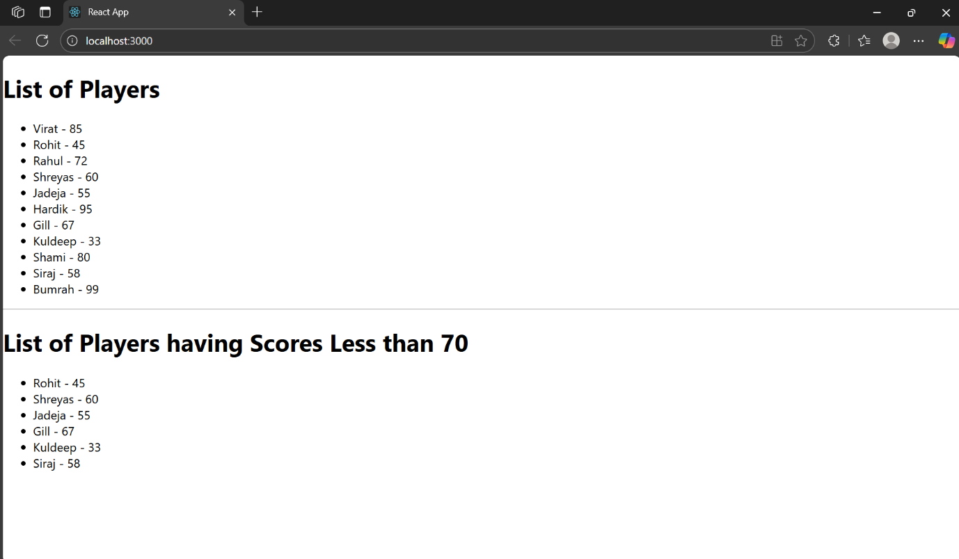

When flag=false

