* <https://www.faceprep.in/c/pattern-programs-in-c/>
* <https://www.geeksforgeeks.org/tag/pattern-printing/>
* <https://www.csinfo360.com/p/pattern-programming-questions-and.html>
* <https://www.techgig.com/practice/pattern-problems/pattern> VERY IMPORTANT
* <https://www.youtube.com/playlist?list=PLzgPDYo_3xuliFyI5dZKgYB99SMUscGyp>

**Patterns**

*

**

***

****

***** **Pattern** 1

*

**

***

****

***** **Pattern** 2

**\***

**\*\*\***

**\*\*\*\*\***

**\*\*\*\*\*\*\***

**\*\*\*\*\*\*\*\*\***

**\*\*\*\*\*\*\*\*\*\*\***

**\*\*\*\*\*\*\*\*\*\*\*\*\*** **Pattern 3**

**\*\*\*\*\*\***

**\*\*\*\*\***

**\*\*\*\***

**\*\*\***

**\*\***

**\* Pattern 4**

1

2 3

4 5 6

7 8 9 10

11 12 13 14 15 **Pattern 5**

A

B B

C C C

D D D D

E E E E E **Pattern 6**

A

B C

D E F

G H I J

K L M N O **Pattern 7**

**\***

**\* \***

**\* * \***

**\* * * \***

**\* * * * \***

**\* * * \***

**\* * \***

**\* \***

**\* Pattern 8**

**\* * * * \***

**\* * * \***

**\* * \***

**\* \***

**\* Pattern 9**

* * * * * * *

* *

* *

*

* *

* *

* * * * * * * **Pattern 10**

1 2 3 4 5

6 7 8 9

10 11 12

13 14

15  **Pattern 11**

15

14 13

12 11 10

9 8 7 6

5 4 3 2 1  **Pattern 12**

*

* * *

* * * * *

* * *

* **Pattern 13**  VTK/VVIP

* * * a * * *

* * a a a * *

* a a a a a *

* * a a a * *

* * * a * * * **Pattern 14** VTK/VVIP

*

a *

a a *

a a a *

a a a a * **Pattern 15**

a a a a *

a a a *

a a *

a *

* **Pattern 16**

* *

* *

*

* *

* * **Pattern 17**

*

* *

* *

* *

* *

* *

* **Pattern 18**

0

1 1

2 3 5

8 13 21 34

55 89 144 233 377 **Pattern 19 VVIPP/VT**

1

1 1

1 2 1

1 3 3 1

1 4 6 4 1 **Pattern 20 VVIPP/VT**

5 * 1 = 5

5 * 2 = 10

5 * 3 = 15

5 * 4 = 20

5 * 5 = 25

5 * 6 = 30

5 * 7 = 35

5 * 8 = 40

5 * 9 = 45

5 * 10 = 50 **Pattern 21 (Print table for n)**

1

2 3 2

3 4 5 4 3

4 5 6 7 6 5 4

3 4 5 4 3

2 3 2

1 **Pattern 22 VVIPP/VT**

1 1

1 2 2 1

1 2 3 3 2 1

1 2 3 4 4 3 2 1

1 2 3 4 5 4 3 2 1 **Pattern 23**

*

* *

* * * * *

* *

* **Pattern 24**

**\* * * * * * \***

**\* \***

**\* \***

**\***

**\* * \***

**\* * * * \***

**\* * * * * * * Pattern 25**

* * * * *

* *

* *

* * * * * * *

* *

* *

* * * * * **Pattern 26**

* *

* *

* *

* * *

* * * *

* * * *

* * **Pattern 27**

* *

* * * *

* * * * * *

* * * * * * * *

* * * * * * * * * *

* * * * * * * * * * * *

* * * * * * * * * * * * * *

* * * * * * * * * * * * * *

* * * * * * * * * * * *

* * * * * * * * * *

* * * * * * * *

* * * * * *

* * * *

* * **Pattern 28**

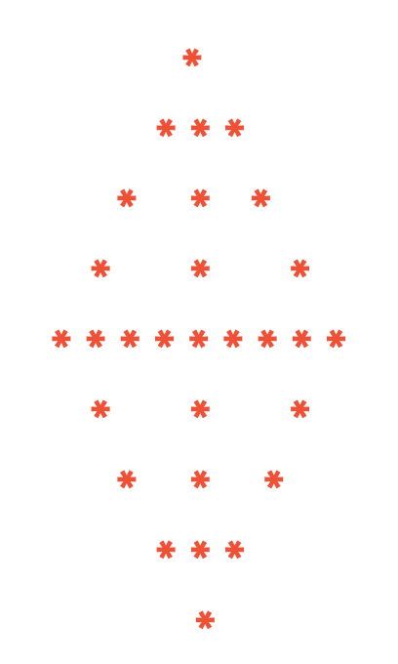 **Pattern 29**

A

A B A

A B C A B

A B C D A B C

A B C D E A B C D **Pattern 30**

9 9 9 9 9 9 9 9 9  
   7 7 7 7 7 7 7  
      5 5 5 5 5  
         3 3 3   
            1 **Pattern 31**

            1  
         3 3 3  
      5 5 5 5 5  
   7 7 7 7 7 7 7  
9 9 9 9 9 9 9 9 9  **Pattern 32**