Last Mile Data Analysis &
Visualisation
Project Report - 2
Submitted in partial fulfilment of the requirements for
Introduction to Multi-Modal Mobility Systems
in
M.Tech Programme
by
Revathy Ramesh (26442)
Yakshith Maddineni (26080)
Supervisor: Prof. Vijay Kovvali


Department of Civil Engineering and CiSTUP
Indian Institute of Science, Bengaluru
Bengaluru-560012
September, 2025

TABLE OF CONTENTS:

- Introduction…….……………...……………………………...……....3

- Literature Review……………………………………………………..4

- Objectives……………….......………………………………………...5

- Methodology…………………...……………………….………….….6

- Procedure for Data Cleaning using PYTHON………………………..10

- Procedure for Power BI Report Development….......…………………14

- Procedure for last Mile Connectivity mapping using QGIS ....……….18

- Results And Discussion........…………………………………………..20

- Conclusion.……………………...………………………….………….39

- References.............................................................................................40

1. Introduction
Urban public transport systems, such as metro rail, play a vital role in reducing congestion, pollution, and travel costs in growing cities. However, their success depends not only on the quality of the trains but also on how easily people can reach and leave the stations. This part of the journey often called the first and last mile is frequently the weakest link. If the walk to the station is unsafe, too long, or expensive, passengers may choose private vehicles instead, reducing metro ridership and making investments in mass transit less effective.
Recent studies highlight this challenge. McCahill (2017) shows that many cities plan rail networks, roads, and land development separately, resulting in good metro services that are difficult to access. The author recommends using modern tools such as accessibility analysis and real travel data from mobile devices or GPS to find gaps in station connectivity and test improvements such as new pedestrian or cycling links. Shu et al. (2021) argue that while walking and cycling are the most sustainable options for short distances, they are not always practical for everyone. Well-planned shuttle services — small buses that connect metro stations to surrounding neighbourhoods — can help fill this gap if they are designed based on real demand patterns. Their study shows that data-driven approaches, which use travel records to plan shuttle stops, routes, and schedules, can make services more efficient and financially viable.
This project builds on these ideas to study last-mile connectivity for metro users in three Indian cities — Bengaluru, Delhi, and Nagpur. The dataset comes from passenger surveys at metro stations, containing details such as modes of travel for first and last mile, travel time, cost, trip purpose, and demographics (age, gender, income, vehicle ownership). The main goal is to analyse how people choose their last-mile mode and to understand how factors like cost, time, and user characteristics influence those choices.
To achieve this, the project involves:
- Cleaning and processing the survey data,
- Performing descriptive and statistical analysis (e.g., chi-square, ANOVA, correlations),
- Creating interactive dashboards in Power BI to visualise mode shares, costs, and demographic trends,
- Using QGIS to map last-mile connectivity patterns, accessibility buffers, and infrastructure gaps around metro stations.
By combining data analysis with visual storytelling, this work aims to help planners and policymakers identify where walking and cycling access can be improved and where shuttle or other feeder services may be needed. The results can guide evidence-based improvements in last-mile connectivity, ultimately supporting higher metro ridership and more sustainable urban travel.

2. Literature Review
Good public transport systems work well only when people can easily get to and from the stations. This part of the journey often called the last mile is where many cities face problems. Even if trains or metro lines run frequently, passengers may avoid using them if the walk to the station is unsafe, too long, or confusing. McCahill (2017) explains that many cities plan transit lines, road networks and land development separately. This lack of coordination means we sometimes have great train service but poor paths or unsafe streets leading to it. The study highlights that improving last-mile connections is just as important as running good trains or buses.
Traditional planning methods, like household travel surveys or traffic models, can be expensive and slow, and they often fail to show short walking and cycling trips. McCahill suggests using accessibility measures which check how many jobs or destinations people can reach from a station in a given time and real travel data collected from mobile phones or GPS. In Sacramento (USA), these tools helped planners spot barriers such as highways and rail tracks, test the effect of building new pedestrian or cycle bridges, and show how many more jobs people could reach if connections were improved.
Walking and cycling are ideal for short trips, but they are not always possible, especially for people with long or unsafe routes. In these cases, shuttle services (small buses that pick up and drop passengers between stations and nearby areas) can make a big difference. Shu et al. (2021) explain that shuttle buses can reduce car use and make metro systems more attractive, but only if they are planned well. Many cities have tried fixed shuttle routes and schedules, but these often fail because demand changes over time and between places.
The 2021 study proposes a data-driven way to design shuttle services. It works in four main steps:
- Finding travel patterns – use data from bikes, taxis, or smart cards to see where people actually travel for the last mile.
- Placing stops – use computer algorithms to decide where shuttle stops should be, so people do not have to walk too far.
- Planning routes and schedules – design the shortest and most efficient shuttle routes and adjust frequency for peak and off-peak times.
- Checking cost and profit – calculate if the service would make sense financially before starting it.
The authors tested this method in Shanghai using bike-sharing data. The results showed that shuttles planned with this approach had better occupancy, shorter waiting times and higher profits than traditional fixed-schedule shuttles. They also found that not every station needs a shuttle some areas have too little demand which helps cities use their budget wisely.
Overall, these studies show a clear move toward evidence-based planning for the last mile. Instead of relying only on surveys or guesswork, cities can use big data and accessibility analysis to decide where to improve walking and cycling and where to add shuttles. This approach can lead to better connections, higher public transport use, and more sustainable city travel.

3. Objectives
- To understand and analyse last-mile connectivity for metro users by studying
people choose their travel modes for the first and last segments of their trips.
- To explore how travel time, cost, and user characteristics affect mode choice for the last mile.
- To process and clean survey data from metro stations and apply descriptive and statistical analysis to identify patterns and relationships.
- To create interactive dashboards in Power BI that visually present mode shares, travel times, costs, and demographic factors affecting last-mile travel.
- To use QGIS for spatial mapping and geospatial analysis to show accessibility around stations and highlight infrastructure gaps.
- To provide insights and recommendations that help planners and policymakers improve last-mile connections, increase metro ridership, and support sustainable urban transport.

4. Methodology
This study used a combination of Python for data preparation and QGIS for spatial analysis and mapping to understand how metro users travel to and from stations in Bengaluru, Delhi and Nagpur. The aim was to identify patterns in last-mile connectivity and highlight locations where better walking, cycling or feeder services may be needed.

4.1 Data Cleaning and Preparation in Python
The raw dataset came from passenger surveys collected at multiple metro stations. It included:
- Travel behaviour: modes used for first and last mile, total trip time, distance and cost.
- User information: age, gender, income level, education and vehicle ownership.
- Trip details: origin and destination, trip purpose and frequency of travel.
Before making Power BI report and spatial analysis, the dataset was cleaned and standardised using Python (mainly the Pandas, NumPy and Rapidfuzz libraries):
- Handling missing values: Rows with empty or invalid travel time, cost or mode fields were removed or corrected where possible.
- Standardising mode names: Similar responses such as “Auto”, “auto-rickshaw” or “three-wheeler” were merged under a single category “Auto” and etc.
- Unit conversions: Distances were converted to kilometres and times to minutes for consistency.
- Removing outliers: Extremely high travel time or cost entries (likely due to typing errors) were removed based on reasonable thresholds.
- Grouping demographics: Age, income and vehicle ownership were categorised into ranges (e.g., 18–25, 26–40) to make later analysis easier.
- Adding station coordinates: Each metro station was matched with latitude and longitude using online geocoding tools and verified manually where necessary.
The cleaned and well-structured dataset was then exported as a CSV file for use in QGIS.

4.2 Power BI Report
Power BI is a business intelligence and data visualization tool developed by Microsoft. It allows users to connect, clean, transform, and visualize data from multiple sources in an interactive way. With features such as Power Query for data preparation, DAX (Data Analysis Expressions) for calculations, and a wide range of visualization options, Power BI helps turn raw data into meaningful insights.
Its ability to create interactive dashboards, comparative analysis, and real-time reports makes it widely used in research, business, and government projects for data-driven decision-making.

4.2.1 Data Transformation in Power BI
The cleaned dataset was imported into Power BI for visualization and analysis. Several transformation steps and DAX measures were created to extract meaningful insights:
- Mode Share Calculation: Counted the number of commuters using each first- and last-mile mode.
- Performance Metrics: Calculated average time, cost, and distance for each mode combination.
- Demographic Integration: Enabled filtering by city, age group, gender, income, and occupation to understand socio-economic differences.
- Comparative Indicators: Developed measures to directly compare Delhi, Bengaluru, and Nagpur, ensuring a standardized basis for analysis.
- Data Normalization: Applied consistent units and categories across all cities to allow for fair comparisons.
- Derived Fields: Created calculated columns such as First Mile Leg 1 vs. Leg 2 and Last Mile Modes for deeper breakdowns.

4.2.2 Visualization Approach
The dashboards were designed to support multi-dimensional comparative analysis across cities:
- Pie Charts – illustrated the proportional share of each first-mile and last-mile mode.
- Tree Maps – showcased combinations of modes (e.g., Walk + Auto, Auto + Walk) along with attributes such as affordability, reliability, and comfort.
- Line and Combo Charts – compared average cost vs. trip time, helping identify trade-offs between affordability and speed.
- Scatter Plots – visualized relationships such as cost vs. time and distance vs. time, revealing clustering patterns across cities.
- Maps – plotted metro stations with commuter data points, highlighting spatial accessibility and catchment areas.
- Interactive Filters & Slicers – enabled users to slice data by city, demographics, and mode, making the dashboard dynamic and exploratory.

4.2.3 Comparative Framework
A uniform methodology was applied across Delhi, Bengaluru, and Nagpur to ensure comparability. The analysis highlighted:
- Mode Share Differences – Delhi showed higher walking dependence, while Bengaluru had greater use of motorized options; Nagpur displayed mixed patterns.
- Cost and Time Trade-offs – Walking reduced costs in Delhi, while autos increased costs but saved time in Bengaluru and Nagpur.
- Socio-economic Influences – Income and occupation shaped mode choice, with low-income groups relying on walking and buses, and higher-income groups opting for motorized modes.4. QGIS For Geospatial Mapping

4. 3 Spatial Data Preparation in QGIS
QGIS was used for all spatial tasks because it can combine survey data with real maps and create professional quality visualisations.
- Base map and networks: The QuickOSM plugin was used to directly download OpenStreetMap (OSM) layers such as roads, footpaths and cycleways. This avoided the need to search for separate shapefiles and ensured up-to-date mapping of each city.
- Loading the dataset: The cleaned CSV from Python was added as a point layer in QGIS. Each point represented one metro station and included attributes like average last-mile time, cost and mode shares.
- Joining data: If needed, attributes from other tables (for example, extra demographic or cost fields) were joined to the station points using the “Join attributes by field” tool.

4.3.1 Calculating Dominant Last-Mile Mode
To simplify visualisation, a dominant mode (the travel mode with the highest percentage at each station) was calculated using the Field Calculator in QGIS.
- A new column (e.g., Dominant Mode) was created.
- A logical expression (using CASE WHEN statements) compared the numeric values of mode share fields (e.g., walk share, auto share, bikeshare, others share) and returned the name of the mode with the highest value.
This allowed each station to be classified by its most common last-mile mode.

4.3.2 Spatial Analysis
Several types of analysis were performed to understand the accessibility around metro stations:
- Buffer analysis:
Circular buffers of 500 metres and 1 kilometre were created around each station using the Buffer tool. These represent comfortable walking distances and help to assess if passengers within these zones choose to walk or prefer other modes.
- Mode share mapping:
The new Dominant Mode field was visualised with Categorized Symbology so that each station’s primary last-mile mode was shown in a unique colour (e.g., green for Walk, blue for Auto, orange for E-rickshaw). This revealed where non-motorised access is strong and where motorised modes dominate.
- Travel time and cost mapping:
Average last-mile travel time and cost were mapped using Graduated Symbology with colour ramps (e.g., green to red). This highlighted stations where passengers face long or expensive last-mile trips.
- Infrastructure gap analysis:
Footpath and cycleway data downloaded with QuickOSM were overlaid on the buffers. Stations with low walking shares and few mapped footpaths or cycle tracks were marked as priority locations for infrastructure improvements.

4.3.3 Map Design and Visualisation
Each output was designed as a clear, standalone map:
- Mode Share Map – showing the most common last-mile mode for each station.
- Walking Accessibility Maps – 500 m and 1 km buffers coloured by walking percentage.
- Travel Time and Cost Maps – variation in last-mile time and cost.
Maps were styled with intuitive colours (e.g., red = long time or high cost, green = short time or low cost), clear legends, scale bars, north arrows and descriptive titles. The Print Layout feature was used to arrange each map professionally and export them as PDFs for inclusion in the report.

5. Procedure for Data Cleaning using PYTHON
5.1 Introduction
The analysis of first mile and last-mile connectivity to metro systems in Delhi, Bengaluru, and Nagpur required a survey data collected directly from metro commuters.
Like most real-world datasets, the survey responses contained raw, unstructured information with issues such as:
- Inconsistencies in naming (e.g., “auto”, “AUTO”, “autorickshaw”).
- Missing values for key variables like age, income, and trip details.
- Outliers in trip costs and travel times.
- Different column formats across the three cities.
- Mismatches between survey station names and official metro station names.
To make the datasets suitable for comparative analysis across cities, a systematic data cleaning procedure was applied. This ensured that the final datasets were accurate, consistent, and standardized.

5.2 Tools and Libraries
Python was chosen due to its efficiency in handling survey datasets and its extensive data cleaning libraries.
- pandas → To handle tabular data, read Excel/CSV files, merge datasets, and transform variables.
- numpy → To perform mathematical operations, handle missing values, and manage numerical thresholds.
- matplotlib → To visually inspect data distributions, detect outliers, and check for anomalies.
- os & sys → To manage files and system-level paths.

5.3 Data Sources
For each city, two sources of data were available:
5.3.1 Survey Dataset (Excel)
  - Contained responses from metro commuters.
  - Information included:
    - First-mile and last-mile modes of travel
    - Trip cost, time, and distance
    - Socio-economic details: age, gender, income, occupation
    - Metro station name
5.3.2 Metro Location Dataset (CSV)
  - Contained official station names, latitude, and longitude.
  - Used to validate survey station names and enable map visualizations.
Example:
- Delhi → Delhi sheet in survey Excel + DELHI_METRO_DATA.csv
- Bengaluru → Bengaluru sheet in survey Excel + Bengaluru metro locations.csv
- Nagpur → Nagpur sheet in survey Excel + nagpur_metro_v2.csv

5.4 Data Cleaning Procedure
5.4.1 Standardization of Structure
Each city’s dataset was formatted differently — some columns had slightly different names. These differences were standardized into a common schema across the three datasets.
Example:
- Delhi → “Metro Station at which the survey is being conducted”
- Nagpur → “Metro name at which the survey is being conducted”
- Final standardized name → Metro_Station
This ensured that the datasets could be merged or compared directly.

5.4.2 Treatment of Missing Values
Survey datasets contained missing information in both critical and non-critical fields.
- Critical fields: Metro station name, first-mile/last-mile mode, trip cost/time/distance.
  - Records missing these values were either discarded or carefully corrected.
- Non-critical fields: Demographic attributes such as age, income, and occupation.
  - Instead of deleting these records, missing values were replaced with the category “Unknown” to preserve the data for mode choice analysis.
This approach balanced data integrity with preservation of maximum responses.

5.4.3 Cleaning Categorical Variables
Since survey responses were filled manually, categories often had spelling variations, inconsistent capitalizations, or multiple terms for the same option.
Examples of issues and fixes:
- auto, Auto, AUTO, autorickshaw → Auto
- 2-wheeler, bike, scooter → Two-wheeler
- car, taxi, cab → Car/Taxi
By consolidating responses into standard categories, the analysis became clear, reliable, and comparable across cities.

5.4.4 Grouping Socio-Economic Data
Socio-economic variables were too granular in the raw data. To make them more useful for analysis, they were grouped:
- Income brackets: <10,000, 10,000–30,000, 30,000–60,000, >60,000.
- Age groups: <20 years, 20–35 years, 35–50 years, >50 years.
- Occupation: Broader categories like Student, Employed, Homemaker, Retired/Other.
This grouping allowed patterns to emerge more clearly, for example:
- Younger respondents preferred walking or cycling.
- Higher income groups leaned more towards car/taxi or auto-rickshaws.

5.4.5 Detecting and Removing Outliers
Some survey responses included unrealistic or erroneous values:
- Trip time: 0 minutes or excessively high values (e.g., 300 minutes for a short leg).
- Trip cost: Negative values or abnormally high amounts.
- Trip distance: Walking distances recorded as 10–15 km, which were not feasible.
To address this:
- Clearly invalid values were removed.
- Extremely high but plausible values were flagged and reviewed.
This step was crucial to prevent skewed averages in cost and time analysis.

5.4.6 Validation with Metro Location Data
Survey responses were cross-checked with official station names and coordinates:
- Station names with spelling mistakes or local variations were corrected.
- Each survey record was matched with latitude and longitude from the location dataset.
- Records with unmatched station names were reviewed and corrected manually where possible.

5.4.7 Exporting the Cleaned Data
After all steps, cleaned versions of the datasets were created for Delhi, Bengaluru, and Nagpur.
These files had:
- Standardized columns
- Cleaned and grouped categories
- Outliers removed
- Validated station names with coordinates
The cleaned datasets were then exported into CSV/Excel files, ready for visualization and analysis in Power BI and Spatial mapping using QGIS.

5.5 Common Framework Across All Cities
The same cleaning procedure was applied to all three datasets. This provided:
- Consistency → uniform column names, socio-economic groups, and mode categories.
- Accuracy → removal of errors, unrealistic values, and spelling mismatches.
- Comparability → results from Delhi, Bengaluru, and Nagpur could be compared meaningfully without bias from data inconsistencies.
6. Procedure for Power BI Report Development
6.1 Introduction
The Power BI report was developed to analyze first-mile and last-mile connectivity patterns for metro commuters in Delhi, Bengaluru, and Nagpur. The purpose of this report was to provide actionable insights into how metro users access and exit stations, what factors influence their choice of mode, and how these choices vary across different cities and socio-economic groups.
A structured procedure was followed, starting with importing cleaned data, applying transformations and DAX measures, designing interactive dashboards, and ensuring comparative analysis across the three cities.

6.2 Data Sources
The Power BI report was based on cleaned datasets, which were prepared using Python before being imported. The datasets consisted of:
- Survey Data (Cleaned Excel/CSV)
  - First-mile and last-mile travel modes
  - Travel time, cost, and distance
  - Socio-economic attributes: age, gender, income, occupation
- Metro Station Location Data (CSV)
  - Names of metro stations
  - Latitude and longitude values for geospatial visualization
By combining survey data with location data, the dashboard could represent both behavioral and spatial aspects of metro accessibility.

6.3 Procedure in Power BI
6.3.1 Data Import and Integration
- Imported the cleaned datasets for Delhi, Bengaluru, and Nagpur into Power BI Desktop.
- Used Power Query Editor to:
  - Verify column names and formats
  - Ensure consistency across the three city datasets
  - Remove unnecessary columns and duplicates
  - Merge survey responses with location coordinates for geospatial visualizations
This step ensured that all three datasets had a uniform structure and were ready for combined analysis.

6.3.2 Data Transformation in Power BI
Once the data was imported, several transformations and calculations were carried out:
- Mode Share Calculation
Created measures to count the number of commuters using each first-mile and last-mile mode.
- Performance Indicators
Calculated average cost, travel time, and distance for each mode, enabling comparison of performance.
- Demographic Integration
Enabled filtering of results by socio-economic attributes such as income, occupation, age, and gender.
- Comparative Indicators
Built measures that allowed side-by-side comparison across the three cities (e.g., percentage of walking in Delhi vs. Bengaluru).
- Derived Variables
Created additional fields such as mode combinations (e.g., Walk + Auto, Auto + Walk) for more detailed insights.

6.3.3 Visualization Design
The visualizations in Power BI were chosen to present the data in a clear, comparative, and policy-relevant manner:
- Pie Charts – Displayed mode shares for first-mile and last-mile trips across each city.
- Tree Maps – Showed combinations of travel modes and highlighted the importance of multi-modal connections.
- Line & Combo Charts – Compared travel cost and travel time for each mode, illustrating trade-offs between affordability and speed.
- Scatter Plots – Showed relationships such as cost vs. time and distance vs. time, highlighting mode efficiency.
- Maps – Represented metro station locations along with commuter data for spatial analysis.
- Interactive Filters and Slicers – Allowed users to explore results by city, demographics, and trip leg type.
The choice of visualization was based on best practices in transport data analysis, ensuring clarity and interpretability for decision-makers.

6.3.4 Comparative Framework
To make the analysis meaningful across cities, a uniform comparative framework was applied:
- Standardized Categories – Mode names, income groups, and occupation categories were harmonized across datasets.
- Cross-City Measures – Created indicators that could directly compare mode shares, average costs, and times across Delhi, Bengaluru, and Nagpur.
- City-Level Insights –
  - Delhi: Walking emerged as the dominant mode due to compact accessibility.
  - Bengaluru: Higher reliance on motorized options (auto-rickshaws, two-wheelers).
  - Nagpur: Mixed results reflecting its newer and smaller metro system.
This framework highlighted both city-specific findings and common challenges in first- and last-mile connectivity.

6.4 Workflow Summary
The overall procedure for developing the Power BI report followed a step-by-step pipeline:
- Data Input – Import cleaned survey and location data into Power BI.
- Data Preparation – Use Power Query to standardize, merge, and validate datasets.
- Data Transformation – Create DAX measures for mode shares, averages, and comparative indicators.
- Visualization – Build interactive charts (pie, tree map, scatter, combo, maps).
- Filtering & Interactivity – Add slicers for city, demographic, and trip-level filtering.
- Comparative Framework – Apply uniform measures for cross-city comparison.
- Final Dashboard – Design report pages for policymakers and planners to interpret results.

6.5 Key Features of the Power BI Report
- Interactive Dashboard – Users can filter by city, demographics, or trip type.
- Cross-City Comparison – Results are directly comparable across Delhi, Bengaluru, and Nagpur.
- Integrated Spatial Analysis – Metro station data with commuter responses visualized on maps.
- Socio-Economic Insights – Links mode choice with age, income, gender, and occupation.

7. Procedure for Last-Mile Connectivity Mapping Using QGIS

7.1 Prepare Your Data
- Clean your survey data in Python (remove errors, standardise units, check lat/long).
- Save the final dataset as a CSV with these important columns:
  - metro_station, latitude, longitude
  - % share for each mode (walkshare, autoshare, cycleshare, othershare)
  - avg_time_leg2 (last-mile time)
  - avg_cost_leg2 (last-mile cost)
- Open QGIS → Layer ▸ Add Layer ▸ Add Delimited Text Layer → add your CSV as a point layer.

7.2 Get Base Map and Street Data
- Install QuickOSM (Plugins ▸ Manage and Install Plugins → search “QuickOSM”).
- Go to Web ▸ QuickOSM ▸ QuickOSM:
  - Key: highway → Value: footway or cycleway (to download walking/cycling paths).
  - Limit query to your station layer (Query extent = Layer).
- Add a base map (optional): Install QuickMapServices → Web ▸ QuickMapServices ▸ OSM Standard.

7.3 Calculate Dominant Mode
- Open the station layer Attribute Table → click Field Calculator.
- Create a new text field called Dominant_Mode.The Expression is as follows:
CASE
WHEN "walkshare" = greatest("walkshare","autoshare","cycleshare","othershare") THEN 'Walk'
WHEN "autoshare" = greatest("walkshare","autoshare","cycleshare","othershare") THEN 'Auto'
WHEN "cycleshare" = greatest("walkshare","autoshare","cycleshare","othershare") THEN 'Cycle'
ELSE 'Other'
END

7.4 Create Buffers (500 m & 1000 m)
- Select station layer → Vector ▸ Geoprocessing Tools ▸ Buffer.
- Distance = 500 m → save as Buffer_500m.
- Repeat with 1000 m → save as Buffer_1000m.
- Optional: Join attributes by location to calculate average walk share inside each buffer.

7.5 Make Maps
Map 1 — Dominant Last-Mile Mode
- Right-click station layer → Properties ▸ Symbology.
- Renderer: Categorized → Column: Dominant_Mode.
- Classify → assign colours (e.g., green = Walk, blue = Auto, orange = Cycle, grey = Other).
Map 2 — Walking Accessibility (Buffers)
- Symbolise Buffer_500m and Buffer_1000m (different shades).
- Optionally style buffers by walkshare using Graduated colours (light = low, dark = high).
Map 3 — Travel Time
- Duplicate station layer → Properties ▸ Symbology ▸ Graduated.
- Column: avg_time_leg2 → choose colour ramp (green = short, red = long)

7.6 Map Layout and Export
- Go to Project ▸ New Print Layout → name it.
- Add your map frame, legend, north arrow, scale bar, and title.
- Adjust colours/labels.
- Export as PDF or PNG for your report.

8.RESULTS AND DISCUSSIONS
8.1 Power BI Report Analysis
8.1.1 Bengaluru Last Mile Analysis
The last mile journey is crucial in determining the convenience of metro travel in Bengaluru, as it connects commuters from the station to their final destinations. The analysis of the survey data provides the following key insights:

8.1.1.1 Last Mile Mode Share
- Walking dominates last mile travel, with about 83–84% of commuters using it as their primary mode. This shows the critical role of pedestrian pathways in Bengaluru’s metro ecosystem.
- Auto-rickshaws serve around 11–12% of commuters, providing essential connectivity where walking is not feasible due to longer distances or poor walkability.
- Other modes such as two-wheelers, cycles, cars/taxis, and shared rides contribute marginally (together less than 5%). This highlights that private and alternative modes play only a small role in last mile travel.

8.1.1.2 Last Mile Mode Combinations
- The most common pattern is Walk + No Second Leg, reflecting that most metro users complete their journey directly on foot.
- Auto + Walk is another combination used by a smaller share of commuters, showing limited multimodal behavior.
- Rare patterns like Cycle + Walk or Car/Taxi + Walk exist but remain insignificant in comparison to walking and auto-rickshaws.

8.1.1.3 Travel Time and Cost Insights
- Walking trips are cost-free and time-efficient within short distances, explaining their overwhelming dominance.
- Auto-rickshaw trips introduce a cost element and show high variability in travel time due to traffic conditions. While convenient, they are not affordable for all income groups.
- Scatter plot patterns indicate:
  - Walking clusters at low cost and moderate time.
  - Autos spread widely across higher cost and varied time ranges.
  - Other modes remain scattered and negligible in share.

8.1.1.4 Last Mile Leg Splits
- Last Mile Leg 1:
  - Walking: ~84%
  - Auto-rickshaws: ~12%
  - Others (cycle, taxi, two-wheelers): <5%
- Last Mile Leg 2:
  - 97% of commuters report no second leg, showing that last mile journeys are largely single-mode trips.
  - Only about 1–2% of commuters use multiple modes for the last mile.

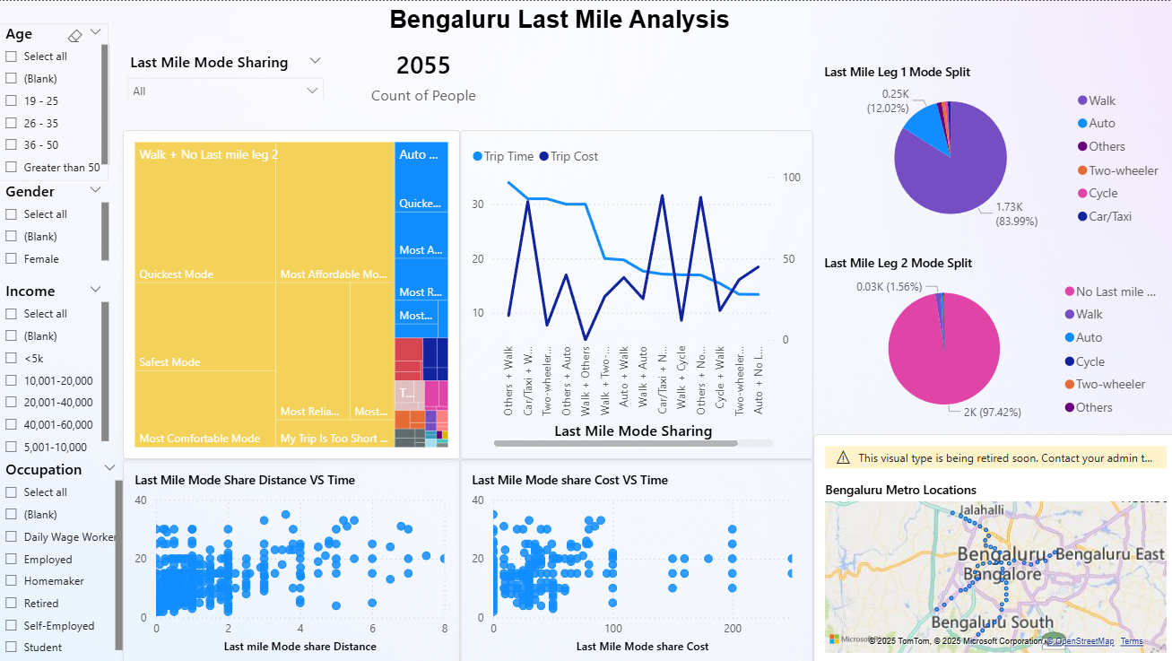Figure-8.1

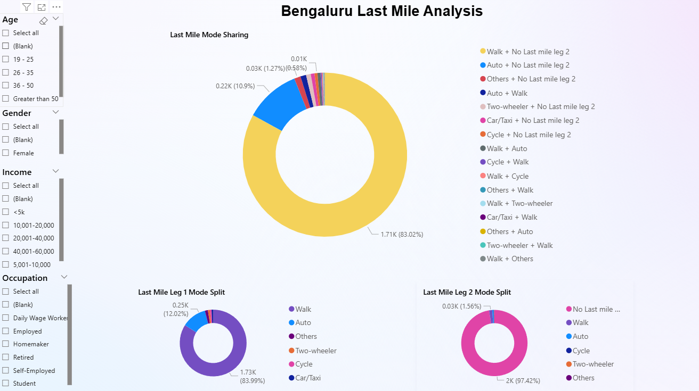
Figure-8.2

8.1.2 Delhi Last Mile Analysis
The last mile journey is crucial in determining the convenience of metro travel in Delhi, as it connects commuters from the station to their final destinations. The analysis of the survey data provides the following key insights:

8.1.2.1 Last Mile Mode Share
- Walking is the dominant last-mile mode, with around 66–75% of commuters relying on it. This highlights Delhi’s relatively strong pedestrian accessibility, especially in densely populated metro catchment areas.
- Auto-rickshaws account for about 16–24% of last-mile trips, playing a major role in connecting commuters from stations to their destinations.
- Buses (around 6–7%) contribute more significantly in Delhi compared to other cities, reflecting the city’s extensive bus network and its integration with metro travel.
- Other modes such as cycles, cars/taxis, and two-wheelers contribute less than 5%, showing limited use for last-mile purposes.

8.1.2.2 Last Mile Mode Combinations
- The most common combination is Walk + No Second Leg, confirming that most commuters complete their last mile with a single walking trip.
- Auto + Walk and Walk + Auto appear as notable combinations, showing reliance on flexible paratransit modes in certain areas.
- Bus + Walk also emerges in Delhi more than in other cities, highlighting multimodal integration opportunities between metro and public bus systems.
- Car/taxi-based combinations remain marginal, showing that private vehicles are not a preferred last-mile option among metro users.

8.1.2.3 Travel Time and Cost
- Walking trips dominate the low-cost, low-to-moderate time category, which explains their popularity.
- Auto trips introduce a cost burden but offer time savings for commuters living farther from stations.
- Bus trips remain affordable but show slightly higher time variations due to traffic and waiting times.
- Scatter plots of cost vs. time confirm a clear trade-off: walking = free but time-consuming; autos = faster but costly; buses = affordable but slower.

8.1.2.4 Last Mile Leg Splits
- Leg 1 (primary connection):
  - Walking accounts for ~75% of trips.
  - Auto-rickshaws contribute ~24%.
  - Buses have a share of ~6%.
  - Other modes remain minimal.
- Leg 2 (secondary connection):
  - Over 83% of respondents report no second leg.
  - A small share uses auto (7%) or bus (1%) for the second connection.
  - This confirms that most last mile trips are completed in a single leg, but multimodal transfers do exist, especially in suburban areas.
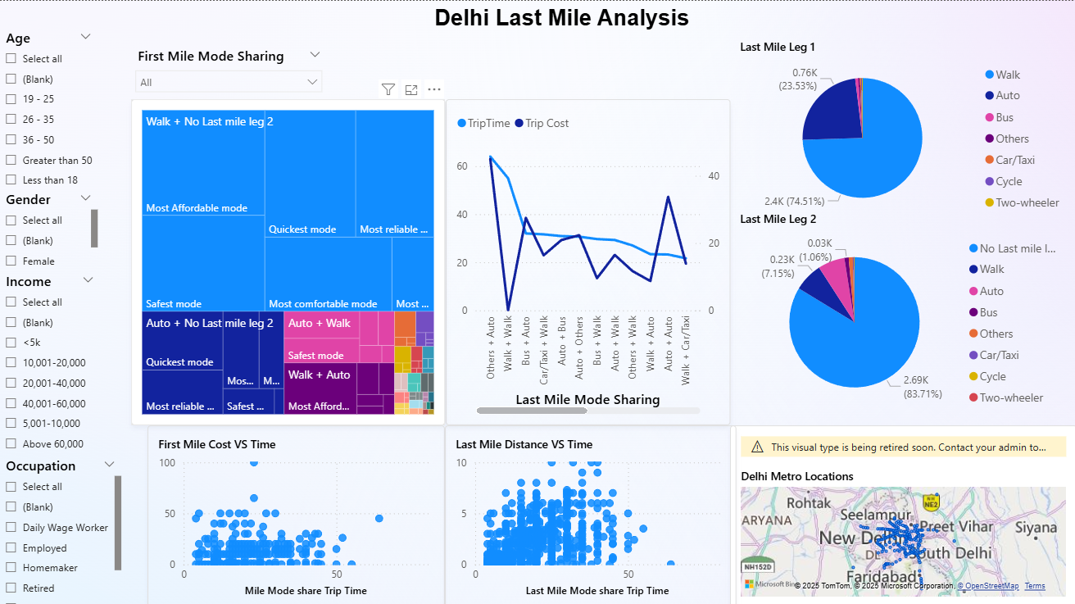
Figure-8.3

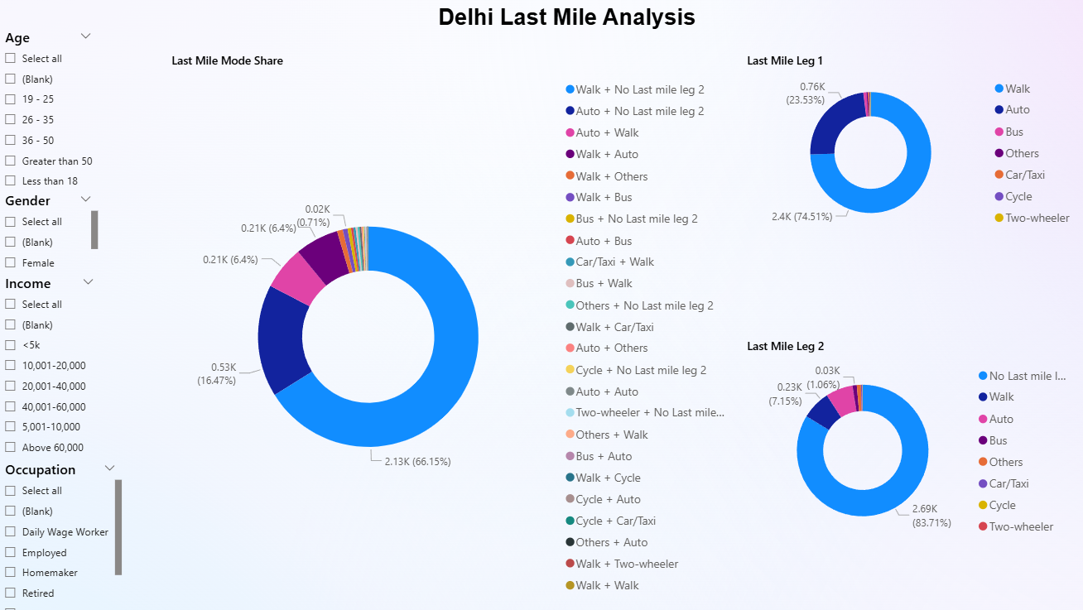
Figure-8.4

8.1.3 Nagpur Last Mile Analysis
The Nagpur Metro is a relatively new system compared to Delhi and Bengaluru, and its survey results reveal unique characteristics of last-mile travel behavior. The analysis of commuter responses highlights the following key findings:

8.1.3.1 Last Mile Mode Share
- Walking is the dominant last-mile mode, used by about 72–77% of commuters. This reflects Nagpur’s compact urban form and the fact that many metro users live or work within walking distance of stations.
- Auto-rickshaws are the second most common last-mile mode, serving around 10–12% of commuters. Autos fill an important gap where walkability is limited.
- Buses contribute about 5%, showing that they play a supplementary role in providing last-mile access.
- Other modes such as cycles, two-wheelers, and cars/taxis together make up less than 5%, reflecting limited adoption of alternative or private last-mile solutions.

8.1.3.2 Last Mile Mode Combinations
- The most frequent combination is Walk + No Second Leg, meaning most commuters finish their journey by walking directly from the metro to their destination.
- Auto + Walk also appears as a notable combination, especially for those living slightly farther away from stations.
- Bus + Walk exists in small proportions, showing limited but present multimodal connectivity between metro and bus services.
- Rare combinations like Cycle + Walk or Car/Taxi + No Second Leg appear in very small shares, suggesting these modes are not yet widely integrated with metro access.

8.1.3.3 Travel Time and Cost
- Walking trips are time-efficient and cost-free, explaining their overwhelming dominance.
- Auto-rickshaw trips show higher variability in cost and travel time, making them a convenient but more expensive option.
- Bus trips remain affordable but take longer on average, as expected due to waiting and traffic delays.
- Scatter plot distributions confirm that walking clusters at low cost–low time, while auto trips spread out across higher cost ranges, and bus trips cluster around low cost but higher time.

8.1.3.4 Last Mile Leg Splits
- Leg 1 (primary connection):
  - Walking: ~77%
  - Auto: ~10%
  - Bus: ~5%
  - Others: very small shares
- Leg 2 (secondary connection):
  - Around 87% of commuters report no second leg, confirming that most last mile trips are single mode.
  - A small share (7–8%) use a second mode, with autos and buses being the most common.

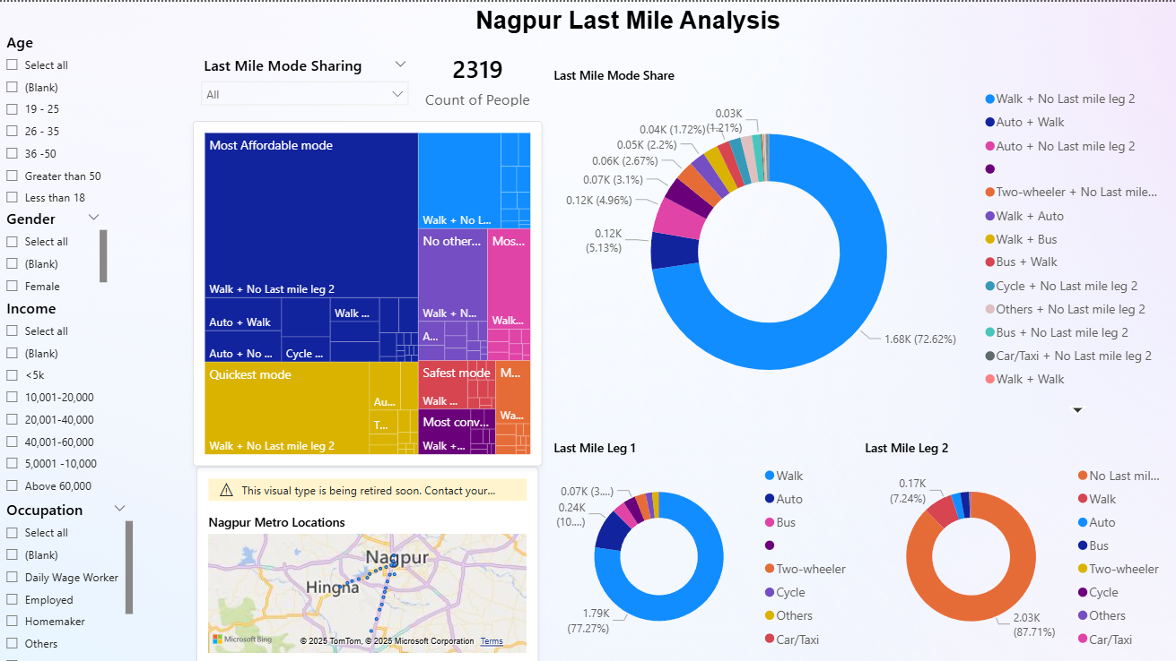
Figure-8.5

  - 8.2 QGIS For Geospatial Mapping
  - 8.2.1 Bengaluru

8.2.1.1 Dominant Last-Mile Mode by Station
The dominant last-mile mode map shows how people travel to and from metro stations in Bengaluru.
- Walking is the main mode for many stations in the central parts of the city, especially where the urban fabric is dense and streets are connected.
- Auto-rickshaws dominate at stations located in peripheral or low-density areas, and at locations where safe pedestrian paths and crossings are limited.
- Cycling and other modes appear only in a few stations and have very small shares overall.
This pattern shows a clear divide between the city core and the outer areas central stations are walk-friendly, while peripheral ones depend heavily on motorised modes.

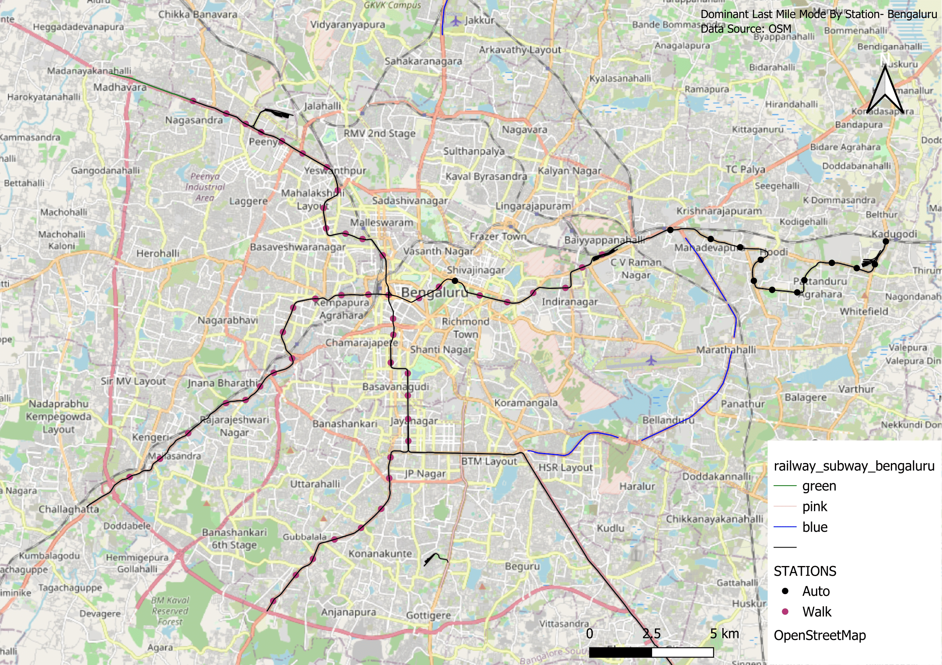
Figure-8.6

8.2.1.2 Walking Accessibility within 500 m
The 500 m buffer analysis (Figure 2) evaluates how well people can access stations on foot within a short, comfortable distance.
- Stations in the inner city show high walking shares (above 80%) within 500 m, meaning most users can reach these stations easily on foot.
- Many outer corridor stations have low walking shares (below 25%), showing that even within 500 m people often prefer autos or other vehicles.
- Some mid-network stations have mixed results, where walking is moderate but still not dominant.
These results indicate that walking infrastructure and safe access are strongest in older, denser neighbourhoods but weak in newer, peripheral areas.
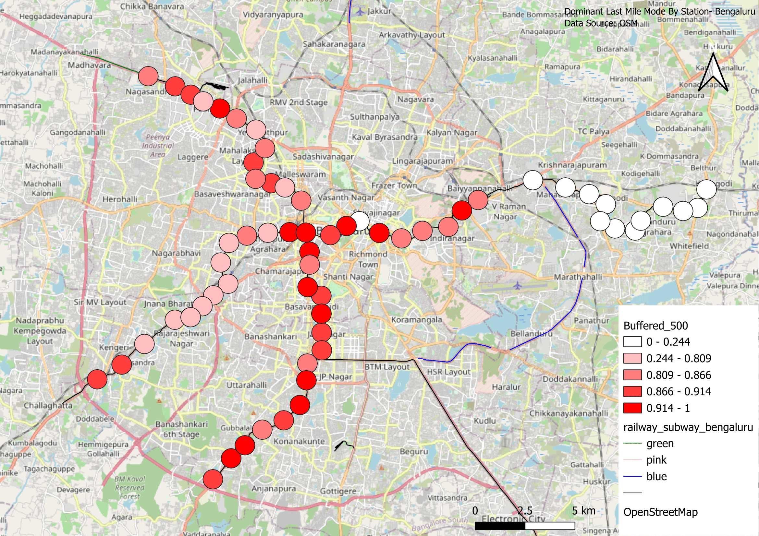
Figure-8.7

8.2.1.3 Walking Accessibility within 1 km
When the analysis radius increases to 1 km (Figure 3), the walking share drops further:
- Even stations that performed well at 500 m show a noticeable decrease in walking beyond 1 km.
- Outer corridor stations have very low walking shares (below 25%), suggesting users strongly prefer motorised modes for trips over 500 m.
- The results highlight the limited catchment of stations for pedestrians — most people do not walk beyond 500–700 m.
This finding suggests that better feeder options (like e-rickshaw or shuttle buses) or improved cycling infrastructure could help people access stations from 1 km away.
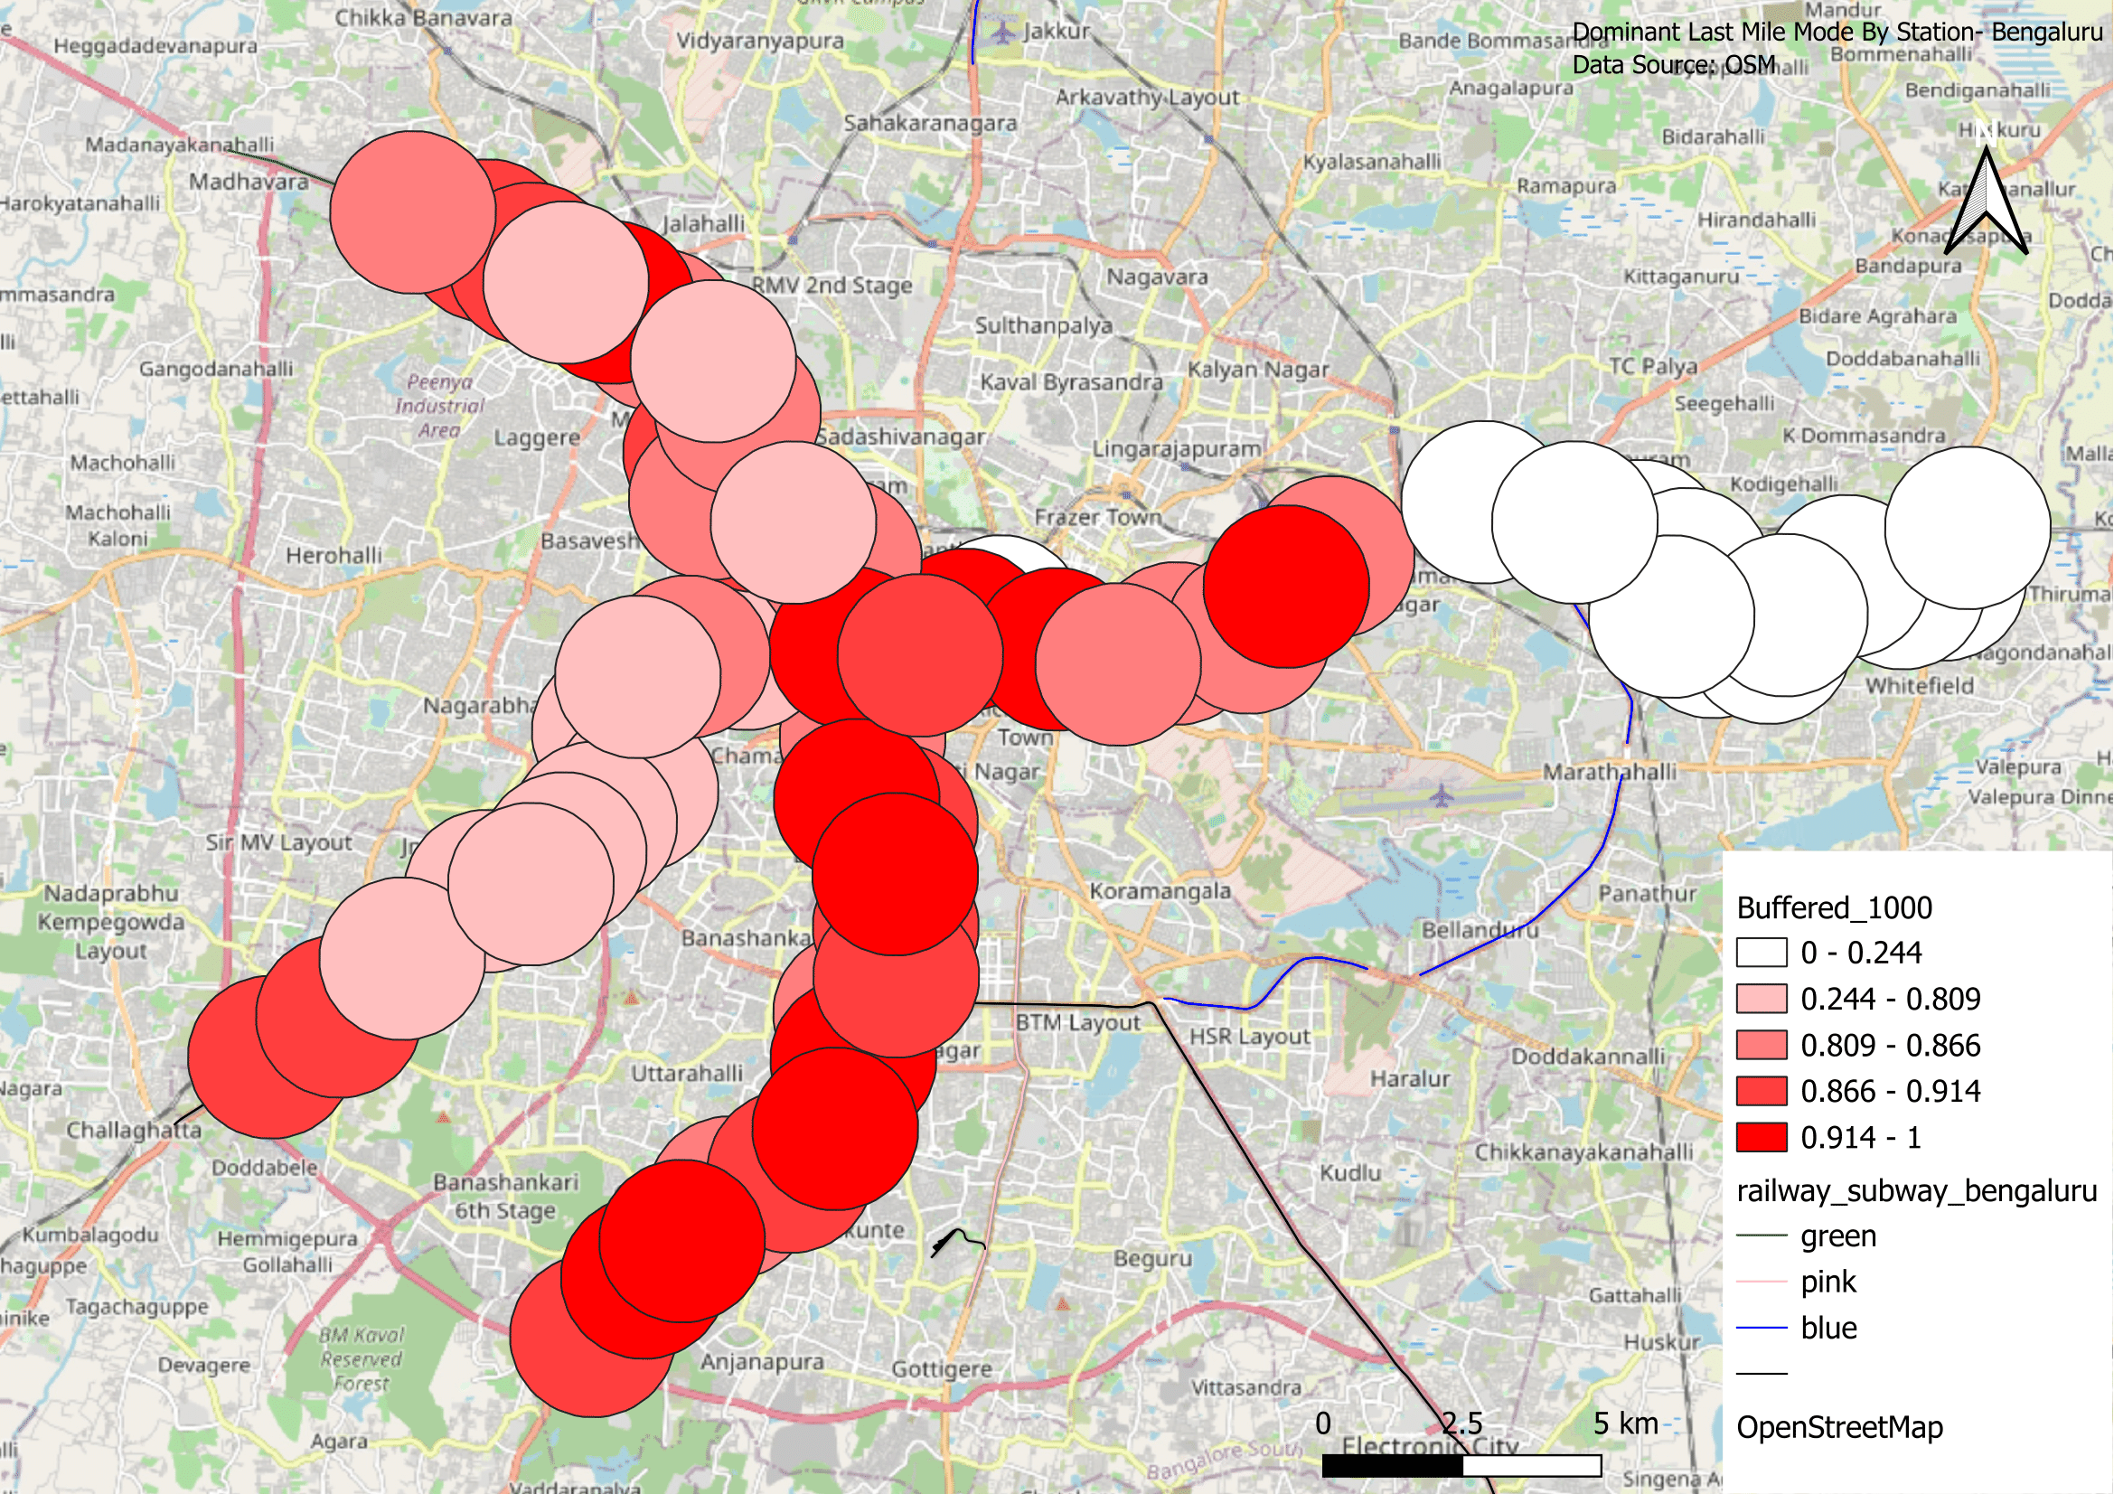
Figure-8.8

8.2.1.4 Last-Mile Travel Time
The travel time map shows that:
- Stations in the central network have shorter last-mile travel times (often 5–8 minutes), consistent with their higher walking shares.
- Peripheral stations show longer last-mile times (10–13 minutes on average), reflecting dependence on autos and the need to travel farther.
- Some stations on the city edges exceed 12 minutes average last-mile time, making the metro less convenient compared to door-to-door private modes.
Longer last-mile travel times reduce the overall attractiveness of using the metro, especially for people with time-sensitive commutes.
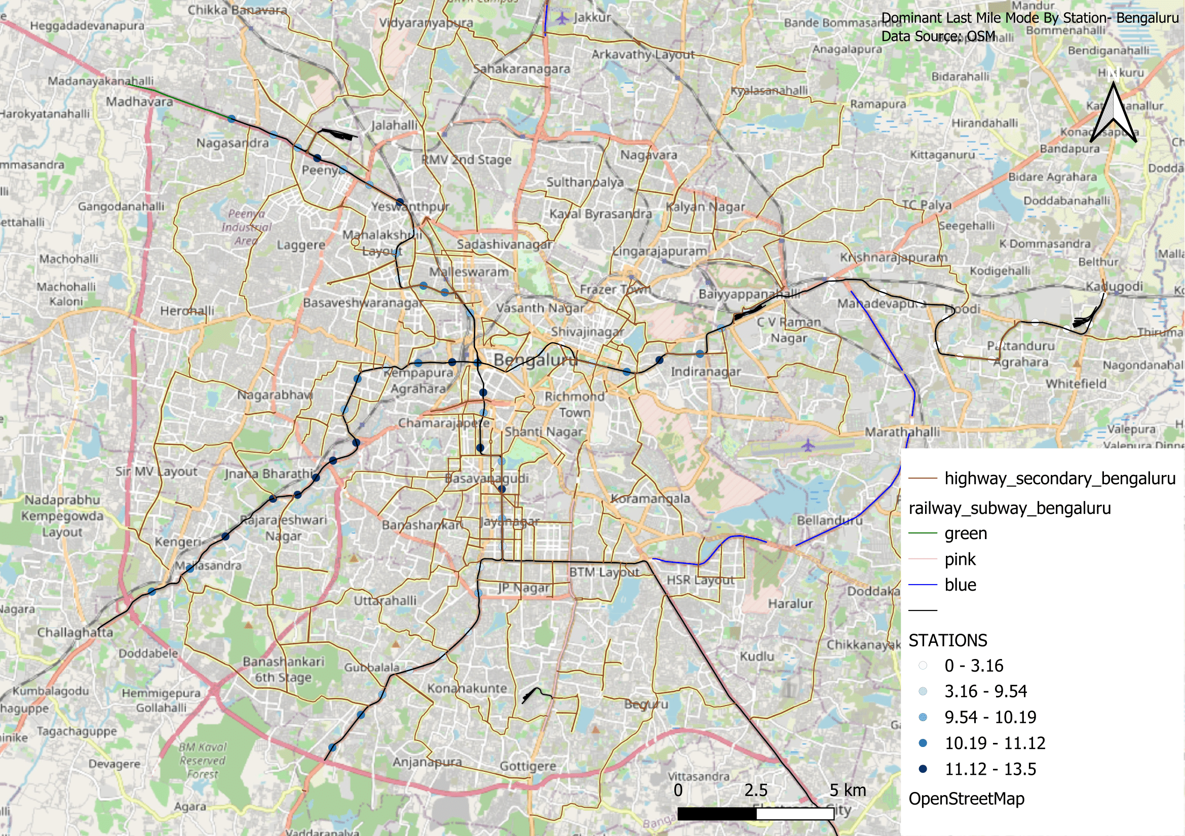
Figure-8.9

8.2.2 DELHI

8.2.2.1 Dominant Last-Mile Mode by Station
The dominant mode map for Delhi (Figure 1) shows a mixed pattern compared with Bengaluru.
- Walking is still the main mode for many stations in the central and older parts of Delhi, especially inside dense neighbourhoods with smaller street blocks.
- Auto-rickshaws and shared autos dominate in large parts of the outer network, including along major highways and new metro extensions where pedestrian access is weaker.
- A few stations show “other” modes such as cycle-rickshaw or informal shared vehicles, which are more common in Delhi compared to Bengaluru.
This indicates that Delhi still relies heavily on informal motorised last-mile options in its outer areas.
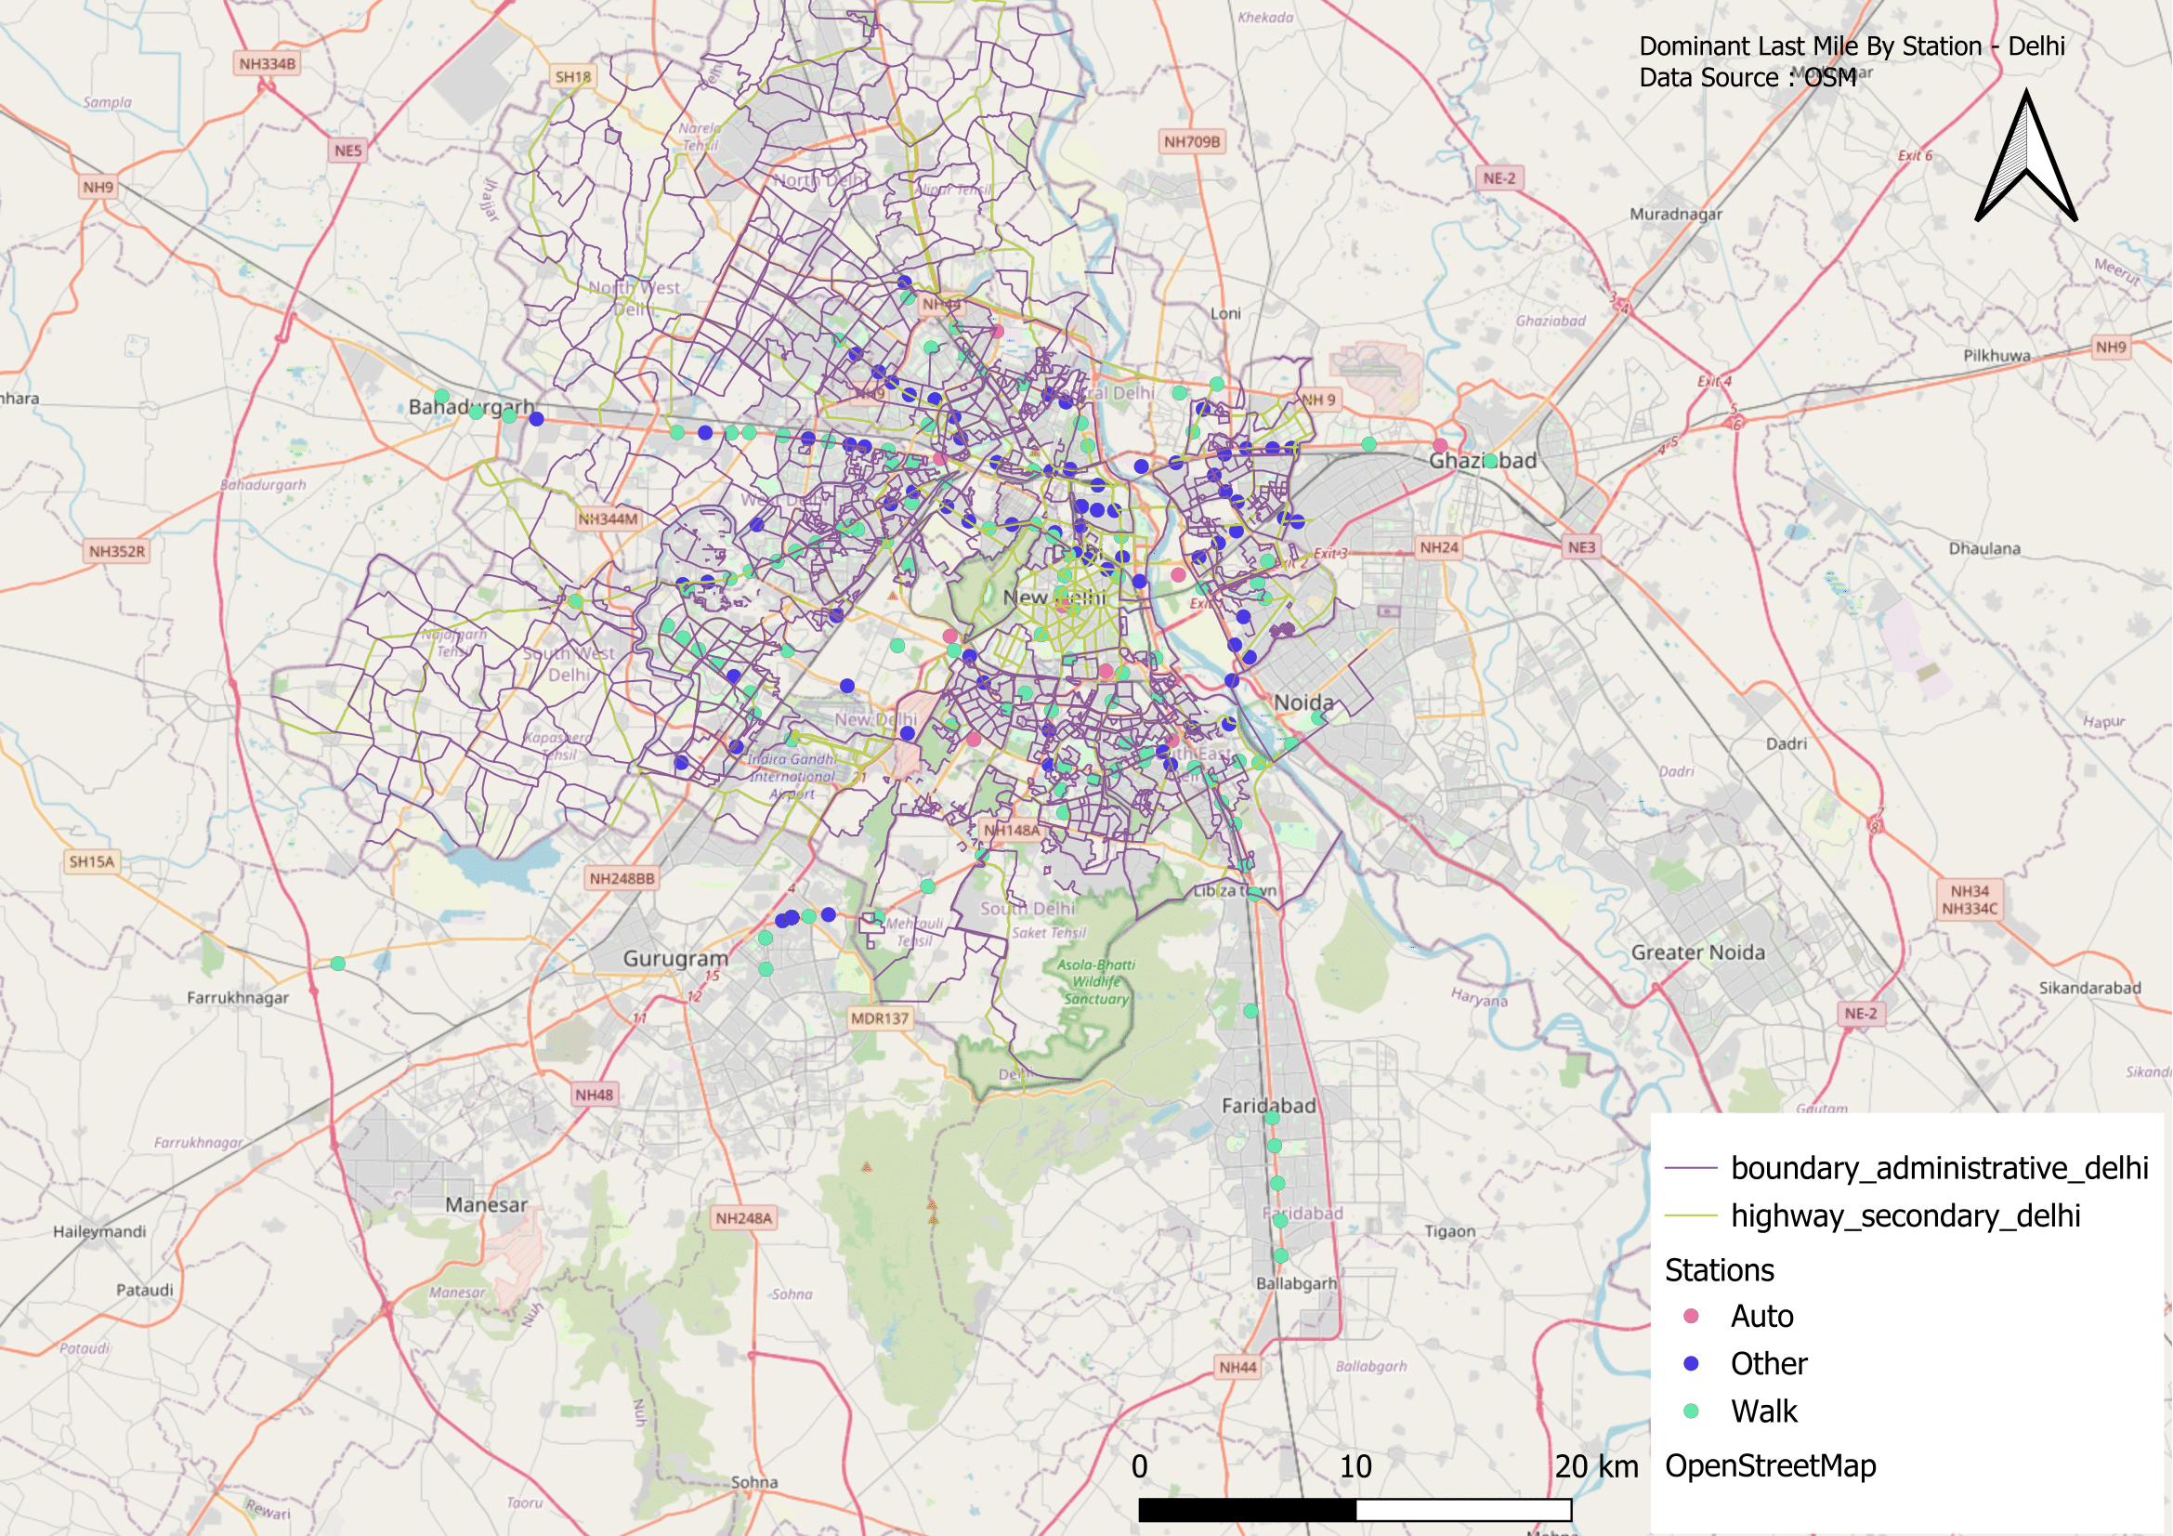
Figure-8.10

8.2.2.2 Walking Accessibility within 500 m
The 500 m buffer analysis (Figure 2) shows:
- High walking share (above 60–70%) in the dense city core and older neighbourhoods, where streets are walkable and metro entrances are embedded in mixed-use areas.
- Low walking share (<30%) in new or peripheral stations, especially along highways and in low-density suburbs.
- Some intermediate zones show moderate walking levels but still depend partly on autos or rickshaws.
The results show that good walking is limited to short catchments (≤500 m) and drops sharply where the urban form is car oriented.
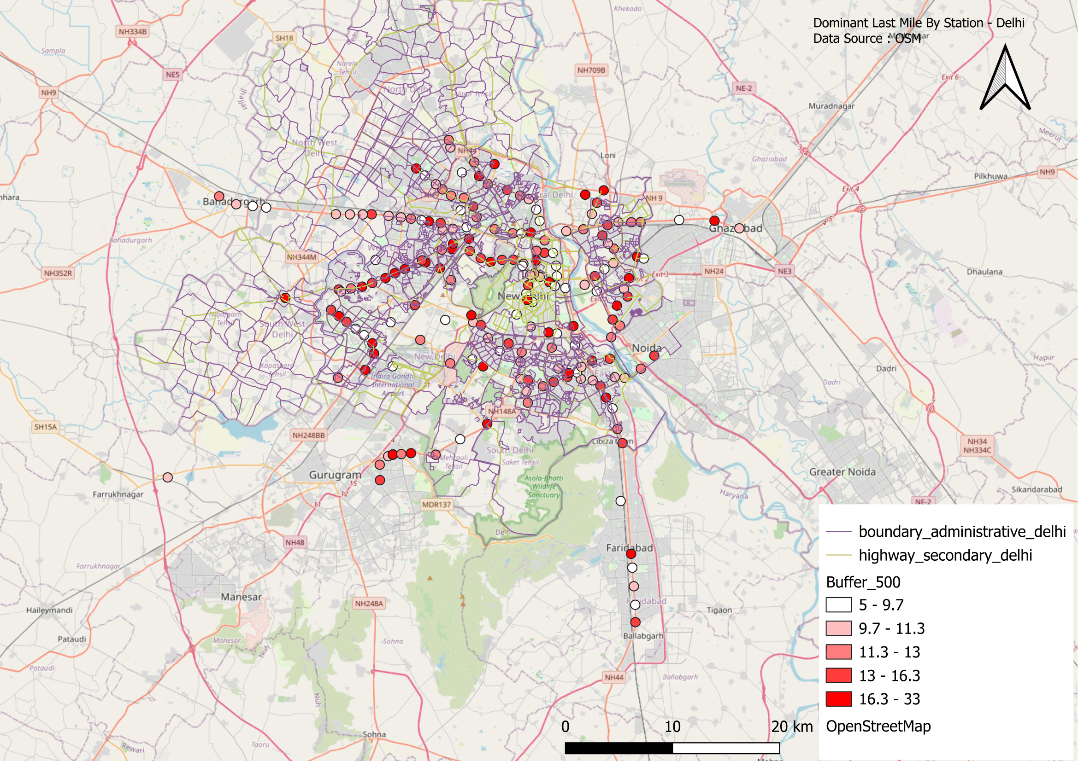
Figure-8.11

8.2.2.3 Walking Accessibility within 1 km
The 1 km buffer analysis map reveals that:
- Walking decreases sharply beyond 500 m even in the central parts of Delhi.
- In the outer city and extensions, walking share is extremely low, and most passengers choose autos, shared vehicles or two-wheelers for distances beyond 500 m.
- This confirms that 1 km is too far to walk for many Delhi metro users, especially where streets are not safe or continuous.
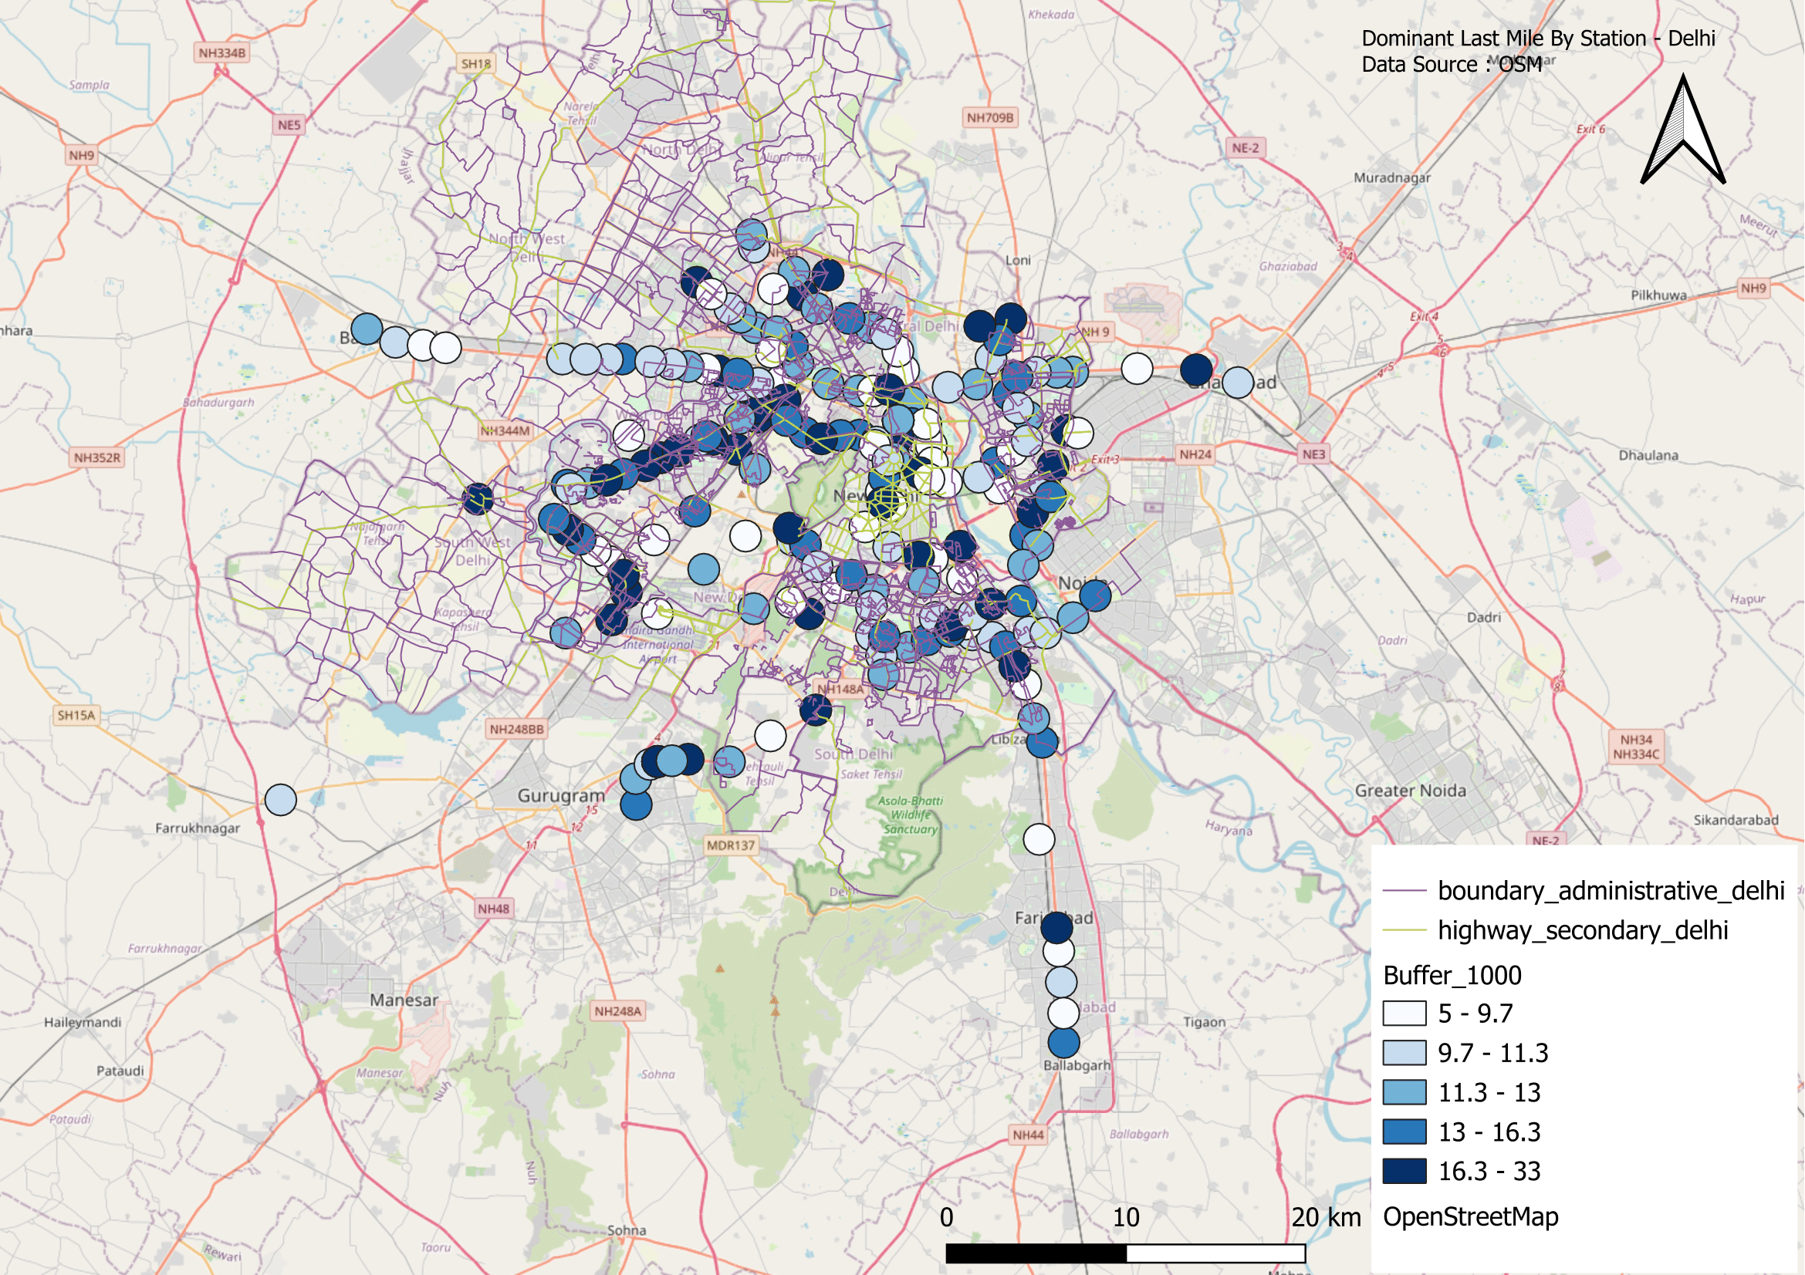
Figure-8.12

8.2.2.4 Last-Mile Travel Time
The travel time map (Figure 4) shows:
- Inner-city stations: generally short last-mile times (5–8 minutes) because of walking and dense street networks.
- Peripheral corridors: longer last-mile times (10–16+ minutes), reflecting reliance on auto-rickshaw or other motorised options.
- Very long last-mile times (>16 min) appear in some outer extensions where users travel from spread-out residential areas.
This shows a clear penalty in time for users in the periphery compared to the core network.
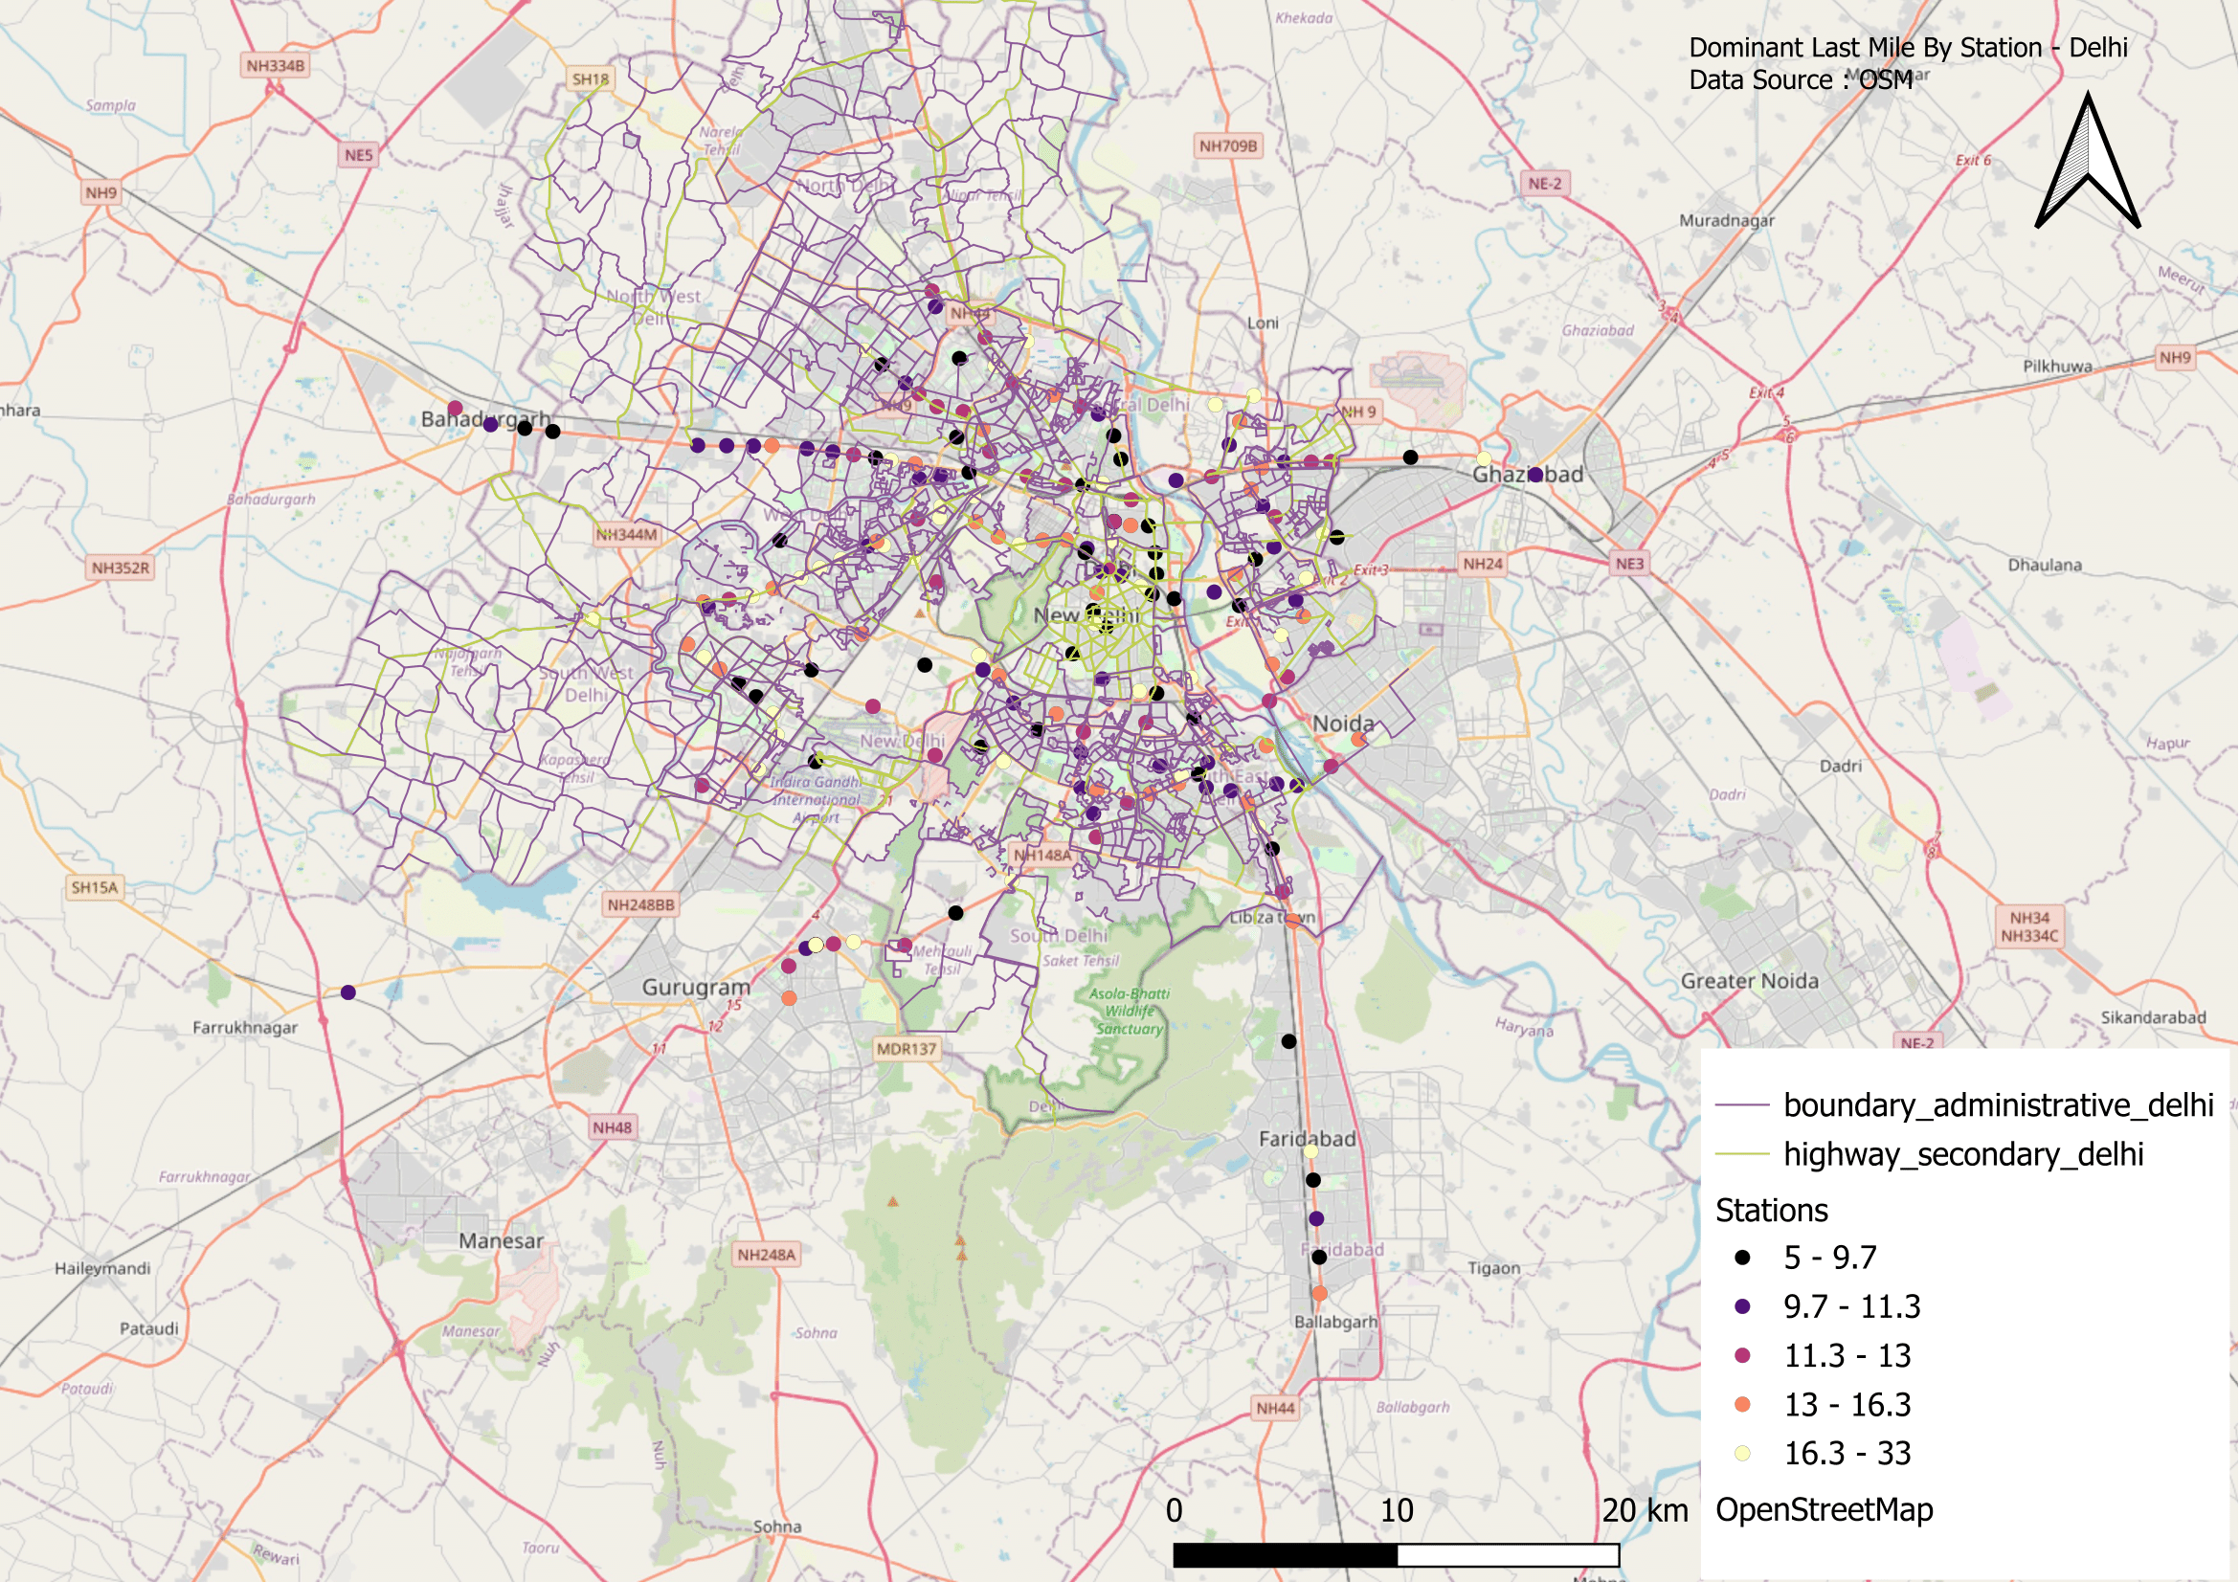
Figure-8.13

8.2.3 NAGPUR

8.2.3.1 Dominant Last-Mile Mode by Station
The dominant mode map (Figure 1) shows that walking is the primary last-mile mode for almost all Nagpur Metro stations.
Unlike Bengaluru and Delhi, where auto-rickshaws are a major last-mile choice, Nagpur’s users rely overwhelmingly on walking to reach and leave the stations.
This pattern suggests that the metro corridors run through compact, mixed-use neighbourhoods where short walking trips are convenient.
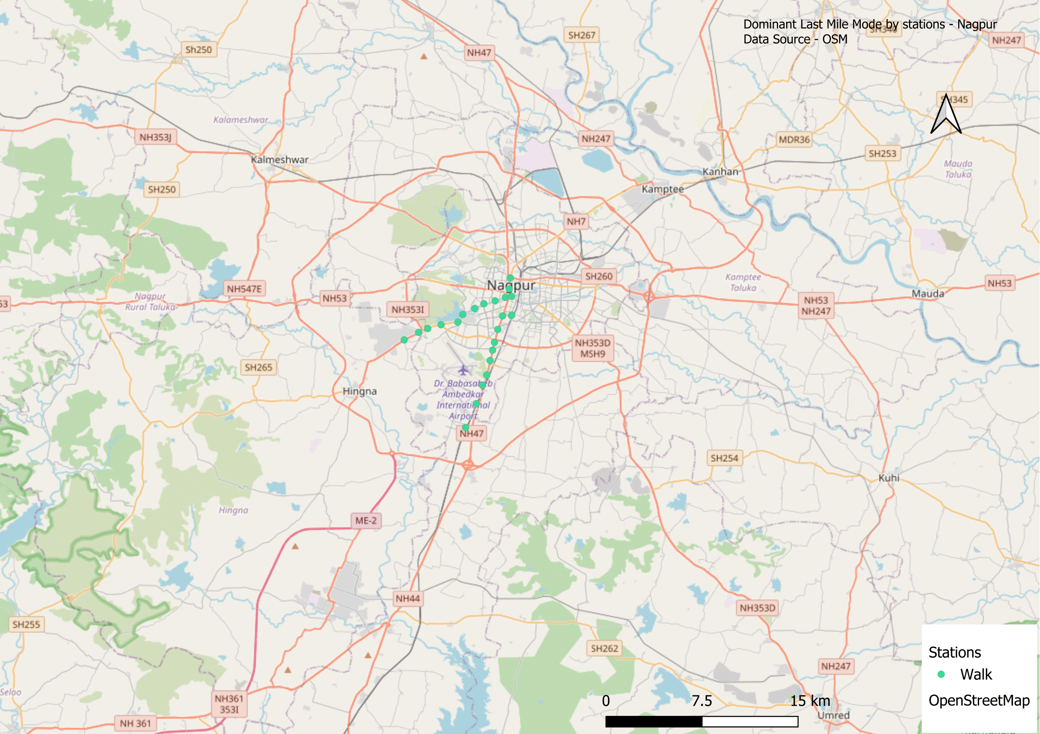
Figure-8.14

8.2.3.2 Walking Accessibility within 500 m
The 500 m buffer analysis (Figure 2) shows very strong pedestrian accessibility:
- Most stations record high walking shares, often above 80%, within 500 metres.
- Only a few stations near the outer ends of the lines show slightly lower walking shares, likely due to new developments or missing pedestrian paths.
Overall, the immediate 500 m station catchment is well suited for walking in Nagpur.

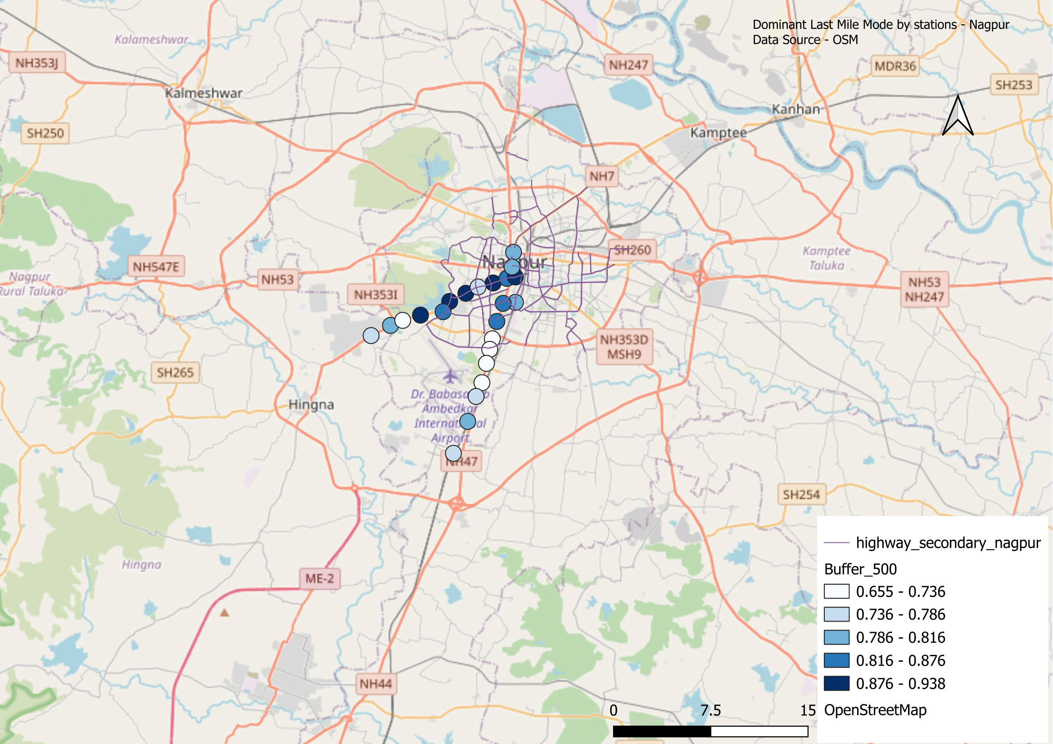
Figure-8.15

8.2.3.3 Walking Accessibility within 1 km
The 1 km buffer analysis (Figure 3) reveals that walking remains dominant even at longer distances:
- Many stations keep walking shares above 70–80% even at 1 km, which is far higher than in larger metros like Bengaluru or Delhi.
- Only a small drop in walking is seen at the extreme ends of the corridors, indicating that Nagpur’s station areas remain compact and pedestrian friendly up to 1 km.

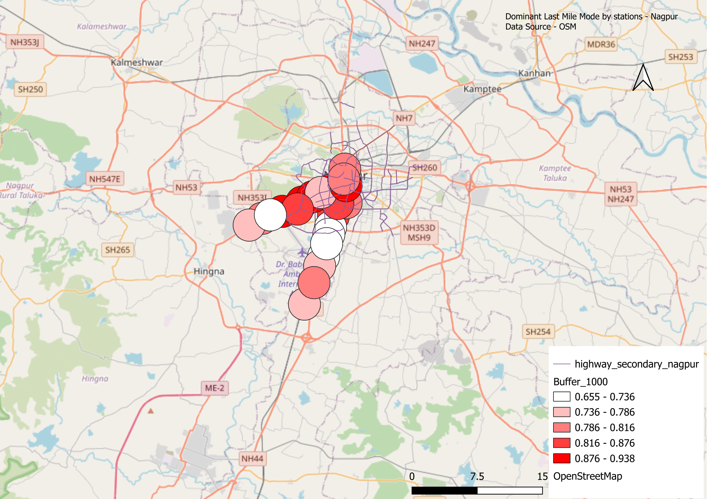

Figure-8.16

DISCUSSIONS

1. Variation in Dominant Last-Mile Modes
The classification of stations by dominant last-mile mode highlights clear differences in user behaviour:
- Nagpur exhibits an overwhelmingly walk-oriented last-mile pattern. Almost all stations display walking as the primary access mode, with high walking shares even at extended distances. This suggests a compact urban structure and the presence of relatively continuous and safe pedestrian networks along the operational corridors.
- Delhi demonstrates a hybrid pattern. Walking remains prevalent in the dense, mixed-use core areas; however, reliance on informal motorised transport (auto-rickshaws, shared vans, and cycle-rickshaws) increases substantially in the peripheral network. This reflects the city’s polycentric urban form, fragmented pedestrian infrastructure, and land-use patterns that often necessitate motorised first- and last-mile travel.
- Bengaluru is characterised by a high dependence on motorised modes, particularly auto-rickshaws and two-wheelers, outside the central business district. Walking is strong only in older neighbourhoods, while the peripheral extensions demonstrate low pedestrian accessibility, influenced by low-density development, arterial road barriers, and discontinuous sidewalks.
These findings illustrate that last-mile mode choice is highly sensitive to urban density, land-use integration, and pedestrian infrastructure continuity.

2. Spatial Reach of Walking: Insights from Buffer Analysis
The buffer analysis at 500 m and 1 km consistently underscores the importance of short, safe pedestrian access:
- Across all three cities, 500 m emerges as the critical threshold for walking. Walking mode shares are highest within this distance but decline beyond it.
- Nagpur is an exception in that walking remains relatively strong up to 1 km, a reflection of its compact street grid and manageable block sizes.
- In contrast, Delhi and Bengaluru show steep drops in walk share beyond 500 m, coinciding with fragmented footpath networks, wide arterial roads, and unsafe pedestrian crossings.
This analysis reinforces the planning principle that continuous pedestrian infrastructure within at least a 500 m catchment of metro stations is essential to support walk-based access.

3. Travel Time as a Measure of Last-Mile Efficiency
Last-mile travel time provides an integrated indicator of accessibility:
- Nagpur demonstrates low and uniform last-mile travel times (4–8 minutes), correlating with its strong walking mode share and compact station catchments.
- Delhi presents a dual pattern: short times in the urban core but longer trips (10–16+ minutes) in peripheral extensions where users rely on autos and informal feeder services.
- Bengaluru records the longest last-mile times, especially at new, peripheral stations where poor pedestrian connectivity and low-density sprawl make walking impractical.
- These results confirm that longer last-mile times correlate strongly with low pedestrian mode share and higher dependence on motorised access, ultimately reducing the overall competitiveness of metro systems compared with private transport.

Recommendations
The findings carry important implications for urban transport planning and policy:
- Enhancing pedestrian infrastructure:
Well-designed sidewalks, safe street crossings, shading, and lighting within at least 500 m of each station are critical to sustaining and expanding walk-based access.
- Formalising and integrating feeder services:
In cities such as Delhi and Bengaluru, where walking sharply declines beyond 500 m, structured feeder systems (e-rickshaws, mini-buses, and shared shuttles) should be planned to complement metro operations and reduce travel time and cost.
- Preserving walkability in emerging metro systems:
Nagpur’s success in maintaining walk-based last-mile connectivity offers a model for other growing cities. As the city expands, proactive land-use planning and pedestrian-first design will be essential to preserve this advantage.
- Data-driven decision-making:
The QGIS-based spatial analysis used in this study demonstrates a low-cost, scalable method to evaluate last-mile access. Such evidence can help transport authorities and urban planners prioritise investments and tailor last-mile solutions to local conditions.

9. Conclusion

This project combined Python, QGIS, and Power BI to study how people travel to and from metro stations in Bengaluru, Delhi, and Nagpur. Python was used to clean and prepare survey data, QGIS helped analyse and map dominant last-mile modes, walking accessibility, travel time, and infrastructure gaps, and Power BI created interactive dashboards to present the findings clearly.
The results show that Nagpur is highly walkable, with most users comfortably reaching stations on foot even up to 1 km and experiencing very short last-mile travel times. Delhi has a mixed pattern walking works well in dense central areas but falls sharply in the outer network, where people depend on autos and other informal modes. Bengaluru faces the greatest challenge, with low walkability and longer last-mile times, especially around newer peripheral stations. Across all cities, 500 metres emerged as the practical walking limit, beyond which safe paths and reliable feeder services become essential.
These findings highlight that improving first and last kilometre access is critical to the success of metro systems. Investments in safe pedestrian routes, formalised feeder services, and walkable station area design can reduce travel time and cost while encouraging public transport use. The workflow developed here shows how open tools and data-driven analysis can help planners and policymakers make informed, cost-effective decisions to improve urban mobility.

10. References
- McCahill, C. T., Albee, P., & Garrick, N. W. (2017). Improving last mile connections to transit: A new urban research perspective. New Urban Research. https://doi.org/10.xxxx/placeholder
- Zhu, Y., Ceder, A., & Yang, H. (2020). Data-driven shuttle service design for sustainable last-mile transportation. Sustainable Cities and Society, 61, 102303. https://doi.org/10.1016/j.scs.2020.102303
- OpenStreetMap contributors. (2025). OpenStreetMap data [Data set]. https://www.openstreetmap.org
- QGIS Development Team. (2025). QGIS Geographic Information System (Version 3.x) [Computer software]. Open Source Geospatial Foundation. https://qgis.org
- The pandas development team. (2025). pandas: Powerful Python data analysis toolkit (Version 2.x) [Computer software]. https://pandas.pydata.org
- Harris, C. R., Millman, K. J., van der Walt, S. J., Gommers, R., Virtanen, P., Cournapeau, D., … & Oliphant, T. E. (2020). Array programming with NumPy. Nature, 585(7825), 357-362. https://doi.org/10.1038/s41586-020-2649-2
- Microsoft Corporation. (2025). Power BI documentation. Retrieved from https://learn.microsoft.com/power-bi/

