
FACULTY OF TECHNOLOGY AND ENGINEERING
DEVANG PATEL INSTITUTE OF ADVANCE TECHNOLOGY
AND RESEARCH

DEPARTMENT OF COMPUTER ENGINEERING

A.Y 2026 – 27 Semester – 3

LAB MANUAL

CSUC201 Fundamentals of Data Structures and Algorithms

Practical 4 : Singly Linked List: Dynamic Insertion, Deletion,
and Traversal
Practical Aim:
To implement core singly linked list operations and develop the ability to manipulate dynamic sequences through real-world problem scenarios.
Problem 1 :
A hospital manages a queue of patient tokens. New critical patients must be added to the front,
routine patients are added to the end, and occasionally a patient with a priority number must be
inserted at a specific position in the queue. Given a sequence of such operations, implement all
three insertion types and print the final queue after each operation.
Describe how your insertion at a specific position works. What does your solution do if the
position given is greater than the current length of the queue? Is that handled explicitly or does it
cause an error?
Problem 2 :
The hospital also needs to remove a patient token from the queue when a patient leaves, print
all remaining tokens from last to first for an end-of-day audit, and display the full queue from
front to back at any point. Implement deletion by value, reverse printing, and forward traversal
on the same queue from Problem 4.1a.
Describe how your reverse printing works. Does it use any extra storage, or does it work purely
by following the links? Can you think of another way to reverse-print without modifying the
original queue?

For Code:
https://github.com/yakshu205/DSA/tree/6abc6fc9b088b332c6c3b366719caf1c414683db/Sorting%20algo/practical-4
Output:
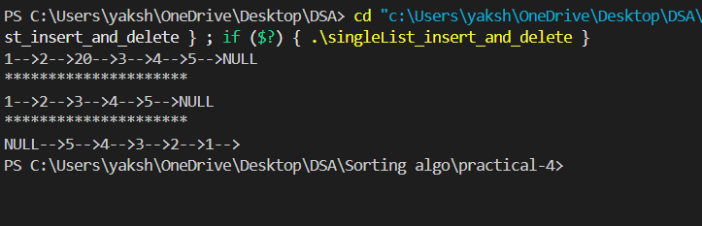
Key Questions / Analysis / Interpretation to be Evaluated During/After
Implementation :
1. [Problem 1] Inserting at a position beyond the current length of the list is an invalid
operation. Should your solution silently insert at the end, report an error, or do something
else entirely? Justify your choice and explain what assumption about the caller your
choice makes.
2. [Problem 2] If the node to be deleted is the only node in the list, how many pointers need
to change and what must they be set to? How is this case structurally different from
deleting a node in the middle?

Supplementary Problems :
1. A train has n coaches numbered in order. The train manager wants to detach the coach
that is exactly k positions from the rear of the train, without counting from the front. Given
the list of coach numbers and the value k, remove the correct coach and print the
remaining sequence.
Describe the approach you used to find the correct coach without knowing the total
number of coaches in advance. What happens if k equals the total number of coaches?
2. A dance instructor pairs up students standing in a line and swaps each pair — the first
with the second, the third with the fourth, and so on. Given the list of student IDs, swap
every two adjacent students and print the new order. If the total number of students is
odd, the last student stays in place.
Describe how your solution handles the swapping. Does it swap the actual node
positions or just the values inside the nodes? What is the difference, and does it matter
here?
3. A relay race has runners lined up in a chain. The coach wants to identify the runner
standing exactly in the middle of the chain to give them a special baton. Given the list of
runner IDs, find and print the middle runner's ID. If there are two middle runners, print
the second one.
Describe the approach you used. Does your solution make more than one pass through
the list? Can you think of a way to find the middle in a single pass without knowing the
total count first?
4. A film strip has frames stored in a linked sequence. A technician needs to reverse the
order of all frames so the film plays backwards. Given the list of frame numbers, reverse
the sequence and print the result.
Describe how your solution reverses the links. How many passes through the list does it
make, and how many extra nodes does it create? Can you think of a way to do it using
recursion instead?
5. A message is stored as a sequence of characters in a linked chain. A decoder needs to
verify whether the message reads the same forwards and backwards before accepting it.
Given the sequence of characters, determine whether it forms a palindrome and print
Yes or No.
Describe the approach you used. Does your solution modify the original sequence at any
point? If yes, does it restore it before finishing, and why might that matter?
Key Skills to be Addressed
Dynamic node insertion and deletion, pointer/link manipulation, sequence traversal and
reversal, two-pointer reasoning, and handling edge cases in dynamic data structures.
Applications :
Task and patient queue management, undo/redo sequences in editors, playlist and media
management, and message validation systems.
Learning Outcome :
Students will be able to implement and manipulate singly linked lists through pointer-based
operations, trace link changes step by step, and reason about the trade-offs between
approaches that modify structure versus those that use extra storage.

