Practical - 1
Practical Title: Project Initiation, Requirement Analysis, Sitemap, Wireframe, and GitHub Setup

Problem Definition: Initiate the semester-long StudentHub portal by identifying the problem scope, user roles, key modules, navigation flow, and minimum 10 pages. Create a sitemap, low-fidelity wireframe, project folder structure, README file, and GitHub repository.

Theory

What is URL and parts of URL?
Answer: A URL (Uniform Resource Locator) is the address of a unique resource on the internet. It is one of the key mechanisms used by browser to retrieve published resources, such as HTML pages, CSS documents, images, and so on. Scheme, Subdomain, Domain Name, Top-Level Domain, Port Number, Path, Query Parameters, Fragment .
( https://developer.mozilla.org/en-US/docs/Learn_web_development/Howto/Web_mechanics/What_is_a_URL)

How does HTML file process in web browser?
Answer: -You Write HTML Code
-You create an HTML file (.html) that contains the structure and content of your webpage — text, headings, images, links, forms, etc.
-You Open the File in a Browser
-When you double-click the file or open it through a web server, a browser like Chrome, Firefox, or Safari reads the code.
-The Browser Parses the HTML
-The browser scans your code from top to bottom. It starts with the <!DOCTYPE html> declaration, then reads sections.
-The Browser Builds the Page
-It displays content (like text, images, and videos) inside the
.
-It applies styles from CSS (if linked or embedded).
-It runs JavaScript for interactivity (if included).

Result: A Visual Web Page
What you see in the browser is a visual version of the HTML. The browser turns your code into a formatted page that looks clean and interactive — just like any website you visit.
(https://dev.to/ofodile/how-html-works-in-the-browser-25pa)

3. How will page navigation flow managed among all HTML pages?
Answer: - Mapping your structure: page hierarchy, menus and links
Before diving into specific components, it helps to state that how users move through the information or navigate the pages of a website depends on a coherent skeleton. The following sections break down that skeleton into manageable parts.
- Page hierarchy as the backbone
- Breadcrumb trails and path indicators
- Responsive behaviour across devices
- Internal linking for discoverability
- Measuring and mapping flows
- Designing for efficient movement
- Scroll behaviour and interactive elements
(https://www.parallelhq.com/blog/how-users-move-through-information-or-navigate-pages-of-website)

4. How will GitHub commits be maintained after each practical?
Answer:
- git init
- git add .
- git commit -m “any commit message”
-git push origin main/master
(https://github.com/git-guides)

Implementation/ Output/Result

Project Requirements for StudentHub-Portal

Pages Included:
- index.html
- PAGES/home.html
- PAGES/about.html
- PAGES/admin.html
- PAGES/contact.html
- PAGES/dashboard.html
- PAGES/edit.html
- PAGES/events.html
- PAGES/faq.html
- PAGES/feedback.html
- PAGES/login.html
- PAGES/profile.html
- PAGES/register.html

Core Requirements:
- Static web application using HTML, CSS, and JavaScript
- Responsive layout for desktop and mobile screens
- Navigation across all pages via links or menu
- Login and registration forms on `PAGES/login.html` and `PAGES/register.html`
- User dashboard and profile pages for authenticated users
- Admin interface on `PAGES/admin.html`
- Contact page with message submission form
- Events listing page on `PAGES/events.html`
- FAQ, feedback, and about pages for user support and information
- Edit page to allow profile or content updates

Evidence of Work (Screenshots)
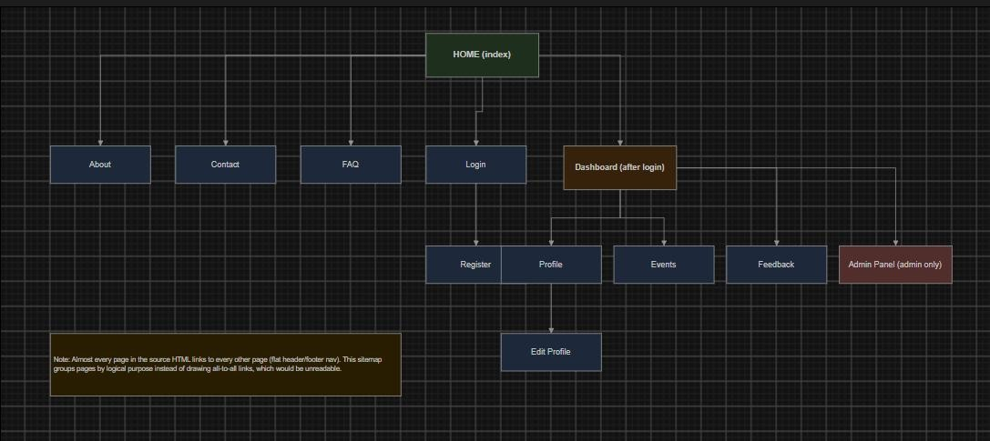
SiteMap:

Figure 1.1

WireFrame:
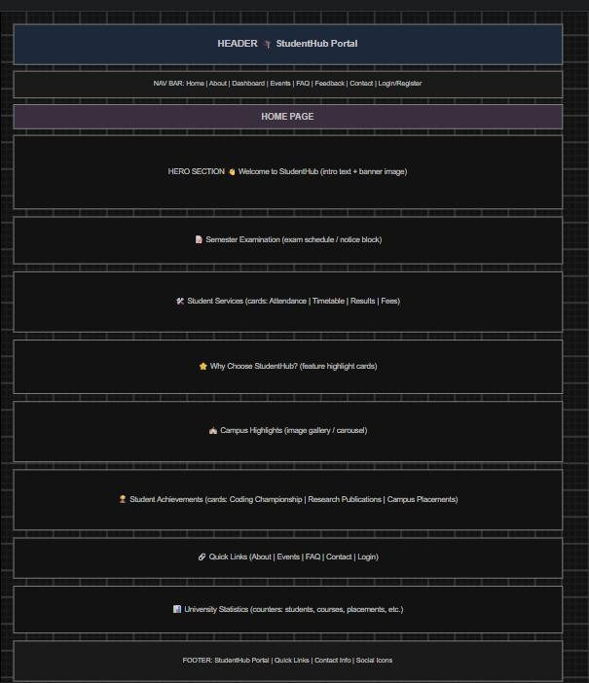
Figure 1.2(Home page)
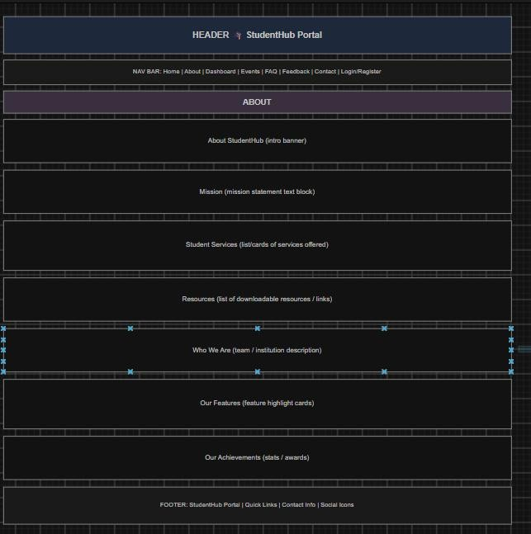
Figure 1.3(About page)
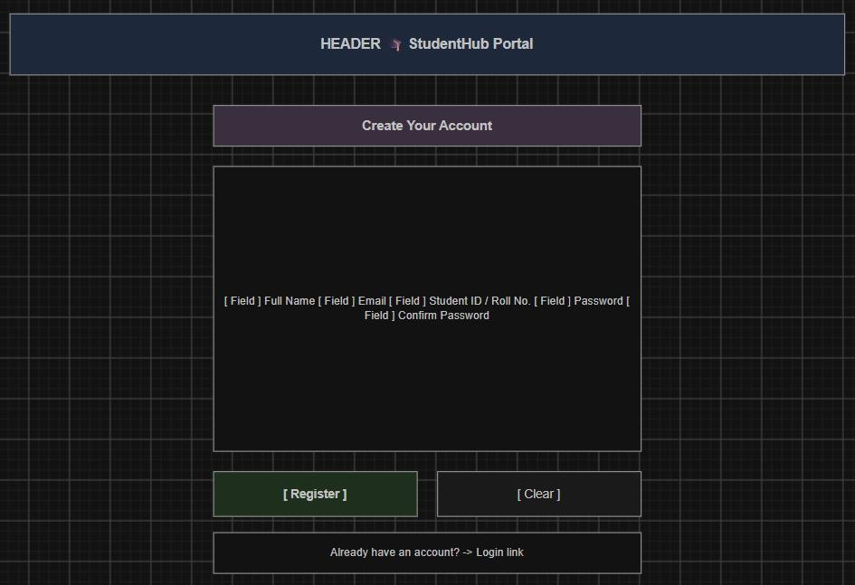
Figure 1.4(Register page)
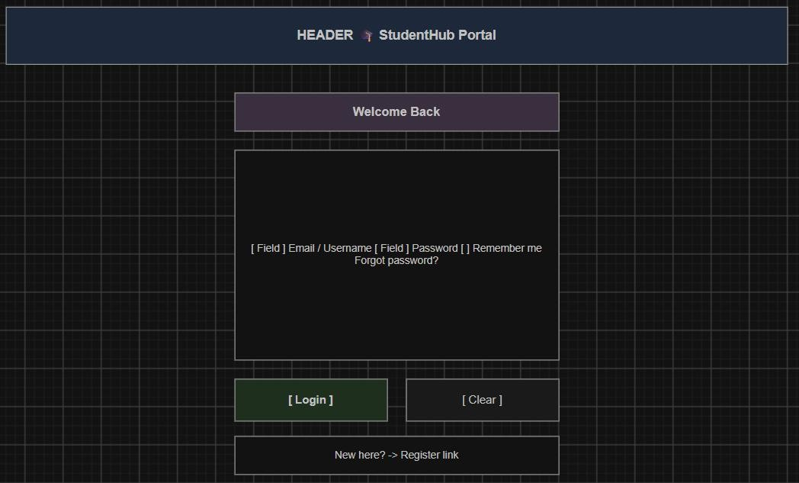
Figure 1.5(Login page)
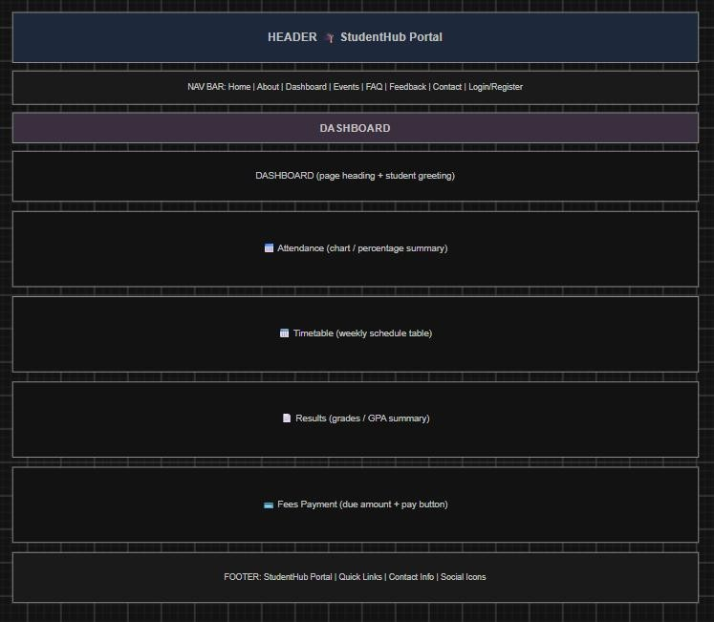
Figure 1.6(Dashboard page)

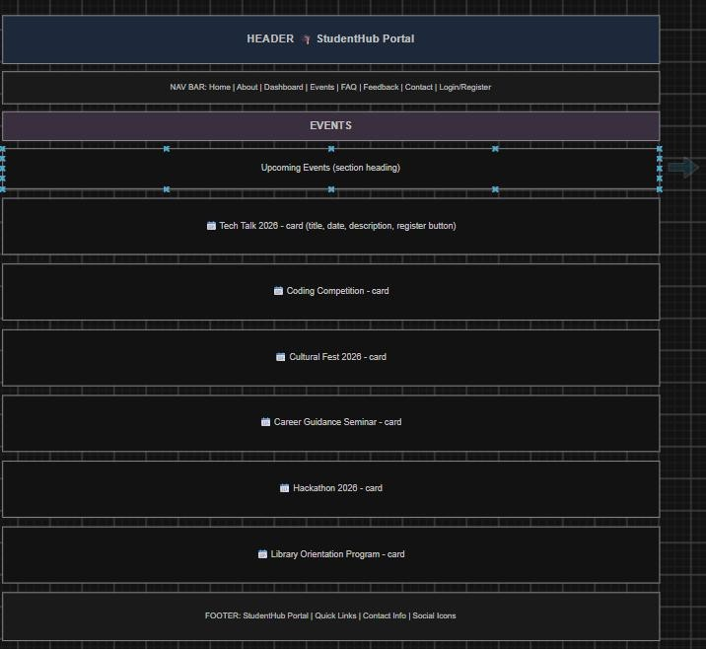
Figure 1.7(Event page)
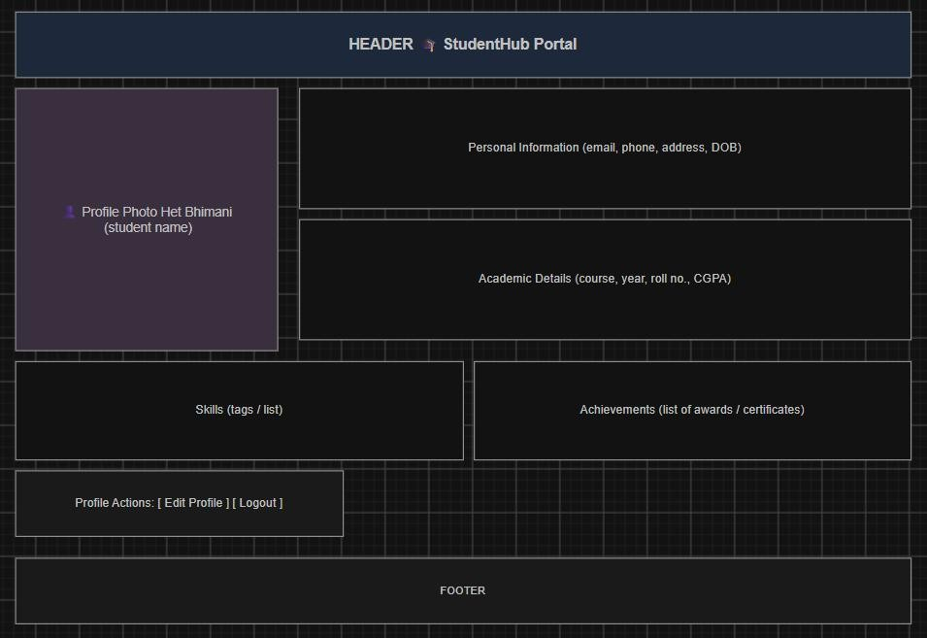
Figure 1.8(Profile page)
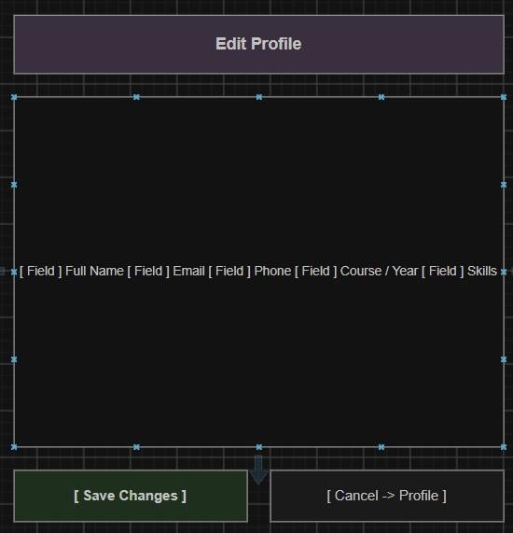
Figure 1.9(Edit page)
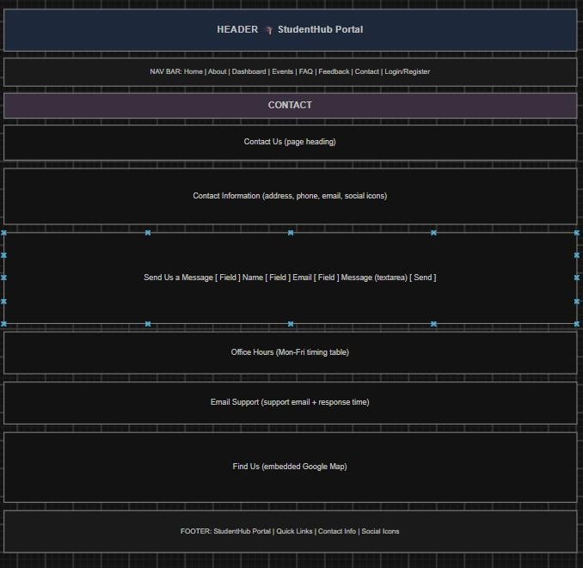
Figure 1.10(Contact page)
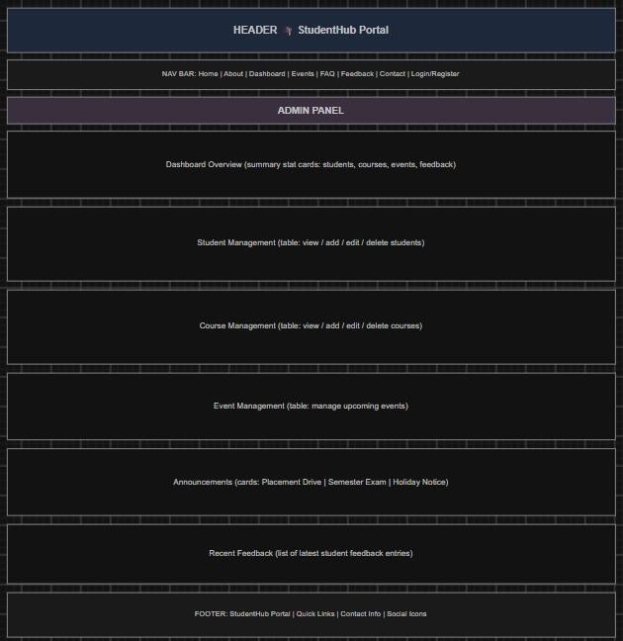
Figure 1.11(Admin page)
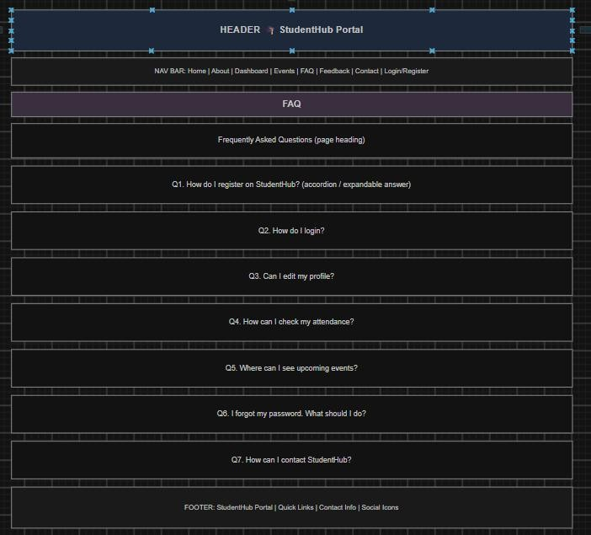
Figure 1.12(FAQ page)
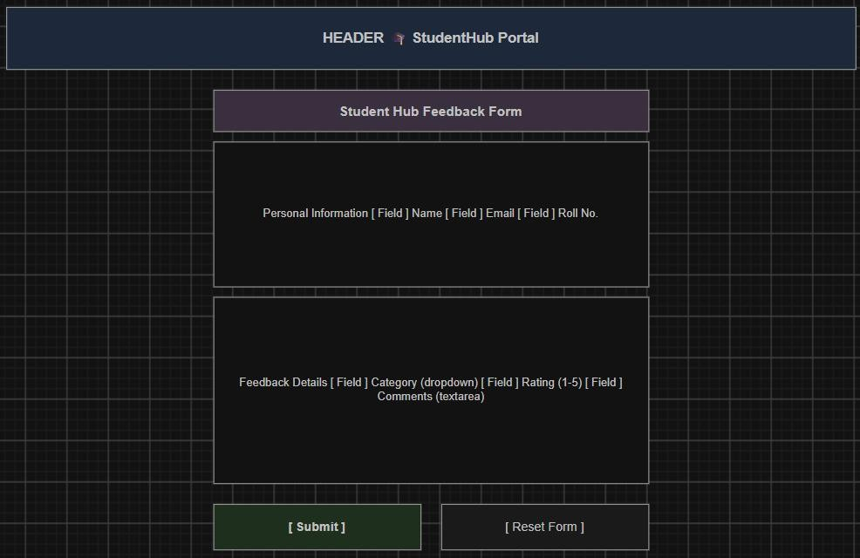
Figure 1.13(Feedback page)

GitHub Repository Link:
https://github.com/yakshu205/StudentHub.git

Challenges Faced:

First time when I start to think about requirement at that time I stuck . I thought that what type of pages we will make etc . But I start collecting info or requirement from my friend and then , I make sitemap and wireframe in tool like draw.io. I also faced difficulty when I make repos and push code and commit changes through command prompt , then I show a tutorial video of Git/GitHub version control , then I am good commit and etc.

Learning Outcomes:
I will be able to analyze requirements and prepare a structured project foundation before implementation and I am able to push , pull and commit my changes into my Github repo.

Faculty Remarks: (Keep this blank for faculty)

Practical - 3
Practical Title:Responsive UI Design using CSS Grid, Flexbox, and Bootstrap/Tailwind

Problem Definition:Design responsive layouts for Home, About, Registration, Dashboard,

and Events pages using CSS Grid and Flexbox. Optional to use CSS framework such as Bootstrap or Tailwind. Ensure mobile-first responsiveness.

Theory
- How does the layout adapt for mobile, tablet, and desktop screens?
Answer: A layout adapts across mobile, tablet, and desktop screens using fluid grids, flexible images, and breakpoints (typically under 600px for mobile, 601px–1024px for tablets, and 1025px+ for desktops). Elements reflow, resize, or stack vertically to fit the available screen space.
(https://developer.mozilla.org/en US/docs/Learn_web_development/Core/CSS_layout/Responsive_Design)

2.Which layout technique is used and why?
Answer: Common web design layout techniques include CSS Flexbox, CSS Grid, and traditional Float or Responsive structures. Because your specific project or graphic was not provided, the correct technique depends entirely on the design goal.
(https://www.w3schools.com/html/html_layout.asp)

3. Are typography, spacing, colors, and contrast readable?
Answer: Yes, typography, spacing, colors, and contrast directly determine whether text is readable. When properly balanced, they prevent eye strain and make content easy to scan. When poorly configured, text becomes difficult or impossible to read.
(https://guidelines.india.gov.in/activity/the-impact-of-typography-on-web-design-a-comprehensive-guide-to-aesthetics-and-readability/)

4. Is the framework used consistently without unnecessary inline CSS?
Answer: style="" attributes. While they look like inline styles in the markup, they compile into clean external stylesheets and maintain design consistency without unnecessary true inline CSS.
(https://www.reddit.com/r/Frontend/comments/rk3lr4/are_css_frameworks_really_necessary/)

Implementation/ Output/Result :
- CSS Selectors Used:
*, body, header, nav, main, section, article, footer, div,
h1, h2, h3, h4, p, ul, li, a, img,
form, label, input, textarea, select, button,
table, tr, td, hr, small, i, marquee,
.class, #id,
:hover, :focus, :first-child, :last-child,
input[type="text"], input[type="email"], input[type="password"],
input[type="radio"], input[type="checkbox"],
input[type="submit"], input[type="reset"],
@media
- CSS Properties Used:

margin, padding, box-sizing,
display, width, height, max-width,
background, background-size, background-position, background-repeat,
color,
font-family, font-size, font-weight,
text-align, text-decoration, line-height,
border, border-left, border-top, border-radius,
box-shadow,
position,
justify-content, align-items,
flex-direction, flex-wrap,
gap,
grid-template-columns,
list-style,
cursor,
transition,
transform,
outline,
resize,
object-fit,
overflow

Evidence of Work (Screenshots)

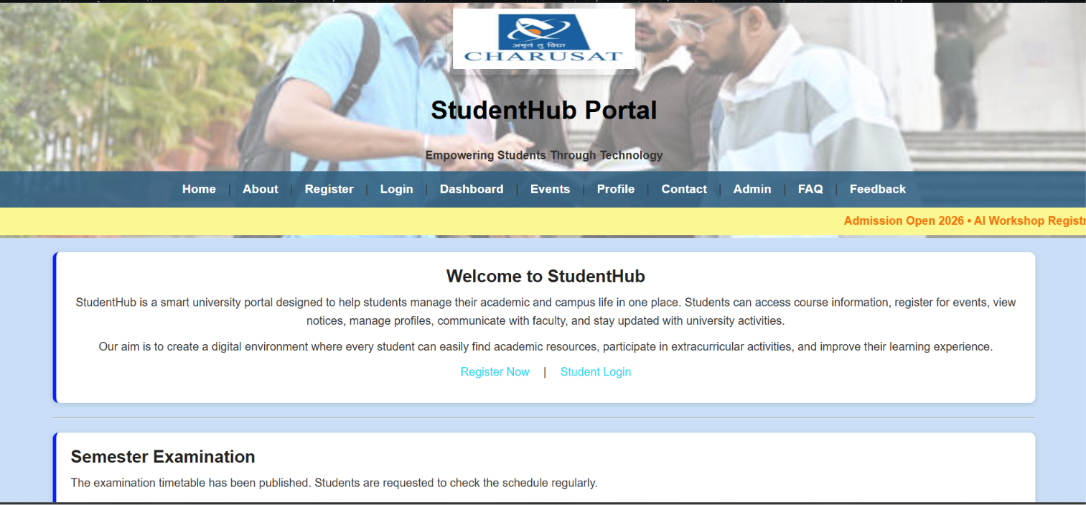
Figure 3.1(Home page)
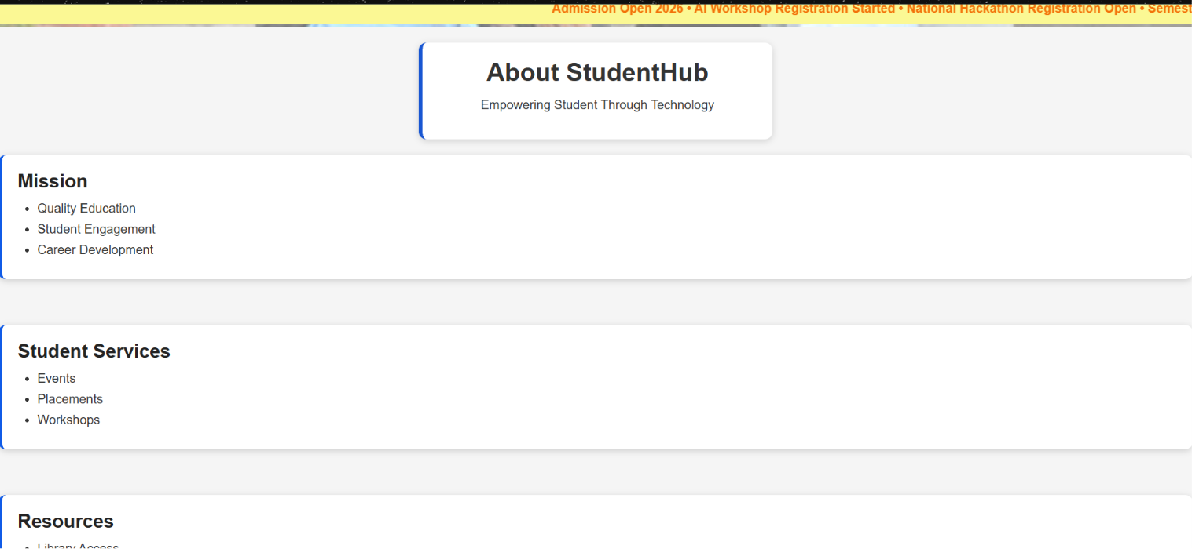
Figure 3.2(About page)
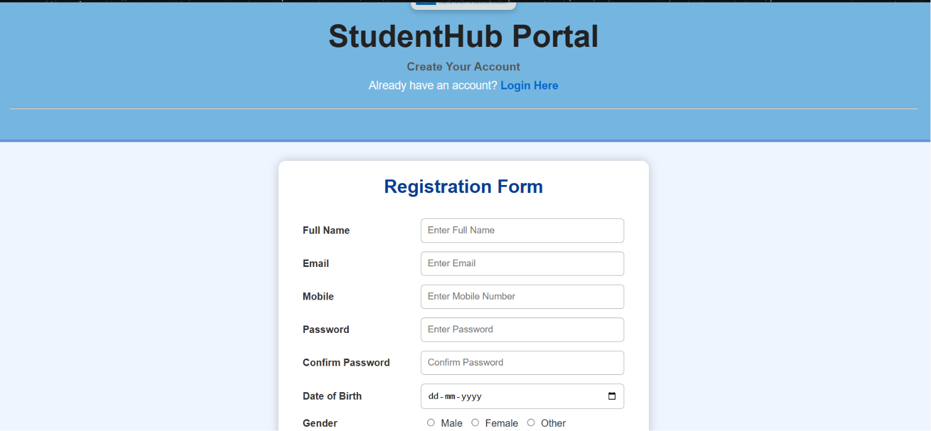
Figure 3.3(Registration page)
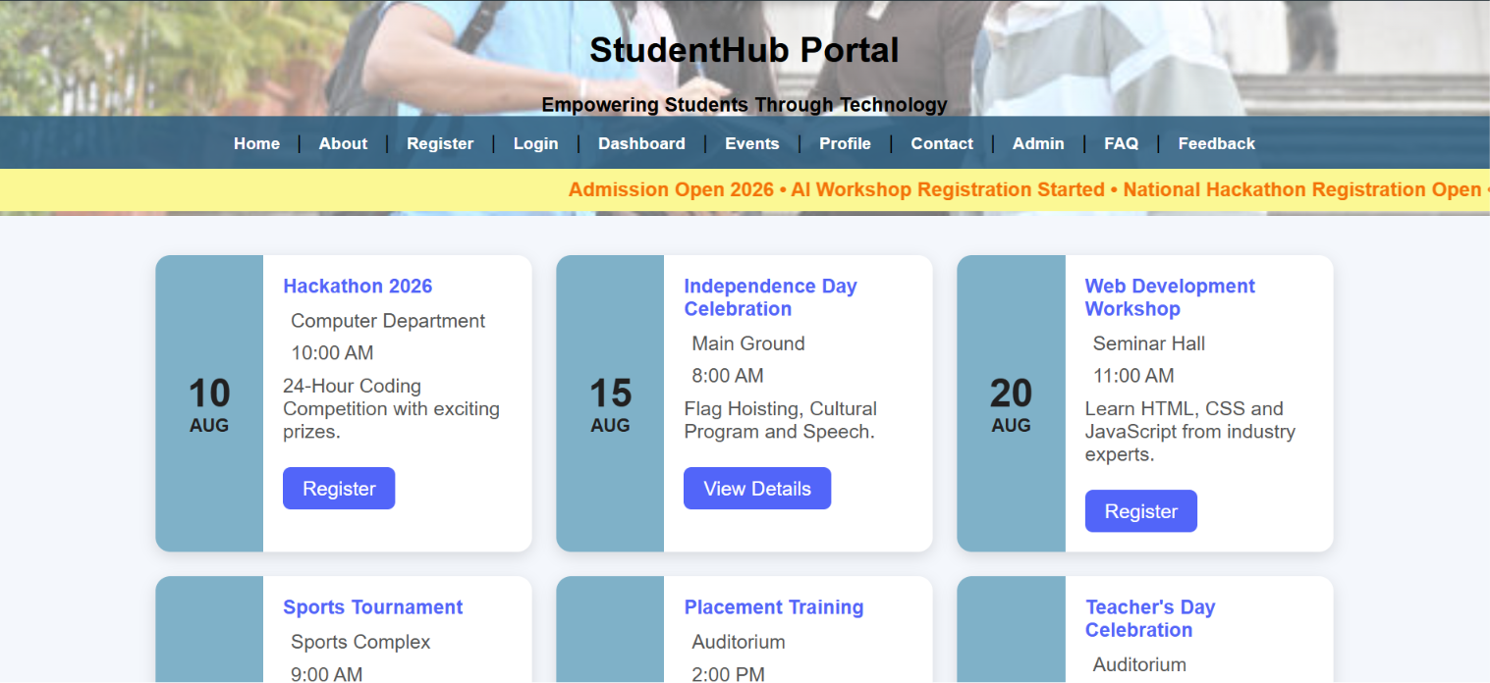
Figure 3.4(Event page)
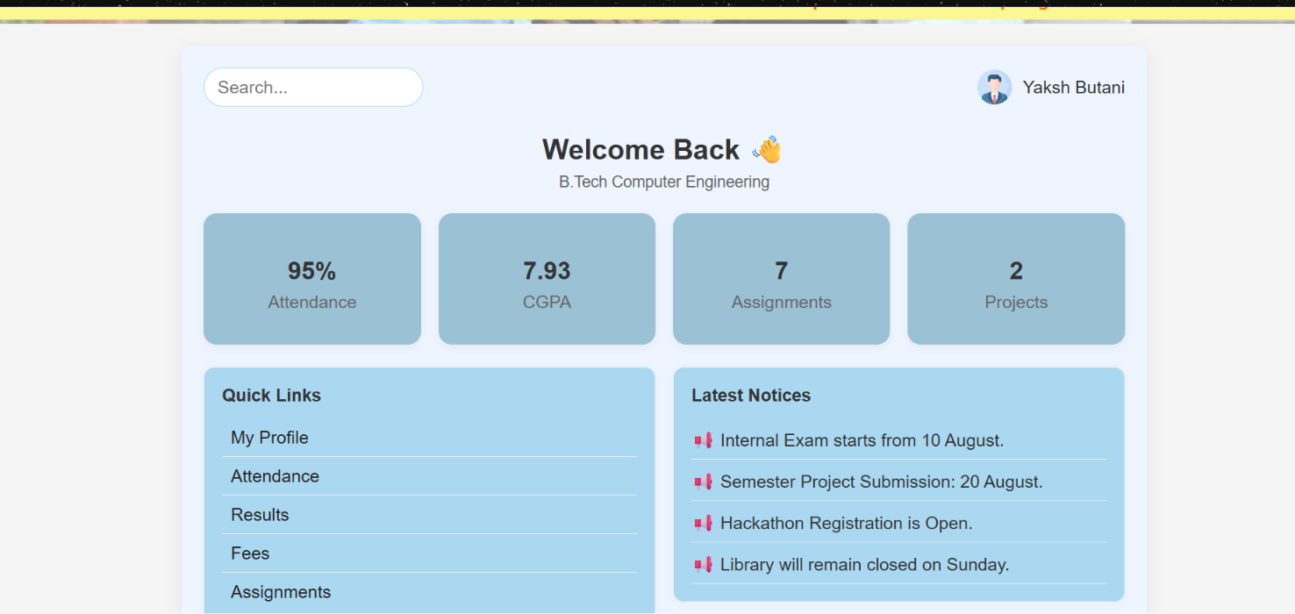
Figure 3.5(Dashboard page)

GitHub Repository Link:

https://github.com/yakshu205/StudentHub.git

Challenges Faced:
When I was styling the html files , I had no idea about how I put image behing the text and blur it . then I told ChatGPT that I want to put image behing text at header which concept or styling function I should use , give syntax and opacity code and gradient code like (255,255,255,0.20);
It gave me function that name is linear gradient and also I learned padding , card , form styling , box , responsive etc.. concept.
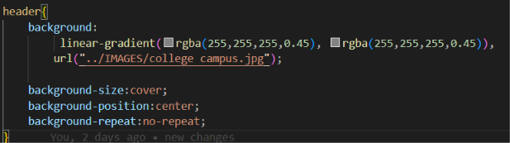

Learning Outcomes:
I will design a professional, responsive, and reusable UI layout.

Faculty Remarks: (Keep this blank for faculty)

Practical - 2
Practical Title: Semantic HTML5 Pages with Accessibility-Ready Structure

Problem Definition:Develop static HTML5 skeletons for at least 10 StudentHub pages such as Home, About, Register, Login, Dashboard, Events, Profile, Contact, Admin, FAQ, and Feedback. Use semantic tags and accessibility-friendly structure.

Theory
- Are semantic tags such as header, nav, main, section, article, aside, and footer used properly?
Answer: Yes , I use tags such as nav ,header, main, section, footer .

Are form labels, headings, image alt text, and navigation links accessible?
Answer: Yes , all imgage, lables and navigation links are accessible by browser .
(using <a> and href =”link”);

3. Is the page structure consistent across all pages?
Answer: Yes , all pages have consistent structure . (title,header,body,footer)

Implementation/ Output/Result :
<!DOCTYPE html> | Declares the document as HTML5.

<html> | Root element of the HTML page.

<head> | Contains page information like title and CSS links.

<meta> | Defines character encoding and viewport settings.

<title> | Sets the title shown in the browser tab.

<link> | Links an external CSS file.

<header> | Defines the page header section.

<center> | Centers the content (deprecated tag).

<img> | Displays an image/logo.

<h1> | Main heading of the page.

<h2> | Section heading.

<h3> | Sub-heading.

<p> | Defines a paragraph.

<b> | Makes text bold.

<nav> | Contains navigation links.

<a> | Creates hyperlinks.

<marquee> | Displays scrolling text (deprecated tag).

<body> | Contains all visible page content.

<main> | Represents the main content of the page.

<section> | Groups related content into sections.

<article> | Represents independent content or an article.

<ul> | Creates an unordered (bulleted) list.

<li> | Defines a list item.

<hr> | Inserts a horizontal line.

<footer> | Defines the footer section.

Evidence of Work (Screenshots)
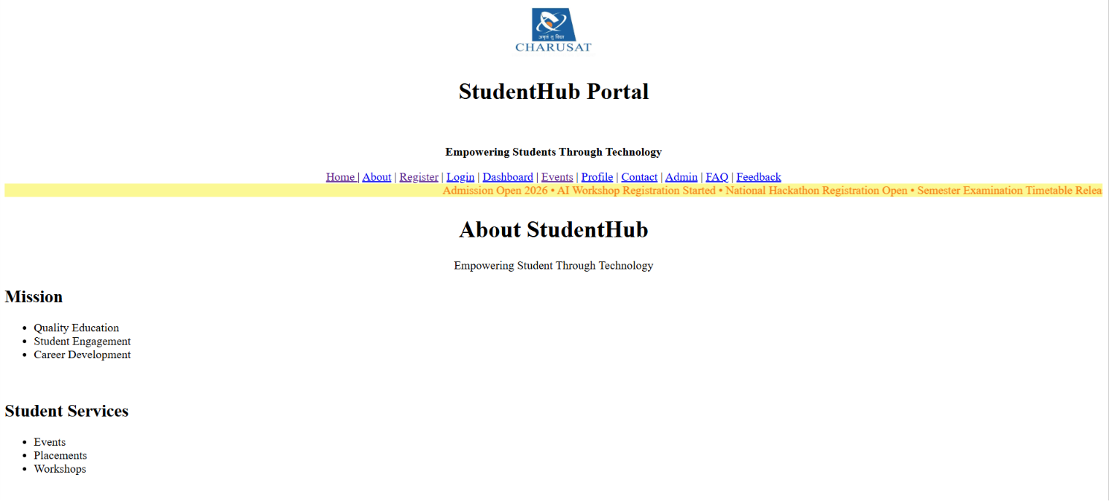

Figure 2.1(Home Page)
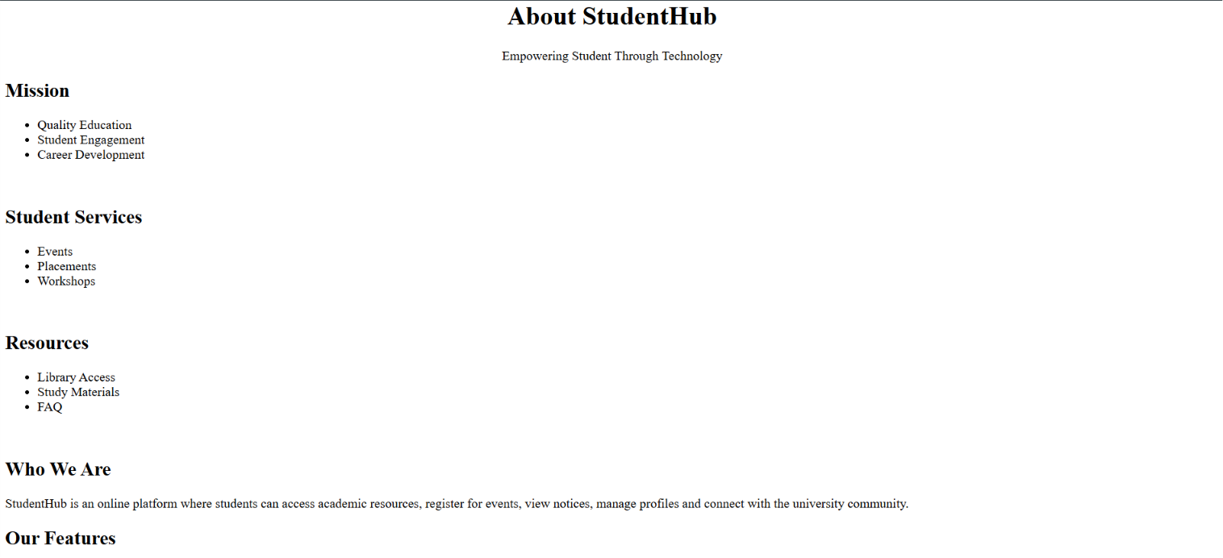
Figure 2.2(About Page)
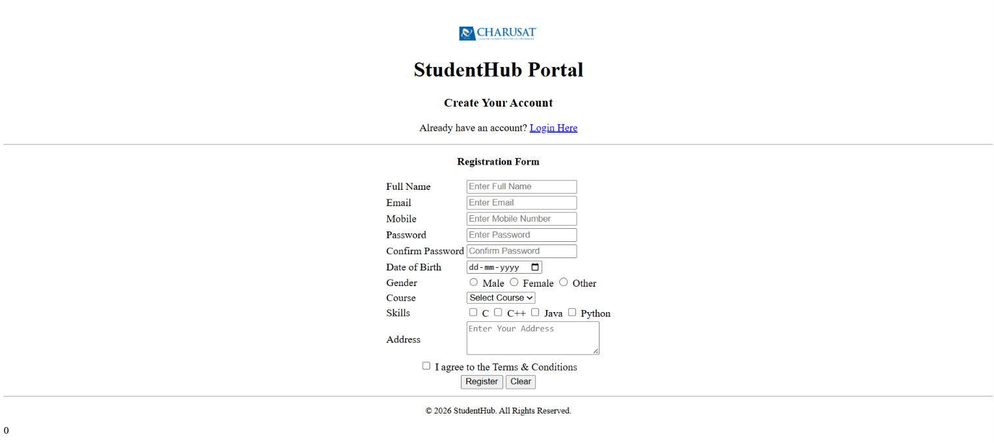
Figure 2.3(Register Page)
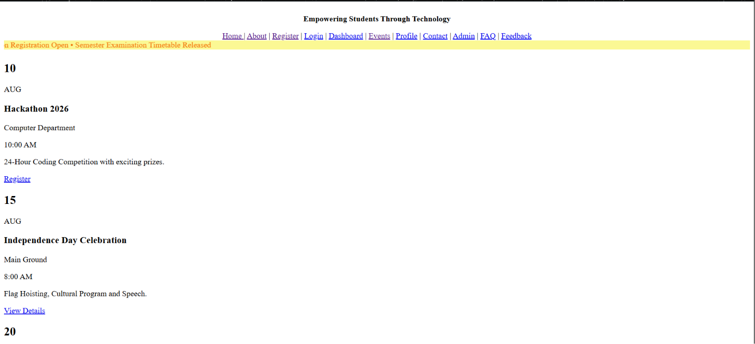
Figure 2.4(Event Page)
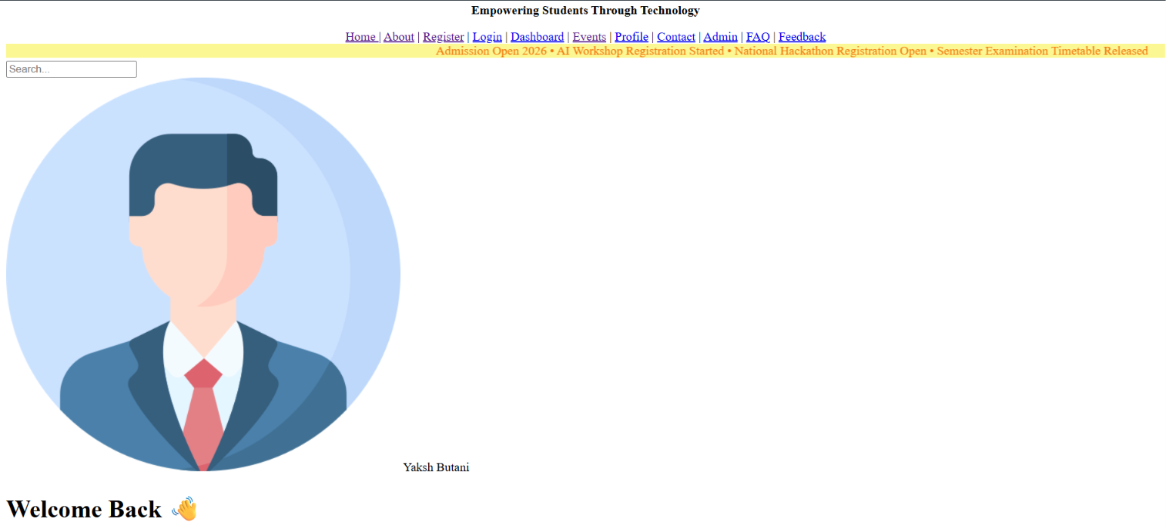
Figure 2.5
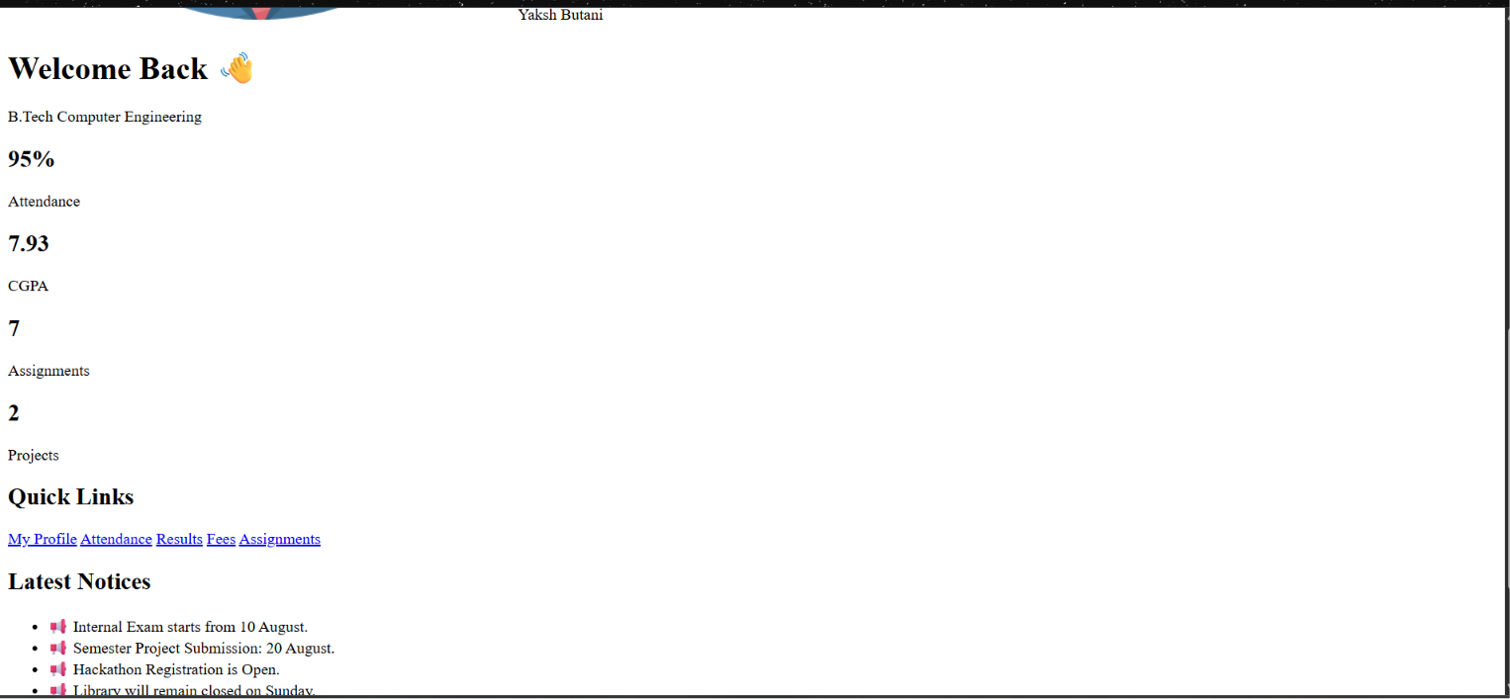
Figure 2.6
Figure 2.5 And Figure 2.6 (Dashboard Page)

GitHub Repository Link:

https://github.com/yakshu205/StudentHub.git

Challenges Faced:
- I have a design in my mind that how I make my header but I was stuck when scrolling text problem comes , I saw charusat portal where at footer part one text link is scrolling automatically , I don’t know what concept I can use , then I go to MDN Website and find that the tag named “<marquee>” is reason for scrolling text.

- Then , I was stuck , when I making webpage of Dashboard , for Dashboard I want default user profile picture photo in round shape for an example if we do not keep profile picture in social media profile , then it keeps default white-grey default picure .
So , for that picture I search in google and it gives me pic link also for some emoji there is some class keyword in html (i.e. : <i class="fa fa-shopping-cart"></i> and graduation cap etc.. )
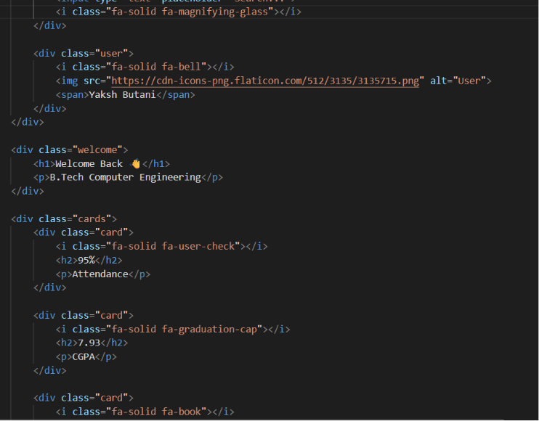

Learning Outcomes:
I will create clean, linked, and accessibility-ready HTML page structures.

Faculty Remarks: (Keep this blank for faculty)

