Practical - 1
Practical Title: Project Initiation, Requirement Analysis, Sitemap, Wireframe, and GitHub Setup

Problem Definition: Initiate the semester-long StudentHub portal by identifying the problem scope, user roles, key modules, navigation flow, and minimum 10 pages. Create a sitemap, low-fidelity wireframe, project folder structure, README file, and GitHub repository.

Theory

What is URL and parts of URL?
Answer: Write your answer in your own words. Do not copy and paste content directly from AI tools. At the end of your answer, provide the website(s) or reference link(s) you used for research.

How does HTML file process in web browser?
Answer: Write your answer in your own words. Do not copy and paste content directly from AI tools. At the end of your answer, provide the website(s) or reference link(s) you used for research.

3. How will page navigation flow managed among all HTML pages?
Answer: Write your answer in your own words. Do not copy and paste content directly from AI tools. At the end of your answer, provide the website(s) or reference link(s) you used for research.

4. How will GitHub commits be maintained after each practical?
Answer: Write your answer in your own words. Do not copy and paste content directly from AI tools. At the end of your answer, provide the website(s) or reference link(s) you used for research.

Implementation/ Output/Result

Project Requirements for StudentHub-Portal

Pages Included:
- index.html
- PAGES/home.html
- PAGES/about.html
- PAGES/admin.html
- PAGES/contact.html
- PAGES/dashboard.html
- PAGES/edit.html
- PAGES/events.html
- PAGES/faq.html
- PAGES/feedback.html
- PAGES/login.html
- PAGES/profile.html
- PAGES/register.html

Core Requirements:
- Static web application using HTML, CSS, and JavaScript
- Responsive layout for desktop and mobile screens
- Navigation across all pages via links or menu
- Login and registration forms on `PAGES/login.html` and `PAGES/register.html`
- User dashboard and profile pages for authenticated users
- Admin interface on `PAGES/admin.html`
- Contact page with message submission form
- Events listing page on `PAGES/events.html`
- FAQ, feedback, and about pages for user support and information
- Edit page to allow profile or content updates

Evidence of Work (Screenshots)
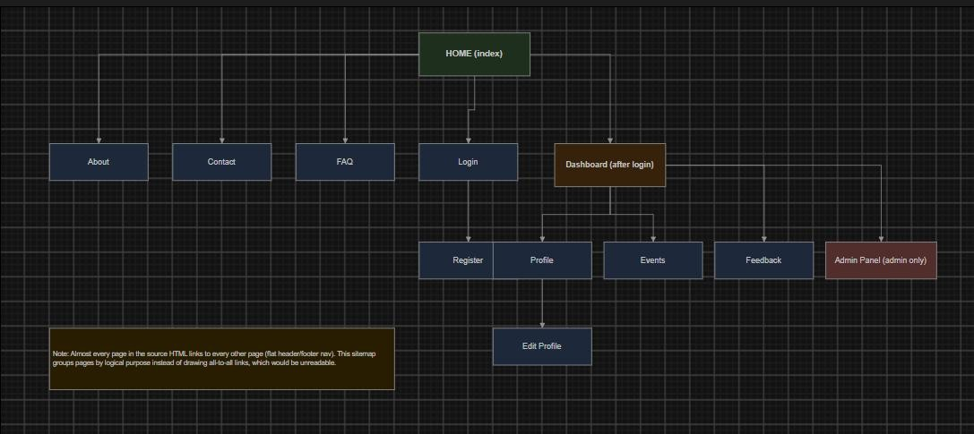
SiteMap:

Figure 1.1

WireFrame:
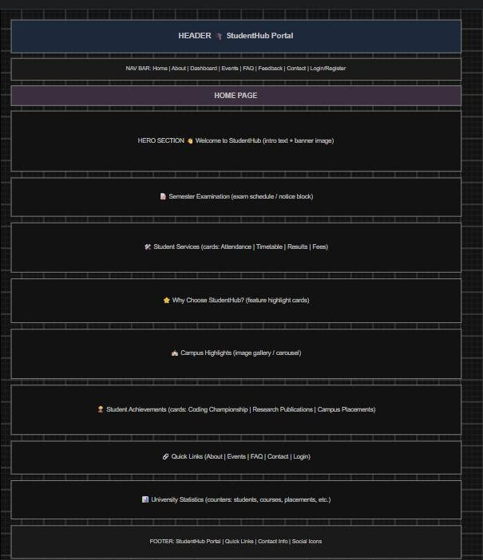
Figure 1.2(Home page)
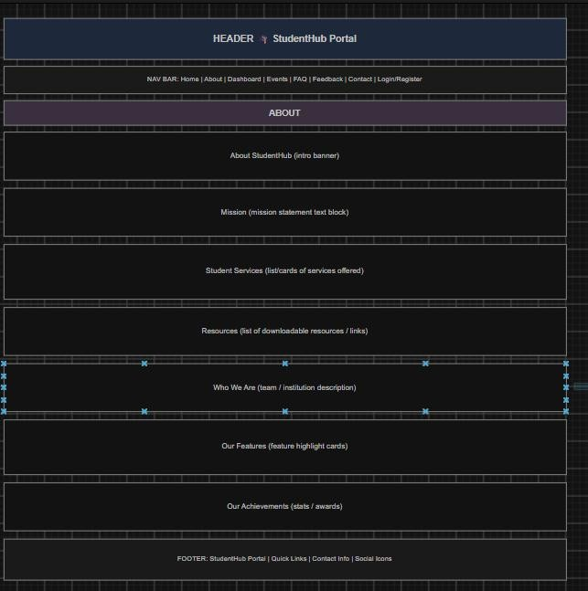
Figure 1.3(About page)
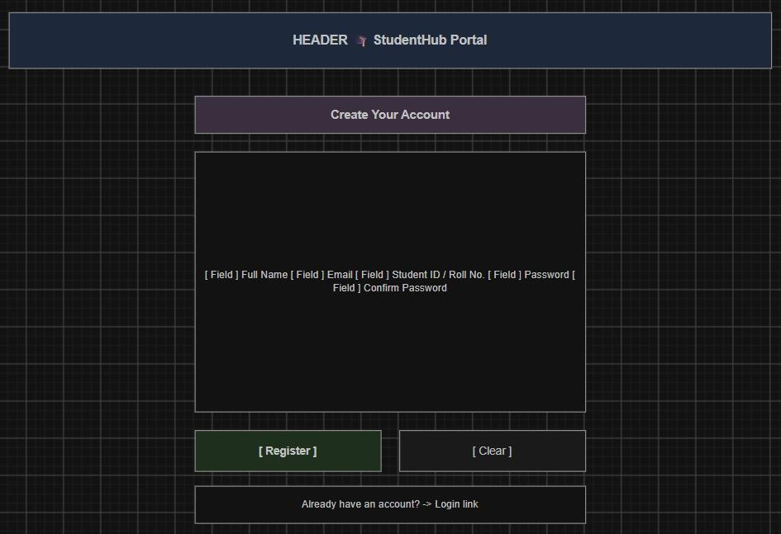
Figure 1.4(Register page)
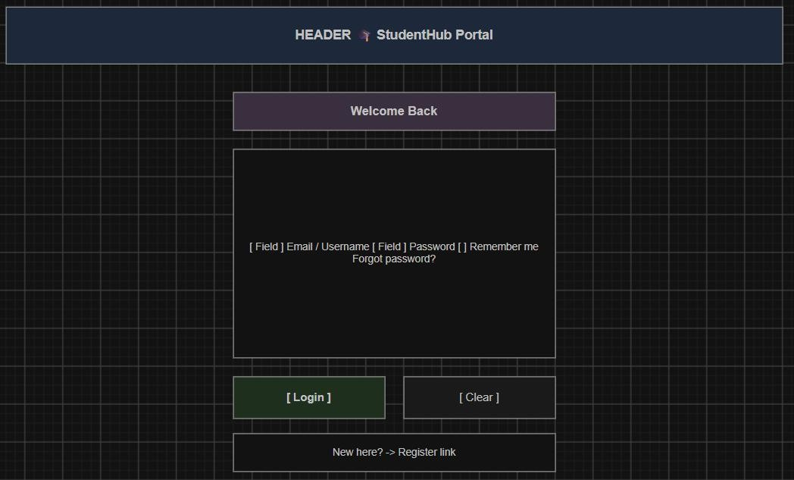
Figure 1.5(Login page)
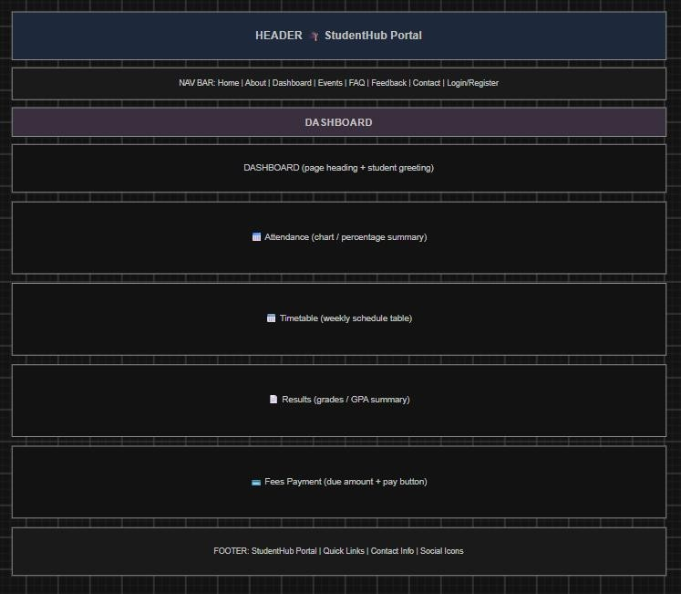
Figure 1.6(Dashboard page)

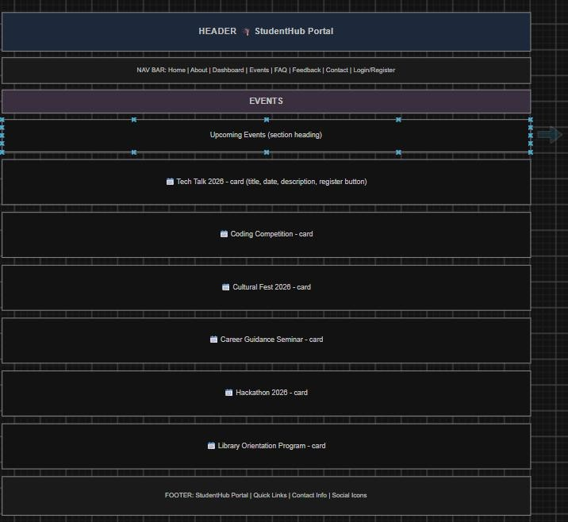
Figure 1.7(Event page)
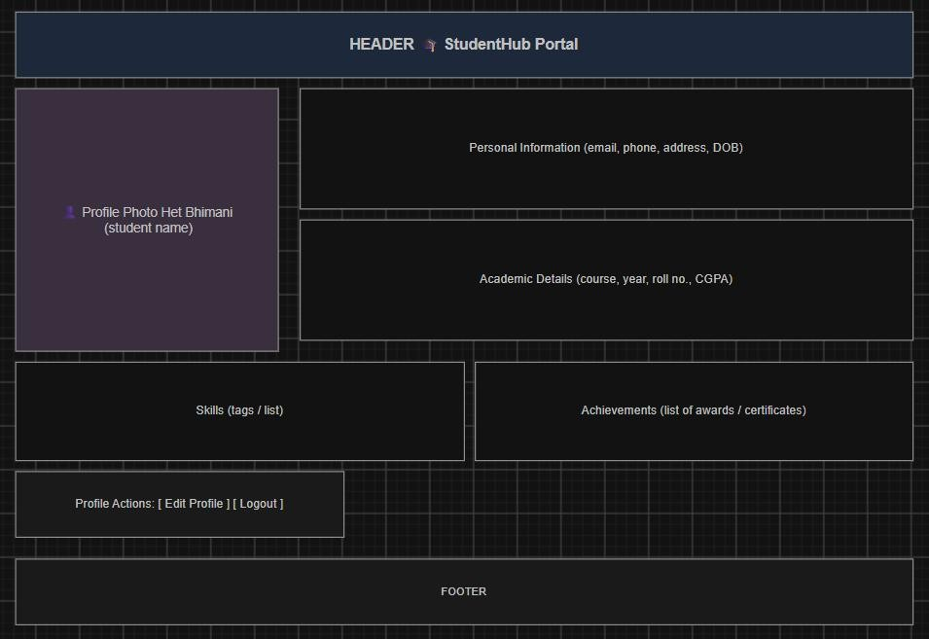
Figure 1.8(Profile page)
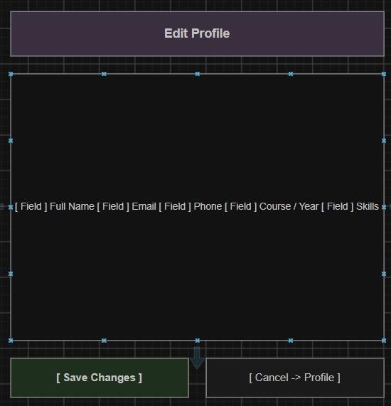
Figure 1.9(Edit page)
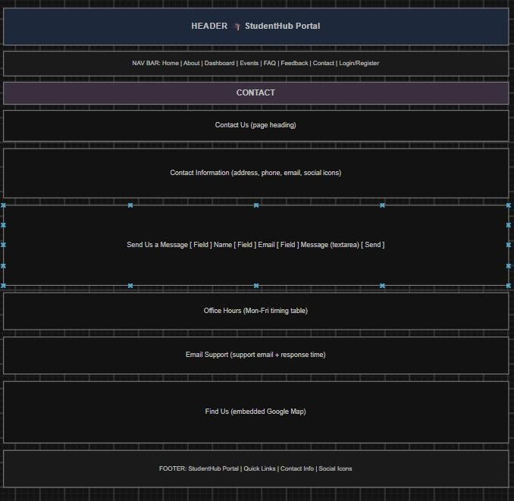
Figure 1.10(Contact page)
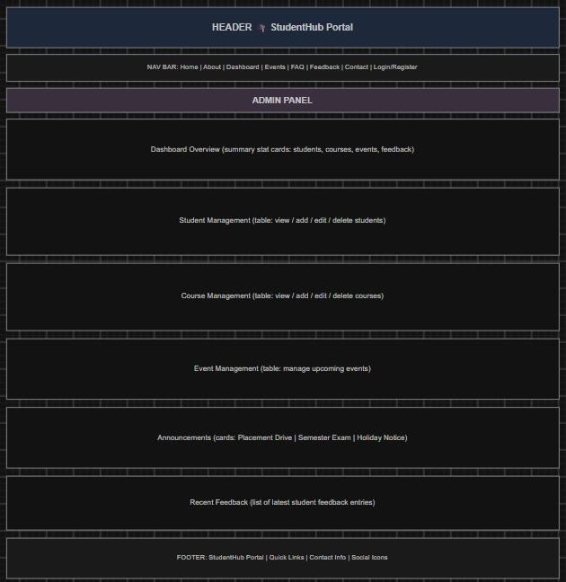
Figure 1.11(Admin page)
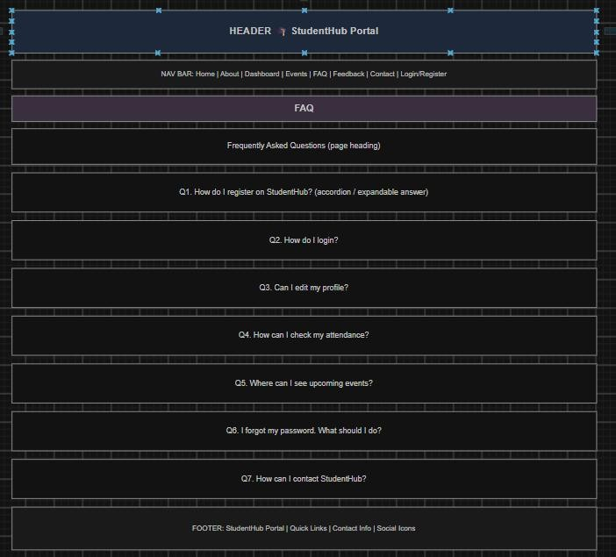
Figure 1.12(FAQ page)
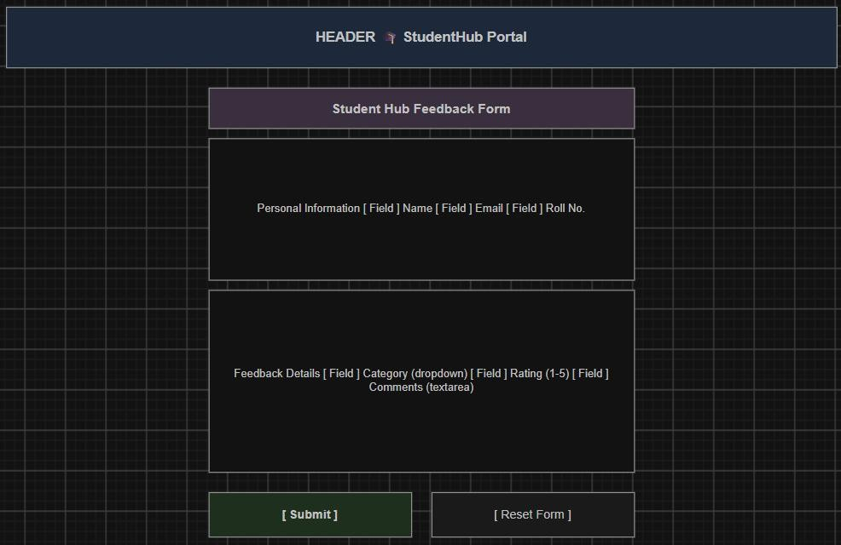
Figure 1.13(Feedback page)

GitHub Repository Link:

Challenges Faced:

Here you can add your learning code difficulties/challenges you have solved with screenshot

Learning Outcomes:
I will be able to analyze requirements and prepare a structured project foundation before implementation.

Faculty Remarks: (Keep this blank for faculty)

Practical - 3
Practical Title:Responsive UI Design using CSS Grid, Flexbox, and Bootstrap/Tailwind

Problem Definition:Design responsive layouts for Home, About, Registration, Dashboard,

and Events pages using CSS Grid and Flexbox. Optional to use CSS framework such as Bootstrap or Tailwind. Ensure mobile-first responsiveness.

Theory
- How does the layout adapt for mobile, tablet, and desktop screens?
Answer: Write your answer in your own words. Do not copy and paste content directly from AI tools. At the end of your answer, provide the website(s) or reference link(s) you used for research.

2.Which layout technique is used and why?
Answer: Write your answer in your own words. Do not copy and paste content directly from AI tools. At the end of your answer, provide the website(s) or reference link(s) you used for research.

3. Are typography, spacing, colors, and contrast readable?
Answer: Write your answer in your own words. Do not copy and paste content directly from AI tools. At the end of your answer, provide the website(s) or reference link(s) you used for research.

4. Is the framework used consistently without unnecessary inline CSS?
Answer: Write your answer in your own words. Do not copy and paste content directly from AI tools. At the end of your answer, provide the website(s) or reference link(s) you used for research.

Implementation/ Output/Result (Keep only one option which is suitable to practical)

Here you can add your learning code/tags/style etc

Evidence of Work (Screenshots)
Screenshot 1 (Add proper title and figure number Figure 1.1)
Description:
Screenshot 2 (Add proper title and figure number Figure 1.2)

Description:

GitHub Repository Link:

Challenges Faced:

Here you can add your learning code difficulties/challenges you have solved with screenshot

Learning Outcomes:
I will design a professional, responsive, and reusable UI layout.

Faculty Remarks: (Keep this blank for faculty)

Practical - 2
Practical Title: Semantic HTML5 Pages with Accessibility-Ready Structure

Problem Definition:Develop static HTML5 skeletons for at least 10 StudentHub pages such as Home, About, Register, Login, Dashboard, Events, Profile, Contact, Admin, FAQ, and Feedback. Use semantic tags and accessibility-friendly structure.

Theory
- Are semantic tags such as header, nav, main, section, article, aside, and footer used properly?
Answer: Write your answer in your own words. Do not copy and paste content directly from AI tools. At the end of your answer, provide the website(s) or reference link(s) you used for research.

Are form labels, headings, image alt text, and navigation links accessible?
Answer: Write your answer in your own words. Do not copy and paste content directly from AI tools. At the end of your answer, provide the website(s) or reference link(s) you used for research.

3. Is the page structure consistent across all pages?
Answer: Write your answer in your own words. Do not copy and paste content directly from AI tools. At the end of your answer, provide the website(s) or reference link(s) you used for research.

Implementation/ Output/Result (Keep only one option which is suitable to practical)

Here you can add your learning code/tags/style etc

Evidence of Work (Screenshots)
Screenshot 1 (Add proper title and figure number Figure 1.1)
Description:
Screenshot 2 (Add proper title and figure number Figure 1.2)

Description:

GitHub Repository Link:

Challenges Faced:

Here you can add your learning code difficulties/challenges you have solved with screenshot

Learning Outcomes:
I will create clean, linked, and accessibility-ready HTML page structures.

Faculty Remarks: (Keep this blank for faculty)

