Practical - 13
Practical Title: PHP JSON API and AJAX/Fetch-Based CRUD without Page Reload
Problem Definition: Create simple PHP JSON API endpoints for events or students and consume them using Fetch API. Perform list, add, update, and delete operations asynchronously without full page reload.
Theory :
1. Do PHP endpoints return valid JSON responses?
Yes. Each endpoint sets the header Content-Type: application/json and returns the response using json_encode(). The response contains a status, a message and the data. The output can be checked in the Network tab of the browser.
2. Are GET and POST requests handled properly?
Yes. GET requests are used to list records, and POST requests are used to add, update and delete records. The endpoint checks $_SERVER['REQUEST_METHOD'], and for an unsupported method it returns an error response in JSON.
3. Are loading, success, and error states shown on the frontend?
Yes. A "Loading..." message is shown while the fetch request is running. After the response, the data is rendered and a success message is shown. If the response is not OK or the request fails, the error is handled using .catch() and an error message is displayed on the page.
4. Is input validation performed before database operations?
Yes. The PHP endpoint checks required fields, valid email format and numeric id, and trims the input before using it. Prepared statements are used for the queries, and for invalid input a JSON error message is returned instead of running the query.

Implementation/ Output/Result
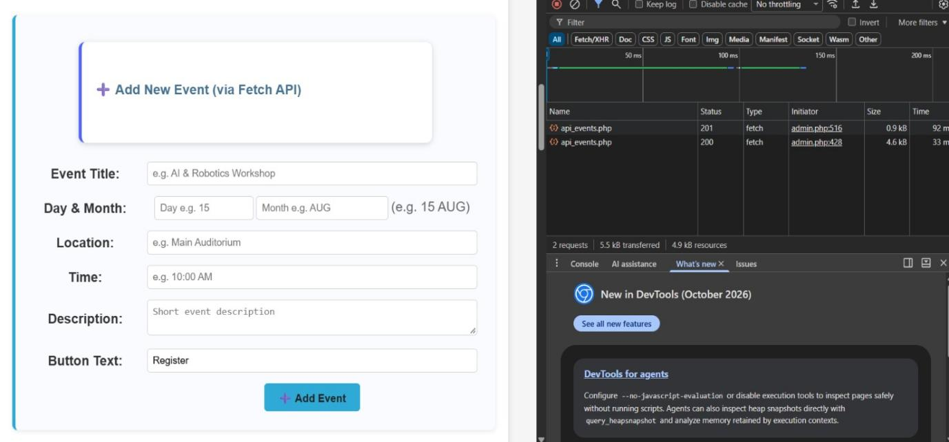
1.Event added without page reloading
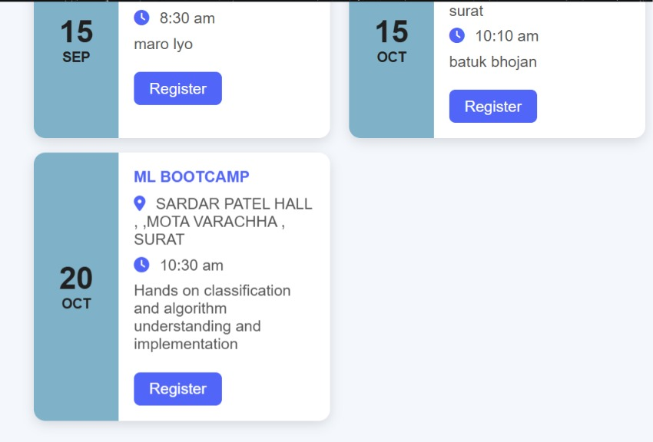
2.Added event named(ML BOOTCAMP)
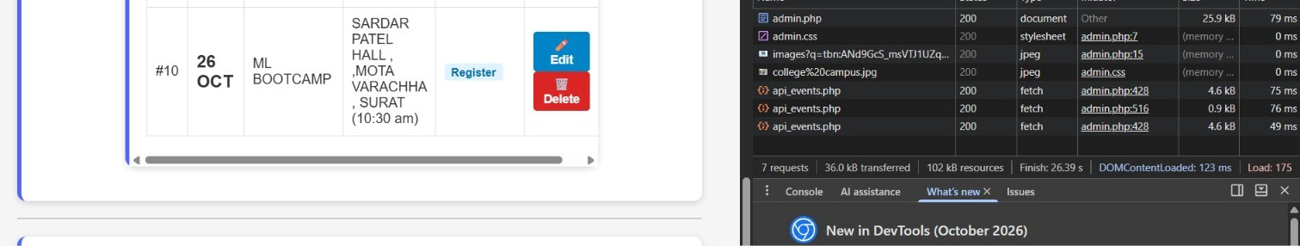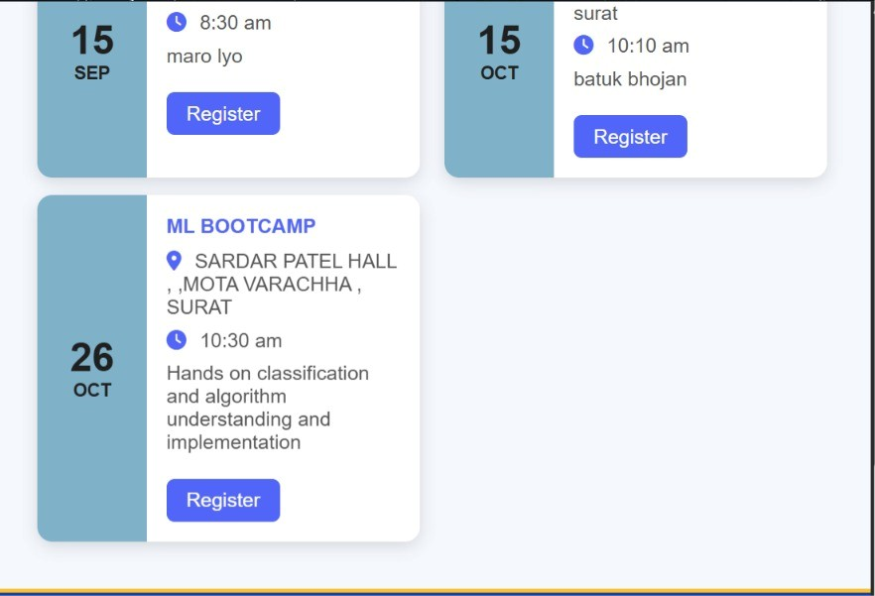
3. After editing date of ML BOOTCAMP event with 200 success status code
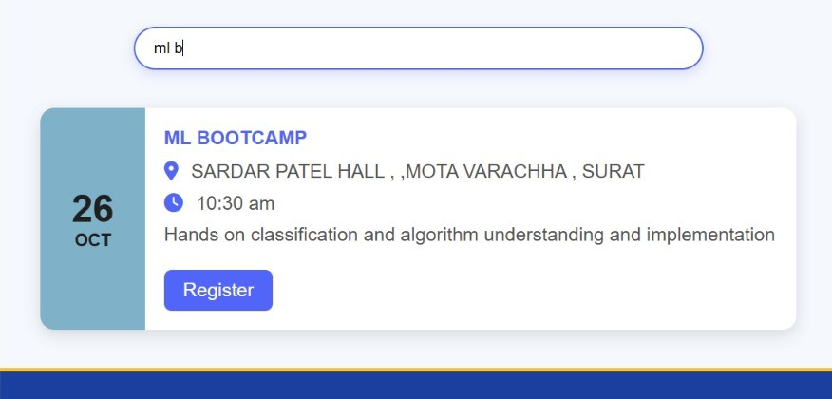
4. Search event in event page

GitHub Repository Link:
https://github.com/ayushposhiya00-lab/Student-Hub/tree/main/Practical-13

Learning Outcomes:
- Create PHP API endpoints that return JSON responses.
- Use the Fetch API to perform asynchronous CRUD operations.
- Handle GET and POST requests and validate input on the server.
- Show loading, success and error states on the frontend.
- Integrate frontend JavaScript with the PHP backend.
Faculty Remarks: (Keep this blank for faculty)

