Practical - 8
Practical Title: MySQL Schema Design, ER Model, PDO Connectivity, and Prepared Statements
Problem Definition: Design the database for StudentHub with students, events and registrations. Create PHP database connection using MySQL statements.
Theory :
1. Is the schema normalized properly?
Yes, the schema is normalized up to the Third Normal Form (3NF). Student details, event details and registration details are stored in separate tables (students, events and registrations), so there is no repeated data. The registrations table connects students and events (many-to-many relationship), and every non-key column depends only on the primary key of its table.
2. Are primary keys and foreign keys correctly defined?
Yes. Each table has an AUTO_INCREMENT primary key (student_id, event_id and registration_id). The registrations table has student_id and event_id as foreign keys that refer to the students and events tables. A UNIQUE constraint on (student_id, event_id) stops the same student from registering twice for the same event.
3. Is the database connection handled securely?
Yes. The connection is written once in db.php using PHP PDO inside a try-catch block with exception error mode. Prepared statements are used so that SQL injection is avoided, and a simple error message is shown to the user instead of the real database error details.

Implementation/ Output/Result

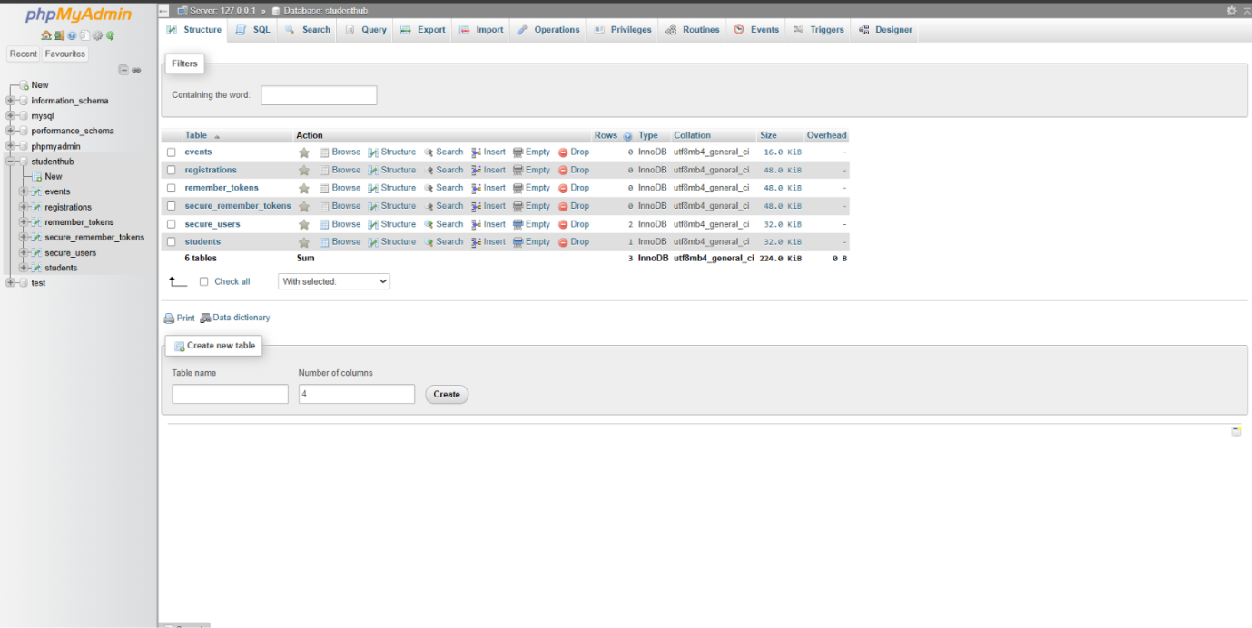

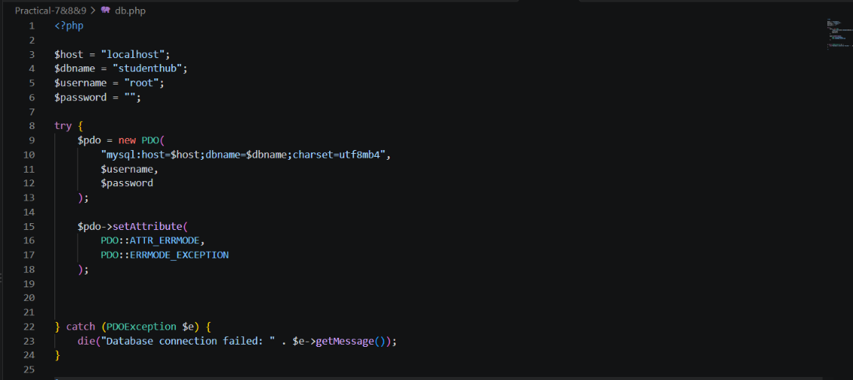

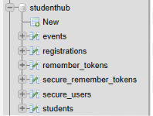
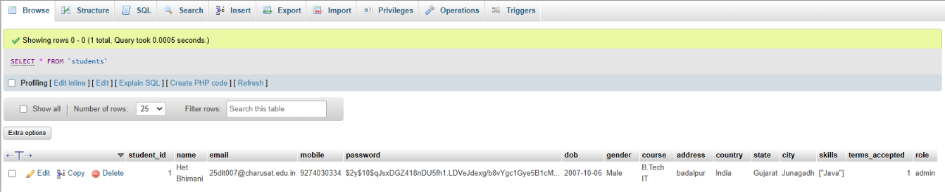

GitHub Repository Link:
https://github.com/ayushposhiya00-lab/Student-Hub/tree/main/Practical-7%268%269

Learning Outcomes:

- Understand how to design a normalized database using ER modeling.
- Create tables with primary keys, foreign keys and constraints in MySQL.
- Connect PHP with MySQL securely using PDO and prepared statements.
- Handle database connection errors properly using try-catch.
Faculty Remarks: (Keep this blank for faculty)

