Practical - 11
Practical Title: Student Management CRUD with Search and Filter
Problem Definition: Create a student management module to add, view, edit, delete, search and filter student records. All database operations must use MySQLi statements and clear success/failure messages.
Theory :
1. Are SELECT, INSERT, UPDATE, and DELETE operations working?
Yes. INSERT adds a new student record, SELECT displays all student records in a table, UPDATE edits the selected student record using an edit form, and DELETE removes a student record. All operations use MySQLi prepared statements, and a success or failure message is shown after each operation.
2. Is search by name/email/course implemented?
Yes. A search box sends the keyword using the GET method, and the SELECT query uses LIKE to match the name, email or course. A course dropdown is also provided for filtering using a WHERE condition, and search and filter can work together.
3. Are delete operations confirmed before execution?
Yes. When the user clicks the Delete button, a JavaScript confirm() dialog asks "Are you sure you want to delete this student?". The record is deleted only when the user clicks OK. Otherwise nothing happens.

Implementation/ Output/Result
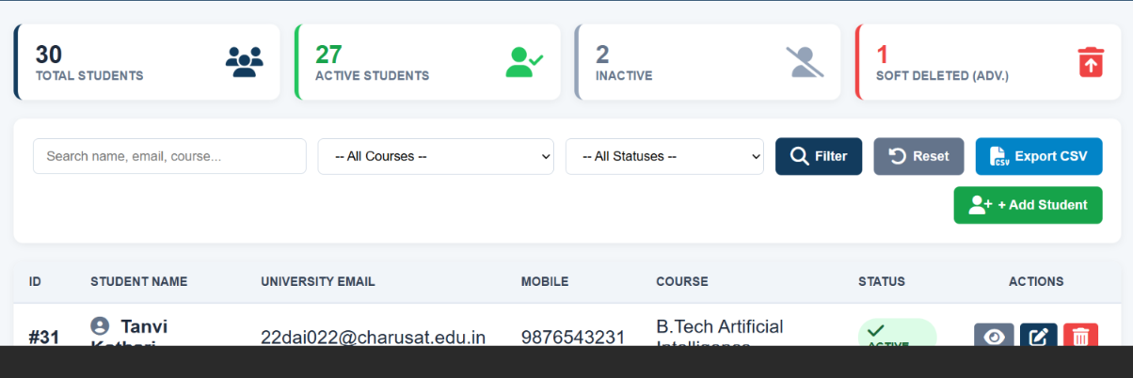
(Main)
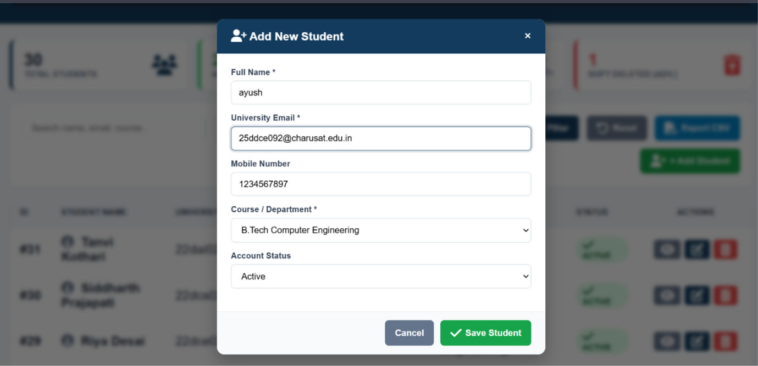
(Add new)
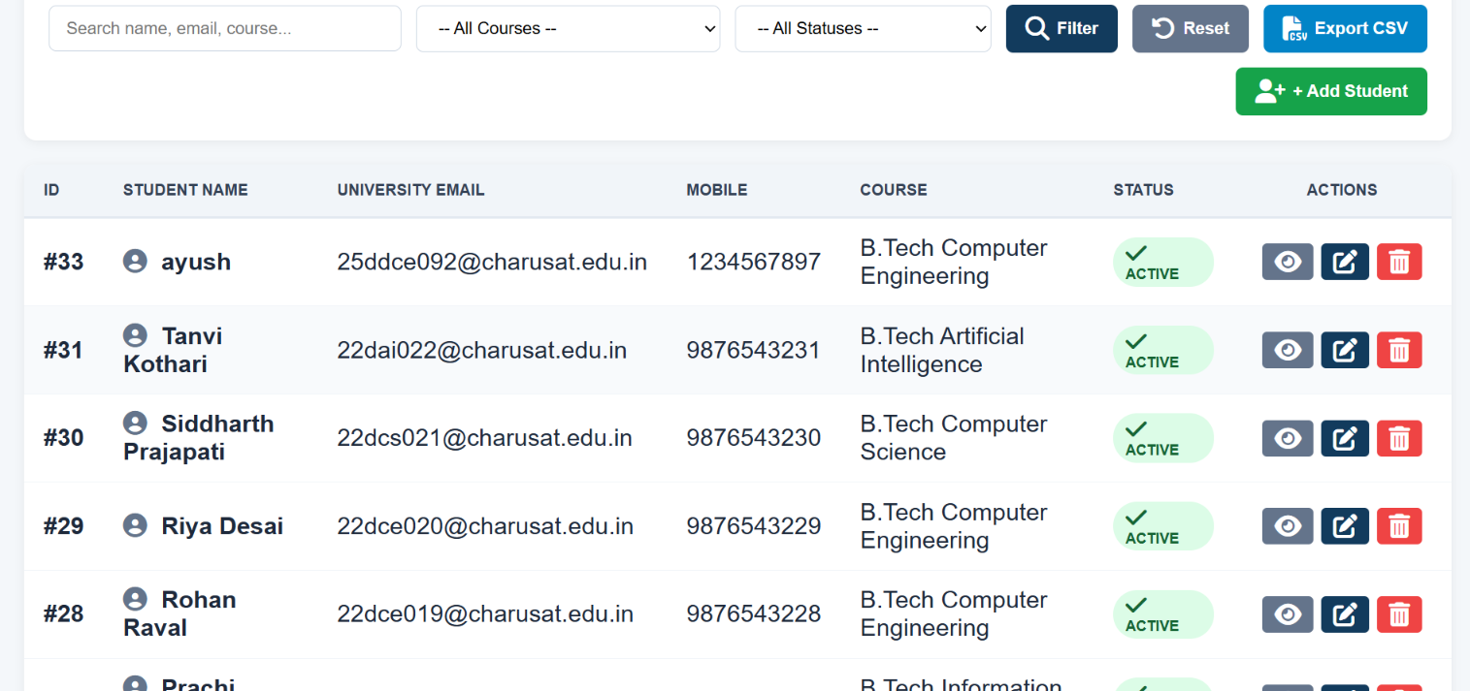
(Updated)
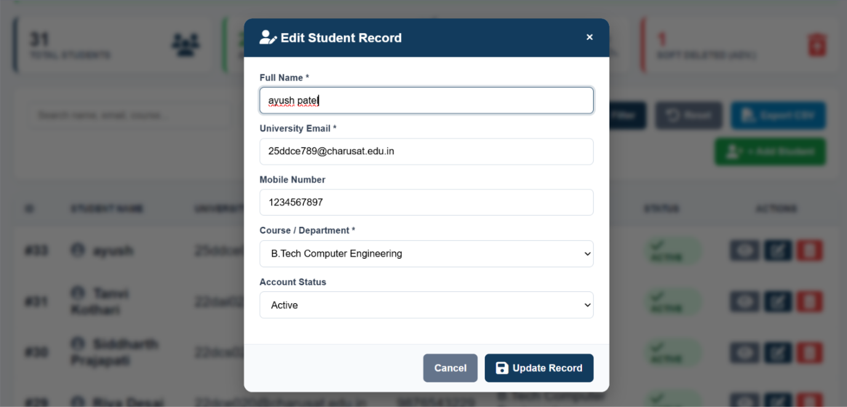
(Update Record)
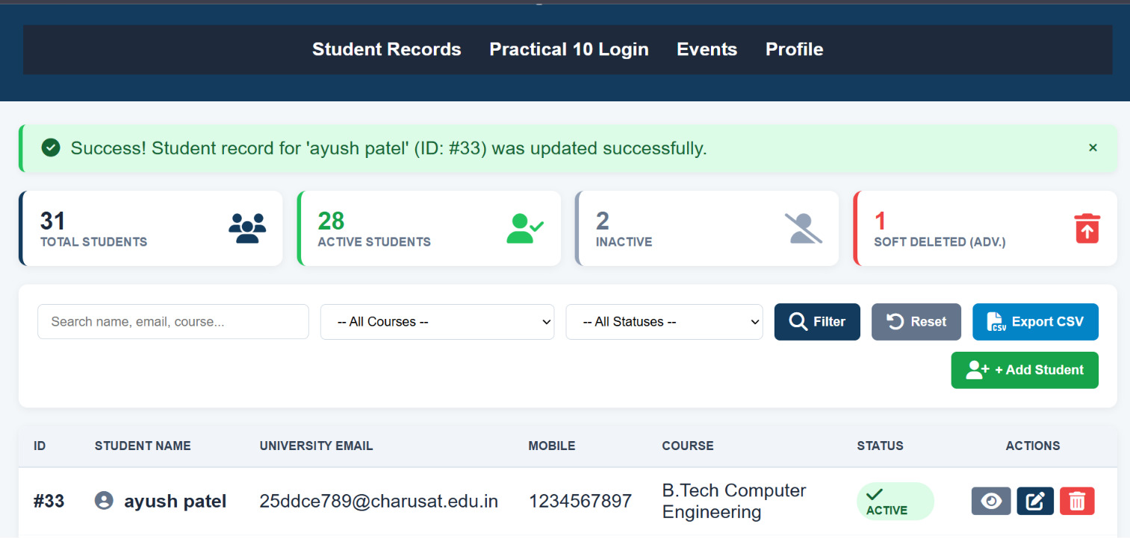
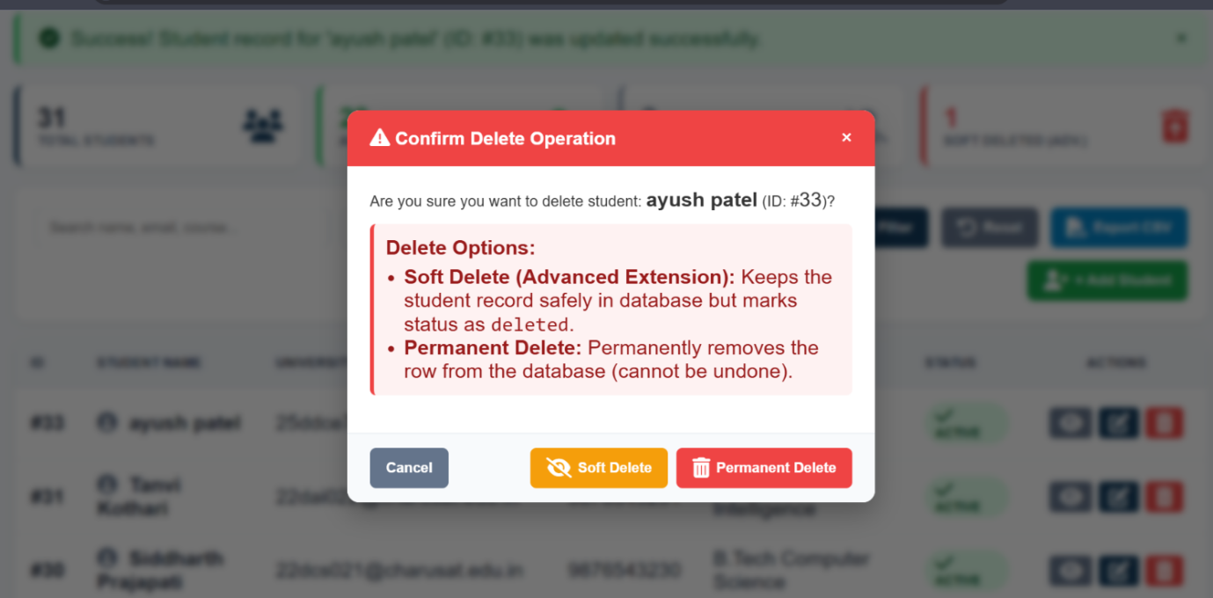
(Delete)
GitHub Repository Link:
https://github.com/ayushposhiya00-lab/Student-Hub/tree/main/Practical-11

Learning Outcomes:
- Understand how to perform CRUD operations using PHP and MySQLi.
- Implement search and filter for database records.
- Show clear success and failure messages to the user.
- Develop a complete and secure data-management page.
Faculty Remarks: (Keep this blank for faculty)

