Practical - 9
Practical Title: Secure User Registration with Database Insert, Duplicate Email Check, and Password Hashing
Problem Definition: Implement secure user registration by inserting user details into MySQL using MySQLi. Validate input on frontend and backend, check duplicate email/username, hash passwords using password_hash(), and display appropriate messages.
Theory :
1. Is password_hash() used before storing passwords?
Yes. The password entered by the user is converted using password_hash() with PASSWORD_DEFAULT before it is inserted into the database. The original password is never stored, and PHP adds a random salt to the hash automatically.
2. Is duplicate email/username checked?
Yes. Before the INSERT query, a SELECT query checks whether the email or username already exists. If it exists, the message "Email or username already registered" is shown and no new record is inserted. A UNIQUE key on the email column in the table gives extra protection.
3. Are frontend and backend validations consistent?
Yes. The same rules are used on both sides: all fields are required, the email format must be valid, the password must be at least 8 characters, and the confirm password must match. The frontend (JavaScript) gives quick feedback, and the backend (PHP) validates again because frontend checks can be bypassed.

Implementation/ Output/Result
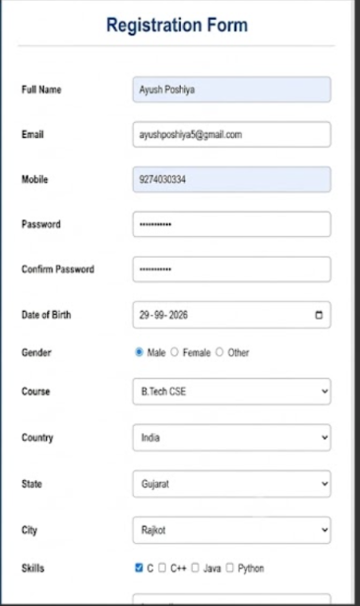

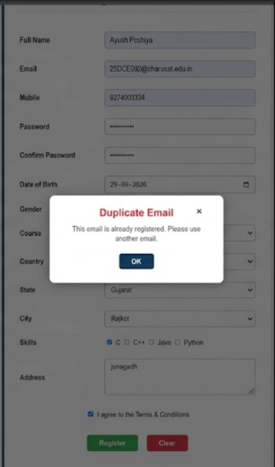

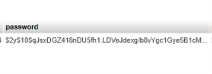

GitHub Repository Link:
https://github.com/ayushposhiya00-lab/Student-Hub/tree/main/Practical-7%268%269

Learning Outcomes:

- Understand how to insert user data into MySQL using MySQLi.
- Hash passwords securely using password_hash().
- Implement duplicate email/username checking before insert.
- Apply consistent frontend and backend validation.
- Display clear success and error messages to the user.
Faculty Remarks: (Keep this blank for faculty)

