Practical - 1

Practical Title: Project Initiation, Requirement Analysis, Sitemap, Wireframe, and GitHub Setup
Problem Definition: Initiate the semester-long StudentHub portal by identifying the problem scope, user roles, key modules, navigation flow, and minimum 10 pages. Create a sitemap, low-fidelity wireframe, project folder structure, README file, and GitHub repository.

Theory
  - What is URL and parts of URL?
Answer: A URL (Uniform Resource Locator) is the address of a unique resource on the internet. It is one of the key mechanisms used by browser to retrieve published resources, such as HTML pages, CSS documents, images, and so on. Scheme, Subdomain, Domain Name, Top-Level Domain, Port Number, Path, Query Parameters, Fragment .
( https://developer.mozilla.org/en-US/docs/Learn_web_development/Howto/Web_mechanics/What_is_a_URL)

  - How does HTML file process in web browser? Answer: -You Write HTML Code
-You create an HTML file that contains the structure and content of your webpage — text, headings, images, links, forms, etc.
-You Open the File in a Browser
-When you double-click the file or open it through a web server, a browser like Chrome, Firefox, or Safari reads the code.
-The Browser Parses the HTML
-The browser scans your code from top to bottom. It starts with the <!DOCTYPE html> declaration, then reads sections.
-The Browser Builds the Page
-It displays content (like text, images, and videos) inside the
.
-It applies styles from CSS (if linked or embedded).
-It runs JavaScript for interactivity (if included).

Result: A Visual Web Page
What you see in the browser is a visual version of the HTML. The browser turns your code into a formatted page that looks clean and interactive — just like any website you visit.
(https://dev.to/ofodile/how-html-works-in-the-browser-25pa)

  - How will page navigation flow managed among all HTML pages? Answer: - Mapping your structure: page hierarchy, menus and links
Before diving into specific components, it helps to state that how users move through the information or navigate the pages of a website depends on a coherent skeleton. The following sections break down that skeleton into manageable parts.
    - Page hierarchy as the backbone
    - Breadcrumb trails and path indicators
    - Responsive behaviour across devices
    - Internal linking for discoverability
    - Measuring and mapping flows
    - Designing for efficient movement
    - Scroll behaviour and interactive elements
(https://www.parallelhq.com/blog/how-users-move-through-information-or-navigate-pages-of-website)

  - How will GitHub commits be maintained after each practical? Answer:
    - git init
    - git add .
    - git commit -m “any commit message”
-git push origin main/master (https://github.com/git-guides)

Implementation/ Output/Result

Project Requirements for StudentHub-Portal

Pages Included:
    - index.html
    - PAGES/home.html
    - PAGES/about.html
    - PAGES/admin.html
    - PAGES/contact.html
    - PAGES/dashboard.html
    - PAGES/edit.html
    - PAGES/events.html
    - PAGES/faq.html
    - PAGES/feedback.html
    - PAGES/login.html
    - PAGES/profile.html
    - PAGES/register.html

Core Requirements:
    - Static web application using HTML, CSS, and JavaScript
    - Responsive layout for desktop and mobile screens
    - Navigation across all pages via links or menu
    - Login and registration forms on `PAGES/login.html` and `PAGES/register.html`
    - User dashboard and profile pages for authenticated users
    - Admin interface on `PAGES/admin.html`
    - Contact page with message submission form

    - Events listing page on `PAGES/events.html`
    - FAQ, feedback, and about pages for user support and information
    - Edit page to allow profile or content updates

Evidence of Work (Screenshots)
SiteMap:
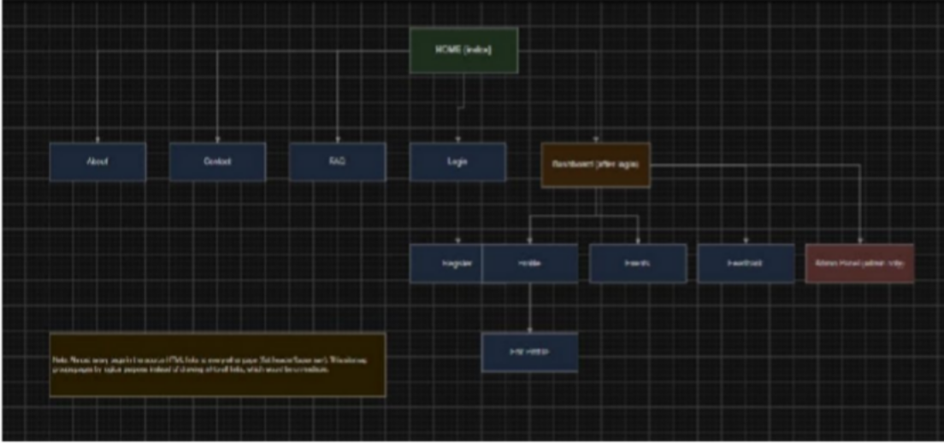
Figure 1.1

WireFrame:

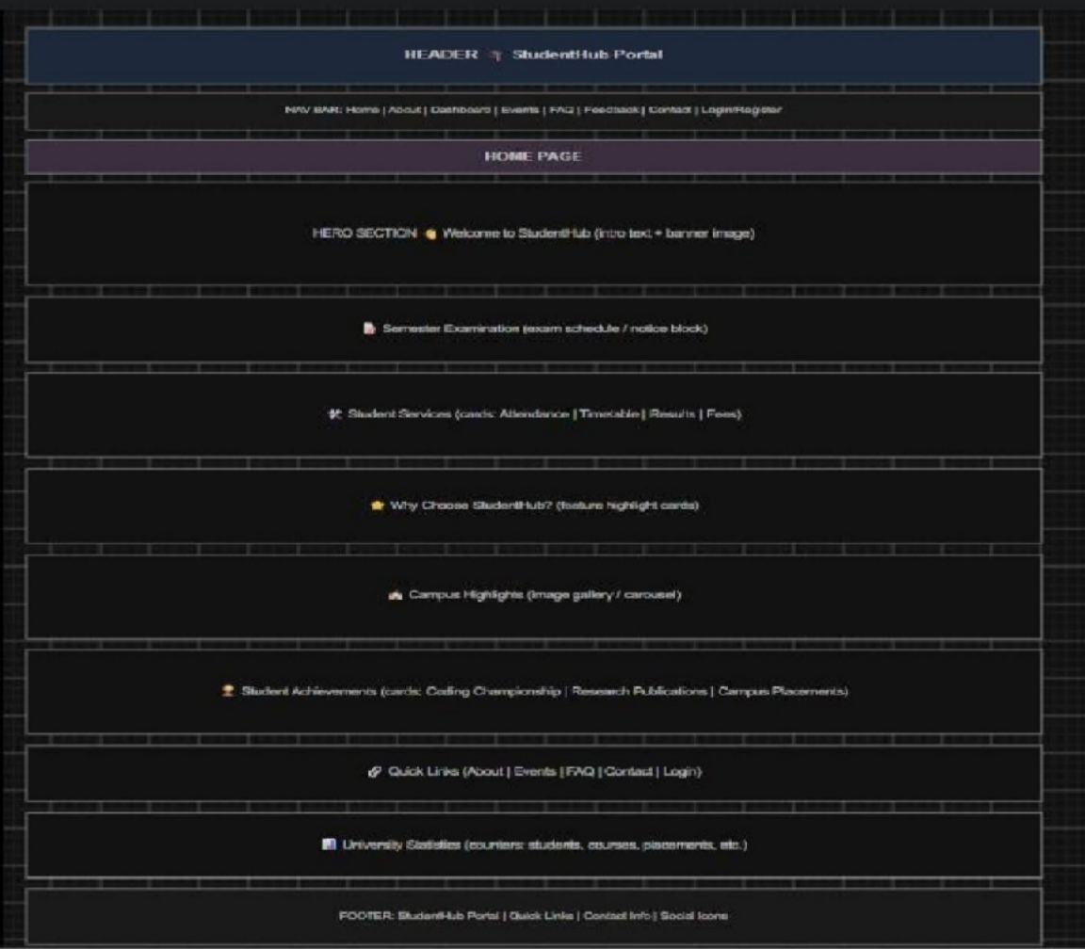
Figure 1.2(Home page)

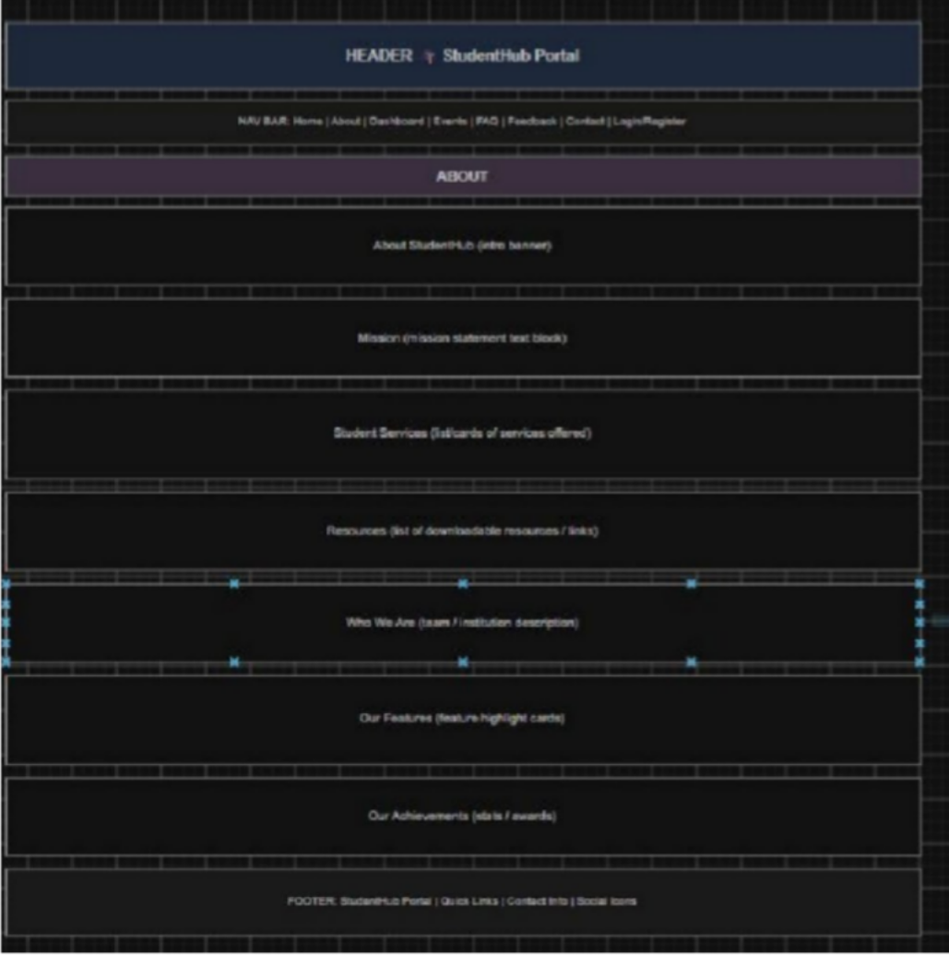
Figure 1.3(About page)

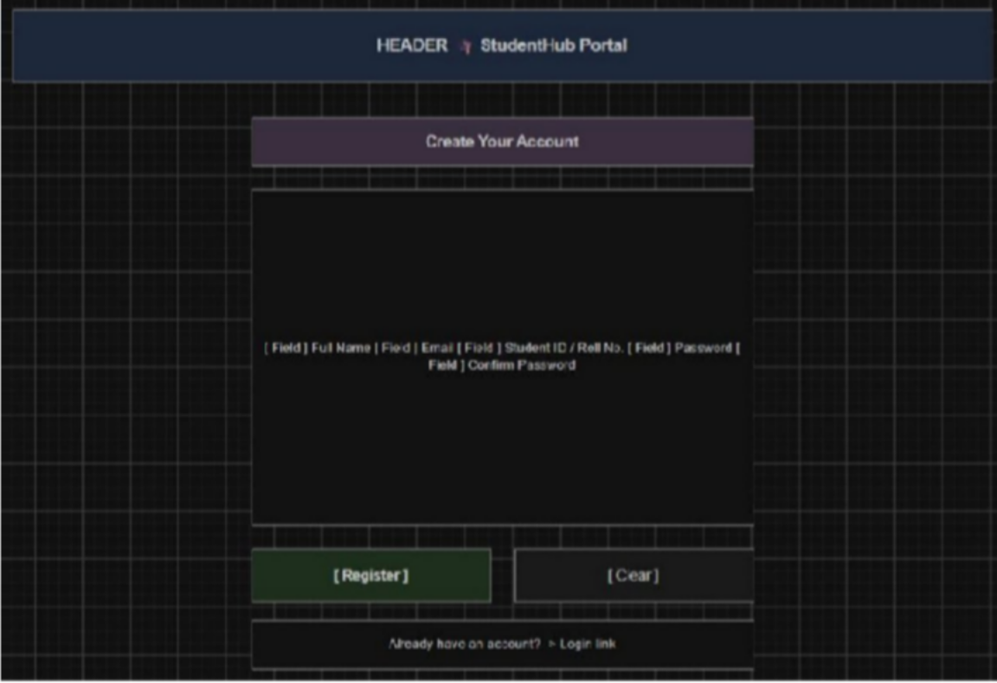
Figure 1.4(Register page)
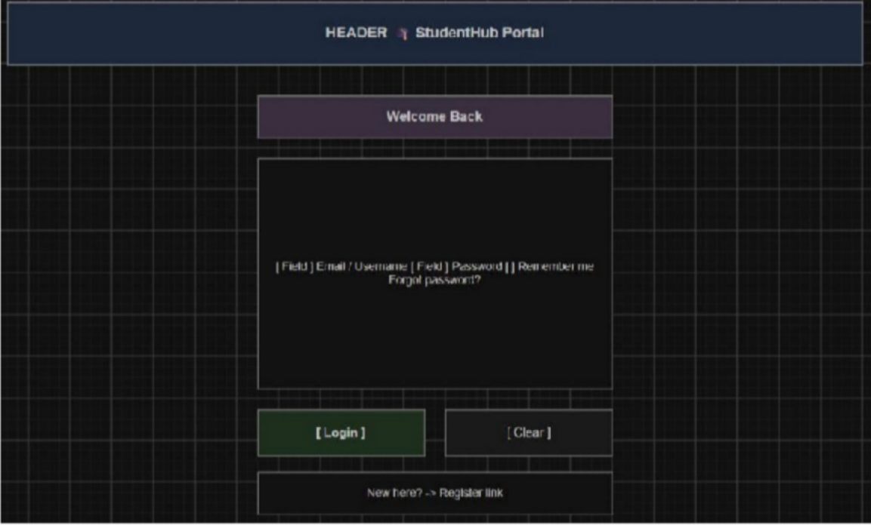
Figure 1.5(Login page)

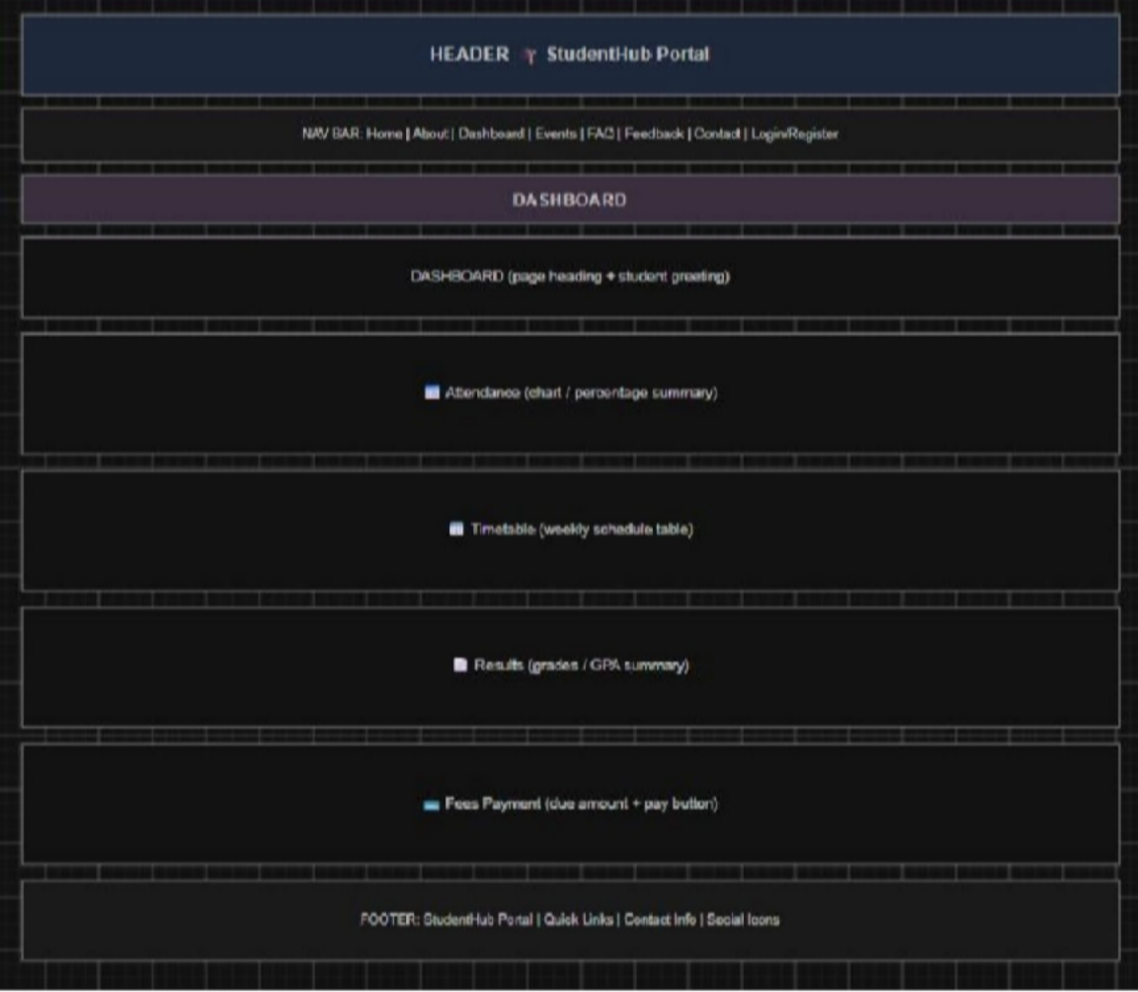
Figure 1.6(Dashboard page)

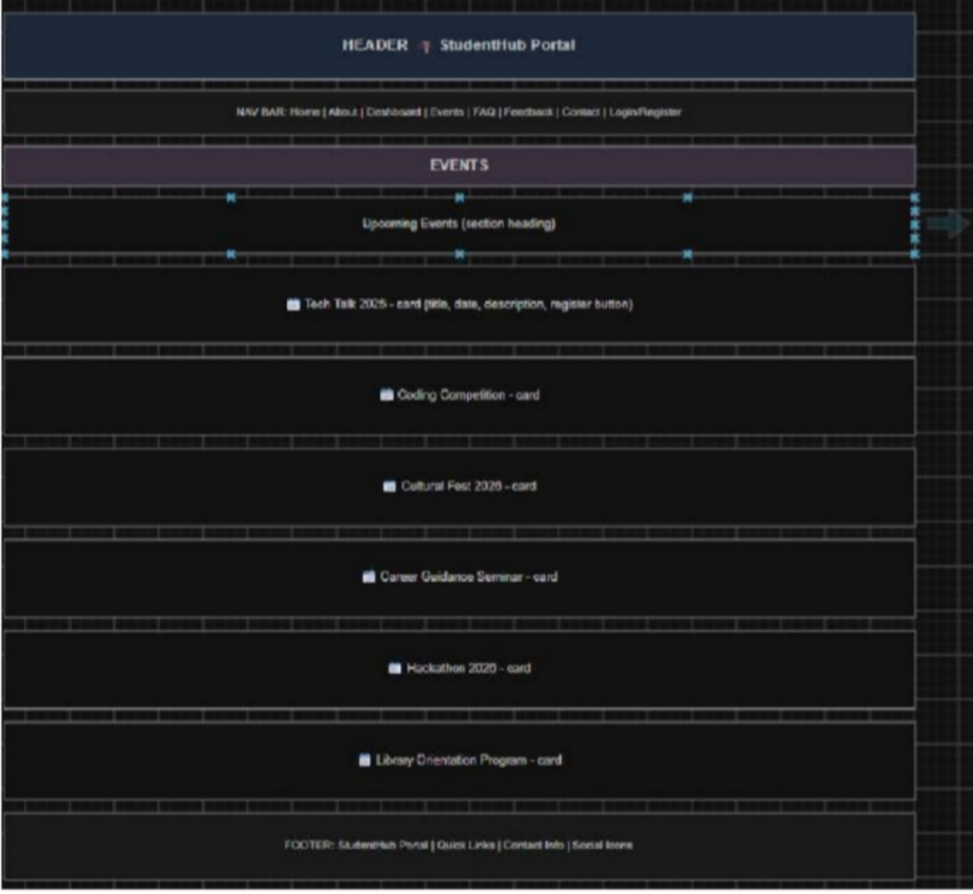
Figure 1.7(Event page)

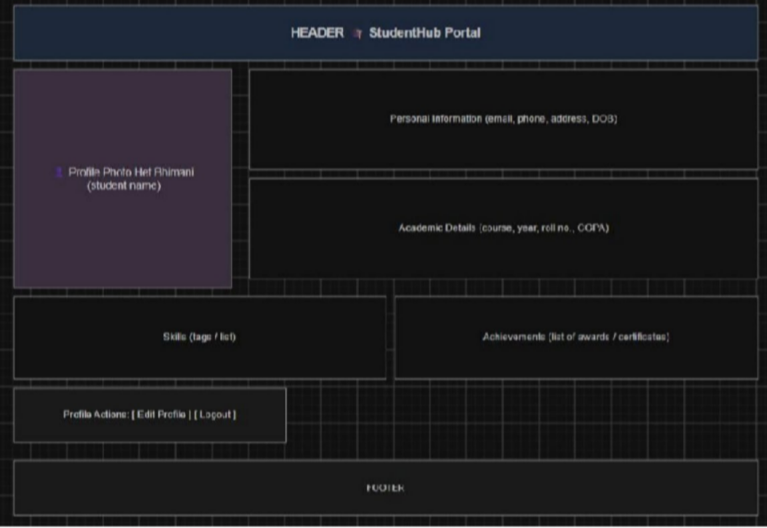
Figure 1.8(Profile page)
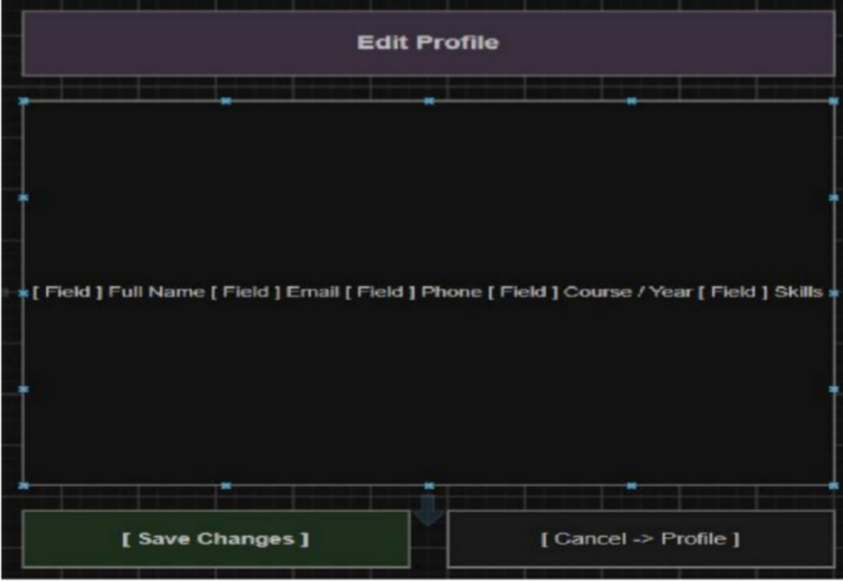

Figure 1.9(Edit page)
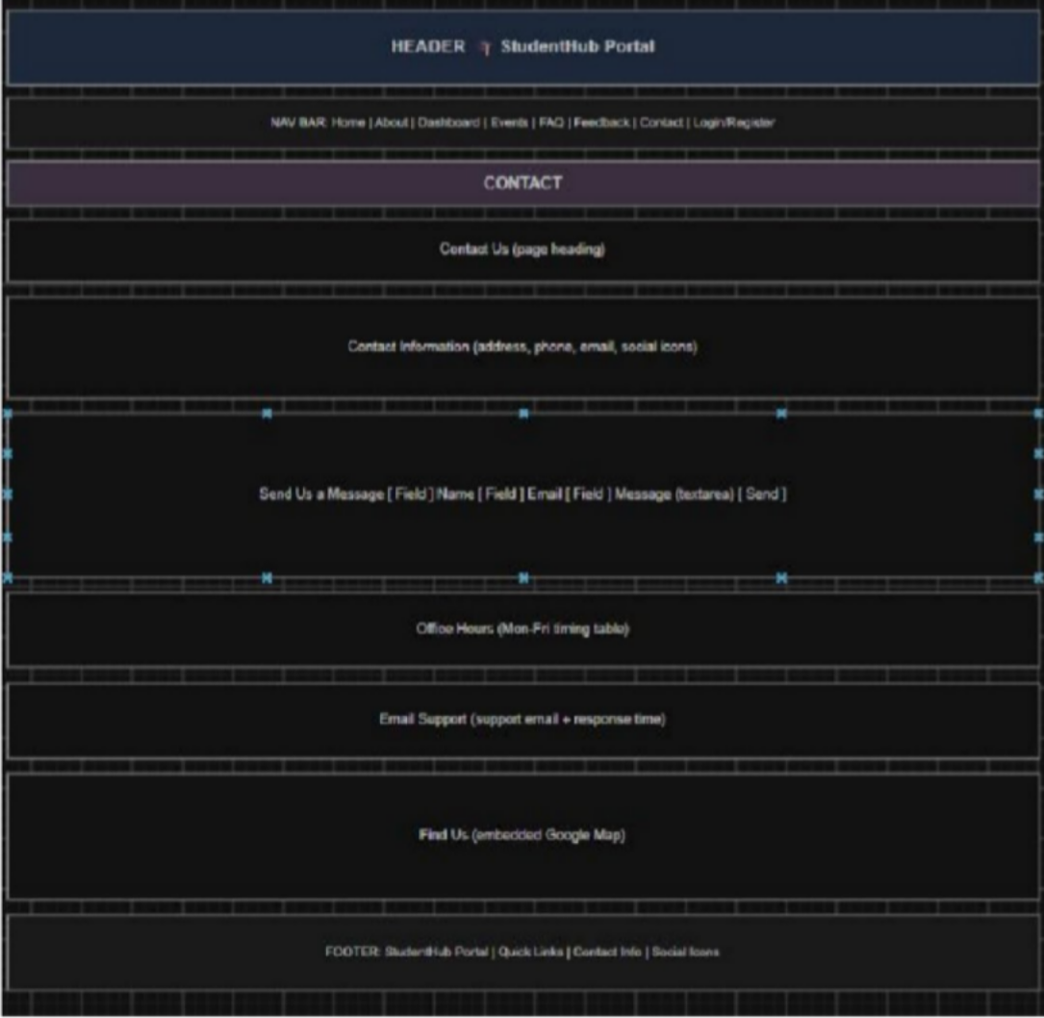
Figure 1.10(Contact page)

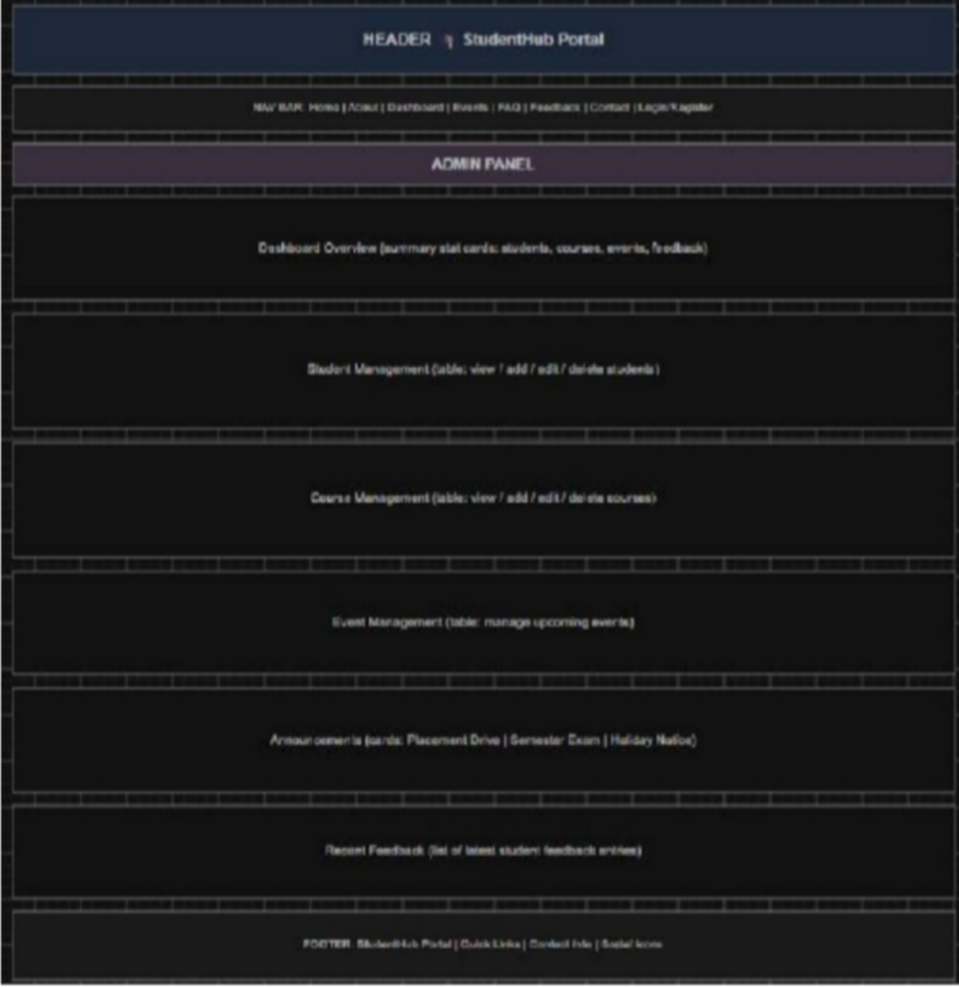
Figure 1.11(Admin page)

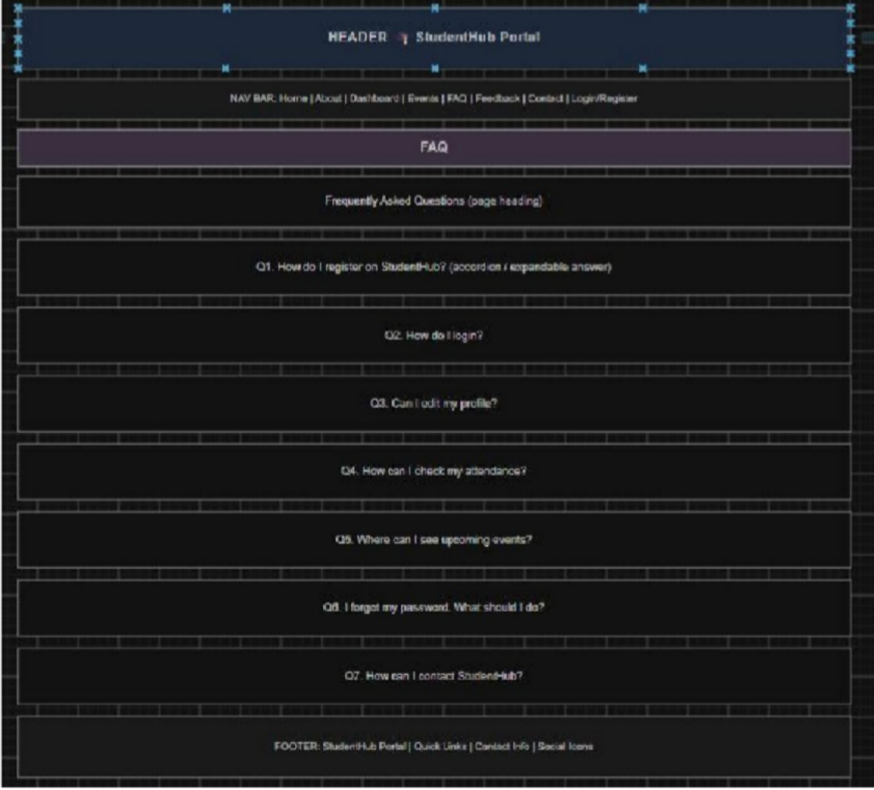
Figure 1.12(FAQ page)

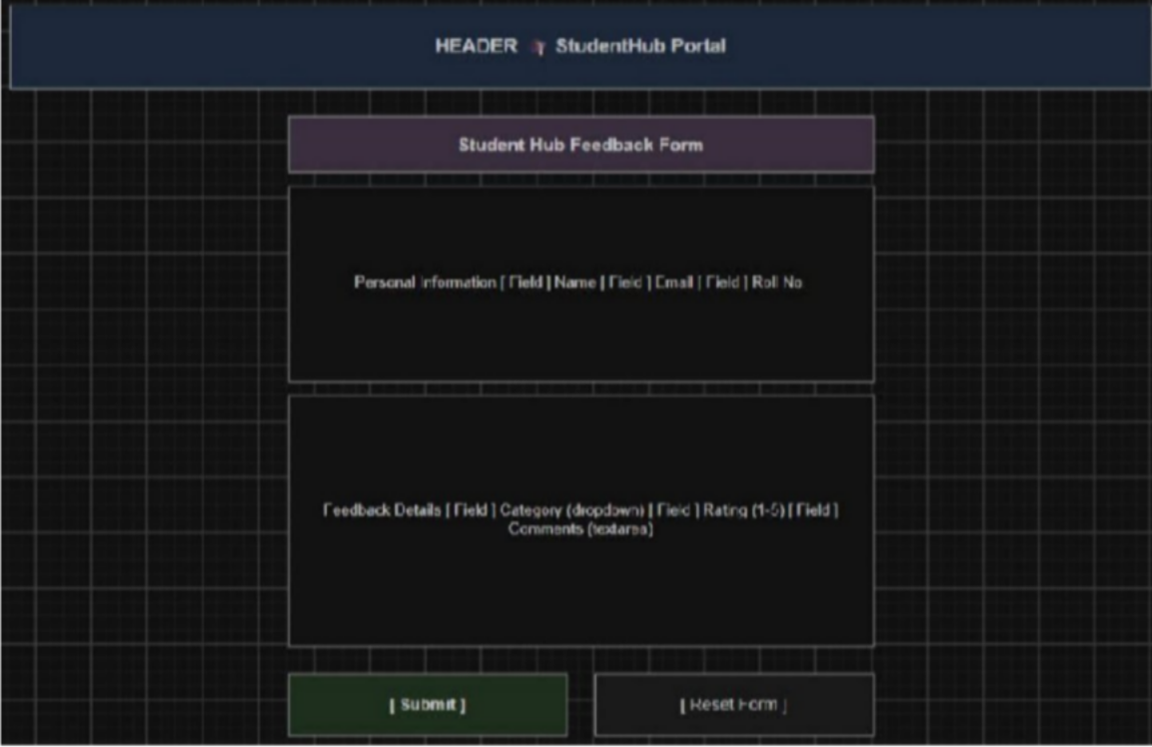
Figure 1.13(Feedback page)

GitHub Repository Link:
https://github.com/yakshu205/StudentHub.git

Challenges Faced:

First time when I start to think about requirement at that time I stuck . I thought that what type of pages we will make etc . But I start collecting info or requirement from my friend and then , I make sitemap and wireframe in tool like draw.io. I also faced difficulty when I make repos and push code and commit changes through command prompt , then I show a tutorial video of Git/GitHub version control , then I am good commit and etc.

Learning Outcomes:
I will be able to analyze requirements and prepare a structured project foundation before implementation and I am able to push , pull and commit my changes into my Github repo.

Faculty Remarks: (Keep this blank for faculty)

Practical - 3

Practical Title:Responsive UI Design using CSS Grid, Flexbox, and Bootstrap/Tailwind
Problem Definition:Design responsive layouts for Home, About, Registration, Dashboard,
and Events pages using CSS Grid and Flexbox. Optional to use CSS framework such as Bootstrap or Tailwind. Ensure mobile-first responsiveness.

Theory
  - How does the layout adapt for mobile, tablet, and desktop screens?
Answer: A layout adapts across mobile, tablet, and desktop screens using fluid grids, flexible images, and breakpoints (typically under 600px for mobile, 601px–1024px for tablets, and 1025px+ for desktops). Elements reflow, resize, or stack vertically to fit the available screen space.
(https://developer.mozilla.org/en US/docs/Learn_web_development/Core/CSS_layout/Responsive_Design)

  - Which layout technique is used and why?
Answer: Common web design layout techniques include CSS Flexbox, CSS Grid, and traditional Float or Responsive structures. Because your specific project or graphic was not provided, the correct technique depends entirely on the design goal. (https://www.w3schools.com/html/html_layout.asp)

  - Are typography, spacing, colors, and contrast readable?
Answer: Yes, typography, spacing, colors, and contrast directly determine whether text is readable. When properly balanced, they prevent eye strain and make content easy to scan. When poorly configured, text becomes difficult or impossible to read. (https://guidelines.india.gov.in/activity/the-impact-of-typography-on-web-design-a-comprehensive-guide-to-aesthetics-and-readability/)

  - Is the framework used consistently without unnecessary inline CSS?
Answer: style="" attributes. While they look like inline styles in the markup, they compile into clean external stylesheets and maintain design consistency without unnecessary true inline CSS. (https://www.reddit.com/r/Frontend/comments/rk3lr4/are_css_frameworks_really_necess ary/)

Implementation/ Output/Result :

- CSS Selectors Used:
*, body, header, nav, main, section, article, footer, div, h1, h2, h3, h4, p, ul, li, a, img,
form, label, input, textarea, select, button, table, tr, td, hr, small, i, marquee,
.class, #id,
:hover, :focus, :first-child, :last-child,
input[type="text"], input[type="email"], input[type="password"], input[type="radio"], input[type="checkbox"], input[type="submit"], input[type="reset"],
@media

- CSS Properties Used:

margin, padding, box-sizing, display, width, height, max-width,
background, background-size, background-position, background-repeat, color,
font-family, font-size, font-weight, text-align, text-decoration, line-height,
border, border-left, border-top, border-radius, box-shadow,
position,
justify-content, align-items,

flex-direction, flex-wrap, gap,
grid-template-columns, list-style,
cursor, transition, transform, outline, resize, object-fit, overflow

Evidence of Work (Screenshots)

Figure 3.1(Home page)

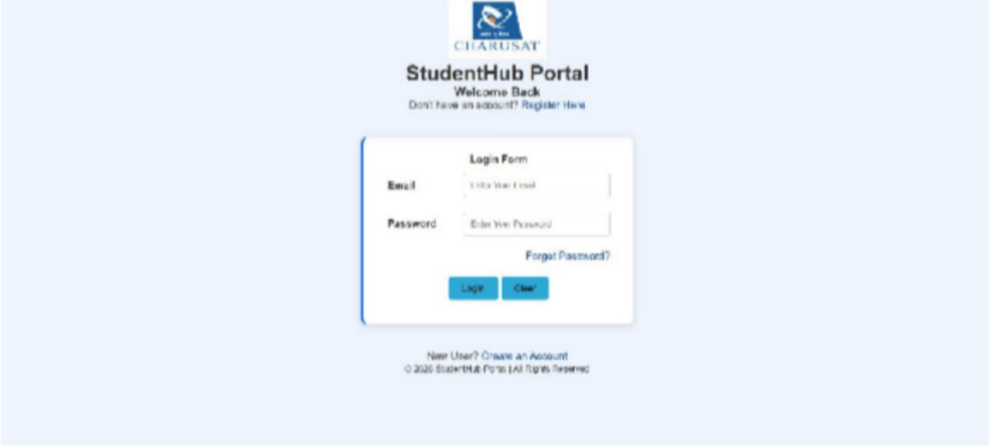
Figure 3.1(Login page)

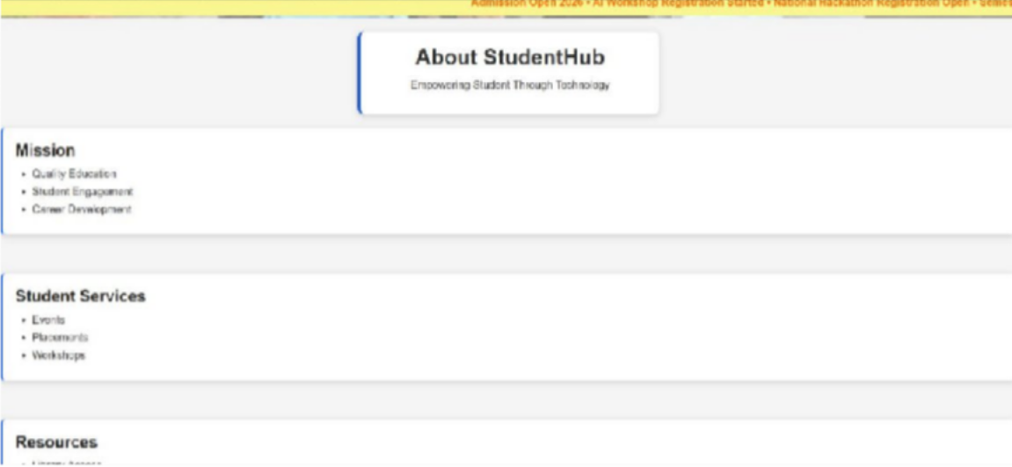
Figure 3.2(About page)

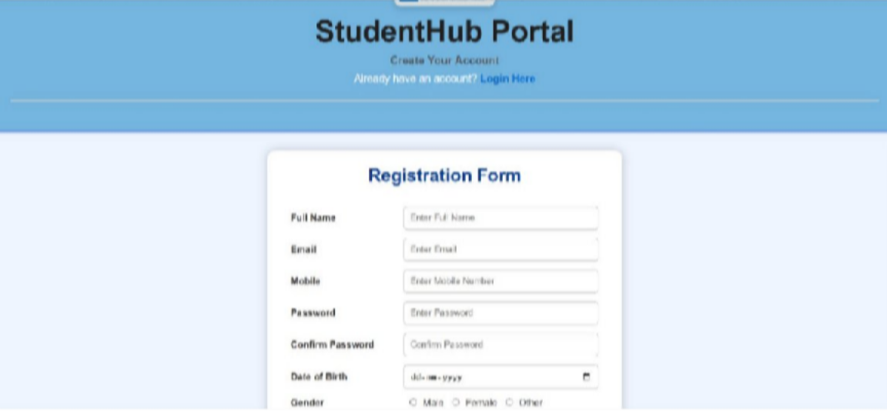
Figure 3.3(Registration page)
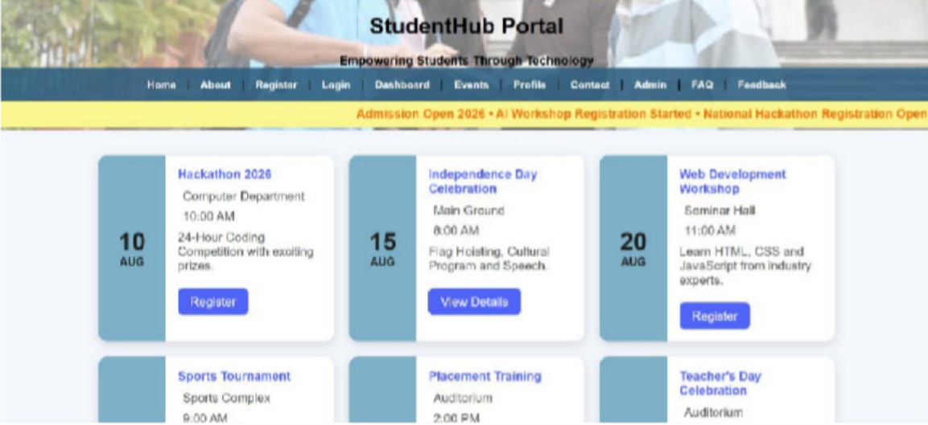
Figure 3.4(Event page)

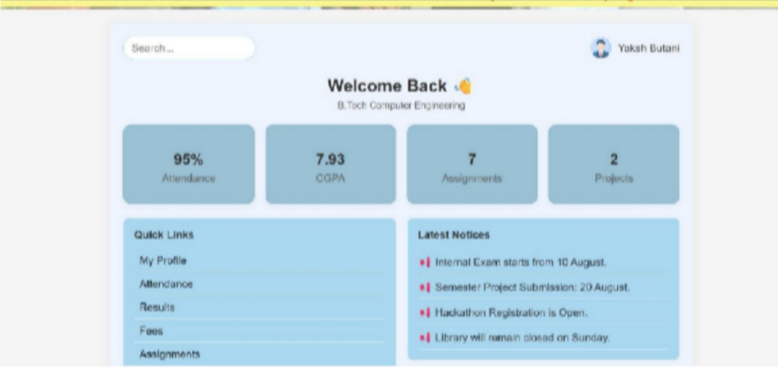
Figure 3.5(Dashboard page)
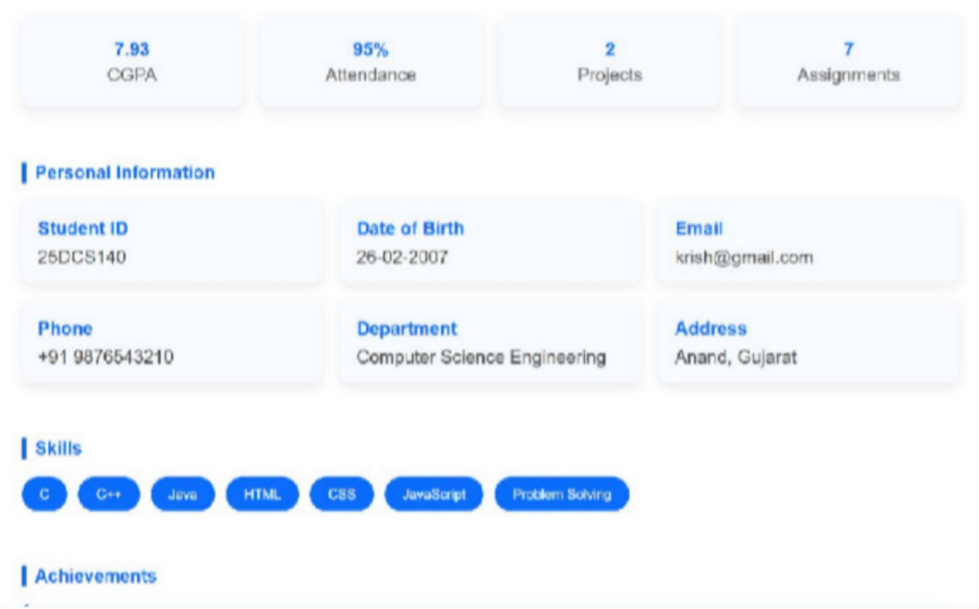
Figure 3.5(Profile page)

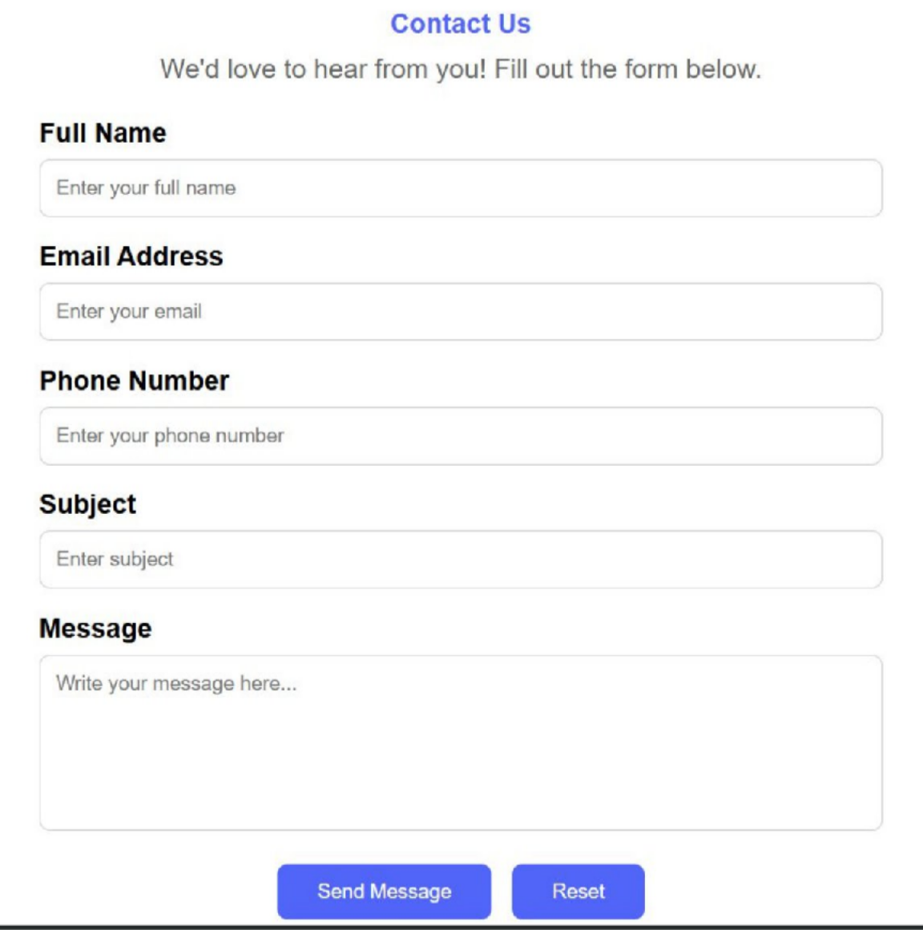
Figure 3.5(Contact us page)

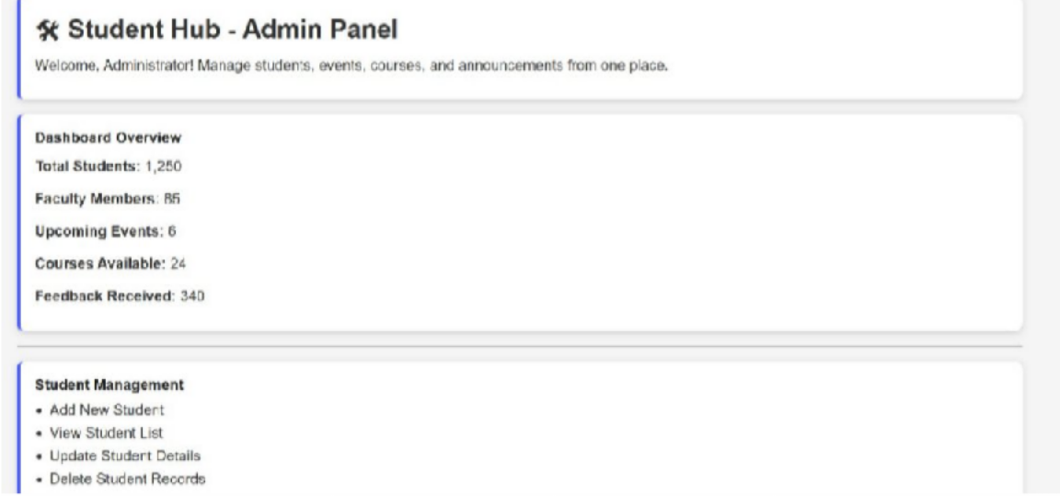
Figure 3.5(Admin page)
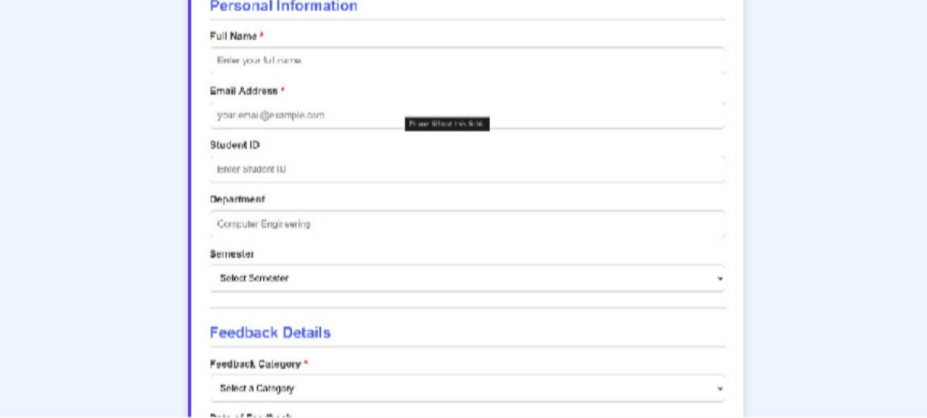
Figure 3.5(Feedback page)

GitHub Repository Link:
https://github.com/yakshu205/StudentHub.git

Challenges Faced:
When I was styling the html files , I had no idea about how I put image behind the text and blur it . then I told ChatGPT that I want to put image behind text at header which concept or styling function I should use , give syntax and opacity code and gradient code like (255,255,255,0.20);
It gave me function that name is linear gradient and also I learned padding , card , form, Flex , grid, styling , box , responsive etc.. concept.

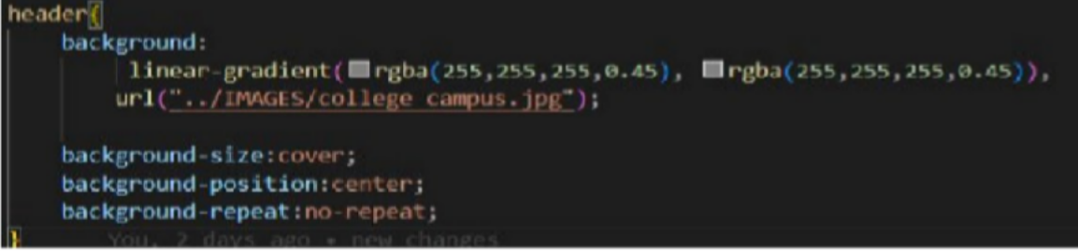

Learning Outcomes:
I will design a professional, responsive, and reusable UI layout.

Faculty Remarks: (Keep this blank for faculty)

Practical - 2

Practical Title: Semantic HTML5 Pages with Accessibility-Ready Structure
Problem Definition:Develop static HTML5 skeletons for at least 10 StudentHub pages such as Home, About, Register, Login, Dashboard, Events, Profile, Contact, Admin, FAQ, and Feedback. Use semantic tags and accessibility-friendly structure.

Theory
  - Are semantic tags such as header, nav, main, section, article, aside, and footer used properly?
Answer: Yes , I use tags such as nav ,header, main, section, footer .

  - Are form labels, headings, image alt text, and navigation links accessible? Answer: Yes , all imgage, lables and navigation links are accessible by browser .
(using <a> and href =”link”);

  - Is the page structure consistent across all pages?
Answer: Yes , all pages have consistent structure . (title,header,body,footer)

Implementation/ Output/Result :
<!DOCTYPE html> Declares the document as HTML5.

<html> Root element of the HTML page.

<head> Contains page information like title and CSS links.

<meta> Defines character encoding and viewport settings.

<title> Sets the title shown in the browser tab.

<link> Links an external CSS file.

<header> Defines the page header section.

<center> Centers the content (deprecated tag).

<img> Displays an image/logo.

<h1> Main heading of the page.

<h2> Section heading.

<h3> Sub-heading.

<p> Defines a paragraph.

<b> Makes text bold.

<nav> Contains navigation links.

<a> Creates hyperlinks.

<marquee> Displays scrolling text (deprecated tag).

<body> Contains all visible page content.

<main> Represents the main content of the page.

<section> Groups related content into sections.

<article> Represents independent content or an article.

<ul> Creates an unordered (bulleted) list.

<li> Defines a list item.

<hr> Inserts a horizontal line.

<footer> Defines the footer section.

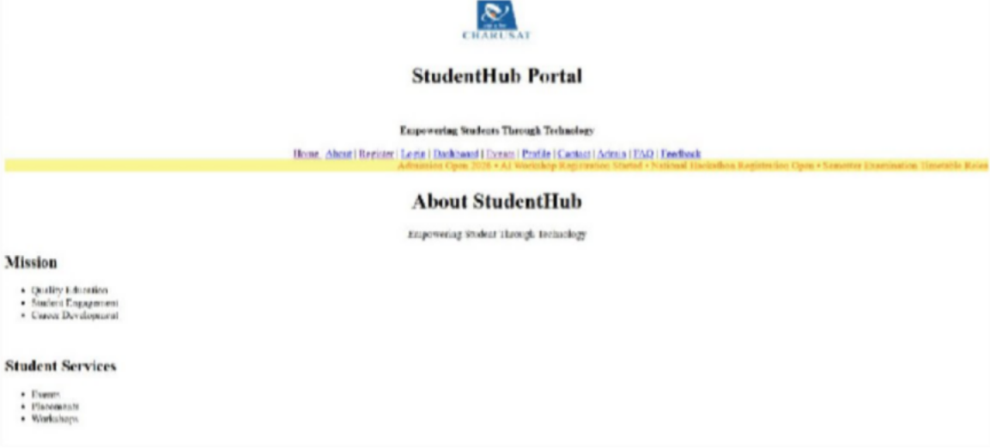
Evidence of Work (Screenshots)

Figure 2.1(Home Page)
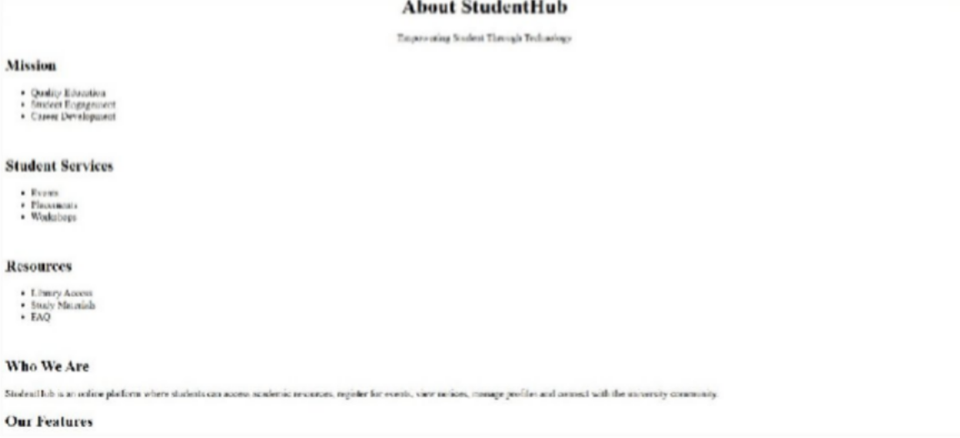
Figure 2.2(About Page)

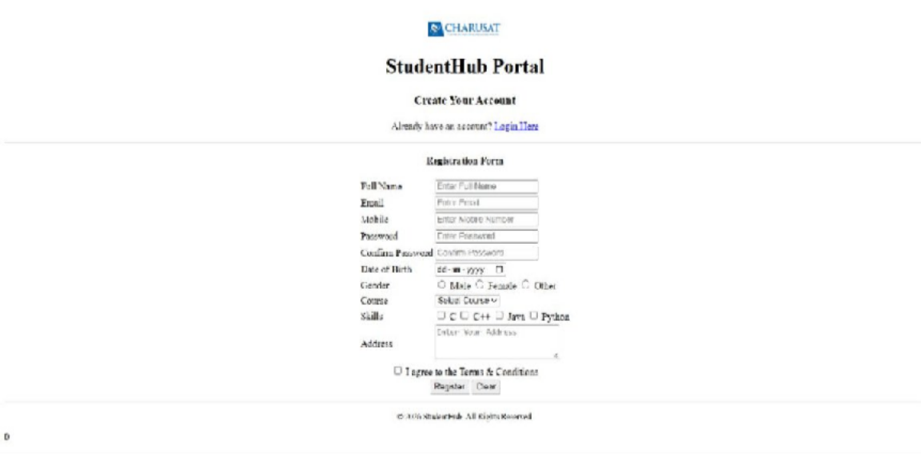
Figure 2.3(Register Page)
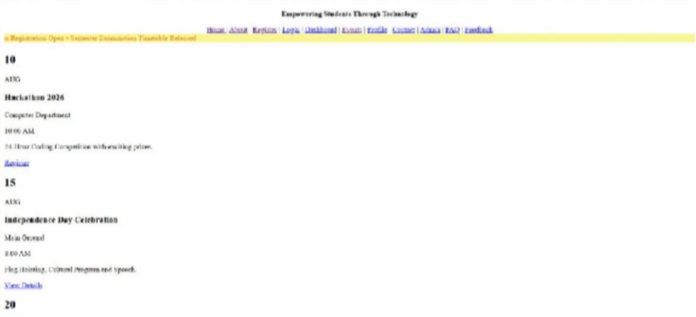
Figure 2.4(Event Page)

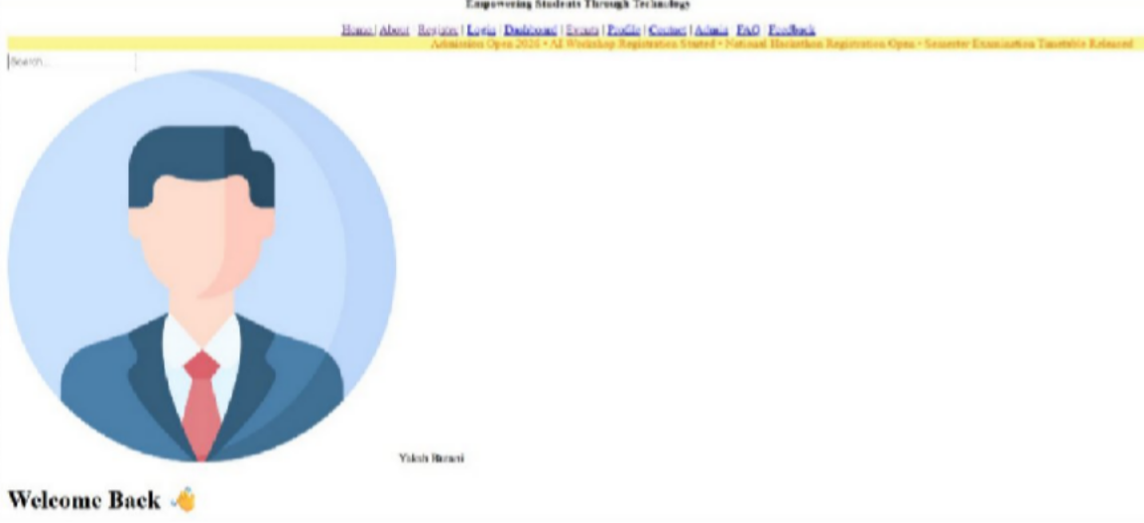
Figure 2.5
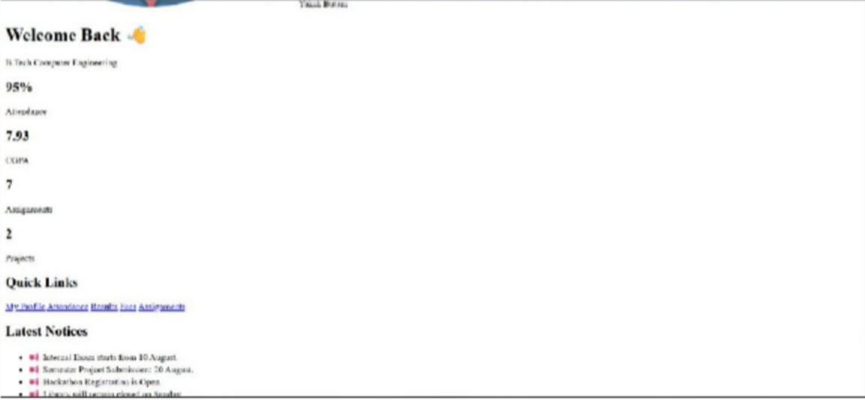
Figure 2.6
Figure 2.5 And Figure 2.6 (Dashboard Page)

GitHub Repository Link:
https://github.com/yakshu205/StudentHub.git

Challenges Faced:
- I have a design in my mind that how I make my header but I was stuck when scrolling text problem comes , I saw charusat portal where at footer part one text link is scrolling

automatically , I don’t know what concept I can use , then I go to MDN Website and find that the tag named “<marquee>” is reason for scrolling text.
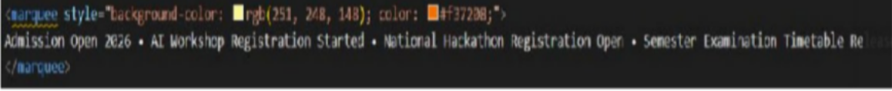

- Then , I was stuck , when I making webpage of Dashboard , for Dashboard I want default user profile picture photo in round shape for an example if we do not keep profile picture in social media profile , then it keeps default white-grey default picure .
So , for that picture I search in google and it gives me pic link also for some emoji there is some class keyword in html (i.e. : <i class="fa fa-shopping-cart"></i> and graduation cap etc.. )
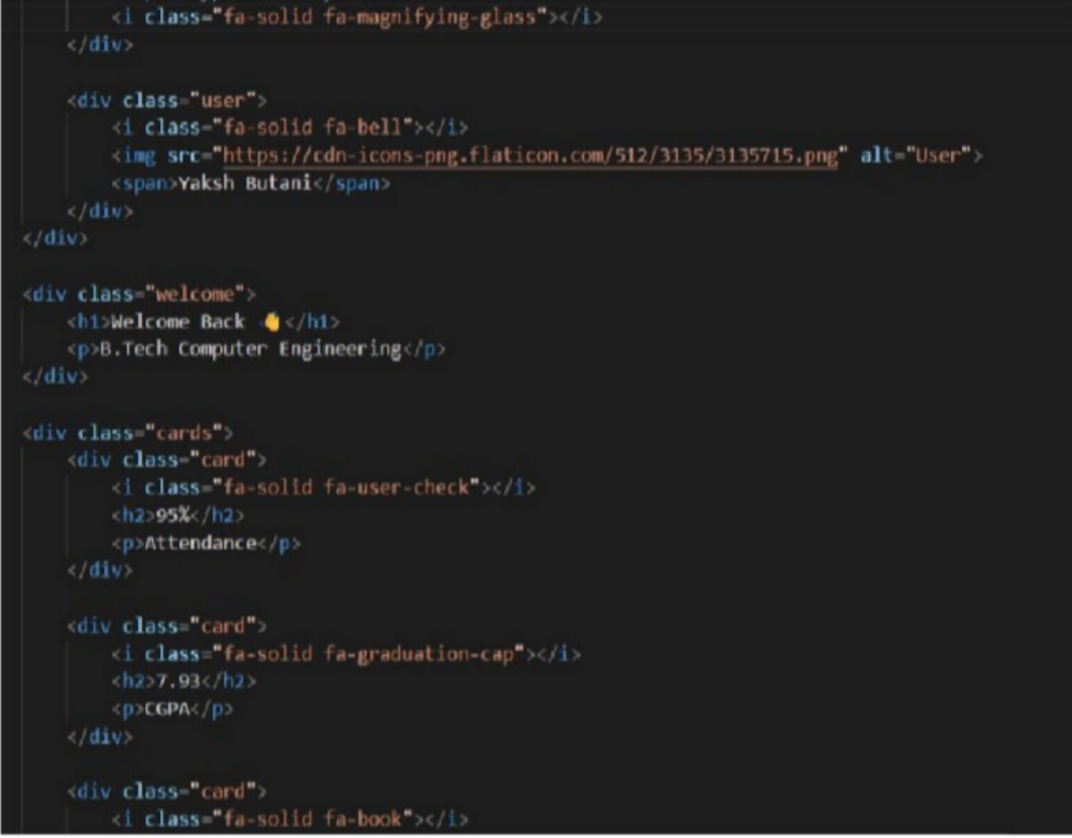

Learning Outcomes:
I will create clean, linked, and accessibility-ready HTML page structures.

Faculty Remarks: (Keep this blank for faculty)

Practical - 4

Practical Title: JavaScript DOM Manipulation, Event Handling, and UI Interactivity
Problem Definition: Add dynamic UI components such as collapsible FAQ, modal popup, image/content slider, notification banner, hamburger menu, and light/dark theme switcher using JavaScript.

Theory :

How are DOM elements selected and modified?

DOM manipulation means selecting an HTML element using JavaScript and then changing its text, HTML, style, attributes, classes, or values.

Are event listeners attached correctly?

Yes, event listeners are correctly attached using addEventListener(). It connects an HTML element with an event such as click or submit and executes a function when that event occurs.

Is localStorage used for remembering theme choice?

Yes. localStorage can be used to remember the user's theme choice. setItem() stores the selected theme, and getItem() retrieves it when the page is reopened, allowing the website to maintain the Dark/Light mode preference.

Does interactivity improve usability without breaking accessibility?

Yes. Interactivity improves usability when features such as buttons, notifications, menus, and forms make the website easier to use. Accessibility should be maintained by using proper HTML elements, keyboard support, readable text, clear messages, and sufficient contrast so all users can interact with the website.

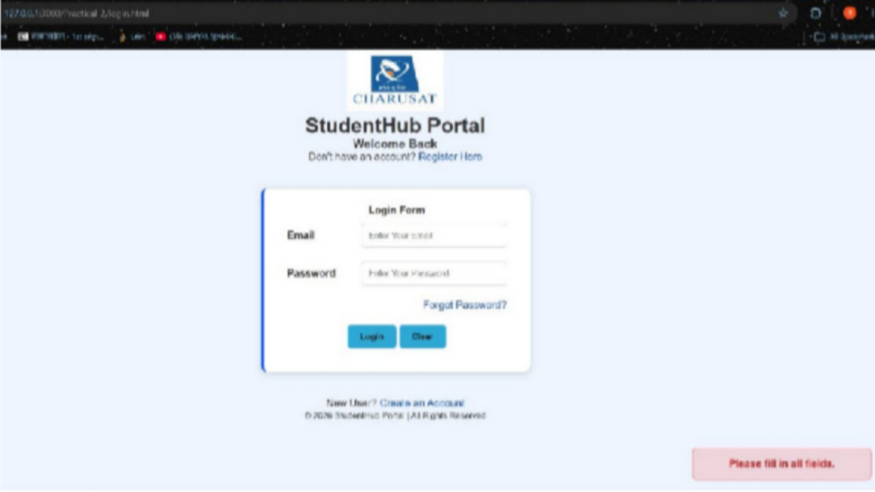
Implementation/ Output/Result

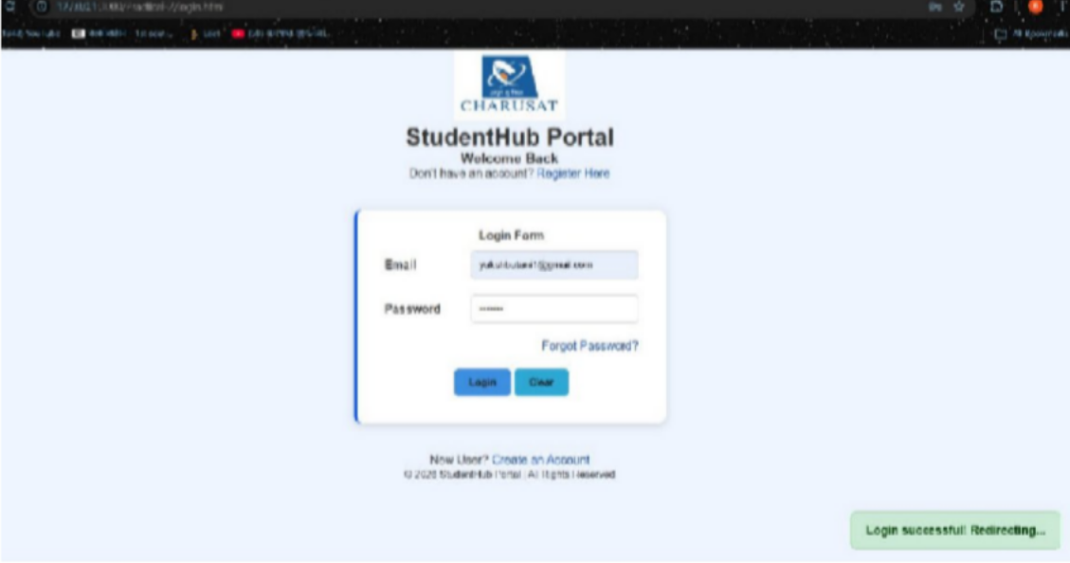

GitHub Repository Link:
https://github.com/yakshu205/StudentHub.git

Learning Outcomes:

Use JavaScript DOM manipulation
  - Handle user events like clicks and form submissions
  - Create interactive UI components
  - Implement dark/light theme switching
  - Use localStorage to remember user preferences
  - Improve the website's usability and interactivity.

Faculty Remarks: (Keep this blank for faculty)

Practical - 5

Practical Title: Registration Form with Frontend Validation and User-Friendly Error Handling
Problem Definition: Create a student registration form with HTML5 input types and JavaScript validation for name, email, mobile number, password, confirm password, course, year, gender, and terms acceptance. Use Regular Expression for validations.

Theory :

Are correct input types and attributes used?

Yes, correct input types and attributes are used. Text is used for names, email for email addresses, password for passwords, and the required attribute ensures that mandatory fields cannot be left empty.

Are validation errors displayed near the relevant fields?

No. Validation errors are currently displayed through alert messages rather than near the relevant input fields.

Is password strength checked?

Yes, password strength is checked using JavaScript validation with minimum length and character requirements.

Is the form accessible using keyboard and screen-reader-friendly labels?

Partially. Keyboard access is supported, but labels should be linked to their corresponding input fields using the for attribute for better screen-reader accessibility.

Validation:
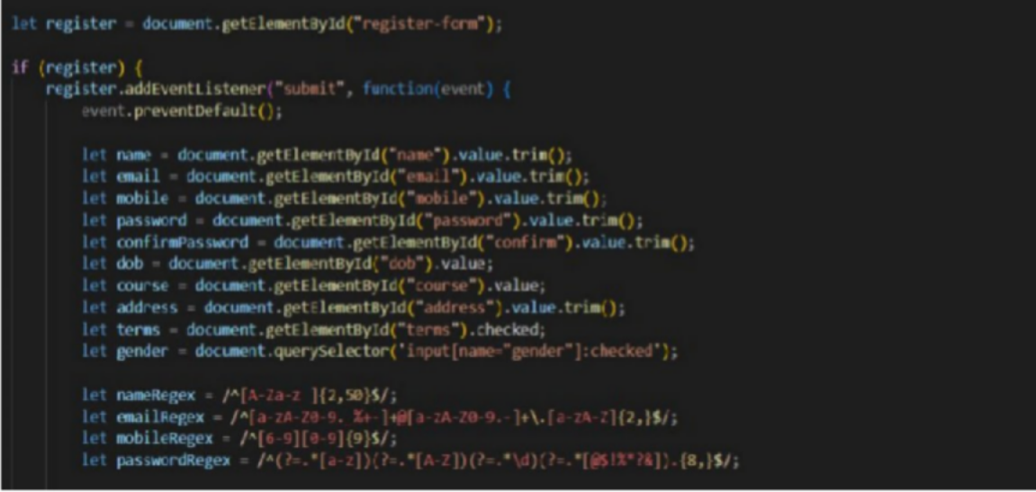

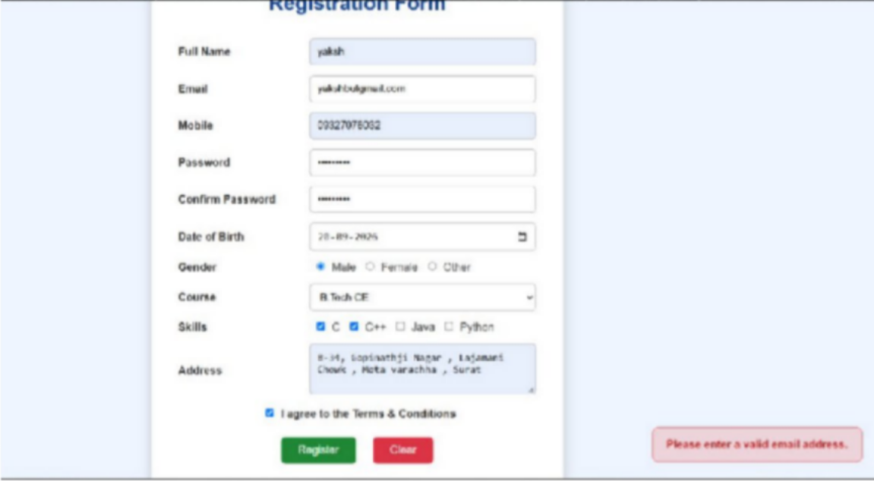
Implementation/ Output/Result

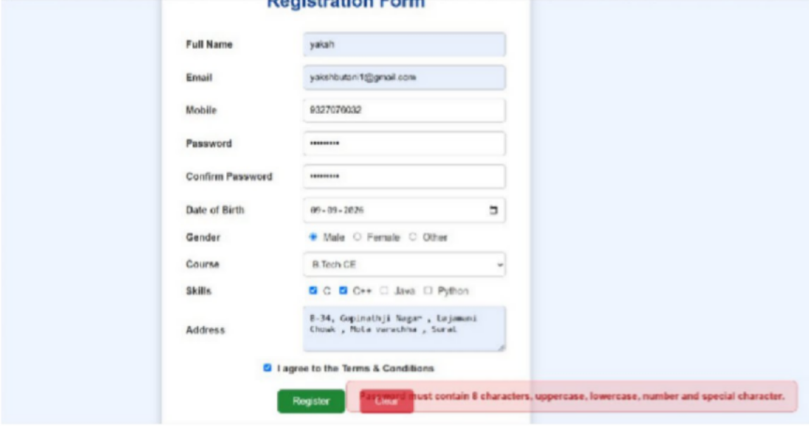
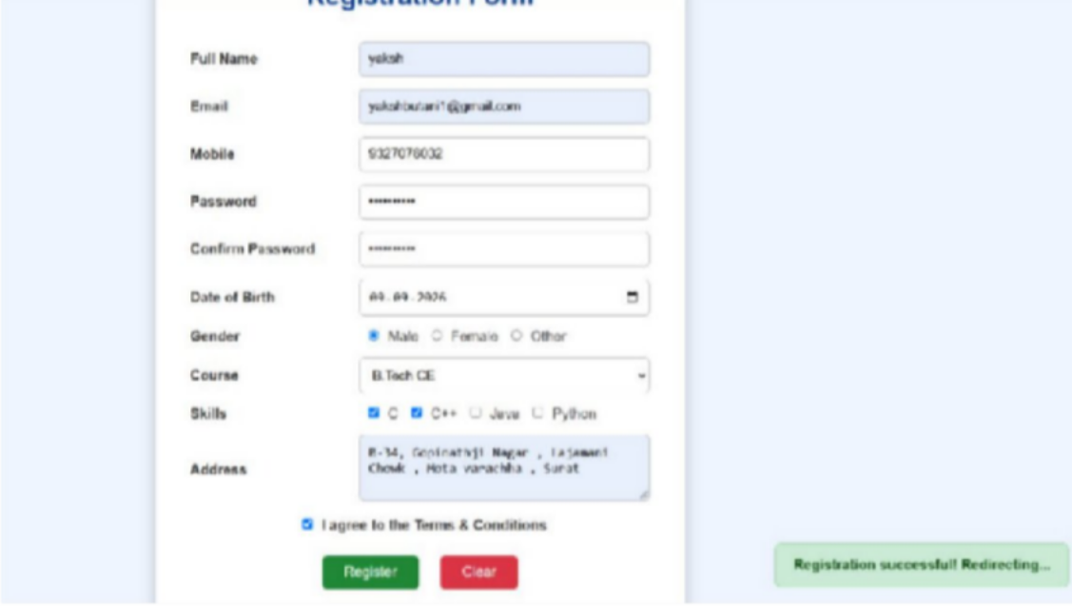

GitHub Repository Link:
https://github.com/yakshu205/StudentHub.git

Learning Outcomes:
- Understand HTML form creation and different input types.
- Implement client-side form validation using JavaScript.
- Use Regular Expressions for validating user inputs.
- Implement password strength and confirmation checks.
- Handle validation errors and provide user-friendly messages.
- Understand basic form accessibility for keyboard and screen-reader users.
Faculty Remarks: (Keep this blank for faculty)

Practical - 6

Practical Title: Rendering External JSON Data using Fetch API, Search and Filter
Problem Definition: Display event lists, student profiles, notices, or FAQs from external JSON files using Fetch API. Implement dynamic rendering, search, filter, sorting, and pagination.

Theory :

How is JSON fetched, parsed, and rendered?

JSON is fetched using the Fetch API, parsed using response.json(), and then rendered dynamically on the webpage using JavaScript DOM methods such as textContent or innerHTML.

Which array methods are used for search, filter, sort, and pagination?

filter() is used for search and filtering, sort() for sorting, and slice() for pagination.

How are loading and error states handled?

Loading is handled using the Fetch API, while errors are handled using the .catch() method and displayed in the browser console.

How is modularity maintained in JavaScript files?

Modularity is maintained by using an external JavaScript file and separating different functionalities into independent code sections or functions.

Data:
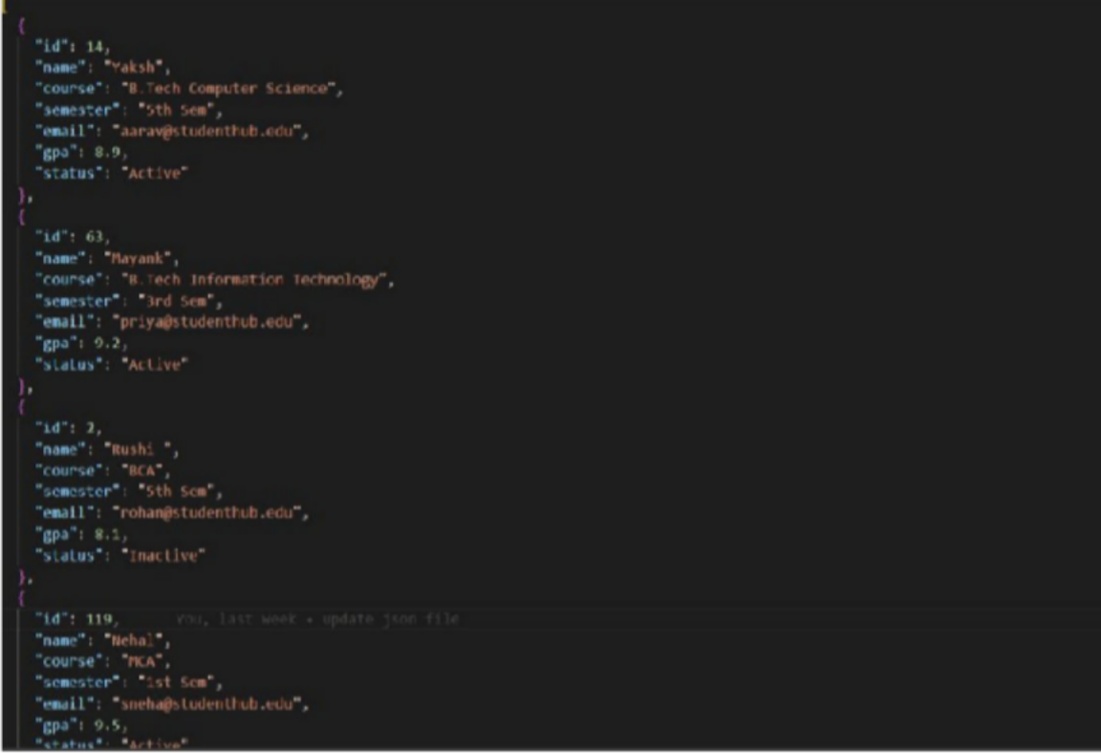

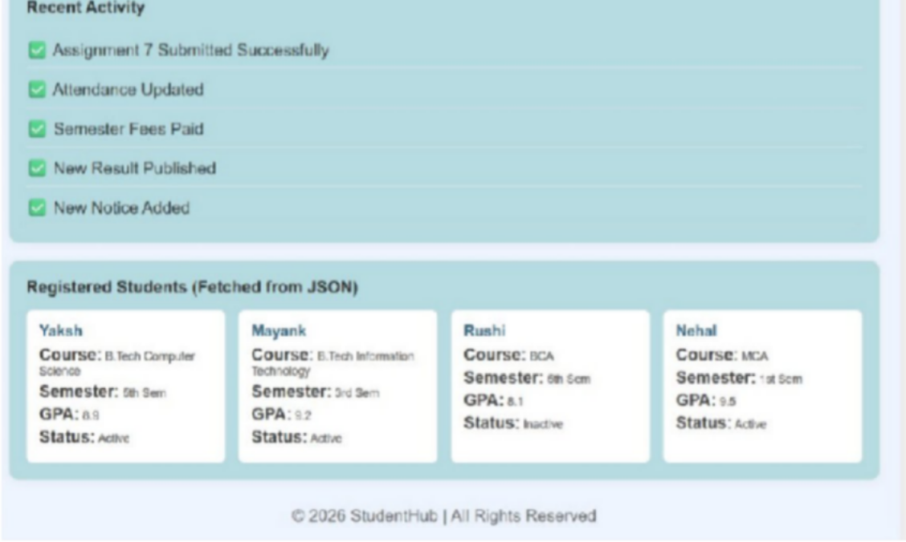
Implementation/ Output/Result

GitHub Repository Link:
https://github.com/yakshu205/StudentHub.git

Learning Outcomes:
- Understand how to fetch and parse external JSON data using the Fetch API.
- Dynamically render JSON data on web pages using JavaScript.
- Implement search, filtering, sorting, and pagination using JavaScript array methods.
- Handle loading and error states while fetching data.
- Develop modular and reusable JavaScript code for dynamic web applications.
Faculty Remarks: (Keep this blank for faculty)

Practical - 7

Practical Title: PHP Form Processing with Server-Side Validation and CSV/JSON File StorageProblem Definition: Display event lists, student profiles, notices, or FAQs from external JSON files using Fetch API. Implement dynamic rendering, search, filter, sorting, and pagination.

Theory :
- Is the form submitted using POST?
Ans:Yes, the form uses the POST method to submit data securely.

- Are inputs validated and sanitized server side?
Ans: Yes, inputs are validated and sanitized on the server side.

- Is file writing handled safely?
Ans: Yes, file writing is performed safely with proper handling.

- Are success and error responses displayed clearly?

Ans:Yes, clear success and error messages are displayed to the user.

Data:

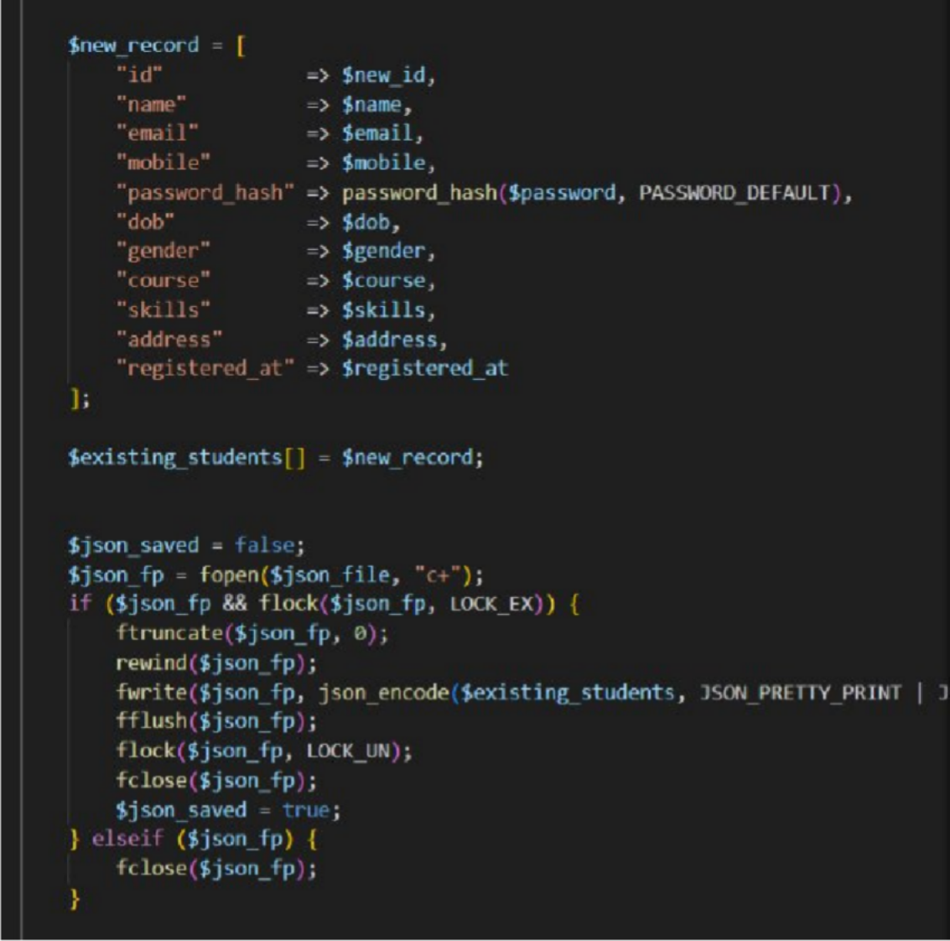

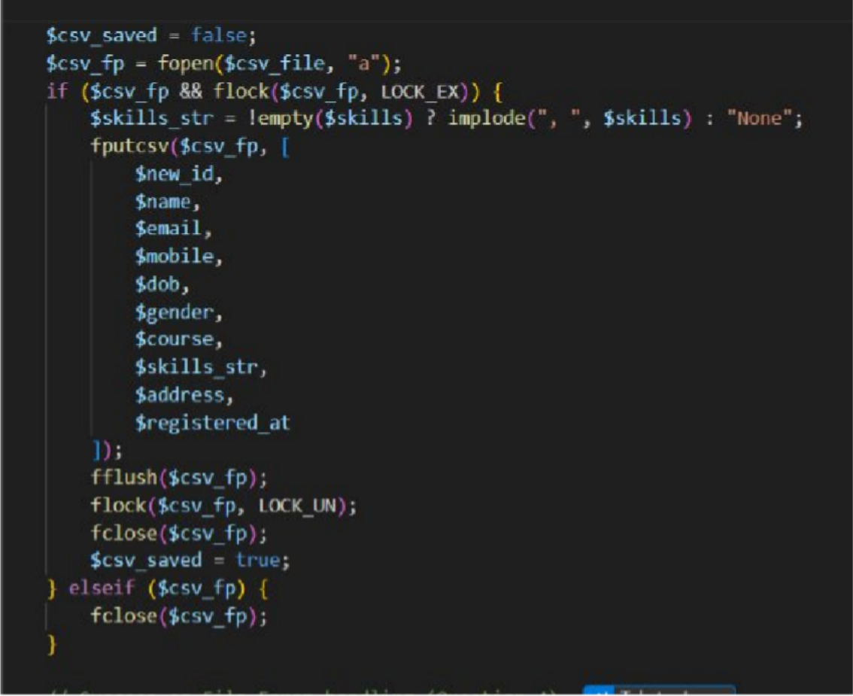

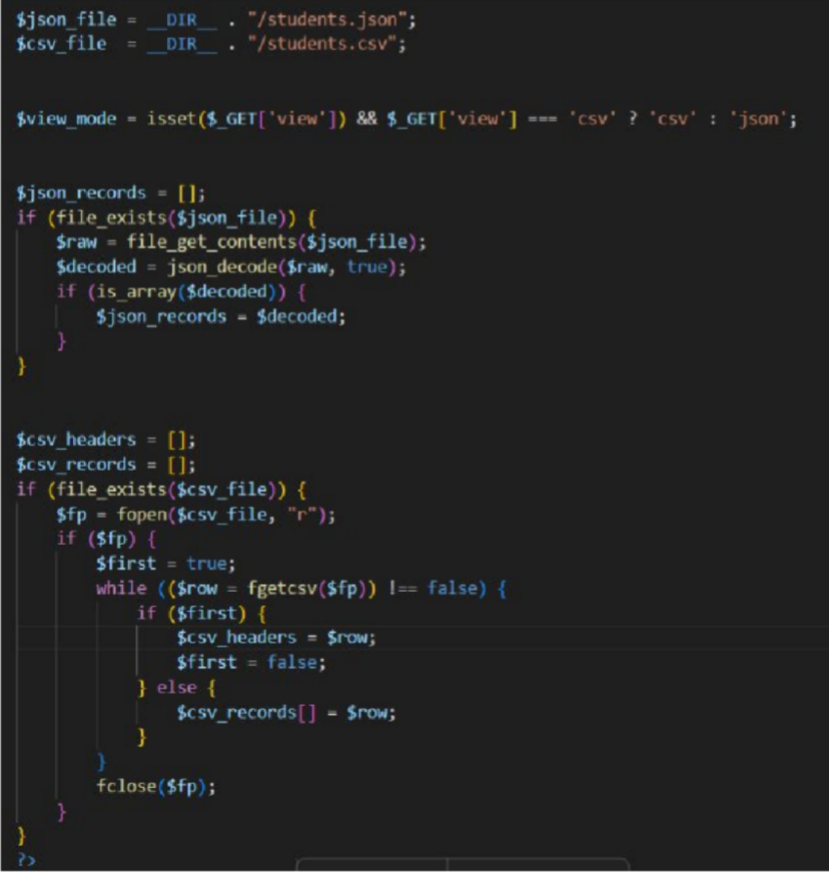

Implementation/ Output/Result

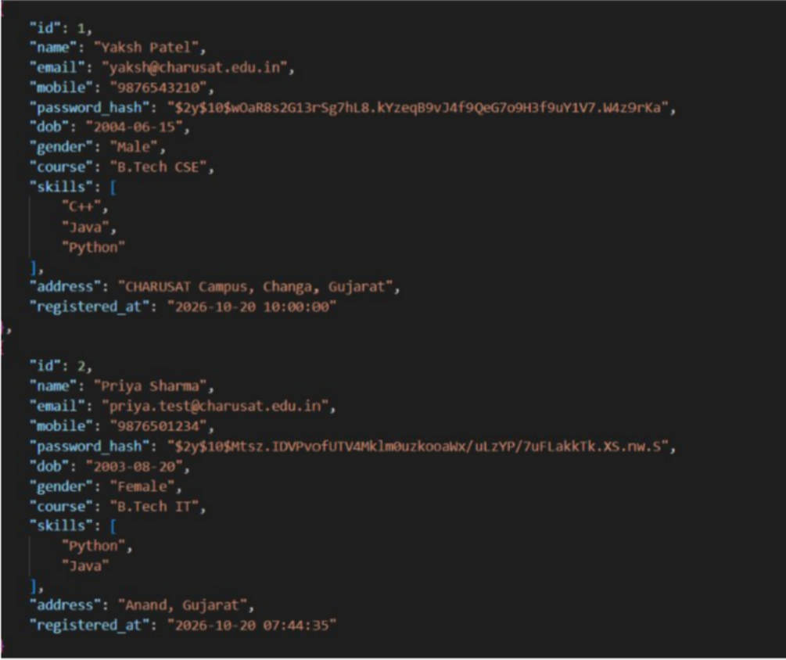
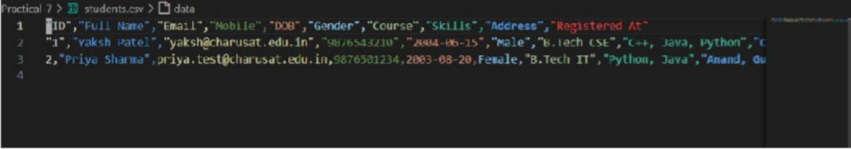

GitHub Repository Link:
https://github.com/yakshu205/StudentHub/tree/main/Practical-7
Learning Outcomes:

->Students will understand how to process form data using PHP POST requests.

->Students will implement server-side validation and input sanitization.

->Students will learn safe file handling and storage using CSV/JSON formats.

->Students will display clear success and error messages based on processing results.

->Students will develop a secure and reliable backend form-processing system.

Faculty Remarks: (Keep this blank for faculty)

Practical - 8
Practical Title: MySQL Schema Design, ER Model, PDO Connectivity, and Prepared Statements
Problem Definition: Design the database for StudentHub with students, events and registrations. Create PHP database connection using MySQL statements.

Theory :
- Is the schema normalized properly?
Yes, the schema is normalized up to the Third Normal Form (3NF). Student details, event details and registration details are stored in separate tables (students, events and registrations), so there is no repeated data. The registrations table connects students and events (many-to-many relationship), and every non-key column depends only on the primary key of its table.

Are primary keys and foreign keys correctly defined?
Yes. Each table has an AUTO_INCREMENT primary key (student_id, event_id and registration_id). The registrations table has student_id and event_id as foreign keys that refer to the students and events tables. A UNIQUE constraint on (student_id, event_id) stops the same student from registering twice for the same event.

Is the database connection handled securely?
Yes. The connection is written once in db.php using PHP PDO inside a try-catch block with exception error mode. Prepared statements are used so that SQL injection is avoided, and a simple error message is shown to the user instead of the real database error details.

Implementation/ Output/Result

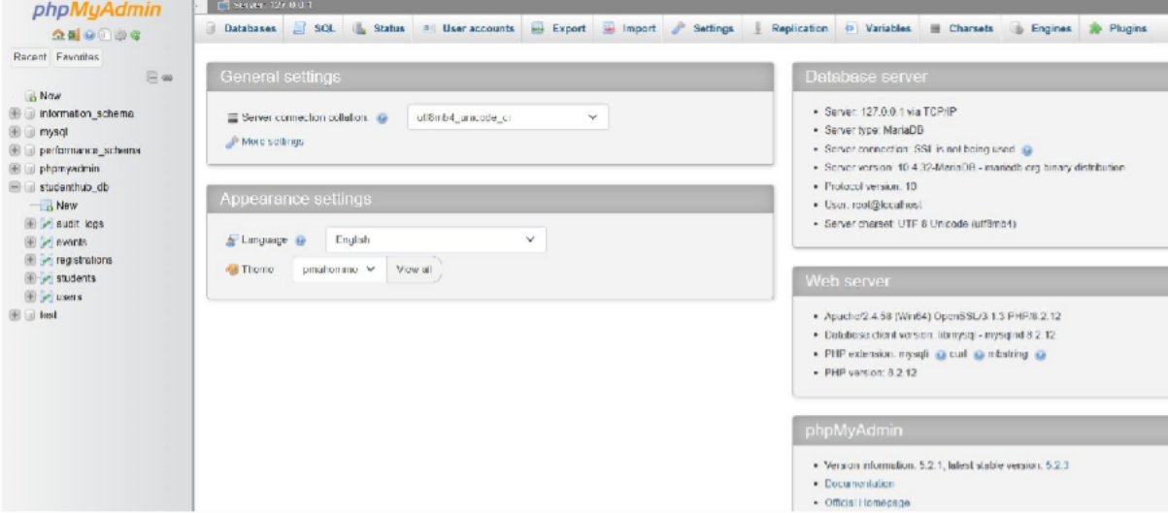

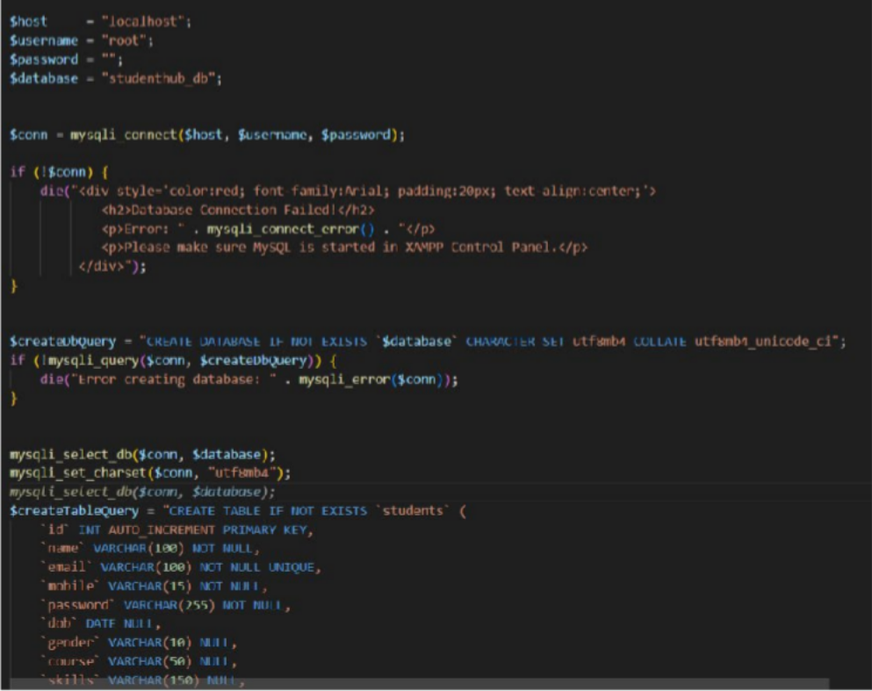

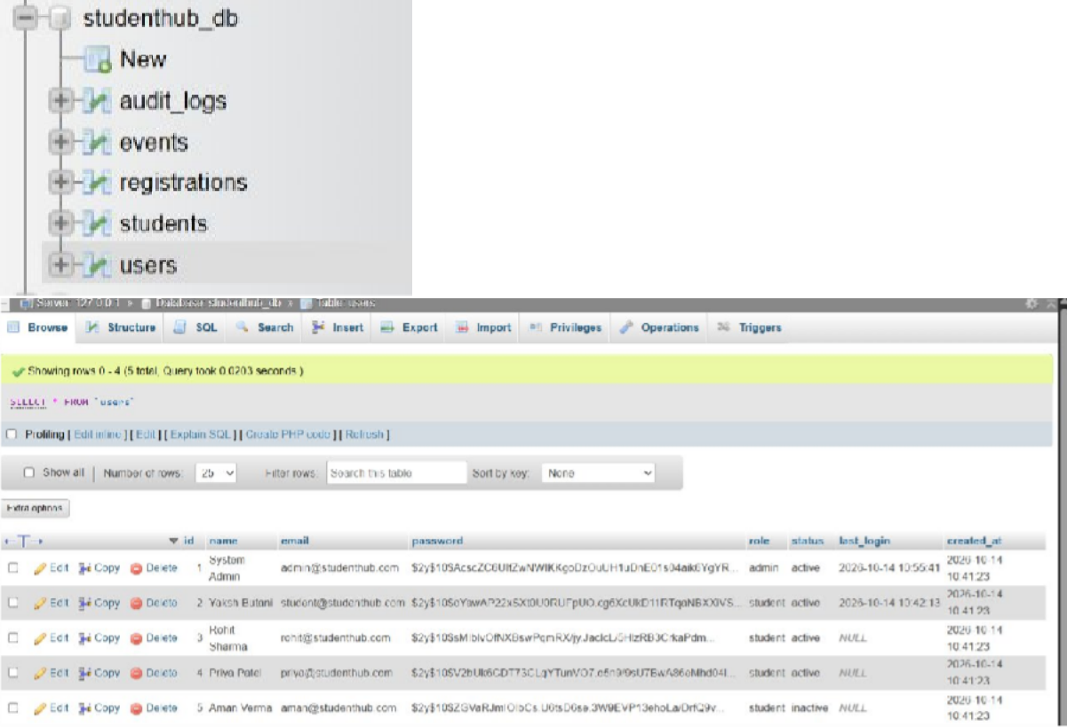

GitHub Repository Link:
https://github.com/yakshu205/StudentHub/tree/main/Practical-8

Learning Outcomes:
  - Understand how to design a normalized database using ER modeling.
  - Create tables with primary keys, foreign keys and constraints in MySQL.
  - Connect PHP with MySQL securely using PDO and prepared statements.
  - Handle database connection errors properly using try-catch.

Faculty Remarks: (Keep this blank for faculty)

Practical - 9
Practical Title: Secure User Registration with Database Insert, Duplicate Email Check, and Password Hashing
Problem Definition: Implement secure user registration by inserting user details into MySQL using MySQLi. Validate input on frontend and backend, check duplicate email/username, hash passwords using password_hash(), and display appropriate messages.

Theory :
- Is password_hash() used before storing passwords?
Yes. The password entered by the user is converted using password_hash() with PASSWORD_DEFAULT before it is inserted into the database. The original password is never stored, and PHP adds a random salt to the hash automatically.

Is duplicate email/username checked?
Yes. Before the INSERT query, a SELECT query checks whether the email or username already exists. If it exists, the message "Email or username already registered" is shown and no new record is inserted. A UNIQUE key on the email column in the table gives extra protection.

Are frontend and backend validations consistent?
Yes. The same rules are used on both sides: all fields are required, the email format must be valid, the password must be at least 8 characters, and the confirm password must match. The frontend (JavaScript) gives quick feedback, and the backend (PHP) validates again because frontend checks can be bypassed.

Implementation/ Output/Result
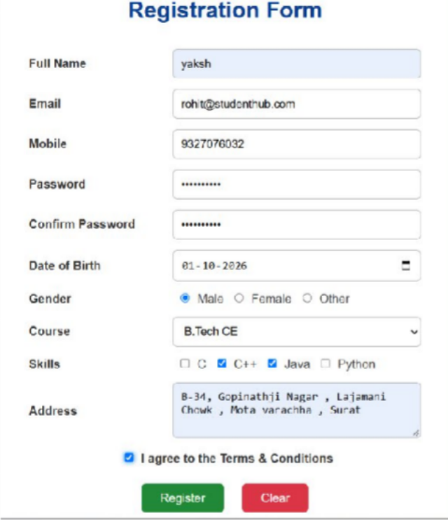
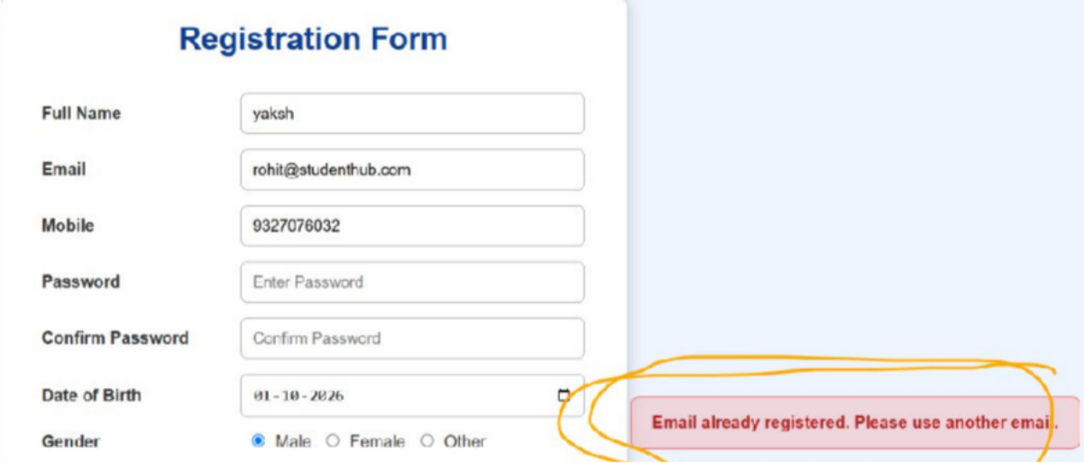
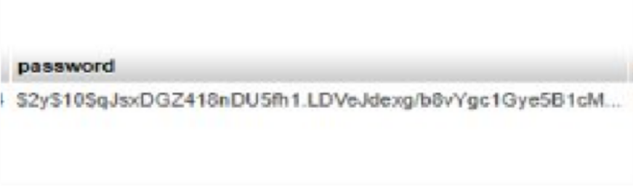

GitHub Repository Link:
https://github.com/yakshu205/StudentHub/tree/main/Practical-9%2C10%2C11%2C12

Learning Outcomes:
  - Understand how to insert user data into MySQL using MySQLi.
  - Hash passwords securely using password_hash().
  - Implement duplicate email/username checking before insert.
  - Apply consistent frontend and backend validation.
  - Display clear success and error messages to the user.

Faculty Remarks: (Keep this blank for faculty)

Practical - 10
Practical Title: Secure Login/Logout with Sessions, Role-Based Access, Timeout, and Remember-Me Token
Problem Definition: Develop secure login and logout functionality using PHP sessions. Verify password using password_verify(), regenerate session ID after login, restrict dashboard access, implement role-based redirection, session timeout, and optional secure remember-me token.

Theory :
- Are sessions started and destroyed securely?
Yes. session_start() is called at the top of every protected page, and session_regenerate_id(true) is used after a successful login to prevent session fixation. On logout, session_unset() and session_destroy() are used, the session cookie is deleted, and the user is redirected to the login page.
- Is password_verify() used correctly?
Yes. The user is found by email using a prepared statement, and the entered password is compared with the stored hash using password_verify(). Passwords or hashes are never compared directly using ==, and a general message "Invalid email or password" is shown on failure.

Is unauthorized dashboard access blocked?
Yes. Every dashboard page checks whether $_SESSION['user_id'] is set. If the user is not logged in, the user is redirected to the login page and exit() stops the remaining code from running.

Is session timeout implemented?
Yes. The time of the last activity is saved in $_SESSION['last_activity']. On every request, if the difference between the current time and the last activity is more than the allowed time (for example 30 minutes), the session is destroyed and the user is redirected to the login page with a timeout message.

Are admin and student users redirected to appropriate dashboards?
Yes. The role of the user is stored in the session after login. Admin users are redirected to the admin dashboard and student users are redirected to the student dashboard. Admin pages also check that the role is admin, so a student cannot open them.

Implementation/ Output/Result
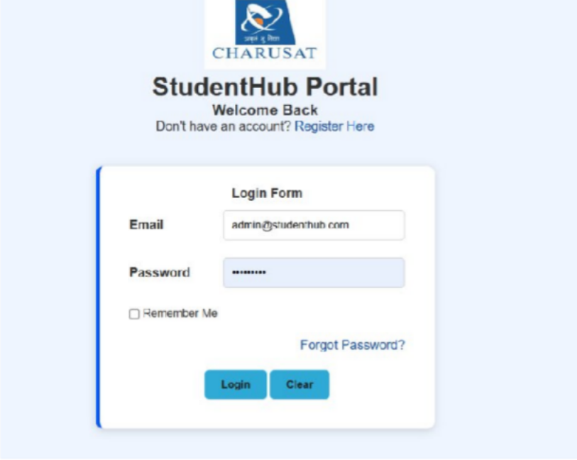
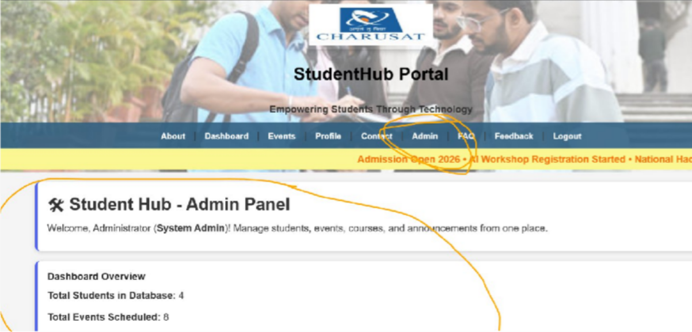

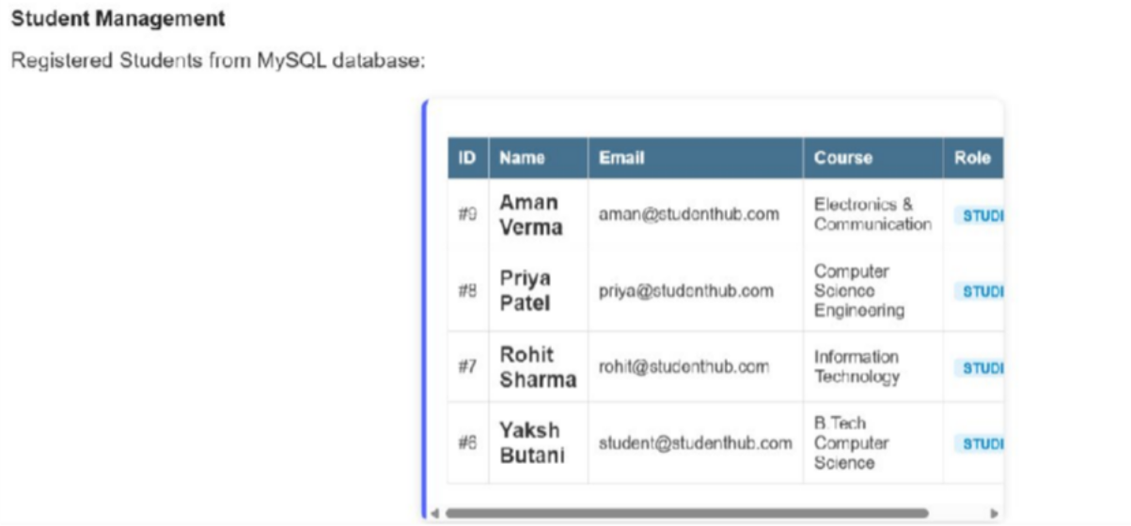
(Admin Role)

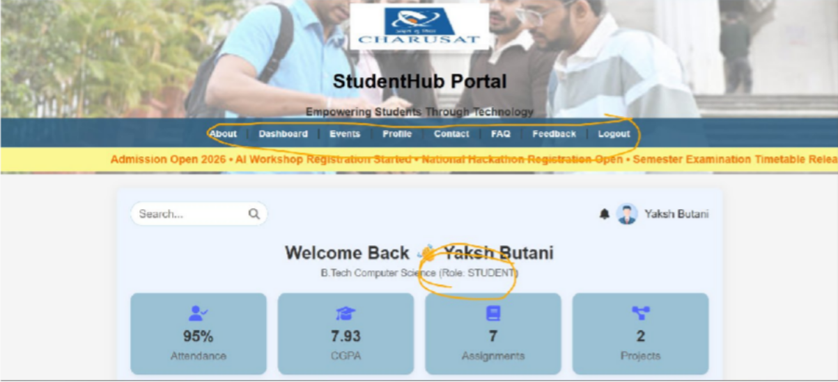
(Student Role - admin page is not here and student cannot see other student detail and cannot add and delete event )

GitHub Repository Link:
https://github.com/yakshu205/StudentHub/tree/main/Practical-9%2C10%2C11%2C12

Learning Outcomes:
- Understand how PHP sessions and cookies are used for authentication.
- Verify passwords securely using password_verify().
- Protect pages using session checks and role-based access control.
- Implement session timeout and secure logout.
- Redirect users to different dashboards based on their role.

Faculty Remarks: (Keep this blank for faculty)

Practical - 11
Practical Title: Student Management CRUD with Search and Filter
Problem Definition: Create a student management module to add, view, edit, delete, search and filter student records. All database operations must use MySQLi statements and clear success/failure messages.

Theory :
- Are SELECT, INSERT, UPDATE, and DELETE operations working?
Yes. INSERT adds a new student record, SELECT displays all event records in a table, UPDATE edits the selected student record using an edit form, and DELETE removes a student record. All operations use MySQLi prepared statements, and a success or failure message is shown after each operation.

Is search by name/email/course implemented?
Yes. A search box sends the keyword using the GET method, and the SELECT query uses LIKE to match the name.

Are delete operations confirmed before execution?
No,

Implementation/ Output/Result

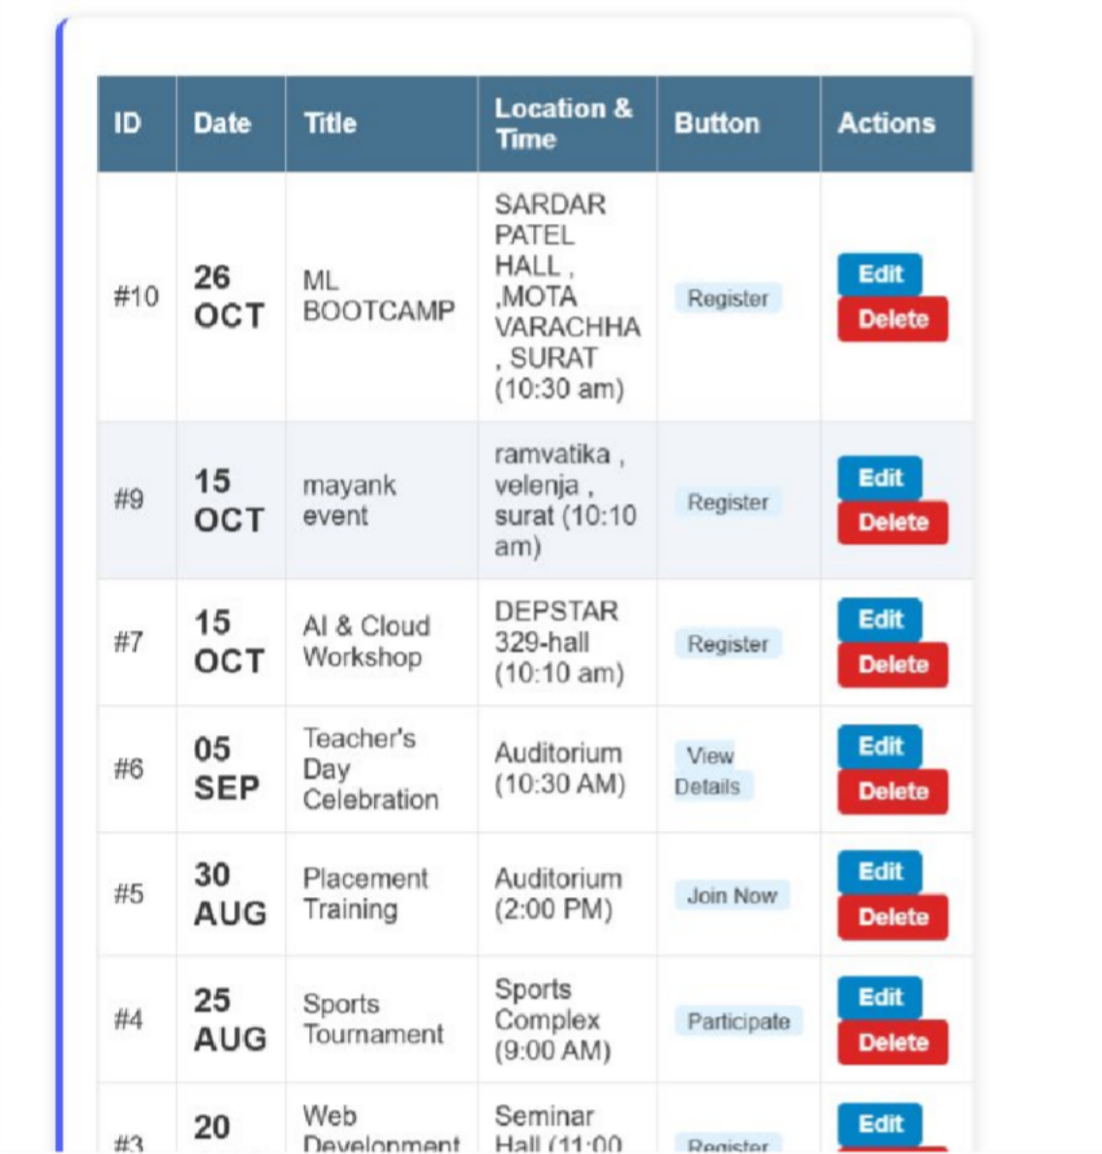

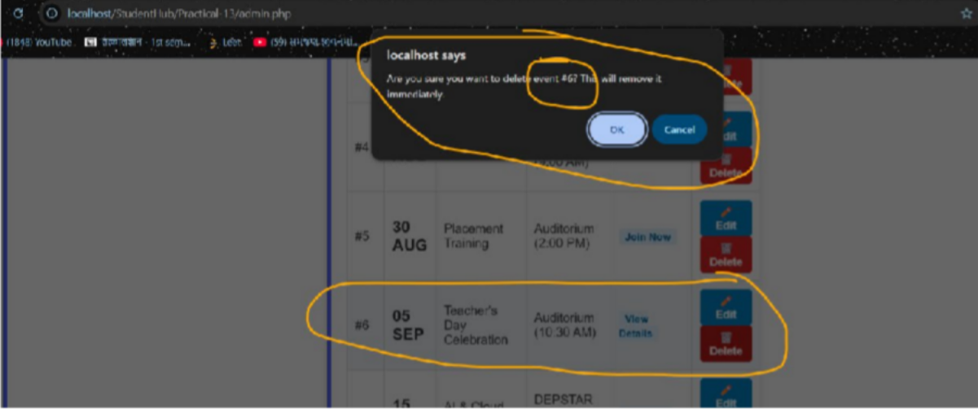

GitHub Repository Link:
https://github.com/yakshu205/StudentHub/tree/main/Practical-9%2C10%2C11%2C12

Learning Outcomes:
- Understand how to perform CRUD operations using PHP and MySQLi.
- Implement search and filter for database records.
- Show clear success and failure messages to the user.
- Develop a complete and secure data-management page.

Faculty Remarks: (Keep this blank for faculty)

Practical - 12
Practical Title: Event Management CRUD with Poster Upload and File Validation
Problem Definition: Develop event management functionality for admin users. Admin can add, view, update, delete, and upload event posters with file type and file size validation.

Theory :
- Are add, update, and delete functionalities implemented correctly?
Yes. The admin can add a new event using a form, update an existing event by editing its saved details, and delete an event after confirmation. All queries use prepared statements, and these pages are available to admin users only.

Is the UI linked with the database correctly?
Yes. Events are fetched from the events table and shown in a table with Edit and Delete buttons. After any add, update or delete operation, the page shows the latest data from the database. Bootstrap is used to keep the page clean.

Are poster uploads validated for type and size? NO
- Are success and failure messages displayed?
NO

Implementation/ Output/Result
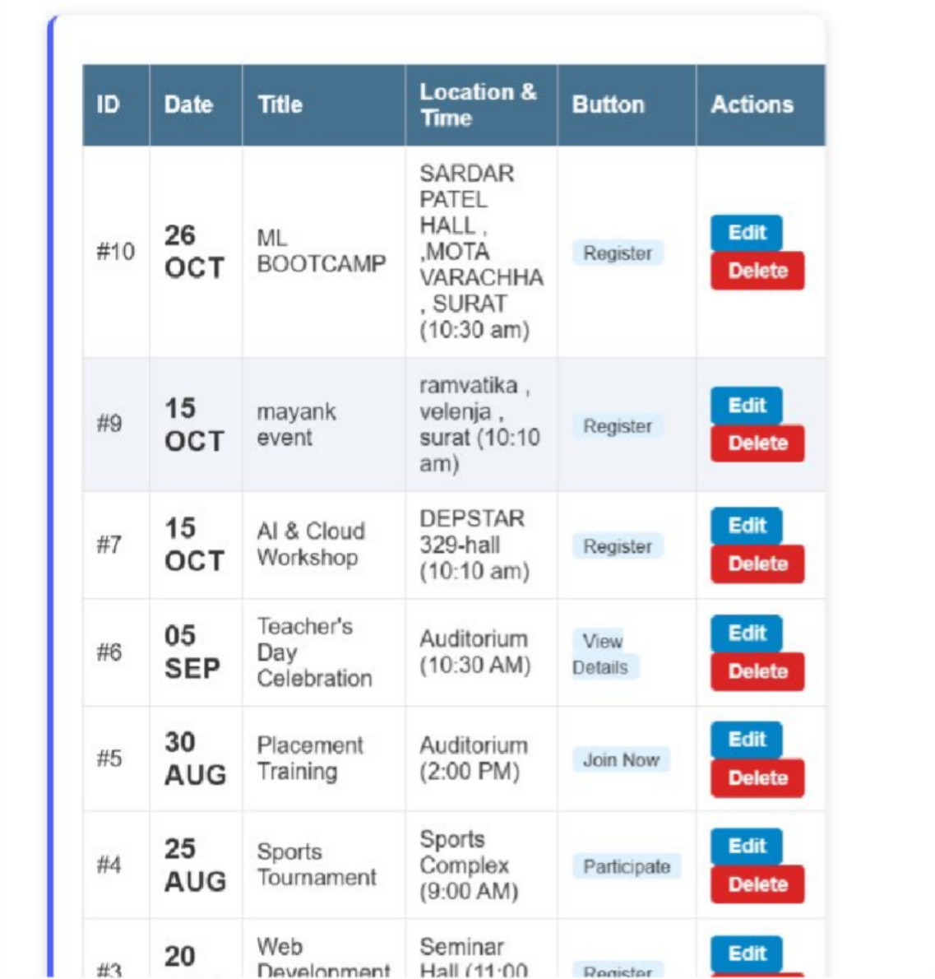
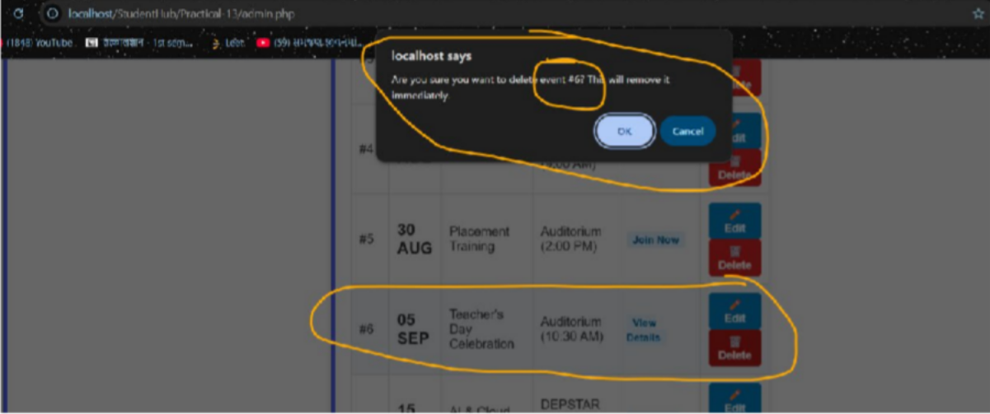

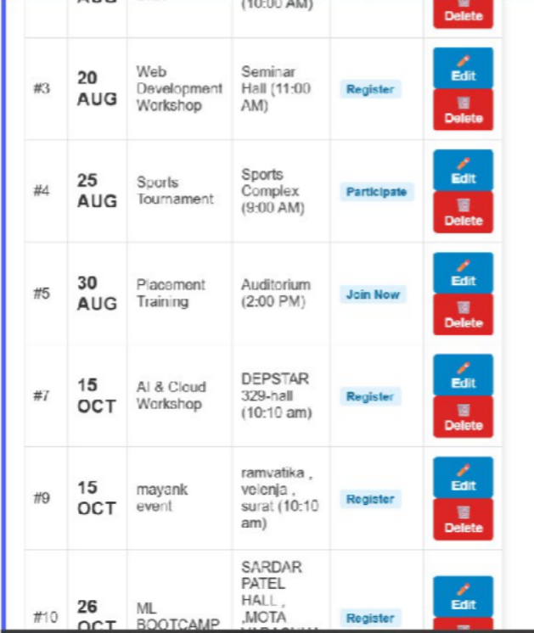
(#6 event deleted )
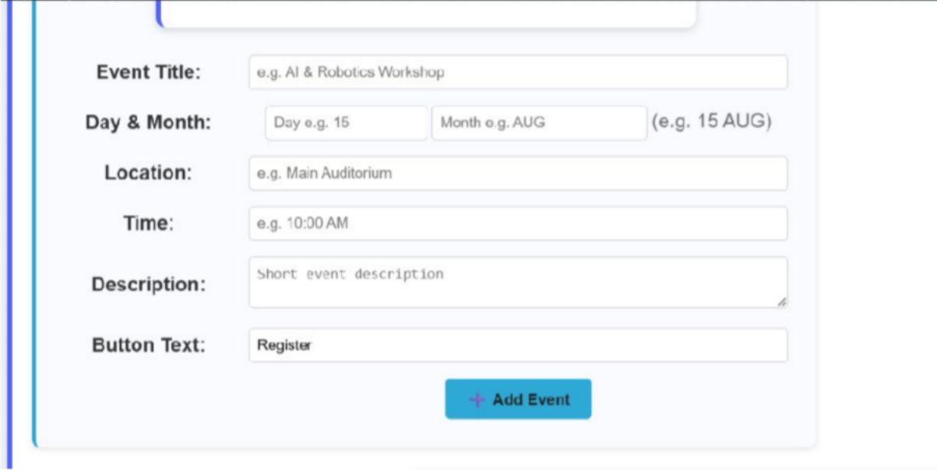

GitHub Repository Link:
https://github.com/yakshu205/StudentHub/tree/main/Practical-9%2C10%2C11%2C12

Learning Outcomes:
- Implement a secure CRUD module for event management.
- Upload files in PHP with file type and file size validation.
- Restrict event management pages to admin users only.
- Link the user interface with the database and show proper messages.

Faculty Remarks: (Keep this blank for faculty)

Practical - 13
Practical Title: PHP JSON API and AJAX/Fetch-Based CRUD without Page Reload
Problem Definition: Create simple PHP JSON API endpoints for events or students and consume them using Fetch API. Perform list, add, update, and delete operations asynchronously without full page reload.

Theory :
- Do PHP endpoints return valid JSON responses?
Yes. Each endpoint sets the header Content-Type: application/json and returns the response using json_encode(). The response contains a status, a message and the data. The output can be checked in the Network tab of the browser.

Are GET and POST requests handled properly?
Yes. GET requests are used to list records, and POST requests are used to add, update and delete records. The endpoint checks $_SERVER['REQUEST_METHOD'], and for an unsupported method it returns an error response in JSON.

Are loading, success, and error states shown on the frontend?
Yes. A "Loading..." message is shown while the fetch request is running. After the response, the data is rendered and a success message is shown. If the response is not OK or the request fails, the error is handled using .catch() and an error message is displayed on the page.

Is input validation performed before database operations?
Yes. The PHP endpoint checks required fields, valid email format and numeric id, and trims the input before using it. Prepared statements are used for the queries, and for invalid input a JSON error message is returned instead of running the query.

Implementation/ Output/Result
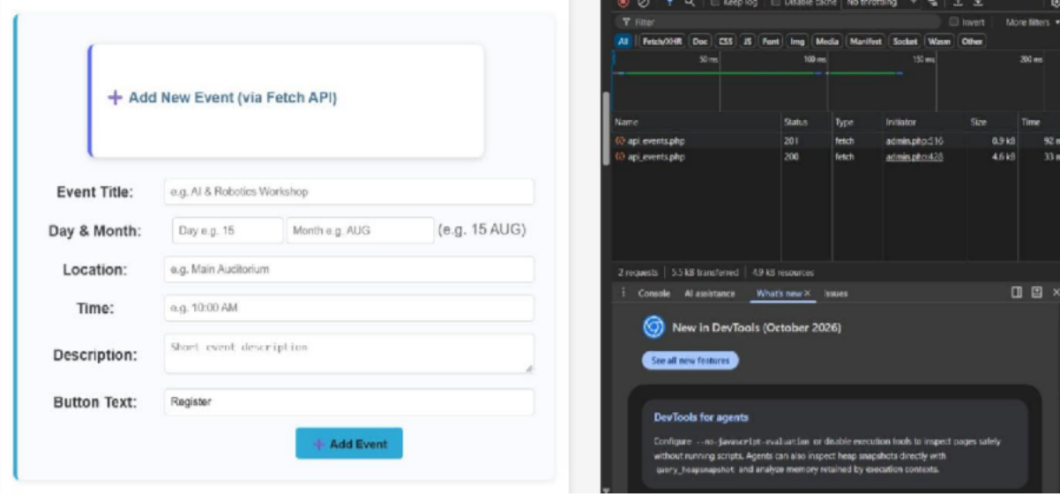

Event added without page reloading
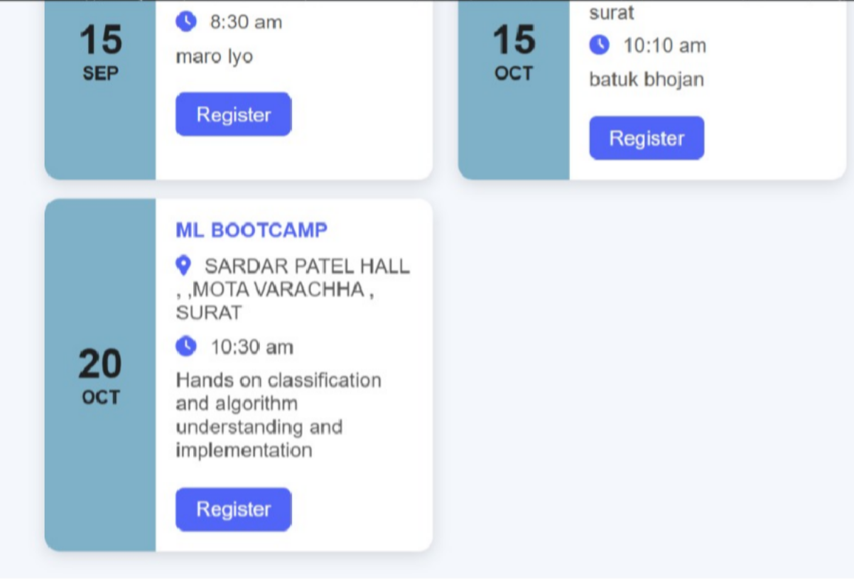

Added event named(ML BOOTCAMP)

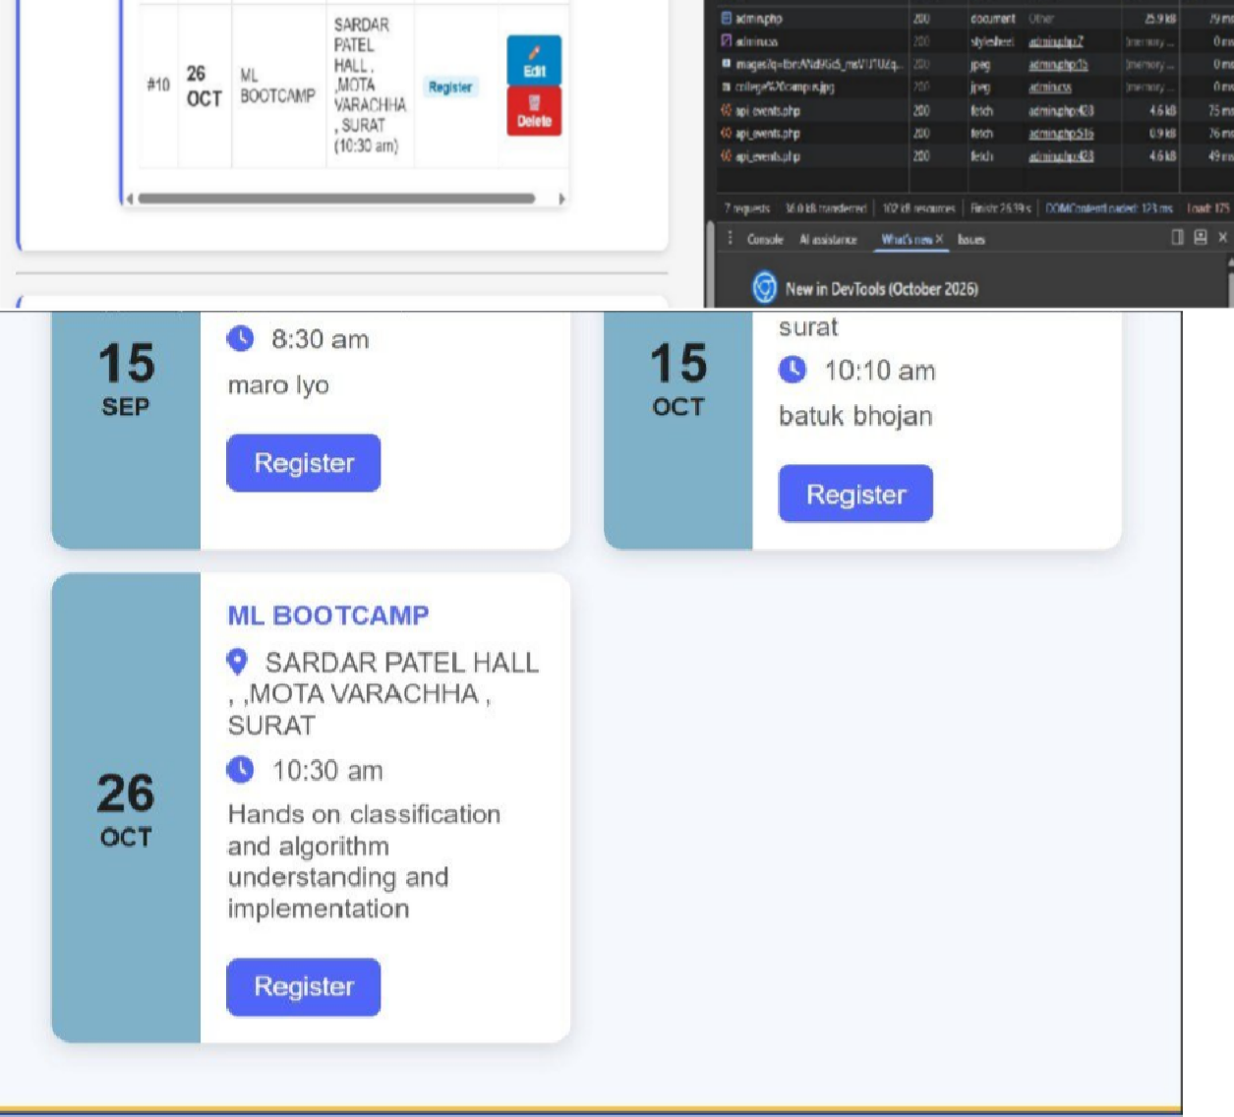

After editing date of ML BOOTCAMP event with 200 success status code
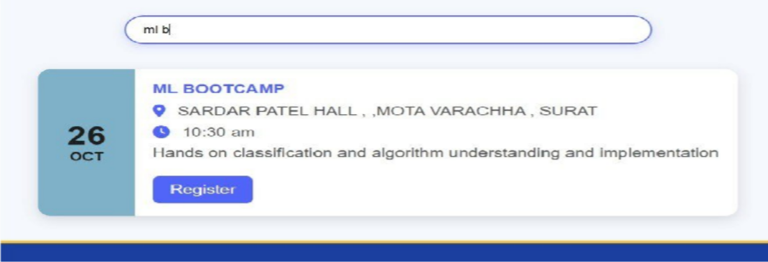
  - Search event in event page

GitHub Repository Link: https://github.com/yakshu205/StudentHub/tree/main/Practical-13
Learning Outcomes:
- Create PHP API endpoints that return JSON responses.
- Use the Fetch API to perform asynchronous CRUD operations.
- Handle GET and POST requests and validate input on the server.
- Show loading, success and error states on the frontend.
- Integrate frontend JavaScript with the PHP backend.

Faculty Remarks: (Keep this blank for faculty)

Practical - 14
Practical Title: Admin Dashboard with Role-Based Access Control, Dynamic Menu, and Audit Log
Problem Definition: Develop an admin dashboard that displays user statistics, student count, event count and latest registrations. Restrict access to admin users only and show dynamic menu options based on role.

Theory :
- Are dashboard values loaded dynamically from the database?
Yes. The user count, student count and event count are taken using SQL aggregation queries such as SELECT COUNT(*). The latest registrations are taken using a JOIN of the registrations, students and events tables with ORDER BY and LIMIT. No value is written manually in the code.

Is access restricted to admin users?
Yes. At the top of the dashboard page, the session is checked for a logged-in user and the role must be admin. If not, the user is redirected to the login page or shown an access denied message.

Are role-based menus working?
Yes. The menu is created in PHP according to the role saved in the session. Admin users see options such as Dashboard, Manage Students, Manage Events, Users and Audit Logs, while student users see only options such as Profile, Events and My Registrations.
- Are important admin actions recorded in audit_logs?
Yes. An audit_logs table stores the user id, action, details, IP address and date-time. A common function is called after important actions such as login, adding, editing or deleting students and events, and changing user status, so every action can be traced.

Implementation/ Output/Result
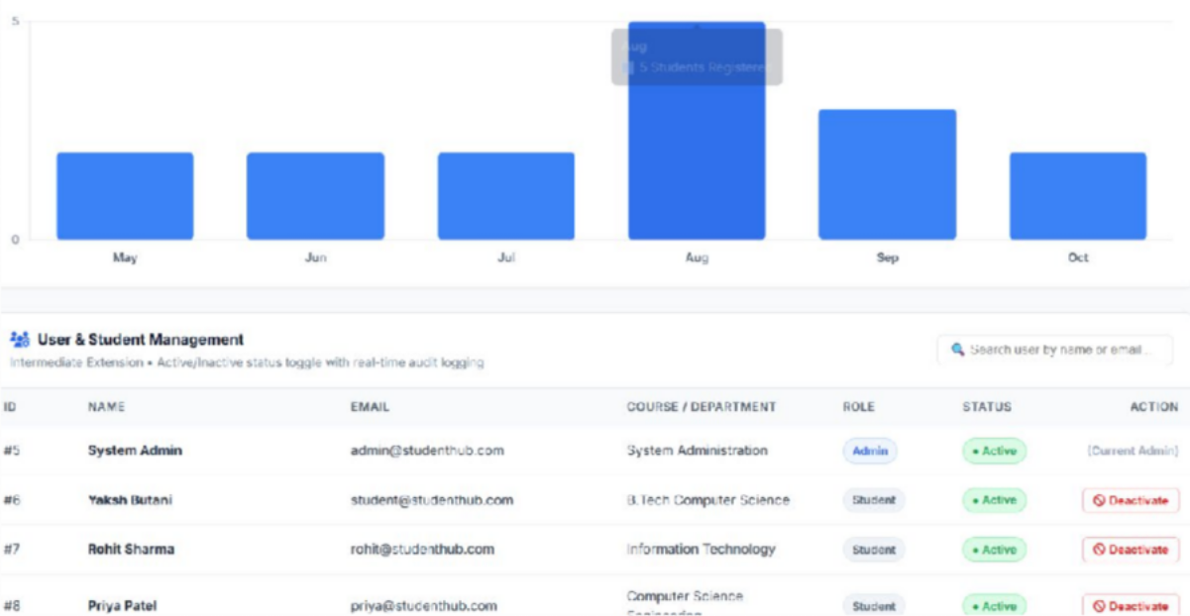

(Analysis)
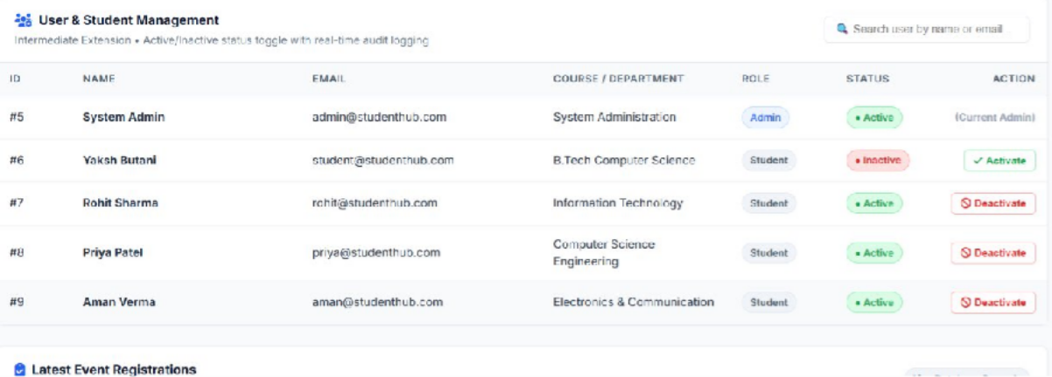

(After active to Deactive)

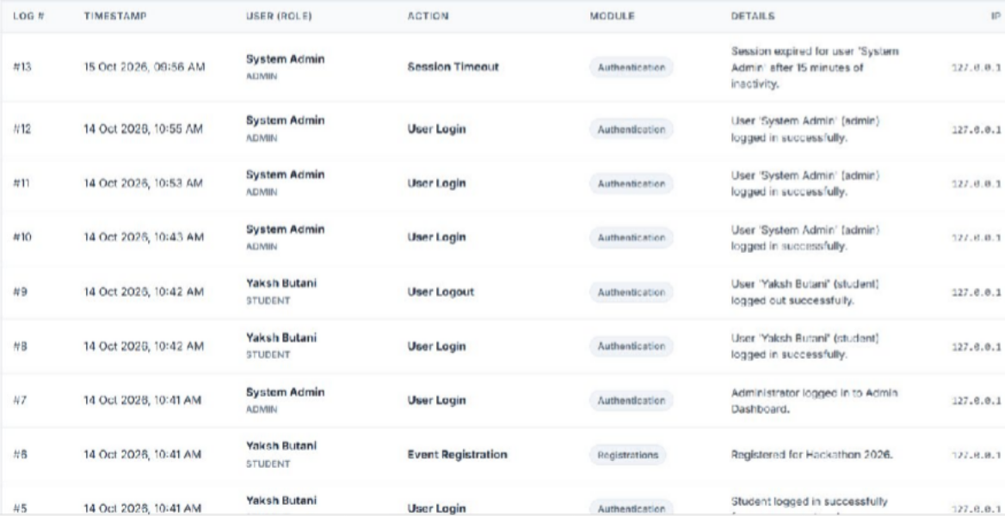

(Security Audit)
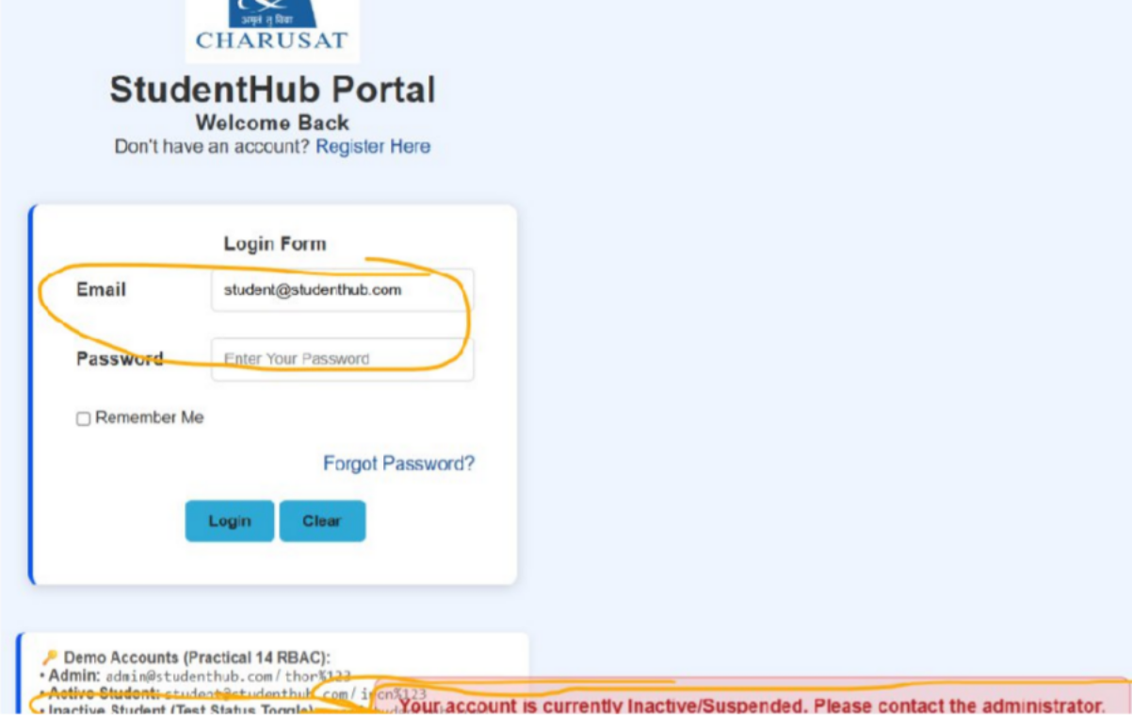

(Permission denied)
GitHub Repository Link:
https://github.com/yakshu205/StudentHub/tree/main/Practical-14

Learning Outcomes:
- Build an admin dashboard with data loaded dynamically from MySQL.
- Implement role-based access control (RBAC) for pages.
- Create dynamic menus based on the user role.
- Record important admin actions using audit logs for traceability.

Faculty Remarks: (Keep this blank for faculty)

Practical - 14
Practical Title: Admin Dashboard with Role-Based Access Control, Dynamic Menu, and Audit Log
Problem Definition: Develop an admin dashboard that displays user statistics, student count, event count and latest registrations. Restrict access to admin users only and show dynamic menu options based on role.

Theory :
- Are dashboard values loaded dynamically from the database?
Yes. The user count, student count and event count are taken using SQL aggregation queries such as SELECT COUNT(*). The latest registrations are taken using a JOIN of the registrations, students and events tables with ORDER BY and LIMIT. No value is written manually in the code.

Is access restricted to admin users?
Yes. At the top of the dashboard page, the session is checked for a logged-in user and the role must be admin. If not, the user is redirected to the login page or shown an access denied message.

Are role-based menus working?
Yes. The menu is created in PHP according to the role saved in the session. Admin users see options such as Dashboard, Manage Students, Manage Events, Users and Audit Logs, while student users see only options such as Profile, Events and My Registrations.
- Are important admin actions recorded in audit_logs?
Yes. An audit_logs table stores the user id, action, details, IP address and date-time. A common function is called after important actions such as login, adding, editing or deleting students and events, and changing user status, so every action can be traced.

Implementation/ Output/Result

(Analysis)

(After active to Deactive)

(Security Audit)

(Permission denied)
GitHub Repository Link:
https://github.com/yakshu205/StudentHub/tree/main/Practical-14

Learning Outcomes:
- Build an admin dashboard with data loaded dynamically from MySQL.
- Implement role-based access control (RBAC) for pages.
- Create dynamic menus based on the user role.
- Record important admin actions using audit logs for traceability.

Faculty Remarks: (Keep this blank for faculty)

