Practical - 12
Practical Title: Event Management CRUD with Poster Upload and File Validation
Problem Definition: Develop event management functionality for admin users. Admin can add, view, update, delete, and upload event posters with file type and file size validation.
Theory :
1. Are add, update, and delete functionalities implemented correctly?
Yes. The admin can add a new event using a form, update an existing event by editing its saved details, and delete an event after confirmation. All queries use prepared statements, and these pages are available to admin users only.
2. Is the UI linked with the database correctly?
Yes. Events are fetched from the events table and shown in a table with Edit and Delete buttons. After any add, update or delete operation, the page shows the latest data from the database. Bootstrap is used to keep the page clean.
3. Are poster uploads validated for type and size?
NO
4. Are success and failure messages displayed?
NO
Implementation/ Output/Result
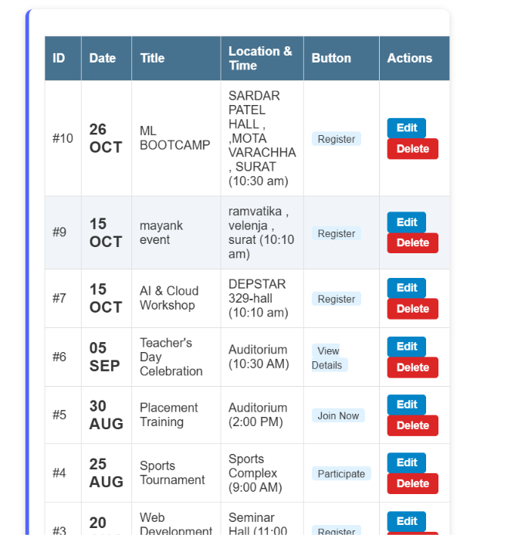
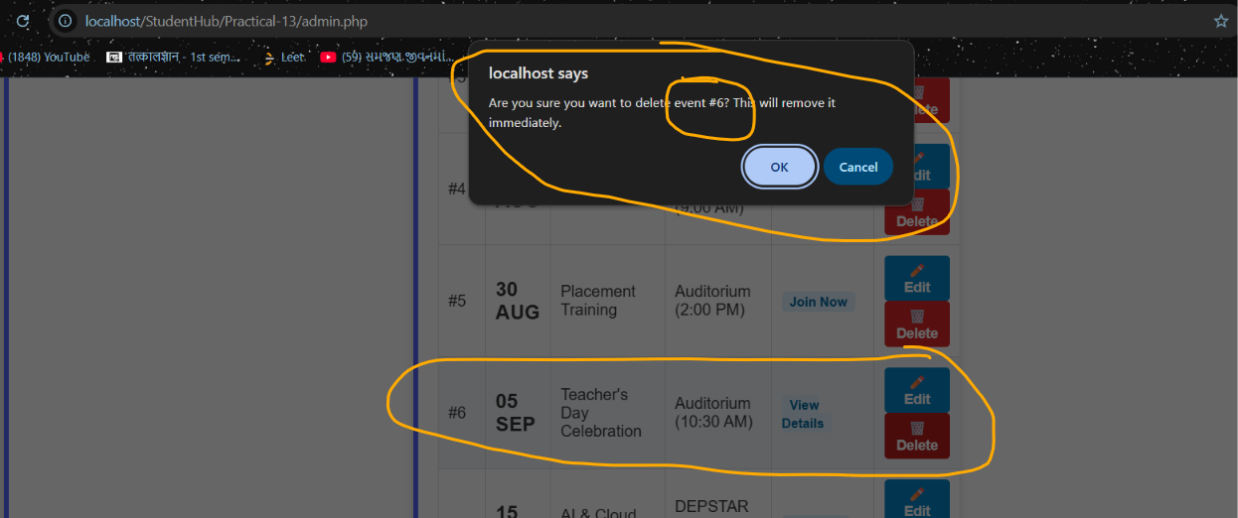
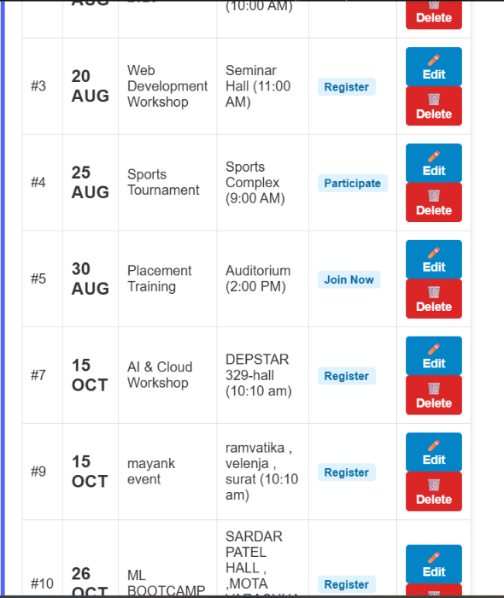
(#6 event deleted )
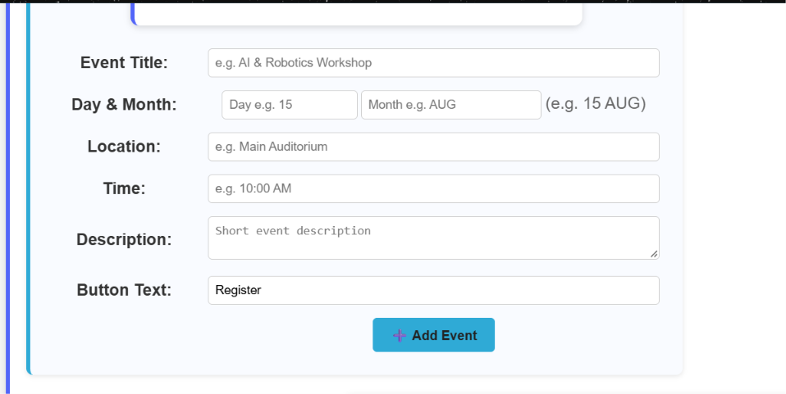
GitHub Repository Link:
https://github.com/yakshu205/StudentHub/tree/main/Practical-9%2C10%2C11%2C12
Learning Outcomes:
- Implement a secure CRUD module for event management.
- Upload files in PHP with file type and file size validation.
- Restrict event management pages to admin users only.
- Link the user interface with the database and show proper messages.
Faculty Remarks: (Keep this blank for faculty)

