Practical - 1

Practical Title: Project Initiation, Requirement Analysis, Sitemap, Wireframe, and GitHub Setup
Problem Definition: Initiate the semester-long StudentHub portal by identifying the problem scope, user roles, key modules, navigation flow, and minimum 10 pages. Create a sitemap, low-fidelity wireframe, project folder structure, README file, and GitHub repository.

Theory
  - What is URL and parts of URL?
Answer: A URL (Uniform Resource Locator) is the address of a unique resource on the internet. It is one of the key mechanisms used by browser to retrieve published resources, such as HTML pages, CSS documents, images, and so on. Scheme, Subdomain, Domain Name, Top-Level Domain, Port Number, Path, Query Parameters, Fragment .
( https://developer.mozilla.org/en-US/docs/Learn_web_development/Howto/Web_mechanics/What_is_a_URL)

  - How does HTML file process in web browser? Answer: -You Write HTML Code
-You create an HTML file that contains the structure and content of your webpage — text, headings, images, links, forms, etc.
-You Open the File in a Browser
-When you double-click the file or open it through a web server, a browser like Chrome, Firefox, or Safari reads the code.
-The Browser Parses the HTML
-The browser scans your code from top to bottom. It starts with the <!DOCTYPE html> declaration, then reads sections.
-The Browser Builds the Page
-It displays content (like text, images, and videos) inside the
.
-It applies styles from CSS (if linked or embedded).
-It runs JavaScript for interactivity (if included).

Result: A Visual Web Page
What you see in the browser is a visual version of the HTML. The browser turns your code into a formatted page that looks clean and interactive — just like any website you visit.
(https://dev.to/ofodile/how-html-works-in-the-browser-25pa)

  - How will page navigation flow managed among all HTML pages? Answer: - Mapping your structure: page hierarchy, menus and links
Before diving into specific components, it helps to state that how users move through the information or navigate the pages of a website depends on a coherent skeleton. The following sections break down that skeleton into manageable parts.
    - Page hierarchy as the backbone
    - Breadcrumb trails and path indicators
    - Responsive behaviour across devices
    - Internal linking for discoverability
    - Measuring and mapping flows
    - Designing for efficient movement
    - Scroll behaviour and interactive elements
(https://www.parallelhq.com/blog/how-users-move-through-information-or-navigate-pages-of-website)

  - How will GitHub commits be maintained after each practical? Answer:
    - git init
    - git add .
    - git commit -m “any commit message”
-git push origin main/master (https://github.com/git-guides)

Implementation/ Output/Result

Project Requirements for StudentHub-Portal

Pages Included:
    - index.html
    - PAGES/home.html
    - PAGES/about.html
    - PAGES/admin.html
    - PAGES/contact.html
    - PAGES/dashboard.html
    - PAGES/edit.html
    - PAGES/events.html
    - PAGES/faq.html
    - PAGES/feedback.html
    - PAGES/login.html
    - PAGES/profile.html
    - PAGES/register.html

Core Requirements:
    - Static web application using HTML, CSS, and JavaScript
    - Responsive layout for desktop and mobile screens
    - Navigation across all pages via links or menu
    - Login and registration forms on `PAGES/login.html` and `PAGES/register.html`
    - User dashboard and profile pages for authenticated users
    - Admin interface on `PAGES/admin.html`
    - Contact page with message submission form

    - Events listing page on `PAGES/events.html`
    - FAQ, feedback, and about pages for user support and information
    - Edit page to allow profile or content updates

Evidence of Work (Screenshots)
SiteMap:
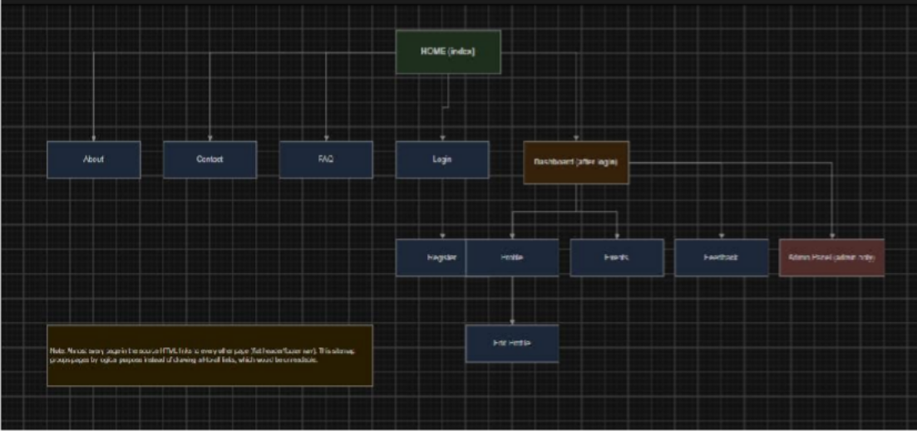
Figure 1.1

WireFrame:

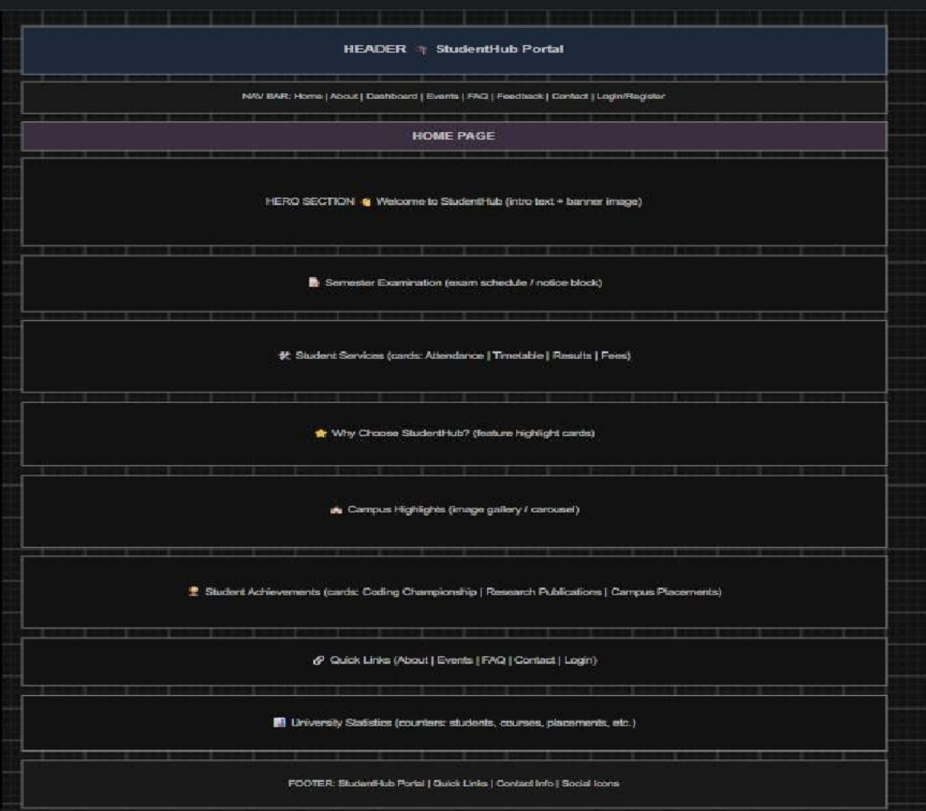
Figure 1.2(Home page)

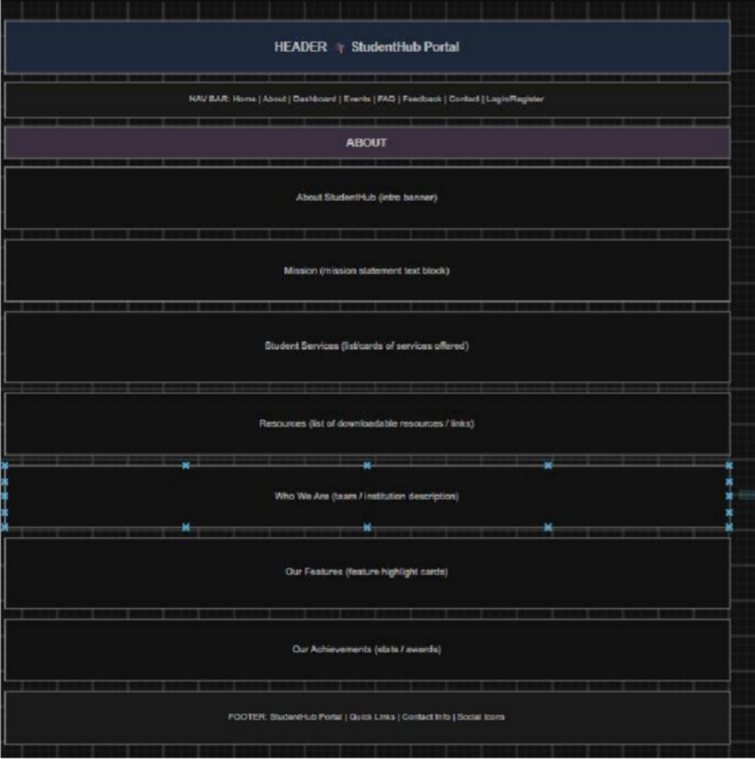
Figure 1.3(About page)

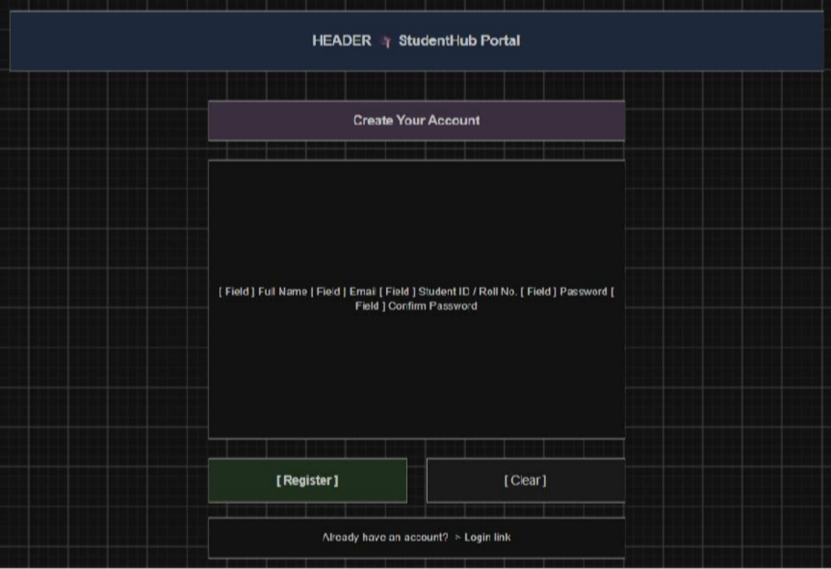
Figure 1.4(Register page)
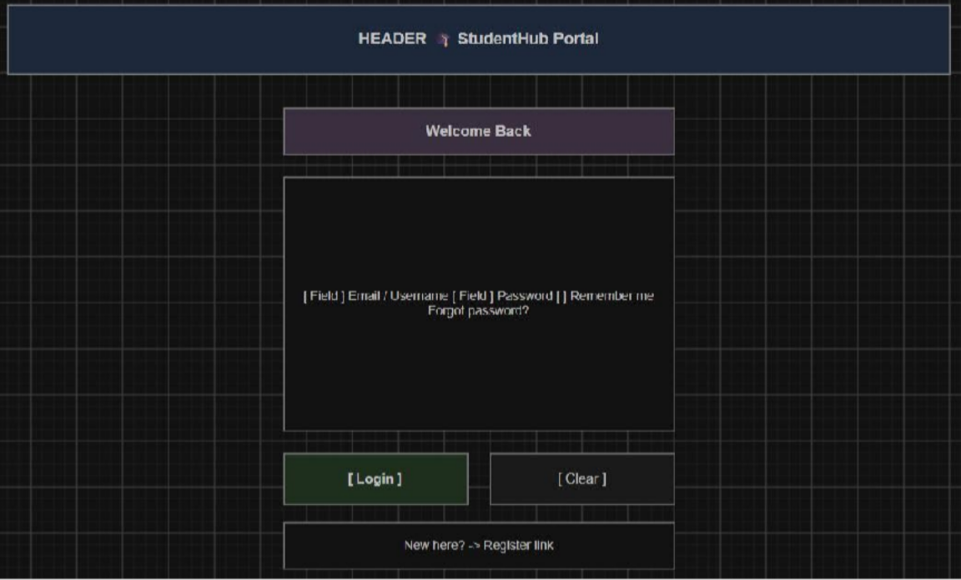
Figure 1.5(Login page)

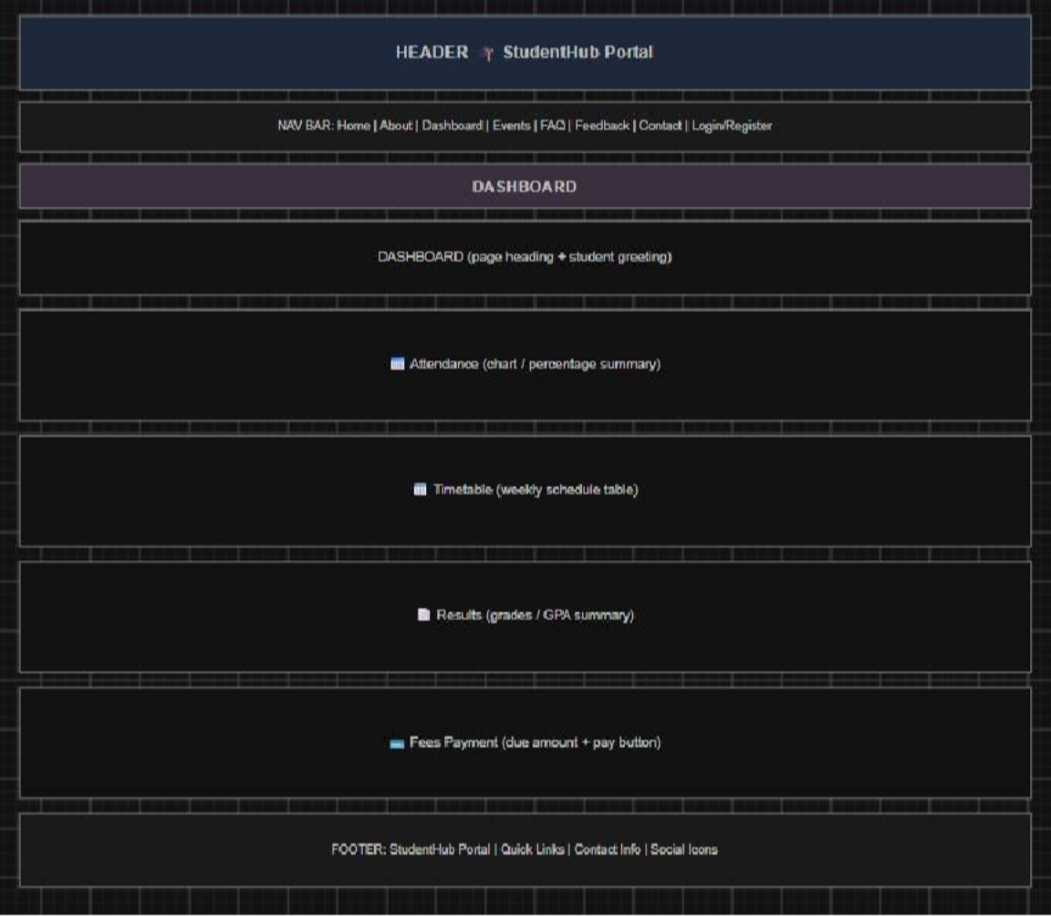
Figure 1.6(Dashboard page)

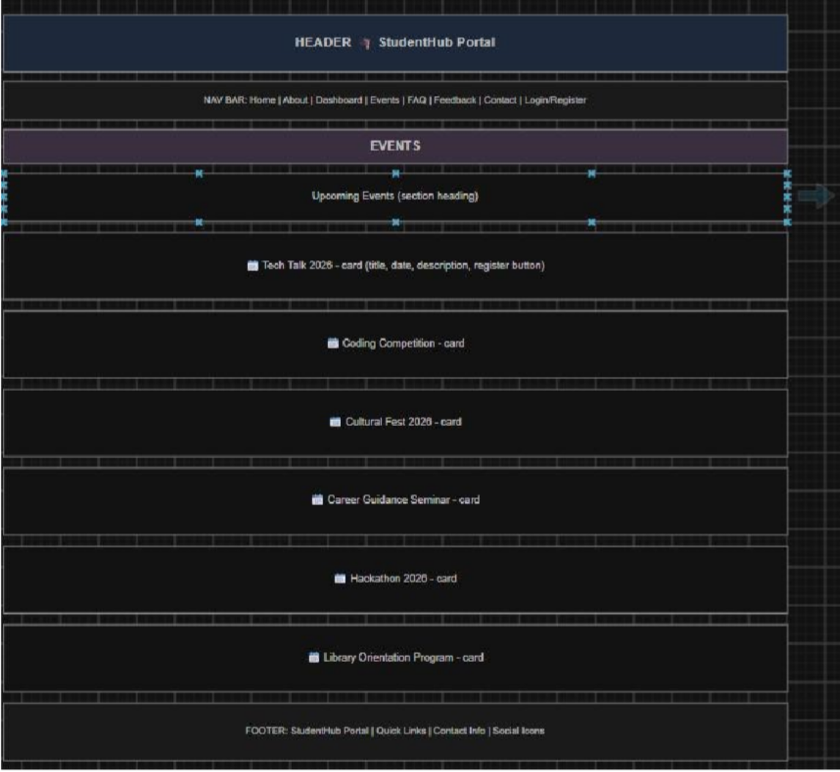
Figure 1.7(Event page)

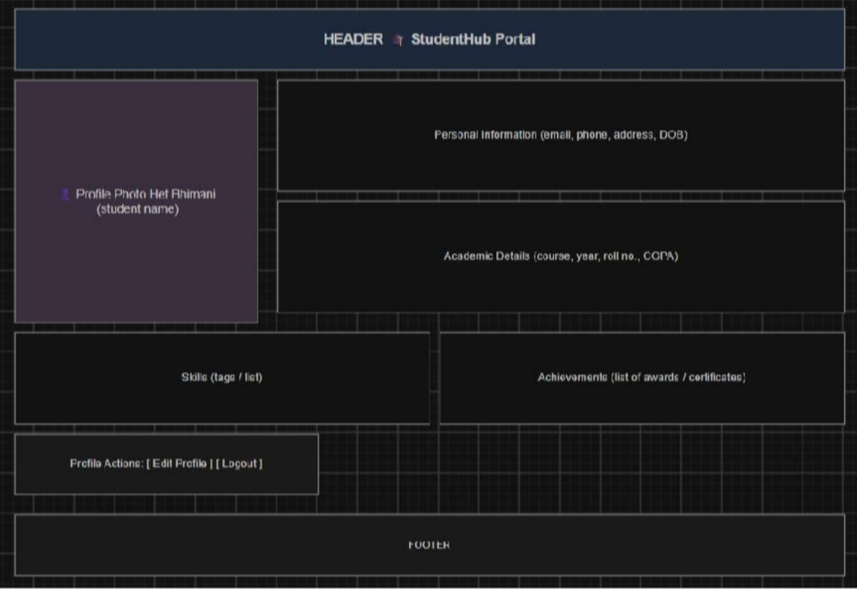
Figure 1.8(Profile page)
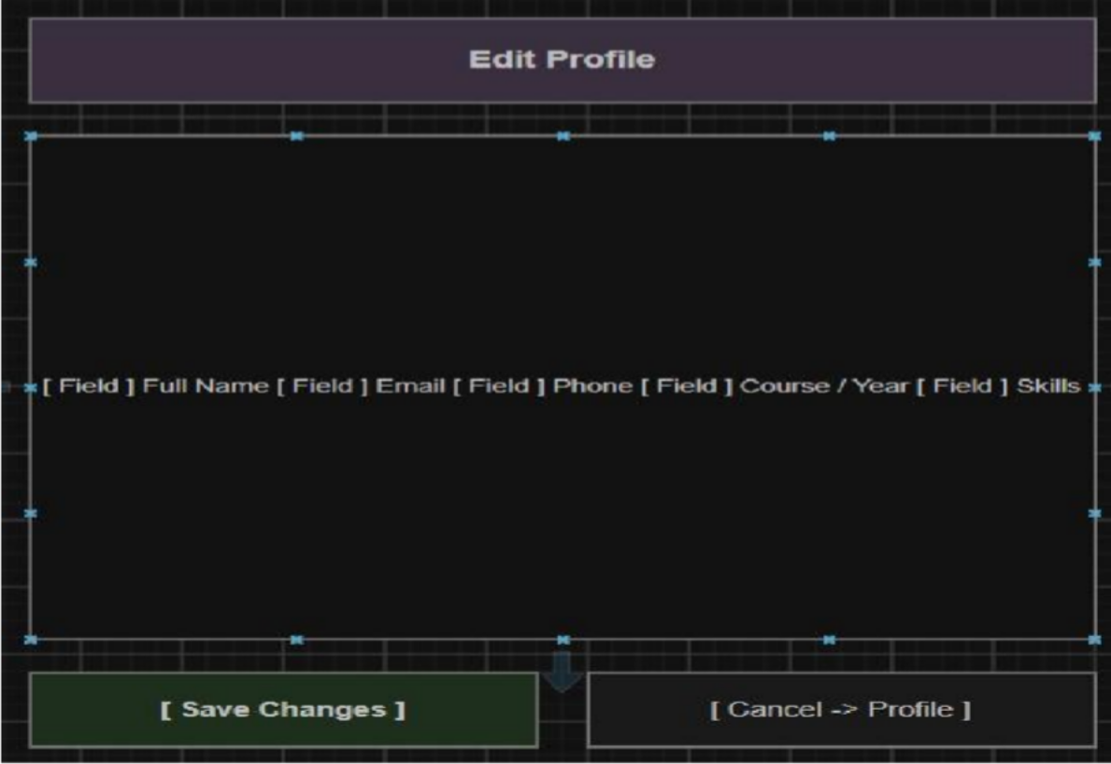

Figure 1.9(Edit page)
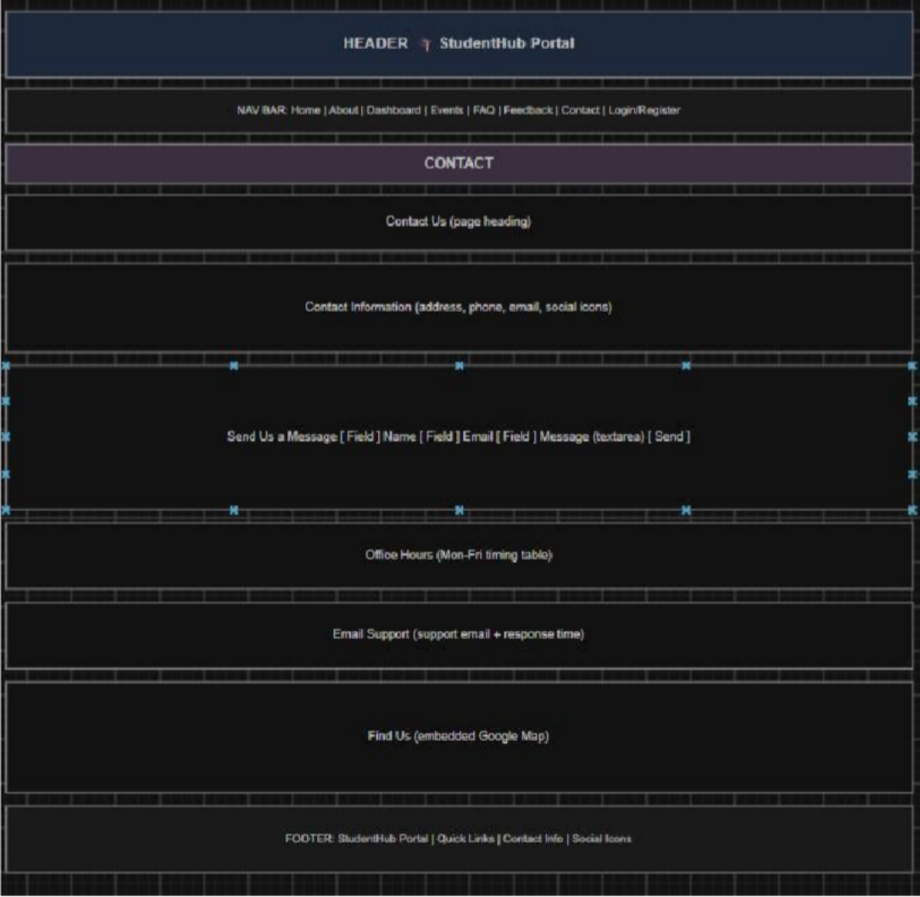
Figure 1.10(Contact page)

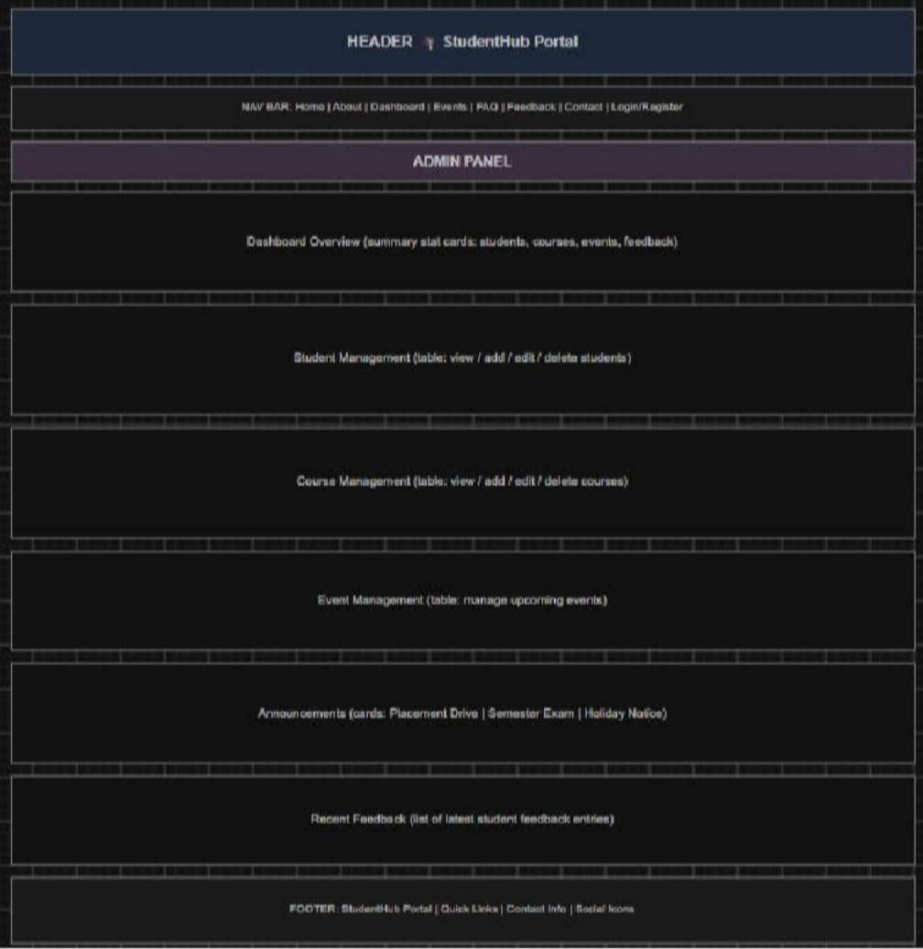
Figure 1.11(Admin page)

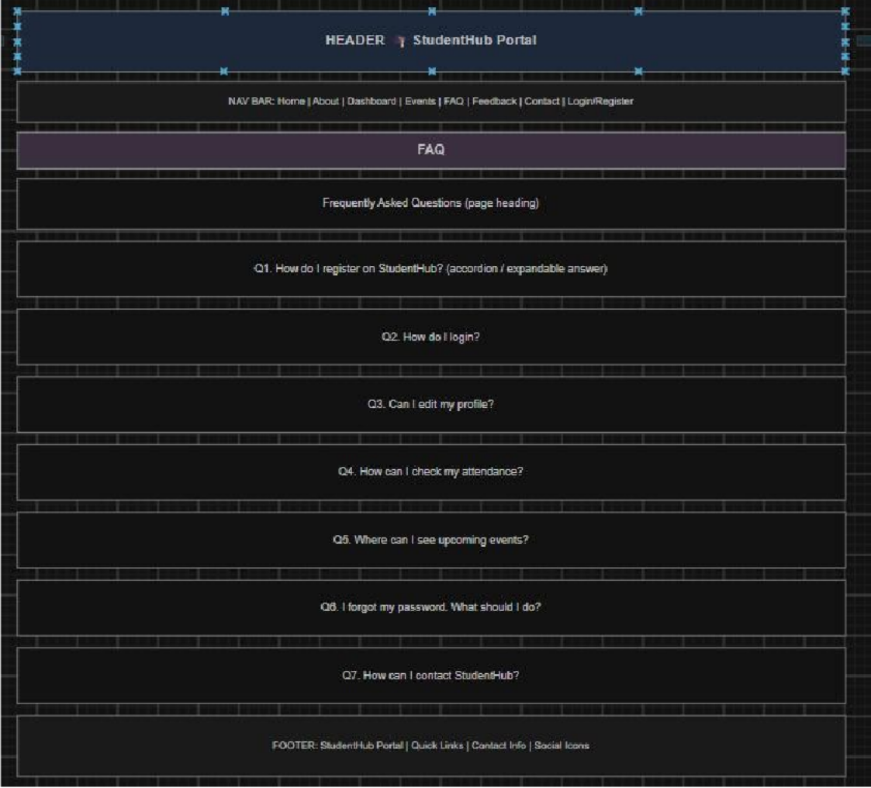
Figure 1.12(FAQ page)

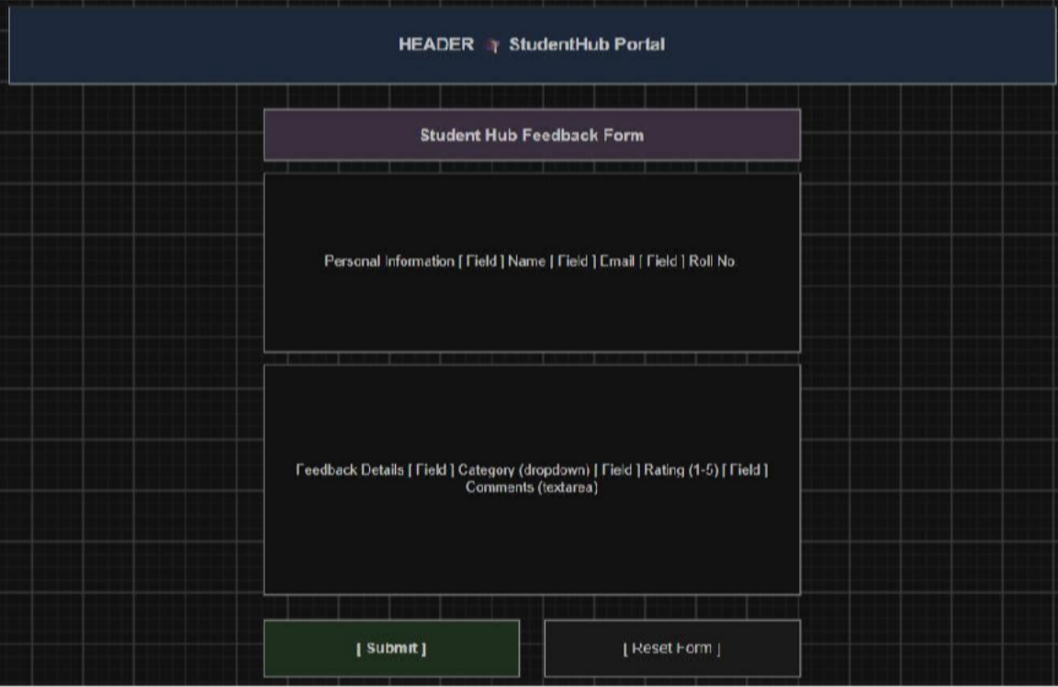
Figure 1.13(Feedback page)

GitHub Repository Link:
https://github.com/yakshu205/StudentHub.git

Challenges Faced:

First time when I start to think about requirement at that time I stuck . I thought that what type of pages we will make etc . But I start collecting info or requirement from my friend and then , I make sitemap and wireframe in tool like draw.io. I also faced difficulty when I make repos and push code and commit changes through command prompt , then I show a tutorial video of Git/GitHub version control , then I am good commit and etc.

Learning Outcomes:
I will be able to analyze requirements and prepare a structured project foundation before implementation and I am able to push , pull and commit my changes into my Github repo.

Faculty Remarks: (Keep this blank for faculty)

Practical - 3

Practical Title:Responsive UI Design using CSS Grid, Flexbox, and Bootstrap/Tailwind
Problem Definition:Design responsive layouts for Home, About, Registration, Dashboard,
and Events pages using CSS Grid and Flexbox. Optional to use CSS framework such as Bootstrap or Tailwind. Ensure mobile-first responsiveness.

Theory
  - How does the layout adapt for mobile, tablet, and desktop screens?
Answer: A layout adapts across mobile, tablet, and desktop screens using fluid grids, flexible images, and breakpoints (typically under 600px for mobile, 601px–1024px for tablets, and 1025px+ for desktops). Elements reflow, resize, or stack vertically to fit the available screen space.
(https://developer.mozilla.org/en US/docs/Learn_web_development/Core/CSS_layout/Responsive_Design)

  - Which layout technique is used and why?
Answer: Common web design layout techniques include CSS Flexbox, CSS Grid, and traditional Float or Responsive structures. Because your specific project or graphic was not provided, the correct technique depends entirely on the design goal. (https://www.w3schools.com/html/html_layout.asp)

  - Are typography, spacing, colors, and contrast readable?
Answer: Yes, typography, spacing, colors, and contrast directly determine whether text is readable. When properly balanced, they prevent eye strain and make content easy to scan. When poorly configured, text becomes difficult or impossible to read. (https://guidelines.india.gov.in/activity/the-impact-of-typography-on-web-design-a-comprehensive-guide-to-aesthetics-and-readability/)

  - Is the framework used consistently without unnecessary inline CSS?
Answer: style="" attributes. While they look like inline styles in the markup, they compile into clean external stylesheets and maintain design consistency without unnecessary true inline CSS. (https://www.reddit.com/r/Frontend/comments/rk3lr4/are_css_frameworks_really_necess ary/)

Implementation/ Output/Result :

- CSS Selectors Used:
*, body, header, nav, main, section, article, footer, div, h1, h2, h3, h4, p, ul, li, a, img,
form, label, input, textarea, select, button, table, tr, td, hr, small, i, marquee,
.class, #id,
:hover, :focus, :first-child, :last-child,
input[type="text"], input[type="email"], input[type="password"], input[type="radio"], input[type="checkbox"], input[type="submit"], input[type="reset"],
@media

- CSS Properties Used:

margin, padding, box-sizing, display, width, height, max-width,
background, background-size, background-position, background-repeat, color,
font-family, font-size, font-weight, text-align, text-decoration, line-height,
border, border-left, border-top, border-radius, box-shadow,
position,
justify-content, align-items,

flex-direction, flex-wrap, gap,
grid-template-columns, list-style,
cursor, transition, transform, outline, resize, object-fit, overflow

Evidence of Work (Screenshots)
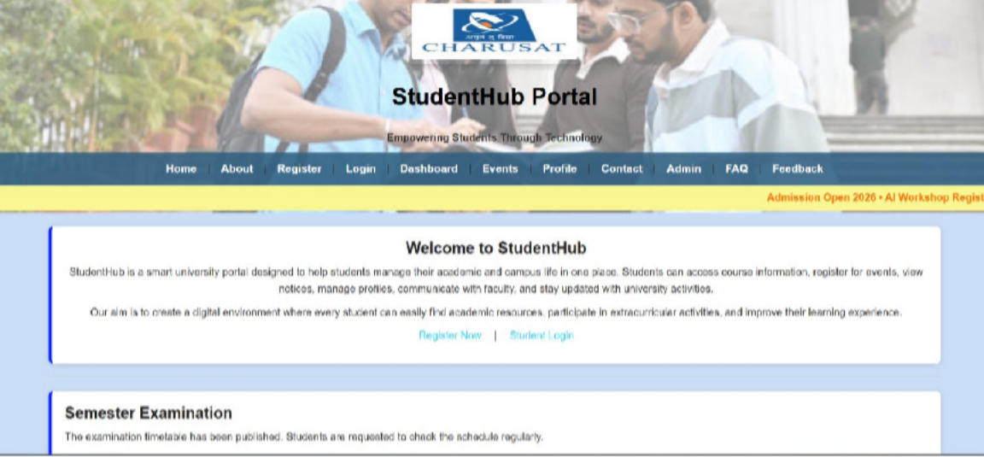
Figure 3.1(Home page)

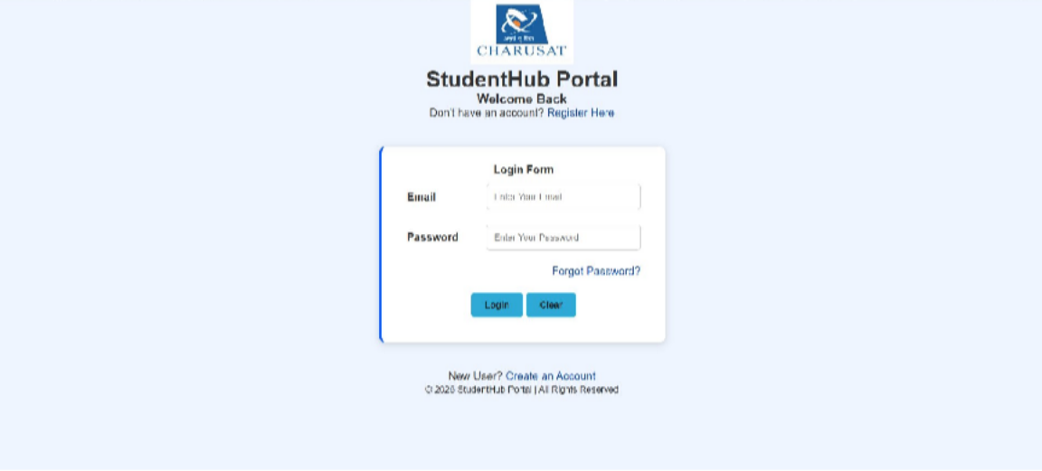
Figure 3.1(Login page)

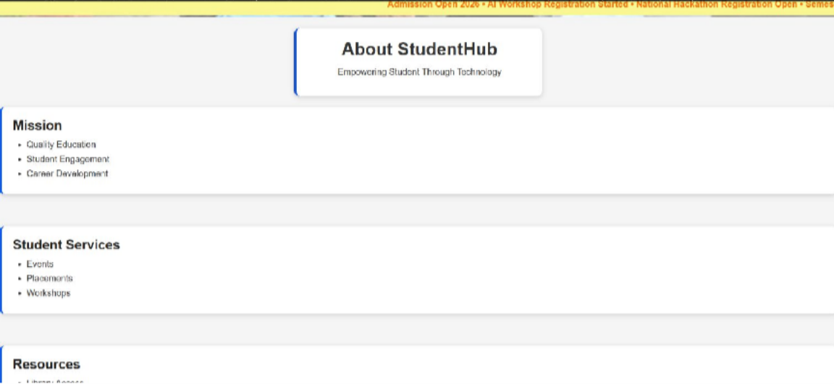
Figure 3.2(About page)

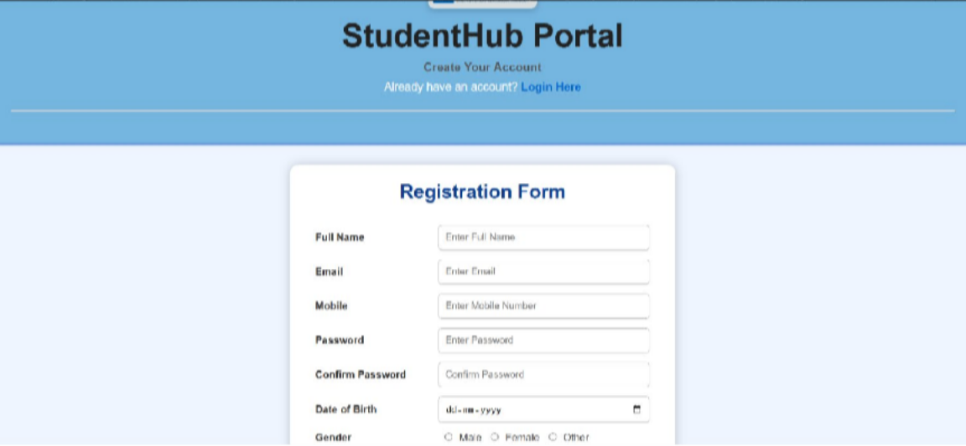
Figure 3.3(Registration page)
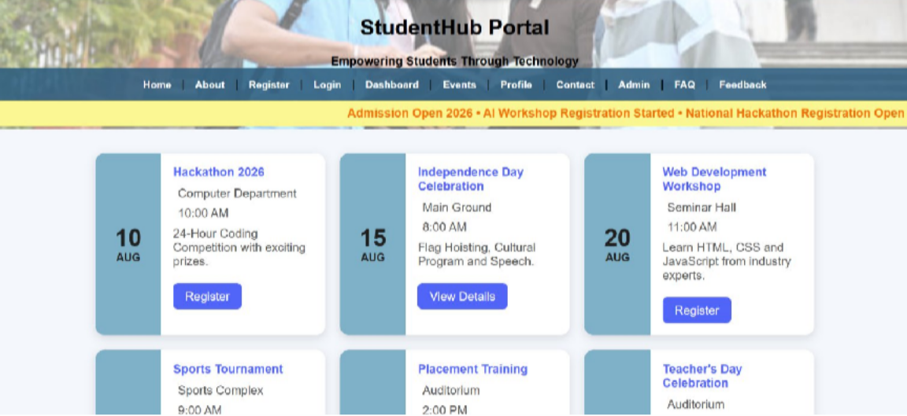
Figure 3.4(Event page)

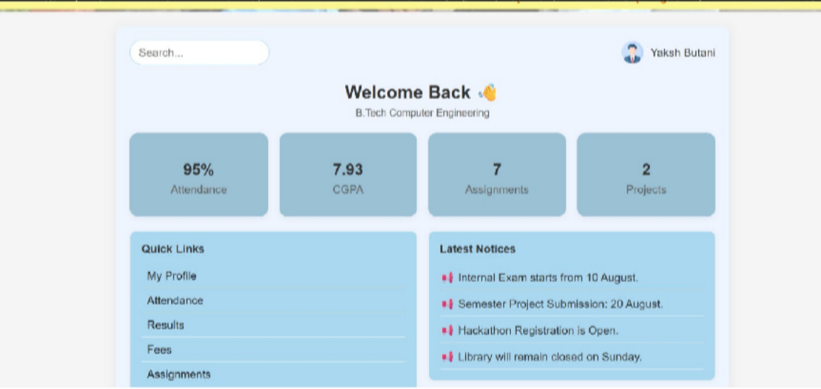
Figure 3.5(Dashboard page)
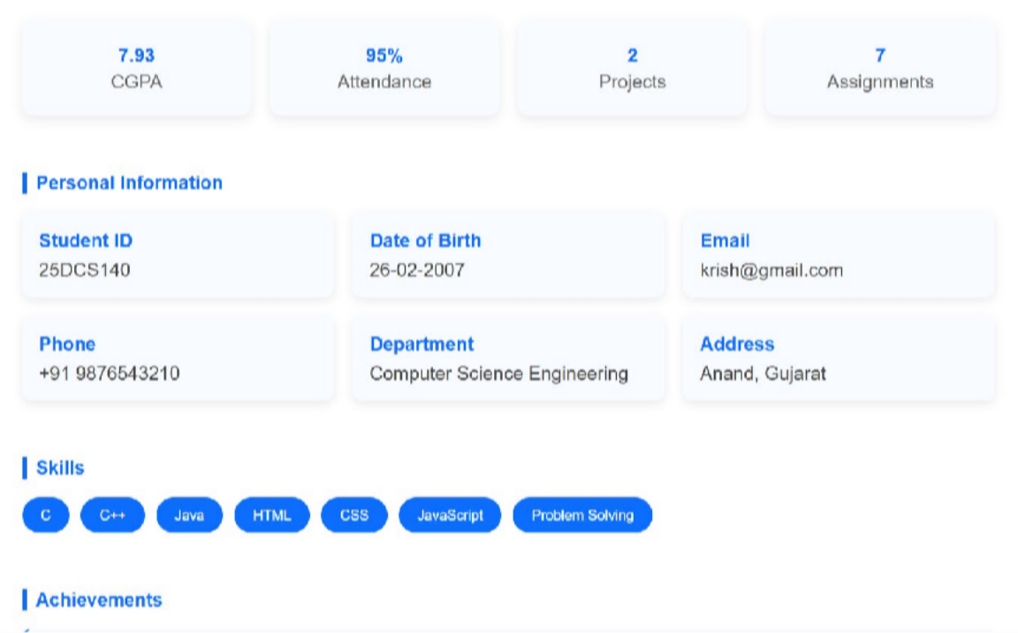
Figure 3.5(Profile page)

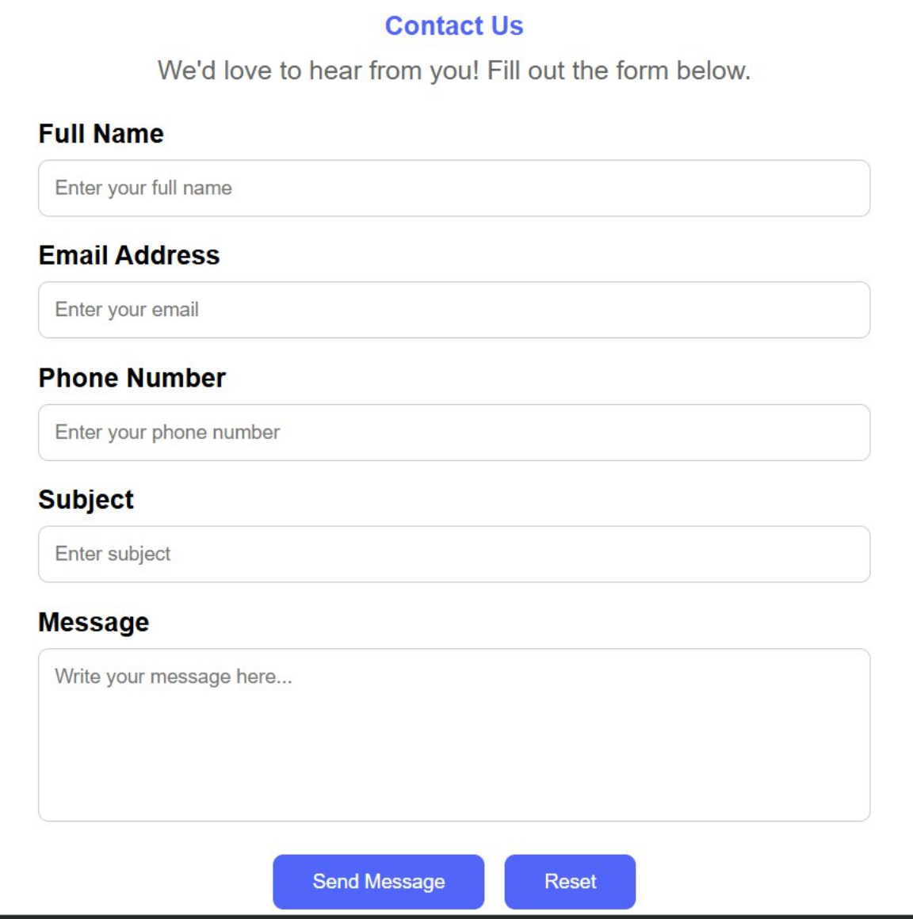
Figure 3.5(Contact us page)

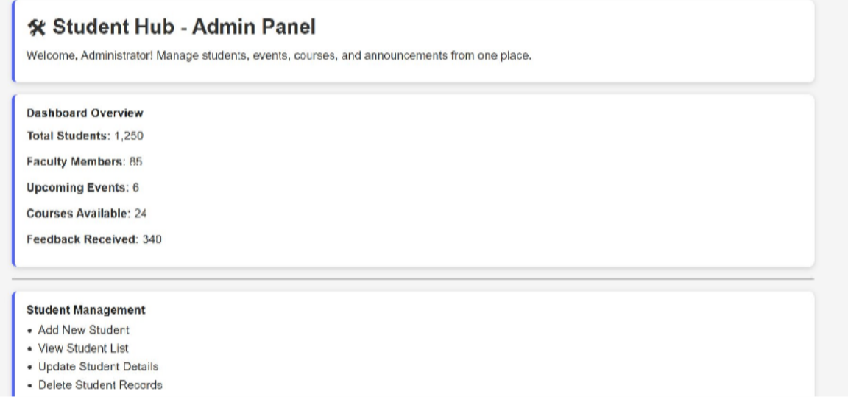
Figure 3.5(Admin page)
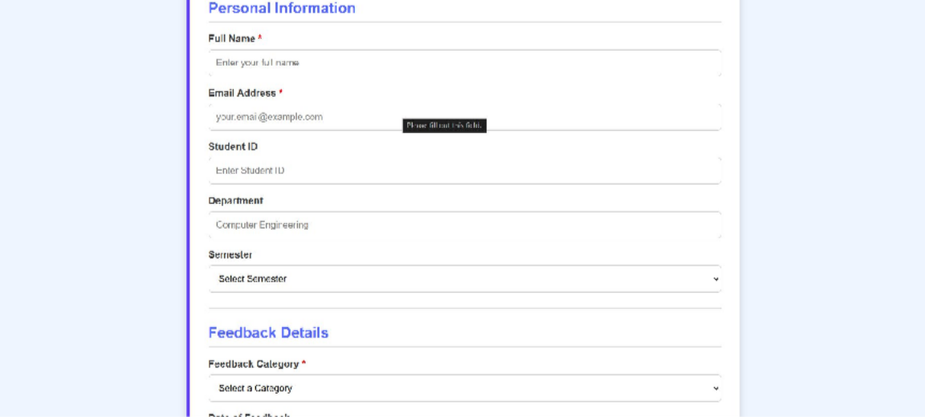
Figure 3.5(Feedback page)

GitHub Repository Link:
https://github.com/yakshu205/StudentHub.git

Challenges Faced:
When I was styling the html files , I had no idea about how I put image behind the text and blur it . then I told ChatGPT that I want to put image behind text at header which concept or styling function I should use , give syntax and opacity code and gradient code like (255,255,255,0.20);
It gave me function that name is linear gradient and also I learned padding , card , form, Flex , grid, styling , box , responsive etc.. concept.

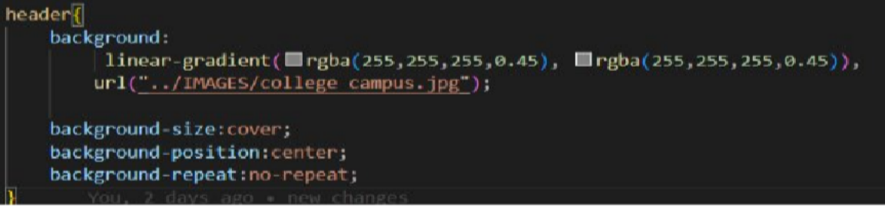

Learning Outcomes:
I will design a professional, responsive, and reusable UI layout.

Faculty Remarks: (Keep this blank for faculty)

Practical - 2

Practical Title: Semantic HTML5 Pages with Accessibility-Ready Structure
Problem Definition:Develop static HTML5 skeletons for at least 10 StudentHub pages such as Home, About, Register, Login, Dashboard, Events, Profile, Contact, Admin, FAQ, and Feedback. Use semantic tags and accessibility-friendly structure.

Theory
  - Are semantic tags such as header, nav, main, section, article, aside, and footer used properly?
Answer: Yes , I use tags such as nav ,header, main, section, footer .

  - Are form labels, headings, image alt text, and navigation links accessible? Answer: Yes , all imgage, lables and navigation links are accessible by browser .
(using <a> and href =”link”);

  - Is the page structure consistent across all pages?
Answer: Yes , all pages have consistent structure . (title,header,body,footer)

Implementation/ Output/Result :
<!DOCTYPE html> Declares the document as HTML5.

<html> Root element of the HTML page.

<head> Contains page information like title and CSS links.

<meta> Defines character encoding and viewport settings.

<title> Sets the title shown in the browser tab.

<link> Links an external CSS file.

<header> Defines the page header section.

<center> Centers the content (deprecated tag).

<img> Displays an image/logo.

<h1> Main heading of the page.

<h2> Section heading.

<h3> Sub-heading.

<p> Defines a paragraph.

<b> Makes text bold.

<nav> Contains navigation links.

<a> Creates hyperlinks.

<marquee> Displays scrolling text (deprecated tag).

<body> Contains all visible page content.

<main> Represents the main content of the page.

<section> Groups related content into sections.

<article> Represents independent content or an article.

<ul> Creates an unordered (bulleted) list.

<li> Defines a list item.

<hr> Inserts a horizontal line.

<footer> Defines the footer section.

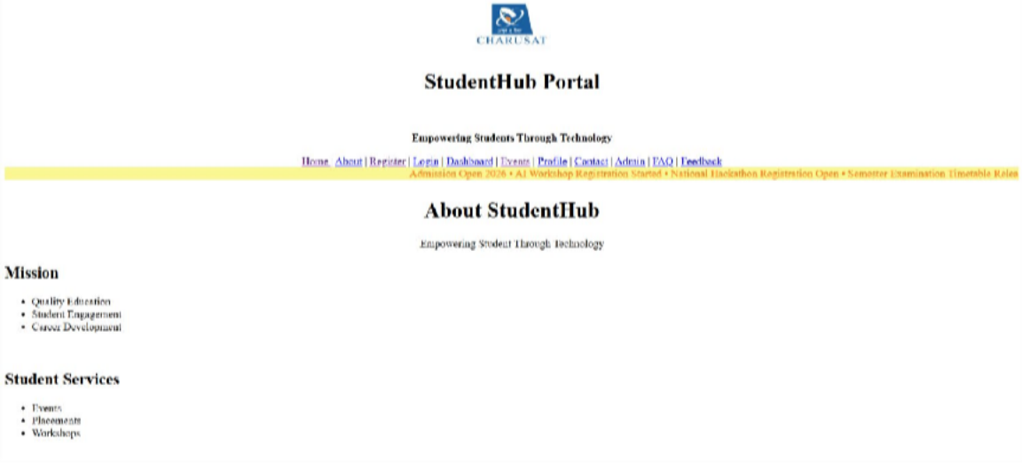
Evidence of Work (Screenshots)

Figure 2.1(Home Page)
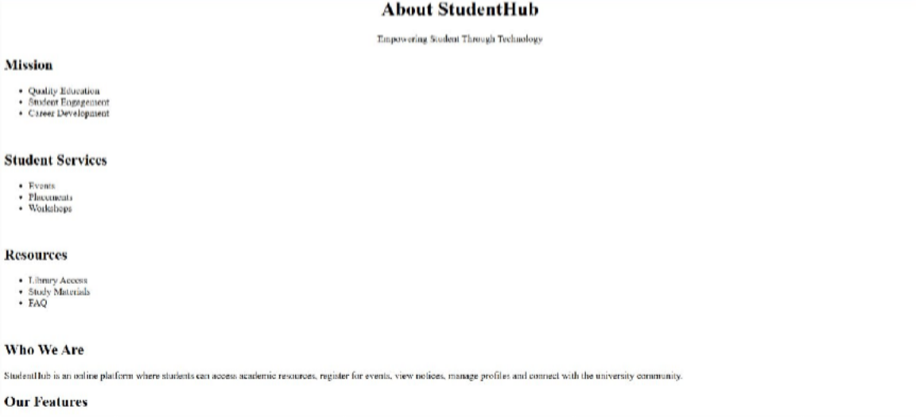
Figure 2.2(About Page)

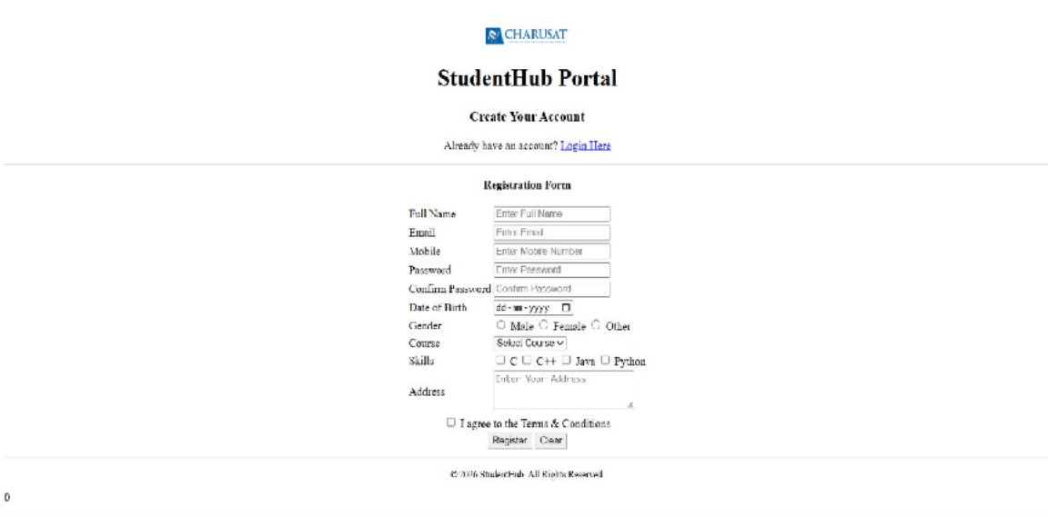
Figure 2.3(Register Page)
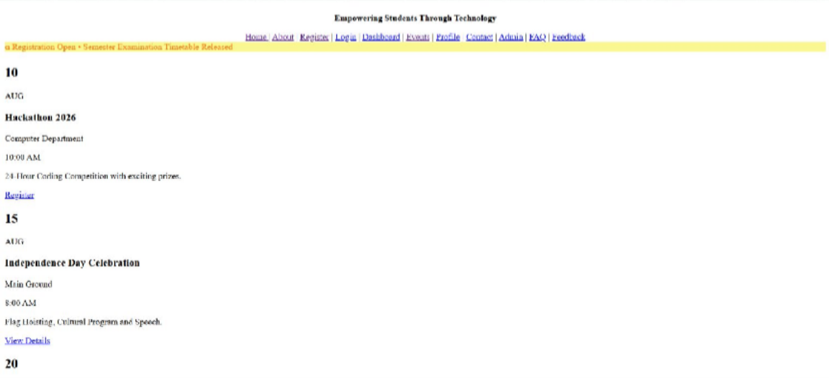
Figure 2.4(Event Page)

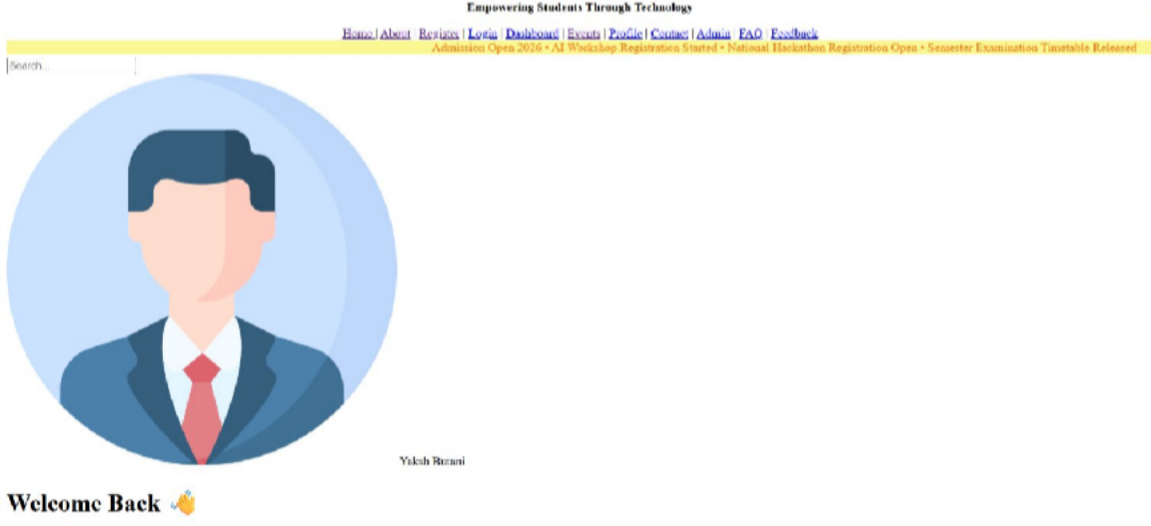
Figure 2.5
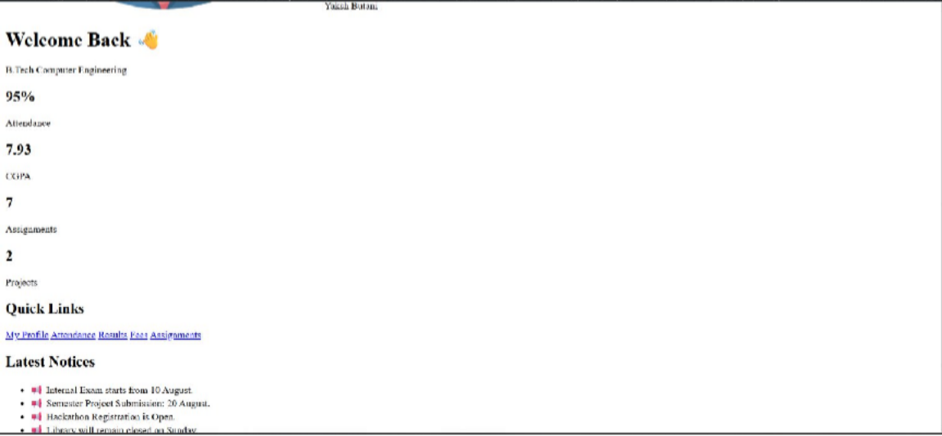
Figure 2.6
Figure 2.5 And Figure 2.6 (Dashboard Page)

GitHub Repository Link:
https://github.com/yakshu205/StudentHub.git

Challenges Faced:
- I have a design in my mind that how I make my header but I was stuck when scrolling text problem comes , I saw charusat portal where at footer part one text link is scrolling

automatically , I don’t know what concept I can use , then I go to MDN Website and find that the tag named “<marquee>” is reason for scrolling text.
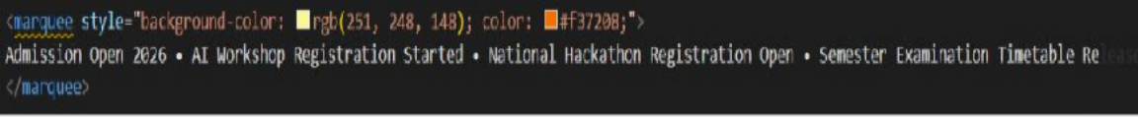

- Then , I was stuck , when I making webpage of Dashboard , for Dashboard I want default user profile picture photo in round shape for an example if we do not keep profile picture in social media profile , then it keeps default white-grey default picure .
So , for that picture I search in google and it gives me pic link also for some emoji there is some class keyword in html (i.e. : <i class="fa fa-shopping-cart"></i> and graduation cap etc.. )
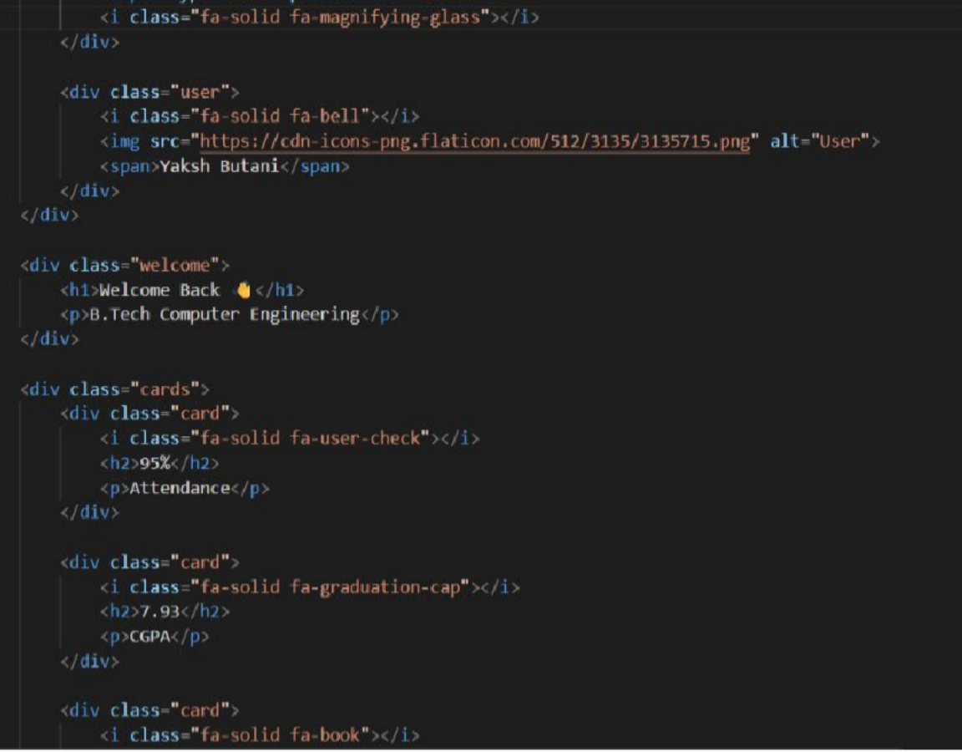

Learning Outcomes:
I will create clean, linked, and accessibility-ready HTML page structures.

Faculty Remarks: (Keep this blank for faculty)

Practical - 4

Practical Title: JavaScript DOM Manipulation, Event Handling, and UI Interactivity
Problem Definition: Add dynamic UI components such as collapsible FAQ, modal popup, image/content slider, notification banner, hamburger menu, and light/dark theme switcher using JavaScript.

Theory :

How are DOM elements selected and modified?

DOM manipulation means selecting an HTML element using JavaScript and then changing its text, HTML, style, attributes, classes, or values.

Are event listeners attached correctly?

Yes, event listeners are correctly attached using addEventListener(). It connects an HTML element with an event such as click or submit and executes a function when that event occurs.

Is localStorage used for remembering theme choice?

Yes. localStorage can be used to remember the user's theme choice. setItem() stores the selected theme, and getItem() retrieves it when the page is reopened, allowing the website to maintain the Dark/Light mode preference.

Does interactivity improve usability without breaking accessibility?

Yes. Interactivity improves usability when features such as buttons, notifications, menus, and forms make the website easier to use. Accessibility should be maintained by using proper HTML elements, keyboard support, readable text, clear messages, and sufficient contrast so all users can interact with the website.

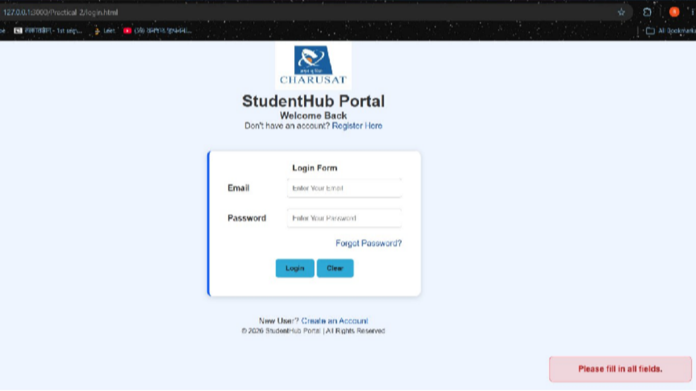
Implementation/ Output/Result

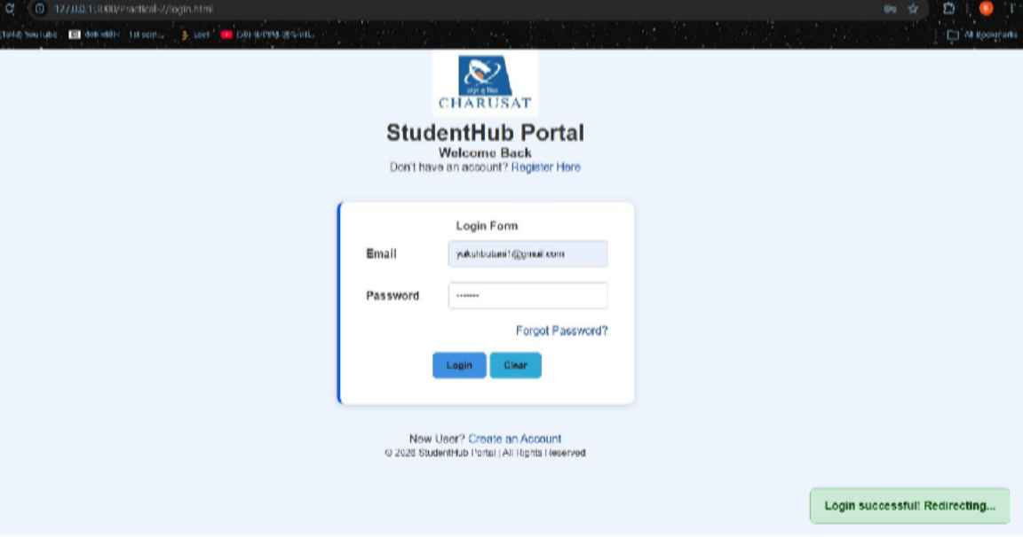

GitHub Repository Link:
https://github.com/yakshu205/StudentHub.git

Learning Outcomes:

Use JavaScript DOM manipulation
  - Handle user events like clicks and form submissions
  - Create interactive UI components
  - Implement dark/light theme switching
  - Use localStorage to remember user preferences
  - Improve the website's usability and interactivity.

Faculty Remarks: (Keep this blank for faculty)

Practical - 5

Practical Title: Registration Form with Frontend Validation and User-Friendly Error Handling
Problem Definition: Create a student registration form with HTML5 input types and JavaScript validation for name, email, mobile number, password, confirm password, course, year, gender, and terms acceptance. Use Regular Expression for validations.

Theory :

Are correct input types and attributes used?

Yes, correct input types and attributes are used. Text is used for names, email for email addresses, password for passwords, and the required attribute ensures that mandatory fields cannot be left empty.

Are validation errors displayed near the relevant fields?

No. Validation errors are currently displayed through alert messages rather than near the relevant input fields.

Is password strength checked?

Yes, password strength is checked using JavaScript validation with minimum length and character requirements.

Is the form accessible using keyboard and screen-reader-friendly labels?

Partially. Keyboard access is supported, but labels should be linked to their corresponding input fields using the for attribute for better screen-reader accessibility.

Validation:
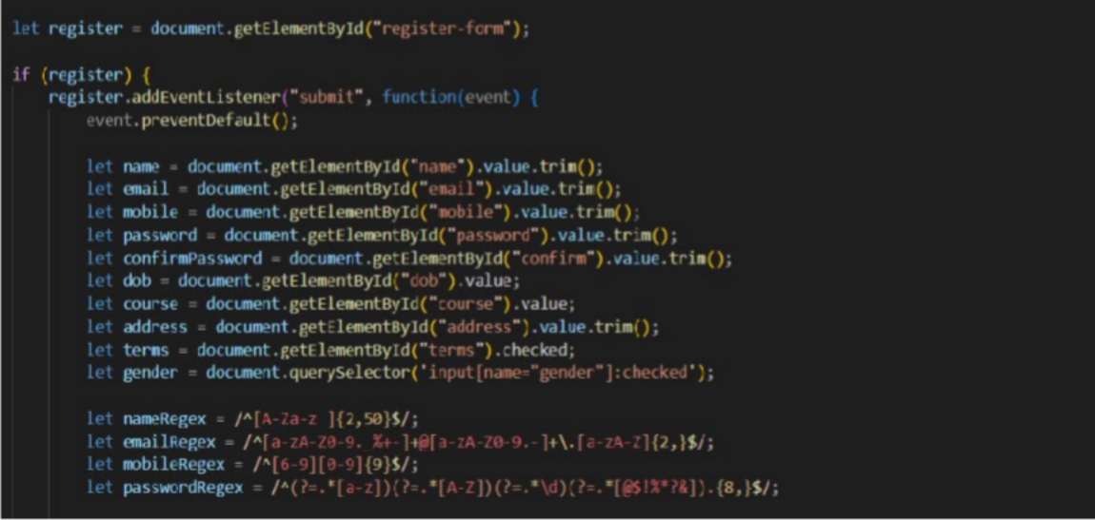

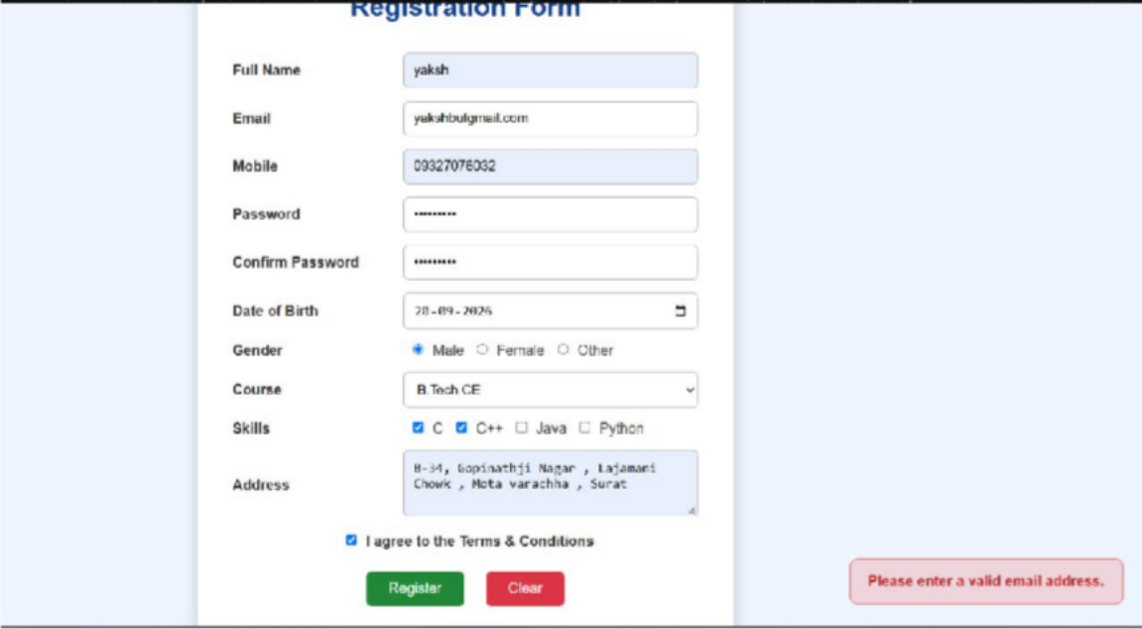
Implementation/ Output/Result

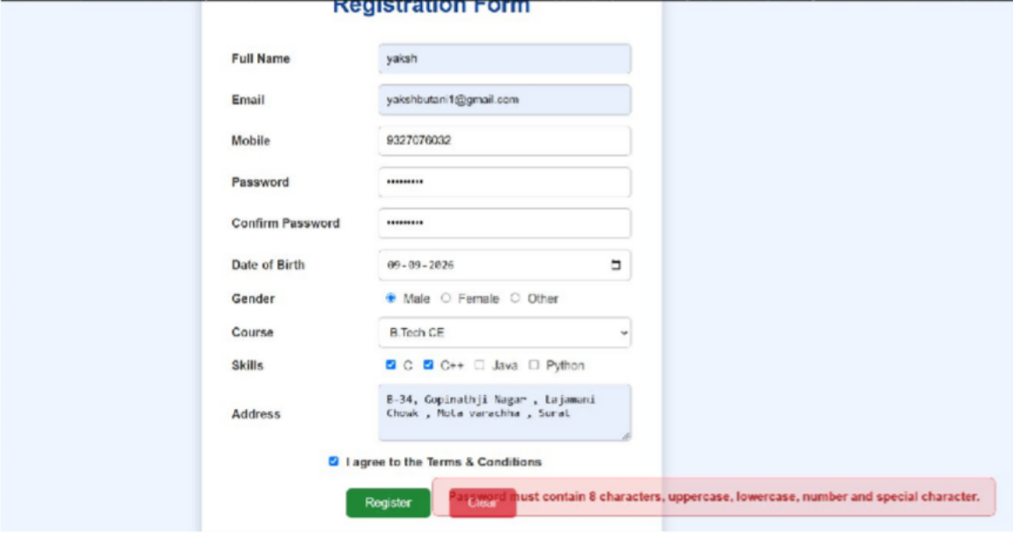
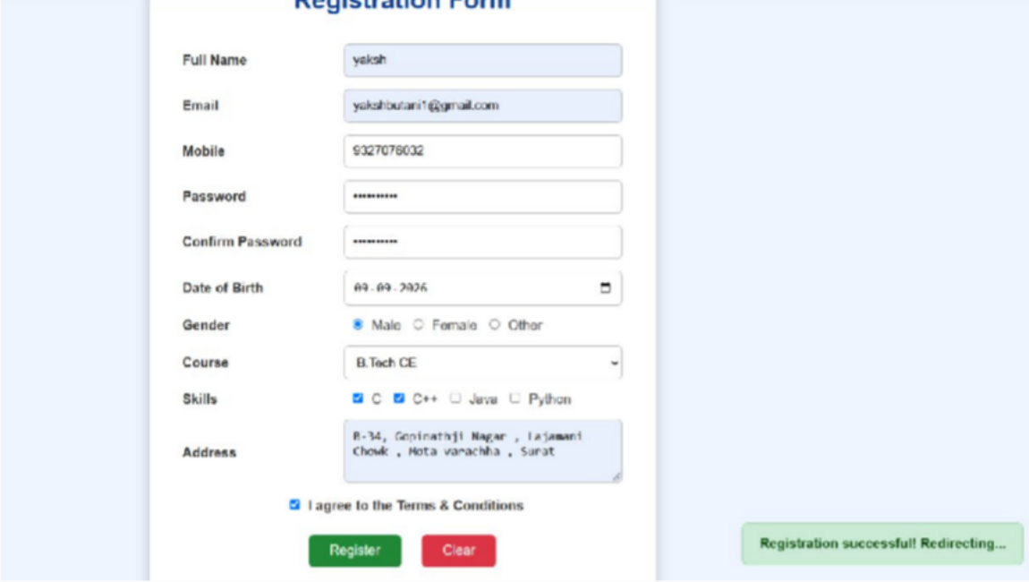

GitHub Repository Link:
https://github.com/yakshu205/StudentHub.git

Learning Outcomes:
- Understand HTML form creation and different input types.
- Implement client-side form validation using JavaScript.
- Use Regular Expressions for validating user inputs.
- Implement password strength and confirmation checks.
- Handle validation errors and provide user-friendly messages.
- Understand basic form accessibility for keyboard and screen-reader users.
Faculty Remarks: (Keep this blank for faculty)

Practical - 6

Practical Title: Rendering External JSON Data using Fetch API, Search and Filter
Problem Definition: Display event lists, student profiles, notices, or FAQs from external JSON files using Fetch API. Implement dynamic rendering, search, filter, sorting, and pagination.

Theory :

How is JSON fetched, parsed, and rendered?

JSON is fetched using the Fetch API, parsed using response.json(), and then rendered dynamically on the webpage using JavaScript DOM methods such as textContent or innerHTML.

Which array methods are used for search, filter, sort, and pagination?

filter() is used for search and filtering, sort() for sorting, and slice() for pagination.

How are loading and error states handled?

Loading is handled using the Fetch API, while errors are handled using the .catch() method and displayed in the browser console.

How is modularity maintained in JavaScript files?

Modularity is maintained by using an external JavaScript file and separating different functionalities into independent code sections or functions.

Data:
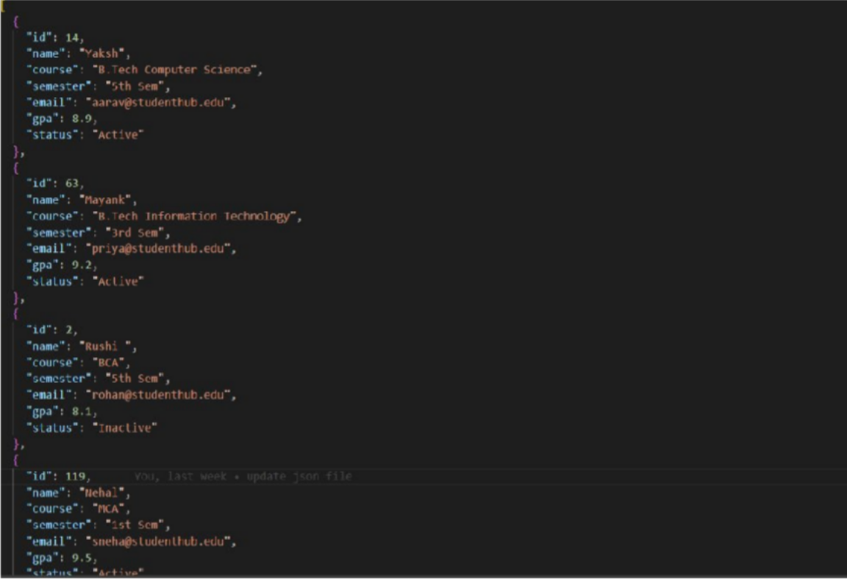

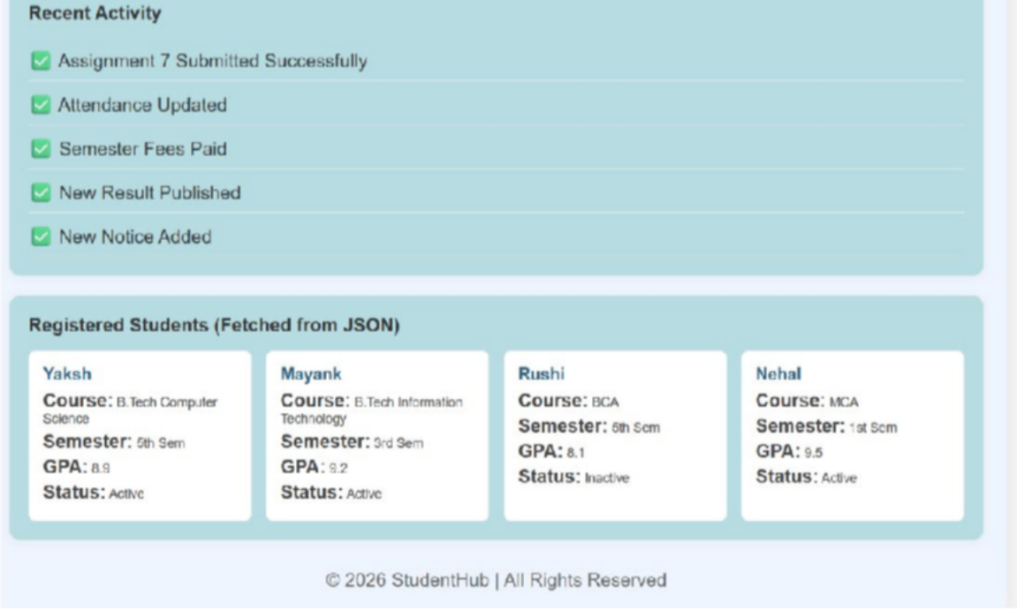
Implementation/ Output/Result

GitHub Repository Link:
https://github.com/yakshu205/StudentHub.git

Learning Outcomes:
- Understand how to fetch and parse external JSON data using the Fetch API.
- Dynamically render JSON data on web pages using JavaScript.
- Implement search, filtering, sorting, and pagination using JavaScript array methods.
- Handle loading and error states while fetching data.
- Develop modular and reusable JavaScript code for dynamic web applications.
Faculty Remarks: (Keep this blank for faculty)

