|  |  |  |
| --- | --- | --- |
| **Yakubu Abiola** | Yakubuabiola2003@gmail.com |  |
| **+2348030960928** |  |
| **Full-Stack Web developer** |  |
|  |  |
|  | **Lagos, Nigeria.** |  |
|  |  |
|  | **https://github.com/yakubu234** |  |
| To | **https://twitter.com/yakubu234** |  |
|  |  |
| **The Hiring Manager,** | **https://www.linkedin.com/in/yakubu-abiola-880061ab/** |  |
|  |  |

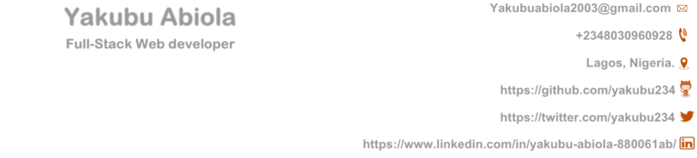

|  |
| --- |
| **yakubuabiola2003@gmail.com**  **+2348030960928**  **Lagos, Nigeria** |
| **https://github.com/yakubu234** |
| **https://twitter.com/yakubu234**  **https://www.linkedin.com/in/yakubu-abiola-880061ab/** |

**New Horizons,**

**5 Babatola Street,**

**Ikeja, Lagos.**

February 1st, 2020.

Dear Hiring Manager,

I am writing to express my interest in the web developer position at new horizons the leading ICT Training and Exam Testing Institute in Nigeria, as it has always been my age-long ambition to leverage my experience in web development.

While studying for my Ordinary National Diploma in Computer Science at the Moshood Abiola polytechnic, I develop a keen interest in web development and I find it exciting and this has influence me to utilize any opportunity I have to improve my stacks, in which I am expressing my sincere interest to join your team of software developer (Web) in your highly reputable organization. During my 3 months industrial training at the DotsIct Hub I passed through vigorous training on Html, CSS, jQuery, PHP, and SQL database and just recently Java (Native Android Application) and React-native. I joined a team in development of an E-agriculture solution at the Nigerian computer society software contest in 2018 and educational solution at the naijahacks 2018 hackathon which are both complemented with certificate of participation. More so my final year project (Encrypted System for Electronic Health Record) has made me understand the operation and integration of cryptography to some degree, also a treasury system for my department where I integrate API's alongside electronic payment. While working as a freelancer I have work on various project such as the official website of the diabetes association of Nigeria Ogun-State chapter [https://danogun.org,](https://danogun.org/) [https://medalinksreporters.com](https://medalinksreporters.com/) an online news medium in Nigeria, in a team that developed the BECE (basic education certificate examination) a standalone Certificate generation system for Ogun-State, various specialized web-based hospital management system deployed at the federal medical Centre Abeokuta, Nigeria , and [https://thechronicleng.com.ng](https://thechronicleng.com.ng/) Nigeria’s Biggest tourism reality shows full-stack web application, Just recently I embark on Google Africa Developer Scholarship Program anchored by Andela Nigeria where I learn the native android development as my one year Industrial attachment. Most of my portfolio can be found at <https://github.com/yakubu234>my repository. It interest me to learn that since 1982, New Horizons Computer Learning Center has grown to become the largest independent IT training company worldwide. And currently the Largest IT training company in Nigeria. I am very passionate about being a competent and contributing team player, and I hope to have this demonstrated in a greater length if offered the opportunity.

As contributing to the socio-economic development of Nigeria is the company’s mission, I will regard it as a great privilege and a step towards my career advancement to contribute my quota while I work with the world-leading company in IT Training. And I am keen to be part of other future success stories of your company. Looking forward to hearing from you and further discussing the value I could bring on board as I utilize my potential and skills in optimality.

Yours Sincerely,

Yakubu Abiola.