Evidence of Nursery Area and Length-Weight Relationships for Longnose Spurdog Squalus blainville in the Eastern Mediterranean
Cemal Turan ^{1,2*}, Servet A. Doğdu ^{2,3}, Alen Soldo⁴
¹Iskenderun Technical University, Faculty of Marine Sciences and Technology, Molecular Ecology and Fisheries Genetics Laboratory, 31220, Iskenderun, Hatay, Türkiye. ²Nature and Science Society, Modernevler Neighborhood 303. St. No:9/1, Iskenderun, Hatay. ³Iskenderun Technical University, Maritime Technology Vocational School of Higher Education, Underwater Technologies, 31200 Iskenderun, Hatay, Türkiye. ⁴Department of Marine Studies, University of Split, Split 21000, Croatia.
Abstract
Nursery areas are essential habitats for sharks, offering protection and increasing the survival of newborns. This study aims to investigate a potential nursery area for Squalus blainville in the Eastern Mediterranean Sea that has very scarce information in the eastern Mediterranean Sea and contributes to the length-weight relationships. We identified the location of the potential nursery area by interviewing local fishermen. We collected 48 adults and 22 embryos neonates of Squalus blainville specimens from the entrance of Iskenderun Bay on 03 April 2024. We recorded 48 longnose spurdog sharks in the catches ranging from 68.9 cm to 120.2 cm TL, which corresponded to mature individuals. The length-weight relations (LWR) of combined sexes of S. blainville were observed as W = 0.0005xL^{3.0277}, R² =0.9303. Our data provide evidence to recognize Iskenderun Bay as a possible nursery area for longnose spurdog sharks, meeting all the criteria proposed to identify nursery areas. These findings constitute the first documented evidence of a longnose spurdog shark nursery area in the Iskenderun Bay in Turkish marine waters.
Keywords: Longnose spurdog, Nursery area, Iskenderun Bay, length-weight relationship
Introduction
The longnose spurdog Squalus blainville (Risso, 1827) is a demersal, medium-sized, and long-lived squalid shark (Kousteni and Megalofonou, 2015). It has been reported over a wide geographical range, from the waters of the Atlantic, Pacific, and Indian Oceans to the Mediterranean and Black Seas (Ebert and Dando 2020; Ebert et al., 2021). Compagno et al., 2005). S. blainville is mainly distributed on the continental shelves and upper slopes between 300–500 m depth down to about 700 m (Cannizzaro et al., 1995). It is considered an opportunistic scavenger, feeding primarily on crustaceans and teleosts (Martinho et al., 2012). Through aplacental viviparity, it produces few embryos during all seasons of the year, ranging between 180 and 210 mm in total length (Kousteni and Megalofonou, 2011).
The longnose spurdog S. blainville is one of the most poorly studied Mediterranean shark species, although it comprises a very common by-catch of bottom trawl fisheries (Damalas and Vassilopoulou, 2011; Bengil and Başusta, 2018). It is listed as data deficient by the IUCN (Nieto et al., 2015; Finucci et al., 2021), since, despite its relatively well-studied biology (Cannizzaro et al., 1995; Merella et al., 1997; Sion et al., 2003; Kousteni and Megalofonou, 2011, 2015; Martinho et al., 2012; Eronat and Özaydın, 2014; Bengil, 2022), there is insufficient information on its distribution, population dynamics, and genetic structure to meaningfully inform extinction risk and population management models.
Currently, there is growing concern over the extent of shark catches in the Mediterranean, as their inherent characteristics make them intrinsically vulnerable to fishing pressure and pollution (Dulvy et al., 2014; Erguden et al., 2022; Ergenler and Turan, 2024; Turan et al., 2024). Although slow growth, late sexual maturity, and low fecundity are common features among chondrichthyans, they are especially pronounced in squalids, which are characterized by a very long population doubling time of a few decades to over a century, making them highly vulnerable to overexploitation (Simpfendorfer and Kyne, 2009). In a recent study (Kousteni and Megalofonou, 2015), the minimum and maximum age recorded for S. blainville were 1 and 28 y, respectively, indicating not only the high longevity of the species but also the fact that it enters the trawl fishery from its first year of life.
This study aimed to contribute to filling the gaps in the biology of the longnose spurdog S. blainville in the eastern Mediterranean, where little is known about the biology and ecology of elasmobranch species. With this study, a new breeding area for this species in the eastern Mediterranean was identified and the importance of these areas for elasmobranch species was revealed. In addition, length-weight relationship and reproductive biology data were obtained from the individuals caught in the study and important information about the species was revealed.
Material and Method
A total of 48 adults and 22 neonates of S. blainville samples were collected at the entrance of the Iskenderun Bay from the eastern Mediterranean on 03 April 2024 by a commercial trawler. The fishing area is given in Figure 1 and covers an area of approximately 107 km² (36.203226 N, 35.389892 E; 36.098440 N, 35.512205 E- 36.168022 N, 35.331516 E; 36.058921 N, 35.452596 E). The species were identified by using Kabasakal (2020), and each specimen's total length (to within 0.1 cm) and total weight (to within 0.1 g) were measured. The presence of claspers determined the sex of each specimen.
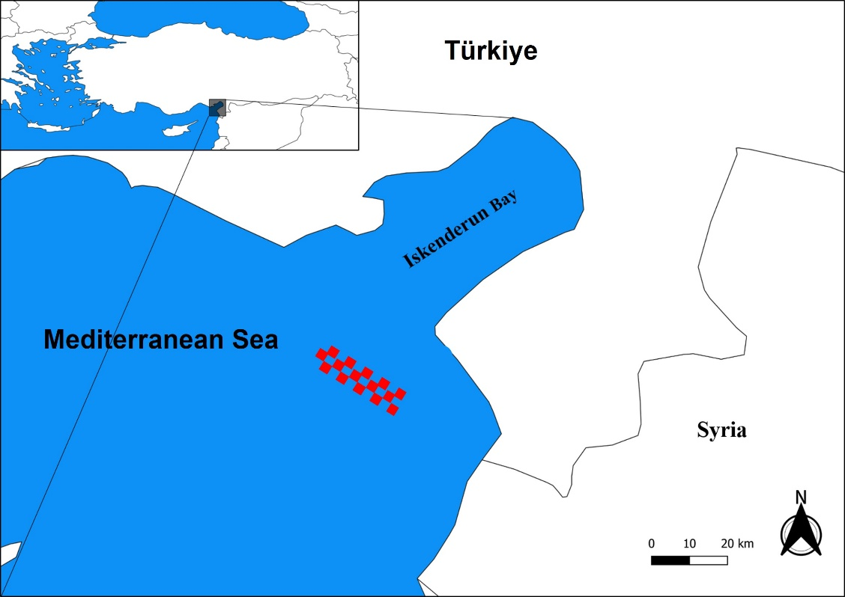
Figure 1. Map of Iskenderun Bay, eastern Mediterranean, and the trawling area where elasmobranch species were caught are shaded in red squares.
The length-weight relationship (LWR) was established following the formula of Ricker (1975):
$$\text{W} \text{=} \text{a}{ \text{x}\text{ L}}^{\text{b}}$$
The abbreviations for the formulation parameters are as follows: W is weight in grams, L is the total length in centimeters, b is the length-weight factor and a is a constant. All samples were analyzed for the LWR, with separate tests conducted for males and females. Then, the parameters were estimated by linear regression on the transformed equation:
$$\text{log}{\text{W} \text{=}\text{log}{\text{a}\text{ + }\text{b} \text{log}{\text{L}}}}$$
The parameters a and b were calculated using least-squares regression as the coefficient of determination (R²). The significance of the regression analysis was determined using ANOVA (Zar, 1999). A Student’s t-test was used to ascertain whether the b values obtained from linear regressions were significantly different from the null hypothesis of isometric growth (H₀: b = 3) using the equation proposed by Sokal and Rohlf (1987).
t_{s} = (b – 3) / sb
where t_{s} is the t-test value, b is the slope, and sb is the standard error of the slope (b).
Microsoft Excel 2016 (Microsoft, Redmond, WA, USA) and SPSS Statistics 19.0 (SPSS Inc., Chicago, IL, USA) were used for statistical analyses.
Results
A total of 48 adults which are 46 females and 2 males, and 22 neonates of longnose spurdog samples were collected entrance of the Iskenderun Bay from eastern Mediterranean. Photographs of the samples obtained as a result of trawling and photographs of these samples taken from the lateral and dorsal lines are given in Figure 2.

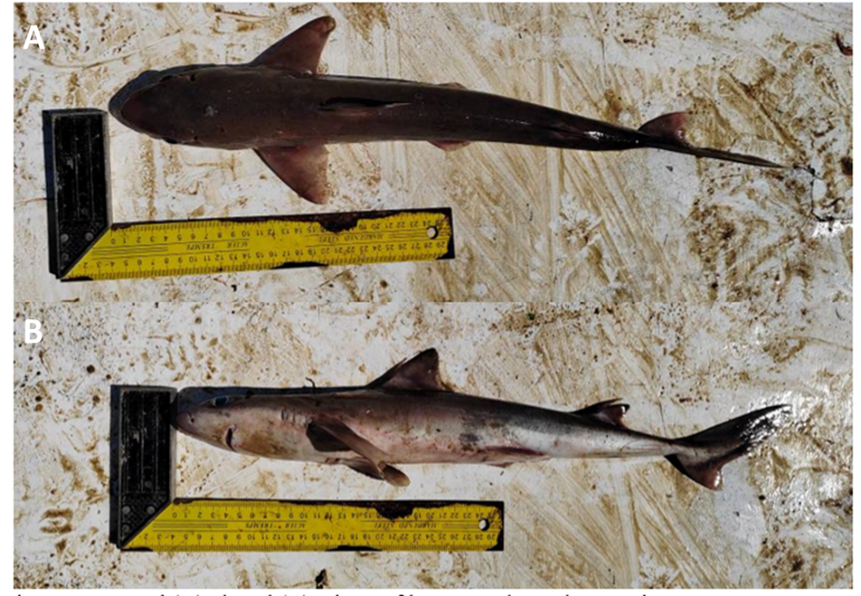
Figure 2. Lateral (A), dorsal (B), views of long-nosed spurdog specimens.
A total of 22 neonates were found at the same developmental stages (Figure 3). All of these 22 neonates were in the final developmental stage and their lengths ranged between 15.2-17.8 (Figure 4).
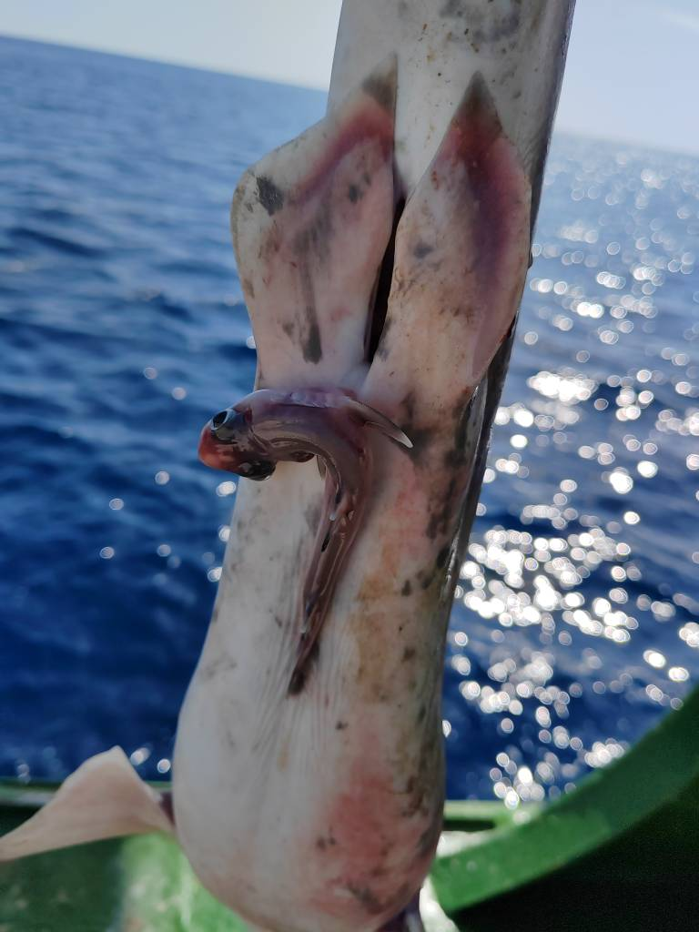
Figure 3. Neonates of Squalus blainville in their final stage of development.
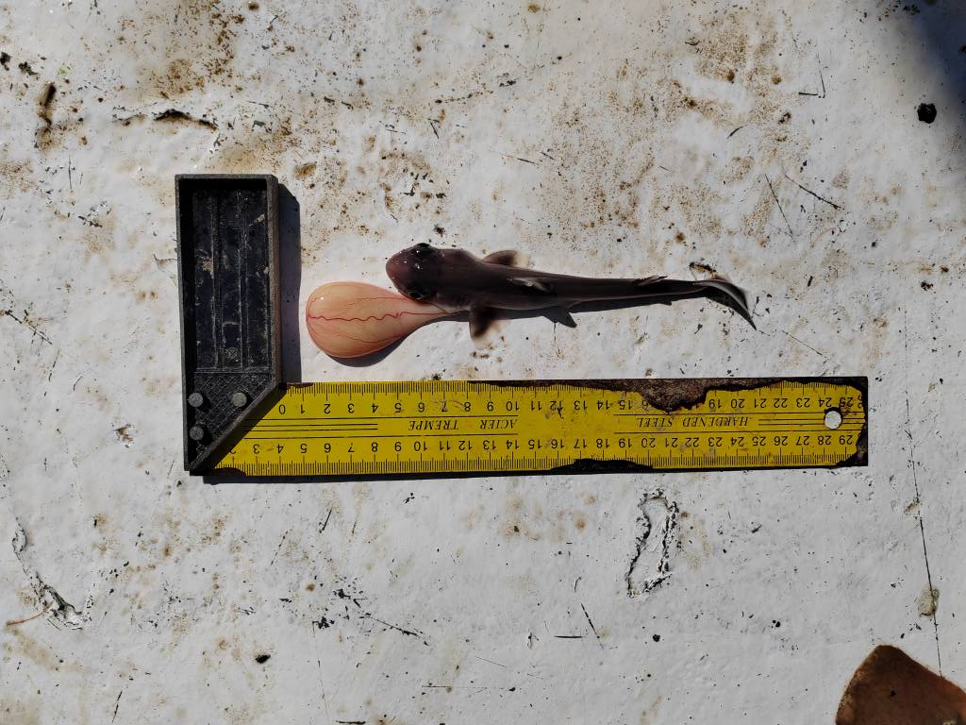
Figure 4. Dorsal view of the Squalus blainville neonates.
The total length range was 68.9 cm to 120.2 cm and the total weight values ranged from 568.2 g to 2010.3 g. The length-weight relationship of S. blainville was calculated as W = 0.0005 x L^{3.0277} (R² = 0.9303) for all samples except for embryos (Table 1, Figure 5). The “b” value, which using least-squares regression, was higher than “3” for all individuals indicates that this species exhibited positive allometric growth and was found to be statistically significant (P < 0.05; t_{test} > t_{0.05,N=47} = 1.67).
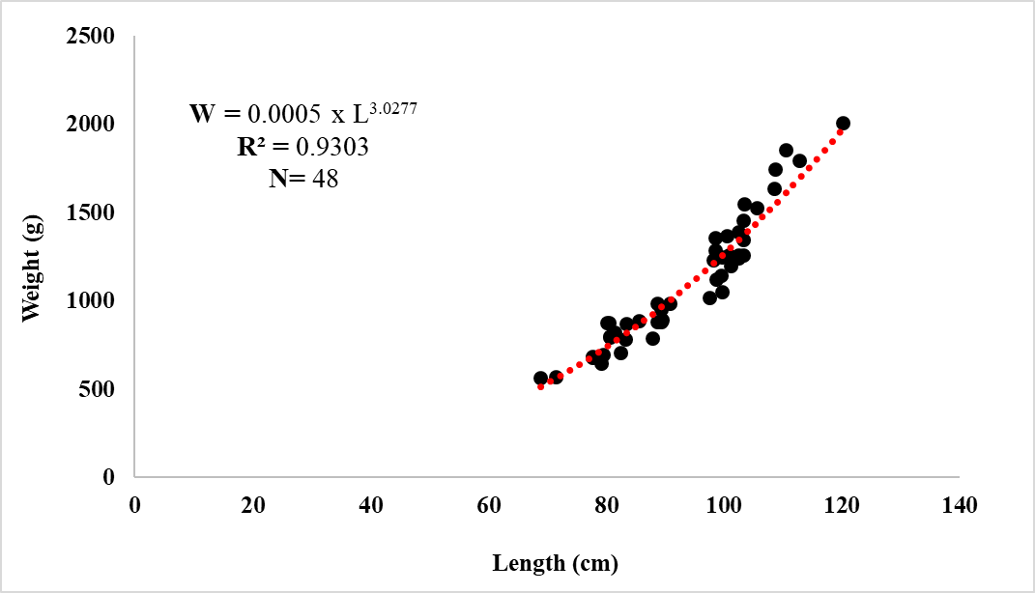
Figure 5. Length-weight relationships of Squalus blainville specimens.
Discussion
Scientific data for chondrichthyans related to life parameters, particularly for the Mediterranean area, are available only for a few common species (Fowler et al., 2005). In Turkey, limited research has been conducted on sharks, with a significant portion focusing on distribution and bycatch data only (Yağlıoglu et al., 2015; Başusta et al., 2016; Kabasakal, 2021a, b; Gül et al., 2022; Kabasakal et al., 2023). To date, studies on S. blainville length-weight relationships in the Mediterranean Sea are given in Table 1.
Table 1. Length-weight relationships studies on Squalus blainville in the Mediterranean Sea.
References | N | a | b | R² | Study Area
Cannizzaro et al. (1995) | 1038 | 0.0033 | 3.09 | 0.97 | Sicilian Channel
Merella et al. (1997) | 27 | 0.0012 | 3.37 | 0.98 | Balearic Islands
Pallaoro et al. (2005) | 88 | 0.0035 | 3.06 | 0.96 | Eastern Adriatic Sea
İşmen et al. (2007) | 299 | 0.00345 | 3.06 | 0.98 | North Aegean Sea
İşmen et al. (2009) | 27 | 0.0030 | 3.07 | 0.98 | North Aegean Sea
Bök et al. (2011) | 18 | 0.00004 | 2.48 | 0.95 | Sea of Marmara
Marouani et al. (2012) | 232 | 0.003 | 3.1 | 0.86 | Gulf of Gabès
Kousteni and Megalofonou  (2011) | 292 | 0.00000007 | 3.30 | 0.99 | Eastern Mediterranean
Güven et al. (2012) | 177 | 0.0033 | 3.06 | 0.99 | Eastern Mediterranean
Eronat and Özaydın (2014) | 308 | 0.0048 | 2.96 | 0.95 | Central Aegean Sea
Kousteni and Megalofonou  (2015) | 445 | 0.00000007 | 3.32 | 0.99 | Eastern Mediterranean
Lteif et al. (2016) | 11 | 0.0819 | 2.89 | 0.82 | Lebanase Marine Water
Öztekin et al. (2016) | 14 | 0.0053 | 2.95 | 0.97 | North Aegean Sea
Bengil (2022) | 184 | 0.0010 | 3.35 | 0.96 | Levantine Sea
Kabasakal et al. (2024) | 28 (F)  39 (M) | 0.00002 (F)  0.00005 (M) | 3.115 (F)  3.816 (M) | 0.79 (F)  0.71 (M) | Sea of Marmara
This Study | 48 | 0.0005 | 3.0277 | 0.93 | Eastern Mediterranean
N, number of samples; F, female; M, male; a, intercept; b, slope; R², coefficient of regression
The coefficient of determination (R²) for S. blainville was observed as 0.9303. The length-weight relationship (LWR) displayed a strong correlation between the length and weight of the specimens. Cannizzaro et al. (1995) reported the R² value of S. blainville at 0.97 in Sicilian Channel. Merella et al. (1997) found of R² value of S. blainville as 0.98 in Balearic Islands. Pallaoro et al. (2005) reported an R² value of S. blainville as 0.96 in the Eastern Adriatic
Sea. İşmen et al. (2007; 2009) were found of R² value of S. blainville as 0.98 in the North Aegean Sea. Bök et al. (2011) reported an R² value of S. blainville as 0.95 in the Sea of Marmara. Marouani et al. (2012) found of R² value of S. blainville as 0.98 in Gulf of Gabès. Kousteni and Megalofonou (2011; 2015) reported an R² value of S. blainville as 0.99 in the eastern Mediterranean. Güven et al. (2012) found of R² value of S. blainville as 0.99 in eastern Mediterranean. Eronat and Özaydın (2014) reported an R² value of S. blainville as 0.95 in the Central Aegean Sea. Lteif et al. (2016) found of R² value of S. blainville as 0.82 in Eastern Mediterranean. Öztekin et al. (2016) reported an R² value of S. blainville as 0.97 in the North Aegean Sea. Bengil (2022) found of R² value of S. blainville as 0.96 in Levantine Sea. Kabasakal et al. (2024) reported R² value of S. blainville as 0.93 in the Sea of Marmara. The results of the study showed a similar correlation to the previous studies. When we compared our study with other studies on S. blainville, it was observed that the coefficient of determination (R²) results were different in each study but very close to each other (Table 1). The reason for these differences can be attributed to various factors such as gonad maturity, sex, nutrition, stomach fullness, health and preservation techniques (Turan et al., 2021; Doğdu and Turan, 2024; Uyan et al., 2024).
In our study, the result of the growth coefficient b values was found as 3.0277 and it was concluded that the growth type was positive allometric. Cannizzaro et al. (1995) reported the b value of S. blainville at 3.09 in Sicilian Channel. Merella et al. (1997) found of b value of S. blainville as 3.37 in Balearic Islands. Pallaoro et al. (2005) reported an b value of S. blainville as 3.06 in the Eastern Adriatic Sea. İşmen et al. (2007; 2009) found of b value of S. blainville as 3.06 and 3.07 in the North Aegean Sea, respectively. Bök et al. (2011) reported a b value of S. blainville as 2.48 in the Sea of Marmara. Marouani et al. (2012) found of b value of S. blainville as 3.1 in Gulf of Gabès. Kousteni and Megalofonou (2011; 2015) reported a b value of S. blainville as 3.30 and 3.32 in the eastern Mediterranean, respectively. Güven et al. (2012) found of b value of S. blainville as 3.06 in eastern Mediterranean. Eronat and Özaydın (2014) reported a b value of S. blainville as 2.96 in the Central Aegean Sea. Lteif et al. (2016) found of b value of S. blainville as 2.89 in eastern Mediterranean. Öztekin et al. (2016) reported a b value of S. blainville as 2.95 in the North Aegean Sea. Bengil (2022) found of b value of S. blainville as 3.35 in Levantine Sea. Kabasakal et al. (2024) reported an b value of S. blainville as 3.02 in the Sea of Marmara. The b value is directly related to the body shape of fish and may vary with the habitat or diet (Ricker, 1975). A b value close to 3 indicates that the body weight of the fish increases in parallel with the growth in length. Our study showed positive allometric growth. However, some previous studies have found negative allometric growth (Bök et al., 2011; Eronat and Özaydın 2014; Lteif et al., 2016; Öztekin et al., 2016). The minor discrepancies in the b values can be attributed to a multitude of factors, including variations in environmental conditions, biological parameters, population size and sampling methodologies e.g. (Ricker, 1975; Ergüden and Doğdu, 2020; Doğdu and Turan, 2021).
The presence of nursery areas, small juveniles, and pregnant females is necessary to declare an area as a nursery (Heupel et al., 2007). Heupel et al. (2007) suggested that an area requires three criteria to be identified as a nursery: (1) species are more commonly encountered in the area than other areas (2) species have a tendency to remain or return for extended periods, and (3) the area or habitat is repeatedly used across years. The data obtained in our study and previous studies in the region prove that this region is a breeding area for elasmobranch species (Yağlıoğlu et al., 2015; Başusta et al., 2021; Akyol and Şen, 2022).
In conclusion, our data provide evidence to recognize Iskenderun Bay as a nursery area for longnose spurdog sharks Squalus blainville, meeting all the criteria proposed to identify nursery areas (Castro, 1993; Heupel et al., 2007). These findings constitute the first documented evidence of a longnose spurdog shark nursery area in the Iskenderun Bay in Turkish marine waters.
Acknowledgements
This study was supported by Turquoise Coast Environment Fund-Turkey with the project “Restoration, Conservation and Monitoring of Shark and Stingray Species Habitats in Hatay Samandağ Hırlavuk Coast-TCEF-2024”, carried out by the Nature and Science Society (www.dogavebilim.com). Some part of this study was presented at the International Workshop on Elasmobranches, 05 July 2024, Iskenderun, Hatay, Türkiye.
Conflict of Interests
The author(s) declare that for this article they have no actual, potential or perceived conflict of interest.
Author Contributions
C.T., S.A.D. and A.S. performed all the experiments and drafted the main manuscript text. Authors reviewed and approved the final version of the manuscript.
Ethics Committee Permission
No ethics committee permissions are required for this study.
References
Akyol, O., Şen, H. (2022). Recent observations on sandbar shark Carcharhinus plumbeus (Carchardinidae) around sea cages of fish farms in Iskenderun Bay (Türkiye, Eastern Mediterranean Sea). Journal of the Black Sea/Mediterranean Environment, 28(3), 361-366.
Başusta, N., Başusta, A., Özbek, E. Ö. (2016). Cartilaginous Fishes and Fisheries in the Mediterranean Coast of Turkey. In The Turkish Part of the Mediterranean Sea; Marine Biodiversity, Fisheries, Conservation and Governance (pp. 248-274). Turkish Marine Research Foundation (TUDAV).
Başusta, N., Başusta, A., Özyurt, C. E. (2021). Evidence of a Second Nursery Area of the Sandbar Shark, Carcharhinus plumbeus (Nardo, 1827) in the Eastern Mediterranean Sea. Mediterranean Marine Science, 22(1), 20-26.
Bayhan, Y. K., Ergüden, D., Cartes, J. E. (2018). Deep sea fisheries in Mersin Bay, Turkey, Eastern Mediterranean: Diversity and abundance of shrimps and benthic fish fauna. Acta Zoologica Bulgarica, 70 (2): 259-268.
Bengil, E. G. T. (2022). Biology and ecology of Squalus blainville (Risso, 1827) from the eastern Mediterranean. Thalassas: An International Journal of Marine Sciences, 38(2), 1423-1432.
Bengil, E. G. T., Başusta, N. (2018). Chondrichthyan species as by-catch: a review on species inhabiting Turkish waters. Journal of the Black Sea/Mediterranean Environment, 24(3), 288-305.
Bök, T. D., Göktürk, D., Kahraman, A. E., Alıçlı, T. Z., Acun, T., Ateş, C. (2011). Length-weight relationships of 34 fish species from the Sea of Marmara, Turkey. Journal of Animal and Veterinary Advances, 10(23), 3037-3042.
Cannizzaro, L., Rizzo, P., Levi, D., Gancitano, S. (1995). Age determination and growth of Squalus blainvillei (Risso, 1826). Fisheries Research, 23(1-2), 113-125.
Castro J. I. (1993). The shark nursery of Bulls Bay, South Carolina, with a review of the shark nurseries of the the southeastern coast of the United States. Environmental Biology of Fishes, 38, 37-48.
Damalas, D., Vassilopoulou, V. (2011). Chondrichthyan by-catch and discards in the demersal trawl fishery of the Central Aegean Sea (Eastern Mediterranean). Fisheries Research, 108(1), 142-152.
Doğdu, S. A., Turan, C. (2021). Genetic and morphological impact of the cultured gilthead sea bream (Sparus aurata Linnaeus, 1758) populations on wild stocks. Egyptian Journal of Aquatic Biology and Fisheries, 25(4), 499-511.
Doğdu, S. A., Turan, C. (2024). Biological and growth parameters of Plotosus lineatus in the Mediterranean Sea. PeerJ, 12, e16945.
Dulvy, N. K., Fowler, S. L., Musick, J. A., Cavanagh, R. D., Kyne, P. M., Harrison, L. R., Carlson, J. K., Davidson, L. N. K., Fordham, S. V., Francis, M. P., Pollock, C. M., Simpfendorfer, C. A., Burgess, G. H., Carpenter, K. E., Compagno, L. J. V., Ebert, D. A., Gibson, C., Heupel, M. R., Livingstone, S. R., Sanciangco, J. C., Stevens, J. D., Valenti, S., White, W. T. (2014). Extinction risk and conservation of the world’s sharks and rays. Elife, 3, e00590.
Ebert, D. A., Dando, M. (2020). Field guide to sharks, rays and chimaeras of Europe and the Mediterranean (Vol. 20). Princeton University Press.
Ebert, D. A., Fowler, S., Dando, M. (2021). A pocket guide to sharks of the world (Vol. 23). Princeton University Press.
Ergenler, A., Turan, F. (2024). Trace metal induced genotoxic damage in nursehound shark, Scyliorhinus stellaris, from the northeastern Mediterranean. Tethys Environmental Science, 1(2), 105-116.
Ergüden, D., Doğdu, S. A. (2020). Age, growth and mortality estimates of Sillago suezensis from Iskenderun Bay, northeastern Mediterranean Sea. Cahiers de Biologie Marine, 61, 81-90.
Erguden, D., Kabasakal, H., and Ayas, D. (2022). Fisheries bycatch and conservation priorities of young sharks in the Eastern Mediterranean. Zoology in the Middle East, 68(2), 135-144.
Eronat, E. G. T., Özaydın, O. (2014). Length-weight relationship of cartilaginous fish species from central Aegean Sea (Izmir Bay and Sığacık Bay). Ege Journal of Fisheries and Aquatic Sciences, 31(3), 119-125.
Finucci, B., Derrick, D. Pacoureau, N. 2021. Squalus blainville. The IUCN Red List of Threatened Species 2021: e.T169229923A179510767.
Gül, G., Yokeş, M. B., Demirel, N. (2022). The Occurrence and feeding of a critically endangered shark species, Oxynotus centrina in the Sea of Marmara. Journal of Fish Biology, 101(3), 728-735.
Güven, O., Kebapçıoğlu, T., Deval, M. C. (2012). Length–weight relationships of sharks in Antalya Bay, eastern Mediterranean. Journal of Applied Ichthyology, 28(2), 278-279.
Heupel, M. R., Carlson, J. K., Simpfendorfer, C. A. (2007). Shark nursery areas: concepts, definition, characterization and assumptions. Marine Ecology Progress Series, 337, 287-297.
Kabasakal, H. (2020). A field guide to the sharks of Turkish waters. Turkish Marine Research Foundation (TUDAV).
Kabasakal, H. (2021a). A review of shark biodiversity in Turkish Waters: updated inventory, new arrivals, questionable species, and conservation issues. Annales Series Historia Naturalis, 31(2), 181-194
Kabasakal, H. (2021b). Chapters from the life story of common angel shark, Squatina squatina, from Turkish waters: a historical, ethnoichthyological and contemporary approach to a little-known shark species. Journal of the Black Sea/Mediterranean Environment, 27(3), 317-341.
Kabasakal, H., Uzer, U., Gönülal, O., Akyüz, O., Karakulak, F. S. (2023). Morphometric analyses of the angular roughshark, Oxynotus centrina (Oxynotidae), with biological notes on specimens from the Sea of Marmara. Journal of Ichthyology, 63(6), 1025-1036.
Kabasakal, H., Uzer, U., Gönülal, O., Karakulak, F. S. (2024). Bioecological lessons learned from the neonate longnose spurdogs Squalus blainville (Squaliformes: Squalidae) suggest a potential nursery ground in the Marmara Sea. Acta Adriatica, 65, 1-14.
Kousteni, V., Megalofonou, P. (2011). Reproductive biology and embryonic development of Squalus blainvillei in the eastern Mediterranean Sea. Scientia Marina, 75(2), 237-249.
Kousteni, V., Megalofonou, P. (2015). Aging and life history traits of the longnose spiny dogfish in the mediterranean sea: new insights into conservation and management needs. Fisheries Research, 168, 6-19.
Lteif, M., Mouawad, R., Jemaa, S., Khalaf, G., Lenfant, P., Verdoit-Jarraya, M. (2016). The length-weight relationships of three sharks and five batoids in the lebanese marine waters, eastern mediterranean. The Egyptian Journal of Aquatic Research, 42(4), 475-477.
Marouani, S., Kadri, H., Saidi, B., Morize, E., Bouain, A., Bradai, M. N. (2012). Age, growth, longevity, natural mortality and maturity of the longnose spurdog, Squalus blainvillei (Chondrichthyes: Squalidae), in the Gulf of Gabès (Central Mediterranean Sea). Cahiers de Biologie Marine, 53(2), 197-204.
Martinho, F., Sá, C., Falcão, J., Cabral, H. N., and Pardal, M. Â. (2012). Comparative feeding ecology of two elasmobranch species, Squalus blainville and Scyliorhinus canicula, off the coast of Portugal. Fishery Bulletin, 110, 71-84.
Merella, P., Quetglas, A., Alemany, F., Carbonell, A. (1997). Length-weight relationship of fishes and cephalopods from the Balearic Islands (Western Mediterranean). Naga, 20, 66-68.
Nieto, A., Ralph, G. M., Comeros-Raynal, M. T., Kemp, J., García Criado, M., Allen, D. J., Dulvy, N. K., Walls, R. H. L., Williams, J. T. (2015). European Red List of marine fishes. Publications Office of the European Union.
Öztekin, A., Özekinci, U., Daban, İ. B. (2016). Length-weight relationships of 26 fish species caught by longline from the Gallipoli Peninsula, Turkey (Northern Aegean Sea). Cahiers de Biologie Marine, 57(4), 335-342.
Pallaoro, A., Jardas, I., Santic, M. (2005). Weight-length relationships for 11 chondrichthyan species in the eastern Adriatic Sea. Cybium, 29(1), 93-96.
Ricker, W. E. (1975). Computation and interpretation of biological statistics of fish populations. The Blackburn Press.
Simpfendorfer, C. A., Kyne, P. M. (2009). Limited potential to recover from overfishing raises concerns for deep-sea sharks, rays and chimaeras. Environmental Conservation, 36(2), 97-103.
Sion, L., D Onghia, G., Tursi, A., Mytilineou, C. (2003). First data on distribution and biology of Squalus bainvillei (Risso, 1826) from the eastern Mediterranean Sea. Journal of Northwest Atlantic Fishery Science, 31, 213.
Sokal, R. R., Rohlf, F. J. (1987). Introduction to Biostatistics (2nd ed.). Dover Publications.
Turan, C., Ergenler, A., Doğdu, S. A., Turan, F. (2021). Age and growth of red sea goatfish, Parupeneus forsskali from Iskenderun Bay, Northeastern Mediterranean Sea. Journal of Ichthyology, 61, 758-763.
Turan, C., Gürlek, M., Doğdu, S. A., Ergüden, D., Uyan, A., Ergenler, A., Soldo, A. (2024). Phylogenetic relationships and conservation implications of shark species from Turkish waters. Annales, Series Historia Naturalis Archives, 34 (1), 27-34.
Uyan, A., Turan, C., Doğdu, S. A., Gürlek, M., Yağlıoğlu, D., Sönmez, B. (2024). Genetic and some bio-ecological characteristics of lessepsian lizardfish Saurida lessepsianus from the northeastern Mediterranean Sea. Tethys Environmental Science, 1(1), 1-16.
Yağlıoglu, D., Deniz, T., Gürlek, M., Ergüden, D., Turan, C. (2015). Elasmobranch bycatch in a bottom trawl fishery in the Iskenderun Bay, northeastern Mediterranean. Cahiers de Biologie Marine, 56(3), 237-243.
Zar, J. H. (1999). Biostatistical Analysis (4th ed.). Prentice Hall.

