
Population Genetic Analysis of Garfish Belone belone from the Bulgarian and Turkish Coasts of the Black Sea
Cemal Turan^{1*}, Petya Pavlova Ivanova² , Servet Ahmet Doğdu^{1,3} , Deniz Ergüden¹ , Violin Stoyanov Raykov² , Maria Yankova² , Deniz Yağlioğlu⁴ , Ayşegül Ergenler¹ , Ivelina Zlateva² , Nina Stoycheva Dzhembekova²
¹Molecular Ecology and Fisheries Genetics Laboratory, Faculty of Marine Sciences and Technology, Iskenderun Technical University, 31200 Iskenderun, Hatay, Türkiye.²Marine Biology and Ecology Department, Institute of Oceanology, Bulgarian Academy of Sciences, First May Street 40, P.O. Box 152, Varna, 9000, Bulgaria. ³Iskenderun Technical University, Maritime Technology Vocational School of Higher Education, Underwater Technologies, 31200 Iskenderun, Hatay, Türkiye. ⁴Department of Biology, Faculty of Arts and Sciences, Duzce University, 81620 Düzce, Türkiye.

Research Article | Abstract  Belone belone is an epipelagic migratory species widely distributed in the northeast Atlantic, Mediterranean and Black Sea. It is a fish species of high economic importance especially for the Mediterranean and Black Sea. An understanding of the genetic structure and diversity of marine fish populations can inform the development of fishing restrictions aimed at preventing overfishing. In this study, we were to investigate the population structure of Belone belone from the Bulgarian and Turkish coasts of the Black Sea with simultaneous use of the mtDNA COI gene and morphology. The results show that genetic diversity was much lower in the Nesebar (0.0004) population than in the Akçakoca population (0.0154). The average genetic diversity value between populations was 0.0107. A total of five haplotypes were found out of 40 sequences, and haplotype I was a common haplotype between populations. The average haplotype diversity was found to be 0.4513. Haplotype diversity within the population observed was 0.5947 in the Akçakoca and 0.1947 in the Nesebar population. In morphological analyses, 16 morphometric and 6 meristic characters were used. According to Canonical Discriminant Function Analysis, the first discriminant function expressed 100% of the total variation. According to the PCA, the first principal component accounted for 23.4% of the total variation and the second principal component accounted for 16.03% of the total variation. The present study revealed the genetic and morphologic differentiation coupled with low genetic diversity at the margins of the geographical separation of B. belone in Bulgaria and Turkish marine waters. Therefore, The Bulgarian and Turkish sides should consider urgent mutual management measures for the conservation of B. belone populations in Bulgarian and Turkish marine waters.  Keywords: Belone belone, garfish, population genetic, black sea, mtDNA COI
Citation: Turan, C., Ivanova, P. P., Doğdu, S. A., Ergüden, D., Raykov, V. S., Yankova, M., Yağlıoğlu, D., Ergenler, A., Zlateva, I., Dzhembekova, N. S. (2024). Population Genetic Analysis of Garfish Belone belone from the Bulgarian and Turkish Coasts of the Black Sea. Tethys Env. Sci. 1(3): 152-163.
DOI:
Received: 12 May 2024
Accepted: 20 September 2024
Available Online: 30 September 2024
Publication Date: 30 September 2024

Copyright
2024 Turan et al.,
Distributed Under
CC-BY 4.0


Introduction
Garfish Belone belone (Linnaeus, 1761) is an epipelagic migratory species that is widely distributed in the north-eastern Atlantic, Mediterranean as well as the Black Sea and mainly found in offshore areas except for the spawning period (Zorica et al., 2011; Zorica and Čikeš Keč, 2011). There have been limited studies concerning some aspects on biometric, biological, and genetic analysis (Dobrovolov et al. 1980; Prodanov 1982; Dorman, 1988; Uçkun et al., 2004; Samsun and Sağlam, 2021; Çayır and Bostancı, 2022; Yankova et al., 2023) carried out for populations that inhabited the Bulgarian and Turkish Black Sea coasts. Despite its wide distribution in the Black Sea, the knowledge of biology, ecology and genetics of its populations is still scarce.
Reliable management of fish populations should be based on accurate biological data for the sustainable use of biological marine resources (Carvalho and Hauser, 1994; Turan and Yağlıoğlu, 2010; Doğdu and Turan, 2021; Uyan et al., 2024). In marine species, demographic processes and fishery activities can vary considerably between populations. The potential capacity of populations to adapt and evolve as independent biological entities in different environmental conditions depends on the exchange of individuals between populations. Identification of intraspecific groups of marine fish species with different genetic and morphological characteristics is essential for understanding population dynamics and the estimation of sustainable harvests (Begg et al., 1999; Turan et al., 2019).
Haplotype diversity and nucleotide diversity are important indicators in terms of identifying mtDNA genetic variation in between and within populations (Hauser et al., 2001; Turan et al., 2015a; Turan et al., 2023a). Among the most common mitochondrial genes used in detecting genetic diversity and population structure, the mtDNA cytochrome c oxidase subunit I (COI) gene represents a useful genetic marker to analyse population genetic diversity and structure in many marine species (Ivanova et al., 2021; Wei et al., 2023; Yankova et al., 2023). COI is mainly used for species identification and phylogeny of Belone belone from the North Atlantic and Mediterranean (Knebelsberger et al. 2014; Yankova et al., 2023; Turan et al., 2023b), and there has been a limited study about genetic diversity and population structure of garfish populations based on COI gene (Yankova et al., 2023). The studies on population genetic structure and genetic diversity of marine fish species could guide for the establishment of fishing restrictions to prevent overharvesting (Turan et al., 2015b).
The objective of the present study was to investigate the population structure of Belone belone from the Bulgarian and Turkish coasts of the Black Sea with simultaneous use of the mtDNA COI gene and morphology.
Material and Methods
Molecular genetic
Belone belone specimens were collected from Akçakoca on the Turkish coast and Nesebar on the Bulgarian coast (Figure 1). All samples were examined morphologically, and muscle and/or fin tissues were taken for genetic analyses. Identification of the specimens was done following Collete and Parin (1990). The specimens were delivered to the laboratory and stored in a deep freeze at -30°C until DNA extraction. Total genomic DNA was extracted from muscle or fin tissues using a modified phenol-chloroform isoamyl alcohol method (Sambrook et al. 1989). The mtDNA COI gene was amplified through PCR with universal primers (Ward et al., 2005). This study does not require Local Ethics Committee Approval as experimental animals were not used in this study.
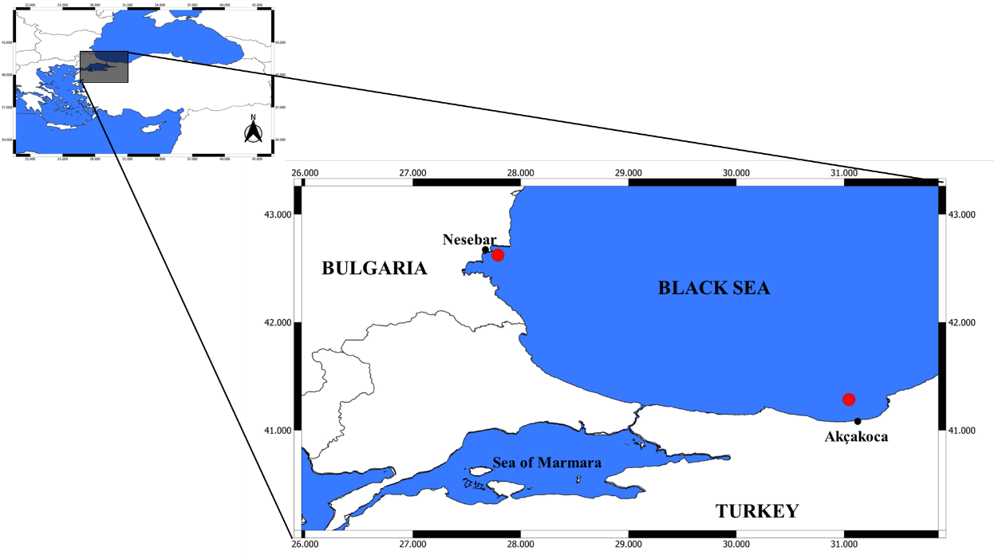
Figure 1. Sampling locations of Belone belone from Turkish and Bulgarian coasts.
Table 1. Universal primers of COI region.
COI_F: | 5’-TCA ACC AAC CAC AAA GAC ATT GGC AC-’3’
COI_R: | 5’-ACT TCA GGG TGA CCG AAG AAT CAG AA-’3’
The PCRs were conducted in a 50 µl total volume with 0.4 uM of each primer, 0.2 mM of dNTP and 1 U of Taq DNA polymerase in a PCR buffer that included 20 mM of Tris–HCl (pH 8.0), 1.5 mM of MgCl2, 15 mM of KCl and 1.5 µl template DNA. The denaturation step was at 94°C for 30 s, 60°C for 30 s, and 75°C for 45 s for 35 cycles followed by a final extension for 7 min at 75 °C. The PCR products were visualized using electrophoresis on 1.5 % agarose gel. DNA sequencing was performed by chain termination method by Sanger et al. (1977) with Bigdye Cycle Sequencing Kit V3.1 and ABI 3130 XL genetic analyzer. The DNA sequence analyses were performed on 10 sample specimens of various sizes from each population. The initial alignments of partial mtDNA sequences were performed with the Clustal W (Thompson et al., 1994), and the final alignment was completed manually with BioEdit (Hall, 1999). Haplotype diversity, genetic diversity (Nei, 1987), and the mean number of pairwise differences (Tajima, 1983) were calculated using the program of Arlequin (Schneider et al., 2000). Haplotypes were obtained with the DnaSP 6 program (Rozas, 2017). The minimum spanning tree (MST) of haplotypes was revealed with the Popart (Leigh et al., 2015).

Morphologic
The BioMorph described for fish body morphometrics (Turan, 1999; Collette, 2016; Kutlu and Turan, 2018) was used to construct a network on B. belone. Digital images from the collected samples were acquired with a good-quality digital camera. The distances on the images were analyzed using BioMorph (Kutlu and Turan, 2018), the image processing tool specially developed for morphometric measurements and analysis of fish populations. Morphometric measurements from B. belone (Figure 2) were taken as; TL: total length, FL: fork length, SL: standard length, PreD: Predorsal distance, PostD: Postdorsal distance, PreA: preanal distance, PostA: Postanal distance, PreV: preventral distance, HL: head length, 12-13: eye diameter (ED), H: maximum body height (MBH), h: minimum body height (MBH), 3-4: dorsal fin base length (DFB), 8-9: anal fin base length (ABL), 14-15: pectoral fin length (PFL), 10-18: ventral fin length (VFL). In addition, meristic characters such as Dorsal fin ray number (DF), anal fin ray number (AF), pectoral fin ray number (PF), Number of upper teeth (UpT), Number of gill rakers (GR), Number of vertebrae (V) were also taken from the specimens.
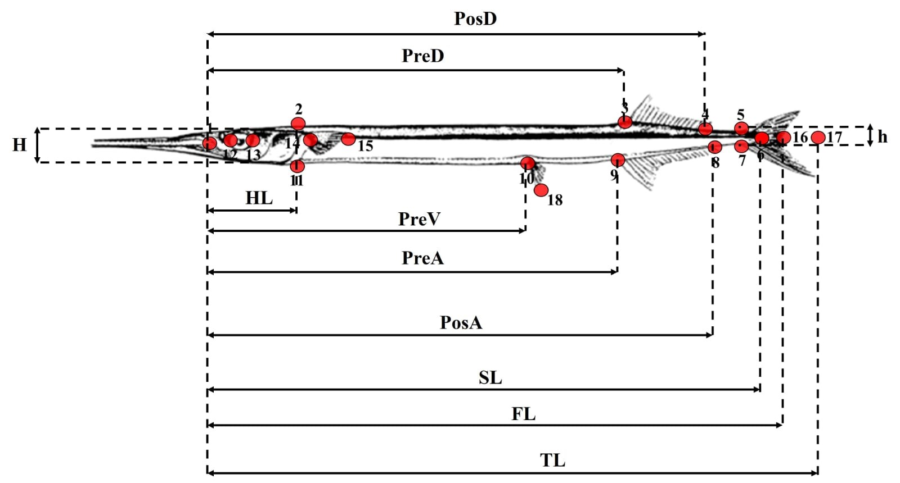
Figure 2. Morphometric measurements of garfish. TL: total length, FL: fork length, SL: standard length, PreD: Predorsal distance, PostD: Postdorsal distance, PreA: preanal distance, PostA: Postanal distance, PreV: preventral distance, HL: head length, 12-13: eye diameter, H: maximum body height, h: minimum body height, 3-4: dorsal fin base length, 8-9: anal fin base length (ABL), 14-15: pectoral fin length, 10-18: ventral fin length (Figure: Collette, 2016).
Most of the variability in morphological characters is due to size (Turan, 1999). Thus, shape analysis should be free from the effect of size to avoid misinterpretation of the results (Strauss, 1985). Therefore, it was necessary to remove the size effect from the morphological data. Thus, the size effect from the shape measures was removed according to Turan (1999). To reveal the relationship between populations, Canonical Discriminant Function Analysis (DFA), Principal Component Analysis (PCA), and Hierarchical Cluster Analysis were used to analyze morphological data. In addition, the hierarchical relationship between species was revealed according to the nearest neighbour participation clustering method. SPSS 18.0 and SYSTAT 13 and R Studio statistical data analysis package programs were used to determine the degree and type of morphological differences between the populations.
Results
Genetic
The mtDNA COI dataset revealed 19 variable and 549 conservative nucleotide sites, 17 of which were parsimony informative over 568 bp sequences. The best model (TN93) was provided by the MEGAX software (Hall, 2013). The mean nucleotide frequencies of COI were estimated as 25.9% (A), 34.0% (T), 24.80% (C), and 15.4% (G).
Genetic diversity is much lower in the Nesebar population than in the Akçakoca population (Table 2). The average genetic diversity value between populations was 0.0107.
Table 2. Mean genetic diversity values within B. belone populations.
Population | Genetic Diversity
Akçakoca (AKC) | 0.0154
Nesebar (BUL) | 0.0004
Five haplotypes were found out of 40 sequences, and haplotype 1 was a common haplotype between populations (Table 3). The average haplotype diversity was found to be 0.4513. Haplotype diversity within the population observed was 0.5947 in the Akçakoca and 0.1947 in the Nesebar population. The minimum spanning tree (MST) analysis revealed a high amount of mutation between the species (Figure 3).
Table 3. Frequencies of COI haplotypes in B. belone populations and distribution according to populations.
Haplotype | Akcakoca | Nesebar | Total
Hap_1 | 11 | 18 | 29
Hap_2 | 7 | - | 7
Hap_3 | 2 | - | 2
Hap_4 | - | 1 | 1
Hap_5 | - | 1 | 1
Total | 20 | 20 | 40
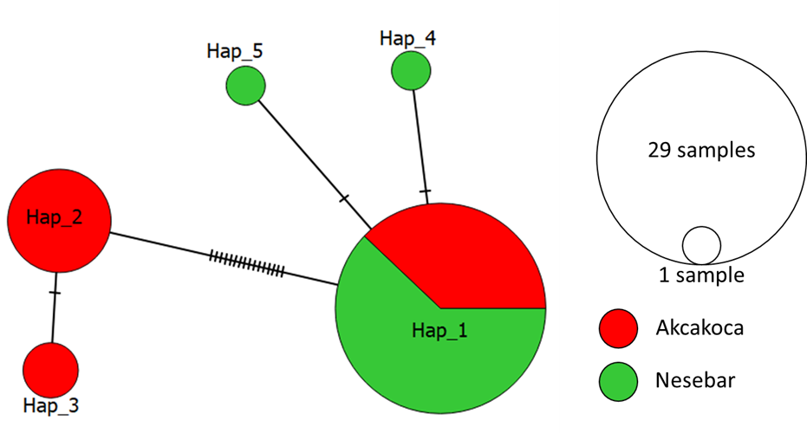
Figure 3. Minimum spanning tree for the COI, showing the evolutionary mutation relationships between haplotypes.
The genetic distance value between populations was found to be 0.0134 (P<0.001). To test whether the populations were in equilibrium, the neutrality test of Tajima (1989) was applied (Table 4). The Tajima neutrality test (D) value was found as 1.343342. With this test, a DNA sequence that develops naturally is distinguished from a DNA sequence that develops as part of an unnatural process.
Table 4. Tajima's test for the presence of neutrality (Tajima, 1989).
m | S | Ps | Θ | π | D
40 | 19 | 0.033451 | 0.007864 | 0.010423 | 1.069883
m, number of sequences; S, number of segregating sites; Ps, polymorphic site rate; Θ, population mutation rate; π, average pairwise distance; D, Tajima’s D.
Morphologic
In morphological analyses, 16 morphometric and 6 meristic characters were used. According to Canonical Discriminant Function Analysis, the first discriminant function expressed 100% of the total variation (Table 5). Since only one discriminant function was obtained, the canonical graph showing the morphometric relationship between populations could not be drawn. Furthermore, it was determined that 100% of the total samples were classified correctly into their group in the correct classification of individuals into its original groups, indicating that the populations are morphologically different from each other.

The graph of the first and second principal component values obtained as a result of PCA to examine the importance of morphological characters that are effective in the separation of populations is given in Figure 1. When the significance levels of the characters that distinguish the populations from each other were analyzed in PCA, it was observed that UpT, PreV, PreA, V, PreD, and PostO played a primary role in the first component, and UpT, PreV, PreA, and ABL were effective in the second component. Vector length indicates the degree of activity of the trait it symbolizes. The degree of contribution of each character (contrib) is also given in colour (Figure 4).
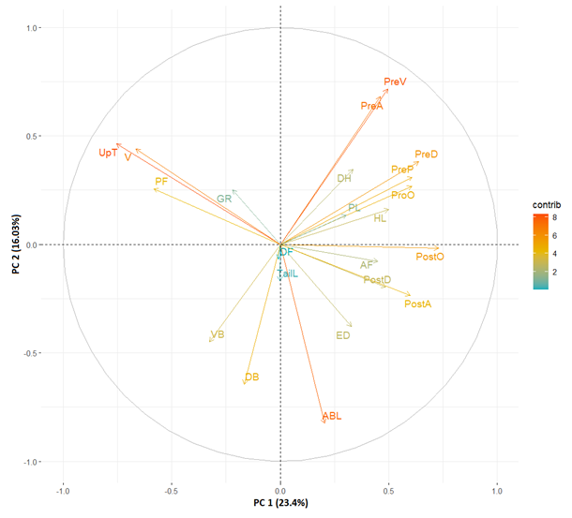
Figure 4. The plot of the first and second principal components of the importance levels of morphological characters involved in the differentiation between populations according to Principal Component Analysis (PCA) of B. belone populations in Turkish and Bulgarian coasts. Vector length indicates the degree of activity of the trait it symbolizes. The degree of contribution of each character (contrib) is also given in colour.
According to the PCA, the first principal component accounted for 23.4% of the total variation and the second principal component accounted for 16.03% of the total variation (Table 5).

Table 5. Distribution of the variance in the first 10 main components obtained from the Principal Component Analysis.
PCs | Eigenvalue | % of Variance | Cumulative %
1 | 5.1580842773 | 23.445837624 | 23.44584
2 | 3.5269551273 | 16.031614215 | 39.47745
3 | 2.7875078024 | 12.670490011 | 52.14794
4 | 2.1354606279 | 9.706639218 | 61.85458
5 | 1.5406653905 | 7.003024502 | 68.85761
6 | 1.2540768461 | 5.700349301 | 74.55795
7 | 1.1148432768 | 5.067469440 | 79.62542
8 | 1.0563774729 | 4.801715786 | 84.42714
9 | 0.8314740160 | 3.779427346 | 88.20657
10 | 0.6330644990 | 2.877565905 | 91.08413
Discussion
Results obtained from genetic and morphologic analyses indicated that there is genetic and morphological structuring of B. belone populations in Turkish and Bulgarian coasts. Mitochondrial mtDNA analysis coupled with morphological analysis indicated two genetically identifiable populations, Akcakoca on the Turkish coast and Nesebar on the Bulgarian coast. Five haplotypes emerged from 40 individuals due to low polymorphism detected in the COI dataset of mtDNA. The average haplotype and nucleotide diversity within populations were 0.4513 and 0.0107 respectively. Vinas et al. (2010) investigated Sarda species using D-loop sequence analysis and reported the nucleotide diversity to be 0.071 for Mediterranean and 0.061 for Atlantic populations. Turan et al. (2015) reported the overall nucleotide diversity of Sarda sarda to be 0.0013. Higher nucleotide diversity was observed in Akçakoca (0.026693) on the Turkish coast than in Nesebar (0.0004) on the Bulgarian coast. The phylogenetic relationships among the identified haplotypes revealed a remarkable number of unique haplotypes between populations, indicating restricted gene flow between the geographically isolated populations. Complementarily, except for the most abundant haplotype (Hap_I), no haplotypes were shared between the populations. Moreover, the detected low haplotype diversity may indicate past bottleneck effects on B. belone populations in the Black Sea. Therefore, since the catch of B. belone in Turkish waters has fallen very low, there may have been a bottleneck effect on B. belone populations in the Black Sea in the past. On the other hand, B. svetovidovi populations are falsely fished as B. belone in Turkish waters, hiding the depletion of B. belone in Turkish waters.
The detected significant genetic divergence indicates that restricted levels of gene flow are occurring between stocks of B. belone, relevant to geographical distance. Morphologic data were also congruent with genetic data. The marine species usually show low genetic differentiation due to a lack of major geographical barriers to dispersal and gene flow (Avise et al., 1987; Ward et al., 1994; Jacobs et al., 2004). Marine species with high dispersal and large population size such as pelagic fish often result in low or no genetic structuring across large geographic scales. Genetic divergence between populations of B. belone was found to be reasonably high in the present study (0.0134) in comparison to other marine species. Mean nucleotide divergence among populations of marine species was 0.00055 for striped red mullet M. surmelatus (Mamuris et al., 2001), 0.00027 for the long-tailed hake, Macruronus magellanicus (D'Amato and Carvalho, 2005), 0.000038 for sardine Sardina pilchardus (Carvalho and Pitcher, 1994), 0.0021 for lizardfish Saurida lessepsianus (Uyan et al., 2024).
The most obvious differentiation between B. belone populations between Turkish and Bulgarian coasts are the Number of upper teeth (UpT), preanal distance (PreA), preventral distance (PreV), number of vertebrae (V), anal base length (ABL). Such variability may be the result of different selective systems generated by the type of habitat where the fish live (Swain and Foote, 1999) creating environmental distinctions. Sampling regions have different environmental characteristics which may give rise to morphological adaptations, as well. Furthermore, different fishing activities or pressures may have caused the detected morphologic divergence between isolated populations of B. belone in Bulgaria and Turkey.
In conclusion, the present study revealed the genetic and morphologic differentiation coupled with low genetic diversity at the margins of the geographical separation of B. belone in Bulgaria and Turkish marine waters. Therefore, The Bulgarian and Turkish sides should consider urgent mutual management measures for the conservation of B. belone populations in Bulgarian and Turkish marine waters.
Acknowledgements
This research was supported by the Scientific & Technological Research Council of Turkey (TUBITAK-121N777) and the Bulgarian Academy of Sciences (BAS-IC-TR/1/2022-2023). The authors thank TUBITAK for their support.
Conflict of Interest
The authors declare that they have no competing interests.
Author Contributions
The authors performed all the experiments and drafted the main manuscript text. All authors reviewed and approved the final version of the manuscript.
Ethical Approval Statements
In this study, no experimental animals were used. Therefore, Local Ethics Committee Approval is not required.
Data Availability Statement
The data used in the present study are available upon request from the corresponding author.
References
Avise, J. C., Arnold, J., Ball, R. M., Bermingham, E., Lamb, T., Neigel, J. E., Saunders, N. C. (1987). Intraspecific phylogeography: the mitochondrial DNA bridge between population genetics and systematics. Annual Review of Ecology and Systematics, 489-522.
Begg, G. A., Friedland, K. D., Pearce, J. B. (1999). Stock identification and its role in stock assessment and fisheries management: an overview. Fisheries Research, 43(1-3), 1-8.
Carvalho, G. R., Hauser, L. (1994). Molecular genetics and the stock concept in fisheries. Reviews in Fish Biology and Fisheries, 4, 326-350.
Carvalho, G. R., Pitcher, T. J. (2012). Molecular genetics in fisheries. Springer Science & Business Media.
Çayır, Z., Bostancı, D. (2022). Kocaeli (Türkiye)’nin Farklı Sahillerinde Yaşayan Zargana Belone belone için Boy-Ağırlık ve Boy-Boy İlişkilerinin Tespiti. Karadeniz Fen Bilimleri Dergisi, 12(1), 33-42.
Collette, B. B. (2016) Belonidae. In: Carpenter KE, De Angelis N (Eds) The living marine resources of the Eastern Central Atlantic. Volume 3: Bony fishes part 1 (Elopiformes to Scorpaeniformes). FAO Species Identification Guide for Fishery Purposes. FAO, Rome, 914 pp.
Collette, B.B. and Parin, N.V. (1990). Belonidae. In: J.C. Quero, J.C. Hureau, C. Karrer, A. Post and L. Saldanha (eds), Check-list of the fishes of the eastern tropical Atlantic (CLOFETA), pp. 592-597. UNESCO, Paris
D'Amato, M. E., Carvalho, G. R. (2005). Population genetic structure and history of the long-tailed hake, Macruronus magellanicus, in the SW Atlantic as revealed by mtDNA RFLP analysis. ICES Journal of Marine Science, 62(2), 247-255.
Dobrovolov, I., Prodanov, K., Dobrovolova, S. V. (1980). Electrophoretic studies on lactate dehydrogenase (LHD) variants in Black Sea garfish Belone belone (L). Izvestiq Institute Ribni Resursi, 18, 155-160.
Doğdu, S. A, Turan, C. (2021). Genetic and morphological impact of the cultured gilthead sea bream (Sparus aurata Linnaeus, 1758) populations on wild stocks. Egyptian Journal of Aquatic Biology and Fisheries, 25(4), 499-511.
Dorman, J. A. (1988). Diet of the garfish, Belone belone (L.), from Courtmacsherry Bay, Ireland. Journal of Fish Biology, 33(3), 339-346.
Hall, T., Biosciences, I., Carlsbad, C. J. G. B. B. (2011). BioEdit: an important software for molecular biology. GERF Bulletin of Biosciences, 2(1), 60-61.
Hauser, L., Turan, C., Carvalho, G. R. (2001). Haplotype frequency distribution and discriminatory power of two mtDNA fragments in a marine pelagic teleost (Atlantic herring, Clupea harengus). Heredity, 87(6), 621-630.
Ivanova, P., Dzhembekova, N., Atanassov, I., Rusanov, K., Raykov, V., Zlateva, I., Nikolov, G. (2021). Genetic diversity and morphological characterisation of three turbot (Scophthalmus maximus L., 1758) populations along the Bulgarian Black Sea coast. Nature Conservation, 43, 123-146.
Jacobs, D. K., Haney, T. A., Louie, K. D. (2004). Genes, diversity, and geologic process on the Pacific coast. Annual Review of Earth and Planetary Sciences, 32(1), 601-652.
Knebelsberger, T., Landi, M., Neumann, H., Kloppmann, M., Sell, A. F., Campbell, P. D., Costa, F. O. (2014). A reliable DNA barcode reference library for the identification of the North European shelf fish fauna. Molecular Ecology Resources, 14(5), 1060-1071.
Kutlu, Y., Turan, C. (2018). An Intelligent Software for Measurements of Biological Materials: BioMorph. Natural and Engineering Sciences, 3(2), 225-233.
Leigh, J. W., Bryant, D., Nakagawa, S. (2015). POPART: full-feature software for haplotype network construction. Methods in Ecology & Evolution, 6(9).
Mamuris, Z., Sfougaris, A. I., Stamatis, C. (2001). Genetic structure of Greek brown hare (Lepus europaeus) populations as revealed by mtDBNA RFLP-PCR analysis: implications for conserving genetic diversity. Biological Conservation, 101(2), 187-196.
Nei, M. (1987). Molecular evolutionary genetics. Columbia University Press.
Prodanov, K. (1982). Biometric studies on garfish (Belone belone euxini, Gunther, 1866) from the Black Sea Area. Proceeding of Institute of Fishery, 19, 67-89.
Rozas, J., Ferrer-Mata, A., Sánchez-DelBarrio, J. C., Guirao-Rico, S., Librado, P., Ramos-Onsins, S. E., Sánchez-Gracia, A. (2017). DnaSP 6: DNA sequence polymorphism analysis of large data sets. Molecular Biology and Evolution, 34(12), 3299-3302.
Sambrook, J., Fritsch, E. F., & Maniatis, T. (1989). Molecular cloning: a laboratory manual (No. Ed. 2). Cold spring harbor laboratory press.
Samsun, S., Sağlam, N. E. (2021). Length-weight relationships and condition factors of six fish species in the southern black sea (Ordu-Turkey). Journal of Agricultural Faculty of Gaziosmanpaşa University, 38(2), 111-116.
Sanger, F., Nicklen, S., Coulson, A. R. (1977). DNA sequencing with chain-terminating inhibitors. Proceedings of the National Academy of Sciences, 74(12), 5463-5467.
Schneider, S., Roessli, D., Excoffier, L. (2000). Arlequin ver. 2.000. A software for population genetics data analysis. Genetics and Biometry Laboratory, University of Geneva, Switzerland.
Tajima, F. (1983). Evolutionary relationship of DNA sequences in finite populations. Genetics, 105(2), 437-460.
Thompson, J. D., Higgins, D. G., & Gibson, T. J. (1994). CLUSTAL W: improving the sensitivity of progressive multiple sequence alignment through sequence weighting, position-specific gap penalties and weight matrix choice. Nucleic Acids Research, 22(22), 4673-4680.
Turan, C. (1999). A note on the examination of morphometric differentiation among fish populations: the truss system. Turkish Journal of Zoology, 23(3), 259-264.
Turan, C., Ergüden, D., Gürlek, M., Çevik, C., Turan, F. (2015a). Molecular Systematic Analysis of Shad Species (Alosa spp.) from Turkish Marine Waters using mtDNA Genes. Turkish Journal of Fisheries and Aquatic Sciences, 15, 149-155.
Turan, C., Gürlek, M., Ergüden, D., Yaglioglu, D., Uyan, A., Reyhaniye, A. N., Soldo, A. (2015b). Population genetic analysis of Atlantic bonito Sarda Sarda (Bloch, 1793) using sequence analysis of mtDNA D-loop region. Fresenius Environmental Bulletin, 24(10), 3148-3154.
Turan, C., Ivanova, P. P., Raykov, V. S., Gurlek, M., Erguden, D., Yaglioglu, D., Giragosov, V. (2019). Genetics structure analysis of turbot (Scophthalmus maximus, Linnaeus, 1758) in the Black and Mediterranean Seas for application of innovative Management Strategies. Frontiers in Marine Science, 6, 740.
Turan, C., Yaglioglu, D. (2010). Population identification of common cuttlefish (Sepia officinalis) inferred from genetic, morphometric and cuttlebone chemistry data in the NE Mediterranean Sea. Scientia Marina, 74(1), 77-86.
Turan, C., Uyan, A., Atalay, M. A., Dogdu, S. A., Ayas, D., Erguden, D., Gurlek, M. (2023a). Genetic Differentiation of Round Sardinella Sardinella aurita (Clupeidae) Populations from the Northeastern Mediterranean. Journal of Ichthyology, 63(5), 962-968.
Turan, C., Yağlıoğlu, D., Doğdu, S. A., Ergüden, D., Ivanova, P. P., Raykov, V. S. (202b3). Existence of Belone svetovidovi Collette & Parin, 1970 (Family: Belonidae) in the Marmara Sea and Black Sea Coasts of Türkiye. Natural and Engineering Sciences, 8(2), 72-81.
Uçkun, D., Akalin, S., Taşkavak, E., Toǧulga, M. (2004). Some biological characteristics of the garfish (Belone belone L., 1761) in Izmir Bay, Aegean Sea. Journal of Applied Ichthyology, 20(5), 413-416.
Uyan, A., Turan, C., Doğdu, S. A., Gürlek, M., Yağlıoğlu, D., Sönmez, B. (2024). Genetic and Some Bio-Ecological Characteristics of Lessepsian Lizardfish Saurida lessepsianus from the Northeastern Mediterranean Sea. Tethys Environmental Sciences, 1(1), 1-16.
Viñas, J., Alvarado Bremer, J. R., Pla, C. (2010). Phylogeography and phylogeny of the epineritic cosmopolitan bonitos of the genus Sarda (Cuvier): Inferred patterns of intra‐and inter‐oceanic connectivity derived from nuclear and mitochondrial DNA data. Journal of Biogeography, 37(3), 557-570.
Ward, R. D., Woodwark, M., Skibinski, D. O. F. (1994). A comparison of genetic diversity levels in marine, freshwater, and anadromous fishes. Journal of fish biology, 44(2), 213-232.
Wei, H., Geng, L., Shang, X., Li, L., Ma, B., Zhang, Y., Xu, W. (2023). Comparison genetic diversity and population structure of four Pseudaspius leptocephalus populations in Heilongjiang River Basin based on mitochondrial COI gene. Frontiers in Marine Science, 10, 1158845.
Yankova, M., Raykov, V., Ivanova, P., Dzhembekova, N., Turan, C., Raev, Y. (2023). Morphological and genetic characteristics of garfish Belone belone (L., 1760) (Belonidae, Teleostei) population from the southern Bulgarian Black Sea coast. Nature Conservation, 54, 1-12.
Zorica, B., Čikeš Keč, V. (2011). Phenotypic characteristics of garfish Belone belone (Linnaeus, 1761) in the Adriatic Sea. Acta adriatica, 52(2), 269-278.
Zorica, B., Sinovčić, G., Keč, V. Č. (2011). The reproductive cycle, size at maturity and fecundity of garfish (Belone belone, L. 1761) in the eastern Adriatic Sea. Helgoland Marine Research, 65, 435-444.

