Inventory of Marine Molluscs in the Taza National Park (Eastern Algeria)

Nahla LAHMER¹, Wahid REFES^{1*}

¹Ecole Nationale Supérieure des Sciences de la Mer et de l’Aménagement du
Littoral. ENSSMAL, Campus Universitaire de Dély Ibrahim, Alger, Algérie
*Corresponding Author: wahid.refes@enssmal.edu.dz

Abstract

In the marine section of Taza National Park, 97 species of molluscs have been documented comprising 37 bivalves, 48 gastropods, one polyplacophoran and 11 cephalopods. The main families are Donacidae with Donax trunculus as the main species (10.59% of bivalves populations) and Nassariidae with Rissoae membrancea as the main species (14.46% of gastropods populations).This includes the discovery of five species new to the Algerian coast, all belonging to the class Gastropoda: Felimare picta (R.A.Philippi, 1836), Felimida luteorosea (Rapp, 1827), Felimida purpurea (Risso,1831), Platydoris argo (Linnaeus, 1767) and Antiopella cristata (Delle Chiaje, 1841). This specific richness represents 23.72% of the malacological richness recorded along the Algerian coast of which bivalves, gastropods, polyplacophores and cephalopods represent 18.14%, 30.38%, 0.80% and 30.56% of the respective specific richness of the different classes of molluscs of the Algerian coast.

Keywords: Inventory, marine molluscs, Taza National Park, Algeria, western Mediterranean

Introduction

Molluscs represent a large and diverse zoological group with 330,253 species names, i.e. 128,005 accepted names and 202,248 synonyms (www.molluscabase.org as of 02/08/2024). Several very old works on Molluscs have been carried out along the Algerian coast, such as those of Dautzenberg (1895), which focused on the Algerian east coast between Cherchell and the Algerian-Tunisian border with the inventory of 164 species of Molluscs, including 82 Gastropoda, 77 Bivalvia, 3 Polyplacophora and 2 Scaphopoda. Pallary (1900) and Llabadore (1935) were interested in the western part of the Algerian coast from the Algerian-Moroccan border to Mostaganem, as well as the Habibas Islands and Rachgoune Island, they inventoried 287 species of Molluscs, including 148 Gastropoda, 131 Bivalvia, 3 Polyplacophora and 5 Scaphopoda. Recent literature (Kerfouf et al., 2007; Bakalem, 2008; Grimes, 2010; Dauvin et al., 2013; Meziane et al., 2020; Kerfouf et al., 2023; Dilmi et al., 2024) indicate the presence on the Algerian coast of 373 species, including 204 Bivalvia, 158 Gasteropoda, 3 Polyplacophora and 8 Scaphopoda. Cephalopods are represented by 36 species based on the work of ISTPM (1982 and 1983), Fernandez et al. (2003) and Massuti et al. (2003 and 2004). The total number of molluscs recorded along the Algerian coast is 409 species.
Taza National Park (PNT) is one of the 3 coastal national parks, the other two are Gouraya National Park (PNG) and El Kala National Park (PNEK), there are also the natural reserves of Habibas Islands, Rachgoune Island and Plane Island. The PNT was created in November 1984 with a land area of ​​3807 hectares and a coastal line of 9km, whose coastal area presents a very great diversity of landscapes by the presence of islets, islands (El Aouana Islands), high bottom (Kabyles bank ; Salamandre), pebble and gravel coves, underwater caves and sandy beaches. The marine part of the PNT was the subject of initial work in 2002-2003 (PNT/ISMAL, 2003) as part of the classification of its maritime area as a marine area to be protected and the extension of its coastal linear of the PNT to 31.4km for a maritime area of ​​11725 ​​hectares up to the break in the slope of the continental shelf at 100m depth. The first works focused on highlighting the main oceanographic and bionomic features of the Jijel region between Ziama Mensouriah and Cap Afia with the highlighting of several important ecological units: Posidonia oceanica seagrass beds – Rocky substrate communauty – Sandy substrate communauty – Muddy substrate communauty, investigations are still ongoing to establish a benthic bionomic map. In 2003, the inventory of Molluscs highlighted 43 species, including 14 Gastropoda, 19 Bivalvia, 1 Scaphopoda and 9 Cephalopoda.
The objective of this present study is to draw up an inventory of marine Molluscs recorded during samples taken in May 2018 in the marine area of ​​the Taza National Park as part of environmental impact studies. The aim of this inventory is part of the creation of a database on marine biodiversity in national parks and marine reserves on the Algerian coast.

Material and Methods

The study site is located between Ziama Mensouriah (36°40'36''N-5°28'44''E) and Cap Afia (36°48'55''N-5°41'34''E) belonging to the eastern maritime facade of the Algerian coast (Fig.1). The surveys were carried out on board a coastal works vessel "NO Ibtacim" powered by two 120 hp engines and equipped with an electric winch. In May 2018, 20 stations were carried out on the benthic communities. The geographical coordinates of each station (Table 1) are recorded on a GPS and the depths specified by a sounder (GARMIN© Striker Plus4). 13 samples were taken with a Van Veen grab with a surface area of ​​0.1m² on the bottoms above 20m deep and 7 samples were taken by scuba diving by scraping with a spatula the surface of a 20x20cm quadrat on the bottoms below 20m deep, they are stored during scuba diving in plastic bags. The samples are sieved through a 1 mm diameter sieve and they are stored in jars and fixed with 5% formalin.

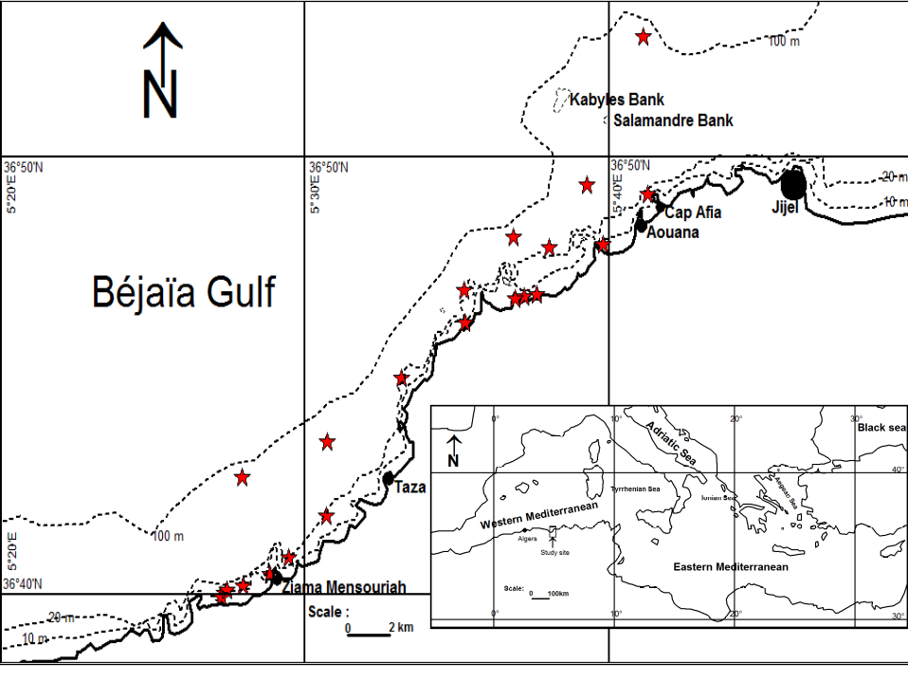
Figure 1. Geographical location of Taza National Park and location of samples taken (red coloured asterisk).

In the laboratory, a sorting of the groups of species is carried out by sampling and an identification by direct observation or under a binocular microscope (Zeiss © Stemi305) is made based on the work of Parenzen (1974) and Poutiers (1987) for Bivalves, Christaens (1973), Bouchet & Ortea (1980), Nordisieck (1982), Garcia Gomez (1984) and Gaillard (1987) for Gastropods and Polyplacophorans. Cephalopods were recorded during landings from the various fisheries in the ports of Aouana and Ziama Mansouriah, the works of Magold & Boletzky (1987) and Guerra Sierra (1992) were consulted for the determination of Cephalopods, as well as consulting websites (https://inpn.mnhn.fr; http://www.mollusca.org; http://www/marinespecies.org; http://dorisffessm.fr). The synonymy of the species recorded was verified on the WORMS database (www.marinespecies.org from 05/05/2024 to 09/08/2024).

Table 1. Geographic coordinates of benthic macrofauna samples.
Sample | Latitude (N) | Longitude (E) | Depth (m) | Sample | Latitude (N) | Longitude (E) | Depth (m)
N° 3 | 36°42'44' | 5°27'52'' | 77 | N° 84* | 36°46'13'' | 5°35'14'' | 7
N° 14 | 36°39'55'' | 5°27'09'' | 87 | N° 93 | 36°46'47'' | 5°36'51'' | 48
N° 19 | 36°40'07'' | 5°27'10'' | 20 | N° 96 | 36°46'46'' | 5°37'14'' | 34
N° 21* | 36°40'19'' | 5°27'59'' | 5 | N° 100* | 36°46'53'' | 5°37'37'' | 19
N° 28 | 36°40'28'' | 5°28'44'' | 83 | N° 107* | 36°48'00'' | 5°39'42'' | 4
N° 31* | 36°40'54'' | 5°29'26'' | 5 | N° 116 | 36°48'10'' | 5°36'50'' | 82
N° 37* | 36°41'52'' | 5°30'39'' | 12 | N° 119 | 36°47'56'' | 5°38'04'' | 21
N° 43 | 36°43'33'' | 5°30'40'' | 66 | N° 125 | 36°49'23'' | 5°39'18'' | 80
N° 66 | 36°44'59'' | 5°33'08'' | 23 | N° 137 | 36°52'45'' | 5°41'09'' | 66
N° 82 | 36°46'57'' | 5°35'14'' | 81 | N° 141* | 36°49'09'' | 5°41'16'' | 10
*, Samples taken while scuba diving.

Results

The mollusc species recorded in the marine area of ​​the Taza National Park (PNT) are presented in Table 2. A total 97 mollusc species have been recorded in Taza National Park, of which 37 are bivalves, 48 are gastropods, 1 is polyplacophores and 11 are cephalopods (Table 2), and the specific richness of listed marine molluscs are 38.14%, 49.48%, 1.04% and 11.34% respectively. Bivalvia are categorized 19 families, with Cardiidae (5 species), Veneridae (4 species), Donacidae (3 species), Mactridae (3 species), Mytilidae (3 species), and Tellinidae (3 species). These major families of Bivalvia represent 56.76% of the specific richness of bivalves and 21.65% of the specific richness of molluscs. Gastropoda are classified into 29 families. The Patellidae family includes 6 species, the Chromodorididae and Nassariidae with 4 species each, the Cassidae and Muricidae with 3 specie and the major families represented 41.67% of the specific richness of gastropods recorded and 20.62% of the specific richness of molluscs. The Polyplacophores are represented by a single species: Acanthochitona fascicularis, it represents 0.80% of the specific richness of polyplacophorans recorded and 0.73% of the specific richness of molluscs. Cephalopods are categorized into six families and the major families of cephalopods, Sepiidae includes three species, while Eledonidae, Loligenidae, and Octopodidae each have two species, together accounting for 30.56% of the species richness of cephalopods and 2.69% of the species richness of molluscs (Table 2).
We counted 171 individuals, 85 bivalves (49.71%), 83 gastropods (48.54%) and 3 polyplacophores (1.75%). Cephalopods are not taken into account because the inventory of cephalopods was done during the landings of fishermen, the quantities of which are very low compared to fish catches.

Table 2. The inventory list of marine mollusc species recorded in Taza National Park and headcount.
Species Classification | Common Name | Number
Class BIVALVIA
Family PHARIDAE
Pharus legumen (Linnaeus, 1758) | Bean razor clam | 2
Family CUSPIDARIIDAE
Cuspidaria cuspidata (Olivi, 1792) | Pointed clam | 4
Family ARCIDAE
Arca noae Linnaeus, 1758 | Noah’s Ark Shell | 4
Barbatia barbata (Linnaeus, 1758) | Hairy ark | 4
Family GLYCYMERIDIDAE
Glycymeris glycymeris (Linnaeus, 1758) | Common European bittersweet | 3
Glycymeris nummaria (Lamarck, 1819) | Violet bittersweet | 5
Family CARDIIDAE
Acanthocardia aculeata (Linnaeus, 1758) | Spiny cockle | 2
Acanthocardia echinata (Linnaeus, 1758) | European prickly cockle | 2
Acanthocardia tuberculata (Linnaeus, 1758) | Moroccan cockle | 2
Laevicardium crassum (Gmelin, 1791) | Norwegian egg cockle | 3
Laevicardium oblongum (Gmelin, 1791) | Oblong cockle | 1
Family DONACIDAE
Donax trunculus Linnaeus, 1758 | Truncated wedge shell | 9
Donax variegatus (Gmelin, 1791) | Polished wedge shell | 2
Donax vittatus (Da Costa, 1778) | Banded wedge shell | 1
Family PSAMMOBIIDAE
Gari depressa (Pennant, 1777) | Depressed sunset clam | 2
Family LIMIDAE
Lima lima (Linnaeus, 1758) | Spiny file clam | 2
Family LUCINIDAE
Loripes orbiculatus Poli, 1791 | Lucinid clam | 2
Family MYTILIDAE
Modiolus adriaticus (Lamarck, 1819) | Adriatic mussel | 3
Mytilus galloprovincialis Lamarck, 1819 | Mediterranean mussel | 1
Perna perna (Linnaeus, 1758) | Brown mussel | 2
Family NUCULIDAE
Nucula nucleus (Linnaeus, 1767) | Common nut clam | 3
Family NUCULANIDAE
Lembulus pella (Linnaeus, 1758) | Crenulate nut clam | 3
Family OSTREIDAE
Magallana gigas (Thunberg, 1793) | Giant cupped oyster | 2
Family PTERIIDAE
Pteria hirundo (Linnaeus 1758) | European wing oyster | 2
Family PECTINIDAE
Talochlamys multistriata (Poli, 1795) | Dwarf fan shell | 2
Mimachlamys varia (Linnaeus, 1758) | Variegated scallop | 3
Family GLOSSIDAE
Glossus humanus (Linnaeus, 1758) | Oxheart cockle | 1
Family MACTRIDAE
Lutraria angustior R.A. Philippi, 1844 | Narrow otter shell | 1
Lutraria lutraria (Linnaeus, 1758) | Mud-dwelling mactra | 1
Mactra glauca Born, 1778 | Grey rough shell | 2
Family TELLINIDAE
Moerella pulchella (Lamarck, 1818) | Beautiful telling | 1
Peronaea planata (Linnaeus, 1758) | Flat tellin | 2
Peronidia albicans (Gmelin, 1791) | White tellin | 2
Family VENERIDAE
Chamelea gallina (Linnaeus, 1758) | Striped venus clam | 1
Mysia undata (Pennant, 1777) | Undulated false lucine | 1
Ruditapes decussatus (Linnaeus, 1758) | Grooved carpet shell | 1
Venus verrucosa Linnaeus, 1758 | Warty venus | 1
Class GASTEROPODA
Family APLYSIIDAE
Aplysia punctata (Cuvier, 1803) | Spotted sea hare | 1
Family CERITHIIDAE
Cerithium lividulum Risso, 1826 | Mediterranean cerithe | 3
Cerithium vulgatum Bruguière, 1789 | Common cerithe | 4
Family TURRETELLIDAE
Turritellinella tricarinata (Brocchi, 1814) | Horny auger | 1
Family HALIOTIDAE
Haliotis tuberculata Linnaeus, 1758 | Green ormer | 1

Family FISSURELLIDAE
Emarginula octaviana Coen, 1939 | Slit-limpet | 2
Fissurella nubecula (Linnaeus, 1758) | Cloudy keyhole limpet | 1

Family PATELLIDAE
Patella caerulea Linnaeus, 1758 | Rayed Mediterranean limpet | 1
Patella ferruginea Gmelin, 1790 | Ferreous limpet | 2
Patella rustica Linnaeus, 1758 | Rustic limpet | 1
Patella ulyssiponensis Gmelin, 1791 | China limpet | 1
Patella vulgata Linnaeus, 1758 | Common limpet | 1
Scutellastra laticostata (Blainville, 1825) | Giant limpet | 1
Family APORRHAIDAE
Aporrhais serresiana (Michaud, 1828) | Serr’s pelican’s foot | 4
Family CALYPTRAEIDAE
Calyptraea chinensis (Linnaeus, 1758) | Chinese hat snail | 2
Family CHARONIIDAE
Charonia lampas (Linnaeus, 1758) | Trumpet shell | 1
Family CASSIDAE
Semicassis granulata (Born, 1778) | Scotch bonnet | 1
Semicassis saburon (Bruguière, 1792) | Saburon bonnet snail | 2
Semicassis undulata (Gmelin, 1791) | Mediterranean bonnet | 1
Family LITTORINIDAE
Echinolittorina punctata (Gmelin, 1790) | Common prickly winkle | 4
Family NATICIDAE
Euspira nitida (Donovan, 1803) | Alder’s natica | 1
Family RISSOIDAE
Rissoa membranacea (J. Adams, 1800) | Thick-lipped spire shell | 12
Family TORNIDAE
Tornus subcarinatus (Montagu, 1803) | White belted shell | 1
Family XENOPHORIDAE
Xenophora pallidula (Reeve, 1842) | Pallid carrier-shell | 1
Family CANCELLARIIDAE
Bivetiella cancellata (Linnaeus, 1767) | Cancellate nutmeg | 1
Cancellaria reticulata (Linnaeus, 1767) | Common nutmeg | 1
Family CONIDAE
Conus ventricosus Gmelin, 1791 | Mediterranean cone | 2
Family FASCIOLARIIDAE
Pseudofusus rostratus (Olivi, 1792) | Rostrate whelk | 1
Family MURICIDAE
Bolinus brandaris (Linnaeus, 1758) | Purple dye murex | 1
Hexaplex trunculus (Linnaeus, 1758) | Banded dye-murex | 1
Stramonita haemastoma (Linnaeus, 1767) | Red-mouthed rock shell | 1
Family NASSARIIDAE
Tritia corniculum (Olivi, 1792) | Horn nassa | 1
Tritia incrassata (Strom, 1768) | Thick-lipped dog whelk | 2
Tritia mutabilis (Linnaeus, 1758) | Changeable nassa | 2
Tritia reticulata (Linnaeus, 1758) | Netted dog whelk | 2
Family CHROMODORIDIDAE
Felimare picta (R.A. Philippi, 1836) | Florida regal doris | 2
Felimare tricolor (Contraine, 1835) | Tricolor doris | 2
Felimida luteorosea (Rapp, 1827) | Yellowdotted purple doris | 2
Felimida purpurea (Risso, 1831) | Pink doris | 1
Family DISCODORIDIDAE
Peltodoris atromaculata Bergh, 1880 | Dotted sea slug | 1
Platydoris argo (Linnaeus, 1767) | Leathery doris | 1
Family FACELINIDAE
Cratena peregrina (Gmelin, 1791) | Pilgrim hervia | 1
Family JANOLIDAE
Antiopella cristata (Delle Chiaje, 1841) | Crested aeolis | 1
Family PLAKOBRANCHIDAE
Elysia timida (Risso, 1818) | Sap-sucking slug | 1
Family SIPHONARIIDAE
Siphonaria pectinata (Linnaeus, 1758) | Striped false limpet | 1
Family TROCHIDAE
Clanculus corallinus (Gmelin, 1790) | Coral top shell | 1
Family TURBINIDAE
Bolma rugosa (Linnaeus, 1767) | Rough turbo | 1
Family CALLIOSTOMATIDAE
Phorcus turbinatus (Born, 1778) | Turbinate monodont | 3
Class POLYPLACOPHORA
Family ACANTHOCHITONIDAE
Acanthochitona fascicularis (Linnaeus, 1767) | Velvety mail shell | 3
Class CEPHALOPODA
Family LOLIGINIDAE
Alloteuthis subulata (Lamarck, 1798) | European common squid
Loligo vulgaris (Lamarck, 1798) | European squid
Family ELEDONIDAE
Eledone cirrhosa (Lamarck, 1798) | Horned octopus
Eledone moschata (Lamarck, 1798) | Musky octopus
Family OCTOPODIDAE
Macrotritopus defilippi (Vérany, 1851) | Lilliput longarm octopus
Octopus vulgaris Cuvier, 1797 | Common octopus
Family OMMASTREPHIDAE
Illex coindetii (Vérany, 1839) | Shorfin squid
Family SEPIIDAE
Rhombosepion elegans (Blainville, 1827) | Elephant cuttlefish
Rhombosepion orbignyanum (A. Férussac, 1826) | Pink cuttlefish
Sepia officinalis Linnaeus, 1758 | Common cuttlefish
Family SEPIOLIDAE
Sepietta neglecta Naef, 1916 | Elephant bobtail squid

The different families of molluscs have numbers of between 1 and 12 individuals (Table 2), of which the main families of Bivalvia are: Donacidae (14.12%), Cardiidae (11.76%), Arcidae (9.41%) and Glycymeridae (9.41%), of which Donax trunculus is the main species (10.59%). In Gastropoda, the main families are: Rissoidae (14.46%), Chromododiridae (8.43%), Cerithiidae (8.43%), Nassariidae (8.43%) and Patellidae (7.22%), of which Rissoa membranacea is the main one (14.46%) (Fig. 2).
It is indicated that the number of individuals collected with the Van Veen grab is lower (40.94%) than the samples taken by scuba diving (59.06%). Bivalves are better represented quantitatively in the samples taken with the Van Veen grab with 68 individuals (80%) compared to the samples taken by scuba diving with 17 individuals (20%), while gastropods are better represented in the samples taken by scuba diving with 53 individuals (63.86%) compared to the samples taken by the grab with 30 individuals (36.14%). While polyplacophores are present only in the samples taken by scuba diving with 3 individuals.

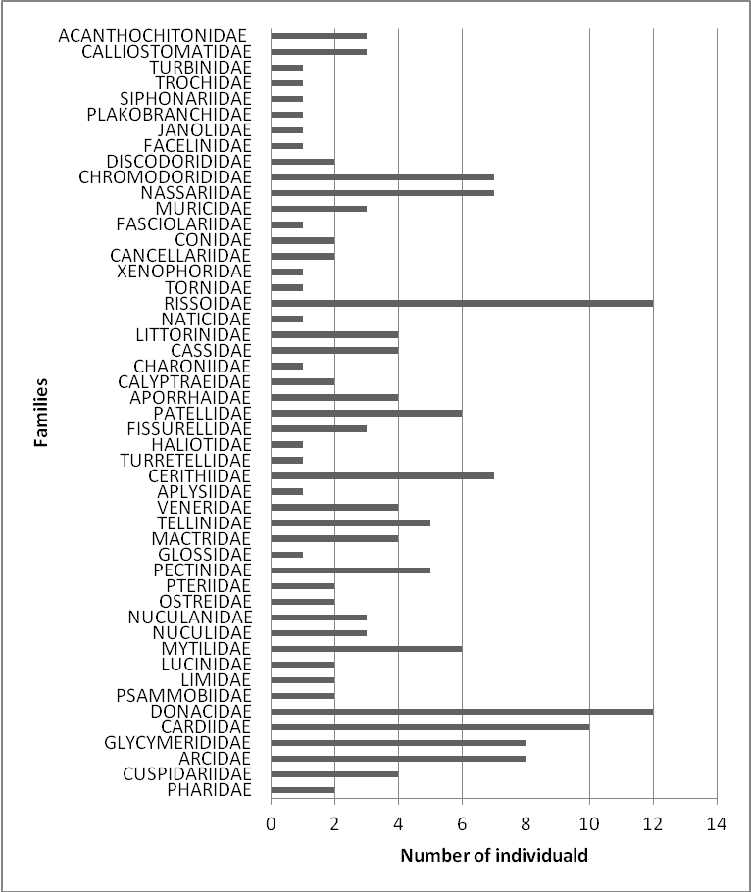
Figure 2. Distribution of individuals by family.

The observations collected make it possible to highlight the ecological characteristics of the species recorded, in particular on the aspects of bathymetric distribution and affinities to the texture of the substrates (Table 3).

Table 3. : Bathymetric limits and substrate affinity of the species recorded.
R, Rock; S, Sand; VS, Sandy mud; V, Mud.
 | Bathymetry (m) |  |  |  |  |  |  |  |  |  | Substrate
 | 5 | 10 | 20 | 30 | 40 | 50 | 60 | 70 | 80 |  | R | S | VS | V
Pharus legumen
Cuspidaria cuspidata
Arca noae
Barbatia barbata
Glycymeris glycymeris
Glycymeris nummaria
Acanthocardia aculeata
Acanthocardia echinata
Acanthocardia tuberculata
Laevicardium crassum
Laevicardium oblongum
Donax trunculus
Donax variegatus
Donax vittatus
Gari depressa
Lima lima
Loripes orbiculatus
Modiolus adriaticus
Mytilus galloprovincialis
Perna perna
Nucula nucleus
Lembulus pella
Magallana gigas
Pteria hirundo
Talochlamys multistriata
Mimachlamys varia
Glossus humanus
Lutraria angustior
Lutraria lutraria
Mactra glauca
Moerella pulchella
Peronaea planata
Peronidia albicans
Chamelea gallina
Mysia undata
Ruditapes decussatus
Venus verrucosa
Aplysia punctata
Cerithium lividulum
Cerithium vulgatum
Turritellinella tricarinata
Haliotis tuberculata
Emarginula octaviana
Fissurella nubecula
Patella caerulea
Patella ferruginea
Patella rustica
Patella ulyssiponensis
Patella vulgata
Scutellastra laticostata
Aporrhais serresiana
Calyptraea chinensis
Charonia lampas
Semicassis granulata
Semicassis saburon
Semicassis undulata
Echinolittorina punctata
Euspira nitida
Rissoa membranacea
Tornus subcarinatus
Xenophora pallidula
Bivetiella cancellata
Cancellaria reticulata
Conus ventricosus
Pseudofusus rostratus
Bolinus brandaris
Hexaplex trunculus
Stramonita haemastoma
Tritia corniculum
Tritia incrassata
Tritia mutabilis
Tritia reticulata
Felimare picta
Felimare tricolor
Felimida luteorosea
Felimida purpurea
Peltodoris atromaculata
Platydoris argo
Cratena peregrina
Antiopella cristata
Elysia timida
Siphonaria pectinata
Clanculus corallinus
Bolma rugosa
Phorcus turbinatus
Acanthochitona fascicularis

The bathymetric limits of the species recorded highlight four groups of families, the first group is confined to the mediolittoral zone, these are the Patellidae and the Acanthochitonidae. The second group brings together the families of the infralittoral zone, it is the largest with 26 families, of which the main families are the Cerithiidae, Chromodorididae, Mytilidae, Muricidae, Nassariidae and Veneridae. The 3rd group of the circalittoral zone with 13 families, of which the main families are the Cancellariidae and Glycymeridae. The fourth group brings together the species located in the infralittoral and circalittoral zones with Arcidae, Cardiidae, Cassidae, Donacidae, Pectinidae and Mactridae as main families (Table 3). The analysis of the affinity to the substrates of the different families listed shows the presence of families having mainly an affinity to the rocky substrate (Arcidae; Cassidae; Chromodorididae; Discodorididae; Fissurellidae; Muricidae; Mytilidae; Patellidae; Pectinidae), to the sands (Cerithiidae), to the sandy muds (Cardiidae; Donacidae; Mactridae; Nassariidae; Tellinidae; Veneridae) and to the muds (Cancellariidae; Glycymerididae) (Table 3).

Discussion

A bibliographic compilation indicates that the number of mollusc species (bivalves, gastropods, polyplacophores, and scaphopods) recorded along the Algerian coast, where Petit (1972) and Bakalem et al. (1981), who worked in the Bay of Algiers, recorded 54 species (39 Bivalvia; 14 Gastropoda; 1 Scaphopoda). In the Bay of Bou-Ismaïl, Hassam (1991) and Oulmi (1991) highlight 106 bivalves, 94 gastropods, 3 scaphopods, a specific richness of molluscs of 203. Kerfouf (1997) and Kerfouf et al. (2007 and 2023) in the Gulf of Oran and Amar (1998) in the Gulf of Arzew highlight a low specific richness of molluscs, respectively 29 species (24 Bivalvia; 5 Gastropoda) and 34 species (26 Bivalvia; 8 Gastropoda). The work of Bakalem (2008) and Grimes (2010), where Dauvin et al. (2013) compile the data from these two works carried out along the Algerian coast on the soft substrates of the different bays and gulfs, also on the main Algerian harbors, and they report 234 species of molluscs either 117 bivalves, 109 gastropods and 8 scaphopods. Meziane et al. (2020) and Dilmi et al. (2024) worked on rocky bottoms with a particularity for the work of Dilmi et al. (2024) on the benthos of the bottoms of mussel farming sectors, they highlighted 259 molluscs either 107 bivalves, 149 gastropods and 3 polyplacophorans. There are 373 species of mollusc based on the cited bibliographic sources either 204 bivalves, 158 gastropods, 3 polyplacophores, and 8 scaphopods. 36 species of cephalopods were recorded during trawling campaigns (ISTPM, 1982 and 1983; Fernandez et al., 2003; Massuti et al. 2003 and 2004). The mollusc fauna of the Algerian coast are 409 species, of which the inventory of molluscs of the PNT accounts for 23.72%. Compared to the literature data previously reviewed, bivalves, gastropods, polyplacophorans and cephalopods of the PNT represent respectively 18.14%, 30.38%, 33.33%, and 30.56% of the specific richness.
The particular presence of Patella ferruginea is noted, a critically endangered species in the Mediterranean Sea (PNUE/PAM – CAR/ASP, 2018). It found on the lower horizon of the central coastline. The presence of 5 new species of Nudibranchs were recorded in the Algerian coast: Felimare picta, Felimida luteorosea, Felimida purpurea (Chromodorididae), Platydoris argo (Discodorididae) and Antiopella cristata (Janolidae).

In conclusion, 97 molluscs species identified in Taza National Park’s marine area constitute only recorded in the marine area of ​​Taza National Park represent only 23.72% of the marine mollusc diversity reported along the Algerian coast. This includes a noteworthy mention of a rare Patellidae species, Patella ferruginea, and the discovery of new Nudibranchs to the region: Felimare picata, Felimida luteorosea, Felimida purpurea, Platydoris argo and Antiopella cristata. Further research is imperative along the Algerian coastline, especially on the less-studied hard substrates, in contrast to the well-documented soft substrates.

Acknowledgements

We thank the National University Research Program, Ministry of Higher Education and Scientific Research (PRFU – MESRS). We thank the reviewers for the corrections made to the manuscript.

Conflict of Interest

The authors declare that they have no competing interests.

Author Contributions

All authors contributed to the fieldwork, analysis ad writing of the manuscript. They revised and approved the final version of the manuscript.

Ethical Approval Statements

Local Ethics Committee Approval was not obtained because experimental animals were not used in this study.

Data Availability

The data used in present study are available upon request from the corresponding author.

References

Amar, Y. (1998). Etude des peuplements macrobenthiques du golfe d’Arzew. Institute of Marine Sciences and Coastal Management, Algiers, p215.
Bakalem, A. (2008). Contribution à l’étude des peuplements benthiques du plateau continental algérien. Thèse de doctorat es sciences en sciences de la nature, Houari Boumediene University of Science and Technology, Algiers, p678.
Bakalem, A., Hily, C., Romano, J.C. (1981). Contribution à l’étude des peuplements benthiques de la baie d’Alger : cartographie et définition des peuplements. Pelagos 6(2), 1-116.
Bouchet, Ph., Ortea, J. (1980). Quelques Chromodorididae bleus (Mollusca, gastropoda, Nudibranchiata) de l’Atlantique oriental. Annales Institut Océanographique, 56(2), 117-125.
Christiaens, J. (1973). Révision du genre Patella (Mollusca, Gasteropoda). Bulletin Muséum national d’histoire naturelle, 182(121), 1305-1392.
Dautzenberg, P. (1895). Mollusques recueillies sur les côtes de la Tunisie et de l’Algérie (Campagne de la « Mélita », 1892). Mémoires Société Zoologique, 8, 363-372.
Dauvin, J.C., Grimes, S., Bakalem, A. (2013). Marine biodiversity on the Algerian continental shelf (Mediterranean Sea). Journal Natural History, 47(25-28), 1745-1765.
Dilmi, S., Bachetarzi, R., Rebzani-Zahaf, C. (2024). Macrobenthic fauna and the ecological status of a shellfish farm in the Mediterranean Sea (Algeria). Mediterranean Marine Science, 25(1), 116–135. https://doi.org/10.12681/mms.34675
Fernandez, A.M., Batle, M., Pérez, J.L., Onate, D., Fliti, K., Refes, W., Miraoui, M., Reghis, M., Zeghdoudi, S., Bouaïcha, M., Ait Feroukh, B., Zereb, N. (2003). Informe de la campana Argelia 0203 – Pc para la evalucion de recursos pelagicos costeros en las costas de Argelia (Mediterraneo sur-occidental). MPRH – IEO, p65.
Gaillard, J.M. (1987). Gastéropodes. In Fiches FAO d’identification des espèces pour les besoins de la pêche. Méditerranée et Mer Noir, zone de pêche 37, 1. Végétaux et invertébrés. (pp. 513-632). https://www.fao.org/4/x0169f/x0169f00.htm
Garcia Gomez, J.C. (1984). A new species of Flabellina (Gastropoda, Nudibranchia) from the Gibraltar strait (southern Spain). Vie et Milieu, 34(1), 61-64.
Grimes, S. (2010). Les peuplements macrobenthiques des substrats meubles algériens : organisation et structure. Es Sénia University of Science and Technology, Oran, p358.
Guerra Sierra, A. (1992). Fauna Iberica. 1. Mollusca Cephalopoda. Museo Nacional de Ciencias Naturales, p327.
Hassam, N. (1991). Contribution à l'étude des peuplements macrobenthiques de la baie de BouIsmaïl : secteur Est. Institute of Marine Sciences and Coastal Management, Algiers, p146.
ISTPM. (1982). Evaluation des ressources halieutiques de la marge continentale algérienne. Stocks pélagiques-Stocks démersaux exploitables au chalut. Institut Scientifique et des Pêches Maritimes, Nantes, p101.
ISTPM. (1983). Prospection aux filets maillants des zones accidentées profondes du plateau continental algérien du cap Sigli à la frontière tunisienne. Démonstration technologique au chalut 4 faces de Bou-Ismaïl à Ghazaouet. Campagne « Ichthys »-« Joamy ». Institut Scientifique et des Pêches Maritimes, Nantes,p35.
Kerfouf, A. (1997). Contribution à l'étude des peuplements macrozoobenthiques du golfe d'Oran. Institute of Marine Sciences and Coastal Management, Algiers, p185.
Kerfouf, A., Amar, Y., Boutiba, Z. (2007). Distribution of Macrobenthos of coastal waters in the Gulf of Oran (Western Algeria). PJBS: Pakistan Journal of Biological Sciences, 10(6), 899-904.
Kerfouf, A., Kies, F., Boucetta, S., Denis, F. (2023). Inventory of marine molluscs in the Gulf of oran (Western Algeria coastline). International Journal of Aquatic Research and Environmental Studies, 3(1), 17-25.
Llabador, F. (1935). Les Mollusques testacés marins, terrestres et fluviales de l’Ouest Algérien. Alger, 175p.
Mangold, K., Boletzky, S.V. (1987). Céphalopodes (Seiches, Calmars et Poulpes/Pieuvres). In Fiches FAO d’identification des espèces pour les besoins de la pêche. Méditerranée et Mer Noir, zone de pêche 37, 1.Végétaux et invertébrés. (pp. 634-714). https://www.fao.org/4/x0169f/x0169f00.htm
Massuti, E., Guijarro, B., Pomar, B., Fliti, K., Reghis, M., Zaghdoudi, S., Bouaïcha M., Ait Ferroukh, B., Zereb, N. (2003). Informe de la campaña Argelia 0203-DP para la evalucion de recursos démersales profundos en las costas de Argelia (Mediterraneo Sur Occidental). IEO, MPRH, SGPM, p103.
Massuti, E., Ordinas, F., Guijarro, B., Pomar, B., Fliti K., Refes, W., Zaghdoudi, S., Bouaïcha M., Reghis, M., Miraoui, M, Naili, R., Ait Ferroukh, B. (2004). Informe de la campaña Argelia 0204 para la evalucion de recursos démersales en las costas de Argelia (Mediterraneo Sur Occidental). IEO, MPRH, SGPM, p123.
Meziane, K., Kerfouf, A., Baaloudj, A. (2020). Checklist of gasteropod molluscs in west coast of Algeria. International Journal Aquatic. Biolology, 8(3), 224-227.
Nordsieck, F. (1982). Die europaischen Meeres-Gehaus. 2 Auflages. Gustav Fischer Verlag.
Oulmi, Y. (1991). Contribution à l'étude des peuplements macrozoobenthiques de la baie de BouIsmaïl : secteur Ouest. Institute of Marine Sciences and Coastal Management, Algiers, p170.
Pallary, P. (1900). Coquille marines du littoral du département d’Oran. Journal de Conchyliologie, 48(1), 211-428
https://www.biodiversitylibrary.org/item/81155#page/7/mode/1up
Parenzan, P. (1974). Carta d’identità delle conchiglie del Mediterraneo. 2.Bivalvi. Bios Tarao.
Petit, J.M. (1972). Contribution à l'étude du peuplement benthique de la baie d'Alger. Pelagos, 4(1), 37-69.
PNT/ISMAL. (2003). Plan de gestion de la zone marine située entre Cap Afia et la limite administrative Jijel-Béjaïa (Wilaya de Jijel) : Approches descriptives et analytiques de la zone marine – Evaluation du patrimoine et définition des objectifs – Plan de travail. Rapport final de la convention Parc National de Taza et Institut National des Sciences de la Mer et de l’Aménagement du Littoral, p314, 2 Cdrom.
PNUE/PAM-CAR/ASP. (2018). Protocole ASP/DB : Annexe II : Liste des espèces en danger ou menacées, p10.
https://www.rac-spa.org/sites/default/files/annex/annex_2_fr_20182.pdf
Poutiers, J.M. (1987). Bivalves (Acephales, Lamellibranches, Pelecypodes). In Fiches FAO d’identification des espèces pour les besoins de la pêche. Méditerranée et Mer Noir, zone de pêche 37, 1.Végétaux et invertébrés. (pp. 369-512).
https://www.fao.org/4/x0169f/x0169f00.htm

