Sand steenbras (Lithognathus mormyrus Linnaeus, 1758), the new host of the parasitic isopod Anilocra physodes (Linnaeus, 1758) from Mersin Bay (Türkiye)

Cafer Erkin KOYUNCU¹, Deniz AYAS^{1,2*}

¹Mersin University, Fisheries Faculty, Mersin, Turkey
²Mersin University Marine Life Museum
Corresponding Author: ayasdeniz@gmail.com

ABSTRACT
Anilocra physodes (Linnaeus, 1758) (Isopoda, Cymothoidae) was reported for the first time on Lithognathus mormyrus (Linnaeus, 1758) (Pisces; Sparidae) from the Mersin Bay (Northeastern Mediterranean Sea, Turkey). This study aimed to report a new host species for A. physodes from Mersin Bay (northeastern Mediterranean Sea). In addition, the distribution of A. physodes host species according to their families and host preferences was detailed in this study.

Keywords: Parasitic Isopod, Crustacea, Lithognathus mormyrus, Sand Steenbras, Mersin Bay, Türkiye

INTRODUCTION
Lithognathus mormyrus is distributed in the eastern Atlantic in the Bay of Biscay, Strait of Gibraltar and the Mediterranean Sea; southwards around the Cape of Good Hope, South Africa; Canary and Cape Verde Islands (Bauchot and Hureau, 1990) and Madeira Island and southern Mozambique in the western Indian Ocean. This species is not found in Tropical East Africa, the Red Sea and the Black Sea (Smith and Smith, 1986; Bauchot and Hureau, 1990; Wirtz et al., 2008; Golani and Bogorodsky, 2010; Russell et al., 2014). L. mormyrus can be found on the shelf, on sandy and muddy bottoms, in seagrass beds and in estuaries. It feeds on worms, molluscs and small crustaceans and is a protandric hermaphrodite, sometimes forming large schools (Bauchot and Hureau, 1990).
Isopods are a group of parasites within the family Cymothoidae. They are known to infect numerous fish families, mainly in tropical and subtropical habitats (Innal et al., 2007). These species of isopods are not host-specific and have been described from a large number of hosts around the world (Ramdane et al., 2007; Trilles and Öktener, 2009; Innal and Kırkım, 2012). Anilocra physodes (Linnaeus, 1758) belongs to the order Crustacea and is a widely distributed order whose members are globally abundant and form an important part of the global marine fauna (Williams and Williams, 1981). They are blood-feeding ectoparasites that require only one host to complete their life cycle (Ramdane et al., 2007) and are typically attached to a specific location on the body of fish species, including the fins, or within the branchial or buccal cavity (Trilles and Öktener, 2009; Navarro-Barranco et al., 2019). They can be found on the body surface, in the mouth, in the gills or even inside the host fish (Smit et al., 2014).
Marine isopods have not been sufficiently studied in Turkey and the cymotoid fauna of Turkey is poorly known (Innal et al., 2007). This study aimed to report a new host species of A. physodes from the Bay of Mersin in the coast of Türkiye. This parasitic isopod species has been reported in many fish species. Even Nemipterus randalli, a Lessepsian migratory fish species distributed along the Turkish coast, has been found with this parasite Ayas et al., 2024). Although A. physodes has been reported from L. mormyrus species in the Gulf of Antalya, it has not been reported from L. mormyrus species in the Bay of Mersin. L. mormyrus is a new host for A. physodes in Mersin Bay.

MATERIAL AND METHODS
The L. mormyrus individual caught on the fishing line was observed to have an isopod parasite on its body surface. The A. physodes individual was positioned on the side of the fish close to the lateral line. The specimen of L. mormyrus was caught in April 2020 in Mersin Bay (Figure 1). The parasitic isopod was removed from the host and fixed in a Falcon tube containing 70% ethanol for examination under a microscope. The identification of the isopod parasite species brought to the laboratory was determined after microscopic examination, and the isopod specimen was identified and photographed using laboratory dissecting microscopy according to Trilles (1965) and Williams & Williams (1981). The parasitic isopod species, A. physodes, was recorded and preserved in the Mersin University Marine Life Museum with catalogue number MEUISC-20-11-002.

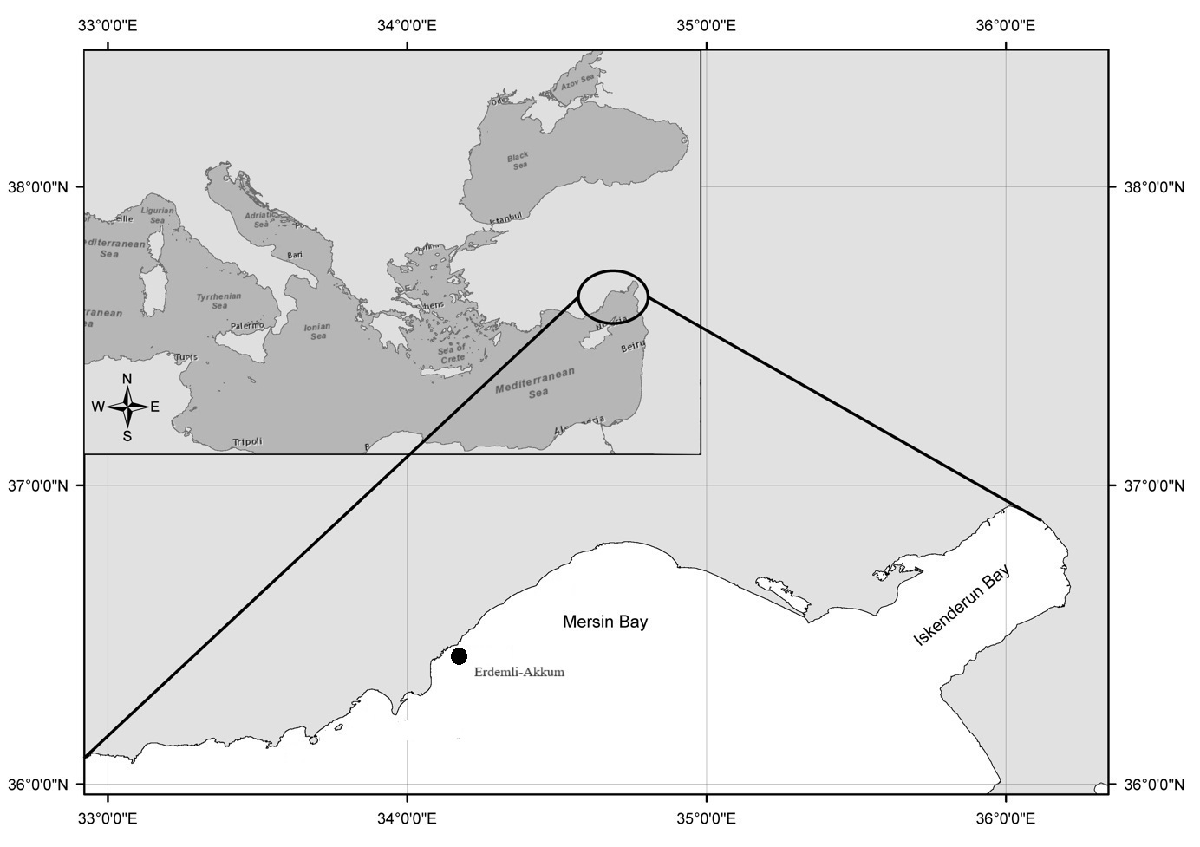
Figure 1. The mark indicates the area where the L. mormyrus individual was captured

RESULTS AND DISCUSSION
Isopod parasitism is a widespread crustacean infestation observed in marine fish species along the Turkish coastline (Öktener and Trilles, 2004). So far, A. physodes has been reported from the North Atlantic, the Mediterranean and the Adriatic (Trilles, 1994). However, until now, two parasitic isopod species (A. physodes and A. frontalis) have been reported in Turkish waters (Kırkım, 1998; Öktener and Trilles, 2004, Ayas et al. 2024) and these species have affected several fishes worldwide (Öktener et al., 2018). In this study, an individual of A. physodes (Linnaeus, 1758) was identified from a fish individual of L. mormyrus species belonging to the family Sparidae. The first records of A. physodes from the Mediterranean waters of Turkey were reported by İnnal et al. (2007) and İnnal and Kırkım (2012) from the coast of Antalya. A. physodes was found by Ayas et al. (2024) in April 2024 in Mersin Bay on N. randalli, a lessepsian migratory species.
A. physodes and A. frontalis, previously known from the Mediterranean coast, are similar to each other. However, the anterior end of the head is truncate in A. physodes and rounded in A. frontalis. In addition, the endopodites of the uropods slightly exceed the distal part of the pleotelson in A. physodes, whereas they significantly exceed it in A. frontalis (Innal et al., 2007). In this study, morphological features of isopod individuals on L. mormyrus were found compatible with A. physodes (Figure 2).
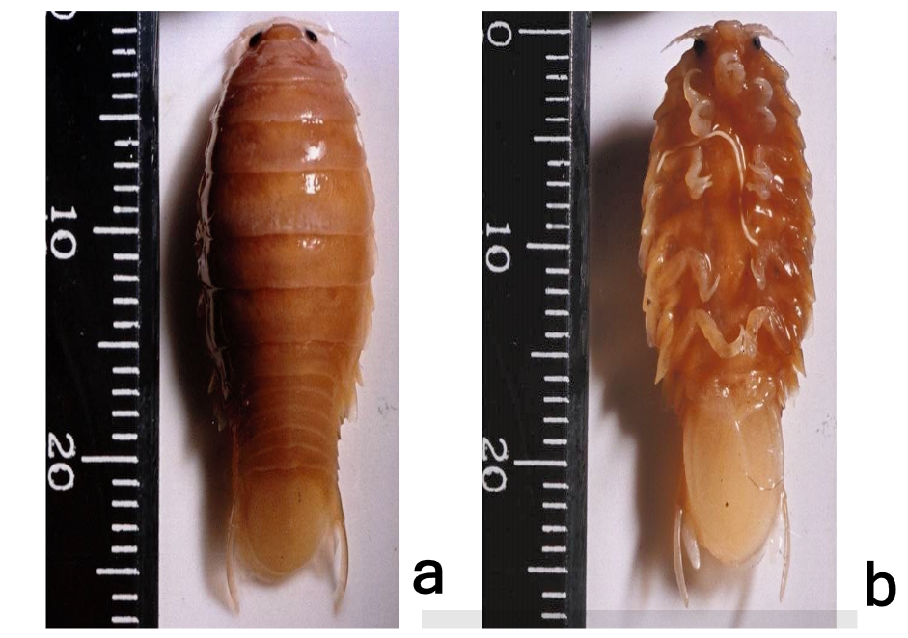
Fig 2. The appearance of the individual of Anilocra physodes (Linnaeus, 1758) obtained from L. mormyrus, which was caught off the coast of Mersin, Turkey. (a) dorsal view (b) ventral view.

A. physodes has been detected in the following fish families in Türkiye: Sparidae, Centracanthidae, Scombridae, Serranidae, Scienidae, Moronidae, Physidae, Labridae, Scienidae, Carangidae, Mugilidae, Belonidae, Pomacentridae, Sphyraenidae, Congridae and Gobidae (Öktener et al., 2010) (Table 1). In addition, the infestation of the Nemipteridae family has also been on record (Ayas et al., 2024). So far, this species has been reported in many fish species from the Mediterranean coast of Türkiye (Öktener and Trilles 2004; Innal et al., 2007; Trilles and Öktener, 2009; Öktener et al., 2010; İnnal and Kırkım, 2012; Öktener et al. 2018, Ayas et al. 2024). Prevalence of parasitic species in host fish species and their distribution by family in previous investigations is shown in Table 1. A. physodes is able to select fish with carnivorous and demersal characteristics, according to Öktener et al. (2018). Similarly, L. mormyrus, a carnivorous and demersal fish species, was the preferred host for this parasite species in the present study.
Parasite infestation in fish distributed in marine protected areas is lower than in marine areas affected by human activities. Sources of anthropogenic change (number of tourists and related leisure activities, fishing, etc.) outside marine protected areas (MPAs) may contribute to an increased probability of A. physodes infestation (Navarro-Barranco et al. 2019). The authors stated that L. mormyrus individuals outside MPAs may be more physiologically stressed or have a less effective immune system and therefore more susceptible to parasite infestation (Navarro-Barranco et al. 2019). Although A. physodes is a widespread and widely distributed species, some aspects of the biology and ecology of this parasite have rarely been studied. The influence of the degree of protection of the host fish's environment on parasite dynamics is not yet known. Changes in the abiotic and biotic environment due to anthropogenic activities in marine areas may lead to changes in the host species. The adaptive response of A. physodes isopod species to these changes is another issue that needs to be examined. Mersin Bay consists of marine areas heavily affected by human activities due to overexploitation of fish stocks, pollution and intensive tourism activities. In the future, parasite infestations, including A. physodes infestation, may be expected to be more intense in the Bay of Mersin.

Table 1. Anilocra physodes and its hosts in the Turkish marine waters (Ayas et al. 2024)
Host | Family | Location | References
Spicara smaris | Sparidae | Sea of Marmara, Türkiye | Demir (1952)
Spicara smaris | Sparidae | Aegean Sea, Türkiye | Geldiay and Kocataş (1972)
Pagellus sp.
Scomber japonicus | Scombridae | Aegean Sea, Türkiye | Akmirza (1997)
Boops boops | Sparidae | Aegean Sea, Türkiye | Akmirza (1998)
Diplodus annularis | Sparidae | Aegean Sea, Türkiye | Akmirza (2000)
Diplodus vulgaris
Diplodus sargus
Pagellus erythrinus
Oblada melanura
Spondyliosoma cantharus
Spicara maena |  |  | Akmirza (2001)
Diplodus annularis | Sparidae | Antalya Gulf, Mediterranean, Sea Türkiye | İnnal et al. (2007)
Lithognathus mormyrus
Pagellus erythrinus
Sphyraena chrysotaenia | Sphyraenidae | Antalya Gulf, Mediterranean, Sea Türkiye | İnnal et al. (2007)
Liza aurata | Mugilidae | Antalya Gulf, Mediterranean, Sea Türkiye | İnnal et al. (2007)
Sparus aurata | Sparidae | Sea of Marmara, Türkiye | Oğuz and Öktener (2007)
Trachurus trachurus | Carangidae | Sea of Marmara, Türkiye | Oğuz and Öktener (2007)
Pagellus erythrinus | Sparidae | Aegean Sea, Türkiye | Kırkım et al. (2008)
Spicara smaris
Sparus aurata
Dentex macroptalmus
Labrus merula | Labridae | Aegean Sea, Türkiye | Kırkım et al. (2008)
Dicentrarchus labrax | Moronidae | Aegean Sea, Türkiye | Kırkım et al. (2008)
Sciaena umbra | Sciaenidae | Aegean Sea, Türkiye | Kırkım et al. (2008)
Serranus scriba | Serranidae | Aegean Sea, Türkiye | Kırkım et al. (2008)
Conger conger | Congridae | Aegean Sea, Türkiye | Öktener et al. (2009)
Belone belone | Belonidae | Aegean Sea, Türkiye | Öktener et al. (2009)
Serranus scriba | Serranidae | Aegean Sea, Türkiye | Öktener et al. (2009)
Chromis chromis | Pomacentridae | Aegean Sea, Türkiye | Öktener et al. (2009)
Dentex dentex | Sparidae | Aegean Sea, Türkiye | Trilles and Öktener (2009)
Diplodus vulgaris | Sparidae | Aegean and Mediterranean Sea, Türkiye | Öktener et al. (2010)
Oblada melanura
Spicara maena
Gobius bucchichi | Gobidae | Mediterranean Sea, Türkiye | Öktener et al. (2010)
Pempheris vanicolensis | Pempheridae | Mediterranean Sea, Türkiye | Öktener et al. (2010)
Boops boops | Sparidae | Antalya Gulf, Mediterranean, Sea Türkiye | İnnal and Kırkım (2012)
Phycis blennoides | Phycidae | North Aegean Sea, Türkiye | Öktener et al. (2018)
Nemipterus randalli | Nemipteridae | Mersin Bay, Mediterranean, Sea Türkiye | Ayas et al. (2024)
Lithognathus mormyrus | Sparidae | Mersin Bay, Mediterranean, Sea Türkiye | Present study

This study reports a new host fish species for A. physodes in Mersin Bay, Northeast Mediterranean, Türkiye. The occurrence of the parasitic isopod A. physodes in a new host fish species in Mersin Bay will contribute to the literature. As there are very few studies in the literature on the distribution of parasitic isopod species in Mersin Bay, this report will be an important contribution to the literature on the distribution of A. physodes in Mersin Bay.
In conclusion, the result of the study indicates a parasitic isopod infection due to the presence of A. physodes parasite on the body surface of L. mormyrus in the northeastern Mediterranean coast. The present study is the first report of A. physodes parasitism on L. mormyrus from Mersin Bay.

REFERENCES

Akmirza A. 1997. The parasites of Chub Mackerel (Scomber japonicus). Ege Journal of Fisheries and Aquatic Sciences, 14: 173-181.

Akmirza A. 1998. Parasites in bogue (Boops boops Linnaeus, 1758). Ege Journal of Fisheries and Aquatic Sciences, 15: 183-198.

Akmirza, A. 2000. Seasonal distribution of parasites detected in fish belonging to the Sparidae family found near Gökçeada. Turkish Journal of Parasitology, 24(1): 435-441.

Akmirza, A. 2001. The samples from metazoon parasites detected in fish around Gökçeada. Congress of National Aegean Islands, 7, pp. 85-96.

Ayas, D. Koyuncu, C. E., and Ergüden, D. . (2024). Parasitic Isopod Anilocra physodes (Linnaeus, 1758) from Mersin Bay (Turkey) with a New Host Record. Advanced Underwater Sciences, 4(1), 22–26.

Bauchot, M.-L. and J.-C. Hureau, 1990. Sparidae. p. 790-812. In J.C. Quero, J.C. Hureau, C. Karrer, A. Post and L. Saldanha (eds.) Check-list of the fishes of the eastern tropical Atlantic (CLOFETA). JNICT, Lisbon; SEI, Paris; and UNESCO, Paris. Vol. 2.

Demir M. 1952. The bentic Invertebrates of the Bosphorus and Islands Coasts. J. St. Univ. Fen Fak. Hidrobiol. A: 362-363.

Geldiay, R. and Kocataş, A. 1972. Isopods collected in Izmir Bay, Aegean Sea. Crustaceana, 3 (Studies on Peracarida):19-30

Golani, D. and S. V. Bogorodsky, 2010. The fishes of the Red Sea - reappraisal and updated checklist. Zootaxa, 2463:1-135.

Innal, D., F. Kirkim, F., Erk'akan, F. 2007. The parasitic Isopods, Anilocra frontalis and Anilocra physodes (Crustacea; Isopoda) on some marine fish in Antalya Gulf, Turkey. Bulletin of the European Association of Fish Pathologists., 27(6), 239-241.
Innal, D., Kirkim, F. 2012. Parasitic isopods of bogue [Boops boops (Linnaeus, 1758)] from the Antalya Gulf (Turkey). Kafkas Üniversitesi Veteriner Fakültesi Dergisi., 18 (Suppl-A): A13-A16.
Kırkım, F. 1998. Ege Denizi Isopoda (Crustacea) Faunasının Sistematiği ve Ekolojisi Üzerine Araştırmalar. PhD thesis, Ege University, Science Institute, İzmir, Turkey. 238 p.

Kırkım F, Kocatas A, Katagan T, Sezgin M (2008). A Report on parasitic Isopods (Crustacea) from marine fishes and Decapods collected from the Aegean Sea (Turkey). Acta Parasitologica Turcica, 32 (4): 382-385.

Navarro-Barranco, C., Tierno de Figueroa, J.M., Ros, M. and Guerra García, J.M. (2019). Influence of Marine Protected Areas on parasitic prevalence: the case of the isopod Anilocra physodes as a parasite of the fish Lithognathus mormyrus. Journal of Zoology, 308: 280-292.

Oğuz, M.C. and Öktener, A. 2007. Four parasitic Crustacean species from marine fishes of Turkey. Turkish Journal Parasitol, 31: 79-83.

Öktener, A. and Trilles J.P. 2004. Report on the Cymothoids (Crustacea, Isopoda) collected from marine fishes in Turkey. Acta Adriatica, 45(2): 145-154.

Öktener, A., Trilles, J.P., Alaş, A. and Solak, K. 2009. New hosts for species belonging to the genera Nerocila, Anilocra, Ceratothoa, Mothocya and Livoneca (Crustacea, Isopoda, Cymothoidae). Bulletin of the European Association of Fish Pathologists, 29: 49-54

Öktener, A., Koç H.T., Erdoğan, Z. and Trilles, J.P. 2010. Underwater photographs taken by scuba divers are useful for taxonomic and ecological studies about parasitic cymothoids (Crustacea, Isopoda, Cymothoidae). Journal of Animal Ecology, 3: 3-9.

Öktener, A., Alaş, A., Türker, D. 2018. First record of Anilocra physodes (Isopoda, Cymothoidae) on the Phycis blennoides (Pisces; Phycidae) with morphological characters and hosts preferences. Jordan Journal of Biological Sciences, 11(1), 1-8.

Ramdane Z., Bensouilah M.A. & Trilles J. 2007. The Cymothoidae (Crustacea, Isopoda), parasites on marine fishes, from Algerian fauna. Belg. J. Zool., 137(1): 67.

Russell, B., K.E. Carpenter, D. Pollard, B.Q. Mann and C.D. Buxton, 2014. Lithognathus mormyrus. The IUCN Red List of Threatened Species 2014

Smith, J.L.B. and M.M. Smith, 1986. Sparidae. p. 580-594. In M.M. Smith and P.C. Heemstra (eds.) Smiths' sea fishes. Springer-Verlag, Berlin.

Smit, N.J., Bruce, N.L. & Hadﬁeld, K.A. (2014). Globaldiversity of ﬁsh parasitic isopod crustaceans of the familyCymothoidae. The International Journal for Parasitology: Parasites and Wildlife. 3, 188–197.

Trilles, J.P. (1965). Sur deux especes d'Anilocres (Isopodes, Cymothoidae) mal connues Anilocra physodes L. et Anilocra frontalis (Milne edwards). Annales de Parasitologie Humaine et Comparée, 40(5), 575-594.

Trilles, J.P. 1994. Les Cymothoidae (Crustacea, Isopoda) du Monde (Prodrome pour une Faune). Studia Marina, 21/22:1-288.

Trilles J.P. & Oktener, A. 2009. New host records for Ceratothoa oestroides and Anilocra physodes (Isopoda, Cymothoidae) in Turkish waters. Kafkas Üniversitesi Veteriner Fakültesi Dergisi., 15(3): 469-471.

Williams, L.B. & Williams E.H. 1981. Nine new species of Anilocra (Crustacea: Isopoda: Cymothoidae) external parasites of West Indian coral reef fishes. Proceedings of the Biological Society of Washington, 94(4), 1005-1047.
Wirtz, P., R. Fricke and M.J. Biscoito, 2008. The coastal fishes of Madeira Island - new records and an annotated check-list. Zootaxa 1715:1-26.

