Expansion of the Invasive Moon Crab Matuta victor in Turkish Waters: A New Record from Mersin

Aybüke Uysal^{1*}, Deniz Ayas², Deniz Ergüden³

¹Middle East Technical University Institute of Marine Sciences, ²Mersin University, Faculty of Fisheries, Mersin, Türkiye
²Faculty of Fisheries, Mersin University, Mersin, Türkiye
³Marine Science Department, Faculty of Marine Science and Technology, Iskenderun Technical University, Iskenderun, Hatay, Türkiye

Corresponding Author: aybuke.uysal@metu.edu.tr

ABSTRACT
In this study, a single female specimen of the moon crab, Matuta victor (Fabricius, 1781), was recorded in Erdemli, Akkum (Mersin) in May 2024. M. victoris is a marine decapod species whose recent sightings in different regions and expanding distribution are increasingly reported. This paper mainly confirms its presence in Erdemli, Akkum (Mersin) and shares concerns about the possible ecological and economic impacts of its expanding presence along the Mediterranean coast of Turkey. The expanding distribution of M. victor suggests an urgent need to assess the invasion process of the species and its impact on the local ecosystem, as well as for studies based on continuous monitoring to understand the ecological impact of this species and develop effective management strategies. This study also provides distribution information on newly introduced species for conservation efforts to protect the local marine ecosystem.
Keywords: Moon crab, Matutidae, Distribution, Expansion, Gulf of Mersin, Türkiye

INTRODUCTION

The genus MatutaWeber, 1795 represents a single genus in the Mediterranean waters (Kondylatos et al., 2018). Matuta species belong to the superfamily Calappoidae and are typically found in sandy beach environments (Zviely et al., 2021). These species, commonly known as "moon crabs," are primarily distributed along coastal regions.
The moon crab, Matuta victor (Fabricius, 1781), is native to the Indo-Pacific region, which includes the Gulf of Suez, Red Sea, Gulf of Oman, Arabian Sea, East Africa, Comoros, Madagascar, India, the Andaman Sea, Malaysia, Indonesia, the South China Sea, Japan, New Caledonia, Australia, the New Hebrides, Taiwan, the southern coast of Thailand and also the western and eastern coasts of Java (Ng, 1998; Ng & Huang, 1997; Ng et al., 2001; Fazrul et al., 2015; Hanim et al., 2023; Syuhada, 2024).
In the Mediterranean, M. victor was first reported from Haifa (Israel) in 2012 (Galil & Mendelson, 2013). It was then reported from Batroun (Lebanon) in 2013, from Tyr and Saida (Lebanon) in 2014 (Crocetta & Bariche, 2015), from Antalya Bay (Turkey) in 2015 (Gokoglu et al., 2016), from Muğla, İztuzu Beach (Turkey) in 2017 (Ateş et al, 2017), from the Syrian coast in 2017 (Zeini & Hasan, 2017), from Greek waters (Rhodes Island, Greece) in 2018 (Kondylatos et al., 2018), and from the Iskenderun coast (Turkey) in 2019 (Yeşilyurt et al., 2019) and Karataş coast (Adana, Turkey) in 2020 (Türeli, 2023).
This paper reports that the most recent record of M. victor along the Turkish coast is from the Gulf of Mersin (Erdemli, Akkum). Moreover, this paper confirms the presence of Moon Crab in Erdemli, Akkum (Mersin), and shares concerns about the possible ecological and economic impacts of its expanding presence along the Mediterranean coast of Türkiye.
MATERIAL AND METHODS
A male moon crab, M. victor, was found during a survey in Mersin Bay in May 2024. Figure 1 shows the location on the map of the Erdemli-Akkum coast where the specimen was collected. The identification of the M. victor was performed according to Galil and Clark (1994), Galil and Mendelson (2013), and Behera et al. (2018). The carapace length, width, and body weight of the moon crab were quantified using a digital caliper (to the nearest mm) and a digital balance (g). The specimen was recorded at the Marine Life Museum of Mersin University with catalog number MEUDC-24-13-015 and preserved in ethanol (Figure 2). Species identification was based on morphological characteristics.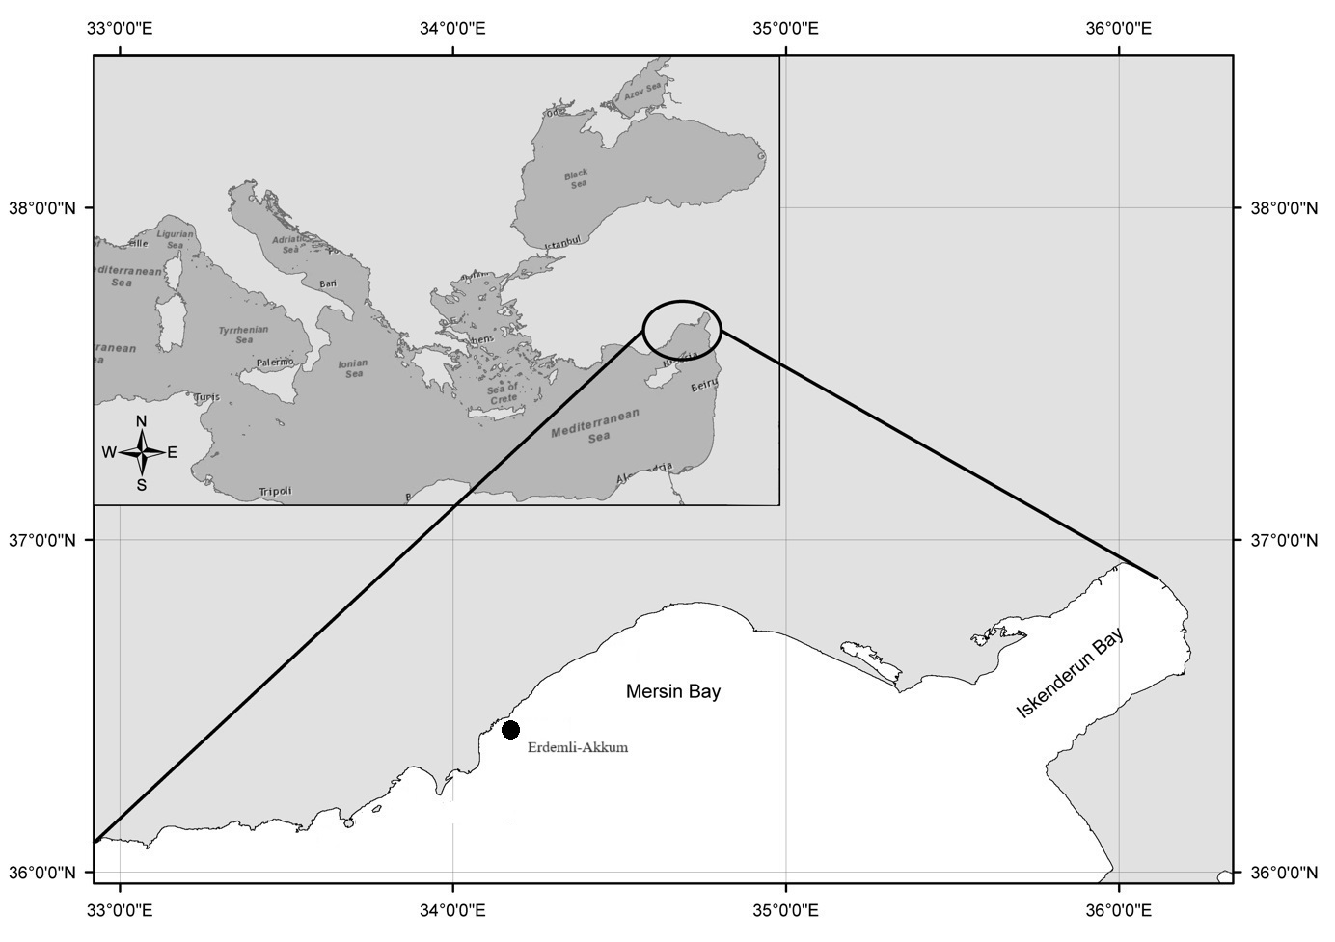
Figure 1. Location where specimens of the Matuta victor were collected in Mersin Bay

RESULTS
A female M. victor specimen had a carapace length (CL) of 23.32 mm and a carapace width (CW) of 38.35 mm. The carapace is subcircular, bearing two long, well-developed lateral spins. Chelepod is subequal; the pollex is slightly shorter than the dactylus. The dactylus contains a clear milled ridge on the outer surface, having two spines in males. However, the milled ridge is absent in females, and the spine is three. Color: The male specimen appears yellowish or light greenish with numerous small and evenly scattered black dots on the carapace.
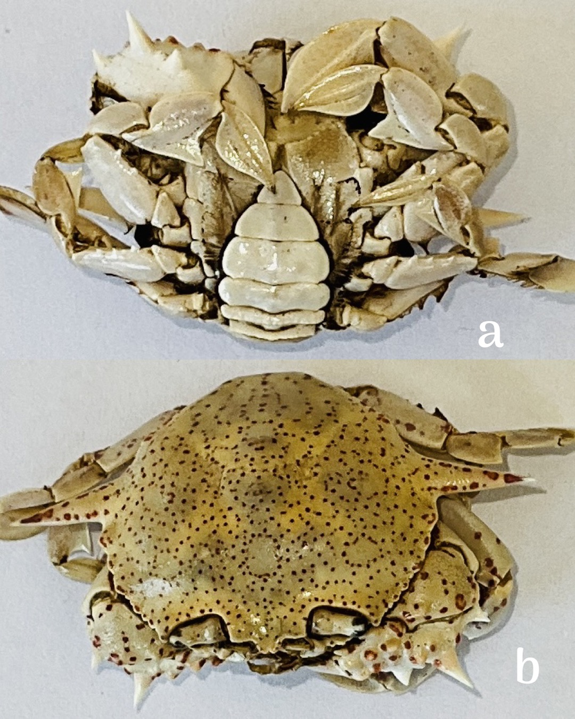
Figure 2. a) Ventral view of female individual of Matuta victor, b) Dorsal view of female individual of Matuta victor CL: 23.32 mm, CW: 38.35 mm

DISCUSSION
In the present study, a single female specimen of M. victor was reported from Erdemli, Akkum (Mersin). This species prefers sandy areas between 0 and 20 m depth and is commonly caught by net, hand, or beach seines (Ng, 1998; Ng & Huang, 1997). Bellwood (2002) noted that Matutid crabs can quickly bury themselves in sand. M. victor is considered a carnivorous Indo-Pacific species. It feeds mainly on crustaceans and molluscs such as anomurans, bivalves and snails (Perez & Bellwood, 1998).
The moon crab is a marine predatory decapod species whose recent sightings in various regions and expanding distribution are increasingly being reported. Known as an aggressive and slow predator of moving benthic invertebrates, M. victor has developed robust populations in the most diverse coastal environments, such as the southeastern Mediterranean Sea and Haifa Bay in northern Israel (Dailianis et al., 2016).
Recently, Türeli (2023) conducted a biological analysis of the invasive moon crab Matuta victor along the Karataş coast of Adana, Turkey, and the study provided important insights into the behavior and ecological impacts of the crab. The invasive nature and adaptability of the moon crab demonstrate its potential to alter the habitats of native species, which would require comprehensive research on its ecological impacts. Zviely et al. (2021) suggest that the presence of M. victor will disrupt the local ecosystem, particularly in sandy beaches and coastal water habitats.
The recent occurrence of M. victor in Erdemli Akkum (Mersin) is the latest record of its expanding distribution, and there are concerns about its potential impact on local biodiversity. M. victor is a newly arrived species in the Mediterranean, and it has recently settled and established a population in Mersin Bay due to suitable environmental conditions. The expanding distribution of M. victor suggests that there is an urgent need to try to assess the invasion process of the crab species. It is necessary to conduct studies based on continuous monitoring to evaluate the invasion process of this crab species and its impact on the local ecosystem, to understand the ecological impact of this species, and to develop effective management strategies.
REFERENCES
Ates, S.A., Katagan, T., Sert, M., Ozdilek, Y.S. (2017). A new locality for common box crab, Matuta victor (Fabricius, 1781), from the eastern Mediterranean Sea. J. Black Sea/Medit Environ 23(2), 191-195.
Behera, P.D., Nayak, L., & Sahu, K.S., (2018). Fresh record of the moon crab Matuta victor (Fabricius, 1781) (Crustacea: Decapoda: Matutidae) from the Odisha coast after a century. Indian Journal of Geo Marine Sciences, 47(09), 1782-1786.
Bellwood, O. (2002). The occurrence, mechanics and significance of burying behavior in crabs (Crustacea: Brachyura). Journal of Natural History, 36(10): 1223-1238.
Crocetta, F., & Bariche, M. (2015). Six new records from Lebanon, with general implications for Mediterranean alien fauna [p. 696–698]. In: Crocetta, F., Agius, D., Balistreri, P., Bariche, M., Bayhan, Y., Çakir, M., Ciriaco, S., Corsini-Foka, M., Deidun, A., El Zrelli, R., Ergüden, D., Evans., Ghelia, M., Giavasi, M., Kleitou, P., Kondylatos, G., Lipej, L., Mifsud, C., Özvarol, Y., Pagano, A., Portelli, P., Poursanidis, D., Rabaoui, L., Schembri, P., Taşkin, E., Tiralongo, F., Zenetos, A., New Mediterranean Biodiversity Records (October 2015). Medit Mar Sci 16(3):682–702.
Galil, B.S., & Clark, P.F. (1994). A revision of the genus Matuta Weber, 1795 (Crustacea: Brachyura: Calappidae). Zool Verh Leiden 294: 1-55.
Galil, B.S., Mendelson, M. (2013). A record of the moon crab Matuta victor (Fabricius, 1781) (Crustacea; Decapoda; Matutidae) from the Mediterranean coast of Israel. BioInvasions Rec 2(1): 69-71.
Gökoğlu, M., Teker, S., & Julian, D., (2016). Some IndoPacific benthic species in Ancient City Phaselis. Disiplinlerarası Akdeniz Araştırmaları Dergisi, 2, 225-233.
Fazrul, H., Hajisamae, S., Ikhwanuddin, Mhd., Pradit, S. (2015). Assessing the impact of crab gill net fishery to bycatch population in the lower Gulf of Thailand. Turkish Journal of Fisheries and Aquatic Sciences, 15: 761-771.
Galil, B.S., Mendelson, M. (2013). A record of the moon crab Matuta victor (Fabricius, 1781) (Crustacea; Decapoda; Matutidae) from the Mediterranean coast of Israel. BioInvasions Records, 2(1): 69-71.
Kondylatos, G., Corsini-Foka, M., & Perakis, E. (2018). Hellen sularında Idotea hectica (Pallas, 1772) (Idoteidae) ve brachyuran yengeç Matuta victor (Fabricius, 1781) (Matutidae)'nin ilk kaydı. Akdeniz Deniz Bilimi, 19(3), 656-661.
Ng, P.K.L., Huang, J.F. (1997). Unrecorded crabs (Crustacea: Decapoda: Brachyura) from Taiwan and Tungsha Islands, with description of a new genus and species of Xanthidae. Zoological Studies 36(4): 261-276.
Ng, P.K.L. (1998). Crabs. In: FAO Species Identification Guide for Fishery Purposes, The Living Marine Resources of the Western Central Pacific 2, Cephalopods, Crustaceans, Holothurians and Sharks (eds., K.E. Carpenter, V.H. Niem), FAO, Rome, pp. 1054-1155.
Ng, P.K.L., Wang, C.H., Ho, P.H., Shih, H.T. (2001) An annotated checklist of brachyuran crabs from Taiwan (Crustacea: Decapoda). National Taiwan Museum Special Publication Series, 11, 86 pp.
Hanim, N., Suman, A., Kembaren, D. D., Perwitasari, D., Wardiatno, Y. & Farajallah A. (2023). Notes on two rare species of brachyuran crabs (Families Matutidae and Parthenopidae) from Indonesian waters with new distribution records. Tropical Life Sciences Research, 34(3). https://doi.org/10.21315/tlsr2023.34.3.10
Perez, O.S. & Bellwood, D.R. (1998). Ontogenetic changes in the natural diet of the sandy shore crab, Matuta lunaris (Forskaş) (Brachyrua: Callappidae). Aust. J. Mar. & Fres. Wat. Res., 39: 139.199.
Syuhada, N. (2024). Distribution of moon crab Matuta victor (Fabricius, 1781) from the western and eastern Java coastline and the characteristic of COI mitochondria among the locations. IOP Conference Series Earth and Environmental Science, 1359(1), 012088. https://doi.org/10.1088/1755-1315/1359/1/012088
Türeli, C. (2023). Some biological characteristics of the invasive moon crab matuta victor (Fabricius, 1781) (Crustacea: Decapoda: Matutidae) in Karataş coasts (Adana, Türkiye). Çanakkale Onsekiz Mart University Journal of Marine Sciences and Fisheries, 6(2), 137-146. https://doi.org/10.46384/jmsf.1373531
Yeşilyurt, İ.N., Türeli, C., & Akamca, E. (2019). Occurrence of the moon crab Matuta victor (Fabricius, 1781) (Crustacea: Decapoda) in Iskenderun Bay, northeastern Mediterranean Sea. In 3rd International Congress on Advances in Bioscience and Biotechnology (ICABB), (pp. 60-63). Kiev, Ukraine.
Zeini, A., & Hasan, H. (2017). A new alien crab from the coast of Syria: Matuta victor (Fabricius, 1781) (Crustacea: Decapoda: Brachyura: Matutidae). Tishreen University Journal for Research and Scientific Studies- Biological Sciences Series 39(4): 273-279.
Zviely, D., Zurel, D., Edelist, D., Bitan, M., & Spanier, E. (2021). Does sand beach nourishment enhance the dispersion of non-indigenous species? -the case of the common moon crab, Matuta victor (Fabricius, 1781), in the southeastern Mediterranean. Journal of Marine Science and Engineering, 9(8), 911. https://doi.org/10.3390/jmse9080911

