Trace Metal Induced Genotoxic Damage in Nursehound Shark, Scyliorhinus stellaris (Linnaeus, 1758) from the Northeastern Mediterranean

Ayşegül ERGENLER^{1,*} and Funda TURAN ¹
^{1,*}Faculty of Marine Science and Technology, University of Iskenderun Technical, 31200, Iskenderun, Hatay, Turkey
*Corresponding author: aergenler@gmail.com
Abstract
A rising number of contaminants in aquatic environments has led to significant concern about environmental degradation, specifically its detrimental impacts on ecosystems and human wellness. The impact of trace metal pollution on aquatic ecosystems is an international issue. High levels of metals may lead to malignant and hazardous consequences in aquatic environments. This study focused on trace metal induced genotoxic damage in the Nursehound shark (Scyliorhinus stellaris) from Iskenderun Bay, the Northeastern Mediterranean. Samples were collected following established protocols according to recognized methods, and the trace elements were detected using the ICP-MS technique. The research applied the damage frequency (%), arbitrary unit (%), and genetic damage index (%) in S. stellaris to evaluate the extent of DNA damage resulting from pollutants. The amounts of Cd, Cr, Fe, Ni, Pb and Zn in the water columns at sample location were below Environmental Protection Agency, 2016 and Turkish Environmental Guideline, 2016. Trace metal concentrations in the liver tissue of S. stellaris were ranged as follows: Fe > Zn> Pb>Cr> Ni>Cd for the sampling site. According to our findings, the frequency of damage in the nursehound shark's gill and liver cells was 62.332±4.041% and 56.332±1.528%, respectively. The gill tissue had a higher frequency of damage than the liver tissue. As a result, peresent study revealed, for the first time, the genotoxic damage of metal contamination in Nursehound shark S. stellaris in the Northeastern Mediterranean Sea.

Keywords: Shark, DNA Damage, Comet Assay, Genotoxicity, Scyliorhinus stellaris

Introduction
The compounds may infiltrate the aquatic environment via processes such as air depositing, earthquakes, urbanization removal, fire, and industrial exhaust. Pollutants often exhibit bioaccumulation and biomagnification, resulting in apex predators being exposed to much higher amounts of pollutants relative to the surrounding environment. The presence of contaminants in teleost fish, mollusks, and marine mammals has been extensively researched. These pollutants have been shown to have detrimental impacts on health, such as inhibiting reproduction, suppressing the immune system, disrupting the hormonal cycle, causing harm to the DNA, and inducing oxidative stresses (Kutlu et al., 2024; Ergenler, 2024). Elasmobranchs have received less focus on contaminants relative to other vertebrate groups, despite their high trophic position and ongoing population reduction (Tiktak et al., 2020). This is a cause for worry. Due to its hydro-geological characteristics and the significant human impact it faces, the Mediterranean is in high danger of ecological problems. Currently, the seas of the Mediterranean face several ecological threats, such as overexploitation, habitat degradation, pollution, and climate change (Carrasco et al., 2024).
Sharks, as the greatest predators in the marine food chain, have the ability to collect significant amounts of metals in their organs by consuming both nourishment and water. This may have detrimental effects on their metabolism and also cause health risks if their flesh is ingested by humans (Squadrone et al., 2022). Sharks are particularly vulnerable to bioaccumulation due to their role as a vital species, often holding top positions in food chains as extreme predators (Barría et al., 2015; Carassco et al., 2024). According to Dulvy et al. (2021), approximately 32.6% of shark and ray species are at risk of becoming extinct. Given that sharks are currently one of the most endangered groups of animals (IUCN, 2024), it is important to consider the environmental dangers that result from chemical contamination. This contamination can lead to reduced people's wellness, a greater likelihood of community extinction, and a decline in species diversity (Araujo et al., 2024).
The Nursehound, scientifically known as Scyliorhinus stellaris (Linnaeus, 1758), is a kind of catshark that lives on the ocean floor. It may be found in the Northeast and Eastern central Atlantic regions, as well as in the Mediterranean Sea. S. stellaris often inhabits nursery sites at depths of 30 to 40 meters inside the fields of the violescent sea-whip (Paramuricea clavata) in the circalittoral region of the Mediterranean Sea. The species may be found in a range of habitats, from the intertidal zone to the continental slope. However, it tends to occur at depths of 200–500 meters (Leonetti et al., 2020; Martinengo et al., 2024). Scyliorhinus stellaris is classified as Vulnerable internationally by the IUCN due to its huge size, patchy distribution, and likely population decreases. However, in the European and Mediterranean seas, it is designated as Near Threatened (Catanese et al., 2022). There is increasing worry about the harmful impact of pollution on sharks. Since sharks are at the top of the food chain, they can accumulate pollutants in their bodies, and some of these pollutants can become more concentrated as they move up the food chain. This poses a particular risk for sharks, especially when it comes to metal contamination (Turan et al., 2021). There is a lack of evidence on shark fisheries that are being taken seriously for the environment, save in a few countries. As a result, sharks are becoming more scarce in the coastal seas of several emerging nations. Sharks have a significant ecological role in the Mediterranean Sea.
Elasmobranchs possess biological and ecological characteristics that resemble those of large-bodied mammals, such as late maturation, delayed reproduction, and a limited number of offspring. Due to their high trophic status and the presence of these features, elasmobranchs are more susceptible to the harmful effects of contaminants (Dulvy et al., 2014; Titak et al., 2020; Fillice et al., 2024). Recent studies have emphasized the use of sharks as monitoring species because they are highly vulnerable to accumulating various pollutants, including metals (Turan et al., 2021; Squadrone et al., 2022; Alves et al., 2023; Fillice et al., 2023; Araujo et al., 2024; Higueruelo et al., 2024). The aim of this study was to examine novel data on harm to DNA caused by metal pollution in the North-Eastern Mediterranean nursehound, S. stellaris.

Materials and Methods
Sample collection and preparation

A total 10 specimens of Nursehound Shark, Scyliorhinus stellaris were collected from Iskenderun Bay (36°38'50"N 36°06'48"E) in the NortheasternMediterranean Sea, during the period of November-December 2020 by gill net (Figure 1).

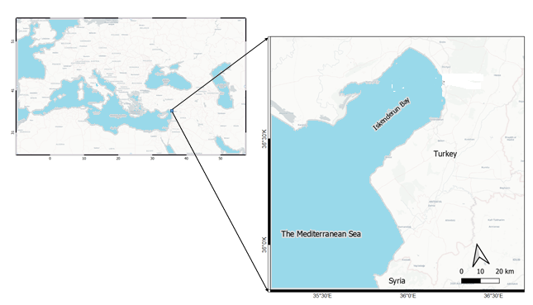

Figure 1. Map of sampling site (•) in the Iskenderun Bay (Türkiye) of the North-Eastern Mediterranean.
A whole of specimens of S. stellaris were collected, with an average length of 36.72±5.09 cm and an average mass of 206.91±74.55 g (mean±standard deviation). These specimens were promptly transferred to the laboratory on ice in an insulated box. The species identity was determined using morphological and meristic characteristics(Reference needed). The length and mass of the Nursehound shark were measured with precision to the nearest centimetre and 0.01 gram, accordingly. An investigation was carried out to examine the concentration of heavy metals in seawater samples obtained from a Nursehound shark. The specimens were gathered using sterile glass containers and treated with ultrapure 6 M hydrogen nitrate. The samples were then examined using an Analytik Jena / Plasmaaquant ICP-MS Elite instrument at Iskenderun Technical University, Science and Technology Research and Application. The heavy metal concentrations were calculated using mathematical processes, expressed as micrograms per liter (µg L-1) of wet weight. The used absorption lines consisted of lead at a wavelength of 217.0 nm, cadmium at 357.9 nm, nickel at 232.0 nm, iron at 248.3 nm, cadmium at 228.8 nm, and zinc at 213.9 nm. The examination also included the calibration and standard solutions for blanks. Analyzing trace metals in muscle cells was conducted using acid elimination, a technique adapted from the AOAC Official Method 999.10 (2002). An ICP-MS Elite at Iskenderun Technical University, Science and Technology Research and Application was used to measure the levels of metals in shark tissue. The algorithms were used to calculate the heavy metal concentration, which was then quantified as micrograms per gram of wet weight (w.w.).

Comet Assay
The laboratories at Iskenderun Technological University's Faculty of Marine Science and Technology used Comet Assay experiments to detect DNA damage in shark tissues. Blood cells were isolated from tissues using cellular dissociation, and samples were generated using a cell suspension and 0.7% LMPA. DNA damage indices were determined by the use of scoring techniques and fluorescence microscopy. The comet tail intensity was examined using a sample size of one thousand cells.
Statistical analysis

The research used Pearson Correlation analysis to establish a potential association between factors and DNA damage, calculating the mean and standard deviation for all data points. The statistical analysis was performed using R-Studio and IBM SPSS Statistics 21 (Zheng et al.,2016).

Results
The values for the concentrations of Cr, Cd, Fe, Ni, Pb and Zn in the sea water columns at the sample location were listed in Table 1. In the sea water columns of the sample location, Fe, Zn 1and Cr were at greater concentrations, while Cd was at the lowest dose. The relative abundance of heavy metals at the sample location were in the following order: Fe>Zn>Cr>Ni>Pb>Zn (Table 1).
Table 1. The mean values of trace metal concentrations (µg L⁻¹) in the Iskenderun Bay with a comparison of the Turkish Environmental Guideline (TEG) and Environmental Protection Agency (EPA, USEPA).

Metals | Iskenderun Bay | TEG (2016) |  |  | EPA (2007, 2016)
 |  | CMC |  |  |  | CMC | CCC
Cr | 5.645±0.483 | 88 |  |  |  | 1.1 | 50.0
Cd | 0.025±0.011 | <0.45(Class) |  |  |  | 33 | 7.9
Fe | 53.699±4.312 | 101 |  |  |  | - | -
Ni | 1.848±0.207 | 34 |  |  |  | 74 | 8.2
Pb | 0.301±0.197 | 14 |  |  |  | - | 5.6
Zn | 34.717±2.793 | 76 |  |  |  | 90 | 81

Data are shown as mean ± standard deviation, TEG: Turkish Environmental Guideline; EPA: Environmental Protection Agency; CMC: Criterion Maximum Concentrations; CCC: Criterion Continuous Concentrations.

The concentrations of Cd, Cr, Fe, Ni, Pb, and Zn in the water columns at the sample site were found to be lower than the limits set by the Environmental Protection Agency (EPA) in 1999 and 2016, as well as the Turkish Environmental Guideline (TEG) in 2016.
The average amounts of Cd, Cr, Fe, Ni, Pb, and Zn in the liver tissue of S. stellaris collected from Iskenderun Bay are shown in Table 2.
Table 2. Average concentrations (concentration unit as μg g -1 ww.) of trace metals in liver
tissue of S. stellaris from Iskenderun Bay.

Metals | Iskenderun Bay | EU (2005) | EPA (1989) | WHO (1989) | TFC (2011)
Cd | 0.153±0.006 | 0.05 | 1.4 | 1.0 | 0.05
Cr | 0.654±0.060 | - | 4.1 | - | -
Fe | 20.940±1.722 | - | 410 | 100 | 50
Ni | 0.291±0.040 | - | 4.6 | - | -
Pb | 2.963±0.084 | 0.2 | 1.0 | 2.0 | 0.3
Zn | 16.609±1.303 | 50 | 410 | 100 | 50
The data are shown as arithmetic mean ± standard deviation.
Trace metal concentrations in the liver tissue of S. stellaris at the sample location were in the following order: Fe>Zn> Pb>Cr>Ni>Cd (Table 2).
The levels of Cr, Fe, Ni, and Zn in the liver tissue of S. stellaris taken from Iskenderun Bay did not exceed the maximum limits set by the EU 2005, EPA 1989, WHO 1989, and TFC 2011 (Table 2). Therefore, a human health risk assessment was not done to determine the potential danger associated with these metals. However, the concentrations of Cd and Pb at the sample site above the maximum limits set by the TFC (2011) and EU (2005), and were significant enough to have detrimental impacts on coastal ecosystems (Table 2).
The results of the comet test conducted on S. stellaris, which measured DNA damage, were provided in Table 3. The table includes the percentage of damage (DF), arbitrary unit values (AU), and the genetic damage index (GDI/%). The incidence of DNA damage in the gill and liver cells of the nursehound shark was 62.332±4.041% and 56.332±1.528%, respectively. The gill tissue had a higher frequency of damage than the liver tissue (Table 3).

Table 3. Means and Standard deviations of DNA damage in the gill and liver cells of S. stellaris obtained from the Iskenderun Bay (n=10).
Fish/Tissues | Damage Frequency (%) | Arbitrary Unit (AU) | Genetic Damage Index (%)
S. stellaris/Gill | 62.332±4.041 | 146.667±13.317 | 1.46±0.133
S. stellaris /Liver | 56.332±1.528 | 127.012±3.005 | 1.27±0.03

The data are shown as arithmetic mean ± standard deviation.
Correlation between metals and genetic damage
A substantial positive connection (P<0.01) was found between the presence of Pb in water columnar and DNA damage metrics. Conversely, a strong negative correlation (P<0.01) was seen between the levels of Fe and Cr in water columns at the sample location and DNA damage parameters in both gill and liver cells. (Refer to Figure 2 and Figure 3). In addition, a strong negative connection (P<0.01) was observed between the accumulation of Fe and Ni in liver tissue and the parameters of DNA damage in gill and liver cells (Figure 3).
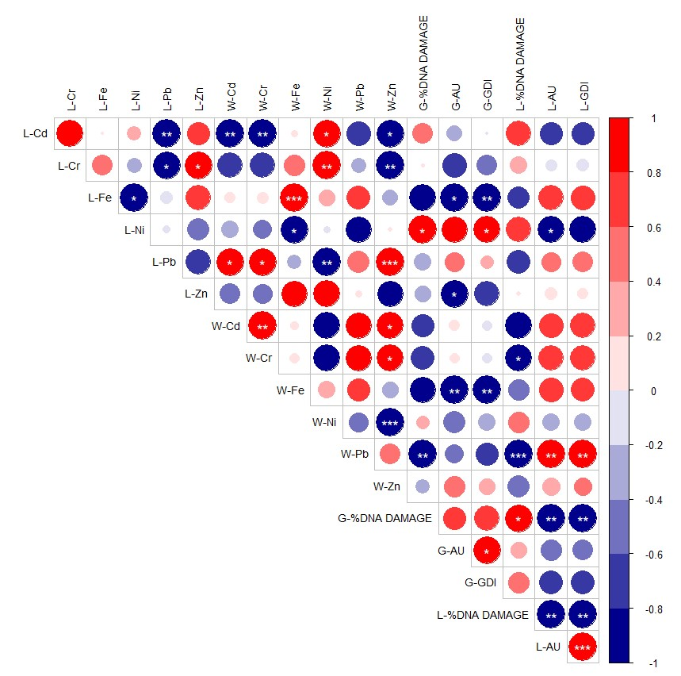
Figure 2. Heat map of Pearson correlations between parameters with significance levels. The
colored correlation levels on the scale color bar indicate a correlation between -1 and +1. The
specified significance levels are given in the circled cells: *, P<0.05; **, P<0.01; P<0.001.

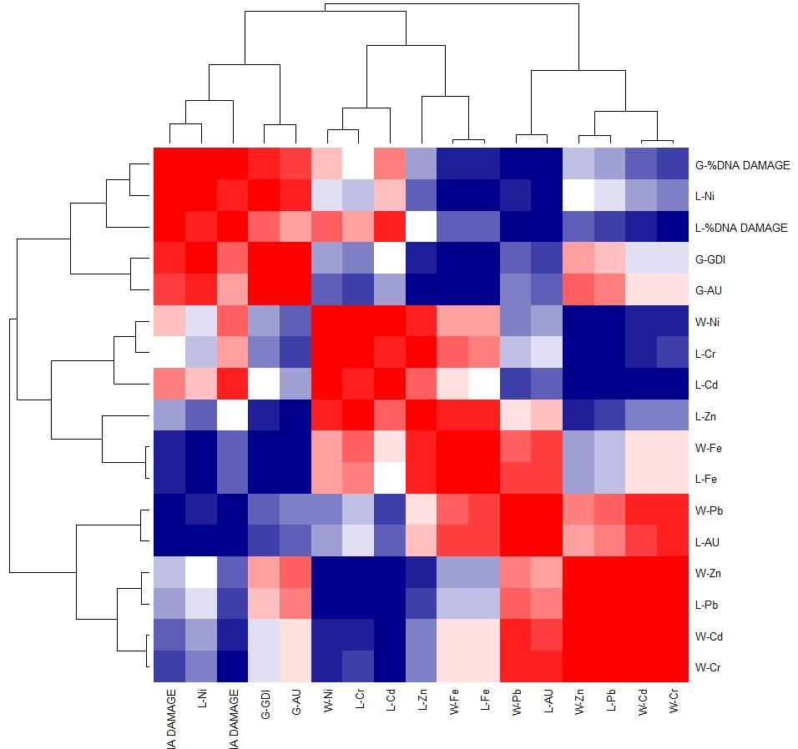
Figure 3. Heatmap of hierarchical cluster analysis of trace metal and DNA Damage parameters in S. stellaris using complete linkage. Significance of relationship range from white to red.

Discussion
The present study highlighted the correlations between trace elements accumulation and markers of DNA damage parameters in the gill and liver cells of the nursehound shark S. stellaris collected from the North-Eastern Mediterranean. Although, the studied metal amounts in the sea water columns at research area were below EPA (Environmental Protection Agency 1999, 2016) and TEG standards (Turkish Environmental Guideline, 2016), Cd and Pb accumulation in liver tissue of S. stellaris exceeded the maximum limits allowed by the TFC (2011), EU (2005) enough to have negative effects on coastal ecosystems. Also, the frequency of DNA damage in the nursehound shark's gill and liver cells were 62.332±4.041% and 56.332±1.528%, respectively. The gill tissue exhibited a greater incidence of injury compared to the liver tissue. Extended exposure to contaminants may lead to the buildup of DNA strand breaks in aquatic creatures like fish due to their inability to repair DNA, which is lower relative to other species (D’Costa et al., 2017). D’Costa et al. (2017) found that the presence of contaminants in the environment leads to increased levels of DNA damage. This was determined via the use of multiple regression analysis. Furthermore, a strong positive association was found between the concentration of Pb in the water columns and the DNA damage parameters. Conversely, a negative correlation was seen between the concentrations of Fe and Cr in the water columns at the sample location and the DNA damage parameters in both gill and liver cells. Multiple investigations assessed the metal concentrations in Scyliorhinus stellaris specimens sourced from the Atlantic Ocean (Vas, 1991), in addition to Scyliorhinus canicula (lesser-spotted dogfish) specimens collected from the Mediterranean Sea and the Atlantic Ocean (Mille et al., 2018; Marques et al. 2021; Squadrone et al., 2022). The gill tissue showed a higher occurrence of injury in comparison to the liver tissue. Based on the information provided in the piece of literature, gills are more vulnerable to pollutants than other organ tissues since they have a high blood flow for respiration and are constantly exposed to saltwater. The gill, with its specialized structure for detecting harmful substances, plays a crucial role in other studies that have also reached findings. Furthermore, the identification of more extensive harm in the gill as opposed to the liver implies a connection between oxidative stress and DNA damage in aquatic species (Ergenler & Turan, 2023). The results of our study were mostly consistent with the information found in the existing literature. Moreover, the presence of greater damage in the gill compared to the liver suggests that oxidative stress is associated with DNA damage in the gill and liver cells of elasmobranchs (Alves et al., 2023; Fillice et al., 2023). Alves et al. (2023) discovered that Prionace glauca sharks captured in approach to the continental coast of Portugal had elevated levels of inorganic pollutants in their livers in comparison to animals collected in more distant oceanic areas. Their suggestion posits that gills have the potential to serve as a source tissue for future monitoring investigations including alternative biomarkers. In their study, Fillice et al. (2023) conducted an eco-toxicological investigation of Pb, As, Cd, Mn, Zn, Ni, Cu, and Fe in Scyliorhinus canicula. They found that there was no significant difference between the sexes. Additionally, they discovered strong associations between the number of white blood cells and the presence of manganese (Mn) and zinc (Zn), as well as between lactate dehydrogenase (LDH) activity and these trace elements. This indicates that the build-up of these elements in dogfish may impact oxidative and antioxidant processes, potentially leading to major effects on their physiology and overall well-being. In their study, Squadrone et al. (2022) investigated the bioaccumulation of metals in the blood, liver, kidneys, and muscles of Scyliorhinus stellaris, a shark species. Researchers discovered that nonessential components are often less abundant, whereas essential components are more abundant in wild elasmobranchs. This suggests a strong correlation between a well-balanced diet and the well-being of these animals. Araujo et al. (2024) examined the correlation between genetic harm in red blood cells and the levels of metals in the blood of three shark species: Galeocerdo cuvier, Negaprion brevirostris, and Ginglymostoma cirratum. It was discovered that G. cuvier exhibited the greatest frequency of genomic damage in erythrocytes, as well as the highest average content of Al, Cd, Cr, Fe, Mn, Ni, Pb, and Zn in the blood. Rojubie et al. (2024) discovered that sharks had a tendency to collect high levels of heavy metals, with the liver typically containing higher median concentrations. In their study, Higueruelo et al. (2024) found that the small-tailed catfish (Scyliorhinus canicula) has the greatest degree of biodegradability among the marine species found on the Catalan coast in the northern Mediterranean. Additionally, the presence of significant concentrations of heavy metals in S. canicula causes concerns about its safety for consumption. This research studied the deleterious effects of heavy metals on DNA, specifically focusing on their ability to accumulate in biological systems. The observed features of the damage were found to be consistent with those described in the referenced paper. Turan et al. (2021) discovered elevated levels of heavy metals in Squatina aculeata, a marine species inhabiting the northern Mediterranean. The species had elevated levels of iron, zinc, arsenic, and mercury, beyond the permissible thresholds set by the law. The research indicates that consuming S.aculeata, a food with a significant probability of causing harm, might potentially endanger the sustainability of its marine habitat. The variations in the measured levels of heavy metals may be mostly ascribed to the intrinsic differences among those species, such as their food, habitat, behavior, distribution, growth rates, age, trophic level, and life strategies (Turan et al., 2021; Carrasco-Puig et al., 2024).

Conclusıon

The results of the present research further confirm the species' sensitivity to heavy metals and its vulnerability to genetic damage, as well as its efficiency in serving as a protective species in environmental monitoring studies. In addition, current research also necessitates the use of genomic damage criteria in several shark species as a component of environmental monitoring initiatives. Further investigation is required to overcome the scarcity of scientific material about the effects of shark exposure to contaminants on animal DNA.
Conflict of Interest
The authors declare that they have no competing interests.
Author Contributions
A.E. and F.T performed all the experiments and drafted the main manuscript text. Authors reviewed and approved the final version of the manuscript.
Ethical Approval Statements
Local Ethics Committee Approval was not obtained because experimental animals were not used in this study.
Funding Informatıon
This study was supported by the Nature and Science Society (www.dogavebilim.com).
Acknowledgments
Thanks to the Nature and Science Society (www.dogavebilim.com).
Data Availability Statement
The data used in the current investigation may be obtained by contacting the appropriate author.

References

Ahmed M. S., Aurpa T. T., & Azad M. A. K. 2022. Fish disease detection using image based machine learning technique in aquaculture. Journal of King Saud University-ComputerandInformationSciences, 34(8):5170518. Doi: 10.1016/j.jksuci.2021.05.03
Alves, L. M., Moutinho, A. B., Gómez, L. J., Oropesa, A. L., Muñoz-Arnanz, J., Jiménez, B., ... & Novais, S. C. (2023). Evidence of contamination-associated damage in blue sharks (Prionace glauca) from the Northeast Atlantic. Science of the Total Environment, 872, 162095.
Araújo, C., Carneiro, P., Fidelis, L., Nascimento, B., Antunes, M., Viana, D., ... & Adam, M. (2023). Comparative genomic damage among three shark species with different habits: Sublethal impacts of human origin in a protected island environment in the South Atlantic. Marine Pollution Bulletin, 191, 114924.
Barría, C., Coll, M., & Navarro, J. (2015). Unraveling the ecological role and trophic relationships of uncommon and threatened elasmobranchs in the western Mediterranean Sea. Marine Ecology Progress Series, 539, 225-240.
Carrasco-Puig, P., Colmenero, A. I., Ruiz-García, D., Molera-Arribas, A. J., Hernández-Martínez, A. M., Raga, J. A., & Barría, C. (2024). Heavy metal concentrations in sharks, rays, and chimeras from the western Mediterranean Sea. Marine Pollution Bulletin, 199, 115942.
D’Costa, A., Shyama, S. K., & Kumar, M. P. (2017). Bioaccumulation of trace metals and total petroleum and genotoxicity responses in an edible fish population as indicators of marine pollution. Ecotoxicology and environmental safety, 142, 22-28.
De Andrade V. M., Da Silva J. Da Silva F. R. Heuser V. D. Dias J. F. Yoneama M. L. & De Freitas T. R. 2004. Fish as bioindicators to assess the effects of pollution in two southern Brazilian rivers using the Comet assay and micronucleus test. Environmental and molecular mutagenesis, 44(5): 459-468. Doi:10.1002/em.20070
De Araújo, C. B. B., de Mendonça, S. A., de Lima Viana, D., da Fontoura Martins, M., Costa, P. G., Bianchini, A., ... & Adam, M. L. (2024). Effects of blood metal (loid) concentrations on genomic damages in sharks. Environmental Pollution, 124569.
De León J. S. D. D., Santos-Medrano G. E. Rico-Martínez R. Rubio-Franchini I. & Robles-Vargas, D. 2021. Preliminary Genotoxicity Assessment of Cadmium, Lead, and Mercury Planktonic Organisms. Metabolism, 4. Doi:10.15244/pjoes/136481
EPA, (2016). Environmental Protection Agency, National Recommended Water Quality Criteria-Aquatic Life Criteria.
Ergenler, A. (2024). Potential Ggnotoxicological evaluation of ulexite on Daphnia magna. Tethys Env. Sci, 1(1), 27-32.
Ergenler, A., & Turan, F. (2023). Metal causing DNA damage in lionfish Pterois miles from the northeastern Mediterranean. Missing journal name, volume and page numbers.
Faria J. J., Dyer J. R. Clément R. O. Couzin I. D. Holt N., Ward, A. J., ... & Krause, J. (2010). A novel method for investigating the collective behavior of fish: introducing ‘Robofish’. Behavioral Ecology and Sociobiology, 64(8), 1211-1218. Doi:10.1007/s00265-010-0988-y
Froese R. & Pauly D. 2016. FishBase. World Wide electronic publication. http://www.fishbase.org, version (10/2016).
Golani D. & Sonin O. 1992. New records of the Red Sea fishes, Pterois miles (Scorpaenidae) and Pteragogus pelycus (Labridae) from the eastern Mediterranean Sea. Japanese Journal of Ichthyology, 39(2): 167-169.Doi:10.1007/bf02906001
Gündoğdu S., Çevik C. Ayat B. Aydoğan B. & Karaca S. 2018 . How microplastics quantities increase with flood events? An example from Mersin Bay NE Levantine coast of Turkey. Environmental Pollution, 239:342-350.
Heng H. H., Goetze S. Ye C. J. Liu G. Stevens J. B. Bremer S. W. ... & Krawetz S. A. 2004. Chromatin loops are selectively anchored using scaffold/matrix-attachment regions. Journal of Cell Science, 117(7): 999-1008.
Higueruelo, A., Constenla, M., Padrós, F., Sánchez-Marín, P., Carrassón, M., Soler-Membrives, A., & Dallarés, S. (2024). Coping with current impacts: The case of Scyliorhinus canicula in the NW Mediterranean Sea and implications for human consumption. Marine Pollution Bulletin, 201, 116200.
Kumar G., Menanteau-Ledouble S, Saleh M. & El-Matbouli M. 2015. Yersinia ruckeri, the causative agent of enteric redmouth disease in fish. Veterinary research, 46(1): 1-10. Doi:10.1186/s13567-015-0238-4
Kumar S., Sándor Zs J. Nagy Z., Fazekas G. Havasi M. Sinha A. K. ... & Gál D. 2017. Potential of processed animal protein versus soybean meal to replace fish meal in practical diets European catfish (Silurus glanis): growth response and liver gene expression. AquacultureNutrition, 23(5):11791189.Doi:10.1111/anu.12487
Kutlu, Y., Turan, F., & Ergenler, A. (2024). An alternative automated tool for the detection and quantification of DNA damage using Comet Assay. Tethys Environmental Scence, 1(1), 17-26.
Leonetti F. L., Giglio G., Leone A., Coppola F., Romano C., Bottaro M., Reinero F. R., Milazzo C., Micarelli P., Tripepi S., & Sperone E. (2020). An updated checklist of chondrichthyans of Calabria (Central Mediterranean, southern Italy), with emphasis on rare species. Mediterranean Marine Science, 21(3), 794–807. https://doi.org/10.12681/mms.23321
López F. F., Cabrera, C., Lorenzo, M. L., & López, M. C. (2002). Aluminum content of drinking waters, fruit juices, and soft drinks: contribution to dietary intake. Science of the Total Environment, 292(3),205-213. Doi:10.1016/s0048-9697(01)01122-6
Martinengo E., Micarelli P., Reinero F. R., Bertelloni F., & Fratini F. (2024). Antibacterial activity in egg samples from small-spotted.Fish Biology (1) 7.
Matsumoto S. T., Mantovani M. S. Malaguttii M. I. A. Dias A. L. Fonseca I. C. & Marin-Morales M. A. 2006. Genotoxicity and mutagenicity of water contaminated with tannery effluents, as evaluated by the micronucleus test and comet assay using the fish Oreochromis niloticus and chromosome aberrations in onion root-tips. Genetics and Molecular Biology, 29:148-158. Doi:10.1590/s1415-47572006000100028
Mayer B., Boyer E. W. Goodale C. Jaworski N. A. Van Breemen N. Howarth R. W. ... & Paustian, K. (2002). Sources of nitrate in rivers draining sixteen watersheds in the northeastern US: Isotopic constraints. Biogeochemistry, 57(1): 171-197. Doi:10.1007/978-94-017-3405-9_5
Mille T., Cresson, P., Chouvelon, T., Bustamante, P., Brach-Papa, C., Bruzac, S., ... & Bouchoucha, M. (2018). Trace metal concentrations in the muscle of seven marine species: Comparison between the Gulf of Lions (North-West Mediterranean Sea) and the Bay of Biscay (North-East Atlantic Ocean). Marine Pollution Bulletin, 135, 9-16.
Nasser N., Boyle P. D. & Puddephatt, R. J. 2013. Organoplatinum chemistry with a Dicarboxamide–Diphosphine Ligand: Hydrogen Bonding, Cyclometalation, and a Complex with two metal–metal donor–acceptorbBonds. Organometallics, 32(19): 5504-5513. Doi:10.1021/om400780q
Omar W. A., Zaghloul K. H. Abdel-Khalek A. A. & Abo-Hegab S. 2012. Genotoxic effects of metal pollution in two fish species, Oreochromis niloticus and Mugil cephalus, highly degraded aquatic habitats. Mutation Research/Genetic Toxicology and Environmental Mutagenesis, 746(1), 7-14. Doi:10.1016/j.mrgentox.2012.01.013
Pitarque M., Vaglenov A., Nosko M. Hirvonen A. Norppa H. Creus A. & Marcos R. 1999. Evaluation of DNA damage by the Comet assay in shoe workers exposed to toluene and other organic solvents. Mutation Research/Genetic Toxicology and Environmental Mutagenesis, 441(1): 115-127. Doi:10.1016/s1383-5718(99)00042-x
Roubie E., Karavoltsos S., Sakellari A., Katsikatsos N., Dassenakis M., & Megalofonou, P. (2024). Trace metals distribution in tissues of 10 different shark species from the Eastern Mediterranean Sea. Fishes, 9(2), 77.
Scalon M. C. S., Rechenmacher C. Siebel A. M. Kayser M. L. Rodrigues M. T. Maluf S. W. ... & Silva L. B. D. 2010. Evaluation of Sinos River water genotoxicity using the comet assay in fish. Brazilian Journal of Biology, 70, 1217-1222.
Squadrone, S., Biancani, B., Da Rugna, C., Favaro, L., Pederiva, S., & Abete, M. C. (2022). Trace and rare earth element bioaccumulation in the spotted dogfish (Scyliorhinus stellaris). Environmental Science and Pollution Research, 29(46), 70262-70268.
Storelli M. M., Cuttone G. & Marcotrigiano G. O. 2011. Distribution of trace elements in the tissues of smooth hound Mustelus mustelus (Linnaeus, 1758) from the southern–eastern waters of Mediterranean Sea (Italy). Environmental monitoring and assessment, 174(1), 271-281. Doi:10.1007/s10661-010-1456-x
Storelli, M. M., Busco, V. P., & Marcotrigiano, G. O. (2005). Mercury and arsenic speciation in the muscle tissue of Scyliorhinus canicula from the Mediterranean Sea. Bulletin of Environmental Contamination & Toxicology, 75(1). page numbers missing?
TEG 2015. Turkish Environmental Guidelines 2015 Publications of Turkish Foundation of Environment
Turan F., Karan S. & Ergenler A. (2020). Effect of heavy metals on toxicogenetic damage of European eels Anguilla anguilla. Environmental Science and Pollution Research, 27(30):38047-38055. Doi:10.1007/s11356-020-09749-2
Turan, F., Yola, M. L., Ergenler, A., & Turan, C. (2021). The first assessment on Metal contamination in‎ the Critically Endangered Sawback Angel Shark ‎‎(Squatina aculeata) from North-Eastern‎ Mediterranean. Pakistan Journal of Marine Sciences, 30(2), 97-108.
US-EPA, (2004). Environmental Protection Agency-US, Integrated risk information system.
Vas P. (1991). Trace metal levels in sharks from British and Atlantic waters. Marine Pollution Bulletin, 22(2), 67-72.
Zheng Q., Bao C., Guo W., Li S., Chen J., Chen B., ... & Huang S. (2016). Circular RNA profiling reveals an abundant circHIPK3 that regulates cell growth by sponging multiple miRNAs. Nature Communications, 7(1), 11215.

