Length-weight relationship of the blackmouth catshark (Galeus melastomus Rafinesque, 1810) on the Turkish coasts of the Mediterranean Sea

Çağdaş Can Cengiz^{1*}, Coşkun Menderes Aydın¹
Aydın Ünlüoğlu², Sencer Akalın³
¹ Mediterranean Fisheries Research Production and Training Institute, Antalya, Türkiye
² Institute of Marine Sciences and Technology, Dokuz Eylül University, İzmir, Türkiye
³ Faculty of Fisheries, Ege University, İzmir, Türkiye

*Corresponding Author: cagdascancengiz@gmail.com

Abstract
This study investigates the relationship between the total length and body weight of the blackmouth catshark (Galeus melastomus) sampled along the Mediterranean coast of Türkiye within the boundaries of the Geographical Sub-Area24 (GFCM GSA24) during August and September 2023. A total of 336 individuals, 106 females, and 230 males, were caught using bottom trawl. The total length and body weight of females range from 17.60 to 54.20 cm and 15.50 to 630 g, respectively. For males, the range is from 16.10 to 50.70 cm in length and from 13 to 426 g in weight. When considering both sexes together, the range is from 16.10 to 54.20 cm in length and from 13 to 630 g in weight. The average weight of males was calculated to be 169.43 ± 7.21 g, while the average length of males was 36.96 ± 0.64 cm. Similarly, the average weight of females was 145.34 ± 15.67 g, and the average length of females was 32.32 ± 1.06 cm. The average length of all individuals without sex separation is 35.50 ± 0.56 cm, and the average weight is 161.83 ± 6.99 g. The length-weight relationship is determined as W = 0.002 × L^{3.13} (r² = 0.97) for females, W = 0.003 × L^{2.94} (r² = 0.98) for males, and W = 0.003 × L^{3.00} (r² = 0.98) for all individuals. The results obtained from this study are expected to contribute to filling the knowledge gap by highlighting the relationship between the length and weight of the blackmouth catshark in the examined area. It will also enable comparisons with other deep-sea locations in the Mediterranean Sea on this particular species.

Keywords: Galeus melastomus, length-weight, body condition, Eastern Mediterranean Sea.

Introduction

Cartilaginous fishes, including sharks and batoids (elasmobranchs), exhibit a wide range of biological and ecological diversity and can be found worldwide. They are crucial in functioning and maintaining marine ecosystems (Dulvy et al., 2014; D’Iglio et al., 2021a; Triay Portella et al., 2023). These species control or are affected by food webs' up-bottom and bottom-up alterations (Dulvy et al., 2017; Pacoureau et al., 2021). They are highly vulnerable to human activities, particularly overfishing, pollution, and habitat loss, due to their life strategies, late sexual maturation, low fecundity, and slow growth rate (Pacoureau et al., 2021; Karampetsis et al., 2022).
Among demersal elasmobranchs, the Scyliorhinidae family, which includes species like Galeus melastomus, Scyliorhinus canicula and S. stellaris, is more capable of resisting high fishing pressure because of some biological features including early maturation, short generation time, faster population dynamics, morpho-functional adaptation of gastroenteric and sensorial systems and, for G. melastomus a continuous reproductive cycle (D’Iglio et al., 2021a). Although bottom trawl fisheries capture small individuals of these species and the high fishing effort in some areas, they can maintain their population (Carbonell et al., 2003).
The blackmouth catshark (G. melastomus) is a small (to 90 cm total length) bottom-dwelling shark widely distributed on the continental shelves and upper slopes of the North-eastern Atlantic Ocean from Faeroe Islands and Norway to Senegal and the Mediterranean Sea (Ebert and Stehmann, 2013). It is an opportunistic demersal supra benthic predator mainly feeds on crustaceans, cephalopods, and teleost fishes that adapt its diet to the seasonal and geographical fluctuations of the prey availability (D’Iglio et al., 2021b) The blackmouth catshark is an oviparous species producing 13–14 egg capsules per litter in the Mediterranean (Metochis et al., 2018; Finucci et al., 2021). Egg deposition occurs throughout the year, with a typical increase in activity during the summer (Tursi and D’Onghia, 1993). The blackmouth catshark has a low commercial value; thus, fisheries aren't particularly interested in it. They are usually incidentally caught during bottom trawl hauls, demersal net operations, trap fisheries, and long-line fishing (Finucci et al., 2021). Despite lacking commercial significance for fisheries, the species is subject to numerous studies focusing on its bioecological characteristics, including its distribution, reproduction, and feeding habits throughout various Mediterranean locations (Rinelli et al., 2005; Ragonese et al., 2009; Metochis et al., 2018; D’Iglio et al., 2021a,b).
The objective of the present study was to investigate the relationship between the length and weight of recently sampled blackmouth catshark at various depths off the Turkish coast of the Eastern Mediterranean and to compare it with previous studies conducted in the Mediterranean.

Material and Methods
The blackmouth catshark samples were collected during a bottom trawl survey along the Mediterranean coast of Türkiye within the boundaries of the Geographical Sub-Area24 (GFCM GSA24) (Figure 1). Entirely, 54 bottom trawl operations were performed at depths ranging from 50 to 800 m by R/V Akdeniz Araştırma 1 in August and September 2023. The blackmouth catshark specimens were captured only in 8 trawls towed at depths ranging from 420 to 780 meters. The trawl haulings were conducted following the standard survey sampling protocol outlined in the MEDITS Handbook (MEDITS Working Group, 2017).

Figure 1.

Trawl hauls were carried out exclusively during daylight hours, commencing 30 minutes after sunrise and concluding 30 minutes before dusk. The duration of hauling was restricted to 30 minutes for depths less than 200 meters and increased to one hour for depths over 200 meters. The trawling speed was approximately 3 knots. Before each sampling, the suitability of the bottom structure for the trawling operation was assessed using the Simrad EK 60 scientific echo-sounder. The Simrad PX II sensors were utilized to monitor essential data, including trawling depth and trawl mouth opening, throughout each trawling operation.
Following each trawl operation, the total length of every blackmouth catshark specimen was measured to the nearest 0.1 mm using a fish measuring board. Subsequently, they were weighted with a precision of 0.5 g using a balance designed for sea (MAREL). The sexes were determined macroscopically.
The mathematical model describing the relationship between weight and total length was expressed as W = a x L^{b}, where W represents weight in grams, L represents total length in centimeters, while a (intercept) and b (slope) are the power regression coefficients (Froese 2006). ‘a’ is a coefficient of body form and ‘b’ is an exponent referring to isometric growth when equal to 3 and allometric growth when significantly different from 3. The regression coefficients (a and b) and the coefficient of determination (r²) were estimated using the least-square fitting method applied to the logarithmically transformed expression of the length-weight relationship equation: ln W = ln a + b ln L. The 95% confidence intervals of b were also calculated to assess the type of growth.

Results
A total of 336 blackmouth catshark specimens, 106 females and 230 males, were examined. Their body weight ranged from 13 to 630 g, while their total length varied from 16.1 to 54.2 cm. The length frequency distribution is presented in Figure 2, with 5 cm class intervals. A significantly higher number of males were captured than females, especially among individuals measuring between 30 and 50 cm. However, females were more dominant in individuals larger than 50 cm.

Figure 2

The total length and body weight of females range from 17.6 to 54.2 cm and 15.5 to 630 g, respectively. For males, the range is from 16.1 to 50.7 cm in length and from 13 to 426 g in weight. The average weight of males was calculated to be 169.43 ± 7.21 g, with a standard error, while the average length of males was 36.96 ± 0.64 cm. Similarly, the average weight of females was 145.34 ± 15.67 g, and the average length of females was 32.32 ± 1.06 cm. The average length of all individuals without sex separation is 35.5 ± 0.56 cm, and the average weight is 161.83 ± 6.99 g (Table 1).

Table 1

The total length-weight relationships for females, males, and combined are reported in Table 2. This relationship is also represented graphically for males and females in Figure 3. b values together with their confidence intervals (± 95%) were calculated as 3.13 ± 0.087 for females, 2.94 ± 0.051 for males and 3.00 ± 0.045 for all individuals. Since the lower and upper confidence interval values of the b for both males and females differ from the theoretical value of 3, they exhibit allometric growth (negative allometry for males, positive allometry for females). However, upon examining all fish, it was observed that they show isometric growth because the 95% confidence interval values of b include 3.
Figure 3

Discussion
The blackmouth catshark is one of the most commonly caught elasmobranch species on the continental slope around the Mediterranean Sea (Rinelli et al., 2005; D’Iglio et al., 2021a; Karampetsis et al., 2022). Some of the previous studies providing length-weight relationships for the blackmouth catshark from various locations in the Mediterranean are reported in Table 2. Table 2 indicates that certain studies have yielded comparable results, whereas variations have been noted in others. Isometric growth was observed in male and female blackmouth catsharks by Rinelli et al. (2005) in the Tyrrhenian Sea, Ragonese et al. (2009) in Sicily (Central Mediterranean), and Güven et al. (2012) in Antalya Bay (Eastern Mediterranean). On the other hand, Özütemiz et al. (2007) in the Aegean Sea, Metochis et al. (2016) in the North-Western Aegean, Cabbar and Yığın (2021) in the North Aegean Sea, and Mutlu et al. (2022) in the Eastern Mediterranean detected a positive allometric growth type for both females and males. The findings of the present study align with the research conducted by Gönülal (2017) in the North Aegean Sea and D’Iglio et al. (2021) in the South Tyrrhenian Sea, which both observed positive allometry in females and negative allometry in males. The existing differences can be ascribed to discrepancies in sample size, duration of sampling, and sampling location, as diverse environmental conditions may influence growth.
Table 2
The study yielded high coefficient of determination values (r² = 0.97 for females and r² = 0.98 for males), indicating a strong predictive accuracy of the linear regression model for the species under analysis. This suggests that extrapolation of future catches within a comparable size range and geographical location of the specimen is feasible.

Conclusion
Length-weight relationships serve multiple purposes, including converting lengths into biomass, assessing fish condition, comparing fish growth across different areas, and enhancing species-specific studies on reproduction and feeding. They play a vital and practical role in studying fish biology, fisheries, and conservation and contribute to our understanding of population ecology (Ricker, 1973; Froese, 2006; Froese et al., 2011). Elasmobranchs play a crucial role in marine ecosystems but are severely affected by human-induced activities in the Mediterranean (Ferretti et al., 2013; Dulvy et al., 2014; Triay Portella et al., 2023). For this reason, a wide range of biological and ecological data, including length-weight relationships, are essential for effectively managing them (Mohanraj et al., 2024). Furthermore, gathering long-term fishery data to evaluate cartilaginous populations and ensure their sustainability is imperative. Ongoing monitoring is essential to safeguarding these highly threatened organisms.

Acknowledgments
We are grateful to the captain and crew of the R.V. Akdeniz Araştırma 1 for their invaluable support throughout the bottom trawl survey.
Funding Source
The data used in this study were collected as part of the "bottom trawls scientific surveys at sea along the Turkish coast," which was funded by the Republic of Türkiye Ministry of Agriculture and Forestry, the General Directorate of Agricultural Research and Policies (TAGEM), and the Food and Agriculture Organization (FAO) under contract number 2023/CSLP/NFIGD/CPA-360879.
Author Contributions
Conceptualization, Ç.C.C. and A.Ü.; methodology, C.M.A and S.A.; data analysis, Ç.C.C and S.A.; writing—original draft preparation, Ç.C.C. and A.Ü.; visualization, C.M.A and A.Ü.; review and editing, C.M.A and S.A.; All authors have read and agreed to the final version of the manuscript.
Data Availability Statement
The data used in the present study are available upon request from the corresponding author.
Conflict of Interest
The authors declare that they have no competing interests.
Compliance with Ethical Standards
Local Ethics Committee Approval was not obtained because experimental animals were not used in this study.

References

Bottari, T., Rinelli, P., Ragonese, S. (2017). Investigating gear and seasonal effects in experimental trawl surveys: The case of Galeus melastomus Rafinesque, 1810 (Chondrichthyes, Scyliorhinidae) in the South of Sicily (Central Mediterranean). The Egyptian Journal of Aquatic Research, 43(1), 93-100.

Cabbar, K., Yığın, C. Ç. (2021). Length-weight relationships of Elasmobranch species from Gökçeada Island in the Northern Aegean Sea. Thalassas: An International Journal of Marine Sciences, 37(2), 497-504.

Carbonell, A., Alemany, F., Merella, P., Quetglas, A., Román, E. (2003). The by-catch of sharks in the western Mediterranean (Balearic Islands) trawl fishery. Fisheries Research, 61(1-3), 7-18.

Darna, S. A., Bendiab, A. A. T., Mouffok, S., Belmahi, A. E., Bouderbala, M. (2018). Observation on distribution, biology, growth, diet and feeding strategy of blackmouth catshark Galeus melastomus (Rafinesque, 1810)(Chondrichthyes Scyliorhinidae) in Western Algerian coast. Biodiversity Journal, 9, 357-368.

D’Iglio, C., Albano, M., Tiralongo, F., Famulari, S., Rinelli, P., Savoca, S., ... Capillo, G. (2021a). Biological and ecological aspects of the blackmouth catshark (Galeus melastomus Rafinesque, 1810) in the Southern Tyrrhenian Sea. Journal of Marine Science and Engineering, 9(9), 967.

D’Iglio, C., Savoca, S., Rinelli, P., Spanò, N., Capillo, G. (2021b). Diet of the deep-sea shark Galeus melastomus Rafinesque, 1810, in the Mediterranean sea: What we know and what we should know. Sustainability, 13(7), 3962.

Dulvy, N. K., Fowler, S. L., Musick, J. A., Cavanagh, R. D., Kyne, P. M., Harrison, L. R., ... White, W. T. (2014). Extinction risk and conservation of the world’s sharks and rays. elife, 3, e00590.

Dulvy, N. K., Simpfendorfer, C. A., Davidson, L. N., Fordham, S. V., Bräutigam, A., Sant, G., Welch, D. J. (2017). Challenges and priorities in shark and ray conservation. Current Biology, 27(11), 565-572.

Ebert, D. A., Stehmann, M. (2013). Sharks, batoids and chimaeras of the North Atlantic. Food and Agriculture Organization of the United Nations.

Ferretti, F., Osio, G. C., Jenkins, C. J., Rosenberg, A. A., & Lotze, H. K. (2013). Long-term change in a meso-predator community in response to prolonged and heterogeneous human impact. Scientific Reports, 3(1), 1057.

Finucci, B., Derrick, D., Neat, F.C., Pacoureau, N., Serena, F. VanderWright, W. J. (2021). Galeus melastomus. The IUCN Red List of Threatened Species 2021: e.T161398A124477972.

Froese, R. (2006). Cube law, condition factor and weight–length relationships: history, meta‐analysis and recommendations. Journal of Applied Ichthyology, 22(4), 241-253.

Froese, R., Tsikliras, A. C., Stergiou, K. I. (2011). Editorial note on weight–length relations of fishes. Acta Ichthyologica et Piscatoria, 41, 261-263.

Gönülal, O. (2017). Length-weight relationships of 16 fish species from deep water of Northern Aegean Sea (500-900 m). Turkish Journal of Fisheries and Aquatic Sciences, 17(5), 995-1002.

Güven, O., Kebapçıoğlu, T., Deval, M. C. (2012). Length-weight relationships of sharks in Antalya Bay, eastern Mediterranean. Journal of Applied Ichthyology, 28(2), 278-279.

İşmen, A., Özen, Ö., Altınağaç, U., Özekinci, U., Ayaz, A. (2007). Weight–length relationships of 63 fish species in Saros Bay, Turkey. Journal of Applied Ichthyology, 23(6), 707-708.

Karampetsis, D., Gubili, C., Touloumis, K., Adamidou, A., Triantafillidis, S., Evangelopoulos, A., ... Koutrakis, E. (2022). Biological parameters and spatial segregation patterns in sharks from the North Aegean Sea, Greece. Marine and Freshwater Research, 73(11), 1378-1392.

MEDITS Working Group, (2017). MEDITS-Handbook, Version n. 9. MEDITS Working Group.
Metochis, C. P., Carmona-Antoñanzas, G., Kousteni, V., Damalas, D., Megalofonou, P. (2018). Population structure and aspects of the reproductive biology of the blackmouth catshark, Galeus melastomus Rafinesque, 1810 (Chondrichthyes: Scyliorhinidae) caught accidentally off the Greek coasts. Journal of the Marine Biological Association of the United Kingdom, 98(4), 909-925.

Mohanraj, T., Rajathy, T. J., Cross, S. S. (2024). Length-weight relationship, condition factor, and diet analysis of thresher sharks (Family: Alopiidae) along the southern coast of India. Fisheries Research, 277, 107067.

Mutlu, E., Deval, M. C., Miglietta, C., Saygu, İ. (2022). Biometrical distribution of sharks in a low Elasmobranches-diversified shelf, the eastern Mediterranean Sea. Acta Biologica Turcica, 35(2), 2-1.

Özütemiz, Ş., Kaya, M., Özaydın, O. (2009). Growth and Feeding Characteristics of Two Sharks Species [Galeus melastomus Rafinesque, 1810 and Squalus blainvillei (Risso, 1826)] from Sığacık Bay (Aegean Sea). Ege Journal of Fisheries and Aquatic Sciences, 26(3).

Pacoureau, N., Rigby, C. L., Kyne, P. M., Sherley, R. B., Winker, H., Carlson, J. K., ... Dulvy, N. K. (2021). Half a century of global decline in oceanic sharks and rays. Nature, 589(7843), 567-571.

Ragonese, S., Nardone, G., Ottonello, D., Gancitano, S., Giusto, G. B., Sinacori, G. (2009). Distribution and biology of the Blackmouth catshark Galeus melastomus in the Strait of Sicily (Central Mediterranean Sea). Mediterranean Marine Science, 10(1), 55-72.

Ricker, W. E. (1973). Linear regressions in fishery research. Journal of the Fisheries Board of Canada, 30(3), 409-434.

Rinelli, P., Bottari, T., Florio, G., Romeo, T., Giordano, D., Greco, S. (2005). Observations on distribution and biology of Galeus melastomus (Chondrichthyes, Scyliorhinidae) in the southern Tyrrhenian Sea (central Mediterranean). Cybium, 29(1), 41-46.

Triay Portella, R., González Pérez, J. A., Lorenzo Nespereira, J. M., González Pajuelo, J. M. (2023). Length-weight relationship of 15 species of deep-water chondrichthyans in the Canary Islands (eastern-central Atlantic). Cybium, 47(2), 167-171.

Tursi, A. R., D’Onghia, G. (1993). Observations on population biology of catshark Galeus melastomus (Chondrichthyes, Scyliorhinidae) in the Ionian Sea. Cybium, 17(3), 187-196.

Table 1. Descriptive statistics of the blackmouth catshark specimens
 |  | Valid N | Mean | Confidence  Interval  -95% | Confidence  Interval  95% | Minimum | Maximum | Std.Dev. | Standard  Error
Male | Total Length (cm) | 230 | 36.96 | 35.69 | 38.22 | 16.10 | 50.70 | 9.74 | 0.64
 | Body Weight (g) | 230 | 169.43 | 155.22 | 183.64 | 13.00 | 426.00 | 109.37 | 7.21
Female | Total Length (cm) | 106 | 32.32 | 30.217 | 34.43 | 17.60 | 54.20 | 10.94 | 1.06
 | Body Weight (g) | 106 | 145.33 | 114.27 | 176.40 | 15.50 | 630.00 | 161.32 | 15.66
All | Total Length (cm) | 336 | 35.49 | 34.38 | 36.60 | 16.10 | 54.20 | 10.35 | 0.56
 | Body Weight (g) | 336 | 161.83 | 148.06 | 175.59 | 13.00 | 630.00 | 128.29 | 6.99

Table 2. Comparison of the length-weight relationship, including growth type of Galeus melastomus from various geographic localities in the Mediterranean Sea.
Authors | Areas | Depth Range  (m) | Gender | Total  Length  (mm) | Body  Weight  (g) | N | a | b | r² | Growth  Type
Rinelli et al. (2005) | Tyrrhenian Sea | 300-700 | F | 140-500 | - | 509 | 0.084 | 2.96 | 0.98 | I
 |  |  | M | 135-500 | - | 537 | 0.078 | 3.01 | 0.98 | I
İşmen et al. (2007) | Saroz Bay | 28-370 |  | 120-317 | 5-86 | 93 | 0.00238 | 3.02 | 0.98 | I
Özütemiz et al. (2009) | Aegean Sea | - | F | 90-190 | - | 130 | 0.004 | 2.85 | 0.88 | A+
 |  |  | M |  |  |  | 0.002 | 3.05 | 0.93 | A+
 |  |  | C |  |  |  | 0.0025 | 3.04 | 0.88 | A+
Ragonese et al. (2009) | Central Mediterranean (Sicily) | 200-800 | F | 70-590 | - | - | 0.000027 | 3.02 | - | I
 |  |  | M |  |  |  | 0.000041 | 2.95 | - | I
Güven et  al. (2012) | Eastern Mediterranean  (Antalya Bay) | 200-800 | F | 115-575 | 4.6-693 | 267 | 0.0024 | 3.03 | 0.986 | I
 |  |  | M | 117-501 | 4.7-361.3 | 277 | 0.0028 | 2.97 | 0.976 | I
 |  |  | C | 115-575 | 4.6-693 | 544 | 0.0026 | 3 | 0.982 | I
Bottari et al. (2016) | Central Mediterranean (Sicily) | 200-700 | F | 70-540 | - | 1572 | - | 3 | - | I
 |  |  | M | 80-550
Metochis et al. (2016) | North-Western Aegean | 200-450 | F | - | - | 452 | - | 3.34 | - | A+
 |  |  | M |  |  |  |  | 3.31 |  | A+
Gönülal, (2017) | North Aegean Sea | 500-900 | F | 362-523 | 125-525 | 26 | 0.0003 | 3.65 | 0.95 | A+
 |  |  | M | 261-478 | 135-435 | 13 | 0.1746 | 2.08 | 0.85 | A-
Darna et al. (2018) | South Mediterranean (Algeria) | 200-400 | F | 290-560 | - | 191 | 0.0085 | 2.80 | 0.93 | A-
 |  |  | M | 250-550 |  | 360 | 0.0035 | 2.90 | 0.93 | A-
Cabbar and Yığın, (2021) | North Aegean Sea | 120-400 | F | 100-480 | 23-322 | 438 | 0.001706 | 3.14 | 0.97 | A+
 |  |  | M | 119-420 | 43.5-190 | 357 | 0.001688 | 3.14 | 0.97 | A+
D’Iglio et al. (2021) | South Tyrrhenian Sea | - | F | 145-520 | 9.5-538 | 127 | 0.001 | 3.20 | 0.96 | A+
 |  |  | M |  |  |  | 0.003 | 2.95 | 0.99 | A-
 |  |  | C |  |  |  | 0.002 | 3.04 | 0.98 | I
Karampetsis et al. (2022) | North Aegean Sea | 108-607 | F | 95-560 | - | 3053 | 0.001 | 3.34 | 0.92 | -
 |  |  | M |  |  |  | 0.001 | 3.23 | 0.92 | -
Mutlu et al. (2022) | Eastern Mediterranean | - | F | 130-510 | - | 132 | 0.0018 | 3.13 | - | A+
 |  |  | M |  |  |  | 0.0023 | 3.04 | - | A+
 |  |  | C |  |  |  | 0.0022 | 3.06 | - | A+
Present Study (2024) | Eastern Mediterranean | 420-780 | F | 176-542 | 15.5-630 | 106 | 0.000001 | 3.13 | 0.97 | A+
 |  |  | M | 161-507 | 13-426 | 230 | 0.000004 | 2.94 | 0.98 | A-
 |  |  | C | 161-542 | 13-630 | 336 | 0.000003 | 3 | 0.98 | I
N, sample size; F, female; M, male; C, combined sexes. …

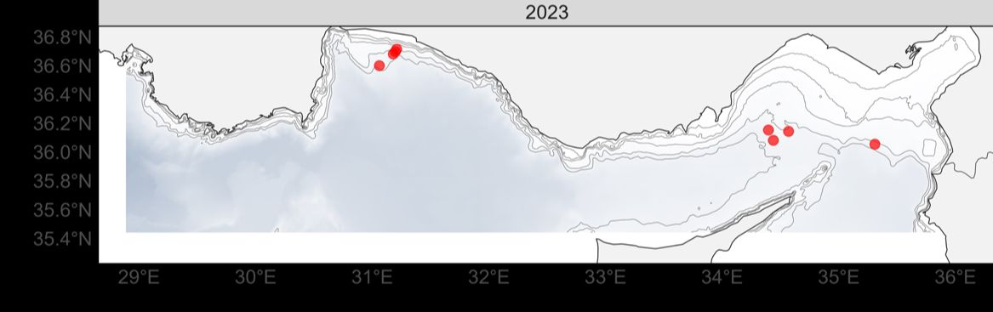
Figure 1. The locations where Blackmouth catshark specimens were caught throughout a bottom trawl survey along the Mediterranean coast of Türkiye in 2023.

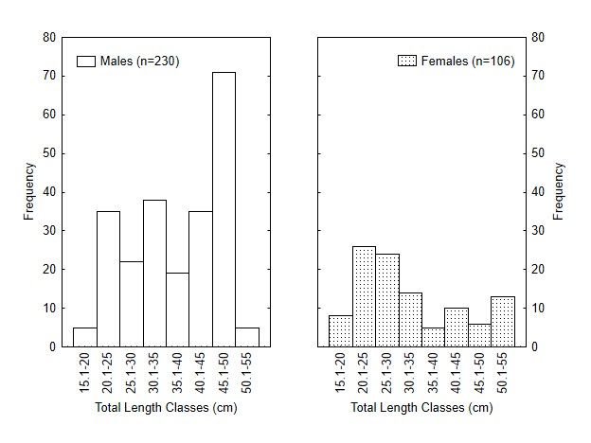
Figure 2. Length frequency distribution of blackmouth catshark specimens by gender.

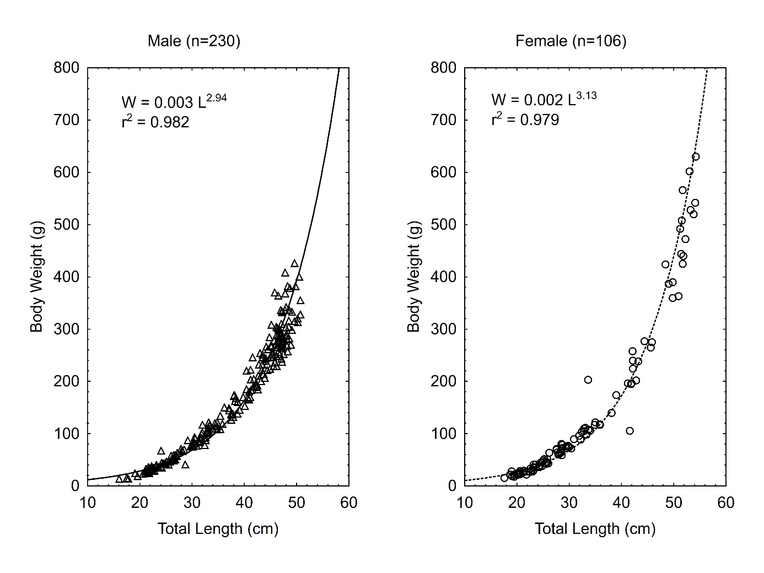
Figure 3. Length-weight relationship of blackmouth catshark specimens by gender.

