First record of the Blonde Ray Raja brachyura (Rajidae) on Turkish Coasts
Cemal Turan, Ali Uyan, Servet Ahmet Doğdu, Deniz Ergüden
Iskenderun Technical University, Faculty of Marine Sciences and Technology, Molecular Ecology and Fisheries Genetics Laboratory, 31220 Iskenderun, Hatay, Türkiye.
*Corresponding author: cemal.turan@yahoo.com
Abstract
The blonde ray Raja brachyura Lafont, 1873 was reported for the first time from Turkish marine waters. Two specimens female and male were captured during a trawling survey on 17 March 2019 in Antalya Bay, north-eastern Mediterranean. This study represents the first record of R. brachyura from the Turkish coasts, making it the fourteenth Rajid species for Turkish marine ichthyofauna to date.
Keywords: Raja brachyura, first occurrence, checklist, Turkish marine waters.

Introduction
The blonde ray Raja brachyura Lafont, 1873, belonging to the family Rajidae, is a benthic species found on sandy and sand-rock bottoms, mostly on the continental shelf and upper slope, from shore to 380 m depth (Brito, 1991; Serena, 2005). It consumes a variety of benthic organisms. Larger individuals tend to be more piscivorous, whereas juveniles primarily consume small crustaceans such as amphipods and natantids (Holden and Tucker, 1974; Farias et al., 2005). Blonde ray exhibits oviparous reproduction, reaches a total length of 80-90 cm at sexual maturity, and lays between 30 to 70 eggs annually (Gallagher et al., 2005).
The blonde ray, R. brachyura is distributed throughout the Eastern Atlantic, from the Shetland Islands (Scotland) to Morocco (Froese and Pauly, 2024), whereas their Mediterranean distributions were previously considered rare (Matallanas, 1974), and were mainly confined to the western-central Mediterranean basin rather than the eastern basin (Ellis et al., 2005; Serena et al., 2010). In contrast, various observations revealed that R. brachyura has expanded its distribution eastwards to the Sardinian and western Sicily coasts (Follesa et al., 2003; Ragonese et al., 2003; Catalano et al., 2007), Ionian Sea (Leonetti et al., 2020), Greek coasts of Aegean Sea (Damalas and Vassilopoulou, 2011; Giovos et al., 2022), and Cyprus (Giovos et al., 2021).
The blonde ray is a commercially important rajid species, caught and landed in areas where it is distributed throughout the northeastern Atlantic (Machado et al., 2004), while it is captured as a bycatch in semi-industrial (Spain) and artisanal (Morocco and Greece) fisheries, and in bottom trawling, gillnet and longline in the Mediterranean (Bauchot, 1987). R. brachyura is categorised as Near Threatened (NT) in the IUCN Red List (IUCN, 2024).
Rajidae family in Turkish marine waters consisted of thirteen species, namely Dipturus batis, D. oxyrinchus, Leucoraja circularis, L. fullonica, L. naevus, Raja asterias, R. clavata, R. miraletus, R. montagui, R. polystigma, R. radula, R. undulata, and Rostroraja alba (Bilecenoğlu et al., 2014). R. brachyura has not been reported from the Turkish coasts so far. Therefore, this study reports the first occurrence of R. brachyura from Antalya Bay (northeastern Mediterranean) with morphometric and meristic characters of the captured specimens.

Material and Methods
On March 17, 2019, two specimens, one female and one male, of blonde ray Raja brachyura were captured by trawling in the Antalya Bay (36°45′N, 31°06′E), on the northeastern Mediterranean coast of Türkiye, at a depth of 180 m on muddy bottoms (Figure 1). Morphometric and meristic characters of the specimens were taken, and morphometric measurements were performed to the nearest 0.01 mm using a digital caliper. All morphological descriptions of R. brachyura specimens were measured according to (Clark, 1926; Stehmann and Bürkel, 1984).
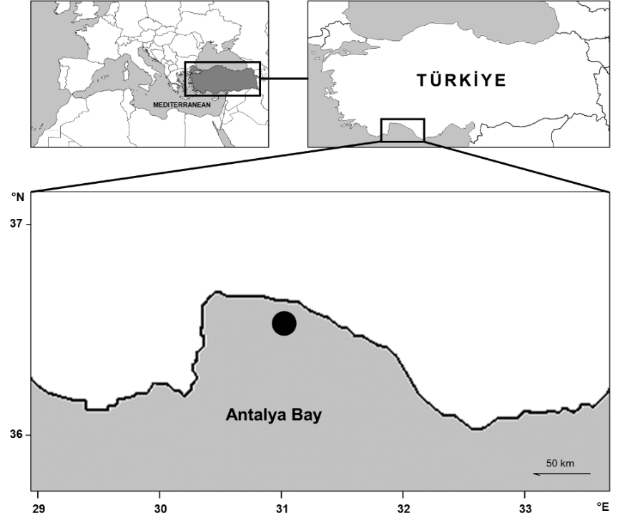
Figure 1. Map showing the sampling site of blonde ray Raja brachyura in Antalya Bay, northeastern Mediterranean
Results
The total lengths (TL) of the female and male specimens of R. brachyura are 278.2 mm and 399.3 mm, respectively, with weights of 380 g for the female and 640 g for the male. The morphometric and meristic data for both specimens were summarized in Table 1. The identification of R. brachyura was confirmed by the following diagnostic features: a medium-sized ray with a rhombic disc nearly 1.3 times its length in width, a moderately long and rigid rostral cartilaginous snout with a slightly pronounced tip, and a few spines before and after the orbit. The tail is moderately long and slender, about half the total length, and is densely covered with fine dark spots. The disc is broad yet slender, with leading edges that are weakly undulating and pectoral-fin corners that are either narrowly or acutely rounded. The snout’s anterior angle is wide, about twice the length of the interorbital area, and the eyes are relatively small, with the orbital length about half of the interorbital space. The upper jaw contains 60-90 rows of teeth. There are 40-45 spines arranged in a regular row from the nape to the first dorsal fin, interrupted on the back in large males. There is one inter dorsal spine, and larger individuals display a row of strongly hooked spines near the tail. The ventral disc is smooth. The pelvic fins are moderately large and not deeply split. The dorsal fins have rounded edges and are well spaced at the base. There are 95-100 pectoral fin radials and 53-58 pre-dorsal tail vertebrae. The upper surface of the disc is yellowish to pale greyish brown, with numerous small dark spots reaching the margins and several larger, circular pale spots symmetrically paired on both wings, encircled by closely spaced dark spots. The undersurface is white, with posterior pectoral and pelvic margins in pale greyish, devoid of dark-bordered pores (Figure 2). According to morphometric descriptions defined by Clark (1926), and Stehmann and Bürkel (1984), the captured R. brachyura was observed to mirror general morphological characteristics and colorations.
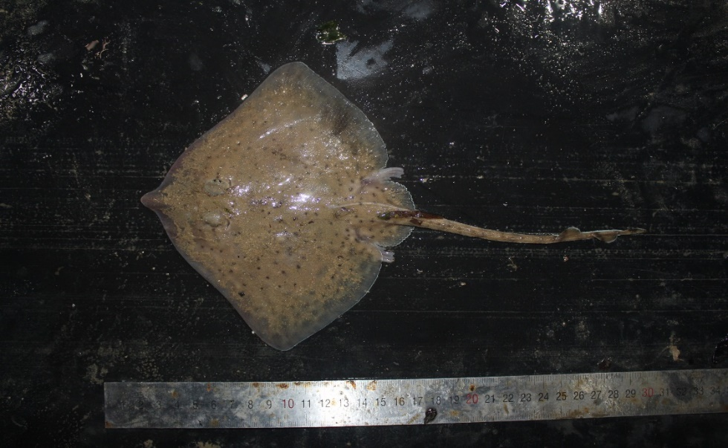
Figure 2. Dorsal view of Raja brachyura female specimen caught from Antalya Bay (northeastern Mediterranean)
Table 1. Morphometric and meristic data of female and male specimen of Raja brachyura obtained
Specimen | Female |  |  | Male
Morphological characters | mm | No. | %TL | mm | No. | %TL
Total length | 278.2 |  | 100.0 | 399.3 |  | 100.0
Disc width | 172.5 |  | 62.0 | 270.5 |  | 67.7
Disc length | 133.6 |  | 48.0 | 215.3 |  | 53.9
Snout tip to maximum disc length | 119.4 |  | 42.9 | 185.7 |  | 46.5
Preorbital snout length | 35.2 |  | 12.7 | 46.9 |  | 11.7
Orbit diameter | 9.2 |  | 3.3 | 10.8 |  | 2.7
Orbit + spiracle length | 16 |  | 5.8 | 22.1 |  | 5.5
Spiracle length | 3.5 |  | 1.3 | 10.4 |  | 2.6
Interorbital width | 12.5 |  | 4.5 | 23.4 |  | 5.9
Distance between spiracles | 17.5 |  | 6.3 | 28.7 |  | 7.2
Distance between snout and cloaca | 114.2 |  | 41.0 | 238.8 |  | 59.8
Tail length to first dorsal fin | 111.8 |  | 40.2 | 189.8 |  | 47.5
Tail length to second dorsal fin | 131.1 |  | 47.1 | 215.3 |  | 53.9
Tail length | 158.7 |  | 57.0 | 237.2 |  | 59.4
Pre-oral length | 21.9 |  | 7.9 | 57.3 |  | 14.4
Pre-nasal length | 28.1 |  | 10.1 | 45.7 |  | 11.4
Mouth width | 20.4 |  | 7.3 | 39.9 |  | 10.0
Distance between nostrils | 27.1 |  | 9.7 | 37.8 |  | 9.5
Distance between first-gill slit | 36.6 |  | 13.2 | 73.1 |  | 18.3
Distance between fifth-gill slit | 18.5 |  | 6.6 | 38.4 |  | 9.6
Tail width at axil of pelvic fins | 13.8 |  | 5.0 | 28.4 |  | 7.1
Tail height at axil of pelvic fins | 2.7 |  | 1.0 | 16.1 |  | 4.0
First dorsal fin base | 10.9 |  | 3.9 | 27.3 |  | 6.8
First dorsal fin height | 4.7 |  | 1.7 | 14.2 |  | 3.6
Second dorsal fin base | 10.4 |  | 3.7 | 23.1 |  | 5.8
Second dorsal fin height | 5.2 |  | 1.9 | 14.8 |  | 3.7
First dorsal fin to caudal fin tip | 45.7 |  | 16.4 | 100.9 |  | 25.3
Second dorsal fin to caudal fin tip | 28.1 |  | 10.1 | 54.7 |  | 13.7
Distance between first and second dorsal fin | 17.6 |  | 6.3 | 48.9 |  | 12.2
Tooth rows in upper jaw |  | 61 |  |  | 62
Tooth rows in lower jaw |  | 64 |  |  | 64
Thorns in median row |  | 41 |  |  | 43
Pre-dorsal tail vertebrae |  | 53 |  |  | 54
Pectoral fin radials left/right |  | 70/70 |  |  | 71/71
Pelvic fin radials left/right |  | 15/15 |  |  | 15/15
No., number; TL%, percentage proportion of measured morphometric characters to the total length.
Discussion
Raja brachyura is distributed in the eastern Atlantic and Mediterranean extending from the west-central to the east of various regions, but there is no evidence of its occurrence in the northeastern Mediterranean. Therefore, R. brachyura is the fourteenth species reported for the Rajidae family in Turkish marine waters, allowing the update of cartilaginous biodiversity. R. brachyura can be distinguished from similar Raja species (R. clavata and R. montagui) by its medium-sized snout, midline spines count and comparatively high tooth row count and the specimens captured generally conform to the morphological descriptions of Clark (1926) and Stehmann and Bürkel (1984).
The number of non-indigenous species recorded in Turkish marine waters is constantly increasing, and species originate from both the Atlantic and Indo-Pacific Oceans (Turan et al., 2018, 2024). Climate change encourages lower-latitude Atlantic species to expand their range and establish in the Mediterranean. Increasing seawater temperature and salinity trends in the Atlantic waters flowing eastward in the Mediterranean have also caused uncertainties about how regional biodiversity may be affected (Turan et al., 2016). Because, the Mediterranean is warming four times faster than global warming, making it one of the main marine ecosystems severely affected by climate change. This rapid warming will seriously affect marine biodiversity and unbalanced biogeochemical processes (Goffredo and Dubinsky, 2014).
Like many native fish species of the Mediterranean, R. brachyura originated in the Atlantic waters. However, the increase in seawater temperature in the eastern basin has prevented its spread, as has been the case with many others (Golani et al., 2006). Contrary to other Atlantic-origin species that naturally extend eastward in the Mediterranean Sea via the Strait of Gibraltar, the distribution of R. brachyura in the Mediterranean has been unusual in that it was restricted to the western-central Mediterranean basin until about 20 years ago and its distribution has since expanded eastwards, likely due to the influence of climate change. From a biogeographical perspective, supported by bottom trawling surveys and regional checklists, have demonstrated the notable eastward expansion of R. brachyura along the coasts of Sardinia and western Sicily (Follesa et al., 2003; Ragonese et al., 2003; Catalano et al., 2007), throughout the Ionian Sea (Leonetti et al., 2020), along the Greek Aegean coast (Damalas and Vassilopoulou, 2011; Giovos et al., 2022), and around Cyprus (Giovos et al., 2021). In addition, Serena et al. (2020) evaluated the relative abundance of R. brachyura in the western and central Mediterranean that it is as occasional in the Adriatic Sea, as abundant in the eastern Mediterranean, and as questionable in the Black Sea.
In conclusion, a considerable number of species on the Mediterranean cartilaginous fish checklist are included in the fish fauna of Turkish marine waters. This record provides the first evidence for the distribution of R. brachyura in Turkish marine waters. Additionally, the occurrence of two specimens of blonde ray in Antalya Bay may point out a potentially established population of the species in Turkish marine waters. However, more research is needed to confirm such a hypothesis.
Acknowledgements
This study was funded by the Republic of Türkiye Ministry of Food, Agriculture and Livestock General Directorate of Agricultural Research and Policies (TAGEM-16/ARGE/21).
References
Bauchot, M. L. (1987). Raies at autres batoidés. In: M. Fisher, M. Schneider and M.-L. Bauchot (eds), Fiches FAO d'Identification des Espècs pour les Besoins de la Peche. Méditerranée et Mer Noire. Zone de Peche 37. Revision 1. II, pp. 847-885. FAO, Rome.
Bilecenoğlu, M., Kaya, M., Cihangir, B., Çiçek, E. (2014). An updated checklist of the marine fishes of Turkey. Turkish Journal of Zoology, 38(6), 901-929.
Brito, A. (1991). Catálogo de los pesces de las Islas Canarias. Francisco Lemus, La Laguna.
Catalano, B., Dalu, M., Scacco, U., Vacchi, M. (2007). New biological data on Raja brachyura (Chondrichthyes, Rajidae) from around Asinara Island (NW Sardinia, Western Mediterranean). Italian Journal of Zoology, 74(1), 55-61.
Clark, R. S. (1926) Rays and skates. A revision of the European species. Fishery Board for Scotland, Scientific Investigations, 1, 1-66.
Damalas, D., and Vassilopoulou, V. (2011). Chondrichthyan by-catch and discards in the demersal trawl fishery of the central Aegean Sea (Eastern Mediterranean). Fisheries Research, 108(1), 142-152.
Ellis, J. R., Cruz-Martinez, A., Rackham, B. D., Rogers, S. I. (2005). The distribution of chondrichthyan fishes around the British Isles and implications for conservation. Journal of Northwest Atlantic Fishery Science, 35(195-213), 113.
Farias, I., Figueiredo, I., Serra-Pereira, B., Bordalo-Machado, P., Moura, T. and Gordo, L. S. (2005). Diet comparison of four ray species [Raja clavata Linnaeus, 1758; Raja brachyura Lafont, 1873; Leucoraja naevus (Müller & Henle, 1841) and Raja montagui Fowler, 1910] caught along the Portuguese continental coast. Elasmobranch Fisheries Science, ICES CM 28, pp. 1-28.
Follesa, M. C., Addis, P., Murenu, M., Saba, R., Sabatini, A. (2003). Annotated checklist of the skates (Chondrichthyes, Rajidae) in the Sardinian seas. Biologia Marina Mediterranea, 10, 828-833.
Froese, R. and D. Pauly. Editors. 2024. FishBase. World Wide Web electronic publication. www.fishbase.org, version (02/2024).
Gallagher, M. J., Nolan, C. P., Jeal, F. (2005). Age, growth and maturity of the commercial ray species from the Irish Sea. Journal of Northwest Atlantic Fishery Science, 35, 47-66.
Giovos, I., Serena, F., Katsada, D., Anastasiadis, A., Barash, A., Charilaou, C., Hall-Spencer, J. M., Crocetta, F., Kaminas, A., Kletou, D., Maximiadi, M., Minasidis, V., Moutopoulos, D. K., Aga-Spyridopoulou, R. N., Thasitis, I., Kleitou, P. (2021). Integrating literature, biodiversity databases, and citizen-science to reconstruct the checklist of Chondrichthyans in Cyprus (Eastern Mediterranean Sea). Fishes, 6(3), 24.
Giovos, I., Aga-Spyridopoulou, R. N., Serena, F., Soldo, A., Barash, A., Doumpas, N., Gkafas, G. A., Katsada, D., Katselis, G., Kleitou, P., Minasidis, V., Papastamatiou, Y. P., Touloupaki, E., Moutopoulos, D. K. (2022). An Updated Greek National Checklist of Chondrichthyans. Fishes, 7(4), 199.
Goffredo, S., & Dubinsky, Z. (Eds.). (2013). The Mediterranean Sea: Its history and present challenges. Springer Science & Business Media.
Golani, D., Öztürk, B., Başusta, N. (2006). Fishes of the eastern Mediterranean. Turkish Marine Research Foundation, Istanbul, Turkey.
Holden, M. J., Tucker, R. N. (1974). The food of Raja clavata Linnaeus 1758, Raja montagui Fowler 1910, Raja naevus Müller and Henle 1841 and Raja brachyura Lafont 1873 in British waters. ICES Journal of Marine Science, 35(2), 189-193.
IUCN. 2024. The IUCN Red List of Threatened Species. Version 2024-1. https://www.iucnredlist.org. Accessed on [28 July 2024].
Leonetti, F., Giglio, G., Leone, A., Coppola, F., Romano, C., Bottaro, M., Reinero, F., Milazzo, C., Micarelli, P., Tripepi, S., Sperone, E. (2020). An updated checklist of chondrichthyans of Calabria (Central Mediterranean, southern Italy), with emphasis on rare species. Mediterranean Marine Science, 21(3), 794-807.
Machado, P. B., Gordo, L. S., Figueiredo, I. (2004). Skate and ray species composition in mainland Portugal from the commercial landings. Aquatic Living Resources, 17(2), 231-234.
Matallanas, J. (1974). Sobre la presencia de Raja brachyura Lafont (Rajiformes, Rajidae), en la Mar Catalana. Bolletí de la Societat d'Història Natural de les Balears, 51-56.
Ragonese, S., Cigala-Fulgosi, F., Bianchini, M. L., Norrito, G., Sinacori, G. (2003). Annotated check list of the skates (Chondrichthyes, Rajidae) in the strait of Sicily (Central Mediterranean). Biologia Marina Mediterranea, ISSN: 1123-4245. Biologia Marina Mediterranea, 10, 874-881.
Serena, F., Abella, A. J., Bargnesi, F., Barone, M., Colloca, F., Ferretti, F., Jenrette, J., Moro, S. (2020). Species diversity, taxonomy and distribution of Chondrichthyes in the Mediterranean and Black Sea. The European Zoological Journal, 87(1), 497-536.
Serena, F., Mancusi, C., Barone, M. (2010). Guida pratica di identificazione delle razze (RAJIDAE) del Mar Mediterraneo. Linee guida per la raccolta e l’analisi dei dati. Biologia Marina Mediterranea, 204 pp.
Serena, F. (2005). Field Identification Guide to the Sharks and Rays of the Mediterranean and Black Sea. FAO, Rome, 96 pp.
Stehmann, M., and Bürkel, D. L. (1984). Rajidae. pp. 163-196. In: Whitehead, P.J.P. et al. (Eds.). Fishes of the Northeastern Atlantic and the Mediterranean (FNAM). Vols. 1-3. Paris, UNESCO, 1473 p.
Turan, C., Ergüden, D., Gürlek, M. (2016). Climate change and biodiversity effects in Turkish Seas. Natural and Engineering Sciences, 1(2), 15-24.
Turan, C., Gürlek, M., Başusta, N., Uyan, A., Doğdu, S. A., Karan, S. (2018). A checklist of the non-indigenous fishes in Turkish marine waters. Natural and Engineering Sciences, 3(3), 333-358.
Turan, C., Ergüden, D., Gürlek, M., Doğdu, S. A. (2024). Checklist of Alien Fish Species in The Turkish Marine Ichthyofauna for Science and Policy Support. Tethys Environmental Sciences, 1(2), 50-86.

