Occurrence of the Indo-Pacific Stonefish, Synanceia verrucosa Bloch and Schneider, 1801 in the Northeastern Mediterranean

Deniz Ergüden^{1”}, Cemal Turan¹, Sibel Alagöz Ergüden², Deniz Ayas³

¹Marine Science Department, Faculty of Marine Science and Technology, Iskenderun Technical University, 31220 Iskenderun, Hatay, Türkiye
²Vocational School of Imamoglu, University of Cukurova, Imamoglu, Adana, Türkiye
³Faculty of Fisheries, University of Mersin, Mersin, Türkiye

Corresponding author: deniz.erguden@iste.edu.tr; derguden@gmail.com

Abstract

A single adult specimen of the stonefish, Synanceia verrucosa Bloch and Schneider, 1801, was observed on June 13, 2024, from Konacık (Iskenderun Bay), northeastern Mediterranean coast of Türkiye. The occurrence of this species in Turkish Mediterranean waters is probably due to its migration from the Red Sea via the Suez Canal. The present paper reports the second occurrence of the stonefish, S. verrucosa after thirteen years from the coast of Türkiye. Thus, this study is an important record that S. verrrucosa may have settled on the Northern Mediterranean coast of Türkiye.

Keywords: Stonefish, Synanceiidae, Iskenderun Bay, Eastern Mediterranean, Türkiye

Introduction
The immigration of Red Sea fish species from the Suez Canal is an ongoing process that is continuously changing the fish communities of the eastern Mediterranean (Golani, 1998; Por, 1990). After the opening of the Suez Canal, a migration from the Red Sea to the Mediterranean began, and the influx of Indo-Pacific originated some venomous/poisonous fish entering the Mediterranean. In recent years, new non-native fish species have been added to the ichthyofauna of Türkiye, and all of the newly included species and those recorded in previous years are presented in detail in the new checklist by Turan et al. (2024) according to their historical chronology and distribution in Turkish seas. Some species have become important in the composition of the ichthyofaunal communities of the eastern Mediterranean and have also acquired economic importance in regional fisheries (Bariche et al., 2004).

The stonefish, Synanceia verrucosa Bloch and Schneider, have a wide distribution throughout the Indo-Pacific (Froese and Pauly, 2024). The stonefish, a solitary fish species, inhabits coastal reefs and sandy or rubble areas of reefs and rocks that can be found in the 0-30 m depth range (Myers, 1999; Froese and Pauly, 2024). S. verrucosa reaches a maximum size of 37.2 cm and feeds on small fishes and crustaceans (Randall, 1995; Poss, 1999).

S. verrucosa is known as the most venomous fish in the world (Myers, 1999). The dorsal fin has 2 grooves serving as seringes of venom. The stonefish uses its venom only as a defense mechanism, using its dorsal fins into the up to attack if disturbed. The stings of S. verrucosa are excruciatingly painful and can occasionally be fatal to humans (Froese and Pauly, 2024).

The first record of S. verrucosa from the Mediterranean was provided by Edelist et al. (2011) from the coast of Israel in 2010, and the second specimen, caught by an artisanal fisherman using a bottom longline, was reported from the coast of Yumurtalık in 2011 (Bilecenoglu, 2012). Later, this species was recorded in Lebanon in 2012 (Crocetta et al., 2015), from the Syrian coast in 2018 (İbrahim et al., 2019), in 2019 from Palestine (Gaza City) Bariche et al. (2019), in May 2020 from the north of the island of Cyprus (Akbora et al., 2021), and also in 2008-2023 from Palestine (Abd Rabou, 2023).

This paper reports the second record of S. verrucosa from the Mediterranean waters of Türkiye. This observation is crucial because a new individual of this species is seen again from Iskenderun Bay (Northeast Mediterranean, Türkiye) after about 13 years. It is an important evidence that this species is probably established in this region.

Material and Methods
On June 13, 2024, a single adult specimen of stonefish (350 mm in TL, about 4.5 kg in weight) was collected with a trammel net on the Konacık coast, Iskenderun Bay (36º 21' N - 35º 48' E) from a depth of 11 m (Figure 1). The specimen was held on the deck of the boat by local fishermen, videotaped, and photographed with a camera before being released alive into the sea (Figure 2 and Figure 3). Therefore, only the total length and weight of the specimen could be measured on the boat. The morphological identification and color of this species agree with the descriptions of Golani et al. (2021).

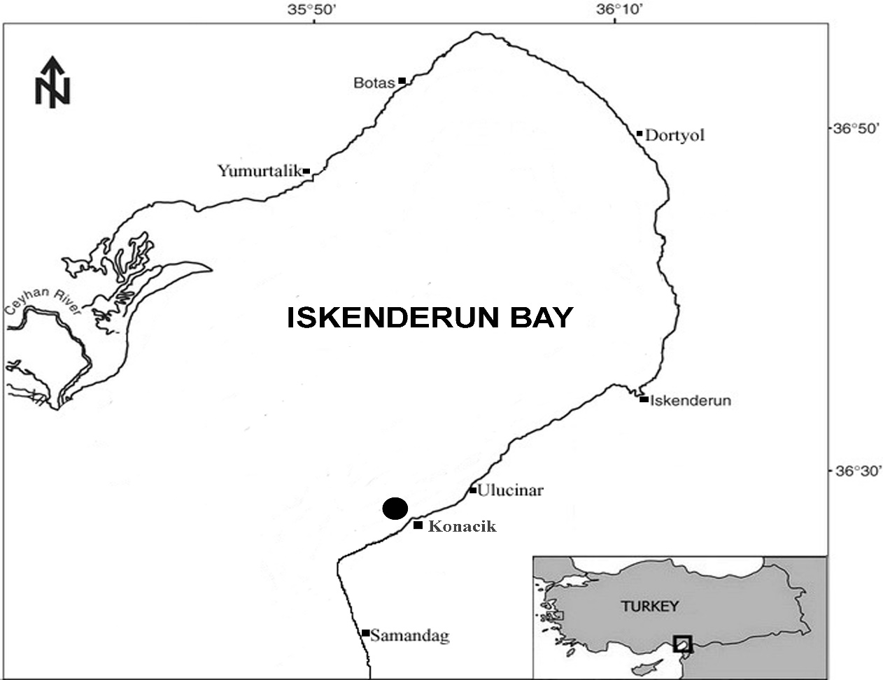
Figure 1. Map showing the capture site (●) of Synanceia verrucosa in Iskenderun Bay (Konacık), Türkiye

Results
The stonefish, S. verrucosa specimen, had a total length of 35 cm, TL, and 2000 g. Description of the stonefish specimen based on the photograph (Figure 2 and Figure 3). Head strongly depressed, eyes only slightly raised and far apart, separated by a deep depression; mouth semicircular; gill slits limited by fusion of branchiostegal membranes to the isthmus. There are no scales on the body, but thick skin covered with protuberances.

Color (fresh specimen): The body is light brownish and may have patches of orange and pinkish.
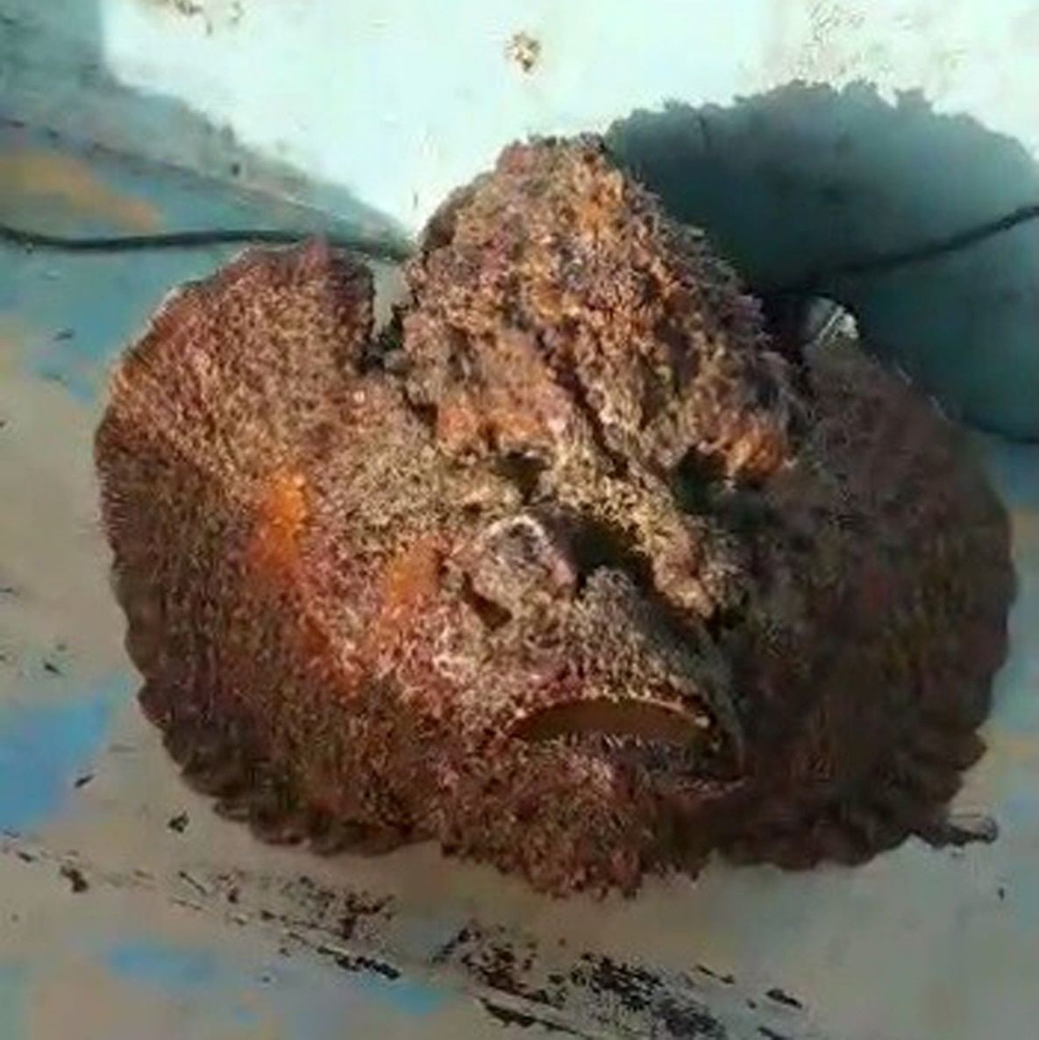
Figure 2. Synanceia verrucosa captured from Iskenderun Bay, Northeastern Mediterranean Sea, Türkiye

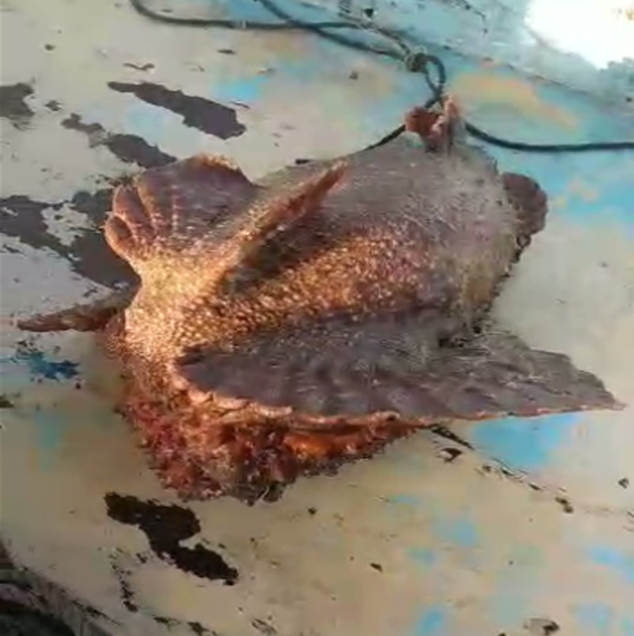
Figure 3. Ventral view of Synanceia verrucosa

Discussion
To date, two species of the genus Synanceia have been reported from the Red Sea (Golani and Bogorodsky, 2010): S. verrucosa Bloch and Schneider, 1801 and Synanceia nana Eschmeyer and Rama Rao, 1973. S. verrucosa is clearly distinguished from S. nana by having 18-19 pectoral rays and 13 dorsal rays. S. verrucosa has pectoral, pelvic, and caudal fins tipped with white; and caudal fin with subterminal dark bands. However, S. nana has 14-15 pectoral and 14 dorsal rays and a distinct lack of dark margins on the pectoral, pelvic, and caudal fins. (Eschmeyer and Rama Rao, 1973; Fischer et al., 1990; Lieske and Myers, 2004; Edelist et al., 2011).

The stonefish S. verrucosa has venom glands near the base of the hypodermis-like dorsal fin spines. It has thirteen stout dorsal fin spines that can inject an extremely venomous. Although no cases of intoxication by S. verrucosa have been reported in the Mediterranean, some cases of injury or death have been reported in other countries (Maillaud et al., 2020; Ghanem et al., 2019).

Edelist et al. (2011) mentioned that the pelagic larvae of this species could arrive in a pelagic larval dispersal through the Suez Canal instead of active swimming since larger individuals are mostly inactive and rarely move. Katsanevakis et al. (2013) stated that the likelihood of this species escaping from aquariums is quite low.

In this study, the total length of the specimen caught from the northeastern Mediterranean coast of Turkey was 35 cm. The common length for this species is reported to be 27 cm (Bouhlel, 1988), and adult specimens in previous Mediterranean records of this species appear to be of similar length. Previous Mediterranean records of S. verrucosa are listed in Table 1, together with the results of this study.

Table 1. Records of Synanceia verrucosa from the Mediterranean Sea covering the period 2011-2024
References | Record Date | Number of Samples | Location | Sampling Gear | Depth  (m) | Length,  TL (cm) | Weight (g)
Edelist et al. (2011) | April 2010 | 1 | Tel Aviv-Jaffa (Palmakhim), Israel | Trammel net | 3 | 25 | 700
Bilecenoglu (2012) | 18 November 2011 | 1 | Yumurtalık, Adana, Iskenderun Bay, Türkiye | Longline | 10 | 30/35 | 5000
Crocetta et al. (2015) | 29 January 2012 | 1 | Tyre, Lebanon | - | - | - | -
Bariche et al. (2019) | 4 December 2018 | 1 | Gazza City, Palestine | Trammel net | - | - | -
İbrahim et al. (2019) | 12 October 2019 | 1 | Lattakia coast, Syria | Longline | ~15 | - | -
Akbora et al. (2021) | May 2020 | 1 | Kumyalı, North Cyprus | Speargun | - | - | -
Abd Rabou et al. (2023) | 2008-2023 | 5 | Gazza City, Palestine | Bottom trawlers | - | 35-40 | -
This study | 13 June 2024 | 1 | Konacik,  Iskenderun Bay, Türkiye | Trammel net | 11 | 35 | 2000
Stonefish are very well adapted to rocky areas with their body structure, and they can also bury themselves in the sand to camouflage themselves. The vast majority of individuals of this species recorded so far in the Mediterranean have been scientifically published through "citizen science" solidarity, obtained from video footage taken by fishermen or photographs shared on social media. This situation has once again demonstrated the importance of citizen science.

The stonefish individual reported from Iskenderun Bay is the second record of the species from the Mediterranean waters of Türkiye. This record from Mediterranean waters indicates that S. verrucosa probably has an established population in this northeastern Mediterranean region. In addition, S. verrucosa is a species that needs attention because it has venomous spines that are lethal to humans and can be found in swimming areas. Therefore, more scientific studies and monitoring are needed in areas where the presence of this species is confirmed.

Acknowledgements
The authors would like to thank Mr. İsa Turan for providing the information about the stonefish, the video and also for valuable photographs.

Conflict of Interest

The authors declare that they have no competing interests.

Author Contributions
D.E., C.T., S.A.E., and D.A. contributed equally to the study. The authors reviewed and approved the final version of the manuscript.

Ethical Approval Statements
In this study, no experimental animals were used. Therefore, Local Ethics Committee Approval is not required.

References
Abd Rabou, A.F.N., Elkahlout, K. E., Elnabris, K.J., Shurrab, H. M., Almalfouh, A. M., Baroud, A.F., Alattili, I.R., Alamassi, R.M., Abd Rabou, M. A., Abd Rabou, O.A., Salah, J.Y., Awadalah, S.M., Saqallah W.M. and Aboutair, M.A. (2023). Rare records of the exotic Reef Stonefish (Synanceia verrucosa Bloch and Schneider, 1801) in the Mediterranean waters of the Gaza Strip, Palestine. International Journal of Fisheries and Biology Studies, 10 (3), 24-28.
Akbora, H. D., Çiçek, B.A. and Ayas, D. (2021). The first record of Synanceia verrucosa Bloch & Schneider, 1801 and Pagrus auriga Valenciennes, 1843 from Cyprus. Journal of Black Sea/Mediterranean Environment, 27 (1), 109-116.
Bariche, M., Letourneur, Y. and Harmelin-Vivien, M. (2004). Temporal fluctuations and settlement patterns of native and Lessepsian herbivorous fishes on the Lebanese coast (eastern Mediterranean). Environmental Biology of Fishes, 70, 81-90.
Bariche, M., Sayar, N. and Balistreri, P. (2019). Records of two non-indigenous fish species Synanceia verrucosa Bloch and Schneider, 1801 and Acanthurus sohal (Forsskål, 1775) from the Gaza strip (eastern Mediterranean Sea). BioInvasion Records, 8(3), 699-705.
Bilecenoğlu, M. (2012). First sighting of the Red Sea originated stonefish (Synanceia verrucosa) from Turkey. Journal of Black Sea/Mediterranean Environment, 18(1), 76-82.
Bouhlel, M. (1988). Poissons de Djibouti. Placerville (California, USA): RDA International, Inc. 416 p.
Crocetta, F., Agius, D., Balistreri, P., Bariche, M., Bayhan, Y.K., Çakir, M., Ciriaco, S., Corsini-Foka, M., Deidun, A., El Zrelli, R., Ergüden, D., Evans, J., Ghelia, M., Giavasi, M., Kleitou, P., Kondylatos, G., Lipej, L., Mifsud, C., Özvarol, Y., Pagano, A., Portelli, P., Poursanidis, D., Rabaoui, L., Schembri, P.J., Taşkin, E., Tiralongo, F. and Zenetos, A. (2015). New Mediterranean biodiversity records (October 2015). Mediterranean Marine Science, 3, 682-702.
Edelist, D., Spanier, E. and Golani, D. (2011). Evidence for the occurrence of the Indo-Pacific Stonefish, Synanceia verrucosa (Actinopterygii: Scorpaeniformes: Synanceiidae), in the Mediterranean Sea. Acta Ichthyologica et Piscatoria, 41(2), 129-131.
Eschmeyer, W.N. and Rama-Rao, K.V. (1973). Two new stonefishes (Pisces, Scorpaenidae) from the Indo-west Pacific, with a synopsis of the subfamily Synanceiidae. Proceedings of the California Academy of Science, 39(18), 337-382.
Eschmeyer, W.N. (1986). Scorpaenidae. In: Smith M.M. and Heemstra P.C. (Eds.), Smiths' sea fishes. Springer-Verlag, Berlin, pp. 463-478.
Fischer, W., Sousa, I., Silva, C., De Freitas, A., Poutiers, J.M., Schneider, W., Borges, T.C., Feral, J.P., Massinga, E.A. (1990). Fichas FAO D'identificaçao d'espécies para actividades de pesca. Guida de campo das espécies comerciais marinhas e d'águas salobras de Moçambique. Roma, FAO, 424 p.
Froese, R. and Pauly D. Editors (2024). FishBase. World Wide Web Electronic Publication. Version (01/2024). Available from: www.fishbase.org. (07/2024).
Ghanem, H., Khan, M. T., Al-Ghanem, S. and Al-Qasem, G. (2019). Stonefish (Synanceiea verrucosa) Envenomation in the Kingdom of Bahrain. Journal of the Bahrain Medical Society, 31 (1), 5-9.
Golani, D. (1998). Impact of Red Sea Fish migrants through the Suez Canal on the Aquatic Environment of the Eastern Mediterranean. Yale School of Forestry & Environmental Studies, 103, 375-387.
Golani, D., Azurro, E., Dulcic, J. Massuti, E. and Orsi-Relini, L. (2021). Atlas of exotic species in the Mediterranean. Vol. 2. Entirely Revised Edition, CIESM Publisher/Paris, Monaco, 365 p.
Golani, D. and Bogorodsky, S.V. (2010). The fishes of the Red Sea reappraisal and updated checklist. Zootaxa, 2463, 1-135.
İbrahim, A., Alshawy, F. and Hussein, C. (2019). Stonefish Synanceia verrucosa Bloch & Schneider, 1801 (Actinopterygii: Synanceiidae): the first record in the Syrian coast and the fourth in the Mediterranean. International Journal of Aquatic Biology, 7 (6), 383-386.
Katsanevakis, S., Zenetos, A., Belchior, C. and Cardoso, A.C. (2013). Invading European Seas: Assessing pathways of introduction of marine aliens. Ocean and Coastal Management 76, 64-74.
Lieske, E. and Myers, R.F. (2004): Coral reef guide; Red Sea to Gulf of Aden, South Oman. Harper Collins, London, 384 p.
Maillaud, C., Hoang-Oppermann, T., Hoang-Oppermann, V., Rigot, H., Girardot, S. and Nour, M. (2020). Is stonefish Synanceia verrucosa envenomation potentially lethal? Toxicon, 184, 78-82.
Myers, R.F. (1999). Micronesian reef fishes: a comprehensive guide to the coral reef fishes of Micronesia, 3rd revised and expanded edition. Coral Graphics, Barrigada, Guam, 330 p.
Por, F.D. (1990). Lessepsian migration. An appraisal and new data. Bulletin of the Institute of Oceanography, Monaco, 7, 1-10.
Poss, S.G. (1999). Scorpaenidae, scorpionfishes (also, lionfishes, rockfishes, stingfishes, stonefishes and waspfishes. In: Carpenter, K.E. and Niem, V. (Eds.), FAO species identification guide for fishery purposes. Vol. 4. Bony fishes, part 2 (Mugilidae to Carangidae). FAO, Rome, pp. 2291-2352.
Randall, J.E. (1995). Coastal fishes of Oman. University of Hawaii Press, Honolulu, Hawaii, 439 p.
Turan, C., Ergüden, D, Gürlek, M. and Doğdu, S.A. (2024). Checklist of alien fish species in the Turkish marine ichthyofauna for science and policy support. Tethys Environmental Sciences, 1 (2), 50-86.

