
First Record of Wahoo Acanthocybium solandri Cuvier, 1832 in Turkish Marine Waters
Mehmet Gökoğlu^{1*} , Cemal Turan² , Mesut Yılmaz³ , Alper Yıldız² 
¹Akdeniz University Fisheries Faculty, Antalya, Türkiye. ²Iskenderun Technical University, Faculty of Marine Sciences and Technology, Molecular Ecology and Fisheries Genetics Laboratory, 31220 Iskenderun, Hatay, Türkiye.

Short Communication | Abstract  Wahoo Acanthocybium solandri Cuvier, 1832 in the present study was reported for the first time from Turkish marine waters. A. solandri was captured from Üçadalar area in the Antalya Bay on 25 June 2024, and Samandağ coast in 2024 from the İskenderun Bay by Amateur fishermen in the northeastern Mediterranean coast of Türkiye. A. solandri is an important recreational fish with high economic value. A. solandri was previously reported from two locations in the Mediterranean Sea, and with this report it has reached three in the Mediterranean Sea.  Keywords: First record, non-indigenous species, Acanthocybium solandri, Turkish Seas
Citation: Gökoğlu, M., Turan, C., Yılmaz, M, Yıldız, A. (2024). First Record of Wahoo Acanthocybium solandri Cuvier, 1832 in Turkish Marine Waters. Tethys Env. Sci. 1(2): 44-49.
DOI: …………………..
Received: 26 Jun 2024
Accepted: … July 2024

Published: 30 July 2024
Copyright
2024 Gökoğlu et al.
Distributed Under

CC-BY 4.0

Introduction
Wahoo Acanthocybium solandri, Cuvier, 1832 is one of the highly mobile and predatory fish species of the oceans in the Scombridae family. Although it has been suggested that this fish is related to billfishes, molecular studies have reported that it is a Scombrid, not an Isthiophorid (Collette et al., 2006). Wahoo, which has a slim and aerodynamic body structure, is an important ocean fish for both commercial and recreational fisheries (Oxenfordt et al., 2003). Wahoo is a large epipelagic species distributed in tropical and subtropical temperate waters of the Pacific, Indian and Atlantic oceans (Collette & Nauen 1983). Although their weight is usually between 20-40 kg, the maximum recorded weight is reported to be 96.4 kg. A. solandri is an epipelagic and oceanic fish, preferring sea surface temperatures between 20-30°C, with important habitats including temperature and current gradients, deep ocean ridges, shallow coastal reefs and the proximity of floating debris (Zischke, 2012). Although it is recognized as a highly migratory fish, little is known about the extent of its migration, probably because it moves seasonally.
The first published record of A. solandri from the Mediterranean was a single specimen of 144 cm (total length) caught in a tuna trap off Sicily coast of Italy in 1872 (Romeo et al., 2005). According to the same researchers, two more specimens of A. solandri, each weighing 15 kg, were caught by harpoon in the Messina strait in 1990. In June 2004, another fish was caught from the same area with a harpoon used in traditional swordfish fishing. In this reports, the specimens caught in the Mediterranean Sea were mainly from Sicily.
The second locality record of A. solandri outside this region in the Mediterranean was given from the Lebanese coasts (Fatfat et al., 2024). Apart from these reports, there is no other record of the presence of A. solandri in the Mediterranean.
Apart from those reports, there has been no other record of the presence of wahoo in the Mediterranean Sea. Hence, we here report the first occurrence of Acanthocybium solandri from the Turkish marine waters, and third occurrence localities in the Mediterranean.
Material and Methods
Wahoo Acanthocybium solandri was captured at 40-50 m depth on 25 June 2024 by an amateur fisherman (Figure 1) with in Üçadalar locality of Antalya Bay at the coordinates 36.459928 N, 30.562678 E.
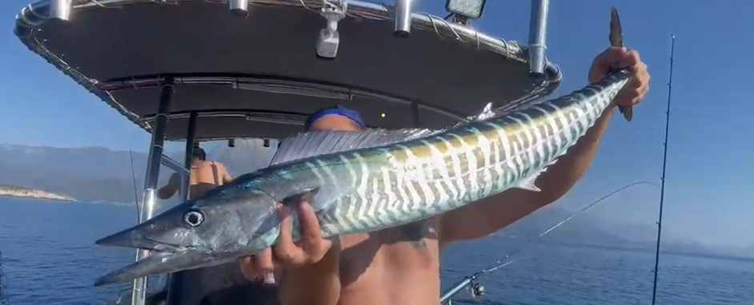
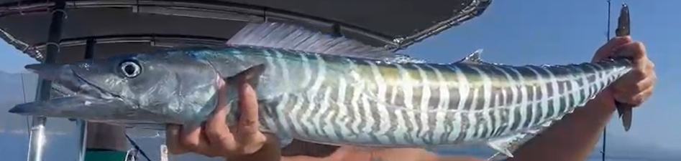
Figure 1. A. solandri caught in the Antalya Bay, the northeastern Mediterranean.
Another specimen of A. solandri was captured with an underwater rifle rom (Figure2) the coast of Samandağ/Hatay in the İskenderun Bay at the coordinates 36°07'35.6"N 35°54'28.7"E, the northeastern Mediterranean in 2024.
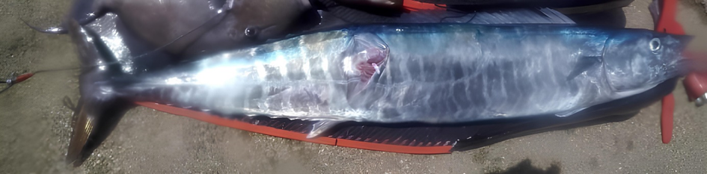
Figure 2. A. solandri spearfished in the coast of Samandağ/Hatay in the İskenderun Bay, the northeastern Mediterranean.
Photographs and videos of both fish captures off the coasts of Antalya and İskenderun Bays were taken and sent to us for species identification. The species identifications of the fish were made from these photographs and videos and other data were obtained by interviewing the fishermen.
Locations where A. solandri was caught in the Antalya and Iskenderun Bays were given in Figure 3.
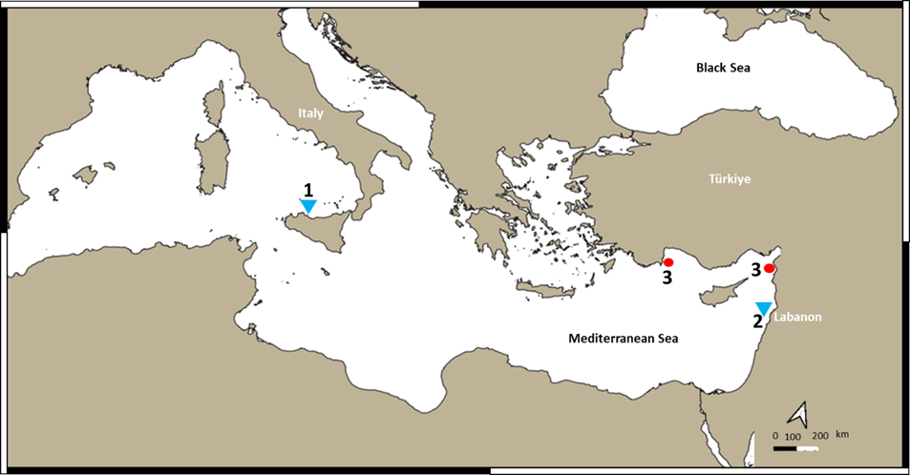
Figure 3. Map showing the capture sites of A. solandri in the Mediterranean Sea. Red circles represent present study records in Turkish marine waters; blue triangles represent previous records in the Mediterranean.
Results and Discussion
The species identification of A. solandri caught in the Antalya and Iskenderun Bays, based on the photographs and videos, revealed that these specimens were wahoo Acanthocybium solandri. With this study, A. solandri was reported for the first time from the coasts of Türkiye and the number of location records in the Mediterranean reached three.
A. solandri caught at the 40-50 m depth in the Antalya Bay was measured to be 110 cm in total length and 5 kg in weight. This area is a natural reef area that looks like a sunken island in the sea and always has strong currents. The area is within the main currents of the Mediterranean Sea where upwelling occurs due to the collision of the deep currents with the shallowing heel. Morphologically, the fish has a long, fusiform, semi-cylindrical body with dark grey blue vertical bars. The head has a long, pointed conical snout, the mouth has a wide single row of serrated triangular teeth (Figure 4). The fish caught in Samandağ coasts in the Iskenderun Bay were similar in size and weight (Figure 3).
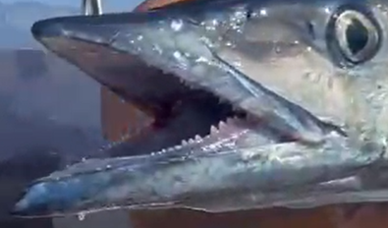 | 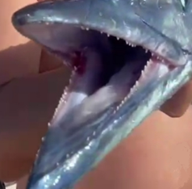
Figure 4. Mouth and teeth structure of A. solandri.
A. solandri is a fish of tropical and subtropical waters of the oceans. So far, two known locations have been reported for the presence of this fish in the Mediterranean Sea. These locations are the Strait of Messina in Sicily and the Lebanese coast (Romeo et al., 2005; Fatfat et al., 2024). In this study, wahoo were reported fort he first time in two different locations from the Turkish Mediterranean coasts, Iskenderun and Antalya Bays. Together with these locations, presence of A. solandri from Turkish marine waters at two localities in the Mediterranean Sea were marked (Figure 3). Wahoo is very similar to marrow-barred Spanish mackerel (S. commerson). Because of this similarity, some specimens of A. solandri caught by fishermen may have been confused with S. commerson, which is frequently caught in the eastern Mediterranean Sea.
The Mediterranean Sea is connected to the Red Sea via the Suez Canal and to the Atlantic Ocean via the Strait of Gibraltar by which alien species penetrate to the Mediterranean Sea (Galil, 2008; Turan et al., 2016; Langeneck et al., 2023; Doğdu and Turan, 2024; Uyan et al., 2024). Wahoo A. solandri is a fish species naturally living in the Red Sea (Williams et al., 2022). Fatfat et al. (2024) mentioned that Wahoo caught off the coast of Lebanon belong to the Indo-Pacific population and that the passage route of these fish to the Mediterranean may be through the Suez Canal. The same researchers state that the reproduction of wahoo in the Mediterranean, which is an important species in terms of both economic and sport fishing, can make positive contributions. Furthermore, recent genetic studies have reported evidence of differentiation between Indo-Pacific and Atlantic populations of wahoo (Portella et al., 2023). Therefore there might be a genetic bottleneck effect in the populations of A. solandri in the Mediterranean Sea.
This is the first report of Wahoo A. solandri from the coast of Turkey. With this report, one more species has been added to the alien species Ichthyofauna in Turkish marine waters. A. solandri would be an important species in terms of fisheries. On the other hand, there is a lack of data on the ecology, biology, distribution and population status of A. solandri in the Mediterranean Sea (Romeo et al., 2005; Fatfat et al., 2024). There is also uncertainty about the ecological impacts of this species on the Mediterranean native species. Therefore, bio-ecological researches are needed on A. Solandri in the Mediterranean Sea.
Acknowledgement
We would like to thank Kemer Fishing (Ersin Karakaş) for sending us the photos and videos of the Wahoo specimen and the data of the fish.
Conflict of Interest
The authors declare that they have no competing interests.
Author Contributions
M.G., C.T., M.S., and A.Y. performed all the experiments and drafted the main manuscript text. All authors reviewed and approved the final version of the manuscript.
Ethical Approval Statements
Local Ethics Committee Approval was not obtained because experimental animals were not used in this study.
Data Availability Statement
The data used in the present study are available upon request from the corresponding author.
References
Collette, B. B., and Nauen, C. E. (1983). Scombrids of the world: an annotated and illustrated catalogue of tunas, mackerels, bonitos, and related species known to date. v. 2.
Collette, B. B., McDowell, J. R., & Graves, J. E. (2006). Phylogeny of recent billfishes (Xiphioidei). Bulletin of Marine Science, 79(3), 455-468.
Doğdu, S. A., and Turan, C. (2024). Biological and growth parameters of Plotosus lineatus in the Mediterranean Sea. PeerJ, 12, e16945.
Fatfat, S., Badreddine, A., & Aguilar, R. (2024). Catch of the Day: The Wahoo Acanthocybium solandri (Cuvier, 1832) in the Lebanese Waters, Eastern Mediterranean. Journal of Fisheries and Livestock Production, 12, 490.
Galil, B. S. (2008). Alien species in the Mediterranean Sea—which, when, where, why?. In Challenges to Marine Ecosystems: Proceedings of the 41st European Marine Biology Symposium (pp. 105-116). Springer Netherlands.
Langeneck, J., Bakiu, R., Chalari, N., Chatzigeorgiou, G., Crocetta, F., and Zenetos, A. (2023). New records of introduced species in the Mediterranean Sea (November 2023). Mediterranean Marine Science, 24(3), 610-632.
Oxenford, H. A., Murray, P. A., and Luckhurst, B. E. (2003). The biology of wahoo (Acanthocybium solandri) in the western central Atlantic. Gulf and Caribbean Research, 15(1), 33-49.
Romeo, T., Azzurro, E., and Mostarda, E. (2005). Record of Acanthocybium solandri in the central Mediterranean Sea, with notes on parasites. Journal of the Marine Biological Association of the United Kingdom, 85(5), 1295-1296.
Theisen, T. C., Bowen, B. W., Lanier, W., and Baldwin, J. D. (2008). High connectivity on a global scale in the pelagic wahoo, Acanthocybium solandri (tuna family Scombridae). Molecular Ecology, 17(19), 4233-4247.
Triay-Portella, R., González, J. A., Lorenzo, J. M., Correia, S., and Pajuelo, J. G. (2023). Reproductive biology of wahoo (Acanthocybium solandri) in the Canary Islands (eastern-central Atlantic). Regional Studies in Marine Science, 65, 103076.
Turan, C., Ergüden, D., and Gürlek, M. (2016). Climate change and biodiversity effects in Turkish Seas. Natural and Engineering Sciences, 1(2), 15-24.
Uyan, A., Turan, C., Doğdu, S. A., Gürlek, M., Yağlıoğlu, D., and Sönmez, B. (2024). Genetic and Some Bio-Ecological Characteristics of Lessepsian Lizardfish Saurida lessepsianus from the Northeastern Mediterranean Sea. Tethys Environmental Sciences, 1(1), 1-16.
Williams, C. T., Arostegui, M. C., Braun, C. D., Gaube, P., Shriem, M., and Berumen, M. L. (2022). First records of two large pelagic fishes in the Red Sea: wahoo (Acanthocybium solandri) and striped marlin (Kajikia audax). Journal of the Marine Biological Association of the United Kingdom, 102(7), 505-508.

