
First Live-Stranding Record of a Risso’s Dolphin (Grampus griseus) on the Mediterranean Coast of Türkiye
Cemal Turan ¹* , Sefa Ayhan Demirhan ² , Servet Ahmet Doğdu ^{1,3} , Alper Yanar ² , Nebil Yücel ⁴ , Fatih Akbulut ⁵ 
¹ Iskenderun Technical University, Faculty of Marine Sciences and Technology, Molecular Ecology and Fisheries Genetics Laboratory, 31220 Iskenderun, Hatay, Türkiye. ² Iskenderun Technical University, Faculty of Marine Sciences and Technology, 31220 Iskenderun, Hatay, Türkiye. ³ Iskenderun Technical University, Maritime Technology Vocational School of Higher Education, Underwater Technologies, 31220 Iskenderun, Hatay, Türkiye. ⁴ Iskenderun Technical University, Faculty of Marine Science and Technology, Department of Water Resources Management and Organization, 31220 Iskenderun, Hatay, Türkiye. ⁵ Directorate of District Agriculture and Forestry, Arsuz, Hatay, Türkiye.

Short Communication | Abstract  Grampus griseus was stranded alive on the coast of the Iskenderun Bay, northeastern Mediterranean, on 28 March 2022. It was found dead in the same location the next day (29 March 2022). G. griseus was identified as female and measured to be 370 kg weight and 294 cm long. Deep ulceration areas containing the amorphic and necrotic substance were observed, and neutrophils, bacteria or parasites were not detected in necropsy. It had a poor body condition and displayed several lacerations and scratches on the rostrum. The blubber thickness in the central body was 2.8 cm. In this study, the live-stranding record of a Risso’s dolphin (Grampus griseus) for the first time in the Iskenderun Bay, the Mediterranean coast of Türkiye.  Keywords: Grampus griseus, risso's dolphin, eastern Mediterranean, live-stranding
Citation: Turan, C., Demirhan, S. A., Doğdu, S. A., Yanar, A., Yücel, N., Akbulut, F. (2023) First Live-Stranding Record of a Risso’s Dolphin (Grampus griseus) on the Mediterranean Coast of Türkiye. Tethys Env. Sci. 1(1): …… pp.
DOI: -------------------
Received: ----------, 2023
Accepted: --------------, 2023

Published: ---------, 2023
Copyright
2023 Turan et al.
Distributed Under

CC-BY 4.0

Introduction
The Risso's dolphin (Grampus griseus, Cuvier, 1812), is a member of the subfamily Globicephalinae (Delphinidae). It is one of the lesser-known species because of its patchy distribution and its low stranding frequency (Hartman, 2018; Luna et al., 2021). t is listed as Least Concern by the IUCN Red List since 2008 (IUCN, 2021). G. griseus is a widely distributed species that occurs throughout tropical and temperate waters in the Atlantic, Pacific, and Indian Oceans (Jefferson et al., 2014). It shows a strong preference for mid-temperate waters warmer than 12°C and it does not occur in Polar Regions. It has been sighted in deep offshore waters (Hartman, 2018).
Stranding records can be good indicators of the cetacean fauna of the area, although they may not represent the true composition of local populations (Maldini et al., 2005). Nevertheless, though there is little sighting effort and relatively rare information on these species, information obtained from stranding cannot be ignored (Turan et al., 2023). There have been several Risso's dolphins stranding records in the Mediterranean with full necropsies conducted in the Ligurian Sea (Carlini et al., 1992; Bello and Bentivegna, 1996; Maio, 1998), Tyrrhenian Sea (Bello, 1992; 1996), Adriatic Sea (Blanco et al., 2006), West Mediterranean (García Polo et al., 2014), Italy (Pedà et al., 2015), Aegean Sea (Öztürk et al., 2007) and Sea of Marmara (Dede et al., 2013). Threats including bycatch in offshore gillnets, pelagic longlines, and other fishing gears may be causing declines in this species (Bearzi et al., 2011).
This study reports the first live-stranding record of a Risso’s dolphin Grampus griseus in the Mediterranean coast of Türkiye.
Material and Methods
Risso’s dolphin (Grampus griseus) was stranded alive on the coast of Arsuz-Uluçınar, Iskenderun Bay in the northeastern Mediterranean on 28 March 2022 (Figure 1). When it was seen first, it was alive but unable to dive underwater. Afterwards, the Risso’s dolphin was transferred offshore by the Turkish coast guard, but it came to inshore again after several hours. It was found dead on the beach in the same location the next day (29 March 2022). After that, it was transferred from Iskenderun Technical University, Marine Sciences and Technology Faculty garden for the necropsy (Figure 2).
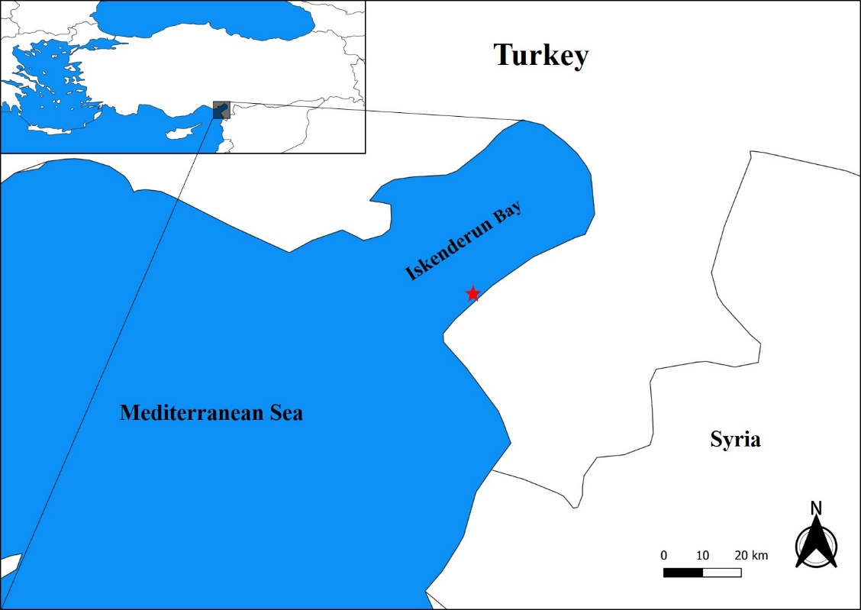
Figure 1. Stranding location of G. griseus.
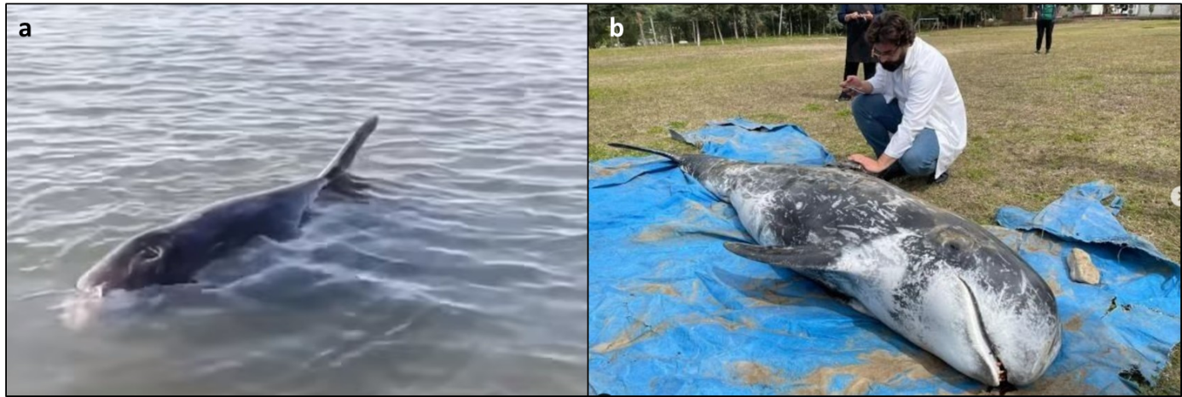
Figure 2. a: Live-stranded Risso’s dolphin 28 March 2022, b: Necropsy analyzes.
Results and Discussion
G. griseus was identified as female and measured to be 370 kg weight and 294 cm long, and several lacerations and scratches on the rostrum were observed. Blubber thickness in the central body was 2.8 cm. Other morphometric measurements are listed in Table 1.
Table 1. Morphometric measurement of the stranding Risso’s dolphin Grampus griseus.
Character | Length (cm)
Body length, tip of rostrum to tail notch | 294
Tip of rostrum to mid-point of anus | 240
Tip of rostrum to mid-point of genital slit | 195
Tip of rostrum to mid-point of umbilicus | 161
Tip of rostrum to tip of dorsal fin | 180
Tip of rostrum to font of dorsal fin, at anterior insertion of dorsal fin | 127
Tip of rostrum to centre of blowhole | 31
Tip of rostrum to end of gape | 27
Tip of rostrum to centre of eye | 33
Tip of rostrum to front of pectoral ﬁn, at  anterior insertion of pectoral ﬁn | 51
Length of left ﬂuke | 38
Length of right ﬂuke | 38
Total ﬂuke span, tip to tip | 76
Basal length of dorsal ﬁn | 37
Height of dorsal ﬁn | 31
Maximum width of pectoral ﬁn | 25
Outer length of pectoral ﬁn, from anterior insertion to tip | 60
Inner length of pectoral ﬁn, from posterior insertion to tip | 43
Girth behind pectoral ﬁn, at posterior  insertion of pectoral ﬁn | 60
Girth in front of dorsal ﬁn, at anterior  insertion of dorsal ﬁn | 70
Girth behind the dorsal ﬁn, at posterior  insertion of dorsal ﬁn | 59
Girth at the genital slit | 45
Girth at anus | 25
Deep ulceration areas containing the amorphic and necrotic substances were observed. neutrophils, bacteria or parasites were not detected in necropsy. The internal examination began with DNA sampling. The Necropsy procedure was conducted according to Mazzariol and Centelleghe (2007). The carcass condition was intact. Body bloating, protruded tongue, dry mucous membranes, and crackings in the skin were observed. Eyes were clear and general appearance was good. The dorsal axis was examined to assess nutritional condition. The epaxial muscle to both sides of the dorsal fin was rounded. The condition of this muscle shows that the dolphin has not been exposed to long term nutritional problems. According to body length, a missing tooth and having excessively worn teeth, this female dolphin is an old adult. Discolouration of the skin, any lesions and parasites neither on the skin nor in the blowhole were observed. Some fine grazes were observed on the skin. But is predicted that this graze happened after death, by chafing to sea ground caused by drifting. The ribs were removed and the entire organs were examined, but nothing was found. The gastrointestinal tract was dissected, beginning with the tongue and proceeding caudally. The stomach contained remnants of squid. No remarkable findings were observed in the other organs, including the brain and heart muscle.
It is known that it takes 8–10 years for a female Risso’s dolphin to be sexually mature. A five-year-old Risso’s dolphin is considered too young to be sexually mature, based on previous records (Kim et al., 2019). A report from the fisherman was taken that the Risso’s dolphins got caught in the trammel net and fluttered in the net for an unknown amount of time. The fisherman gently freed the dolphin from the net and released it. Risso’s dolphins are rarely found to be stranded, Risso’s dolphin is prone to by-catch as their prey with the fishery target species or baits species of some fishery fields (Lo Brutto et al., 2021; Luna et al., 2021). Their by-catch has been reported in many countries and is considered the most important threat to Risso’s dolphin population. Some precautions can be taken in the coastal areas that protect the dolphins from fisheries activities.
References
Bearzi, G., Reeves, R. R., Remonato, E., Pierantonio, N., & Airoldi, S. (2011). Risso's dolphin Grampus griseus in the Mediterranean Sea. Mammalian Biology, 76(4), 385-400.
Bello, G. (1992). Stomach contents of a Risso’s dolphin, Grampus griseus: do dolphins compete with fishermen and swordfish, Xiphias gladius. European Research on Cetaceans, 6, 199-202.
Bello, G. (1996). Teutophagus predators as collectors of oceanic cephalopods: The case of the Adriatic Sea. Bolletino Malacologico, 32(1-4), 71-78.
Bello, G., & Bentivegna, F. (1994). Cephalopod remains from the stomach of a Risso’s dolphin, Grampus griseus (Cetacea: Delphinidae), stranded along the eastern Tyrrhenian coast. Atti Soc. It. Sci. nat. Museo Civ. Stor. Nat. Milano, 135, 467-469.
Blanco, C., Raduán, M. Á., & Raga, J. A. (2006). Diet of Risso's dolphin (Grampus griseus) in the western Mediterranean Sea. Scientia Marina, 70(3), 407-411.
Carlini, R., Pulcini, M., Wurtz, M. (1992). Cephalopods from the stomachs of Risso’s dolphins, Grampus griseus (Cuvier, 1812), stranded along the central Tyrrhenian coast. European Research on Cetaceans, 6, 196-198.
Dede, A., Tonay, A. M., Bayar, H., & Öztürk, A. A. (2013). First stranding record of a Risso’s Dolphin (Grampus griseus) in the Marmara Sea, Turkey. Journal of Black Sea/Mediterranean Environment, 19(1), 121-126.
García-Polo, M., Giménez, J., Mons, J., Castillo, J., De Stephanis, R., Santos, M., & Fernández-Maldonado, C. (2014). Stomach contents of cetaceans in the Alborán Sea and Gulf of Cádiz. In Frontiers in Marine Science. Conference Abstract. In Proceedings of the IMMR International Meeting on Marine Research 2014 (pp. 10-11).
Hartman, K. L. (2018). Risso’s dolphin: Grampus griseus. In Encyclopedia of marine mammals (pp. 824-827). Academic Press.
IUCN (2021) The IUCN Red List of Threatened Species. Version 2022-3. https://www.iucnredlist.org. Accessed on [01-12-2022].
Jefferson, T. A., Weir, C. R., Anderson, R. C., Ballance, L. T., Kenney, R. D., & Kiszka, J. J. (2014). Global distribution of Risso's dolphin Grampus griseus: a review and critical evaluation. Mammal Review, 44(1), 56-68.
Kim, S. W., Han, S. J., Lee, Y. R., Kim, B. Y., & Park, S. C. (2019). First report of a Risso’s dolphin (Grampus griseus) stranded in Jeju Island, Republic of Korea: findings from necropsy, histopathology and microbiome analysis. Veterinary Record Case Reports, 7(4), e000860.
Lo Brutto, S., Calascibetta, A., Pavan, G., & Buffa, G. (2021). Cetacean strandings and museum collections: A focus on Sicily Island crossroads for Mediterranean species. Diversity, 13(3), 104.
Luna, A., Sánchez, P., Chicote, C., & Gazo, M. (2022). Cephalopods in the diet of Risso's dolphin (Grampus griseus) from the Mediterranean Sea: A review. Marine Mammal Science, 38(2), 725-741.
Maio, N. (1998). Study of a Risso's dolphin Grampus griseus (Cuvier, 1812), stranded on the coast of the gulf of Naples (Cetacea, Delphinidae): Considerations about the causes of the death.
Maldini, D., Mazzuca, L., & Atkinson, S. (2005). Odontocete Stranding Patterns in the Main Hawaiian Islands (1937–2002): How Do They Compare with Live Animal Surveys? Pacific Science, 59(1), 55-67.
Mazzariol, S., Centelleghe, C. (2007). Standard protocol for post-mortem examination on cetaceans. IPA Adriatic Cross-Border Cooperation Programme, University of Padua.
Öztürk, B., Salman, A., Öztürk, A. A., & Tonay, A. (2007). Cephalopod remains in the diet of striped dolphins (Stenella coeruleoalba) and Risso’s dolphins (Grampus griseus) in the eastern Mediterranean Sea. Vie milieu, 57(1/2), 53-59.
Pedà, C., Battaglia, P., Scuderi, A., Voliani, A., Mancusi, C., Andaloro, F., & Romeo, T. (2015). Cephalopod prey in the stomach contents of odontocete cetaceans stranded in the western Mediterranean Sea. Marine Biology Research, 11(6), 593-602.
Turan, C., Doğdu, S. A., & Uysal, İ. (2023). Mapping stranded whales in turkish marine waters. In Annales: Series Historia Naturalis (Vol. 33, No. 1, pp. 127-136). Scientific and Research Center of the Republic of Slovenia.

