For the given data, I am reading and taking the values from the MATLAB with these functions:

data = xlsread(file);

columnData = data(15,:);

After that, I just initialize from 1 to 30 matrixes to use it later.

Here, I am calculating the mean and variance of the given instruction, and I will put it to the plot with the overall mean and variance separately. Here, one of the graphs that may come is below:

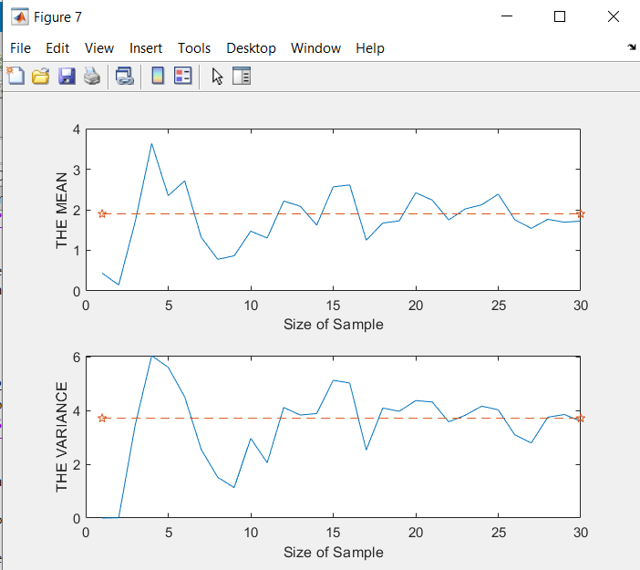

Here, as It can be seen that while increasing the sample size, the value of the mean that belongs to the sample is approaching to the my overall data mean that you gave to me which is at the R2 file and 15th row. Here, there are some couple outputs that may come after running the code:

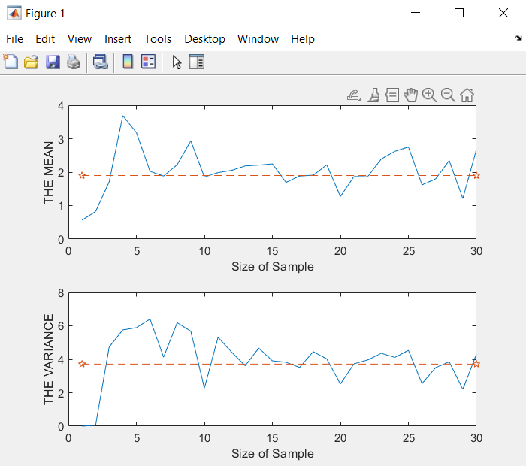 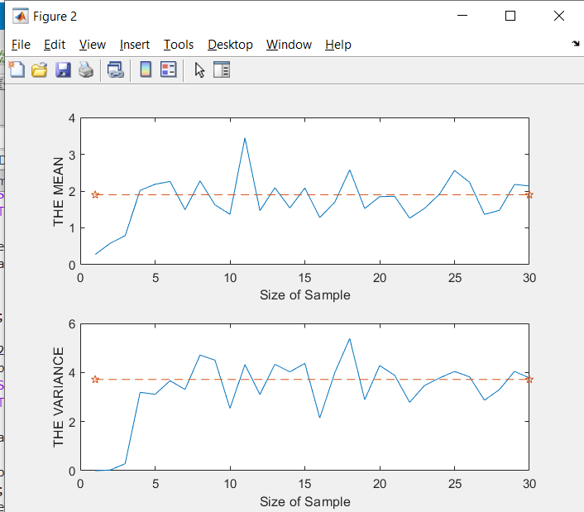

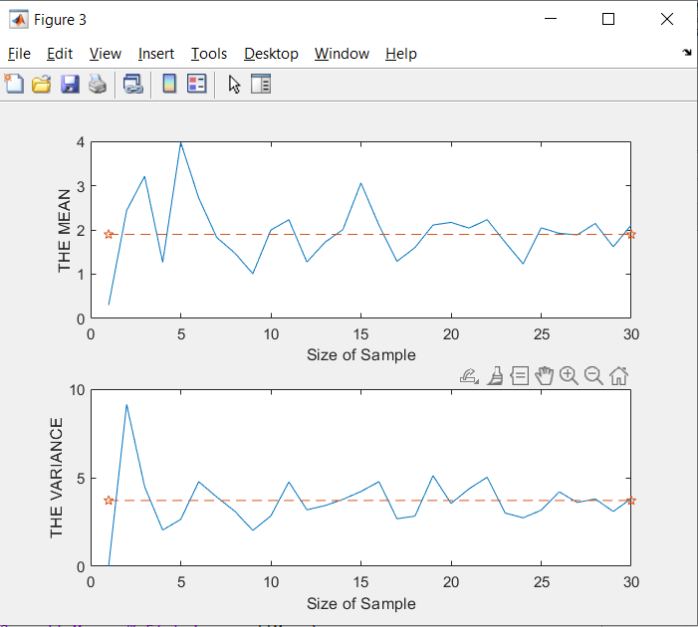 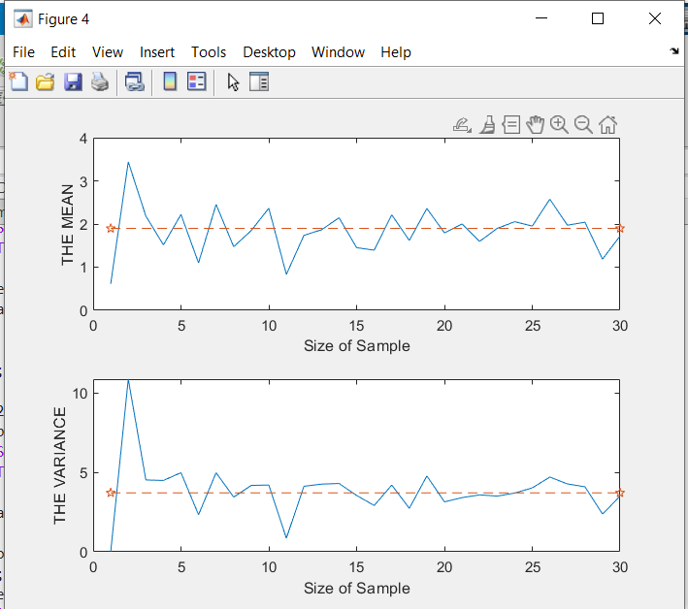

For all examples, as the sample size is increasing, the expected mean value will take closer value to the overall mean value. As the mean value, the variance also acts like the mean value. As sample size increasing, it will be close to the overall variance value as it can be seen by the graph.

It should be concluded that if we will take more sample size, the mean and variance values of this data will be so close to the overall mean and variance value.

As an example, one of possible output is here:

Sample 1 mean value is:0.61464 and the variance is:0.00000 Sample 2 mean value is:3.43929 and the variance is:10.87385 Sample 3 mean value is:2.18395 and the variance is:4.52618 Sample 4 mean value is:1.51568 and the variance is:4.49346 Sample 5 mean value is:2.22124 and the variance is:4.98533 Sample 6 mean value is:1.09962 and the variance is:2.33277 Sample 7 mean value is:2.45270 and the variance is:4.97976 Sample 8 mean value is:1.47352 and the variance is:3.44528 Sample 9 mean value is:1.84849 and the variance is:4.18222 Sample 10 mean value is:2.36597 and the variance is:4.20566 Sample 11 mean value is:0.83022 and the variance is:0.85054 Sample 12 mean value is:1.73722 and the variance is:4.12610 Sample 13 mean value is:1.86624 and the variance is:4.26327 Sample 14 mean value is:2.14523 and the variance is:4.30244 Sample 15 mean value is:1.45124 and the variance is:3.54964 Sample 16 mean value is:1.39307 and the variance is:2.91541 Sample 17 mean value is:2.21314 and the variance is:4.20235 Sample 18 mean value is:1.61881 and the variance is:2.73781 Sample 19 mean value is:2.35965 and the variance is:4.77576 Sample 20 mean value is:1.79515 and the variance is:3.14624 Sample 21 mean value is:2.00184 and the variance is:3.41146 Sample 22 mean value is:1.59709 and the variance is:3.58630 Sample 23 mean value is:1.89718 and the variance is:3.50731 Sample 24 mean value is:2.05381 and the variance is:3.70053 Sample 25 mean value is:1.95188 and the variance is:4.02531 Sample 26 mean value is:2.57577 and the variance is:4.70735 Sample 27 mean value is:1.97198 and the variance is:4.27496 Sample 28 mean value is:2.04267 and the variance is:4.09583 Sample 29 mean value is:1.18514 and the variance is:2.37859 Sample 30 mean value is:1.72403 and the variance is:3.50510

Overall Mean: 1.89833

Overall Variance: 3.71433

I just used the MATLAB functions such as mean(), var(), plot and etc. The graphs belong to my code.