**Assignment-based Subjective Questions**

1. From your analysis of the categorical variables from the dataset, what could you infer about their effect on the dependent variable? (3 marks)

A:

display bar plot for each categorical variable with ‘cnt’ as target variable, display trend year wise

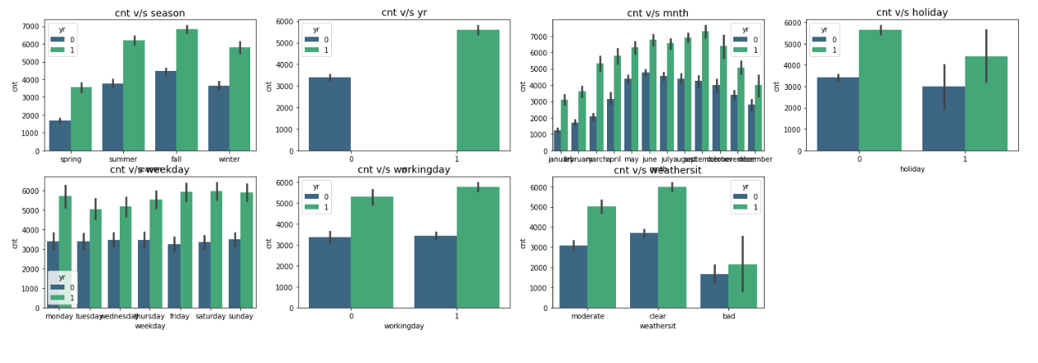

Effect of categorical variables on target variable:

* The Hiring rate is more for 2019 than 2018.
* Fall shows a higher demand followed by summer season.
* May to October period also shows a higher demand then other parts of the year.
* working days are having a higher demand than holidays and weekends.
* Clear weather days attract a hire demand then other days.
* Temperature is having a positive correlation(0.63) with demand. And higher temp attracts more bike hiring.

2. Why is it important to use **drop_first=True** during dummy variable creation? (2 mark)

A:

* drop_first=True is important to use, as it helps in reducing the extra column created during dummy variable creation. Hence it reduces the correlations created among dummy variables.
* n-1 columns required to represent n categorical variables.
* Dropping your first categorical variable is possible because if every other dummy column is 0, then this means your first value would have been 1.
* By dropping one of the one-hot encoded columns from each categorical feature, we ensure there are no reference columns—the remaining columns become linearly independent.

3. Looking at the pair-plot among the numerical variables, which one has the highest correlation with the target variable? (1 mark)

A: Temperature is having a highest correlation (0.63) with target variable.

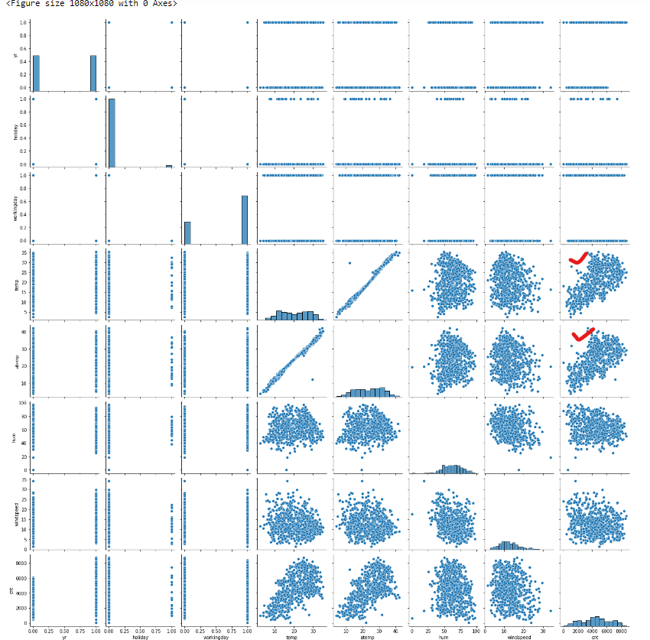

4. How did you validate the assumptions of Linear Regression after building the model on the training set? (3 marks)

A:

Assumptions of Linear Regression are:

* 1. Linear relationship between X and Y
* 2. Error terms are normally distributed (not X, Y)
* 3. Error terms are independent of each other
* 4. Error terms have constant variance (homoscedasticity)

There is linear relation between X and Y.

From the distribution plot for error term, it clearly shows that mean is centered around zero and normally distributed.

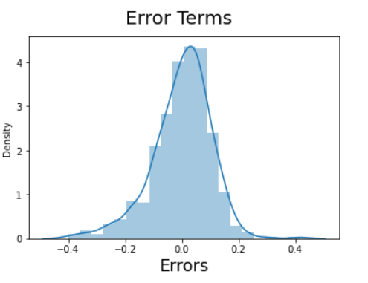

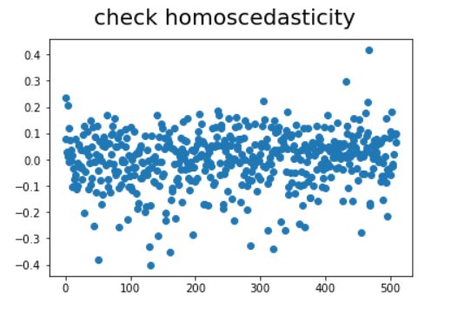

From above scatter plot, it clearly shows that error is having constant variance and no visible patterns are there. It satisfies condition of homoscedasticity.

All the assumptions of Linear Regression are satisfied.

5. Based on the final model, which are the top 3 features contributing significantly towards explaining the demand of the shared bikes? (2 marks)

A: Based on trained model and our analysis, top three features contributing to shared bikes demand are yr, weather situation, September month.

**General Subjective Questions**

1. Explain the linear regression algorithm in detail. (4 marks)

A:

Linear Regression is a machine learning algorithm based on supervised learning. It performs a regression task. Regression models a target prediction value based on independent variables. It is mostly used for finding out the relationship between variables and forecasting.

Linear regression algorithm shows a linear relationship between a dependent (y) and one or more independent (y) variables, hence called as linear regression. Since linear regression shows the linear relationship, which means it finds how the value of the dependent variable is changing according to the value of the independent variable.

The linear regression model provides a sloped straight line representing the relationship between the variables. Consider the below image:

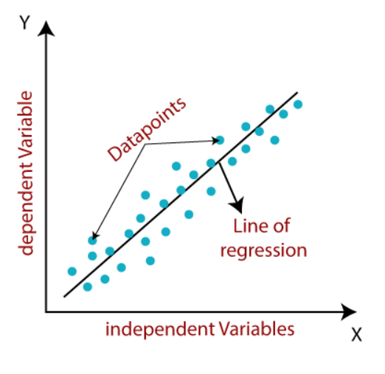

Equation of Simple Linear Regression, where bo is the intercept, b1 is coefficient or slope, x is the independent variable and y is the dependent variable

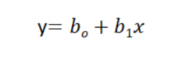

Equation of Multiple Linear Regression, where bo is the intercept, b1,b2,b3,b4…,bn are coefficients or slopes of the independent variables x1,x2,x3,x4…,xn and y is the dependent variable.

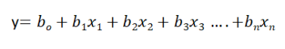

Assumptions of Linear Regression are:

1. Linear relationship between X and Y

2. Error terms are normally distributed (not X, Y)

3. Error terms are independent of each other

4. Error terms have constant variance (homoscedasticity)

2. Explain the Anscombe’s quartet in detail. (3 marks)

A: Anscombe’s Quartet can be defined as a group of four data sets which are nearly identical in simple descriptive statistics, but there are some peculiarities in the dataset that fools the regression model if built. They have very different distributions and appear differently when plotted on scatter plots.

It was constructed in 1973 by statistician Francis Anscombe to illustrate the importance of plotting the graphs before analyzing and model building, and the effect of other observations on statistical properties. There are these four data set plots which have nearly same statistical observations, which provides same statistical information that involves variance, and mean of all x,y points in all four datasets.

This tells us about the importance of visualizing the data before applying various algorithms out there to build models out of them which suggests that the data features must be plotted in order to see the distribution of the samples that can help you identify the various anomalies present in the data like outliers, diversity of the data, linear separability of the data, etc. Also, the Linear Regression can be only be considered a fit for the data with linear relationships and is incapable of handling any other kind of datasets. These four plots can be defined as follows:

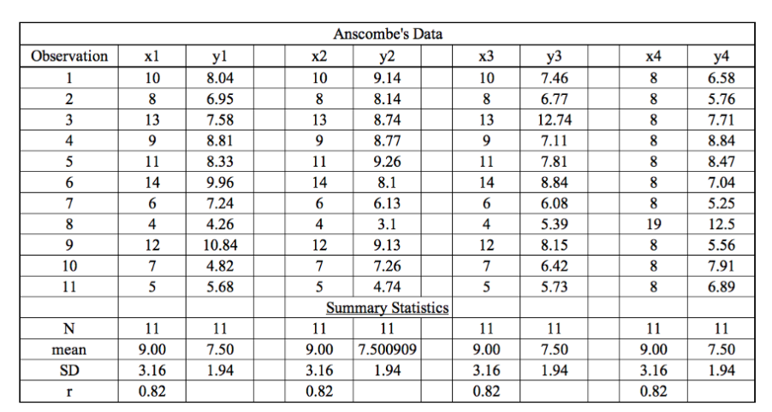

When these models are plotted on a scatter plot, all datasets generate a different kind of plot that is not interpretable by any regression algorithm which is fooled by these peculiarities and can be seen as follows:

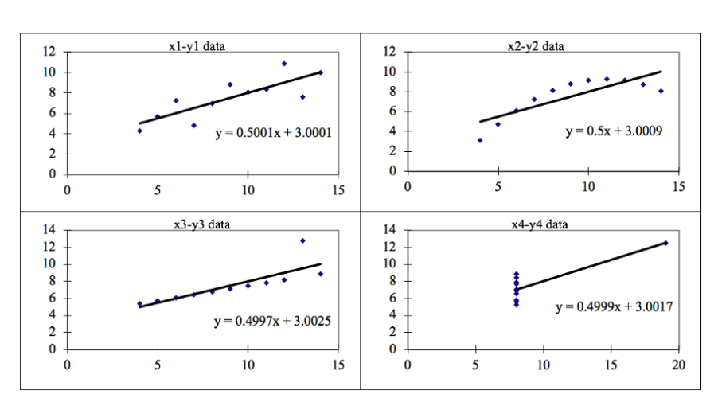

The four datasets can be described as:

Dataset 1: this fits the linear regression model pretty well.

Dataset 2: this could not fit linear regression model on the data quite well as the data is non-linear.

Dataset 3: shows the outliers involved in the dataset which cannot be handled by linear regression model

Dataset 4: shows the outliers involved in the dataset which cannot be handled by linear regression model

As you can see, Anscombe’s quartet helps us to understand the importance of data visualization and how easy it is to fool a regression algorithm. So, before attempting to interpret and model the data or implement any machine learning algorithm, we first need to visualize the data set in order to help build a well-fit model.

3. What is Pearson’s R? (3 marks)

A:

Correlation coefficients are used to measure how strong a relationship is between two variables. There are several types of correlation coefficient, but the most popular is Pearson’s. Pearson’s correlation (also called Pearson’s R) is a correlation coefficient commonly used in linear regression.

Correlation coefficient formulas are used to find how strong a relationship is between data. The formulas return a value between -1 and 1, where:

* 1 indicates a strong positive relationship.
* -1 indicates a strong negative relationship.
* A result of zero indicates no relationship at all.

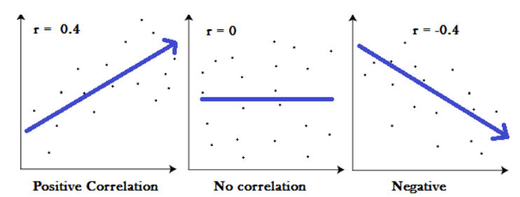

* A correlation coefficient of 1 means that for every positive increase in one variable, there is a positive increase of a fixed proportion in the other. For example, shoe sizes go up in (almost) perfect correlation with foot length.
* A correlation coefficient of -1 means that for every positive increase in one variable, there is a negative decrease of a fixed proportion in the other. For example, the amount of gas in a tank decreases in (almost) perfect correlation with speed.
* Zero means that for every increase, there isn’t a positive or negative increase. The two just aren’t related.

One of the most commonly used formulas is Pearson’s correlation coefficient formula.

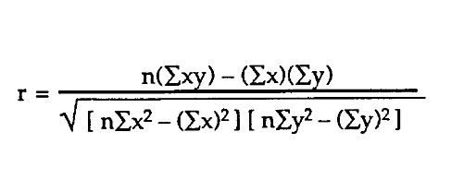

4. What is scaling? Why is scaling performed? What is the difference between normalized scaling and standardized scaling? (3 marks)

A:

Feature scaling is one of the most important data preprocessing step in machine learning. Algorithms that compute the distance between the features are biased towards numerically larger values if the data is not scaled.

Tree-based algorithms are fairly insensitive to the scale of the features. Also, feature scaling helps machine learning, and deep learning algorithms train and converge faster.

**Normalization or Min-Max Scaling** is used to transform features to be on a similar scale. The new point is calculated as:

**X_new = (X - X_min)/(X_max - X_min)**

This scales the range to [0, 1] or sometimes [-1, 1]. Geometrically speaking, transformation squishes the n-dimensional data into an n-dimensional unit hypercube. Normalization is useful when there are no outliers as it cannot cope up with them. Usually, we would scale age and not incomes because only a few people have high incomes but the age is close to uniform.

**Standardization or Z-Score Normalization** is the transformation of features by subtracting from mean and dividing by standard deviation. This is often called as Z-score.

**X_new = (X - mean)/Std**

Standardization can be helpful in cases where the data follows a Gaussian distribution. However, this does not have to be necessarily true. Geometrically speaking, it translates the data to the mean vector of original data to the origin and squishes or expands the points if std is 1 respectively. We can see that we are just changing mean and standard deviation to a standard normal distribution which is still normal thus the shape of the distribution is not affected.

Standardization does not get affected by outliers because there is no predefined range of transformed features

Differences between normalized scaling and standardized scaling:

|  |  |
| --- | --- |
| **Normalization** | **Standardization** |
| Minimum and maximum value of features are used for scaling | Mean and standard deviation is used for scaling. |
| It is used when features are of different scales. | It is used when we want to ensure zero mean and unit standard deviation. |
| Scales values between [0, 1] or [-1, 1]. | It is not bounded to a certain range. |
| It is really affected by outliers. | It is much less affected by outliers. |
| Scikit-Learn provides a transformer called MinMaxScaler for Normalization. | Scikit-Learn provides a transformer called StandardScaler for standardization. |
| Scikit-Learn provides a transformer called StandardScaler for standardization. | It translates the data to the mean vector of original data to the origin and squishes or expands. |
| It is useful when we don’t know about the distribution | It is useful when the feature distribution is Normal or Gaussian. |
| It is a often called as Scaling Normalization | It is a often called as Z-Score Normalization. |

5. You might have observed that sometimes the value of VIF is infinite. Why does this happen?

(3 marks)

A: If there is perfect correlation, then VIF = infinity. This shows a perfect correlation between two independent variables. In the case of perfect correlation, we get R2 =1, which lead to 1/(1-R2) infinity. To solve this problem, we need to drop one of the variables from the dataset which is causing this perfect multicollinearity.

An infinite VIF value indicates that the corresponding variable may be expressed exactly by a linear combination of other variables (which show an infinite VIF as well).

6. What is a Q-Q plot? Explain the use and importance of a Q-Q plot in linear regression.

(3 marks)

A:

Quantile-Quantile (Q-Q) plot, is a graphical tool to help us assess if a set of data plausibly came from some theoretical distribution such as a Normal, exponential or Uniform distribution. Also, it helps to determine if two data sets come from populations with a common distribution.

A Q–Q plot is used to compare the shapes of distributions, providing a graphical view of how properties such as location, scale, and skewness are similar or different in the two distributions.

Q-Q Plots (Quantile-Quantile plots) are plots of two quantiles against each other. A quantile is a fraction where certain values fall below that quantile. For example, the median is a quantile where 50% of the data fall below that point and 50% lie above it. The purpose of Q Q plots is to find out if two sets of data come from the same distribution. A 45 degree angle is plotted on the Q Q plot; if the two data sets come from a common distribution, the points will fall on that reference line.

A Q Q plot showing the 45 degree reference line:

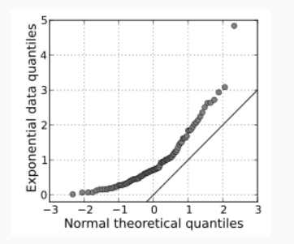

If the two distributions being compared are similar, the points in the Q–Q plot will approximately lie on the line y = x. If the distributions are linearly related, the points in the Q–Q plot will approximately lie on a line, but not necessarily on the line y = x. Q–Q plots can also be used as a graphical means of estimating parameters in a location-scale family of distributions.