JAVA PROJECT

ONLINE STORE CART & ORDER PIPELINE

CODE
import java.util.Scanner;
public class OnlineStore {
public static void main(String[] args) {
Scanner sc = new Scanner(System.in);
String[] products = {"Laptop", "Phone", "Headphones", "Keyboard"};
double[] prices = {50000, 25000, 2000, 1500};
int[] cart = new int[4];
int choice;
do {
System.out.println("\n===== ONLINE STORE =====");
System.out.println("1. View Products");
System.out.println("2. Add Product to Cart");
System.out.println("3. View Cart");
System.out.println("4. Place Order");
System.out.println("5. Exit");
System.out.print("Enter your choice: ");
choice = sc.nextInt();
switch (choice) {
case 1:
System.out.println("\n--- PRODUCTS ---");
for (int i = 0; i < products.length; i++) {
System.out.println(
(i + 1) + ". " + products[i] +
" - ₹" + prices[i]
);
}
break;
case 2:
System.out.println("\nEnter product number:");
for (int i = 0; i < products.length; i++) {
System.out.println(
(i + 1) + ". " + products[i] +
" - ₹" + prices[i]
);
}
int product = sc.nextInt();
if (product >= 1 && product <= products.length) {
System.out.print("Enter quantity: ");
int quantity = sc.nextInt();
cart[product - 1] += quantity;
System.out.println(
products[product - 1] +
" added to cart!"
);
} else {
System.out.println("Invalid product number!");
}
break;
case 3:
System.out.println("\n--- YOUR CART ---");
double total = 0;
boolean empty = true;
for (int i = 0; i < products.length; i++) {
if (cart[i] > 0) {
empty = false;
double itemTotal =
prices[i] * cart[i];
System.out.println(
products[i] +
" x " + cart[i] +
" = ₹" + itemTotal
);
total += itemTotal;
}
}
if (empty) {
System.out.println("Your cart is empty.");
} else {
System.out.println("----------------");
System.out.println("Total = ₹" + total);
}
break;
case 4:
double orderTotal = 0;
for (int i = 0; i < products.length; i++) {
orderTotal += prices[i] * cart[i];
}
if (orderTotal == 0) {
System.out.println("Cart is empty!");
} else {
System.out.println("\n===== ORDER PLACED =====");
System.out.println("Order Total: ₹" + orderTotal);
System.out.println("Order Status: Confirmed");
// Empty the cart after ordering
for (int i = 0; i < cart.length; i++) {
cart[i] = 0;
}
}
break;
case 5:
System.out.println("Thank you for visiting!");
break;
default:
System.out.println("Invalid choice!");
}
} while (choice != 5);
sc.close();
}

OUTPUT
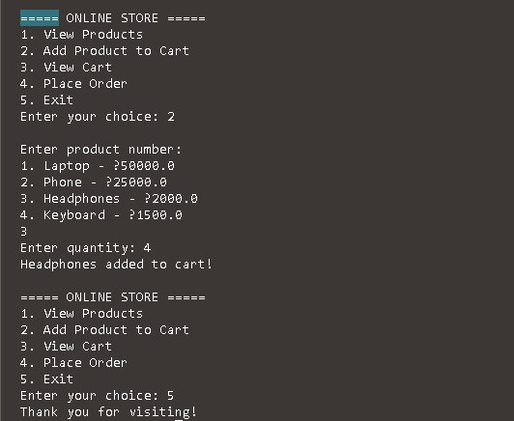

ABSTRACT
The Online Store Cart & Order Pipeline is a Java-based application designed to simulate the basic process of online shopping. The system allows users to view available products, select products according to their requirements, and add them to a shopping cart. Users can specify the quantity of each product, and the system stores the selected products along with their quantities. It automatically calculates the total price of the items in the cart and allows users to view their cart before placing an order. After confirming the purchase, the system processes the order and displays an order confirmation. The cart is cleared after the order is successfully placed. This project demonstrates important Java programming concepts such as arrays, loops, conditional statements, switch statements, and user input using the Scanner class. Overall, the project provides a basic understanding of how an online shopping cart and order-processing pipeline works.

ADVANTAGES
The Online Store Cart & Order Pipeline provides several advantages. It offers a simple and user-friendly menu-based interface that makes the shopping process easy to understand. The system saves time by allowing users to quickly select products, specify quantities, and calculate the total price automatically. It provides effective cart management by allowing multiple products to be added to the cart. Automatic price calculation also reduces errors that may occur during manual calculations. The system provides a simple order-processing mechanism that allows users to place an order after reviewing their cart. Since the project uses basic Java concepts, it is easy for beginners to understand and modify. The system can also be expanded in the future by adding features such as discounts, payment methods, customer details, product search, order tracking, and delivery status.
Conclusion
Online Store Cart and Order Pipeline project demonstrates how Java can be used to develop a simple e-commerce system. It allows users to add products to a cart, manage their selected items, calculate the total price, and process orders. This project helps in understanding important Java concepts such as classes, objects, arrays, methods, conditional statements, and data handling. Overall, it provides a basic understanding of how an online shopping system works and how Java can be used to build practical applications.

