Table 1. List of ncRNAs from Normal Patients (Normal Hipoxia vs Normal Normoxia)
Gene | Gene name | Also known as | Down/Up | Description | Reference
FENDRR | FOXF1 adjacent non-coding developmental regulatory RNA | HSALNG0113304; FOXF1AS1; Lnc-MTHFSD-3 | Up | This gene produces a spliced long non-coding RNA transcribed bidirectionally with FOXF1 on the opposite strand. | Gene Cards
HOTAIRM1 | HOXA transcript antisense RNA, myeloid-specific 1 | Hox Transcript Antisense RNA, Myeloid-Specific 1; HOX Antisense Intergenic RNA Myeloid 1; HSALNG0056850; NONHSAG047181.2 | Up | This non-coding locus is located in the HOX gene cluster. Transcription of this locus is induced by retinoic acid, and transcripts likely function in regulation of myelopoiesis through transcriptional activation of several genes in the HOXA cluster, in addition to several beta-2 integrins. | (Zhang X, et. al., 2009)
SNORD3D | Small nucleolar RNA, C/D box 3D | SNODB502; SNODB639 | Up | Associate with coiled bodies in interphase cells and are clustered on chromosome 17p11.2 in a complex inverted repeat structure. | (Gao L, et. al., 1997)
MIR503 | microRNA 503 | Mir-503; MI0003188; MIMAT0022925 | Up | Diseases associated with MIR503 include Adrenal Cortical Carcinoma and Retinoblastoma. Among its related pathways are miRNAs involved in DNA damage response. | Gene Cards
LINC00473 | Long Intergenic Non-Protein Coding RNA 473 | HSALNG0055058; LINC00473; PDE10A | Up | Long Intergenic Non-Protein Coding RNA 473 is an RNA Gene, and is affiliated with the lncRNA class. Diseases associated with LINC00473 include Mucoepidermoid Carcinoma and Wilms Tumor 1. Among its related pathways are Phosphodiester-ases in neuronal function. An important paralog of this gene is PDE5A. | Gene Cards
PAPPA-AS1 | PAPPA antisense RNA 1 | PAPPAAS; PAPPAS Antisense Gene Protein 1 | Up | Predicted to be located in endoplasmic reticulum membrane. Predicted to be integral component of membrane. | Gene Cards
KGFLP1 | Fibroblast growth factor 7 pseudogene | FGF7P6 | Up | FGF7 is involved in the development of ovarian cancer. | (Yasuhara T, et. al., 2005)
LINC00578 | Long intergenic non-protein coding RNA 578 | Lnc-KCNMB2-3; HSALNG0030884; NONHSAG036727.2 | Up | Intergenic variants may predispose to major depression disorder through regulation of long non-coding RNA expression. | Gene Cards
PAXIP1-AS2 | PAXIP1 Antisense RNA 2 | PAXIP1 Opposite Strand; PAXIP1OS; NONHSAG049229.2 | Up | PAXIP1 Antisense RNA 2 is an RNA Gene, and is affiliated with the lncRNA class. | Gene Cards
HERC2P7 | Hect domain and RLD 2 pseudogene 7 |  | Up | HERC2 Pseudogene 7 is a Pseudogene. | Gene Cards
MFSD14C | Major facilitator superfamily domain containing 14C | MFSD14CP | Up | Predicted to enable transmembrane transporter activity. Predicted to be involved in transmembrane transport. Predicted to be integral component of membrane. | Gene Cards
NUP50-AS1 | NUP50 Divergent Transcript | NONHSAG034128.2; HSALNG0135921; HSALNG0135922 | Up | NUP50 Divergent Transcript is an RNA Gene, and is affiliated with the lncRNA class. | Gene Cards
ASB16-AS1 | ASB16 antisense RNA 1 | HSALNG0116708; Lnc-ATXN7L3-3; CTB-175E5.4; NONHSAG021910.2 | Up | Functions as a miR-760 Sponge to Facilitate the Malignant Phenotype of Osteosarcoma by Increasing HDGF Expression. | (Yin R, et. al., 2020)
LOC389765 | Kinesin Family Member 27 Pseudogene |  | Up | Kinesin Family Member 27 Pseudogene is a Pseudogene. | Gene Cards
AHCTF1P1 | AT-Hook Containing Transcription Factor 1 Pseudogene 1 | ELYS-Like; AT Hook Containing Transcription Factor 1 Pseudogene | Up | AT-Hook Containing Transcription Factor 1 Pseudogene 1 is a Pseudogene. | Gene Cards
HERC2P9 | Hect domain and RLD 2 pseudogene 9 | FLJ59185 | Up | Ubiquitous expression in urinary bladder, brain, adrenal, esophagus, lung and salivary gland. | Gene Cards
CCT6P1 | Chaperonin Containing TCP1 Subunit 6 Pseudogene 1 | CCT6AP1; Chaperonin Containing TCP1, Subunit 6A Pseudogene | Up | Chaperonin Containing TCP1 Subunit 6 Pseudogene 1 is a Pseudogene. | Gene Cards
RASSF8-AS1 | RASSF8 Antisense RNA 1 | NONHSAG010716.2; HSALNG0089954; RASSF8-AS1 | Up | RASSF8 Antisense RNA 1 is an RNA Gene, and is affiliated with the lncRNA class. | Gene Cards
HERC2P3 | Hect domain and RLD 2 pseudogene 3 |  | Up | Predicted to enable metal ion binding activity and ubiquitin-protein transferase activity. Predicted to be involved in protein ubiquitination. | Gene Cards
NUDT4P1 | Nudix hydrolase 4 pseudogene 1 | NUDT4B | Up | Genetic rationale for microheterogeneity of human diphosphoinositol polyphosphate phosphohydrolase type 2. | Gene Cards
XXYLT1-AS2 | XXYLT1 Antisense RNA 2 | NONHSAG037052.2; HSALNG0031789; XXYLT1-AS2 | Up | XXYLT1 Antisense RNA 2 is an RNA Gene, and is affiliated with the lncRNA class. | Gene Cards
KGFLP2 | Keratinocyte growth factor-like protein 2 | FGF7P3 | Up | Associated with pericentric inversion of chromosome 9 and FGF7 is involved in the development of ovarian cancer. | (Yasuhara T, et. al., 2005)
MEIS3P1 | Meis Homeobox 3 Pseudogene 1 | Homeobox Protein Meis3; Meis Homolog 3; CTD-3157E16.2 | Up | This gene appears to be a retrotransposed pseudogene based on its lack of exons compared to other family members, one of which is found on chromosome 19 (MEIS3). It does appear to be transcribed and has an ORF that may encode a protein of similar size and sequence to that encoded by MEIS3. | Gene Cards
ZBED5-AS1 | ZBED5 antisense RNA 1 | NONHSAG007652.2; CTD-2003C8.1; HSALNG0082661; HSALNG0082659 | Up | ZBED5-AS1 is an RNA Gene, and is affiliated with the lncRNA class. Metazoan signal recognition particle RNA. | Gene Cards
FLJ32255 | Uncharacterized LOC643977 | Lnc-ANXA2R-1 | Up | FLJ32255 is an RNA Gene, and is affiliated with the lncRNA class. | Gene Cards
MIR635 | microRNA 635 | MIMAT0003305; MIRN635; Hsa-MiR-635 | Up | MicroRNA 635 is an RNA Gene, and is affiliated with the miRNA class. Diseases associated with MIR635 include Ovarian Cancer. | Gene Cards
MBNL1-AS1 | MBNL1 antisense RNA 1 | LOC401093; NONHSAG036412.2; HSALNG0029874 | Up | Regulates proliferation, migration, and invasion of cancer stem cells in colon cancer by interacting with MYL9 via sponging microRNA-412-3p. | (Zhu K, et. al., 2020)
RNF217-AS1 | RNF217 Antisense RNA 1 (Head To Head) | NONHSAG044755.2; HSALNG0053252; RNF217-AS1 | Up | RNF217 Antisense RNA 1 (Head To Head) is an RNA Gene, and is affiliated with the lncRNA class. Diseases associated with RNF217-AS1 include Mucocele Of Salivary Gland. | Gene Cards
GABPB1-AS1 | GABPB1 Antisense RNA 1 | NONHSAG016861.2; HSALNG0105872; GABPB1-AS1 | Up | GABPB1 Antisense RNA 1 is an RNA Gene, and is affiliated with the lncRNA class. Diseases associated with GABPB1-AS1 include Colorectal Cancer. | Gene Cards
GTF2IP1 | General transcription factor IIi pseudogene 1 |  | Up | A duplicated gene in the breakpoint regions of the 7q11.23 Williams-Beuren syndrome deletion encodes the initiator binding protein TFII-I and BAP-135, a phosphorylation target of BTK. | (Pérez Jurado LA, et. al., 1998)
LOC153684 | Uncharacterized LOC153684 |  | Up | LOC153684 is an RNA Gene, and is affiliated with the lncRNA class. | LNCpedia
LYRM4-AS1 | LYRM4 Antisense RNA 1 | NONHSAG042907.2; HSALNG0047774; Lnc-PPP1R3G-9 | Up | LYRM4 Antisense RNA 1 is an RNA Gene, and is affiliated with the lncRNA class. Diseases associated with LYRM4-AS1 include Combined Oxidative Phosphorylation Deficiency | Gene Cards
MAP3K14-AS1 | MAP3K14 Antisense RNA 1 | NONHSAG021978.2; HSALNG0116845; Lnc-FMNL1-6 | Up | MAP3K14 Antisense RNA 1 is an RNA Gene, and is affiliated with the lncRNA class. Diseases associated with MAP3K14-AS1 include Temporal Lobe Epilepsy. | Gene Cards
RNU12 | RNA, U12 small nuclear | RNU12P | Up | RNA, U12 Small Nuclear is an RNA Gene, and is affiliated with the snRNA class. Diseases associated with RNU12 include Congenital Cerebellar Ataxia Due To Rnu12 Mutation. | Gene Cards
RPL13P5 | Ribosomal protein L13 pseudogene 5 |  |  | Expression promotes insulin resistance in patients with gestational diabetes. | (Li Y, et. al., 2021)
CCT6P3 | Chaperonin Containing TCP1 Subunit 6 Pseudogene 3 | CCT6-3P | Up | Chaperonin Containing TCP1 Subunit 6 Pseudogene 3 is a Pseudogene. | Gene Cards
STX16-NPEPL1 | STX16-NPEPL1 Readthrough (NMD Candidate) | STX16-NPEPL1 Readthrough (Non-Protein Coding) | Up | STX16-NPEPL1 Readthrough (NMD Candidate) is an RNA Gene, and is affiliated with the lncRNA class. Diseases associated with STX16-NPEPL1 include Pseudohypoparathyroidism, Type Ib. | Gene Cards
LOC344887 | NmrA Like Redox Sensor 2, Pseudogene | NMRAL1P1; NmrA-Like Family Domain Containing 1 Pseudogene | Up | NmrA Like Redox Sensor 2, Pseudogene is a Pseudogene. Diseases associated with NMRAL2P include Gallbladder Cancer and Lung Cancer. | Gene Cards
LOC100129550 | Uncharacterized LOC100129550 |  | Up | LOC100129550 is an RNA Gene, and is affiliated with the lncRNA class. | LNCpedia
LOC103021295 | Uncharacterized LOC103021295 | HSALNG0114005;  Lnc-ANKFY1-5 | Up | Uncharacterized LOC103021295 is an RNA Gene, and is affiliated with the lncRNA class. | Gene Cards
TBX2-AS1 | TBX2 antisense RNA 1 | NONHSAG022407.2; HSALNG0117877; Lnc-NACA2-10; | Up | Correlated with the prognostic survival of ovarian cancer patients. | (Liu C, et. al., 2022)
ZNF625-ZNF20 | ZNF625-ZNF20 Readthrough (NMD Candidate) | Zinc Finger Protein 625; Lnc-ZNF625-ZNF20-1; HSALNG0124094 | Up | This locus represents naturally occurring read-through transcription between the neighboring zinc finger protein 625 (ZNF625) and zinc finger protein 20 (ZNF20) genes on chromosome 19. The read-through transcript is a candidate for nonsense-mediated mRNA decay (NMD), and is thus unlikely to produce a protein product. | Gene Cards
LOC101928161 | Uncharacterized LOC101928161 |  | Up | Uncharacterized LOC101928161 is an RNA Gene, and is affiliated with the lncRNA class. | LNCpedia
SNORD114-30 | Small Nucleolar RNA, C/D Box 114-30 | SNORD114-30; SNODB911 | Down | Small Nucleolar RNA, C/D Box 114-30 is an RNA Gene, and is affiliated with the snoRNA class. | Gene Cards
LIMD1-AS1 | LIMD1 Antisense RNA 1 | NONHSAG034935.2; HSALNG0025628; LIMD1-AS1 | Down | LIMD1 Antisense RNA 1 is an RNA Gene, and is affiliated with the lncRNA class. | Gene Cards
MIR654 | microRNA 654 | Mir-654; MI0003676; Hsa-Mir-154-P23_pre | Down | MicroRNA 654 is an RNA Gene, and is affiliated with the miRNA class. Diseases associated with MIR654 include Systemic Lupus Erythematosus and Maxillary Sinus Cancer. | Gene Cards
MEG3 | Maternally Expressed 3 | HSALNG0103785; Lnc-DLK1-35 | Down | Maternally Expressed 3 is an RNA Gene, and is affiliated with the lncRNA class. Diseases associated with MEG3 include Kagami-Ogata Syndrome and Liver Disease. | Gene Cards
SNORD114-13 | Small Nucleolar RNA, C/D Box 114-13 | 14q(II-13); SNORD114-13 | Down | Small Nucleolar RNA, C/D Box 114-13 is an RNA Gene, and is affiliated with the snoRNA class. Diseases associated with SNORD114-13 include Angelman Syndrome. | Gene Cards
MIR1244-1 | microRNA 1244-1 | MIR1244; Hsa-Mir-1244-1; Hsa-MiR-1244 | Down | MicroRNA 1244-1 is an RNA Gene, and is affiliated with the miRNA class. | Gene Cards
ADAMTS9-AS2 | ADAMTS9 Antisense RNA 2 | NONHSAG035335.2; HSALNG0026583 | Down | ADAMTS9 Antisense RNA 2 is an RNA Gene, and is affiliated with the lncRNA class. Diseases associated with ADAMTS9-AS2 include High Grade Glioma and Renal Cell Carcinoma, Nonpapillary. | Gene Cards
LOC100507156 | Uncharacterized LOC100507156 | NONHSAG049763.2; HSALNG0063981 | Down | Uncharacterized LOC100507156 is an RNA Gene, and is affiliated with the lncRNA class. | Gene Cards
PPP4R1L | Protein Phosphatase 4 Regulatory Subunit 1 Like (Pseudogene) | PPP4R1P1; Protein Phosphatase 4, Regulatory Subunit 1-Like | Down | Predicted to enable protein phosphatase regulator activity. Predicted to be involved in protein dephosphorylation. | Gene Cards
SNORD89 | Small Nucleolar RNA, C/D Box 89 | HBII-289; SNODB1627; SNORD89 | Down | Small Nucleolar RNA, C/D Box 89 is an RNA Gene, and is affiliated with the snoRNA class. Diseases associated with SNORD89 include Bartholin's Gland Carcinoma and Bartholin's Gland Disease. | Gene Cards
SNORD114-10 | Small Nucleolar RNA, C/D Box 114-10 | 14q(II-10); SNORD114-10 | Down | Small Nucleolar RNA, C/D Box 114-10 is an RNA Gene, and is affiliated with the snoRNA class. Diseases associated with SNORD114-10 include Angelman Syndrome. | Gene Cards
MIR24-2 | microRNA 24-2 | Hsa-Mir-1244; MicroRNA 1244; MIRN1244 | Down | MicroRNA 1244-1 is an RNA Gene, and is affiliated with the miRNA class. | Gene Cards
LINC00152 | Long intergenic non-protein coding RNA 152 | CYTOR | Down | This gene produces a long non-coding RNA that is overexpressed in cancer cells and promotes cell proliferation and epithelial-mesenchymal transition. This RNA may bind enhancer of zeste homolog 2 and participate in the transcriptional silencing of tumor suppressor genes. It may act as a sponge for microRNAs. | Gene Cards
AGAP2-AS1 | AGAP2 Antisense RNA 1 | PUNISHER; LOC100130776; HSALNG0091650 | Down | AGAP2 Antisense RNA 1 is an RNA Gene, and is affiliated with the lncRNA class. Diseases associated with AGAP2-AS1 include High Grade Glioma and Glioblastoma. | Gene Cards
EFTUD1P1 | Elongation Factor Like GTPase 1 Pseudogene 1 | FAM42B | Down | Elongation Factor Like GTPase 1 Pseudogene 1 is a Pseudogene. | Gene Cards
ZMIZ1-AS1 | ZMIZ1 Antisense RNA 1 | NONHSAG006320.2;  HSALNG0079114 | Down | ZMIZ1 Antisense RNA 1 is an RNA Gene, and is affiliated with the lncRNA class. | Gene Cards
CD99P1 | CD99 molecule pseudogene 1 |  | Down | Interaction of long noncoding RNAs and microRNAs in the pathogenesis of idiopathic pulmonary fibrosis. | (Huang C, et. al., 2015)
SNORD114-7 | Small Nucleolar RNA, C/D Box 114-7 | SNORD114-7; SNODB1171; SNODB1169 | Down | Small Nucleolar RNA, C/D Box 114-7 is an RNA Gene, and is affiliated with the snoRNA class. | Gene Cards
TPT1-AS1 | TPT1 antisense RNA 1 | TPT1 Antisense RNA 1 | Down | LncRNA profile study reveals four-lncRNA signature associated with the prognosis of patients with anaplastic gliomas. | Gene Cards
PLCXD1 | Phosphatidylinositol Specific Phospholipase C X Domain Containing 1 | LL0XNC01-136G2.1 | Down | Phosphatidylinositol Specific Phospholipase C X Domain Containing 1 is a Protein Coding gene. Diseases associated with PLCXD1 include Leri-Weill Dyschondrosteosis. | Gene Cards
LOC101929771 | Uncharacterized LOC101929771 | ENSG00000227925 | Down | LOC101929771 is an RNA Gene, and is affiliated with the lncRNA class. | LNCpedia
LINC00520 | Long intergenic non-protein coding RNA 520 | LEENE | Down | LINC00520 is induced by Src, STAT3, and PI3K and plays a functional role in breast cancer. | Gene Cards
RPSAP52 | Ribosomal Protein SA Pseudogene 52 | RPSA_17_1251 | Down | RPSAP52 lncRNA Inhibits p21Waf1/CIP Expression by Interacting With the RNA Binding Protein HuR. | (D'Angelo D. et. al., 2020)
SNORD114-17 | Small Nucleolar RNA, C/D Box 114-17 | SNORD114-17; SNODB421 | Down | Small Nucleolar RNA, C/D Box 114-17 is an RNA Gene, and is affiliated with the snoRNA class. | Gene Cards
LOC541472 | Uncharacterized LOC541472 |  | Down | LOC541472 has 158 functional associations with biological entities spanning 5 categories, molecular profile, organism, chemical, cell line, cell type or tissue, gene, protein or microRNA
HIF1A-AS2 | HIF1A Antisense RNA 2 | NONHSAG015184.2; HSALNG0101780; Lnc-TMEM30B-9 | Down | HIF1A Antisense RNA 2 is an RNA Gene, and is affiliated with the lncRNA class. Diseases associated with HIF1A-AS2 include Kidney Cancer and Glioblastoma. | Gene Cards
TCAF2P1 | TRPM8 Channel Associated Factor 2 Pseudogene 1 | FLJ40722-Like; FAM115D; FAM139B | Down | TRPM8 Channel Associated Factor 2 Pseudogene 1 is a Pseudogene. | Gene Cards
LOC101929705 | Uncharacterized LOC101929705 | ENSG00000237686 | Down | LOC101929705 is an RNA Gene, and is affiliated with the lncRNA class. | LNCpedia
LINC00260 | Long Intergenic Non-Protein Coding RNA 260 | Lnc-LAX1-1; C1orf217; MGC5457 | Down | Long Intergenic Non-Protein Coding RNA 260 is an RNA Gene, and is affiliated with the lncRNA class. | Gene Cards
FER1L4 | Fer-1 Like Family Member 4 (Pseudogene) | Fer-1-Like 4; Fer-1-Like Protein 4 | Down | Predicted to enable metal ion binding activity. Predicted to be involved in plasma membrane organization. Predicted to be integral component of membrane. | Gene Cards
STXBP5-AS1 | STXBP5 Antisense RNA 1 | HSALNG0054147; HSALNG0054155; Lnc-SHPRH-10 | Down | STXBP5 Antisense RNA 1 is an RNA Gene, and is affiliated with the lncRNA class. Diseases associated with STXBP5-AS1 include Breast Cancer. | Gene Cards
SNORD114-2 | Small Nucleolar RNA, C/D Box 114-2 | 14q(II-2); SNODB1192 | Down | Small Nucleolar RNA, C/D Box 114-2 is an RNA Gene, and is affiliated with the snoRNA class. | Gene Cards
MIR548AR | microRNA 548ar | Hsa-Mir-548ar | Down | MicroRNA 548ar is an RNA Gene, and is affiliated with the miRNA class. | Gene Cards
SNORA11 | Small Nucleolar RNA, H/ACA Box 11 | U107 SnoRNA; SNODB132 | Down | Small nucleolar RNAs (snoRNAs) are small noncoding RNAs involved in RNA processing. Box H/ACA snoRNAs, such as SNORA11, direct the conversion of uridine to pseudouridine at specific residues of ribosomal RNAs or small nuclear RNAs (snRNAs) | Gene Cards
LOC100507065 | Uncharacterized  LOC100507065 | - | Down | - | -
MIR590 | microRNA 590 | Hsa-Mir-590 | Down | MicroRNA 590 is an RNA Gene, and is affiliated with the miRNA class. Diseases associated with MIR590 include Extrinsic Cardiomyopathy and Myasthenic Syndrome, Congenital. | Gene Cards
TCAF2P1 | TRPM8 Channel Associated Factor 2 Pseudogene 1 | FLJ40722-Like; FAM115D; FAM139B | Down | TRPM8 Channel Associated Factor 2 Pseudogene 1 is a Pseudogene. | Gene Cards
FAM41C | Family With Sequence Similarity 41 Member C | NONHSAG000053.2; HSALNG0000046; FAM41C | Down | Family With Sequence Similarity 41 Member C is an RNA Gene, and is affiliated with the lncRNA class. | Gene Cards
LINC01125 | Long Intergenic Non-Protein Coding RNA 1125 | C2orf92 | Down | Predicted to be integral component of membrane. | Gene Cards
LIMS3-LOC440895 | LIMS3-LOC440895 Readthrough | HSALNG0017824; HSALNG0017804 | Down | LIMS3-LOC440895 Readthrough is an RNA Gene, and is affiliated with the lncRNA class. | Gene Cards
SLC6A10P | Solute Carrier Family 6 Member 10, Pseudogene | SLC6A10 | Down | Solute Carrier Family 6 Member 10, Pseudogene is a Pseudogene. | Gene Cards
LOC154761 | Family with sequence similarity 115, member C pseudogene |  | Down | Ubiquitous expression in esophagus and adrenal. | Gene Cards
MIR6809 | microRNA 6809 |  | Down | MIR6809 is an RNA Gene, and is affiliated with the miRNA class. | Gene Cards
LINC01291 | Long Intergenic Non-Protein Coding RNA 1291 | NONHSAG028242.2; HSALNG0016106; Lnc-POLE4-8 | Down | Long Intergenic Non-Protein Coding RNA 1291 is an RNA Gene, and is affiliated with the lncRNA class. | Gene Cards
LUCAT1 | Lung cancer associated transcript 1 (non-protein coding) | Lnc-ARRDC3-3 | Down | Long Non-Coding RNA LUCAT1 Promotes Proliferation and Invasion in Clear Cell Renal Cell Carcinoma Through AKT/GSK-3β Signaling Pathway. | Gene Cards

Table 2. List of ncRNAs from IPF patients (Fibrotic Hipoxia vs Fibrotic Normoxia)
Gene | Gene name | Also known as | Down/Up | Description | Reference
FLJ32255 | Uncharacterized LOC643977 | Lnc-ANXA2R-1 | Up | FLJ32255 is an RNA Gene, and is affiliated with the lncRNA class. | Gene Cards
MIR5087 | microRNA 5087 | Hsa-Mir-5087; MIMAT0021079; MI0017976 | Up | MIR5087 is an RNA Gene, and is affiliated with the miRNA class. Diseases associated with MIR5087 include Chromosome 1Q21.1 Deletion Syndrome | Gene Cards
LOC153684 | Uncharacterized LOC153684 |  | Up | LOC153684 is an RNA Gene, and is affiliated with the lncRNA class. | LNCpedia
LYRM4-AS1 | LYRM4 Antisense RNA 1 | NONHSAG042907.2; HSALNG0047774; Lnc-PPP1R3G-9 | Up | LYRM4 Antisense RNA 1 is an RNA Gene, and is affiliated with the lncRNA class. Diseases associated with LYRM4-AS1 include Combined Oxidative Phosphorylation Deficiency | Gene Cards
LOC148413 | uncharacterized LOC148413 | lnc-TMEM88B-3; NR_015434; NR_015434.1 | Up | LOC148413 is an RNA Gene, and is affiliated with the lncRNA class. | LNCpedia
NRSN2-AS1 | NRSN2 Antisense RNA 1 | NONHSAG031079.2; NONHSAG031077.2; HSALNG0128018; HSALNG0128021 | Down | NRSN2-AS1 is an RNA Gene, and is affiliated with the lncRNA class. | Gene Cards
HCG4 | HLA complex group 4 (non-protein coding) | HLA Complex Group 4 Pseudogene 10; HCG4P10; HCGIV-10 Pseudogene; NONHSAG045846.2 | Down | HCG4 is an RNA Gene, and is affiliated with the lncRNA class. Diseases associated with HCG4 include Hematocele Of Tunica Vaginalis Testis and Ovarian Cystadenoma. | Gene Cards
ADAMTS9-AS2 | ADAMTS9 Antisense RNA 2 | NONHSAG035335.2; HSALNG0026583 | Down | ADAMTS9 Antisense RNA 2 is an RNA Gene, and is affiliated with the lncRNA class. Diseases associated with ADAMTS9-AS2 include High Grade Glioma and Renal Cell Carcinoma, Nonpapillary. | Gene Cards
LOC100507156 | Uncharacterized LOC100507156 | NONHSAG049763.2; HSALNG0063981 | Down | Uncharacterized LOC100507156 is an RNA Gene, and is affiliated with the lncRNA class. | Gene Cards
LOC154761 | Family with sequence similarity 115, member C pseudogene | ENSG00000291149 | Down | LOC154761 (Family With Sequence Similarity 115, Member C Pseudogene) is a Pseudogene. | Gene Cards
LINC01111 | Long Intergenic Non-Protein Coding RNA 1111 | NONHSAG050557.2; HSALNG0066316; Lnc-ZFHX4-2 | Down | Long Intergenic Non-Protein Coding RNA 1111 is an RNA Gene, and is affiliated with the lncRNA class. Diseases associated with LINC01111 include Sclerocornea and Peters-Plus Syndrome. | Gene Cards
LINC00702 | Long Intergenic Non-Protein Coding RNA 702 | NONHSAG005061.2; HSALNG0075773; Lnc-KLF6-14; LINC00702 | Down | LINC00702 is an RNA Gene, and is affiliated with the lncRNA class. Diseases associated with LINC00702 include Rectum Adenoma. | Gene Cards
EPB41L4A-AS1 | EPB41L4A Antisense RNA 1 | NONHSAG041241.2; HSALNG0044150; EPB41L4A-AS1 | Down | EPB41L4A Antisense RNA 1 is an RNA Gene, and is affiliated with the lncRNA class. | Gene Cards
MSC-AS1 | MSC Antisense RNA 1 | NONHSAG050493.2; HSALNG0066117; MSC-AS1 | Down | MSC Antisense RNA 1 is an RNA Gene, and is affiliated with the lncRNA class. Diseases associated with MSC-AS1 include Episodic Pain Syndrome, Familial, 1. | Gene Cards
MIR548AR | microRNA 548ar | Hsa-Mir-548ar | Down | MicroRNA 548ar is an RNA Gene, and is affiliated with the miRNA class. | Gene Cards
HIF1A-AS2 | HIF1A Antisense RNA 2 | NONHSAG015184.2; HSALNG0101780; Lnc-TMEM30B-9 | Down | HIF1A Antisense RNA 2 is an RNA Gene, and is affiliated with the lncRNA class. Diseases associated with HIF1A-AS2 include Kidney Cancer and Glioblastoma. | Gene Cards
LOC730101 | Uncharacterized LOC730101 | NONHSAG043936.2; Lnc-TMEM14A-1;  HSALNG0050624 | Down | Uncharacterized LOC730101 is an RNA Gene, and is affiliated with the lncRNA class. Diseases associated with LOC730101 include Osteogenic Sarcoma and Lung Cancer. | Gene Cards

Table 3. List of ncRNAs from Normal Patients shared with IPF patients.
Gene | Gene name | Also known as | Down/Up | Description | Reference
FLJ32255 | Uncharacterized LOC643977 | Lnc-ANXA2R-1 | Up | FLJ32255 is an RNA Gene, and is affiliated with the lncRNA class. | Gene Cards
LOC153684 | Uncharacterized LOC153684 |  | Up | LOC153684 is an RNA Gene, and is affiliated with the lncRNA class. | LNCpedia
LYRM4-AS1 | LYRM4 Antisense RNA 1 | NONHSAG042907.2; HSALNG0047774; Lnc-PPP1R3G-9 | Up | LYRM4 Antisense RNA 1 is an RNA Gene, and is affiliated with the lncRNA class. Diseases associated with LYRM4-AS1 include Combined Oxidative Phosphorylation Deficiency | Gene Cards
ADAMTS9-AS2 | ADAMTS9 Antisense RNA 2 | NONHSAG035335.2; HSALNG0026583 | Down | ADAMTS9 Antisense RNA 2 is an RNA Gene, and is affiliated with the lncRNA class. Diseases associated with ADAMTS9-AS2 include High Grade Glioma and Renal Cell Carcinoma, Nonpapillary. | Gene Cards
LOC100507156 | Uncharacterized LOC100507156 | NONHSAG049763.2; HSALNG0063981 | Down | Uncharacterized LOC100507156 is an RNA Gene, and is affiliated with the lncRNA class. | Gene Cards
HIF1A-AS2 | HIF1A Antisense RNA 2 | NONHSAG015184.2; HSALNG0101780; Lnc-TMEM30B-9 | Down | HIF1A Antisense RNA 2 is an RNA Gene, and is affiliated with the lncRNA class. Diseases associated with HIF1A-AS2 include Kidney Cancer and Glioblastoma. | Gene Cards
MIR548AR | microRNA 548ar | Hsa-Mir-548ar | Down | MicroRNA 548ar is an RNA Gene, and is affiliated with the miRNA class. | Gene Cards
LOC154761 | Family with sequence similarity 115, member C pseudogene | ENSG00000291149 | Down | LOC154761 (Family With Sequence Similarity 115, Member C Pseudogene) is a Pseudogene. | Gene Cards

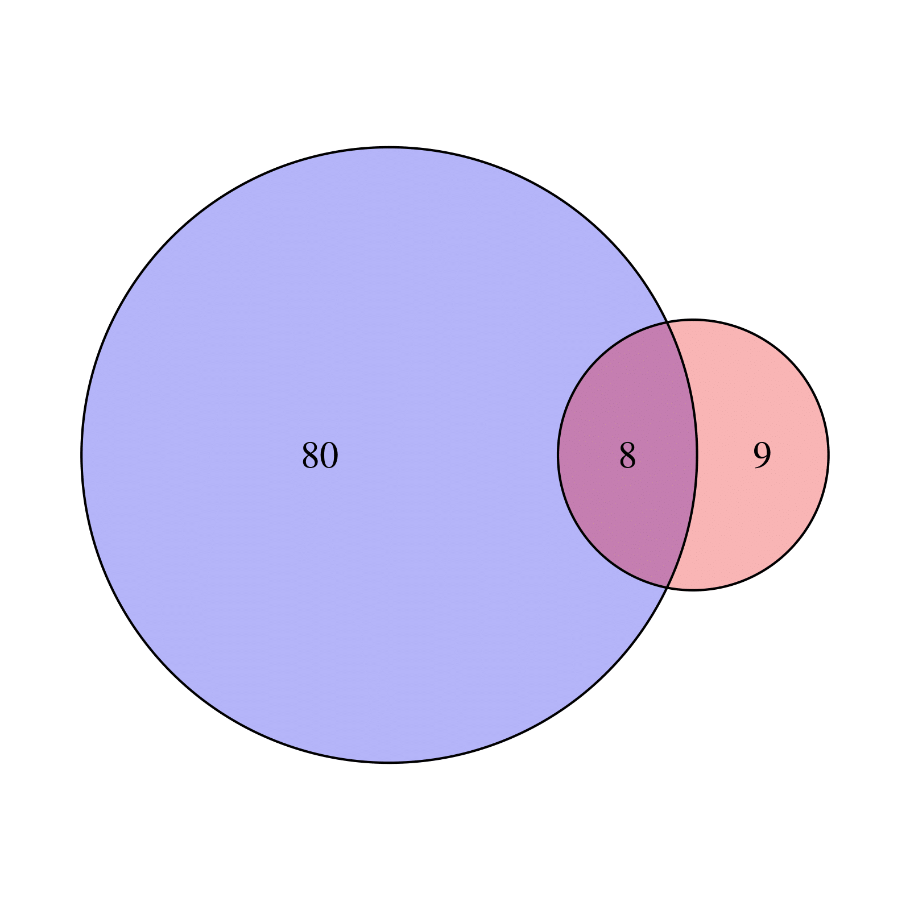
Venn diagram represents the intersection of the ncRNAs shared between cell lines in control fibroblasts or IPF fibroblasts.

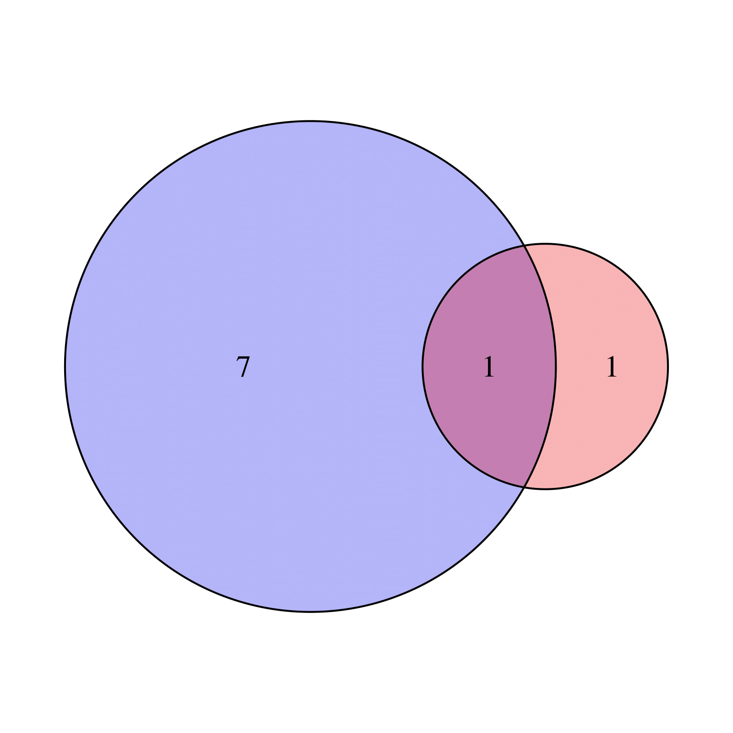
Venn diagram represents the intersection of the miRNAs shared between cell lines in control fibroblasts or IPF fibroblasts.

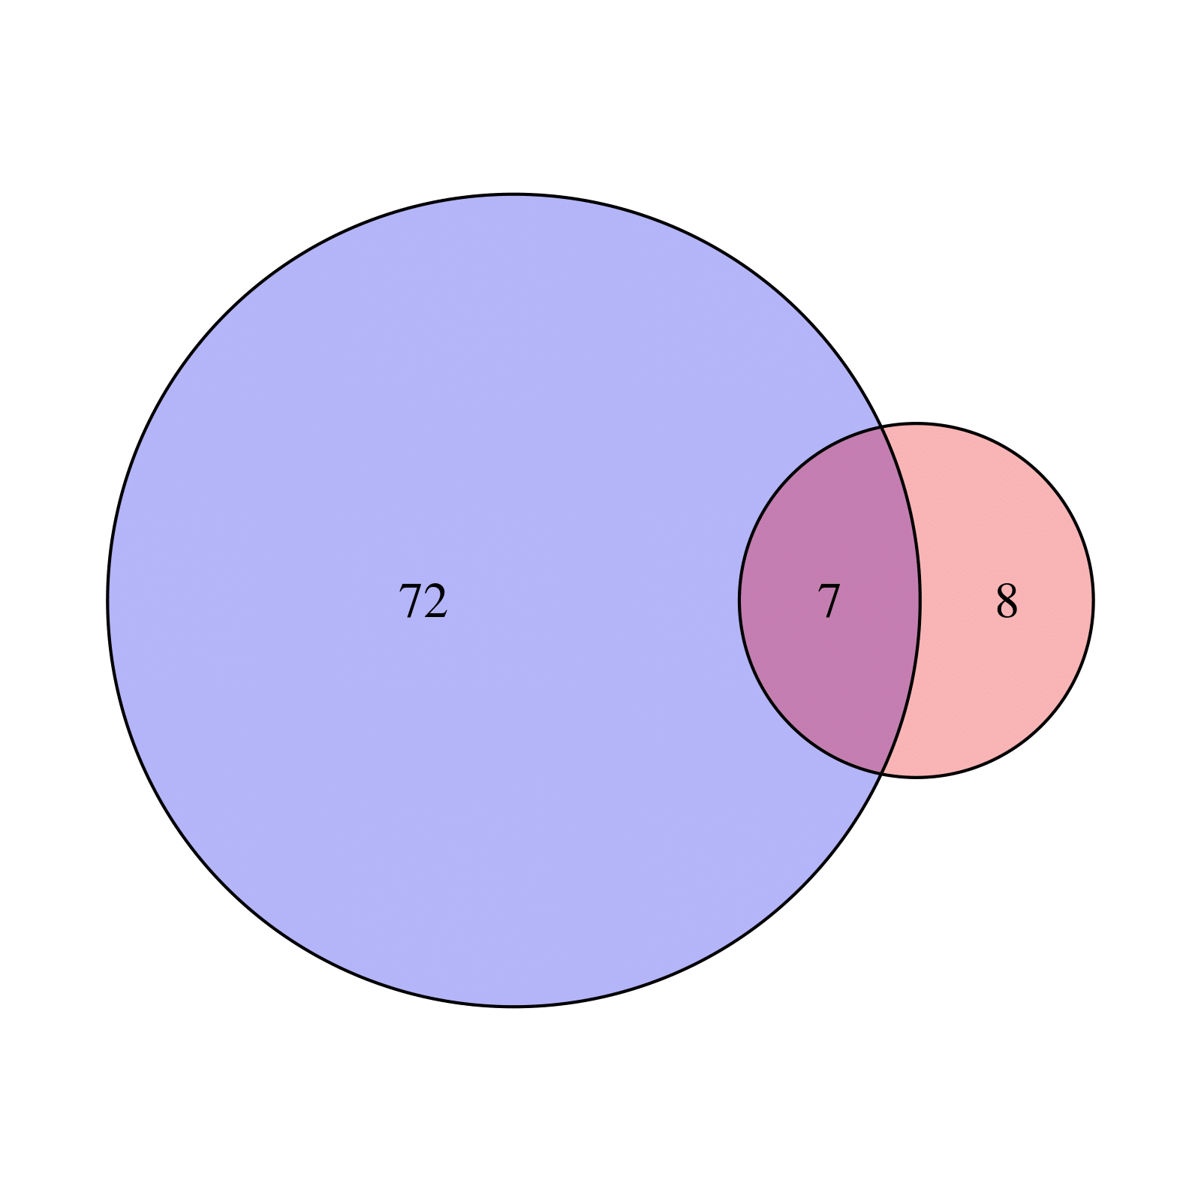
Venn diagram represents the intersection of the lncRNAs shared between cell lines in control fibroblasts or IPF fibroblasts.

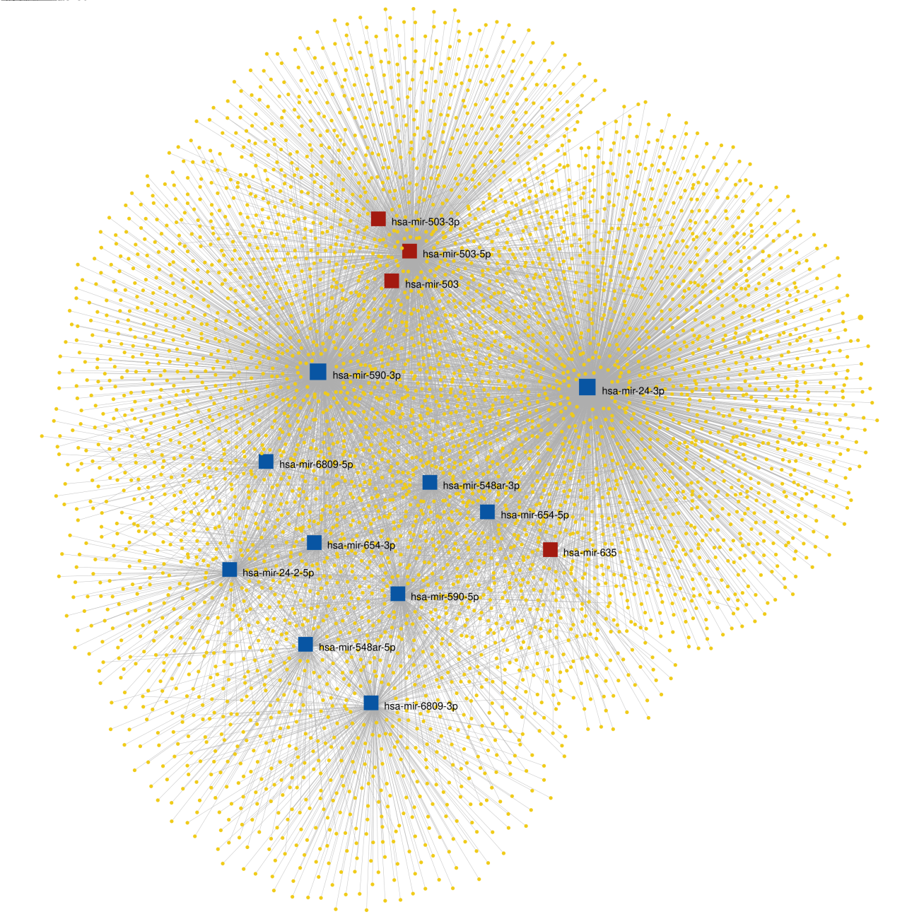
Control fibroblast; the relationships of 14 miRNAs to their 8,051 predicted target genes.
The network shows in yellow the target gene that miRNet associates with the miRNAs, four miRNAs that are Up-regulated are shown in red and ten miRNAs that are Down-regulated are shown in blue.

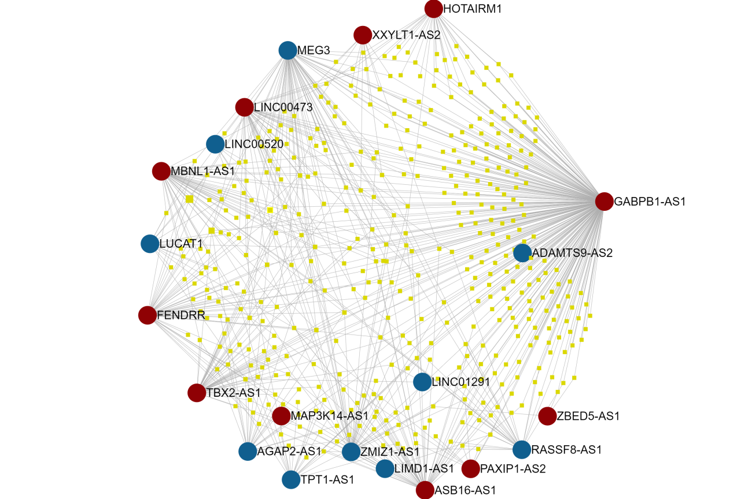
Control fibroblast in hypoxia; The relationships of 21 lncRNAs to their 860 predicted target miRNAs.
The network shows in yellow the miRNAs that miRNet associates with the lncRNAs, eleven miRNAs that are Up-regulated are shown in red and ten miRNAs that are Down-regulated are shown in blue.
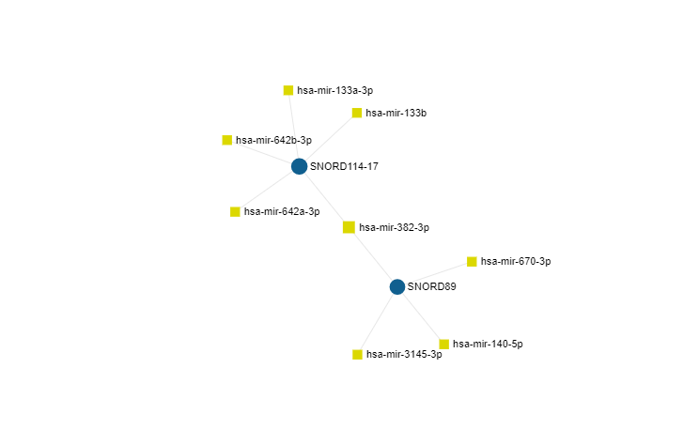
Control fibroblast in hypoxia; The relationships of 3 Small Nucleolar RNA to their 8 predicted target miRNAs.

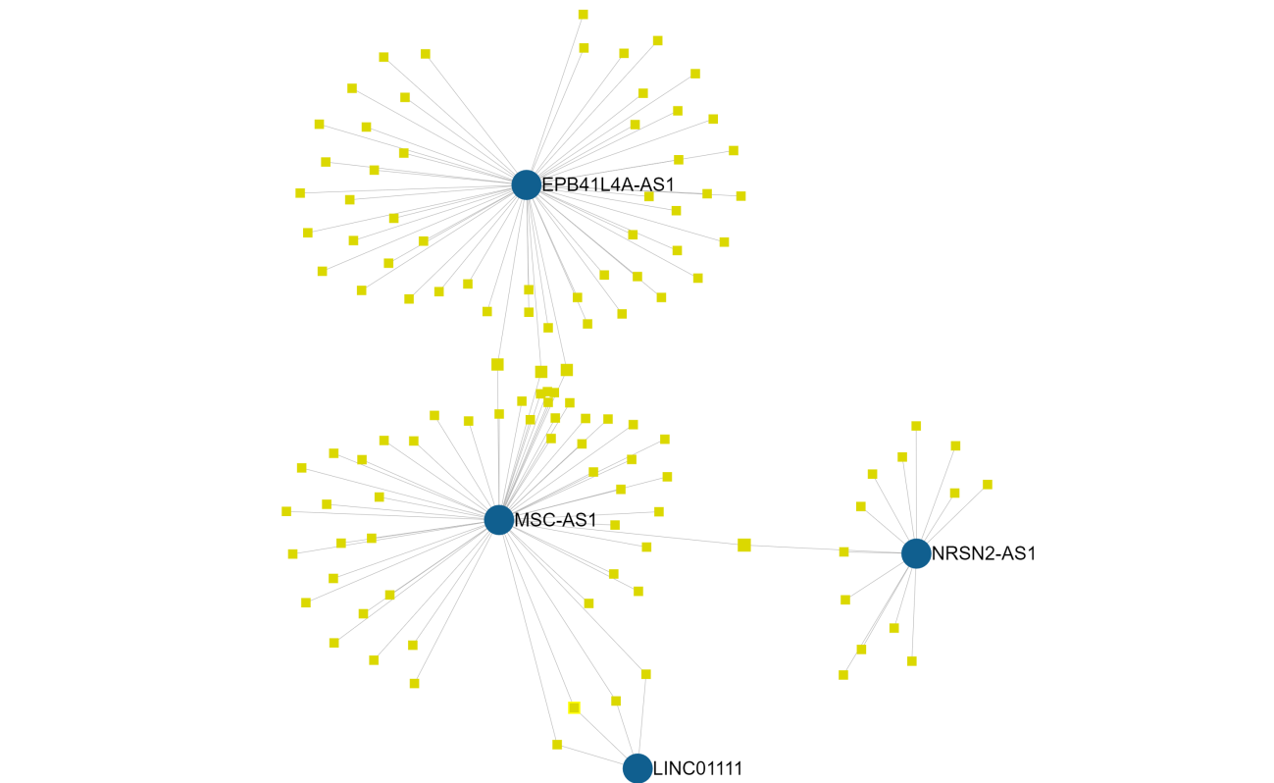
IPF fibroblast in hypoxia; The relationships of 4 lncRNAs to their 137 predicted target miRNAs.
The network shows in yellow the miRNAs that miRNet associates with the lncRNAs, all lncRNAs are Down-regulated and shown in blue.

