Introduction of Risk Management
Today, societies have technological devices, internet access rates and internet access rates are increased. Much more data is circulating on the internet and the capacity of data storage media is increasing with the increase of the capacity of storing large data. We also analyze the data on which products we have received and the products we use. We also analyze the data in university risk management to find out which risks can occur in which department. Data are usually stored in databases that are related or unrelated to each other. This data needs to be analyzed by conscious experts. The large number of data makes it difficult to carry out general statistical analyzes on this data.
Discovery of İnformation in Databases
Problem İdentification:is to determine what to do for the application to be done clearly and clearly. In fact, the phase at which the hypothesis of our research is defined.our goal is to find out the impact of the risks in the categories and possibly the results and find the solution possibilities in this direction.
Data Preparation:
-Data Collection:the problem we want to solve, or the data needed for the hypothesis we want to test, and at the same time the database where these data are stored.we used the ybu-2018 and ybu-2017 evaluation documents to collect data.In addition, data were collected by taking various forms of information when evaluating risk.These are the variables in my datasets.
(subject,assessment,state,impact,likelihood,category)
-Assesment:there may be a discrepancy between data collected from different sources.
-Consolidation and Cleaning:this phase is resolved with a good and detailed observation. All the discrepancies are stored in a single database.In this process we have not found missing values in our analysis.
-Selection:the data that will be used for model training and the variables used in the model and model are selected at this stage.I used the algorithm k-mean algorithm I used in this project. K-means is the best suitable algorithm for risk management.
-Transformation:the values of the variables must be regulated in accordance with the algorithm to be applied according to the model to be used. Therefore, the variable values must be appropriate to the category.In our project we have converted nominal values of impact, likelihood and category variables to numerical values.

Clustering Analysis:
Clustering analysis is one of the methods frequently used by data miners. Clustering analysis is basically a clustering of observations with similar characteristics and it is aimed to classify the items that have no properties together with this. The similarity between the data is measured by measuring the distances of the data.
a-)Hierarchical Clustering:
Hierarchical algorithms can use pre-generated clusters to find clusters that need to be created at a later stage.we can give the nearest neighbors and the farthest neighbors as an example of hierarchical algorithms..

b-)Non-Hierarchical Clustering:
In a non-hierarchical algorithm, a set of clusters is specified. In non-hierarchical clustering applications, two methods are often applied. These methods are k-means and k-medoids algorithms.
K-means Algorithm:
The k-means algorithm was first introduced by MacQueen in 1967. According to the k-means algorithm, the given data is divided into k clusters given by the user according to the clustering environments.The structure of the k-means algorithm is as follows;
What must be entered by the user;
-Dataset
-Number of clusters

Algorihm;
-the specified number of clusters are arbitrarily generated and the centers of these clusters are determined. We can express the centers as m1, m2, .., mk.
-the data in the dataset are assigned mi to the closest set of datasets.
-the values m1, m2, ... mk of the clusters are recalculated.
-the above steps will continue until there are no changes in the clusters.

Result;
-the number of sets initially determined by the user

Rapidminer Application
Introducing Data Set
The data to be used in this analysis are derived from sources such as the ybu-2017 evaluation, the ybu-2018 assessment and the risk mapping assessment to generate data.the types, evaluations, situations, effects, likelihoods and categories of risks are given.In this project, the effects of the risks, the probabilities of the risks and the ratios of the risks in certain categories are used for these risk segments;

1-which parts are risky and risk-free
2-categories that need to be taken for risk, or categories that do not require prevention

Preparing the data for analysis
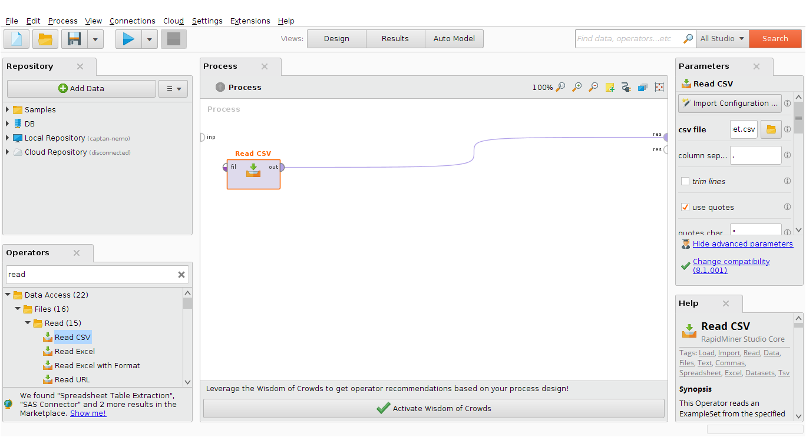
figure-1

Each rectangle added to the process is called the operator in RapidMiner. The small semicircles at the edges of the operators and the process window are called the stream port.
When the "read csv" operator is selected, the "Import Configuration Wizard" specifies the location of the csv file to be loaded.figure-1 to see this situation.Also when we look at the statistical results we can see that there is no missing value value in ours is a very good thing.Rapid Miner result screen image contains 106 examples,0 special attributes and 6 regular attribute)
figure-2
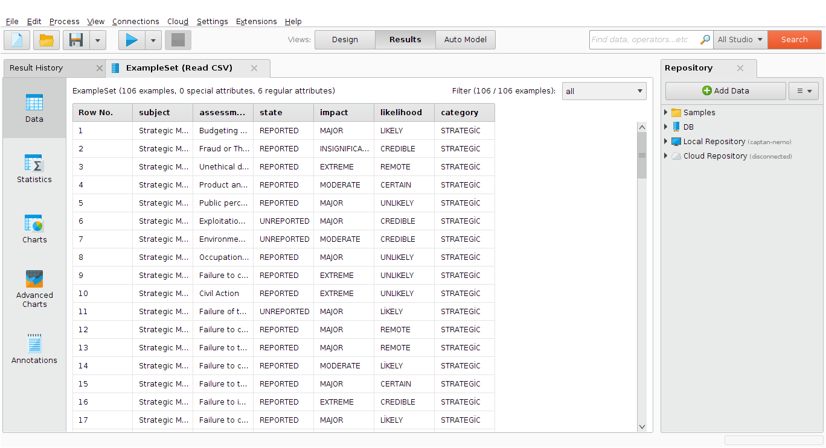
figure-2 Rapid miner result screen image
figure-3
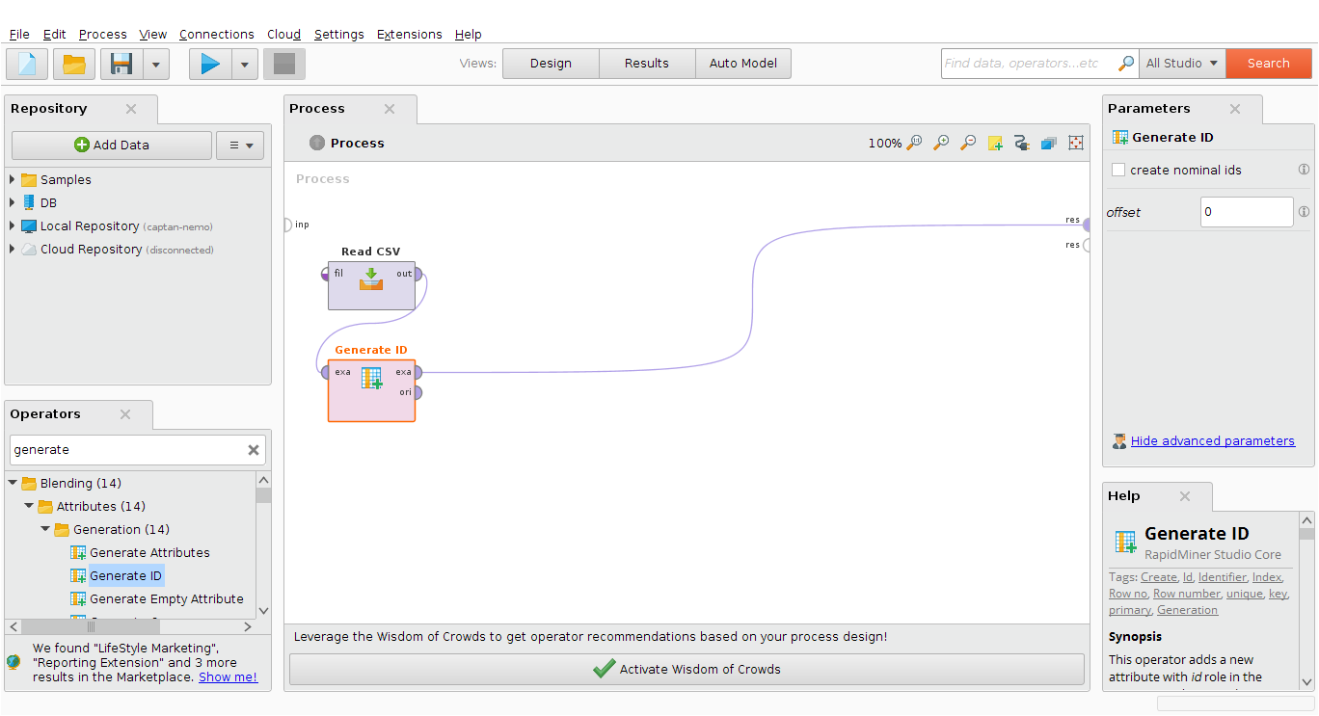
figure-3 Rapid Miner Generate ID
Generate-ID:Adds a new id attribute to the example set,each example is tagged with a random double number
figure-4
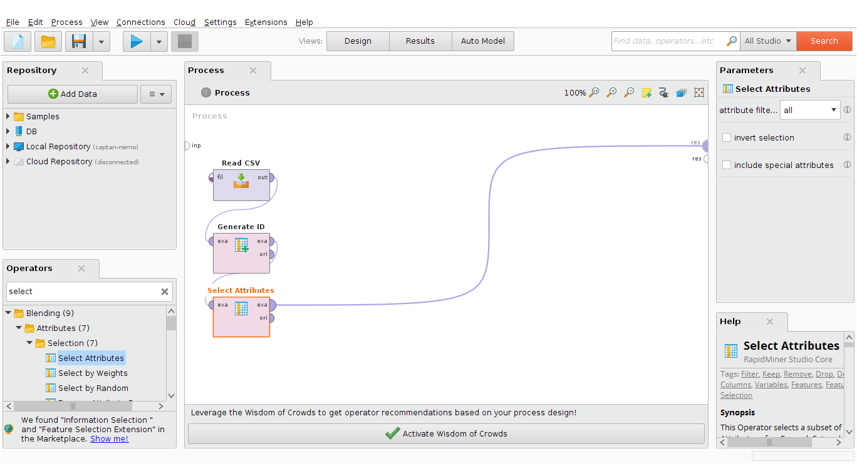
figure-4 Rapid Miner Select Attributes
Select Attributes:This operator allows to select which attributes should be part of the resulting table.İn this operator our goal is to remove the variables we do not need.(assesment, subject, status).when we click through the subset we perform these actions.
You can see result select attributes in the figure-5

Figure-5
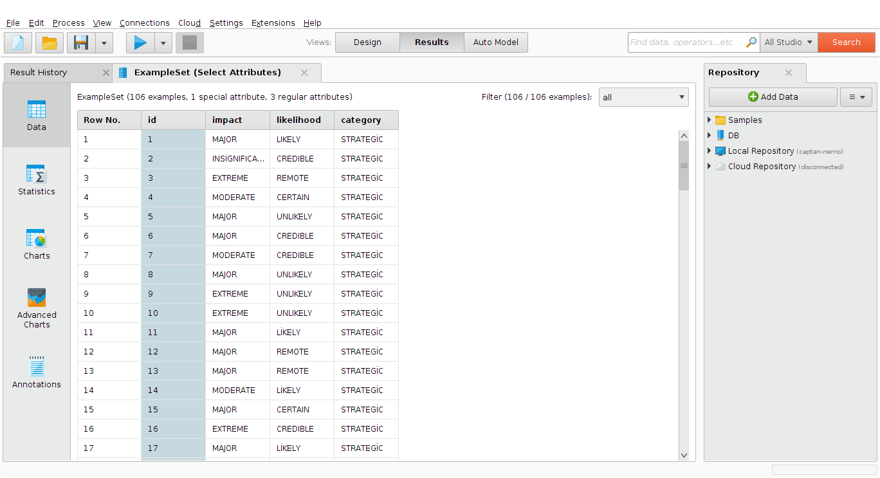
figure-5 Rapid Miner Select Attributes resulting

figure-6
Nominal to Numerical:Converts a nominal table attribute and its values to numerical
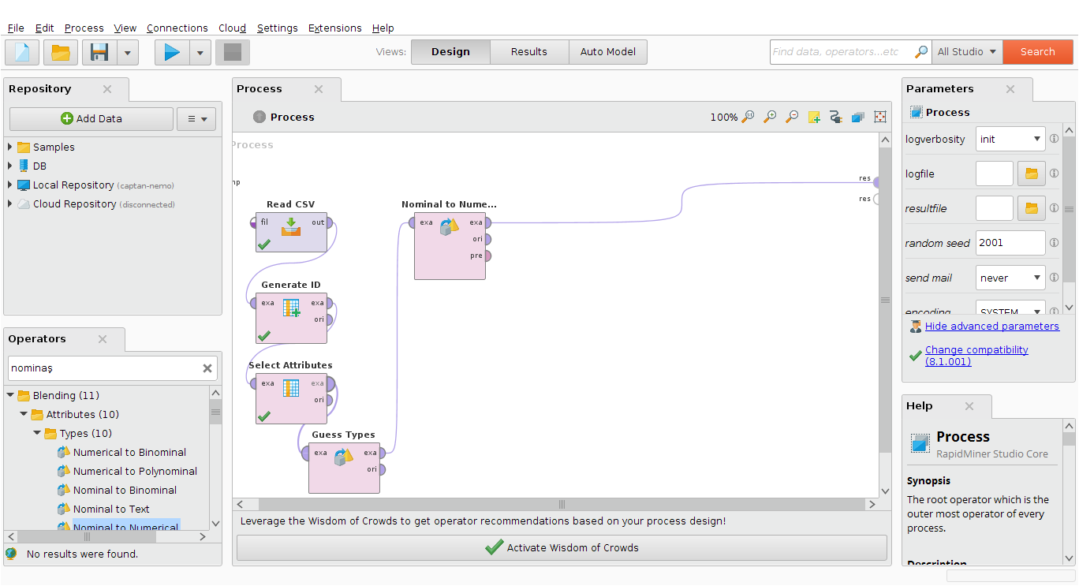
figure-6 Rapid Miner Nominal to Numerical

in this operator, converting the nominal values found in the data conversion process to numerical values.because we will use it for the k-mean algorithm ... the computational value of the k-means algorithm is calculated with numerical values.This values can be such as binary(0 or 1)
figure-7 you can see nomimal to numerical values result in the process

figure-7
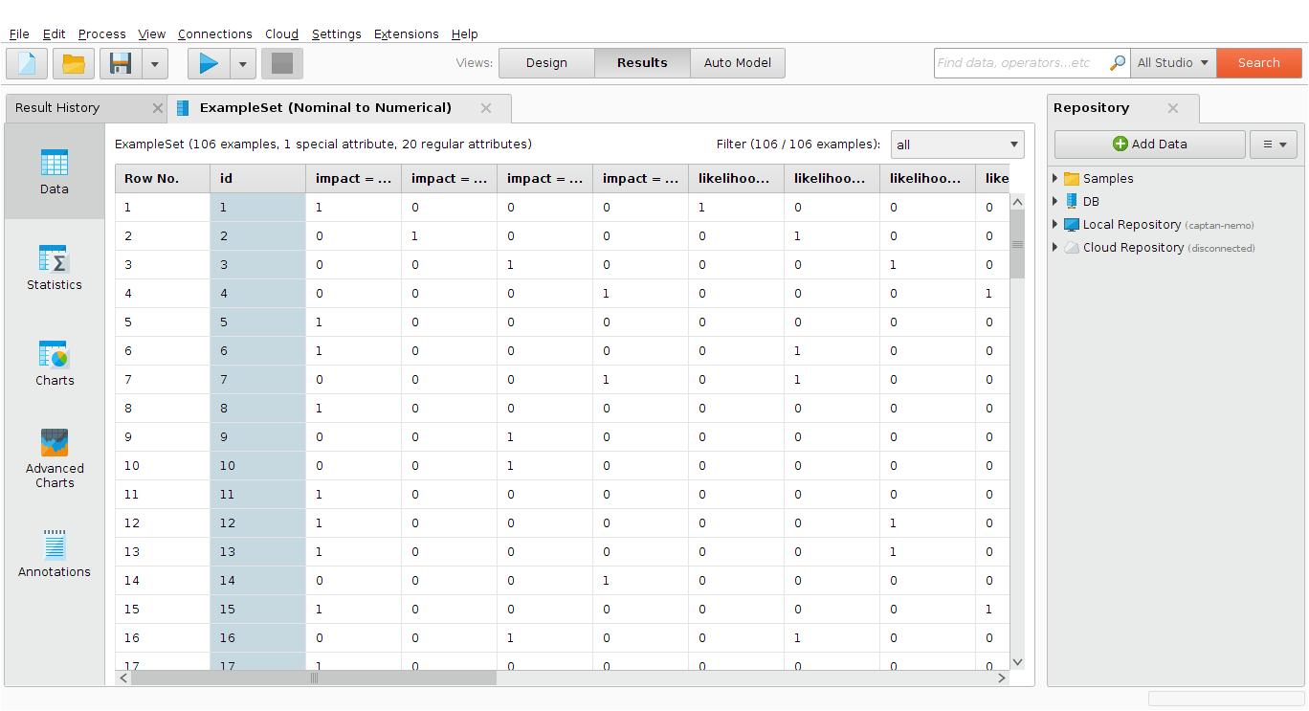
figure-7 Rapid Miner Nominal to Numerical results.

Analysis of Data
after completing the procedures related to preparation of data in the previous section, modeling will be continued and analysis will be carried out in this section and the results will be interpreted in the next section.We can continue our analysis process by including the k-means operator in our process.In the k-Means operator, the parameter k must be determined first.Represents the number of clusters k wants to see.We think we will get better results if we increase the number of k. We also divide k by 4 divisions (high riskly, low riskly, high risk-free, and low risk-free categories).

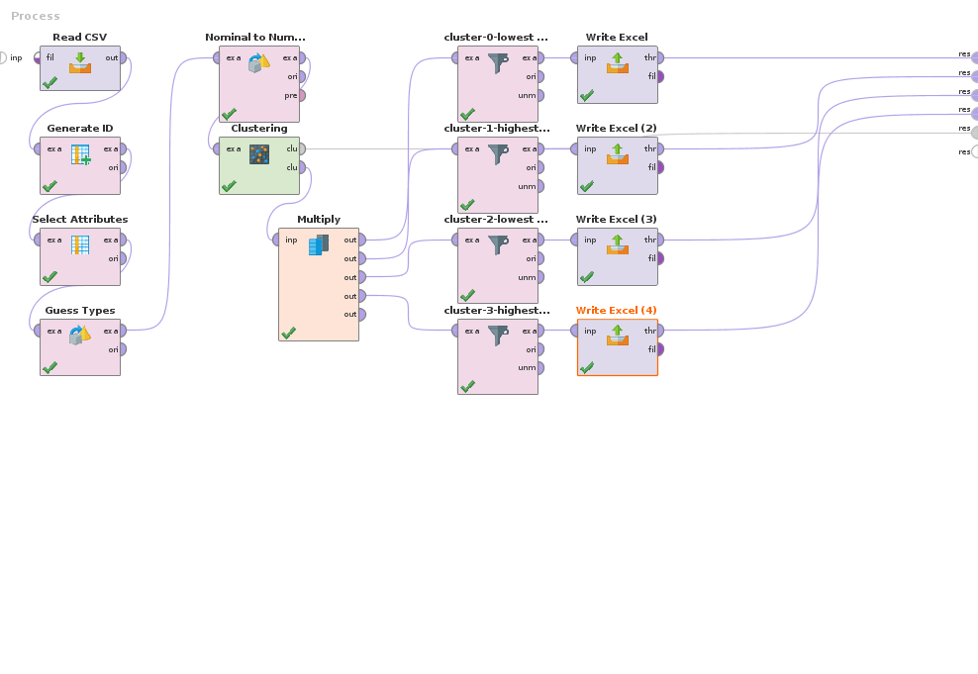
Figure-8-K-means proces
When we set the value of k and set it to 4, we will meet with the following results. In the result window, there is 37 in the first cluster,28 in the second cluster,30 in the third cluster,14 in the forth cluster.The numbering of the clusters starts from 0.

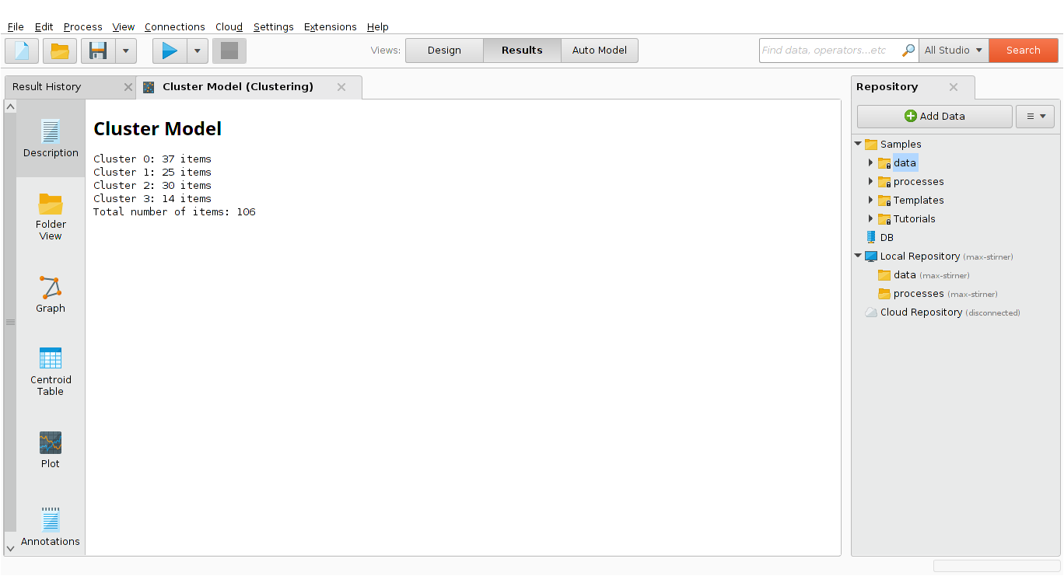
figure-9 Cluster Model results

The graphical representation of the clusters can be reached by pressing the plot tab. The graphical representation will increase the visibility of the distribution of clusters and items.As stated at the beginning of the cluster analysis section, aims to identify risky and risk-free zones for risk management, or in other words areas where measures need to be taken or prevention is not required.we have determined the number of units to perform this operation.

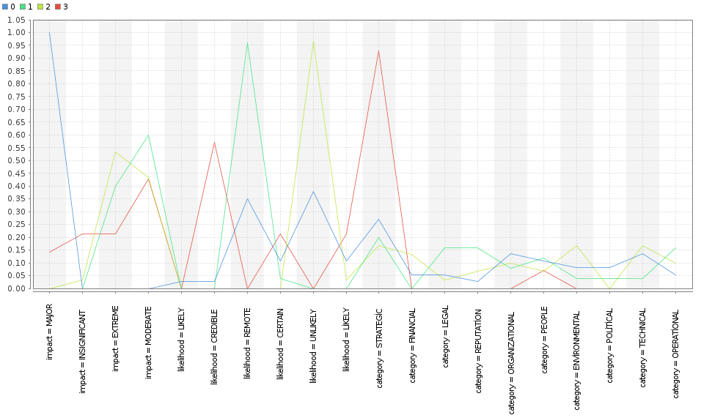
Figure-10 result screen Plot screen

we will see the average of each cluster in the view we will get by pressing the centroid table button.When we look at these results, the most risky region appears in cluster-3.When we look at these results, the risk-free zone appears in cluster-2 at most.If we look at the major part of the impact variable, we can see that cluster-3 has a value of 0.143. cluster 1 and cluster-2 values ​​0 on the other side to give information about the risk-free zone.If we look at the credible section of the likelihood variable, we can see that cluster-3 has a value of 0.571. the other side shows that the credible is low by taking the values ​​of cluster 1 and cluster-2 0.Therefore, the third category is identified as the most risky and risk-taking territory in terms of risk management.so we can focus on the elements of this clusters after the cluster is determined to be the actual cluster.

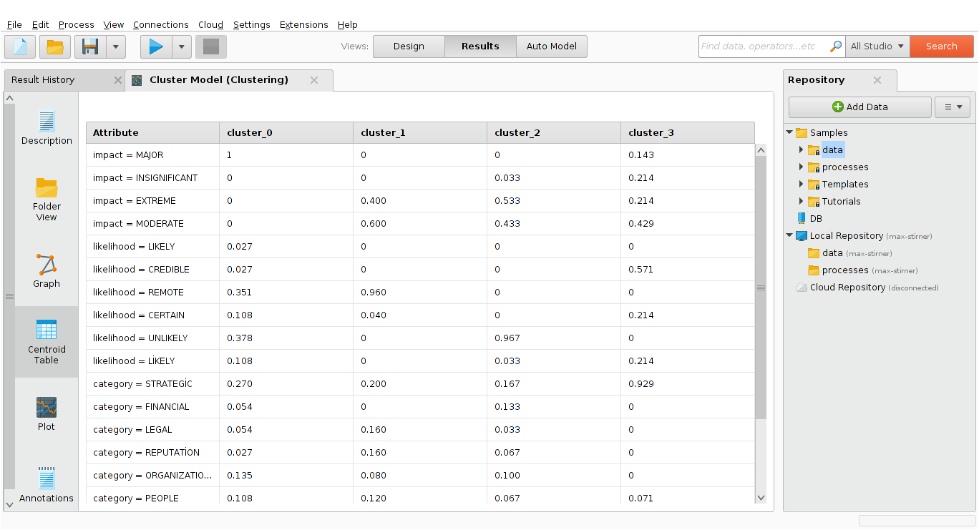
Figure-11 result screen Centroid Table

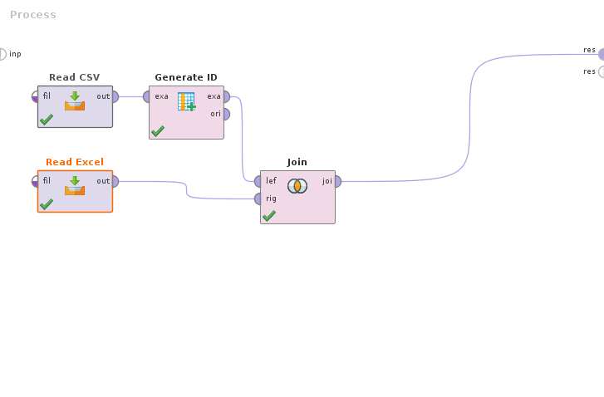
Figure-12 Join-Data Filtering
İnterpretation of clustering analysis results

We have added the generate id parameter to get a more accurate output of the data contained in cluster-3, so that we can create a regular data set between our raw data and output data as a result of the common values for the join operator.We can get even better results by doing sql queries.
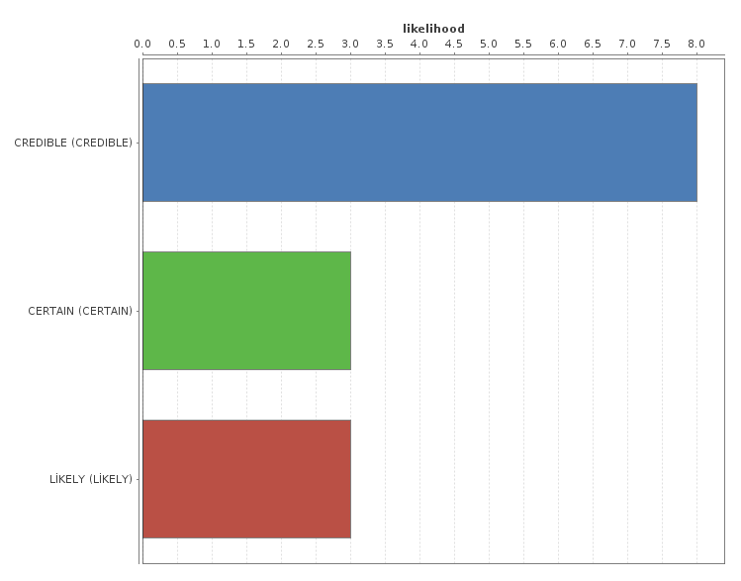

Figure-13-Likelihood
When we examine the likelihood variable for cluster-3.We can see that credible has a value between 7.5 and 8.0.Certain and likely same values ​​were taken as 3.0 values.

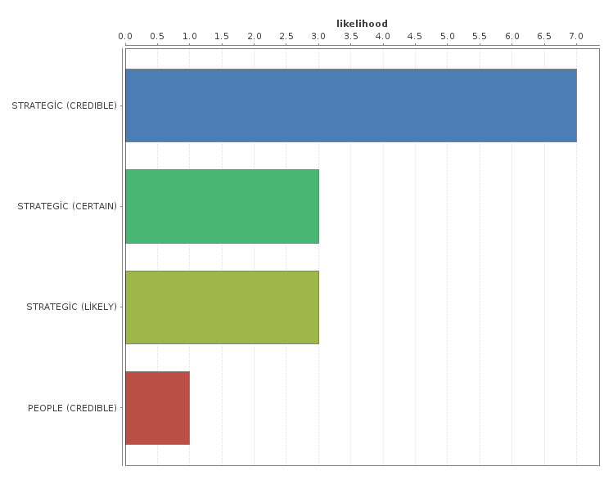
Figure-14-Likelihood-category
When we look at the relation between likelihood and category, we can see that the strategic category has the highest value.Having a value of 6.5 and 7.0.we think that the most serious place for us is to take serious measures for this strategic category.if we solve these risk categories, we are thinking better

