Designing an Intelligent Crisis-Management and Optimal Repair-Crew Dispatch System for Power Distribution Networks
A Dual Machine-Learning Approach: Optimal Team Selection and Repair-Time Estimation
Course: Machine Learning | Instructor: Dr. Bahrami | Authors: Yalda Farshi Aali

Abstract
Repair-crew dispatch in electrical power distribution networks is conventionally performed manually, relying on operator judgement, coarse geographic proximity, and superficial crew availability rather than a systematic, data-driven analysis. This study proposes a two-model machine-learning framework that reformulates dispatch as a pair of supervised-learning problems: a multi-class classification task that identifies the optimal repair team among five candidates, and a regression task that estimates the resulting total repair time. In the absence of confidential real-world utility data, a physics- and rule-based synthetic dataset of 1,997 labeled incidents, described by 52 engineered features, was constructed. Random Forest (Breiman, 2001) and XGBoost (Chen & Guestrin, 2016) were trained and compared for both tasks. The classifier achieved 93% accuracy with XGBoost, while for the regressor, XGBoost's apparently superior training-set R² of 0.909 was found to collapse to 0.534 on held-out test data, revealing severe overfitting; Random Forest, with a stable R² of approximately 0.865 on both partitions, was therefore selected as the final regression model. The results demonstrate both the practical feasibility of data-driven crew dispatch and the necessity of rigorous train/test validation when comparing tree-ensemble methods of differing complexity.
Keywords: repair-crew dispatch, power distribution networks, Random Forest, XGBoost, overfitting, feature engineering, SMOTE, synthetic dataset

1. Introduction
When a fault occurs in an electrical power distribution network, the speed and adequacy of the repair response directly determine the duration for which affected customers remain without power. In most dispatching centers today, this decision — which crew to send, and how long the repair is likely to take — is still made manually by an operator relying on personal experience, approximate geographic proximity, and an informal impression of crew availability. The present study investigates whether this improvised process can be replaced by a reproducible, data-driven one, through two complementary machine-learning models: a classifier that recommends the optimal repair team for an incoming fault, and a regressor that estimates the resulting repair duration. Together, the two models constitute the analytical core of an intelligent crisis-dispatch system.

2. Problem Definition
The prevailing workflow for handling a distribution-network fault consists of three steps: a fault is reported, a human operator decides which crew to dispatch, and the selected crew proceeds to the field. This decision is typically driven by the operator's personal experience, by simple geographic distance without regard to traffic or road conditions, and by the apparent availability of a crew without regard to skill match or current workload. The consequences of this ad-hoc process are concrete: delayed arrival when a distant or traffic-bound crew is chosen; mismatched dispatch when the assigned crew lacks the specialty required for the fault type; extended outage duration for affected customers; and elevated operating cost arising from re-dispatch and overtime. Accordingly, this study frames dispatch as two coupled prediction problems: a five-class classification problem (identifying which of five candidate repair teams is optimal) and a continuous regression problem (estimating, in minutes, the total time — travel plus repair — that the dispatched team will require).

3. Related Work
Repair-crew routing after distribution-network faults or storm damage has been approached from several methodological directions in the power-systems literature. Optimization-based formulations treat crew dispatch as a mixed-integer program that jointly schedules repairs, network reconfiguration, and distributed-generation dispatch to minimize restoration time. More recent contributions frame the problem as sequential decision-making under uncertainty: Wang, Wang, and Chen (2022) model post-storm utility-vehicle routing as a stochastic optimization problem solved with Monte Carlo tree search and deep neural networks, while Amani, Ardali, and Kargarian (2025) propose a transformer-based deep-reinforcement-learning framework for near-real-time crew dispatch following earthquake damage. On the predictive side, closer to the approach adopted here, Ghasemkhani et al. (2024) apply decision trees, random forests, k-nearest neighbours, and XGBoost directly to historical outage records from a Turkish electric utility to forecast outage duration, reporting XGBoost as the strongest performer. The present study is positioned at the intersection of these two directions: rather than optimizing a dispatch policy directly, or forecasting duration from historical utility logs, it learns — from a physics- and business-rule-based simulator — the same two quantities a real dispatcher requires (optimal crew, repair time), using the tree-ensemble families, Random Forest (Breiman, 2001) and XGBoost (Chen & Guestrin, 2016), that recur throughout this body of work.

4. Data: Construction of a Realistic Simulated Dataset
No real, labeled operational data from a power distribution company was available for this study, as such records are confidential. Since supervised learning requires labeled data pairing each fault with the correct team and the true repair time, a rule-based simulator was implemented in place of a purely random data generator. Each simulated incident follows explicit physical and operational logic rather than chance: the geographic distance between the fault location and each of five team depots, hypothetically positioned across different districts of Tehran, is computed with the Haversine great-circle formula; ambient weather (temperature and humidity) is generated as a function of season and time of day with sinusoidal daily variation plus additive noise; each team is assigned a skill matrix with one primary specialty and one or two secondary specialties across five fault types; and each team's instantaneous workload (an integer from 0 to 5) determines availability, with a workload above three rendering the team unavailable. Total repair time is modeled as the sum of a travel component (a function of distance and speed, degraded under rain, storms, or poor road quality) and a repair component (a function of fault type, equipment age, team skill, and weather). The simulator generated 2,000 incidents; three were discarded because no team was available for the incident, leaving 1,997 labeled samples spanning five teams and five fault types, described by 52 engineered features.

4.1 Construction of the Optimal-Selection Label
The central design element of the simulation is the rule defining which team is optimal for a given incident. For every incident, each of the five candidate teams is assigned a cost score, with a lower score indicating a more suitable choice; the score combines travel distance, a skill-inefficiency penalty, a weather penalty, and a workload penalty (Equation 9, below). In 90% of incidents, the team with the lowest score is selected, representing an optimal decision; in the remaining 10%, a random available team is chosen instead, deliberately emulating the inconsistent choices a human dispatcher occasionally makes. The identity of the selected team constitutes the classification target (target_team_id), and its total time constitutes the regression target (target_total_time). Both supervised models are subsequently required to recover this hidden selection logic solely from the observable features, without access to the scoring formula itself.

4.2 Formulas Implemented in the Data-Generation Pipeline
The following nine equations, transcribed directly from the data-generation code, define the physical and business-rule logic underlying every simulated incident, in the order in which they are applied.
Box 1 — Data-Generation Formulas (Equations 1–9)
(1) Haversine great-circle distance between fault and team depot
a = sin²(Δφ/2) + cos(φ₁)·cos(φ₂)·sin²(Δλ/2)
d_km = 2R·arcsin(√a), R = 6371 km
(2) Cyclical encoding of hour and day-of-year
hour_sin = sin(2π·h/24), hour_cos = cos(2π·h/24)
day_sin = sin(2π·d/365), day_cos = cos(2π·d/365)
(3) Dynamic weather generation (temperature, humidity)
T = T_base(season) + 8·cos((h−14)·2π/24) + N(0, 3)
H = clip( H_base(season) − 5·cos((h−4)·2π/24) + N(0, 8), 10, 95 )
(4) Travel time
v = 35 · f_road · f_weather (km/h)
f_road = 0.7 if road_quality ≤ 2, else 1
f_weather = 0.5 (storm), 0.8 (rain), 1.0 (otherwise)
t_travel = (d_km / v) · 60 (minutes)
(5) Estimated repair time (before noise)
t_repair,est = t_base(fault) · (1 + 0.015·age) · (1 + ineff(skill)) · w(weather) · h(humidity)
ineff(skill) = 0.40 / 0.15 / 0.05 for skill = 0 / 1 / 2
w(weather) = 1.8 / 1.3 / 1.2 / 1.0 for storm / fog / rain / good
h(humidity) = 1.1 if humidity > 80, else 1.0
(6) Human/operational noise injection
t_repair = max( 5, t_repair,est · U(0.8, 1.4) )
(7) Engineered risk features
thermal_age_interaction = T · age
equipment_risk_index = (age/25) · (T/40) · (load_kW/1000)
(8) Composite crisis score
crisis_score = 2·complexity(fault) + 1.5·severity(weather) + traffic_level/2
(9) Team dispatch cost score (defines the ground-truth label)
score = 2·d_km + ineff_cost(skill) + penalty(weather) + 5·workload
ineff_cost(skill) = 30 / 15 / 5 for skill = 0 / 1 / 2
penalty(weather) = 50 / 20 / 10 / 0 for storm / fog / rain / good

5. Feature Engineering
Fifty-two features feed both models, grouped into four families: spatial and temporal (fault coordinates; hour and day encoded cyclically via Equation 2, so that, for instance, 23:00 and 00:00 are recognized as adjacent; season and day-of-week one-hot encoded); environmental and network (temperature, humidity, load in kW, voltage drop, traffic level, road quality, weather condition); fault and equipment (fault type one-hot encoded across five classes, equipment age, and the engineered risk indices of Equations 7–8); and per-team features (distance, skill level for the specific fault type, current workload, and historical success rate for each of the five candidate teams).
Categorical variables without a natural order — season, weather condition, and fault type — were one-hot encoded rather than label-encoded, specifically to avoid implying a spurious ranking (e.g., that "winter" is numerically greater than "spring"); genuinely ordered variables, such as traffic level and road quality, were ordinal-encoded instead.

6. Preprocessing Pipeline
Prior to training, the data were passed through a six-stage pipeline: (i) cleaning, in which infinite values were converted to missing and imputed with the median for numeric features and the mode for categorical features; (ii) encoding, comprising one-hot encoding for nominal variables and ordinal (label) encoding for genuinely ordered variables; (iii) scaling, in which StandardScaler was applied to numeric features (Equation 11); (iv) target transformation, in which a log1p transform was applied to the right-skewed repair-time target and inverted with expm1 at evaluation time (Equation 10), since most repairs are short but a long tail of incidents takes substantially longer; (v) class balancing, combining the Synthetic Minority Over-sampling Technique, SMOTE (Chawla et al., 2002), with class_weight='balanced' in Random Forest, since Team 4 occurred considerably more often than the other teams in the classification target; and (vi) an 80/20 stratified train–test split, with all preprocessing parameters fit exclusively on the training partition to prevent data leakage into the test set.
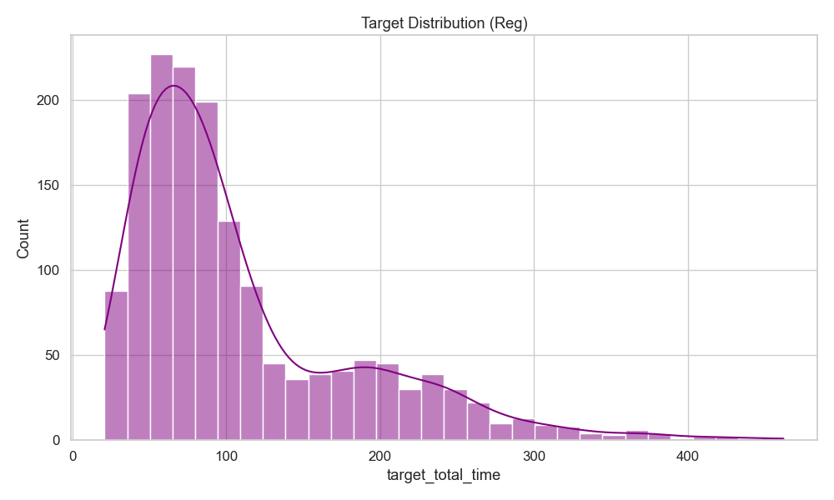
Figure 1. Distribution of the repair-time target (target_total_time) — the pronounced right skew and long tail motivate the log1p transform of Equation 10.
Box 2 — Preprocessing and Evaluation Formulas (Equations 10–13)
(10) Target log-transform and its inverse (applied to target_total_time)
y' = ln(1 + y) [log1p, training]
ŷ = exp(ŷ') − 1 [expm1, evaluation]
(11) Feature standardization (StandardScaler, fit on training data only)
z = (x − μ_train) / σ_train
(12) Regression evaluation metrics
RMSE = √( (1/n) · Σ (yᵢ − ŷᵢ)² )
MAE = (1/n) · Σ |yᵢ − ŷᵢ|
R² = 1 − [ Σ (yᵢ − ŷᵢ)² / Σ (yᵢ − ȳ)² ]
MAPE = (1/n) · Σ |yᵢ − ŷᵢ| / |yᵢ|
(13) XGBoost regularized learning objective (Chen & Guestrin, 2016)
Obj(θ) = Σᵢ l(yᵢ, ŷᵢ) + Σₖ Ω(fₖ)
Ω(f) = γ·T + ½λ·Σ w² + α·Σ |w|

7. Model Selection: Random Forest and XGBoost
Both target problems involve tabular data combining numeric and categorical features across approximately 2,000 samples — a regime in which tree-ensemble methods are widely reported to outperform linear models, support-vector machines, and even neural networks, while requiring no sensitivity to feature scaling, automatically capturing non-linear feature interactions, remaining robust to outliers and missing values, and still yielding interpretable feature-importance scores. Random Forest (Breiman, 2001) and XGBoost (Chen & Guestrin, 2016) were selected specifically to contrast the two dominant tree-ensemble strategies: bagging, in which many independent trees are grown in parallel on bootstrap samples and their outputs averaged (regression) or majority-voted (classification) to reduce variance; and gradient boosting, in which trees are grown sequentially, each correcting the residual error of the ensemble built so far — reducing bias, but, as governed by the regularized objective of Equation 13, more prone to overfitting when regularization and tree complexity are not carefully constrained.

7.1 Hyperparameters
The regressors used a Random Forest with 300 trees, a maximum depth of 20, and the square-root rule for feature subsampling at each split, against an XGBoost regressor with 500 trees, a deliberately shallow maximum depth of 4, a learning rate of 0.2, subsample = 0.8, and colsample = 0.9. The classifiers used a Random Forest with 200 trees, balanced class weights, and a minimum leaf size of 2, against an XGBoost classifier with 300 trees, a maximum depth of 4, a multi:softmax objective over five classes, and a learning rate of 0.1.

8. Results

8.1 Model 1 — Regressor: Repair-Time Prediction
On the evaluation reported at training time, XGBoost initially appeared to be the stronger regressor:
Metric | Random Forest | XGBoost
R² | 0.865 | 0.909
RMSE (min) | 32.5 | 26.7
MAE (min) | 20.2 | 17.2
MAPE | 15.7% | 13.9%

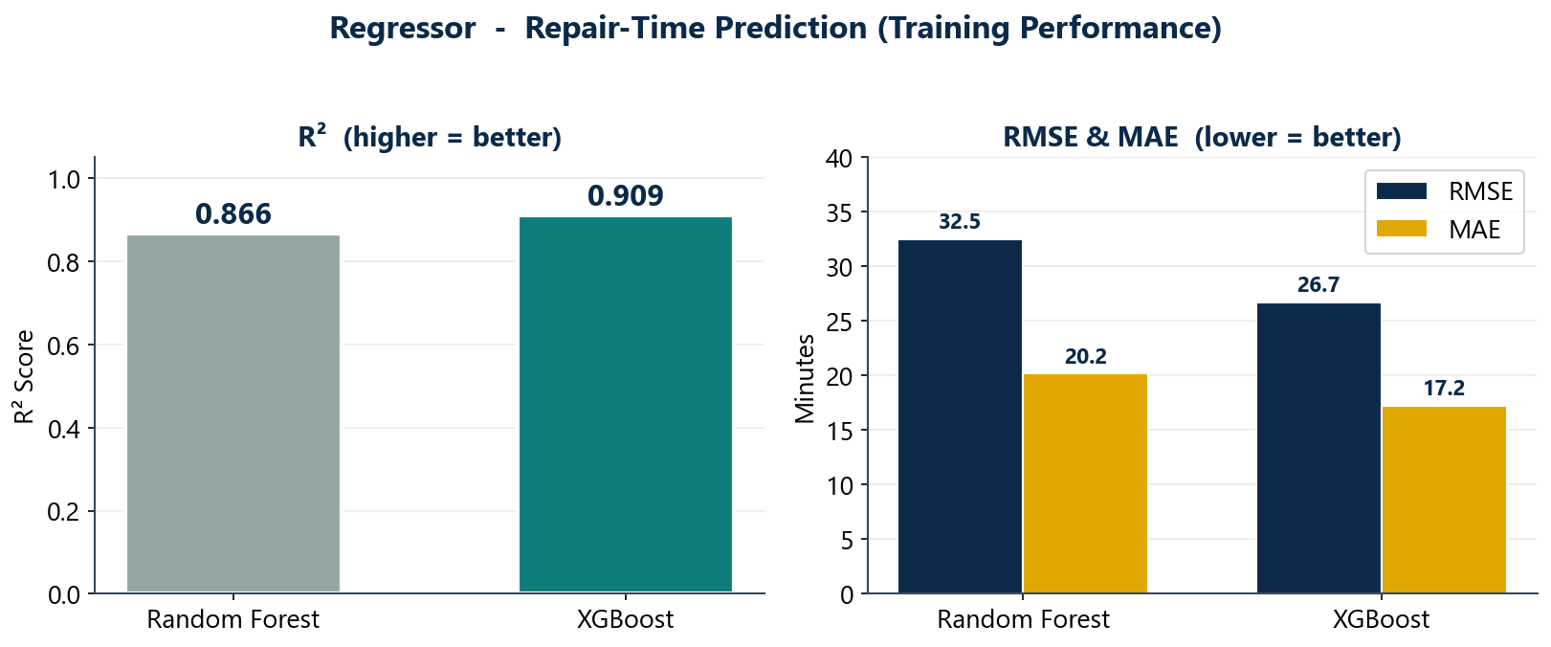
Figure 2. R², RMSE, and MAE comparison between Random Forest and XGBoost regressors (training-time evaluation).
However, an explicit comparison of training and test R² (Equation 12) revealed a critical discrepancy: Random Forest attained an almost identical R² of 0.865 on both partitions, whereas XGBoost's R² fell from 0.909 on training data to 0.534 on held-out test data. This is a textbook instance of overfitting: XGBoost had effectively memorized noise and idiosyncrasies of the roughly 1,600 training examples rather than the underlying pattern, a risk compounded by the dataset's intentional noise and modest size, and by the combination of 500 trees with a comparatively high learning rate of 0.2 — precisely the configuration Chen and Guestrin (2016) caution against absent sufficient regularization in Equation 13. Random Forest's averaging over many independent, decorrelated trees rendered it markedly more stable on unseen data. Consequently, Random Forest — not the model with the higher training-set R² — was adopted as the final repair-time regressor, on the principle that generalization to unseen data outweighs raw training performance. Plausible remedies for XGBoost's overfitting were also identified: shallower trees, fewer estimators, a lower learning rate, stronger regularization (γ, α, λ in Equation 13), early stopping on a validation set, and hyperparameter search via cross-validation.
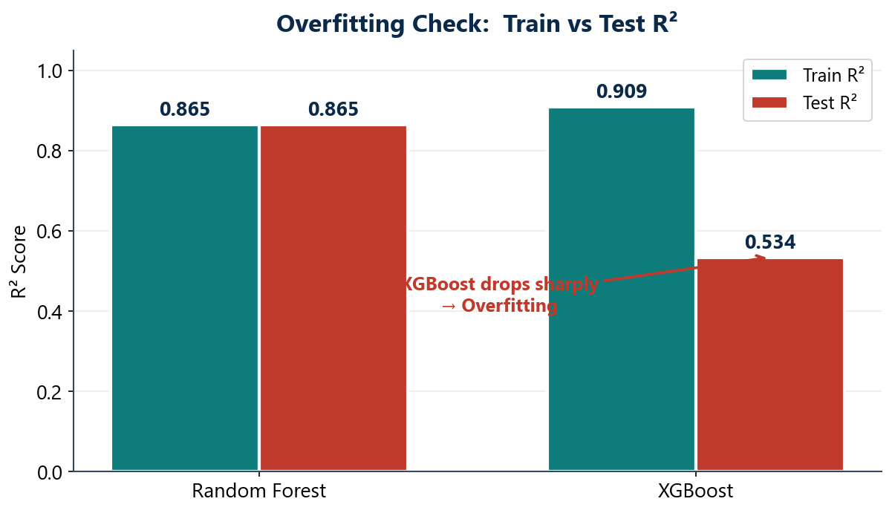
Figure 3. Train vs. test R² for both regressors — Random Forest remains stable (0.865 / 0.865) while XGBoost collapses (0.909 / 0.534).
For the final Random Forest regressor, the most influential features were fault type, followed by team skill level, the composite crisis score (Equation 8), and weather condition — consistent with the intuition that the nature and severity of the fault dominate repair duration more than which specific team responds.
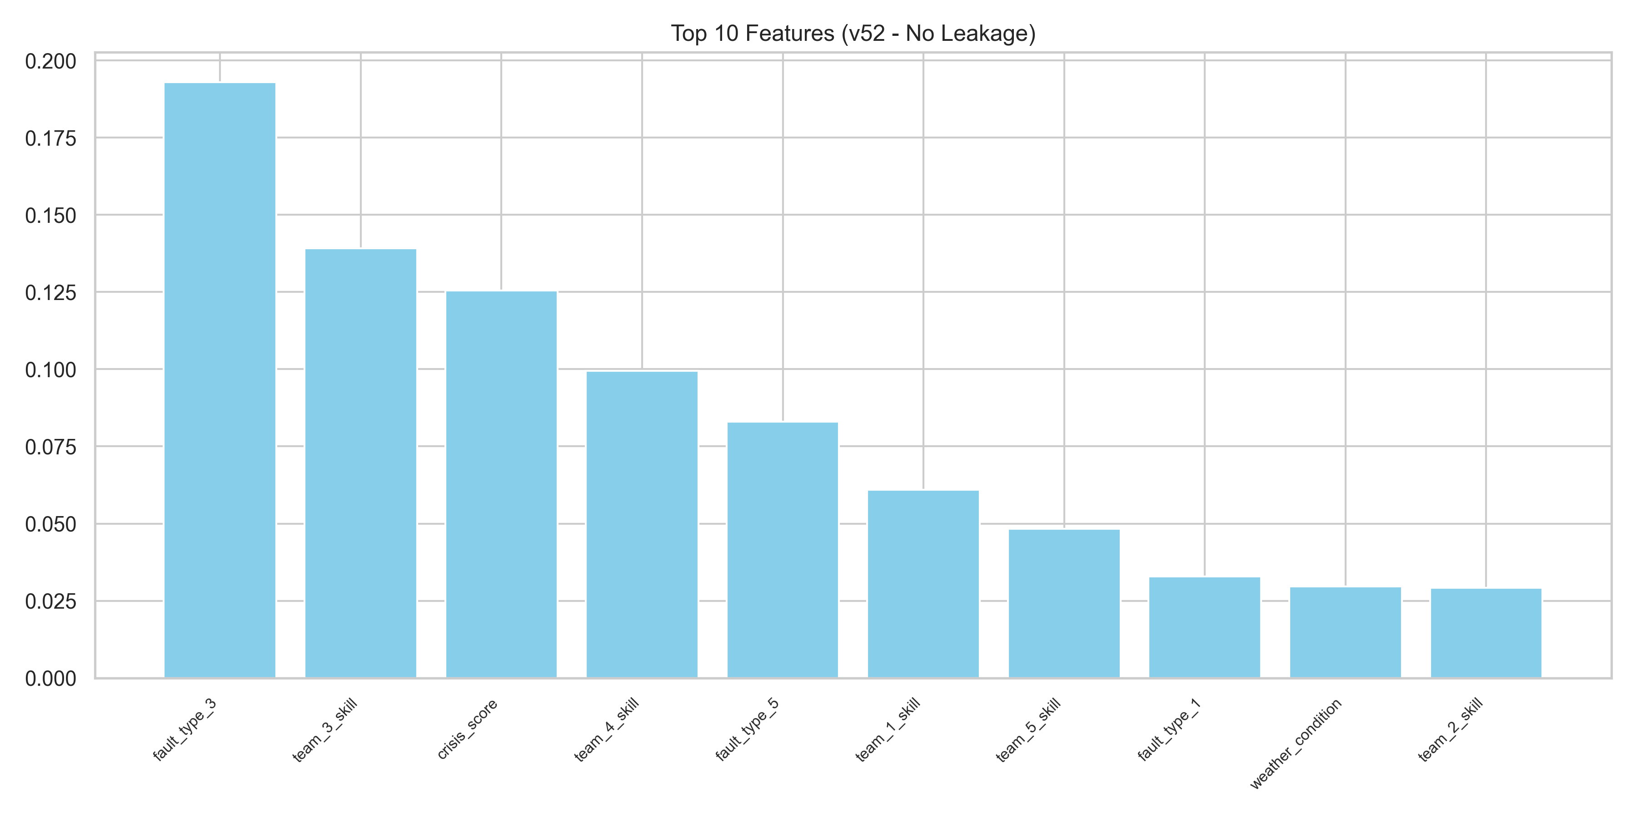
Figure 4. Top-10 feature importances, Random Forest regressor (no leakage).
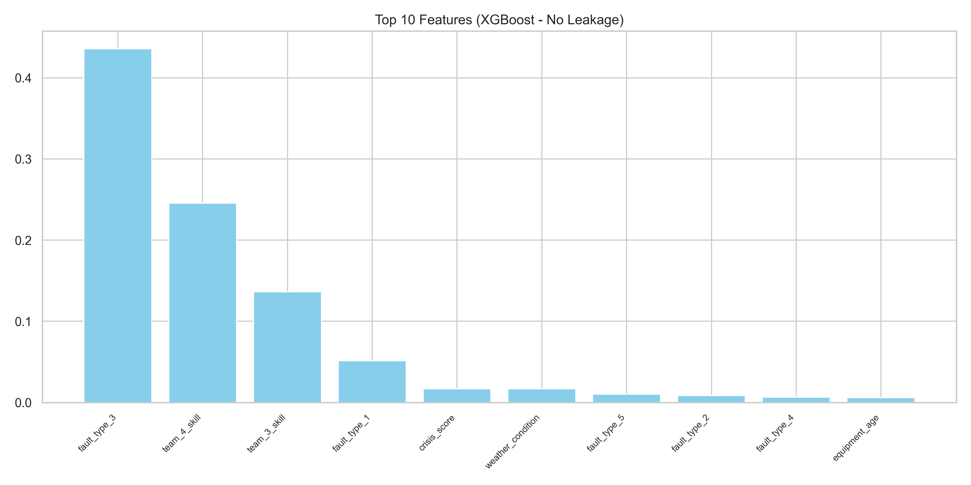
Figure 5. Top-10 feature importances, XGBoost regressor — note the concentration in just 3 features, a further symptom of overfitting.
The Random Forest regressor's fit on the held-out test set — shown below alongside its residual distribution — is the model ultimately adopted for repair-time estimation.
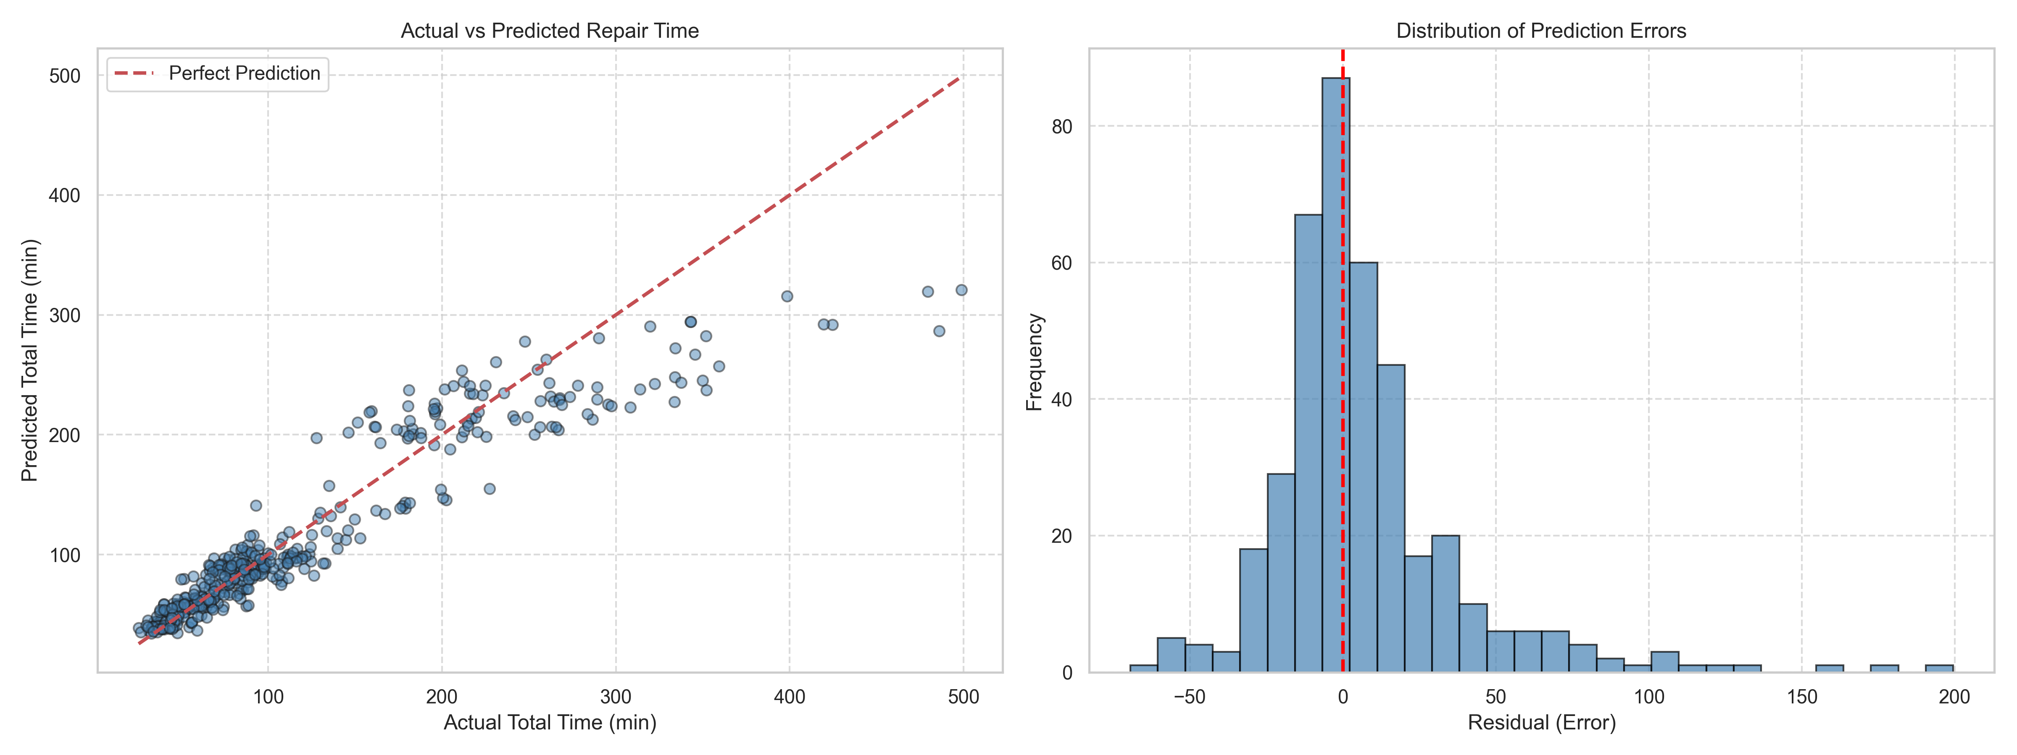
Figure 6. Actual vs. predicted repair time and residual distribution, final Random Forest regressor.
For comparison, the corresponding fit for the XGBoost regressor is shown below; while visually similar on this sample, its underlying test-set R² is substantially lower, as established in Figure 3.
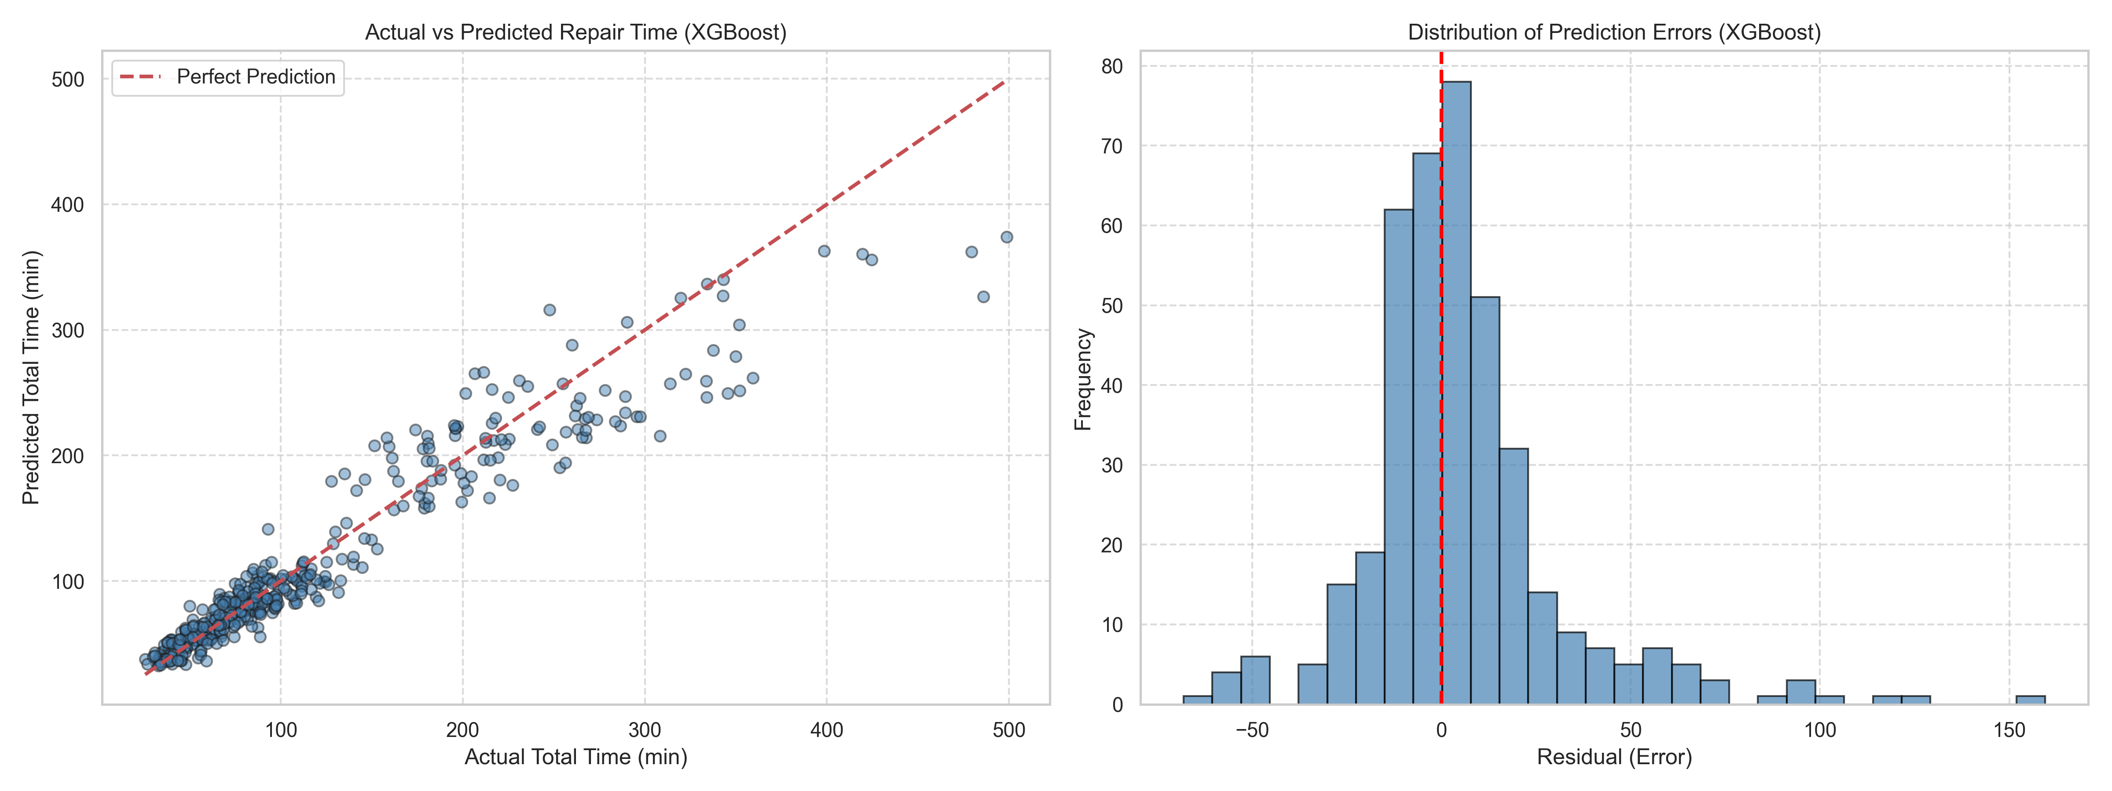
Figure 7. Actual vs. predicted repair time and residual distribution, XGBoost regressor.

8.2 Model 2 — Classifier: Optimal Team Selection
For the five-way team-selection problem, XGBoost was the clear winner and exhibited no comparable overfitting:
Metric | Random Forest | XGBoost
Accuracy | 83% | 93%
Weighted F1 | 0.83 | 0.93

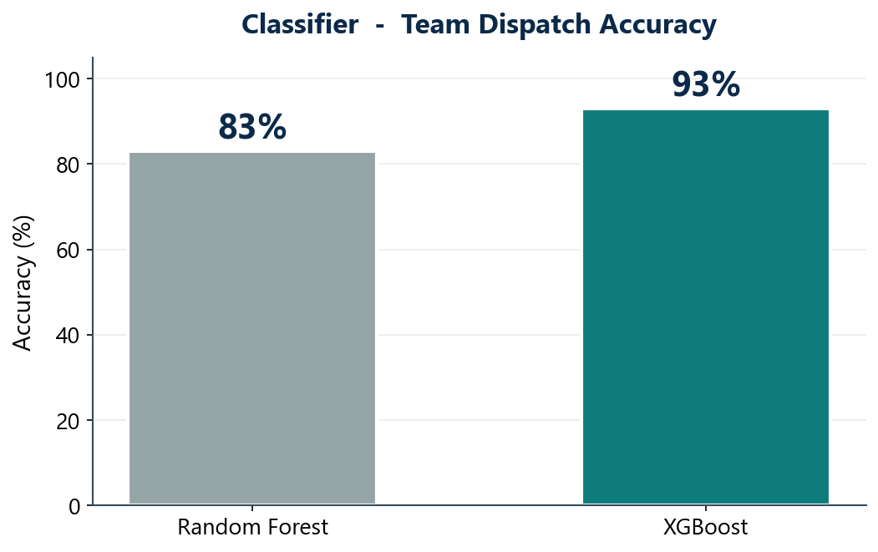
Figure 8. Team-dispatch accuracy, Random Forest (83%) vs. XGBoost (93%).
The confusion matrix for the XGBoost classifier exhibits a strongly dominant diagonal, indicating that the large majority of predictions were correct, with the remaining errors concentrated between teams of plausibly similar distance or skill profile rather than distributed at random.
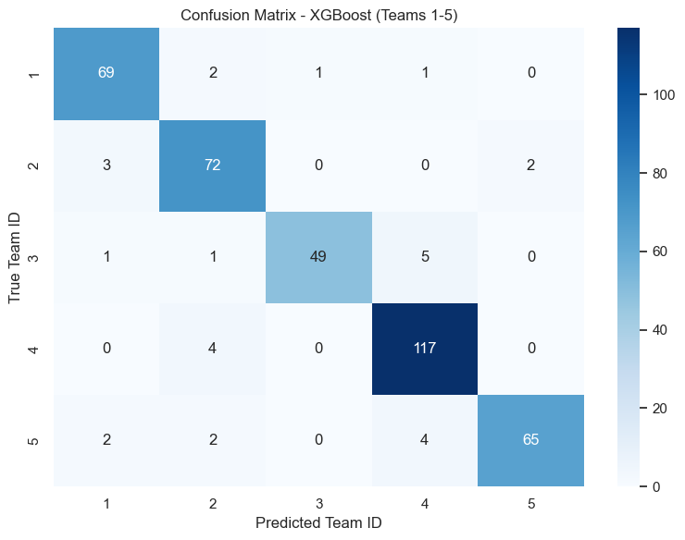
Figure 9. Confusion matrix, XGBoost classifier (Teams 1–5).
Per-team F1-scores ranged narrowly between 0.91 and 0.94, indicating consistent performance across all five teams rather than a bias toward the majority class — evidence that the SMOTE oversampling (Chawla et al., 2002) and class-weighting applied during preprocessing were effective.
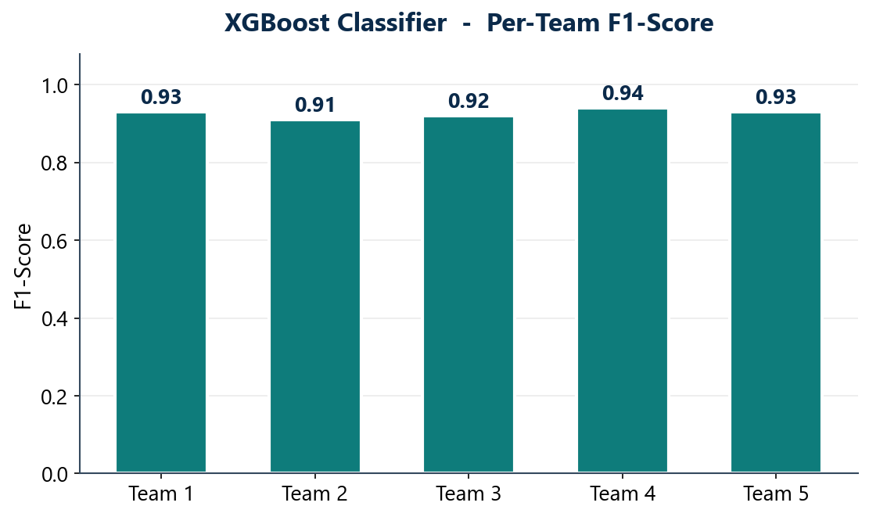
Figure 10. Per-team F1-score, XGBoost classifier.
For this classifier, the dominant features were each team's skill level and workload, together with the fault's geographic coordinates, which is consistent with the fact that the underlying label-generating rule (Equation 9) was itself constructed from exactly these quantities.

9. Discussion: Diagnosing Overfitting
The most consequential methodological finding of this study concerns model validation rather than accuracy alone: a model that appears superior on training data is not necessarily preferable in deployment. Only by explicitly contrasting training and test performance was it possible to detect that the regressor's apparent XGBoost advantage was an artifact of overfitting, whereas the classifier's XGBoost advantage was genuine and persisted on unseen data. This asymmetry between two models trained on the same algorithm family and the same underlying dataset — yet exhibiting opposite generalization behavior — underscores that model selection must be validated independently for each prediction target rather than assumed to transfer from one task to another. This observation echoes the broader caution in the gradient-boosting literature that unconstrained tree depth and learning rate can override the regularization terms intended to prevent it (Chen & Guestrin, 2016).

10. Conclusion
This study converted an inherently subjective, experience-based dispatch decision into a reproducible, data-driven process, implemented as two complementary models: an XGBoost classifier achieving 93% accuracy in recommending which of five teams to dispatch (Chen & Guestrin, 2016), and a Random Forest regressor (Breiman, 2001), with R² ≈ 0.865 stable across training and test partitions, estimating the resulting repair time. The complete pipeline — physically grounded synthetic-data generation, 52-feature engineering, leakage-free preprocessing, dual-model training, and rigorous train/test evaluation — was constructed end to end. Beyond the headline metrics, the principal contribution of this work is methodological: both models were able to reconstruct the hidden optimal-selection logic used to generate their labels from observable features alone, and the comparison between train and test performance proved essential to detecting overfitting before it could undermine real-world usefulness — a consideration consistent with recent outage-duration prediction studies in the same domain (Ghasemkhani et al., 2024).

11. Future Work
- Replace the simulator with real operational data from a power distribution company, once available.
- Extend to simultaneous multi-incident dispatch as a resource-allocation problem, rather than one fault at a time, potentially drawing on sequential decision-making approaches such as those of Wang et al. (2022) and Amani et al. (2025).
- Automate hyperparameter tuning with GridSearchCV or Optuna, and address the regressor's overfitting directly through stronger regularization and early stopping.
- Build a live system with a real-time map and API for use by dispatch-center operators.
- Incorporate live traffic and weather-forecast feeds in place of the simulated environmental features.
- Evaluate operational impact directly, by measuring the realized reduction in outage duration and cost following deployment.

References
The following sources, cited throughout this paper, are additionally ranked from most to least directly relevant/foundational to the methods and problem addressed in this study (Rank 1 = most relevant/foundational).
[Rank 1] Chen, T., & Guestrin, C. (2016). XGBoost: A Scalable Tree Boosting System. In Proceedings of the 22nd ACM SIGKDD International Conference on Knowledge Discovery and Data Mining (KDD '16), 785–794. https://doi.org/10.1145/2939672.2939785 — The original paper introducing XGBoost, the exact algorithm used for both the classifier and the regressor in this study, including the regularized objective (Equation 13) that explains both its accuracy and its overfitting behavior.
[Rank 2] Ghasemkhani, B., Kut, R. A., Yilmaz, R., Birant, D., Arıkök, Y. A., Güzelyol, T. E., & Kut, T. (2024). Machine Learning Model Development to Predict Power Outage Duration (POD): A Case Study for Electric Utilities. Sensors, 24(13), 4313. https://doi.org/10.3390/s24134313 — A directly comparable problem: predicting outage/repair duration for a real electric distribution utility using Decision Tree, Random Forest, KNN and XGBoost, with XGBoost again the strongest performer — closely paralleling this study's regressor comparison.
[Rank 3] Breiman, L. (2001). Random Forests. Machine Learning, 45(1), 5–32. https://doi.org/10.1023/A:1010933404324 — The foundational paper defining the Random Forest algorithm, ultimately selected as the final, more generalizable model for the repair-time regressor in this study.
[Rank 4] Chawla, N. V., Bowyer, K. W., Hall, L. O., & Kegelmeyer, W. P. (2002). SMOTE: Synthetic Minority Over-sampling Technique. Journal of Artificial Intelligence Research, 16, 321–357. https://doi.org/10.1613/jair.953 — Introduces the SMOTE oversampling technique used in this study's preprocessing pipeline to correct the class imbalance in the team-selection target (Team 4 was over-represented).
[Rank 5] Wang, Z., Wang, J., & Chen, C. (2022). Post-storm repair crew dispatch for distribution grid restoration using stochastic Monte Carlo tree search and deep neural networks. International Journal of Electrical Power & Energy Systems, 144, 108477. https://doi.org/10.1016/j.ijepes.2022.108477 — A domain-matching study on the same underlying problem — dispatching repair crews after distribution-grid damage — solved with a sequential decision-making / deep-reinforcement-learning approach, useful as a contrast to this study's supervised-learning framing.
[Rank 6] Amani, F., Ardali, F., & Kargarian, A. (2025). Learning Optimal Crew Dispatch for Grid Restoration Following an Earthquake. arXiv preprint arXiv:2509.04308. https://arxiv.org/abs/2509.04308 — A recent learning-based (transformer + deep reinforcement learning) approach to crew dispatch after infrastructure damage; relevant as an example of where this line of research is heading beyond classical tree ensembles.

