California Housing Price Prediction
An end-to-end regression study with feature engineering, cross-validation, model tuning, error analysis, and interpretability

Final model | Test MAE | Test RMSE | Test R²
Tuned Random Forest | $32,079.78 | $49,636.87 | 0.8188

Machine Learning Project Report
Prepared from the completed project notebook and its recorded experimental outputs

Executive Summary
This project develops a reproducible machine-learning pipeline for predicting median house values in the California housing dataset. The work goes beyond fitting a single estimator: it examines data quality and target behavior, engineers domain-relevant ratio features, compares linear and tree-based regressors under five-fold cross-validation, tunes the strongest candidates, evaluates the selected model once on a held-out test set, and investigates where the final model succeeds and fails.
The tuned Random Forest was selected because it achieved the lowest cross-validation mean absolute error (MAE), $33,059.99. On the untouched test set it reached an MAE of $32,079.78, RMSE of $49,636.87, and R² of 0.8188. The close agreement between cross-validation and test MAE is encouraging: the final result is consistent with the model-selection estimate rather than depending on an unusually favorable test split.
The error analysis also reveals an important limitation that would be hidden by aggregate metrics alone. Error rises markedly with house value. The model tends to overpredict lower-priced districts and underpredict expensive districts; for observations above $400,000, mean residual reaches +$66,448.74. This behavior is particularly relevant because 965 observations (4.68% of the full dataset) are recorded at the maximum target value of $500,001, indicating a target ceiling. Eight of the ten largest test errors occur at this ceiling. The report therefore treats the final score as a useful summary, but not as a complete description of model reliability.

1. Problem Definition and Dataset
The objective is to estimate district-level median house value from demographic, geographic, and housing characteristics. The dataset contains 20,640 observations and ten columns, including the target. Predictors include longitude, latitude, housing median age, total rooms, total bedrooms, population, households, median income, and ocean proximity.
Data check | Observed result
Rows × columns | 20,640 × 10
Missing values | 207 missing values in total_bedrooms; no missing values in the remaining columns
Duplicate rows | 0
Target maximum | $500,001
Rows at target maximum | 965 (4.68%)

Missing numerical values are handled inside the preprocessing pipeline rather than by modifying the source data. This design keeps preprocessing coupled to model fitting and reduces the risk of inconsistent transformations between training and inference.
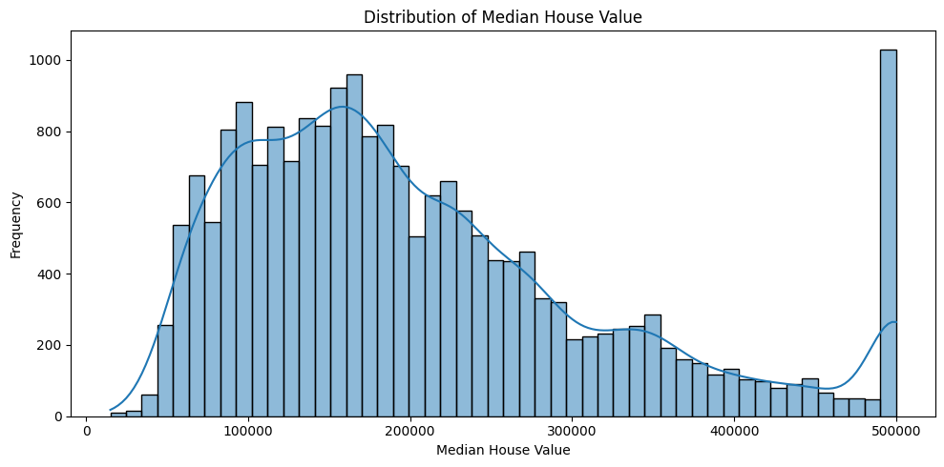
Figure 1. Distribution of median house value. The concentration at the upper boundary motivates a separate target-ceiling check.

1.1 Exploratory observations
Among the numeric variables, median income has by far the strongest simple correlation with the target (0.688). Latitude has a modest negative correlation (-0.144), while total rooms is weakly positive (0.134). These pairwise correlations are descriptive rather than causal and do not capture nonlinear interactions, but they provide a useful starting point for feature design and model choice.
Numeric feature | Correlation with median house value
median_income | 0.688
total_rooms | 0.134
housing_median_age | 0.106
households | 0.066
total_bedrooms | 0.050
population | -0.025
longitude | -0.046
latitude | -0.144

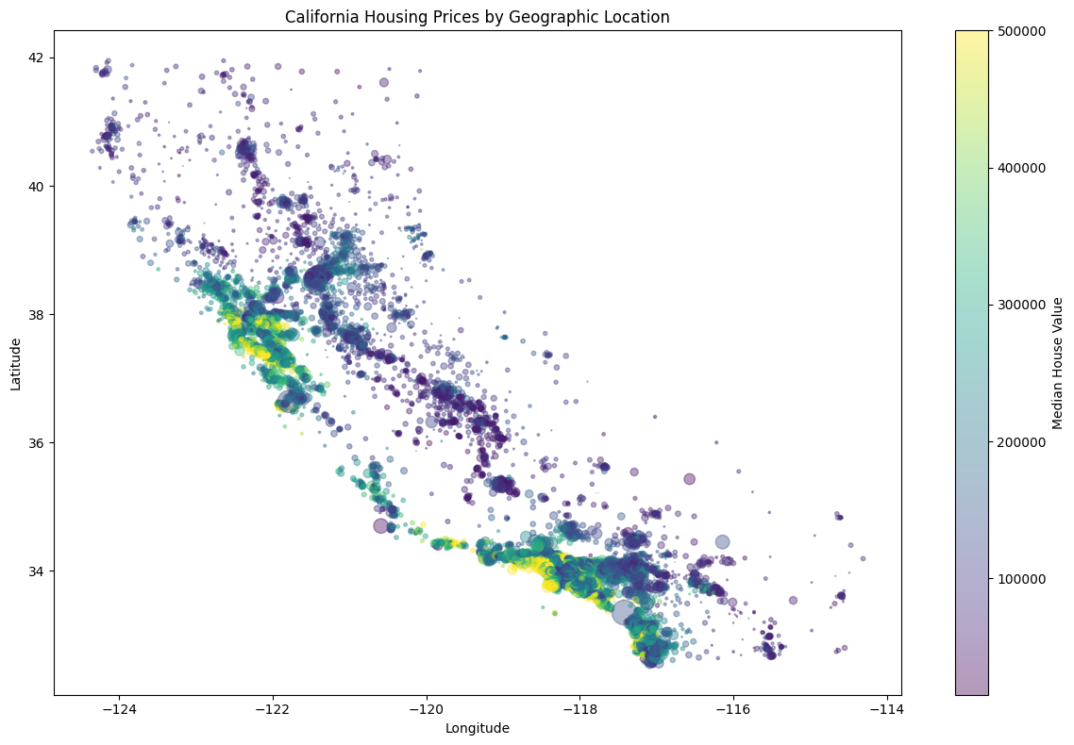
Figure 2. Geographic exploration of the housing data. Location is visibly related to the target and is retained explicitly through longitude and latitude.
Ocean proximity also separates the target distribution. In the notebook summary, INLAND districts have a median house value of $108,500, compared with $214,850 for <1H OCEAN, $229,450 for NEAR OCEAN, and $233,800 for NEAR BAY. The ISLAND category has only five observations, so its much higher median should not be interpreted as a stable group estimate.
Ocean proximity | Count | Mean value | Median value
INLAND | 6,551 | $124,805 | $108,500
<1H OCEAN | 9,136 | $240,084 | $214,850
NEAR OCEAN | 2,658 | $249,434 | $229,450
NEAR BAY | 2,290 | $259,212 | $233,800
ISLAND | 5 | $380,440 | $414,700

2. Modeling Methodology
The project uses a held-out test set for final evaluation and performs model selection on the training data through five-fold cross-validation. MAE is the primary selection metric because it is expressed in the same units as the target and is straightforward to interpret as average absolute prediction error.

2.1 Preprocessing and feature engineering
The preprocessing pipeline combines missing-value handling, scaling, categorical encoding, and engineered features. Three ratio features are used to represent district structure more directly than raw counts: bedrooms per room, rooms per household, and people per household. Skewed count variables and median income are transformed through logarithmic feature pipelines, housing median age is represented with an RBF-based transformation, and ocean proximity is one-hot encoded. Remaining numerical variables, including geographic coordinates, are imputed and standardized.
Keeping these operations inside a scikit-learn Pipeline is important for reproducibility: the transformations learned during training are applied in the same sequence during validation, testing, model serialization, and later inference.

2.2 Candidate models and validation strategy
A Dummy Regressor provides a naive reference point. Linear Regression then establishes a simple learned baseline. Decision Tree, Random Forest, and Gradient Boosting models are evaluated to capture nonlinear relationships and interactions. The tree-based candidates are subsequently tuned with grid search using cross-validated MAE.
Model | 5-fold CV MAE | CV variability (SD)
Tuned Random Forest | $33,059.99 | $560.03
Tuned Gradient Boosting | $34,341.17 | $493.08
Tuned Decision Tree | $40,675.67 | $373.86
Linear Regression | $52,336.34 | $574.22
Dummy Regressor | $88,106.40 | $1,996.13

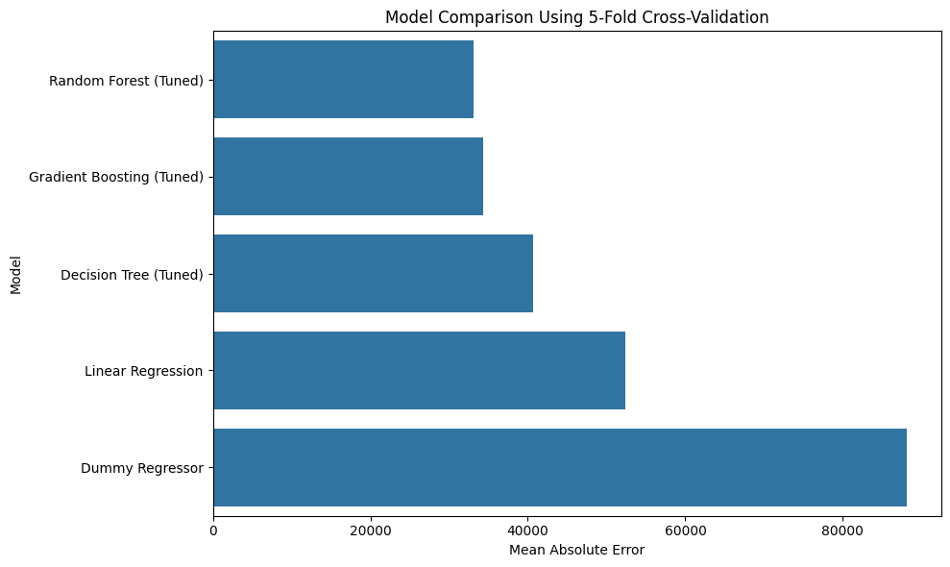
Figure 3. Cross-validation MAE across candidate models. Lower values indicate better predictive accuracy.
The untuned Decision Tree illustrates why validation is necessary: it achieves zero training error but a cross-validation MAE of $46,488.61, a clear sign of overfitting. Tuning improves its CV MAE to $40,675.67, but the ensemble models remain substantially stronger.
The Random Forest is selected for final evaluation. Its best configuration uses 200 trees, no maximum depth constraint, and a minimum of two samples per leaf. Tuning improves its mean CV MAE from $33,176.86 to $33,059.99. The gain is modest, which suggests that the baseline Random Forest was already operating in a strong region of the tested hyperparameter space rather than that performance depended on aggressive tuning.

3. Final Test Evaluation
After model selection was completed, the tuned Random Forest was fitted on the training data and evaluated on the held-out test set. The test set was not used to choose the winning model.
Metric | Final test result | Interpretation
MAE | $32,079.78 | Average absolute prediction error
RMSE | $49,636.87 | Penalizes larger errors more strongly than MAE
R² | 0.8188 | Approximately 81.9% of observed target variance explained on the test set

The final test MAE is about $980 lower than the selected model’s cross-validation MAE ($33,059.99). This small difference supports the view that the reported test performance is broadly consistent with validation performance. RMSE is notably larger than MAE, however, indicating that a subset of observations produces relatively large errors. That observation motivates the detailed residual analysis below.
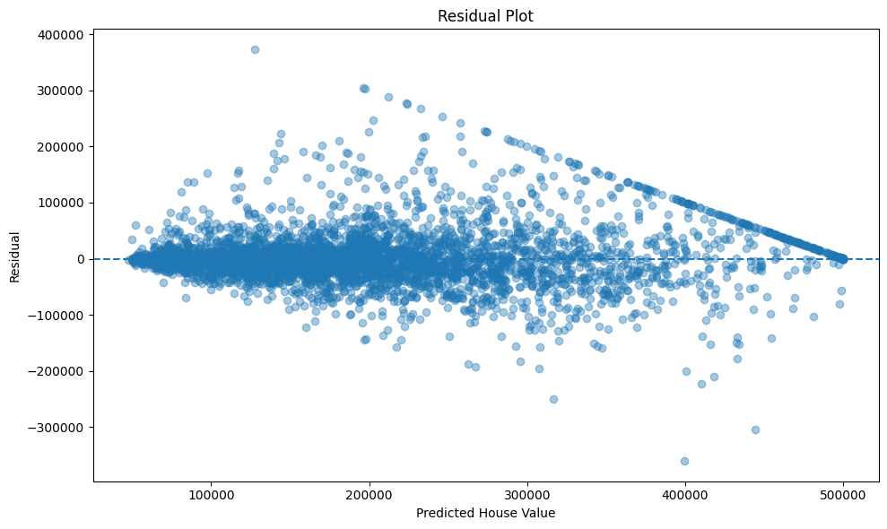
Figure 4. Actual versus predicted house values for the held-out test set.

4. Error Analysis
Residuals are defined as actual value minus predicted value. Positive residuals therefore indicate underprediction, while negative residuals indicate overprediction. Across the test set, the mean residual is +$1,321.67 and the median residual is -$2,774.79. The mean absolute residual equals the MAE, $32,079.78, and 90% of absolute errors are below approximately $74,836.74.
Residual statistic | Value
Mean residual | +$1,321.67
Median residual | -$2,774.79
Residual standard deviation | $49,625.28
Mean absolute residual | $32,079.78
90th percentile absolute error | $74,836.74
Underpredictions | 45.11%
Overpredictions | 54.70%

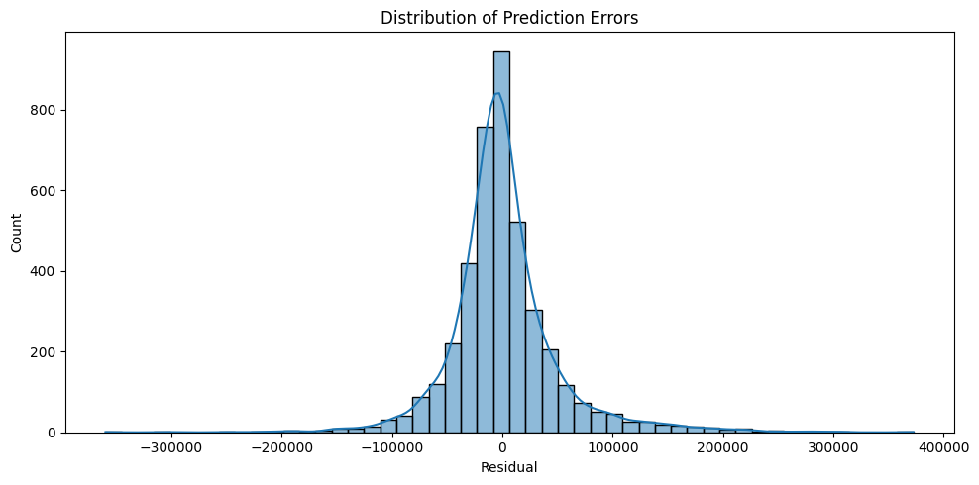
Figure 5. Residual distribution. The overall mean is close to zero relative to the scale of the target, but aggregate balance masks strong price-dependent error patterns.

4.1 Error changes substantially with house value
Actual value range | Test cases | MAE | Mean residual
< $100k | 765 | $19,251.26 | -$15,937.11
$100k–$200k | 1,603 | $24,239.89 | -$10,902.89
$200k–$300k | 987 | $33,721.78 | +$425.51
$300k–$400k | 413 | $50,216.44 | +$26,110.31
$400k+ | 360 | $68,941.11 | +$66,448.74

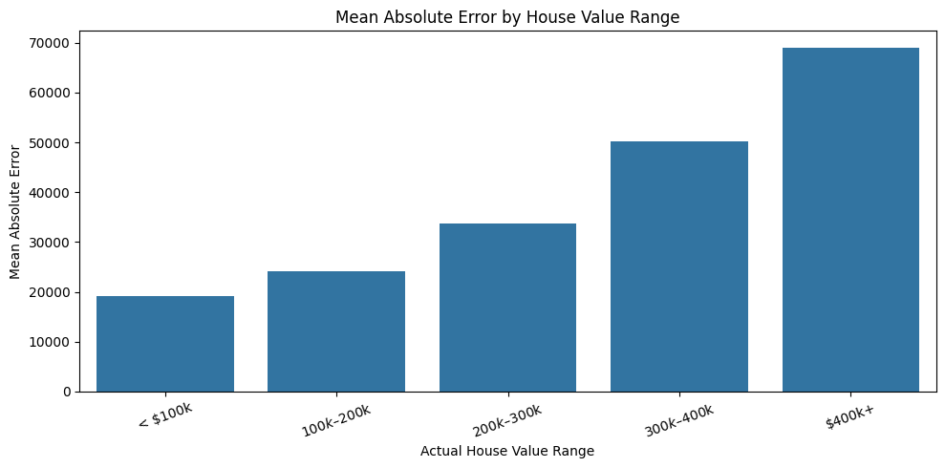
Figure 6. MAE by actual house-value range. Error increases steadily across higher-value segments.
The model is not equally reliable across the target range. MAE rises from about $19.3k below $100k to about $68.9k above $400k. The sign of the residual also changes: lower-priced districts are overpredicted on average, whereas expensive districts are underpredicted. This pattern is more informative than the overall mean residual, which appears small because errors in opposite directions partially cancel.

4.2 The target ceiling affects the most difficult cases
The dataset records 965 observations at exactly $500,001, representing 4.68% of all rows. This upper concentration matters when interpreting high-value predictions. In the ten largest absolute errors from the test set, eight observations have an actual value of $500,001. Several of these are underpredicted by more than $250,000. The ceiling means that the recorded target does not distinguish values beyond that boundary, while the model is asked to learn from features associated with heterogeneous high-value districts.
The two remaining extreme cases demonstrate that the problem is not limited to the ceiling: one $40,000 observation is predicted near $399,702, and one $140,600 observation is predicted near $444,357. These cases indicate that unusual combinations of geographic, demographic, and housing features can also produce large errors.

5. Model Interpretation
Two complementary importance views are used. The Random Forest’s impurity-based importance describes how often and how effectively transformed features reduce split impurity inside the fitted ensemble. Permutation importance instead measures the increase in test MAE after shuffling an original input feature. The two measures answer different questions, so their rankings should not be expected to match exactly.
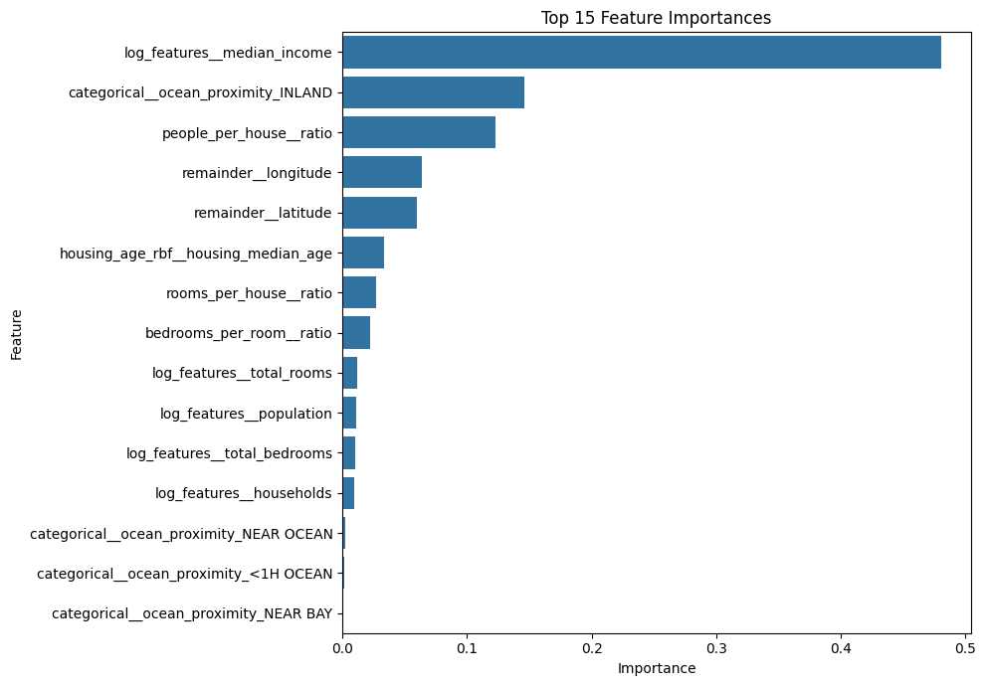
Figure 7. Random Forest impurity-based feature importance after preprocessing and feature engineering.
The transformed median-income feature dominates the impurity-based ranking (importance 0.480), followed by the INLAND indicator (0.146), people per household (0.123), longitude (0.063), and latitude (0.059). This result is consistent with the exploratory finding that income and location contain strong predictive signal.
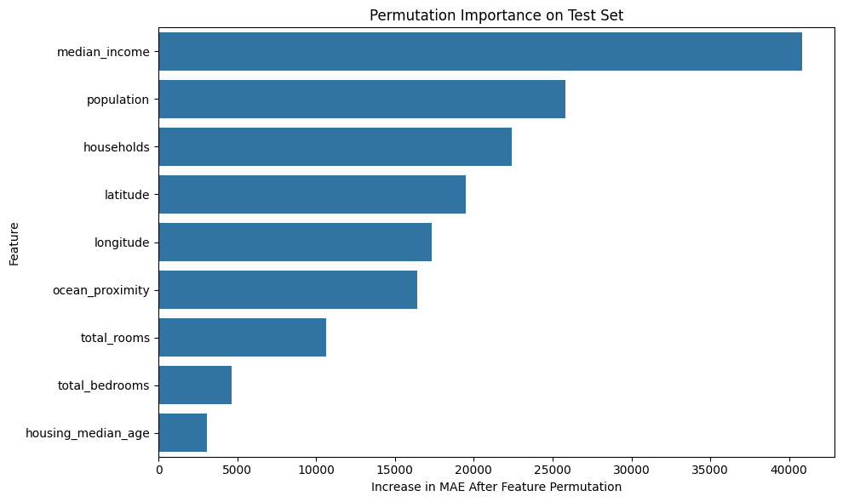
Figure 8. Permutation importance on the held-out test set, expressed as increase in MAE after feature permutation.
Original feature | Increase in MAE after permutation
median_income | $40,838.46
population | $25,835.48
households | $22,410.99
latitude | $19,488.99
longitude | $17,347.51
ocean_proximity | $16,416.84
total_rooms | $10,661.31
total_bedrooms | $4,650.67
housing_median_age | $3,054.57

Permutation importance again places median income first by a wide margin. Population, households, coordinates, and ocean proximity also carry substantial predictive information. These values should be interpreted as predictive dependence within this fitted pipeline, not as evidence that changing a feature would causally change housing prices.

6. Reproducibility and Model Persistence
The final estimator is stored as a single serialized pipeline, including preprocessing and the fitted Random Forest. A post-load verification confirms that the reloaded model reproduces the original predictions exactly within numerical tolerance (np.allclose = True). This reduces the risk of training-serving skew and makes the artifact usable without manually reconstructing preprocessing steps.
Example | Actual price | Loaded-model prediction
1 | $160,300 | $158,212
2 | $150,000 | $149,707
3 | $311,300 | $258,348
4 | $149,000 | $127,018
5 | $112,500 | $106,753

7. Limitations and Possible Extensions
- Target ceiling: the concentration at $500,001 limits direct interpretation of performance in the upper tail and is closely associated with several of the largest errors.
- Price-dependent error: aggregate MAE hides a strong deterioration in accuracy for higher-value districts. Reporting segmented error is therefore important for any downstream use.
- Dataset scope: the model is evaluated only on the available California housing data and should not be assumed to generalize to a different geography or time period without new validation.
- Feature importance is predictive, not causal. Correlated predictors can share or redistribute importance, and neither impurity nor permutation importance establishes causal effects.
- The current project prioritizes a transparent scikit-learn workflow and classical ensemble models. A future extension could compare additional boosting methods or uncertainty-aware prediction, but such additions should be evaluated against the existing cross-validation baseline rather than assumed to improve it.

8. Conclusion
The project produces a complete regression workflow rather than a single headline score. A naive baseline, linear model, single decision tree, Random Forest, and Gradient Boosting model are compared under the same cross-validation criterion; the strongest candidates are tuned; and the selected model is evaluated only after model selection is complete. The tuned Random Forest provides the best validation result and achieves a test MAE of $32,079.78 with R² = 0.8188.
The most useful finding is not only that the ensemble predicts substantially better than the baselines, but also where its reliability changes. Median income and location-related variables are consistently important, while prediction error increases sharply in expensive districts. The upper target ceiling is visible in the data and appears repeatedly among the most severe errors. These observations give a more realistic account of model performance than a single R² value and identify clear directions for further work on high-value observations and uncertainty.

Appendix A. Key Experimental Settings
Component | Setting
Validation | 5-fold cross-validation on training data
Primary model-selection metric | Mean Absolute Error (MAE)
Selected estimator | RandomForestRegressor
Selected Random Forest parameters | n_estimators=200; max_depth=None; min_samples_leaf=2
Categorical handling | Most-frequent imputation + one-hot encoding
Numerical missing values | Median imputation within preprocessing pipelines
Engineered ratios | bedrooms/room; rooms/household; people/household
Final artifact | Serialized full preprocessing + model pipeline

