Enrichment Analysis Workflow 1.0 Data Analysis Report
Server: portal.genego.com
Date: 2018-08-07
Name: Xiting
Login: yale-yanxiting

Experiments

1. |  | correlation_spearman_SCADDING_fdr0.05_BAL_negative_metacore

The experiments uploaded for comparative analysis

Table of content:

• Enrichment analysis
• Pathway Maps
• Top maps (sorted by Statistically significant Maps)
• 1. Map : Cytoskeleton remodeling_RalB regulation pathway
• 2. Map : Stem cells_Schema: Adult neurogenesis in the Subventricular Zone
• 3. Map : Histamine metabolism
• 4. Map : IL-1 beta-dependent CFTR expression
• 5. Map : Th2 cytokine-induced alternative activation of alveolar macrophages in asthma
• Process Networks
• Diseases (by Biomarkers)
• GO Processes

Enrichment analysis (TOC)
Enrichment analysis consists of matching gene IDs of possible targets for the "common", "similar" and "unique" sets with gene IDs in functional ontologies in MetaCore. The probability of a random intersection between a set of IDs the size of target list with ontology entities is estimated in p-value of hypergeometric intersection. The lower p-value means higher relevance of the entity to the dataset, which shows in higher rating for the entity.
Ontologies available for EA in Enrichment Analysis Workflow:

Pathway Maps (TOC)
Canonical pathway maps represent a set of signaling and metabolic maps covering human in a comprehensive way. All maps are created by Thomson Reuters scientists by a high-quality manual curation process based on published peer-reviewed literature. Experimental data is visualized on the maps as blue (for downregulation) and red (upregulation) histograms. The height of the histogram corresponds to the relative expression value for a particular gene/protein.
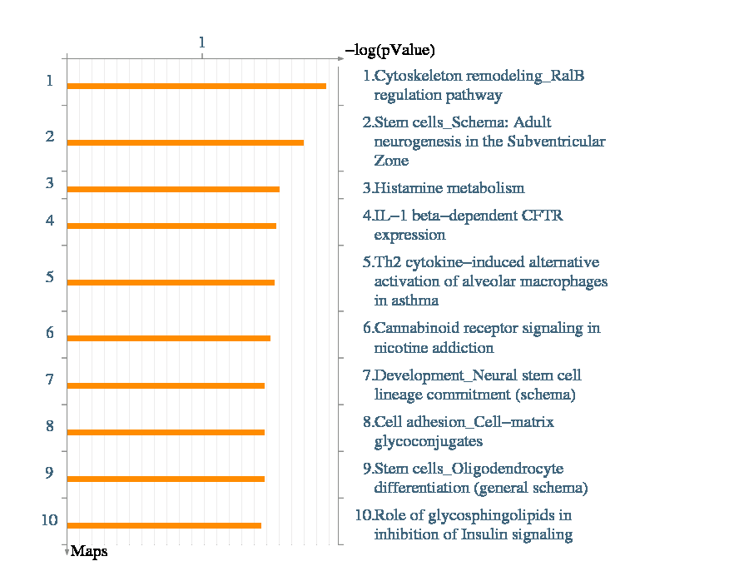
Figure 2. Pathway Maps. Sorting is done for the 'Statistically significant Maps'.

Top maps (sorted by Statistically significant Maps)
1. Map : Cytoskeleton remodeling_RalB regulation pathway (TOC)

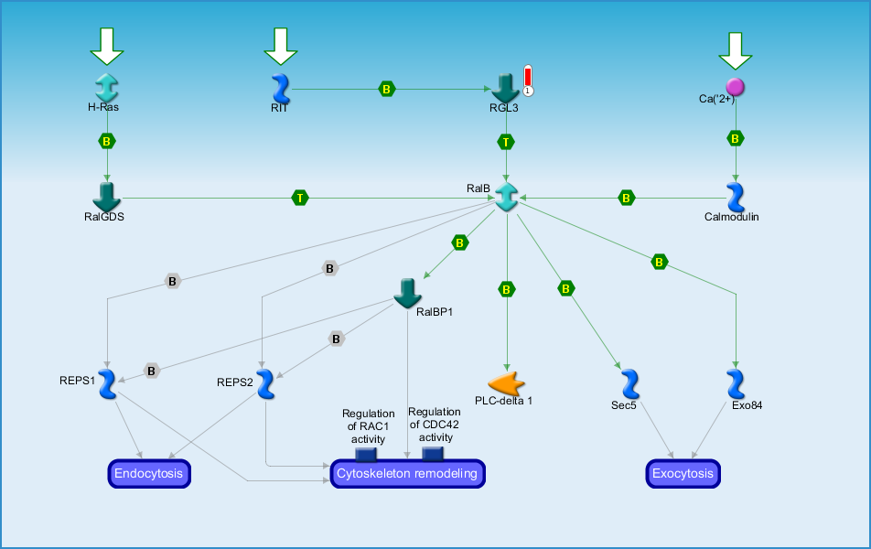
Figure 3. The top scored map (map with the the lowest p-value) based on the enrichment distribution sorted by 'Statistically significant Maps' set. Experimental data from all files is linked to and visualized on the maps as thermometer-like figures. Up-ward thermometers have red color and indicate up-regulated signals and down-ward (blue) ones indicate down-regulated expression levels of the genes.
2. Map : Stem cells_Schema: Adult neurogenesis in the Subventricular Zone (TOC)

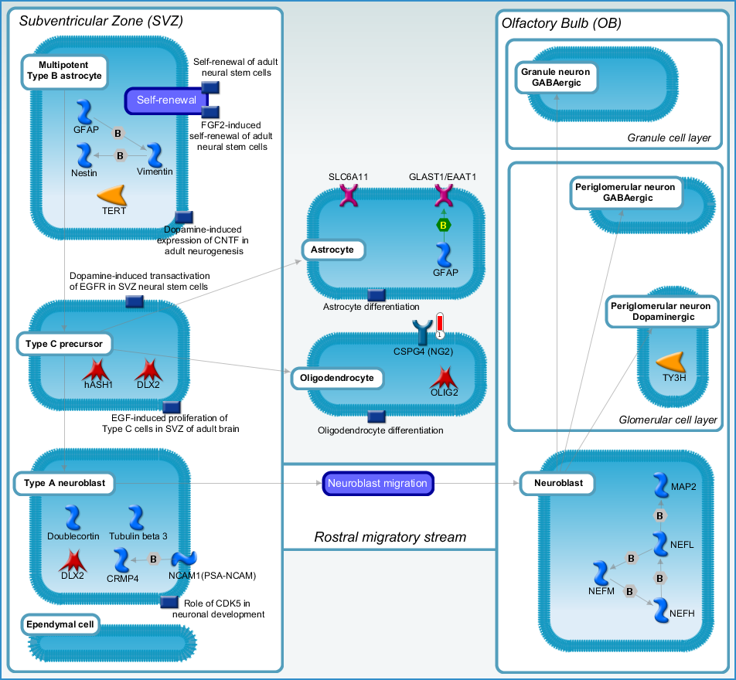
Figure 4. The second scored map (map with the second lowest p-value) based on the enrichment distribution sorted by 'Statistically significant Maps' set. Experimental data from all files is linked to and visualized on the maps as thermometer-like figures. Up-ward thermometers have red color and indicate up-regulated signals and down-ward (blue) ones indicate down-regulated expression levels of the genes.
3. Map : Histamine metabolism (TOC)

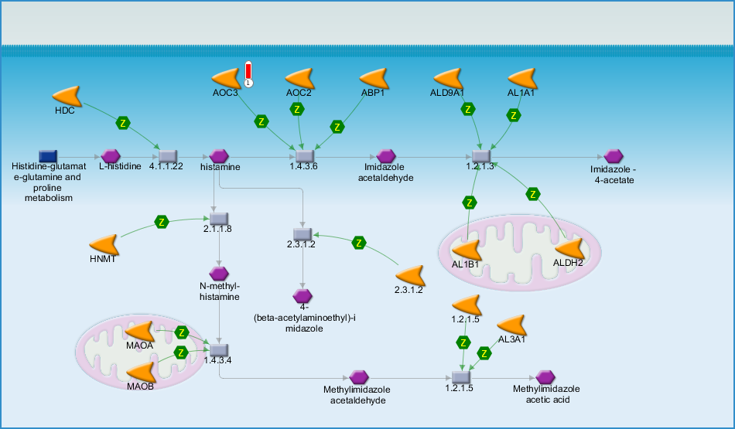
Figure 5. The third scored map (map with the third lowest p-value) based on the enrichment distribution sorted by 'Statistically significant Maps' set. Experimental data from all files is linked to and visualized on the maps as thermometer-like figures. Up-ward thermometers have red color and indicate up-regulated signals and down-ward (blue) ones indicate down-regulated expression levels of the genes.
4. Map : IL-1 beta-dependent CFTR expression (TOC)

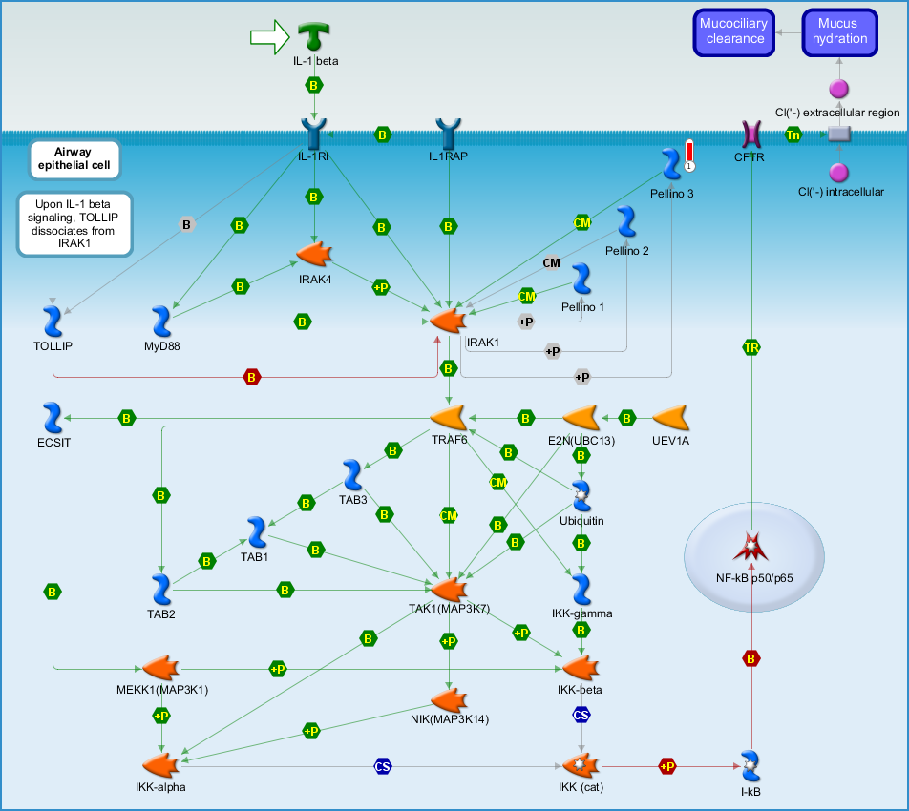
Figure 6. The fourth scored map (map with the fourth lowest p-value) based on the enrichment distribution sorted by 'Statistically significant Maps' set. Experimental data from all files is linked to and visualized on the maps as thermometer-like figures. Up-ward thermometers have red color and indicate up-regulated signals and down-ward (blue) ones indicate down-regulated expression levels of the genes.
5. Map : Th2 cytokine-induced alternative activation of alveolar macrophages in asthma (TOC)

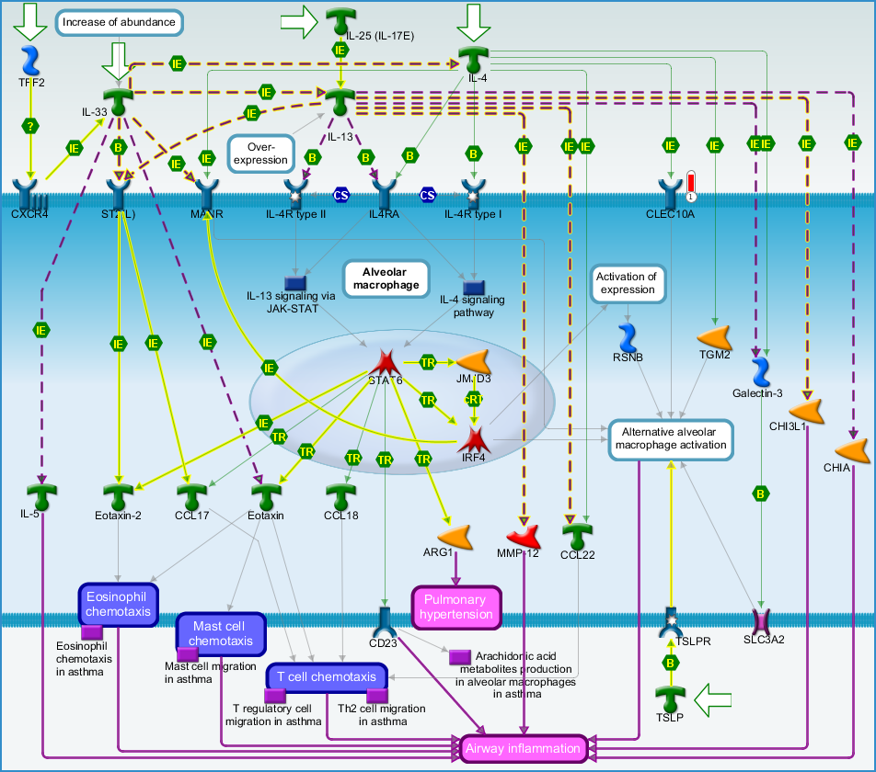
Figure 7. The fifth scored map (map with the fifth lowest p-value) based on the enrichment distribution sorted by 'Statistically significant Maps' set. Experimental data from all files is linked to and visualized on the maps as thermometer-like figures. Up-ward thermometers have red color and indicate up-regulated signals and down-ward (blue) ones indicate down-regulated expression levels of the genes.

Process Networks (TOC)
The content of these cellular and molecular processes is defined and annotated by Thomson Reuters scientists. Each process represents a pre-set network of protein interactions characteristic for the process.
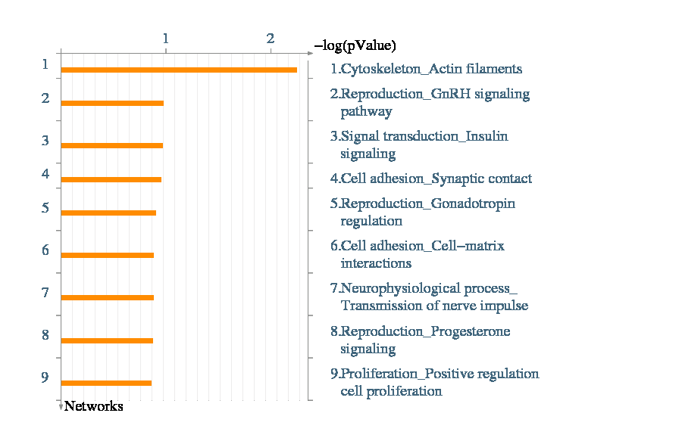
Figure 8. Process Networks. Sorting is done for the 'Statistically significant Networks'.

Diseases (by Biomarkers) (TOC)
Disease folders are organized into a hierarchical tree. Gene content may very greatly between such complex diseases as cancers and some Mendelian diseases. Also, coverage of different diseases in literature is skewed. These two factors may affect p-value prioritization for diseases.
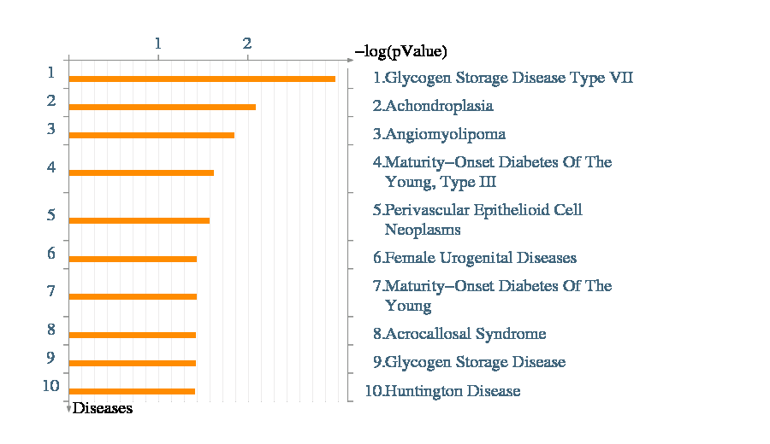
Figure 9. Diseases (by Biomarkers). Sorting is done for the 'Statistically significant Diseases'.

GO Processes (TOC)
These are Gene Ontology (GO) cellular processes. As most GO processes have no gene/protein content, the "empty terms" are excluded from p-value calculations.
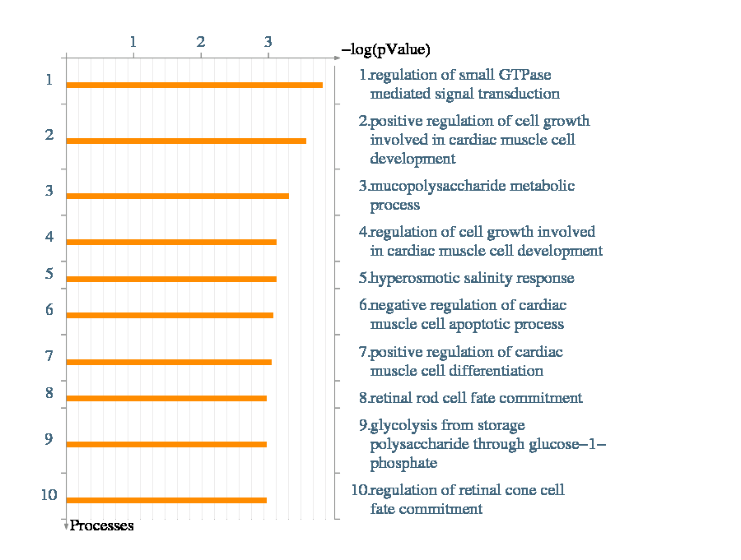
Figure 10. GO Processes. Sorting is done for the 'Statistically significant Processes'.

