**The Relative Strength of a Ballot: The Extent to Which Holding Elections Leads to Leadership Change Across Different Regime Types**

While all but 11 countries in the world held at least one election between 2000 and 2006,[1] not all elections are created equal. Elections in electoral authoritarian regimes are not designed to be lost by the ruling party, while elections in more democratic regimes regularly result in new leadership. But what happens in countries that fall on the spectrum somewhere between autocracy and democracy? More precisely, what is the nuanced relationship between regime type and the probability of leadership change and what effect (if any) does the act of holding elections have on this relationship?

This paper analyzes the NELDA dataset and polity scores from the Polity IV Project – rankings for countries on a 21-point scale between -10 (hereditary monarchy) and 10 (consolidated democracy) – on its way to three main conclusions, one of which is expected and two of which are surprising. First of all, it is not surprising (rather a control of sorts) that I find there is statistical significance for leadership change during election years for all countries rated between 1 and 10 on the Polity Scale (PS). However, for those regimes on the other side of the polity scale (regimes rated between -10 and 0), I will show that election years still have had statistical significance for specific regions (such as the Americas) and for specific time periods (such as 1945 – 1975). Finally, and perhaps most interestingly, I will also show that the probability of leadership change in less-developed democracies (PS +6 to +9) tends to be significantly *greater* than in “full democracies” (PS +10).

**Literature Review:**

While the current literature is not able to provide a nuanced theory as to the effect that regime type and the act of holding elections have on the probability of leadership change, there have been many political scientists who have written on related topics. I will briefly synthesize some of their relevant ideas into a rough sketch of how one might think about this relationship by focusing on what we would expect to see at the endpoints – extreme autocracy and extreme democracy.

### Adam [Przeworski](http://www.nyu.edu/search.directory.html?search=Adam%20Przeworski) makes the assertion that in a developed democracy, elections should be both uncertain and unpredictable.[2] An election is uncertain if “it is possible for an incumbent party to lose” and its unpredictability is derived from the percent probability that the incumbent actually will lose. [Przeworski](http://www.nyu.edu/search.directory.html?search=Adam%20Przeworski) states that this unpredictability – the probability distribution of electoral chances – “is typically known”[3] and I have denoted the existence of this theoretical probability (a value between 0 and 1) as endpoint “B” in the diagram to the right.



### In his acclaimed book Democracy and its Critics, Robert Dahl declares that democracy must have a “decisive stage”, the period during which the electoral process culminates in an outcome and the decision of the people is implemented without further say until the next election.[4] This establishes endpoint “A” in the diagram above: Dahl’s extreme democracy should have no transition in a non-election year because the ‘decisive stage’ concluded during the most recent election year.

### The linear nature of the two curves on the previous page is inspired by the work of Valerie Bunce and Sharon Wolchik (2010). They argue that due to an increasingly more level playing field as one moves between autocracy and democracy, “one would expect more democratic polities to be more vulnerable and … all else being equal … citizens are more predisposed to support the opposition in more democratic political settings.”[5] While this may not necessarily hold true, it seems reasonable to start with the simplest model: a small shift towards democracy leads to a slightly greater probability of leadership change in an election year.

### Moving to analyze extreme electoral authoritarian regimes, I have created the intersection of the two curves at point “C” to signify the idea that the outcomes of some elections in electoral authoritarian regimes are so certain that one wouldn’t expect there to be any difference between election and non-election years in terms of the probability of leadership change. Examples of this scenario would be Iraq between 1994 and 2003 and Syria between 2000 and 2011; while elections were held in Iraq during 1995 and 2002 and in Syria during 2000 and 2007, they were elections in name only.

### Moving beyond the previous theoretical model, it is also important to acknowledge other scholars who have laid the foundation for some of the arguments which will follow throughout the rest of this paper.

### Andreas Schedler popularized the concept of an “electoral authoritarian regime,” emphasizing that such a regime can hold an election with real consequences even if it does not resemble an election in a more democratic regime.[6] Schedler states:

### In electoral authoritarian regimes, elections are more than rituals of acclamation. They are constitutive of the political game. Even if they are marred by repression, discrimination, exclusion, or fraud, they are constitutive of the playing field, the rules, the actors, their resources, and their available strategies. (Schedler, 2006, p. 12)

### Schedler’s previous statement is the driving force to look for statistical significance in the mere act of holding elections in an electoral authoritarian context. Susan Hyde and Nicolai Marinov also expand upon the idea that it is important to rethink “which elections can be lost”[7], urging the reader to consider the other variables that an electoral authoritarian regime must balance. It is common sense that democracies will have a greater probability of leadership change during an election year than a non-election year, but if the same concept holds true for electoral authoritarian regimes as well, then the overarching data would match up with individual case studies such as Daniel Arap-Moi in Kenya (2002) or Augusto Pinochet in Chile (1988) and imply a general significance of elections regardless of the type of regime that holds the election.

### The phrase “third wave of democracy” was coined by Samuel Huntington in reference to the large shift towards the establishment of democracies between 1975 and 1990.[8] I will spend a section of this paper analyzing subsets of the data based on time period in order to determine if this increase in democracy also coincided with an increase in probability of leadership change for all regime types.

### Timothy Hellwig and David Samuels analyzed the ability of voters to reward or punish incumbents under different democratic regimes. In a study of 75 different countries, Hellwig and Samuels found that voters have a greater potential to hold incumbents accountable under presidential systems than under parliamentary systems.[9] I will also test this hypothesis against my full data set of more than 190 countries over 61 years and look at the probability of leadership change as a proxy for reward or punishment of incumbents operating in presidential and parliamentary systems.

**Research Methods:**

The analysis in this paper is derived from a new dataset I have created by merging three established datasets on regime type, elections, and leadership. I will briefly describe the three distinct sources of data, the way in which I merged the data to form a new composite data set, and any adjustments I may have made to the raw data after the merge.

It is important to note that I have limited the scope of my research to all elections for which the office of the chief national executive was being contested. Contrary to Dahl[10], I use the word “contested” to describe any election regardless of number of parties or amount of election fraud so long as it is national and involves the office of the chief executive. I recognize that these distinctions may include “sham elections”[11] or exclude elections for reserved positions or regional posts that do have national implications, but I contend that simply looking at all national elections does give a fair cross-section of elections across all regime types and many different country-specific governmental structures.

The National Elections Across Democracy (NELDA) data set is a source for detailed information on all elections between 1945 and 2006 which involved a national executive figure or a national legislative body. While there are a great deal of variables addressed for each election such as opposition parties, election observers, and economic status of the nation holding the election, I will extract from NELDA the style of government (presidential or parliamentary), whether there was an election during a given year, whether a change in leadership occurred in the country during that election year, and whether there was a successor chosen by the incumbent prior to that election.

The Polity IV Project data set assigns a single number (Polity Score) to reflect the authority characteristics of each nation in the world for each year since 1800. Thus, as countries change leadership and/or governmental structure, the Polity Scores change accordingly. I will utilize the subset of Polity Scores for all countries between 1945 and 2006 in order to overlap with the data available on elections provided by the NELDA data set. To clarify the information provided in the introduction, Polity Scores are integers on a 21-point scale between -10 (hereditary monarchy) and 10 (consolidated democracy). These polity scores are then grouped into five categories (Autocracy, Closed Anocracy, Open Anocracy, Democracy, and Full Democracy) with ranges of -10 to -6, -5 to 0, 1 to 5, 6 to 9, and 10, respectively. I have created a table at the top of the following page to show this information along with current examples of each type of regime:

**TABLE 1: Polity Score Classifications**

|  |  |  |
| --- | --- | --- |
| ***Regime Type Classification*** | ***Polity Score Range*** | ***Current Examples (2010)*** |
| Autocracy | -10, -9, -8, -7, -6 | China, Iran, Belarus |
| Closed Anocracy | -5, -4, -3, -2, -1, 0 | Angola, Venezuela, Singapore |
| Open Anocracy | +1, +2, +3, +4, +5 | Bangladesh, Algeria, Mozambique |
| Democracy | +6, +7, +8, +9 | Turkey, South Africa, Namibia |
| Full Democracy | +10 | Spain, United States, Chile |

The Archigos Data set provides detailed information about the effective leader in each country in the world for each year between 1875 and 2006.[12] Archigos provides the full date range for which each leader was in power along with information about how the leader came to power, how the leader was removed from power, and all elections during their tenure. I have utilized all of this information between the years of 1945 to 2006 in order to complement the NELDA data set; given that the NELDA data set only provides data on transitions in power for countries during years in which an election occurred, the use of the Archigos data set allows me to account for any transitions that may have occurred during non-election years (delineated by ‘violent’ and ‘non-violent’ means).

I merged the relevant variables of these three data sets into a single data frame by inserting the correct matrix elements from each of the data sets into a base matrix containing rows for each country and year. On the following page, I have displayed a small subset of the data frame that applies to the United States between 1960 and 1976 as a way of illustration. The base matrix is shown in the red font, the portions of the matrix extracted from the Polity IV Project dataset are shown in green, the portions extracted from NELDA are shown in yellow, and the cells shown in blue were pulled from the Archigos data set.



I will explain the coding in the table above by highlighting a few examples. An election took place in the United States in 1960 (“election”=1), and John F Kennedy took power (“trans”=1) through non-violent means (“causeoftrans”=0). In 1963, there was no election (“election”=0), but Lyndon Johnson assumed power (“trans”=1) after a violent assassination (“causeoftrans”=1) of President Kennedy. In 1974, Richard Nixon was replaced by Gerald Ford (“election”=0, “trans”=1) after a non-violent impeachment process (“causeoftrans”=0). In 1964 and 1972, there were elections for which the incumbent emerged victorious (“election”=1, “trans”=0) and all of these elections were under a presidential style of government (“pres/parl”=1).

I made a few manual adjustments to the initial merged data set to take into account the “lame duck” period that exists in certain countries. For example, the United States and Uruguay are just two examples of countries for which the election date falls late in the year and inauguration day is at the beginning of the following year. This initially caused a problem because it appeared that for each “lame duck period” there was an incumbent victory followed by a coup d’état the next year as opposed to a regular transition of power via electoral processes.

**Results:**

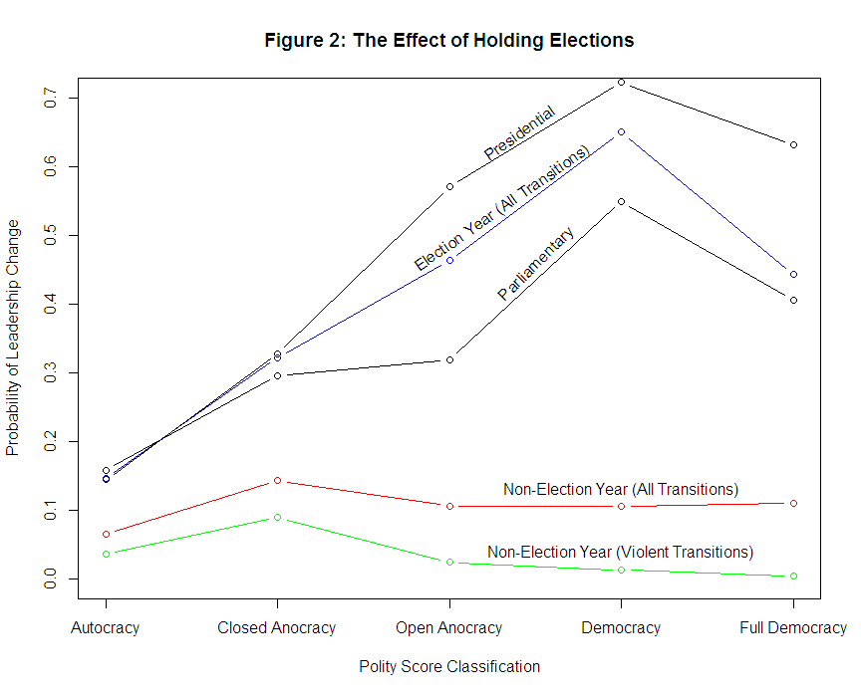Figure 2 is the first attempt to look at the raw data with respect to the effect that elections have on leadership change. The gap between the upper blue line and the lower red line is the effective difference in probability of leadership change between election and non-election years; these are the two lines that formed the theoretical model (Figure 1) delineated in the literature review. I will briefly address the three main differences between Figure 2 and Figure 1.

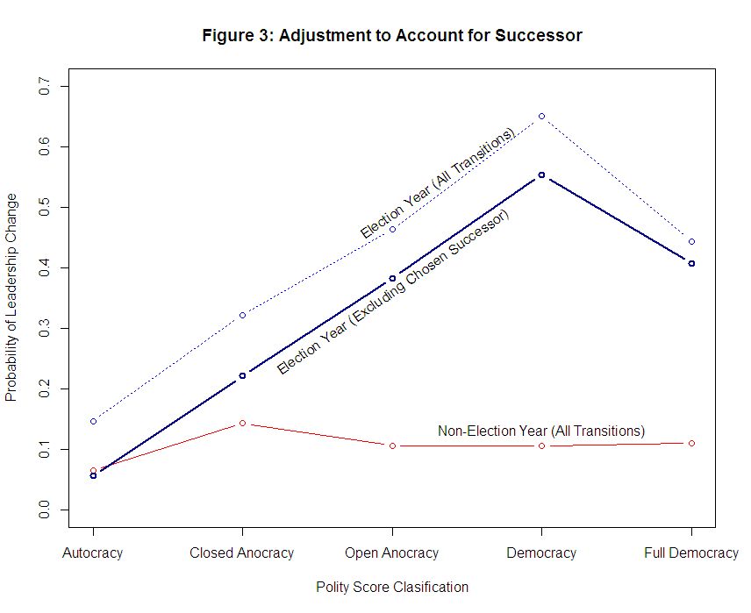 First of all, while the probability of leadership change in non-election years in Figure 2 is roughly the same across all regime types, the theoretical model has a negatively sloping line. This difference can be explained by taking a closer look at the type of transitions which occurred in non-election years. The green line added to the bottom of Figure 2 indicates that nations on the upper half of the polity scale (Open Anocracy, Democracy, Full Democracy) have fewer violent transitions in non-election years when compared with the those nations on the lower half. These non-violent transitions include death by natural causes, parliamentary votes-of-no-confidence, and resigning from office peacefully for any number of reasons.

Secondly, there doesn’t appear to be an intersection point between the two curves in Figure 2. I have accounted for this difference by recoding all cases where a chosen successor took power as a result of an election: Figure 3 considers these cases to *not* be a leadership change. Figure 3 now has the characteristic intersection point that was modeled in Figure 1 and perhaps more accurately captures only cases of true leadership change.

Thirdly, Figure 2 and Figure 3 each contain a drop in the probability of leadership change between “Democracies” and “Full Democracies”, contradicting both the theoretical model and the theory proposed by Bunce and Wolchik. I will show that this trend appears in most of the subsets of the data and is one of the main adjustments that I would make to the theoretical model.

On a distinctly different note, analysis of the subsets of data for parliamentary and presidential elections (black lines in Figure 2) seems to provide even more evidence in favor of Hellwig and Samuels’ hypothesis: there is a higher probability of leadership change in presidential systems than in parliamentary systems for countries with positive polity scores.

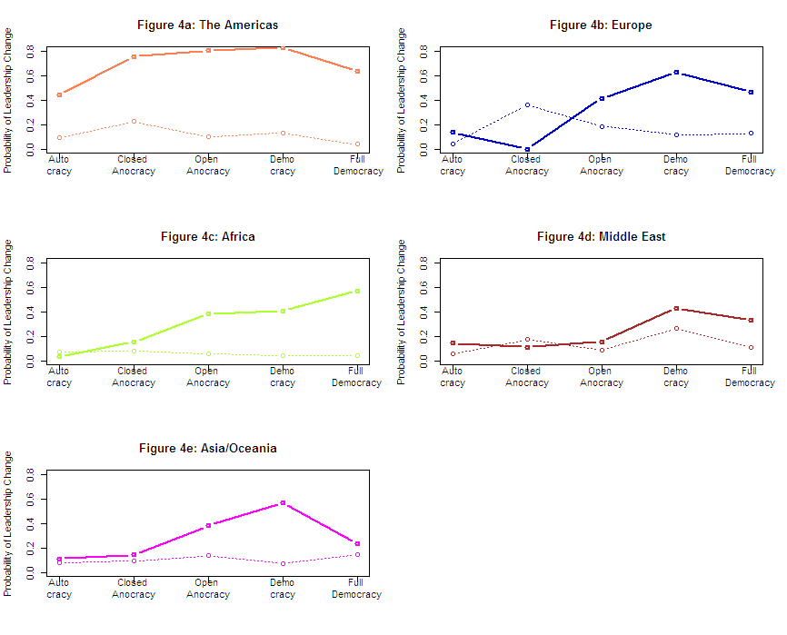The remainder of my results are additional modifications to subsets of Figure 3 in order to determine whether the results of Figure 3 hold up across all time periods and continents within the data set. Figure 4 shows that each continent has had a distinctly different relationship between elections and the probability of leadership change. Each of the continent-specific plots contains all election year data (solid lines) and non-election year data (dotted lines) for the entire span of the dataset (1945-2006).

These plots indicate that elections have had a relatively large effect in the past in the Americas, while they have had a significantly lesser effect in the Middle East. It is worth noting that the strange pattern for Europe is in part due to the fact that there have been hardly any Closed Anocracies since World War II. Similarly, Cape Verde and Mauritius are the only two African nations to have ever spent a period of time in the “Full Democracy” category.

Each of the continents (except Africa) have a sizeable downward slope between “Democracies” and “Full Democracies,” and so it is safe to assume that this downward slope seen in Figures 2 and 3 is not an artifact of some region of the world.

I created the following “mosaic plot” using the merged data set in order to capture the transformation in the relative size of certain polity score classifications. The height of each bar corresponds to the percentage of regimes that fell into a certain category in a given year; the width of each bar corresponds to the number of independent countries in the world at the time.

Figure 5

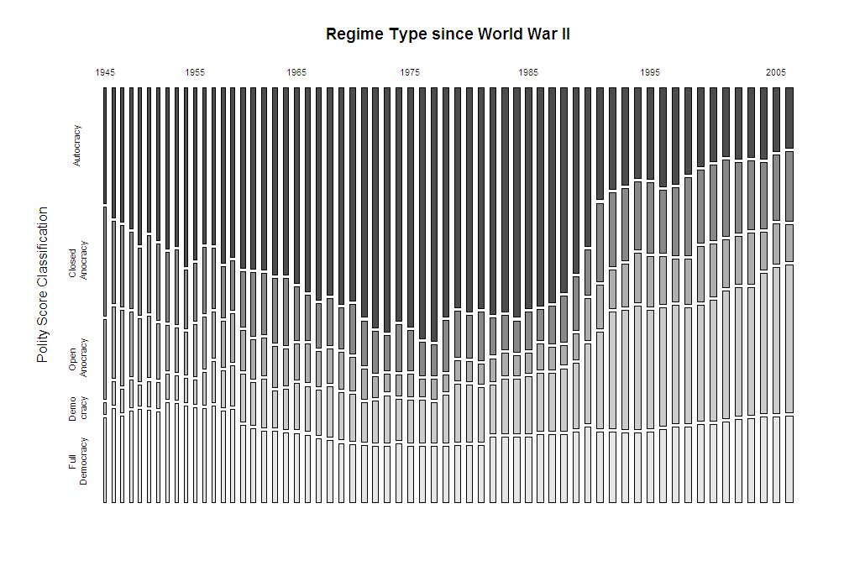

Figure 5 emphasizes the observations by Huntington and other scholars that there have been dramatic shifts in the number of certain types of regimes over the years. Therefore, it is important to cross-check the findings of Figure 3 across different time periods to determine if this is a hidden variable. I chose to break down the roughly 60 year period of the merged data set into four 15-year periods which would all contain enough observations to be statistically significant. I chose to make one of these periods 1975-1990, which is the exact set of dates that Huntington had in mind when referring to the “Third Wave of Democracy.”

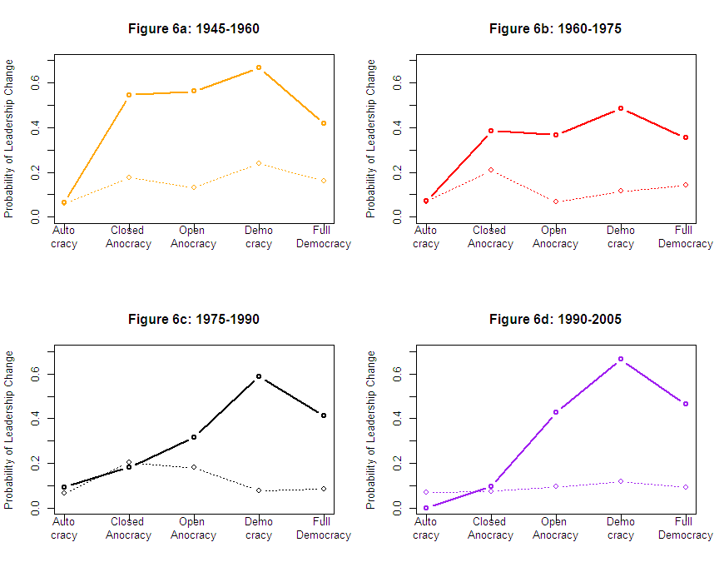

Figure 6 contains visual evidence of both of the main points of this paper. First of all, the downward slope between “Democracies” and “Full Democracies” is present for each of the 15 year periods between 1945 and 2005. The fact that independently splicing by continent *and* by time period did not eliminate this trend further indicates that it is a real trend among democracies. Secondly, between 1945 and 1975, it is easy to see that simply holding elections leads to a greater probability of leadership change for all but the “autocracy” category. In any event, many of the authoritarian regimes that Schedler and Hyde consider would fall into the Closed or Open anocracy categories anyway.

However, I see that the size of the vertical distance between the election years (solid lines) and the non-election years (dotted lines) appears to decrease for countries with negative polity scores as the 20th century progresses, perhaps alluding to the fact that time has a more nuanced effect on the probability of leadership change for certain types of regimes. The following page contains a graph with all of the curves plotted on the same axes to allow for an easier comparison:

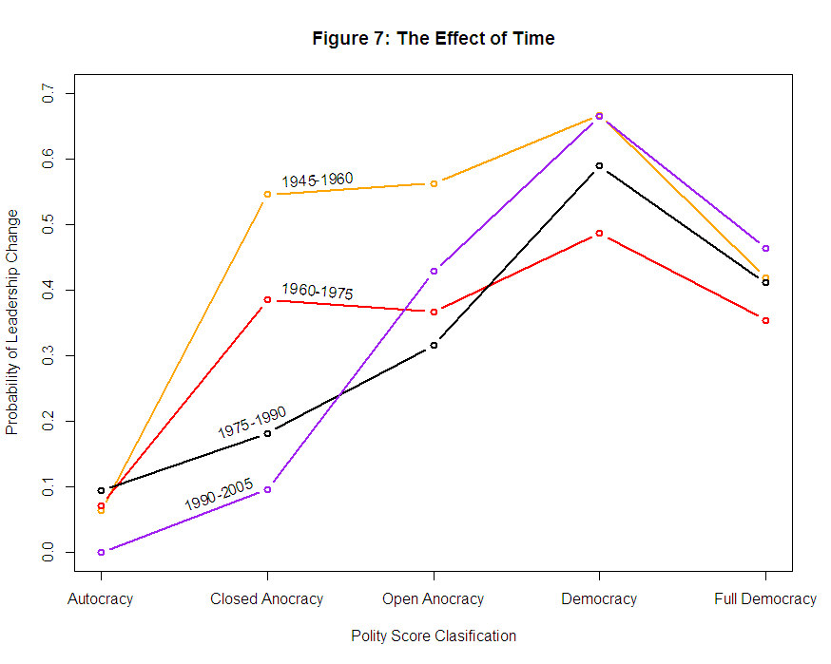

Figure 7 illustrates a secondary change with regard to time period between 1945 and 2005. If I isolate “Closed Anocracies,” there is a steady drop in the probability of leadership change for each passing fifteen year period. The opposite is the case for “Democracies” and “Full Democracies”: between 1960 and 2005, there is a steady rise in the probability of leadership change for these two categories. This “see-saw” effect indicates that perhaps the new democracies established after the Cold War are not particularly stable and the remaining countries in the “autocracy” and “closed anocracy” categories are particularly ruthless or talented. After all, these electoral authoritarian regimes are the countries that have successfully survived the Third Wave of Democracy.

**Conclusions:**

It is a wonder that electoral authoritarian regimes lose elections given that they have the entire “menu of manipulation” available to them – fraud, oppression, voting rules/restrictions are just a few of the ‘menu items’.[13] The data analysis conducted in this paper seems to indicate that all but the most extreme authoritarian regimes seem to have reasonable probabilities of leadership change should they have an election. While this relationship (shown in Figure 3) needs to be investigated further, there are clear policy implications in the previous statements. If an electoral authoritarian regime is significantly more likely to have regime change during an election year than a non-election year, external actors who might want a leader to be overthrown could apply international pressure to get the chief executive to hold elections. However, the trend in Figure 7 seems to indicate that ‘all the low-hanging fruit has been picked’ – the electoral authoritarian regimes that remain are perhaps more savvy than those regimes which have recently succumbed to democracy.

Another interesting point surrounds the reason why there is a lower probability for leadership change in full democracies as opposed to developing democracies. Perhaps this trend has something to do with incumbency advantages in established democracies or a lack of economic crisis and urgency. It does appear that these developing democracies are more unstable and the international community should be aware of what happened to Mali in early 2012; an unstable democracy with a quick cycle of leaders can potentially shift back towards anocracy should the right opportunities arise.

If my data analysis is even remotely accurate, the Global Spread of Elections poses problems for the longevity of electoral authoritarian regimes and may simultaneously create a carousel of fledgling democracies that have difficulty finding a firm footing over the next 20 years. Holding elections may be able to increase the probability of leadership change across all regime types, but it may not be able to guarantee quality leadership or even regime stability.

**Word Count:** 3701 words

**Works Cited:**

Barry, Ellen (2011). “In Kazakhstan, a Good Old-Fashioned Sham Election.” The New York

Times – Breaking News, World News & Multimedia.

Bunce V, Wolchik S (2010). *Defeating Dictators: electoral change and stability in*

*competitive authoritarian regimes.* World Politics, vol. 62(1). pp 43-86.

Dahl, R. (1971). Polyarchy : participation and opposition. New Haven: Yale University Press.

Pg. 7

Dahl, R. (1989). Democracy and Its Critics. New Haven: Yale University Press. Pg. 107.

Goemans H, Gleditsch K, Chiozza G (2009). *Introducing Archigos: A Data Set of Political*

*Leaders.* Journal of Peace Research, vol. 46(2). pp 269-283.

Huntington, S. (1991). The third wave : democratization in the late twentieth century. Norman:

University of Oklahoma Press.

Hyde S, Marinov N (2011). *Which Elections Can be Lost?* Political Analysis.

Przeworski, Adam, Michael E. Alvarez, Jose´ Antonio Cheibub and Fernando Limongi. (2000).

*Democracy and Development: Political Institutions and Well-Being in the World, 1950-*

*1990.* Cambridge: Cambridge University Press.

Samuels D, Hellwig T (2007). *Electoral Accountability and the Variety of*

*Democratic Regimes.* B.J.Political.Science. (37). Cambridge University Press.

Schedler, Andreas (2002). “Elections Without Democracy: The Menu of

Manipulation,” Journal of Democracy. 13 (2): pp. 36-50.

Schedler, Andreas (2006). Electoral authoritarianism: the dynamics of unfree competition.

Boulder, Colo: L. Rienner Publishers.

**Appendix: “R” Code to Merge Polity Scores, Archigos, and NELDA**

z <- read.csv('p4v2010.csv', sep=",", as.is=TRUE, header=TRUE) ##POLITY IV PROJECT##

align <- matrix(NA, nrow=nrow(z), ncol=11)

colnames(align) <- c("country","year","ccode","pscore","election","trans","parl/pres","causeoftrans","termlimit","successor","partylose")

align[,1] <- z$country

align[,2] <- z$year

align[,3] <- z$ccode

align[,4] <- z$polity2

align[,5] <- 0

align[,6] <- 0

align[,7] <- 0

align[,8] <- 0

align[,9] <- 0

align[,10] <- 0

align[,11] <- 0

align <- align[align[,2]>=1945 & align[,2] <=2006,]

align <- as.data.frame(align)

align[,2] <- as.numeric(as.character(align[,2]))

align[,3] <- as.numeric(as.character(align[,3]))

align[,4] <- as.numeric(as.character(align[,4]))

align[,5] <- as.numeric(as.character(align[,5]))

align[,6] <- as.numeric(as.character(align[,6]))

align[,7] <- as.numeric(as.character(align[,7]))

align[,8] <- as.numeric(as.character(align[,8]))

align[,9] <- as.numeric(as.character(align[,9]))

align[,10] <- as.numeric(as.character(align[,10]))

align[,11] <- as.numeric(as.character(align[,11]))

y <- read.csv('NELDA_1945-2006.csv', sep=",", as.is=TRUE, header=TRUE) ##NELDA##

s <- 5:62

m <- 2*s-1

u <- y[,c(m,1:7)]

y <- u[u$nelda20=="yes",]

g <- matrix(NA, nrow=nrow(y), ncol=7)

g[,1] <- y$ccode

g[,2] <- y$year

g[,3] <- 0

g[,4] <- 0

g[,5] <- 0

g[,6] <- 0

g[,7] <- 0

for (b in 1:(nrow(y))) {

if (y[b,43] != y[b,44]) {g[b,3] <- 1}

if (y[b,65]=="Executive") {g[b,4] <- 1}

if (y[b,8]=="yes") {g[b,5] <- 1}

if (y[b,23]=="yes") {g[b,6] <- 1}

if (y[b,24]=="yes") {g[b,7] <- 1}

}

g <- as.data.frame(g)

d<- 1

b<-1

while (b < (nrow(align))) {

d <- 1

while (d < (nrow(g))) {

if (align[b,3] != g[d,1] | align[b,2] != g[d,2]) {

d <- d+1

} else {

align[b,5] <- 1

align[b,6] <- g[d,3]

align[b,7] <- g[d,4]

align[b,9] <- g[d,5]

align[b,10]<- g[d,6]

align[b,11]<- g[d,7]

d <- 10000000}

}

b <- b+1

}

#############################################################

library(foreign) # load ability to read files in other formats: SPSS, Stata, etc.

w <- read.dta('Archigos_v.2.9_tv-Public.dta') ##ARCHIGOS##

h <- matrix(NA, nrow=nrow(w), ncol=4)

h[,1] <- w$ccode

h[,2] <- w$year

h[,3] <- 0

h[,4]<- 0

for (b in 1:(nrow(w)-1)) {

if (w[b,2] == w[b+1,2] & w[b,14]==w[b+1,14]) {h[b,3] <- 1}

if (w[b,17] > 2.9) {h[b,4]<- 1}

}

h <- h[h[,3]==1 & h[,2]>=1945,]

d<-1

b<-1

while (b < (nrow(align))) {

d <- 1

while (d < (nrow(h))) {

if (align[b,5]==0)

if (align[b,3] != h[d,1] | align[b,2] != h[d,2]) {

d <- d+1

} else {

align[b,6] <- 1

align[b,8] <- h[d,4]

d <- 10000000}

else if (align[b,5]==1) {d<- d+1}

}

b <- b+1

}

### data frame "align" is the merged matrix with 11 columns and over 8000 rows ###

1. Hyde S, Marinov N (2011). *Which Elections Can be Lost?* Political Analysis.
2. Przeworski, Adam, Michael E. Alvarez, Jose´ Antonio Cheibub and Fernando Limongi. (2000). *Democracy and Development: Political Institutions and Well-Being in the World, 1950-* *1990.* Cambridge: Cambridge University Press. pg. 16.
3. Ibid. pg. 17.
4. Dahl, R. (1989). Democracy and Its Critics. New Haven: Yale University Press. pg. 107.
5. Bunce V, Wolchik S (2010). *Defeating Dictators: electoral change and stability in*

   *competitive authoritarian regimes.* World Politics, vol. 62(1). pp 43-86.
6. Schedler, Andreas (2006). Electoral authoritarianism: the dynamics of unfree competition.

   Boulder, Colo: L. Rienner Publishers. 
7. Hyde S, Marinov N (2011). *Which Elections Can be Lost?* Political Analysis.
8. Huntington, S. (1991). The third wave : democratization in the late twentieth century. Norman: University of Oklahoma Press. pg 5.
9. Samuels D, Helwig T (2007). *Electoral Accountability and the Variety of Democratic Regimes.*
10. Dahl, R. (1971). Polyarchy : participation and opposition. New Haven: Yale University Press. Pg. 7
11. Barry, Ellen (2011). “In Kazakhstan, a Good Old-Fashioned Sham Election.”
12. Goemans H, Gleditsch K, Chiozza G (2009). *Introducing Archigos: A Data Set of Political Leaders.* Journal of Peace Research, vol. 46(2). pp 269-283.
13. Schedler, Andreas (2002). “Elections Without Democracy: The Menu of Manipulation,” Journal of Democracy. 13 (2): pp. 36-50.