**INFRA RED SENSORS : THE SCIENCE BEHIND**

Black marks on a white surface are detected by RPR-220 infrared sensors -- the same technology that allows robots to follow lines, for example. Infrared (IR) sensors are composed of an IR-emitting light (an LED, to be more specific), and an IR-receiving phototransistor which detects the quantity of light in front of it. When the IR LED emits a light onto the drawing, the phototransistor detects how much light bounced back. This is how these sensors detect black vs. white. This information is all sent to a computer, where it is analyzed and processed to play sounds whenever there is a black mark.

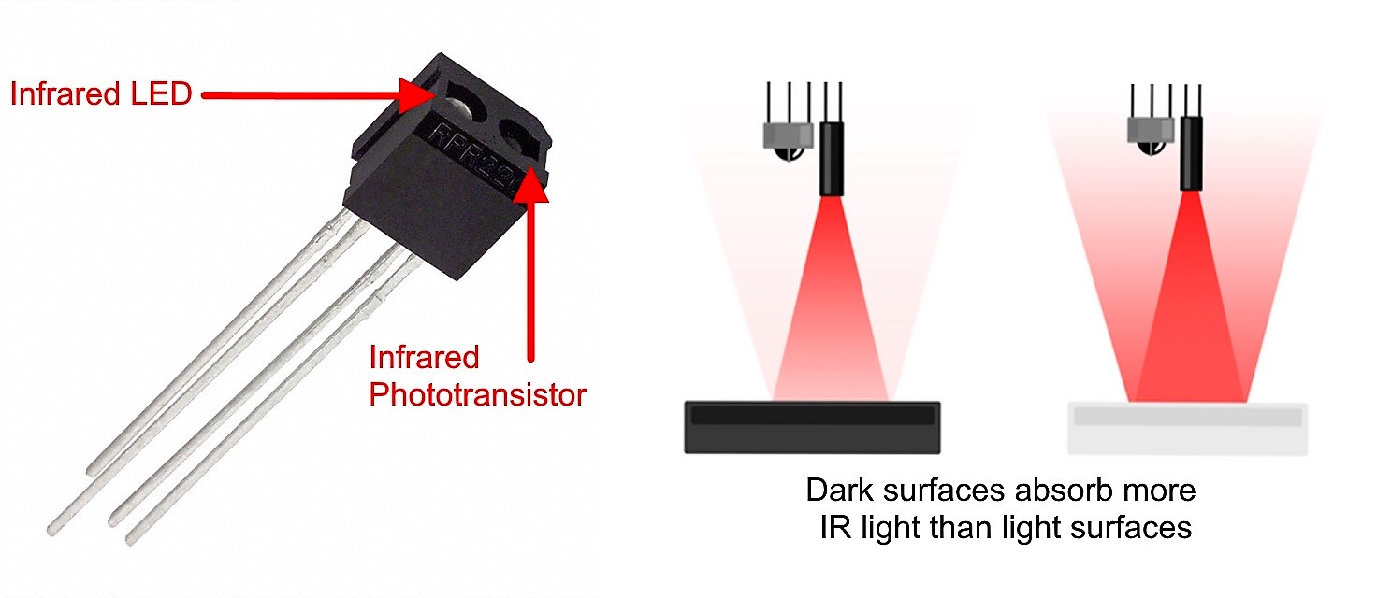

**Reference:**

https://project-music-connector.github.io/opticalTurntable.html