**Coffee Machine Interface in C**

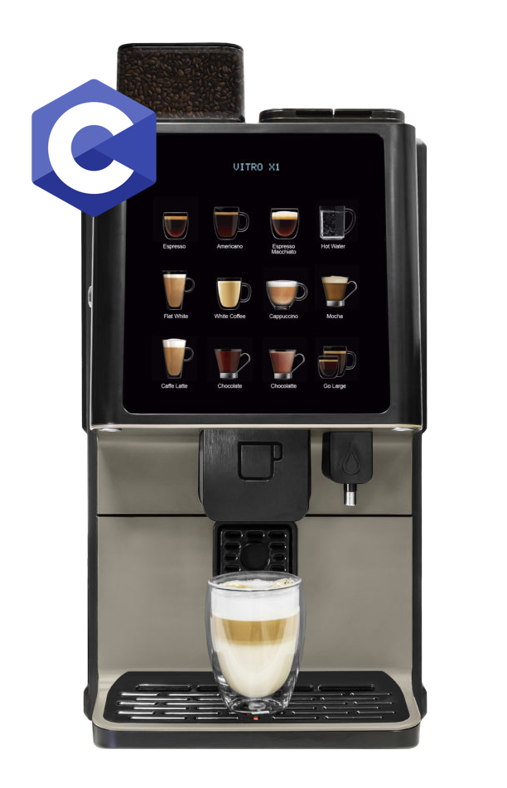

by Muthana Al-Sirhan, #8785995.