# Tutorial – 5A: Arrays

**Objectives:** To practice with Arrays

## Write C statements to do the following:

* 1. Declare an array myArray of 10 elements of the type int.
  2. Output the value of the fifth element of the array myArray using printf() function.
  3. Set the value of the third element of an array myArray to 27.
  4. Set the value of an array's eighth element equal to the sum of the second and the seventh elements.

## What is the output of the following code (when embedded in a complete and correct program)?

int i, temp[10];

for (i= 0; i<10; i++) temp[i]=2*i;

for(i=0; i<10; i++)

printf( "%d ", temp[i] );

Output:

**3. Given the declaration**

int zipCode[50]; int j;

char name[] = "Paul";

## Indicate attempts to access array elements beyond the bounds.

a. for(j = 0; j <= 49; j++)

zipCode[j] = 0;

b. for(j = 50; j >= 0; j--)

zipCode[j-1]= 0;

c. for(j = 0; j <= 50; j++)

zipCode[j] = 0;

## Write C code that compares two arrays.

#define SIZE 5

int data1[SIZE] = { 1, 2, 3, 4, 5 };

int data2[SIZE] = { 1, 2, 3, 4, 0 };

1. **Write a for loop that sums the odd values from the LIST_SIZE element array list. For example, the sum for this list would be 113 (51 + 17 + 45).**

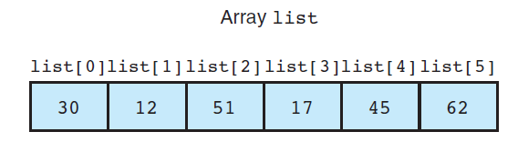

1. **What is the difference in the use of array b that is implied by these two prototypes?**

**int fun_one(int b[], n) ;**

**int fun_two(const int b[], n);**

1. **Define a function multiply that computes and returns the product of the type int elements of its array input argument. The function should have a second input argument telling the number of array elements to use.**
2. **Write a C program segment to display the index of the smallest and the largest numbers in an array x of 20 integers. Assume array x already has values assigned to each element.**
3. **Write a function that displays the values on the diagonal of its 10 × 10 matrix parameter.**