# Tutorial - Week 3

**Objectives:** To practice with

* Relational and logical operators
* if…else and switch selection statements

## Suppose integer variables x=3, y=0, z=-4, what is the value of each of the following expressions true or false?

|  |  |  |  |
| --- | --- | --- | --- |
| a. x >= 0 && y <= b. x != y || x != c. ++x > 3 && y++ | 0  z  == 0 | Answer: Answer: Answer: |  |
| d. !(x != y) |  | Answer: |  |
| *e.* x > 0 && 'B' < | 'A' | Answer: |  |

1. **What is Short-Circuit Evaluation? Evaluate the following expressions and variables?**

bool flag; int x, y;

a. x=y=10;

flag = x>0 || y++; flag = y=

b. x=y=10;

flag = x<0 && --y; flag= y=

c. x=y=10;

if( x==10 && ++y>10 ) flag = true;

else flag= false; flag = y=

## Suppose an integer number = 5 What is the output:

**a.** if(number < 3)

printf("1\n");

else if(number == 5)

printf("2\n");

else

printf("3\n");

Answer:

**b.** if(number < 3)

if(number == 5)

printf("1\n");

else

printf("2\n");

else

printf("3\n");

Answer:

## Suppose integers x=0, y=0, z=1. What are the values of x, y and z after

## executing the code:

switch ( x )

{

case 0: y=2;

z=3;

case 1: y=4;

break; default: z=0;

}

Answer:

1. **Write an expression to test for each of the following relationships.**
2. age is from 18 to 21 inclusive.
3. water is less than 1.5 and also greater than 0.1.
4. year is divisible by 4. (*Hint:* Use %.)
5. speed is not greater than 55.
6. y is greater than x and less than z.
7. w is either equal to 6 or not greater than 3.
8. **Write assignment statements for the following:**
9. Assign a value of 0 to between if n is less than −k or greater than +k; otherwise, assign 1.
10. Assign a value of 1 to divisor if digit is a divisor of num; otherwise, assign a value of 0, including the case digit = 0.
11. Assign a value of 1 to lowercase if ch is a lowercase letter; otherwise, a value of 0.
12. **Write an if statement that displays an acceptance message for an astronaut candidate if the person’s weight is between the values of opt_min and opt_max inclusive, the person’s age is between age_min and age_max inclusive, and the person is a nonsmoker (smoker is false).**
13. **Implement the following decision table using a nested if statement. Assume that the grade point average is within the range 0.0 through 4.0.**



1. **Write a switch statement that assigns to the variable lumens the expected brightness of a standard light bulb whose wattage has been stored in watts. Use this table:**

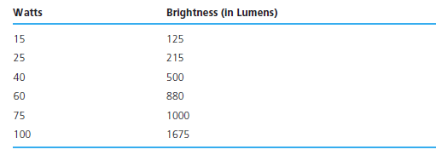

**Assign −1 to lumens if the value of watts is not in the table.**

1. **Implement the flow diagram in below Fig. using a nested if structure.**



1. **Write an interactive program that contains an if statement that may be used to compute the area of a square (area= *side2*) or a circle (area= π × *radius2*) after prompting the user to type the first character of the figure name (S or C).**