**Tutorial - Week 6**

**Objectives:** To practise with

* Struct , Union , and Enumeration
* User defined data types

1. **What is the primary difference between a structure and an array? Which would you use to store the catalog description of a course? To store the names of students in the course?**
2. **Define a struct data type date_t and a function displayDate , that will output its date type parameter in the form dd/mm/year.**

**Example: Assuming that a variable currentDate is of type date and its contents is**

**day month year**

**9 5 2016**

**The function call displaydate (currentDate) will output 9/5/2016**

1. **Considering the following C program segment**

typedef struct

{

char name[20]; int id;

float mark[5];

}person_t;

person_t groupOne[10];

Indicate whether the following statements are valid or invalid

* 1. person_t.id =2907;
  2. groupOne[5].id = 2645;
  3. groupOne[0].mark[4]= 45.7;
  4. printf( "%d\n", groupOne.id );

1. **a) Define a type named long_lat_t that would be appropriate for storing longitude**

**or latitude values. The type comprises components named degrees (an integer), minutes (an integer), and direction (one of the characters 'N' , 'S' , 'E' , or 'W' ).**

**b) The following is a type to represent a geographic location and a variable of this hierarchical structure type. We will assume that STRSIZ means 20.**

typedef struct {

char place[STRSIZ];

long_lat_t longitude,

latitude;

} location_t;

location_t resort;

Figure 1 gives the content of the variable resort in the memory

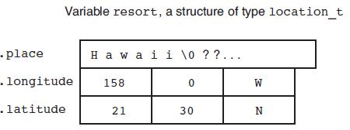

**Figure 1**

**Complete the following table.**

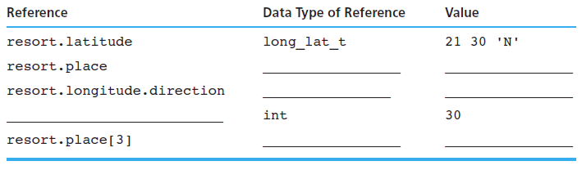

1. **Write functions multiply_complex and divide_complex to implement the operations of multiplication and division of complex numbers defined as follows:**

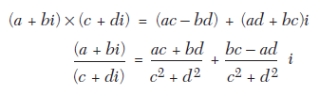

**Hint: Define a struct data type named complex_t, with two double components, real and imag to hold the real and imaginary part of the complex number, respectively.**

1. **Given the following definitions:**

typedef struct {

char fst_name[20],

last_name[20];

int score;

char grade;

} student_t;

. . .

student_t stu1, stu2;

1. **Identify the following statements as possibly valid or definitely invalid. If invalid, explain why.**
2. student_t stulist[30];
3. printf("%s", stu1);
4. printf("%d %c", stu1.score, stu1.grade);
5. stu2 = stu1;
6. if (stu2.score == stu1.score)

printf("Equal");

1. if (stu2 == stu1)

printf("Equal structures");

1. scan_student(&stu1);
2. stu2.last_name = "Martin";
3. **Identify the type of each of the following references:**
4. stu1
5. stu2.score
6. stu2.fst_name[3]
7. stu1.grade
8. **Write a statement that displays the initials of stu1 (with periods).**
9. **How many components does variable stu2 have?**
10. **Declare an array of 40 student_t structures, and write a code segment that displays on separate lines the names (*last name, first name)* of all the students in the list.**
11. **Write functions scan_student and print_student for type student_t variables.**
12. **What output is produced by the following program?**

typedef union /* can store only one value at a time */

{

char var1;

int var2; double var3;

} mixData_t;

int main(void)

{

mixData_t myData;

myData.var1 = 'A'; myData.var2 = 35;

if(myData.var1 == 'A')

myData.var3 = 5.0;

else myData.var3 = -1.5;

printf (“%f”, myData.var3); }

1. **Electromagnetic spectrum is subdivided into several bands:**

LF, MF, HF, VHF, UHF

**Define a new data type band_t that can take only these values. Declare array channels of type band_t that can store 44 elements. Write a function initChannels()that initializes all elements of the array with the value VHF using a for loop.**

1. **Write a function print_day for enumerated type day_t that displays its argument as a string.**

**void print_day(day_t cur_day);**

***Hint:* Use a switch statement to select the appropriate printf statement.**