1a) Find the least squares estimator of $\hat{β}$

[,1]
[1,] -2.381630
[2,] 2.401792
[3,] 1.443504
1b) Compute the estimate $s^{2}$ of $σ^{2}$

[,1]
[1,] 146.5119

1c) Find the variance covariance matrix of $\hat{β}$

[,1] [,2] [,3]
[1,] 119.100534 5.753598 -14.844175
[2,] 5.753598 4.934315 -7.718014
[3,] -14.844175 -7.718014 12.427558

1d) Find the variance of the fitted values $\hat{Y}$

[,1] [,2] [,3] [,4] [,5] [,6] [,7] [,8] [,9]
[1,] 47.341495 3.090929 4.7574245 10.5761923 -32.510619 24.382964 42.183739 27.213213 19.476580
[2,] 3.090929 22.185798 26.6453014 17.6611240 34.959157 10.408612 4.021932 13.071280 14.467784
[3,] 4.757425 26.645301 118.0498307 -0.1143803 -1.859346 -30.000902 -15.748578 37.770785 7.011781
[4,] 10.576192 17.661124 -0.1143803 20.8398337 32.115608 23.006410 15.779168 9.421749 17.226213
[5,] -32.510619 34.959157 -1.8593457 32.1156081 106.380375 19.633520 -16.077089 -10.389992 14.260304
[6,] 24.382964 10.408612 -30.0009017 23.0064103 19.633520 37.600545 32.988091 7.792494 20.700183
[7,] 42.183739 4.021932 -15.7485781 15.7791682 -16.077089 32.988091 43.037601 19.523130 20.803924
[8,] 27.213213 13.071280 37.7707854 9.4217488 -10.389992 7.792494 19.523130 26.822192 15.287067
[9,] 19.476580 14.467784 7.0117814 17.2262126 14.260304 20.700183 20.803924 15.287067 17.278083

1e) Find the variance covariance matrix of the residuals

[,1] [,2] [,3] [,4] [,5] [,6] [,7] [,8] [,9]
[1,] 99.170423 -3.090929 -4.7574245 -10.5761923 32.510619 -24.382964 -42.183739 -27.213213 -19.476580
[2,] -3.090929 124.326120 -26.6453014 -17.6611240 -34.959157 -10.408612 -4.021932 -13.071280 -14.467784
[3,] -4.757425 -26.645301 28.4620870 0.1143803 1.859346 30.000902 15.748578 -37.770785 -7.011781
[4,] -10.576192 -17.661124 0.1143803 125.6720840 -32.115608 -23.006410 -15.779168 -9.421749 -17.226213
[5,] 32.510619 -34.959157 1.8593457 -32.1156081 40.131543 -19.633520 16.077089 10.389992 -14.260304
[6,] -24.382964 -10.408612 30.0009017 -23.0064103 -19.633520 108.911373 -32.988091 -7.792494 -20.700183
[7,] -42.183739 -4.021932 15.7485781 -15.7791682 16.077089 -32.988091 103.474316 -19.523130 -20.803924
[8,] -27.213213 -13.071280 -37.7707854 -9.4217488 10.389992 -7.792494 -19.523130 119.689726 -15.287067
[9,] -19.476580 -14.467784 -7.0117814 -17.2262126 -14.260304 -20.700183 -20.803924 -15.287067 129.233835

2a) Fit the quadratic model to the data, then conduct a test to determine if the incidence rate is curvilinearly related to the estimate rate.

Call:
lm(formula = Rate ~ Estimation + I(Estimation^2))

Residuals:
Min 1Q Median 3Q Max
-101356 -801 -61 207 104498

Coefficients:

Estimate Std. Error t value Pr(>|t|)
(Intercept) -2.884e+02 8.049e+03 -0.036 0.972
Estimation 1.395e+00 3.651e+00 0.382 0.706
I(Estimation^2) 3.509e-05 9.724e-05 0.361 0.722

Residual standard error: 31900 on 21 degrees of freedom
Multiple R-squared: 0.4591, Adjusted R-squared: 0.4076
F-statistic: 8.912 on 2 and 21 DF, p-value: 0.001577

The regression equation is
RATE = - 288 + 1.395 EST + 0.000035 EST^2
We test at $∝ = .05 { H}_{o}: β_{2}=0 vs { H}_{A}: β_{2}≠0$

Our p value is $\frac{0.722}{2}=0.361 > .05$. We fail to reject our null hypothesis and conclude that the data is not curvilinearly related.

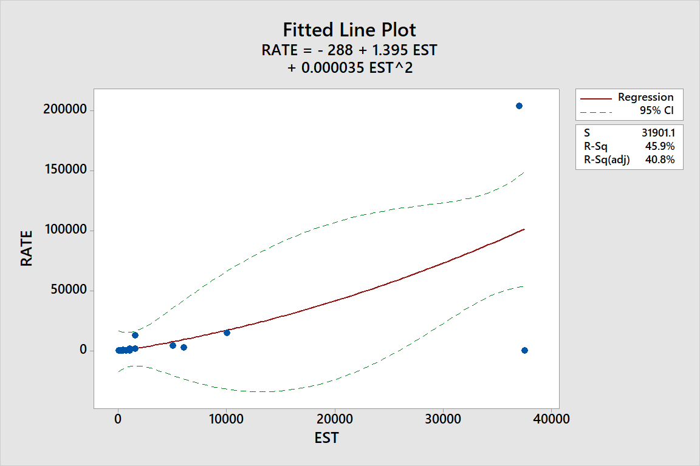

2b) Construct a scatterplot for the data. Locate the data point for Botulism on the graph. What do you observe?

The point for Botulism is located in the right bottom corner of our scatter plot. The data appears to be curvilinear expect for that particular point. This point might be an outlier and might be affecting the R-Squared and Adj.-R Squared

2c) Repeat part a, but omit the data point for Botulism from the analysis. Has the fit of the model improved?

Call:
lm(formula = Rate_Subset ~ Estimation_Subset + I(Estimation_Subset^2))

Residuals:
Min 1Q Median 3Q Max
-2742.0 -726.9 -686.6 -81.4 11666.8

Coefficients:
Estimate Std. Error t value Pr(>|t|)
(Intercept) 7.350e+02 6.959e+02 1.056 0.303
Estimation_Subset -8.096e-02 3.167e-01 -0.256 0.801
I(Estimation_Subset^2) 1.505e-04 8.683e-06 17.336 1.62e-13 ***
---
Signif. codes: 0 ‘***’ 0.001 ‘**’ 0.01 ‘*’ 0.05 ‘.’ 0.1 ‘ ’ 1

Residual standard error: 2757 on 20 degrees of freedom
Multiple R-squared: 0.9961, Adjusted R-squared: 0.9958
F-statistic: 2582 on 2 and 20 DF, p-value: < 2.2e-16

The regression equation is
RATE = 735.0 - 0.0810 EST + 0.000151 EST^2

We test at $∝ = .05 { H}_{o}: β_{2}=0 vs { H}_{A}: β_{2}≠0$

Our p value is $\frac{{1.62(10}^{-13})}{2} < .05$ We reject our null hypothesis and conclude that the data is curvilinearly related. The fit of the model has improved. Prior to removing the Botulism data point our Adj. R Squared was 0.4076. After removing the data point our Adj. R Squared increased to 0.9958

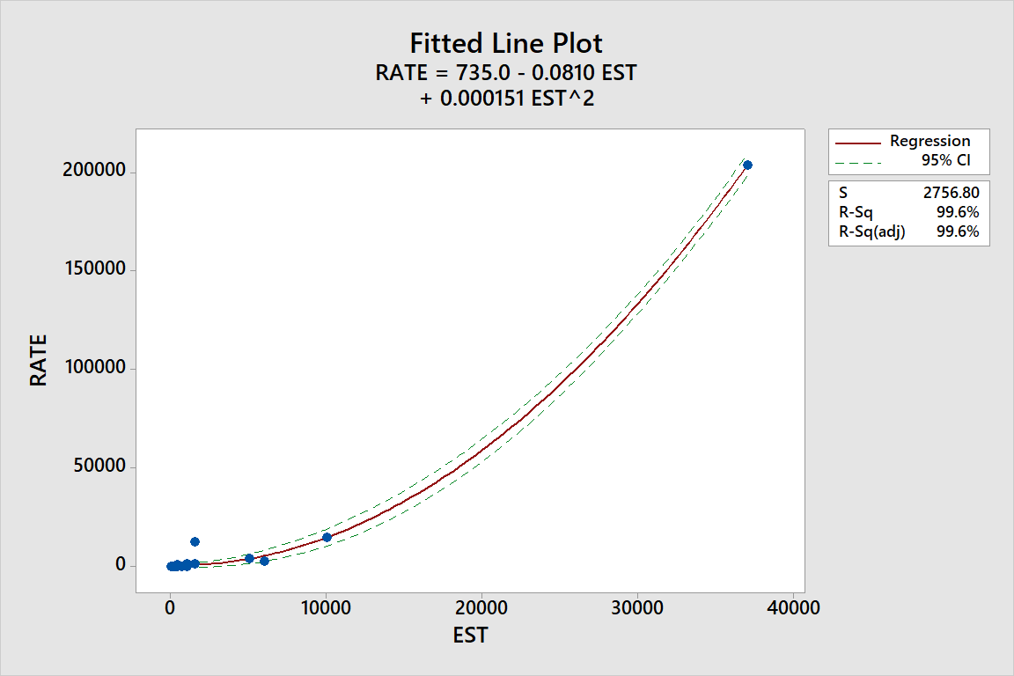

3) Identify any outliers in the INFECTION dataset. Are any of these outliers influential? If so, how should the researchers proceed?

Rate Estimation Cook.Distance F.50thpercentile
1 0.25 300.0 3.620496e-07 0.8148716
2 1.00 1000.0 2.172167e-05 0.8148716
3 1.75 691.0 8.459856e-06 0.8148716
4 2.00 200.0 2.163351e-09 0.8148716
5 3.00 17.5 1.679587e-06 0.8148716
6 5.00 0.8 2.031311e-06 0.8148716
7 9.00 1000.0 2.141802e-05 0.8148716
8 10.00 150.0 1.718607e-07 0.8148716
9 22.00 326.5 4.479051e-07 0.8148716
10 23.00 146.5 2.490307e-07 0.8148716
11 39.00 370.0 7.438326e-07 0.8148716
12 98.00 400.0 6.157626e-07 0.8148716
13 119.00 225.0 1.786763e-07 0.8148716
14 152.00 200.0 5.496425e-07 0.8148716
15 179.00 200.0 7.507440e-07 0.8148716
16 936.00 400.0 8.569887e-06 0.8148716
17 1514.00 1500.0 2.296657e-06 0.8148716
18 1627.00 1000.0 3.935263e-06 0.8148716
19 2926.00 6000.0 5.696970e-03 0.8148716
20 4019.00 5000.0 1.075258e-03 0.8148716
21 12619.00 1500.0 1.945861e-03 0.8148716
22 14889.00 10000.0 4.563122e-03 0.8148716
23 203864.00 37000.0 6.548829e+00 0.8148716
24 15.00 37500.0 7.405753e+00 0.8148716

From Cooks Distance it seems that data point 23 and 24 are influential outliers. The researchers should investigate why these outliers occurred. If the researchers can identify why these observations occurred and if they resulted from error the researchers might drop these observations.

