Lab Sheet (continued): Adding Search to the Students Table

Student details
Full name
Student number
Section
Date

Your unique values
Use these exact values wherever a task says your first name or your last name.
What | Your value | Example
Your full name |  | Juan Dela Cruz
Your first name |  | Juan
Your student number |  | 2026-0147
Your repository link (the one from the Form Validation lab) |  | same as the last example

Before you start
This lab continues the SchoolApp you built in the Form Validation lab (Tasks 0 to 10). Use the same repository and the same Codespace:
- Go to github.com > your repository > Code > Codespaces and open your Codespace.
- In the Terminal, type cd SchoolApp.
- Run the app with dotnet run and open Students. You should see your own row from the last lab.
Your Students table has no search yet. You will add it in two ways:
 | Option A: Search with a button | Option B: Live search
How it works | You type, click Search, and the page reloads with the results | The table filters while you type, with no button and no reload
Who searches | The server asks the database | The browser hides rows that don't match
Files you change | Controller and view | View only
Do Option A first, then Option B, unless your teacher tells you to do only one.
Throughout: stop the app with Ctrl+C and run dotnet run again after every code change.

Task 11: Check your Students page and add test data
11.1 The controller
Open 📄 Controllers/StudentsController.cs. The Index method that the generator wrote looks like this:
// GET: Students
public async Task<IActionResult> Index()
{
return View(await _context.Student.ToListAsync());
}
11.2 The view
Open 📄 Views/Students/Index.cshtml. Find the <table class="table">. Its first three columns are Student No., Full Name and Email Address, and each row is made in a @foreach (var item in Model) loop.
11.3 Add 3 classmates
Run the app, open Students > Create New, and add these 3 students. Fill in every field your validation rules need (Confirm Email too).
Student No. | Full Name | Email Address | Age
2026-0201 | Maria Santos | maria.santos@school.edu | 19
2026-0202 | Pedro Reyes | pedro.reyes@school.edu | 20
2026-0203 | Carlo Mendoza | carlo.m@school.edu | 18
Your own row from the last lab must still be in the table.
Answer
Question | Your answer
How many students are in your table now? | There are a total of 8 now because of the recent tests from the previous activity I didn’t delete (there was no instructions to delete them)
Which validation message did you see, if any, while adding them? | None

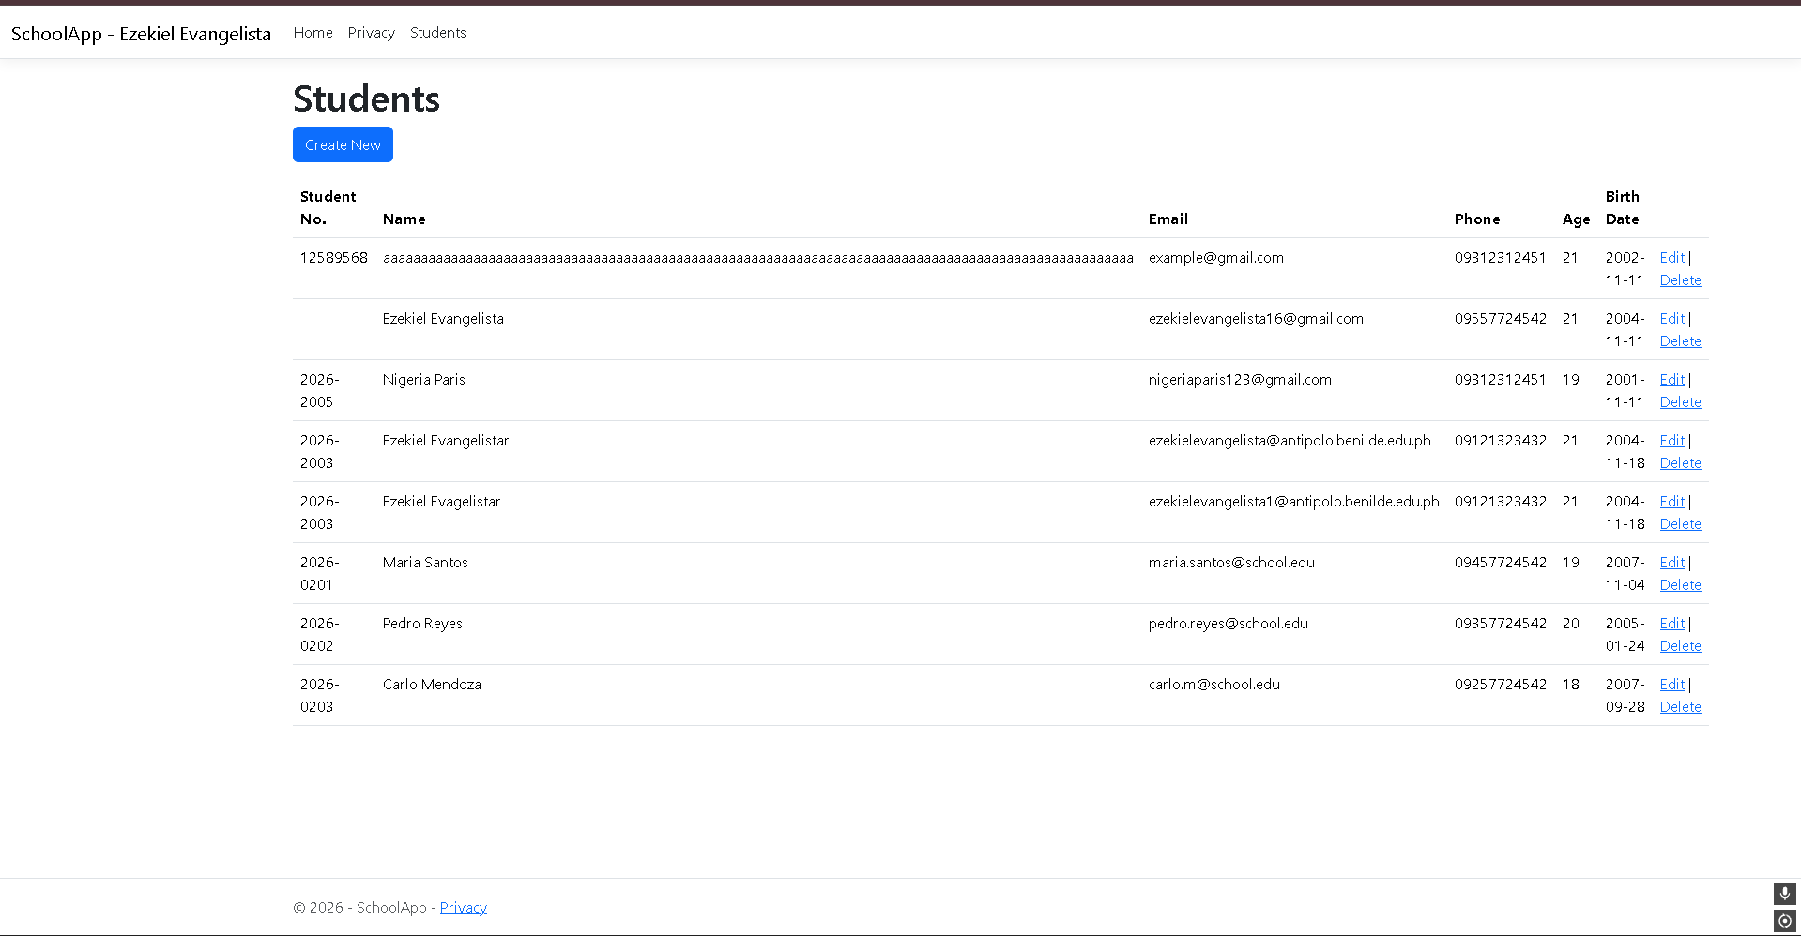Task 12 (Option A): Search with a button
12.1 Change the controller
📄 Controllers/StudentsController.cs: replace the whole Index method with this:
// GET: Students?searchString=maria
// searchString = what the user typed in the search box
public async Task<IActionResult> Index(string? searchString)
{
// Start with all students, but don't load them yet
var students = from s in _context.Student select s;
// If the user typed something, keep only the matching students
if (!string.IsNullOrEmpty(searchString))
{
// Lowercase, so "MARIA" also finds "Maria Santos"
var text = searchString.ToLower();
// Match the name, the student number OR the email
students = students.Where(s => s.Name!.ToLower().Contains(text)
|| s.StudentNo!.ToLower().Contains(text)
|| s.Email!.ToLower().Contains(text));
}
// Send the text back, so it stays in the search box
ViewData["searchString"] = searchString;
// Now run the search and show the results
return View(await students.ToListAsync());
}
12.2 Add the search form to the view
📄 Views/Students/Index.cshtml: add this right above <table class="table">. In the placeholder, replace Juan with your first name.
@* Option A: search with a button *@
@* method="get" puts the search text in the address bar *@
<form asp-action="Index" method="get" class="mb-3">
@* name="searchString" must match the controller's parameter name *@
<input type="text" name="searchString" value="@ViewData["searchString"]"
placeholder="Name, student no. or email - Juan" />
<button type="submit" class="btn btn-primary">Search</button>
@* Clear goes back to /Students with no search, so all rows show *@
<a asp-action="Index" class="btn btn-secondary">Clear</a>
</form>
12.3 Test it
Save, stop the app and run it again. Open Students, type each value below, and click Search.
Answer
Type this | Students shown (write the names)
your first name | Ezekiel Evangelista and Ezekiel Evangelistar
your student number | 2026-2003
MARIA | Maria Santos
2026-020 | Maria Santos, Pedro Reyes, Carlo Mendoza
school.edu | Maria Santos, Pedro Reyes, Carlo Mendoza
xyz | none
(click Clear) | Aaaaaaaaaaaaaaaaaaaaaaaaaaaaaaaaaaaaaaaaaaaaaaaaaaaaaaaaaaaaaaaaaaaaaaaaaaaaaaaaaaaaaaaaaaaaaaaaaaaa  Ezekiel Evangelista  Nigeria Paris  Ezekiel Evangelistar  Maria Santos  Pedro Reyes  Carlo Mendoza

Question | Your answer
After searching your first name, what is the full address in the address bar? | If email address yes If home address no
Did the page reload when you clicked Search? (Yes / No) | yes
Which line in the controller makes the search match the email too? (copy it) | || s.Email!.ToLower().Contains(text));

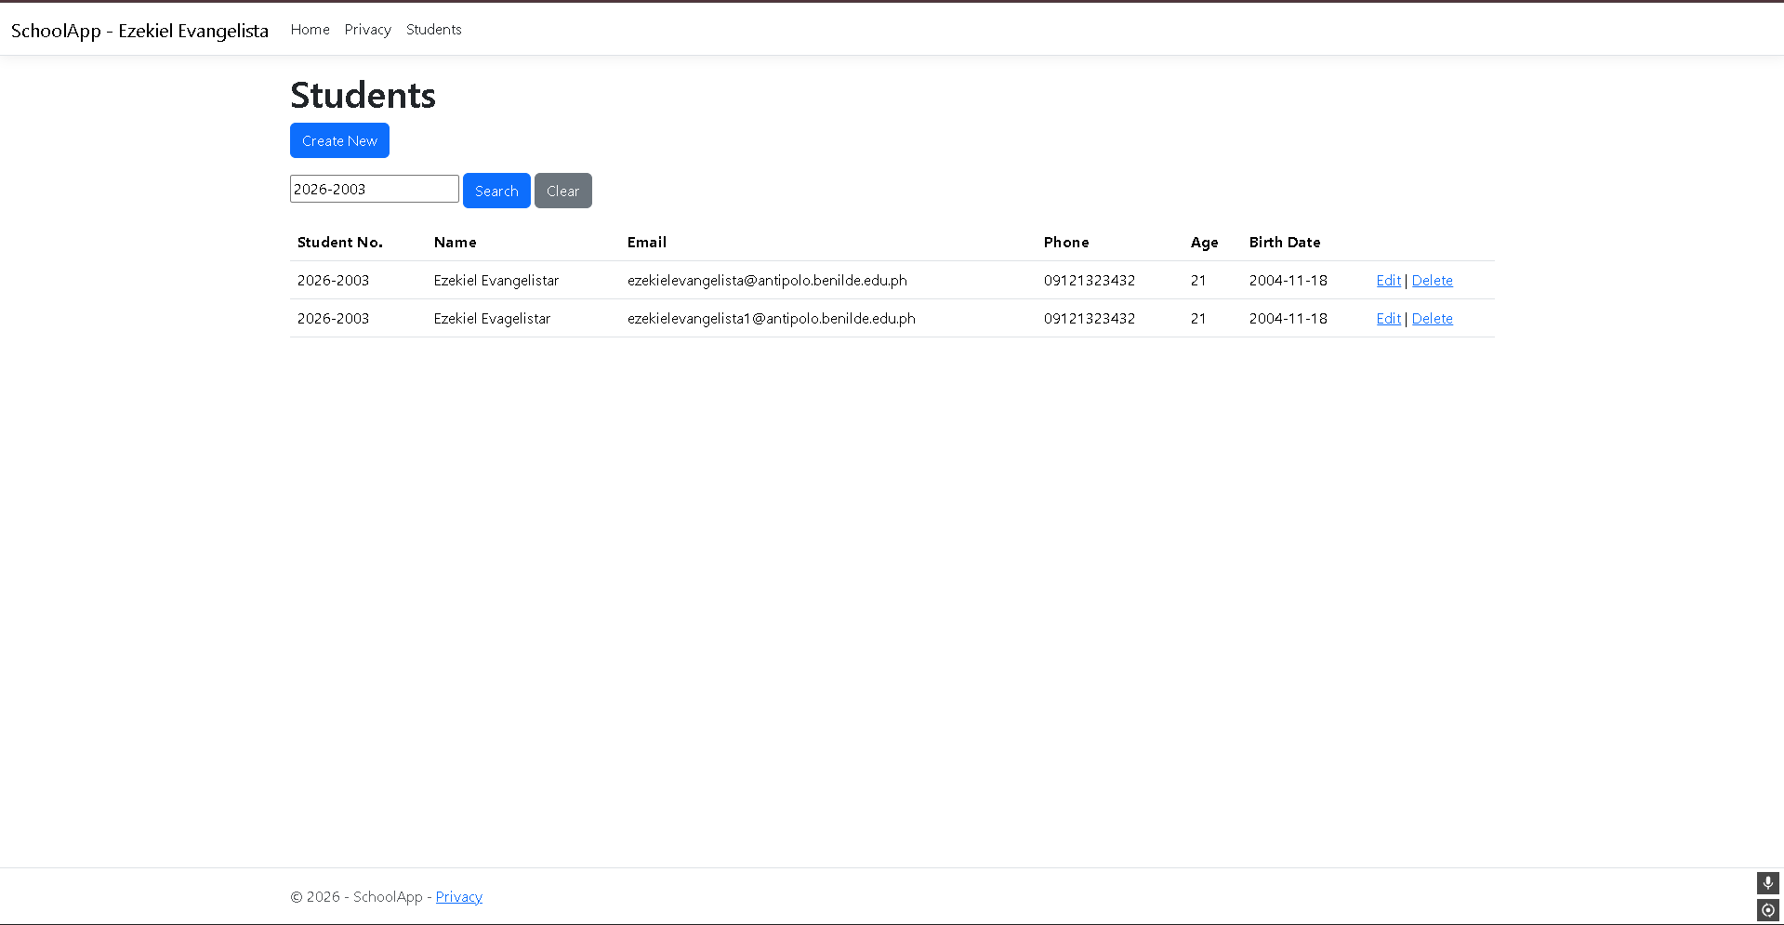Task 13 (Option B): Live search (no button)
The controller stays as it is after Task 12. Everything happens in 📄 Views/Students/Index.cshtml.
13.1 Replace the search form with one box
Delete the whole <form>...</form> from Task 12 (skip this if you didn't do Option A) and put this in its place. Replace Juan with your first name:
@* Option B: live search. No form and no button: it filters while you type *@
<input type="text" id="searchBox" class="form-control mb-3"
placeholder="Live search - Juan" />
13.2 Give the table body an id
In the same file, change <tbody> to:
<tbody id="studentRows">
13.3 Add the script
Add this at the very bottom of the file:
@section Scripts {
<script>
// Runs every time a key is typed in the search box
document.getElementById("searchBox").addEventListener("input", function () {
// What the user typed, in lowercase so "MARIA" matches "Maria"
const text = this.value.toLowerCase();
// Look at every row in the table
document.querySelectorAll("#studentRows tr").forEach(function (row) {
// Student No. (cell 0), Full Name (cell 1) and Email (cell 2) together
const rowText = (row.cells[0].textContent + " " +
row.cells[1].textContent + " " +
row.cells[2].textContent).toLowerCase();
// Show the row if it contains the text, hide it if not
row.style.display = rowText.includes(text) ? "" : "none";
});
});
</script>
}
If you see the error "Section 'Scripts' is already defined": your file already has a @section Scripts { ... }. Put only the <script>...</script> part inside the one you have.
13.4 Test it
Save, stop the app and run it again. Open Students and type one letter at a time. Don't press Enter.
Answer
Type this | Students shown (write the names)
m | Aaaaaaaaaaaaaaaaaaaaaaaaaaaaaaaaaaaaaaaaaaaaaaaaaaaaaaaaaaaaaaaaaaaaaaaaaaaaaaaaaaaaaaaaaaaaaaaaaaaa  Ezekiel Evangelista  Nigeria Paris  Maria Santos  Carlo Mendoza  (these showed up because I used gmail so there’s a “m”
Maria Santos
ma | Aaaaaaaaaaaaaaaaaaaaaaaaaaaaaaaaaaaaaaaaaaaaaaaaaaaaaaaaaaaaaaaaaaaaaaaaaaaaaaaaaaaaaaaaaaaaaaaaaaaa  Ezekiel Evangelista  Nigeria Paris
mar
  Maria Santos
your first name | Ezekiel Evangelista  Ezekiel Evangelistar
your student number | Ezekiel Evangelistar
(delete everything in the box) | Aaaaaaaaaaaaaaaaaaaaaaaaaaaaaaaaaaaaaaaaaaaaaaaaaaaaaaaaaaaaaaaaaaaaaaaaaaaaaaaaaaaaaaaaaaaaaaaaaaaa  Ezekiel Evangelista  Nigeria Paris  Ezekiel Evangelistar  Maria Santos  Pedro Reyes  Carlo Mendoza

Question | Your answer
Did the address bar change while you typed? (Yes / No) | No
Did the page reload while you typed? (Yes / No) | No
Why do we search cells[0], cells[1] and cells[2] and not the whole row? (Hint: look at the Edit, Details and Delete links) | The whole row includes the Edit and Delete links, which contain only the words “Edit” and “Delete” and the link addresses. If we searched the whole row, typing “e” or “dit” would match every row, and the search would pick up text that isn’t student data. By checking only cells 0, 1 and 2 (Student No., Name and Email), the search looks at just the fields the user cares about.
Screenshot 13: the Students page while your first name is typed in the live search box, showing only your row.
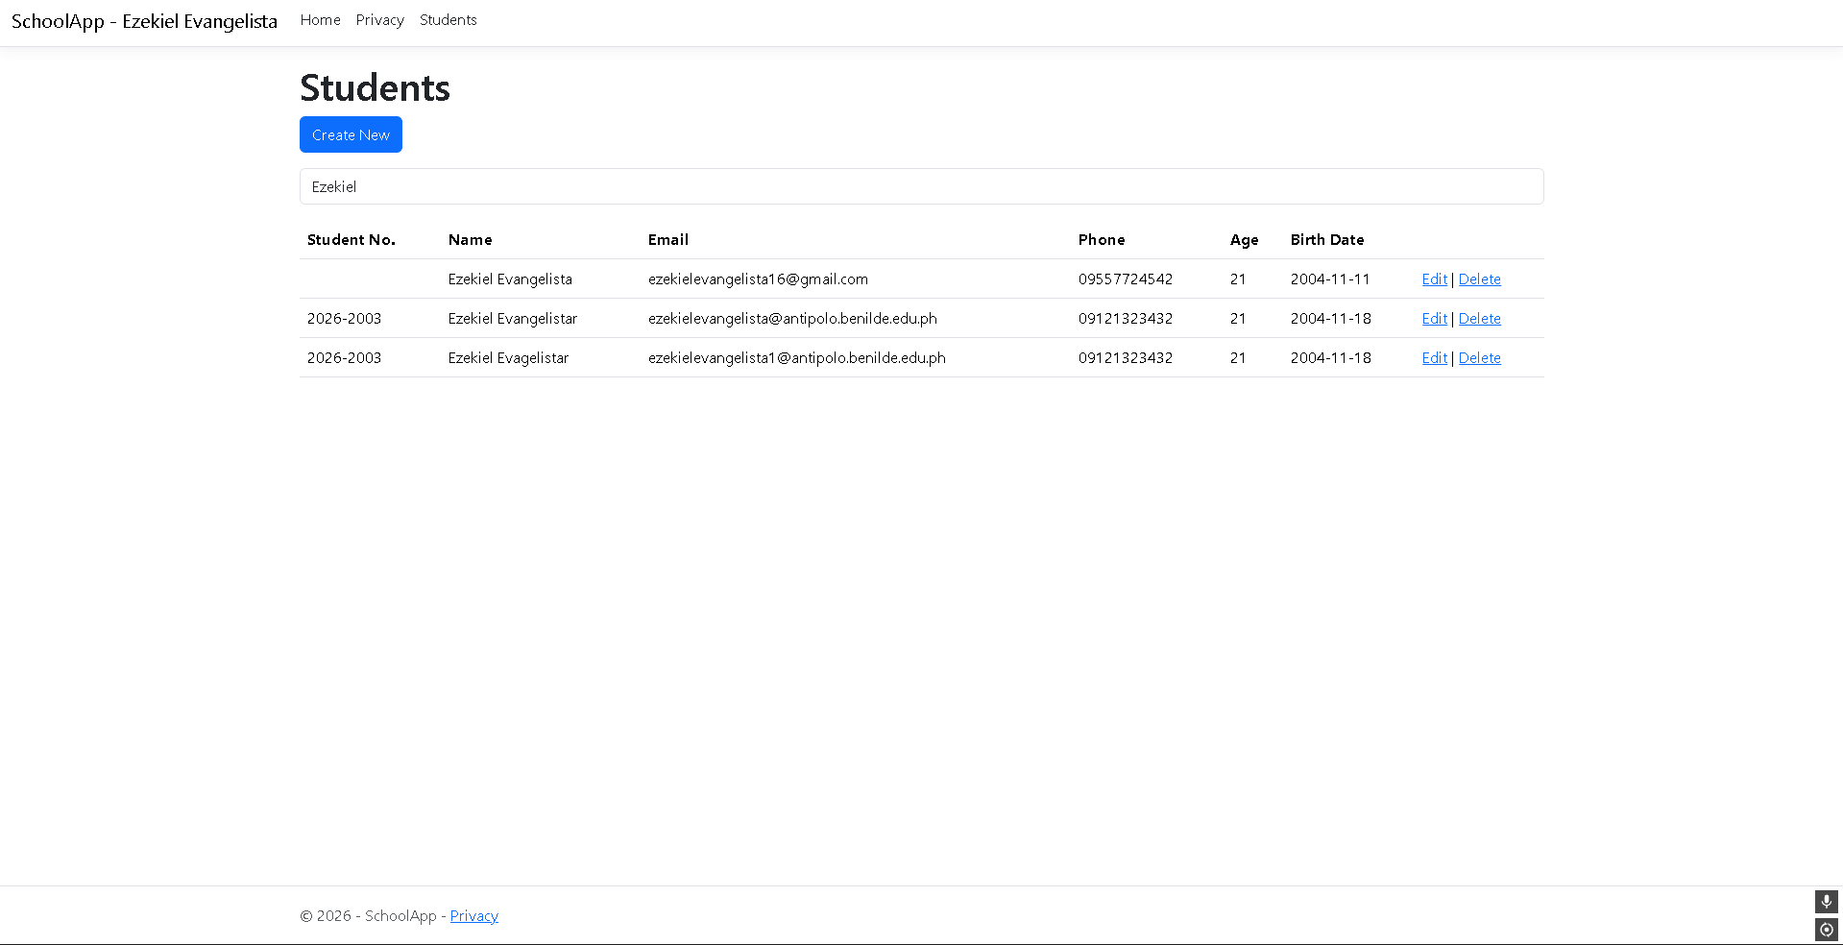

Task 14: Compare and save your work
14.1 Compare the two options
Question | Your answer
Which option asks the database every time you search? | Option A (search with a button). Each search sends a request to the server, and the controller runs a query against the database to get the matching rows.
Which option works without reloading the page? | Option B (live search). The JavaScript filters the rows that are already on the page, so nothing is sent to the server.
The school has 10,000 students. Which option is better, and why? | The school has 10,000 students. Which option is better, and why?  Option A is better. Live search only filters the rows that were loaded into the page, so it has to load all 10,000 students every time the page opens, which is slow and uses a lot of memory. Option A asks the database for only the matching rows, so the page stays small and fast no matter how many students there are.
You want to send a classmate a link to the search results. Which option lets you do that, and why? | Option A. Its form uses method="get", so the search text is added to the address bar (for example /Students?searchString=maria). Copying that URL and sending it lets your classmate open the same results. Option B never changes the address bar, so the link would just open the full list.
14.2 Push to GitHub
Stop the app (Ctrl+C), then run these lines one at a time. Replace Juan Dela Cruz with your full name:
git add Controllers/StudentsController.cs Views/Students/Index.cshtml
git commit -m "Search lab – Ezekiel Evangelista"
git push
Question | Your answer
The commit message shown on GitHub | Search lab – Ezekiel Evangelista  Your push succeeded (195e024..d0444f3 main -> main),

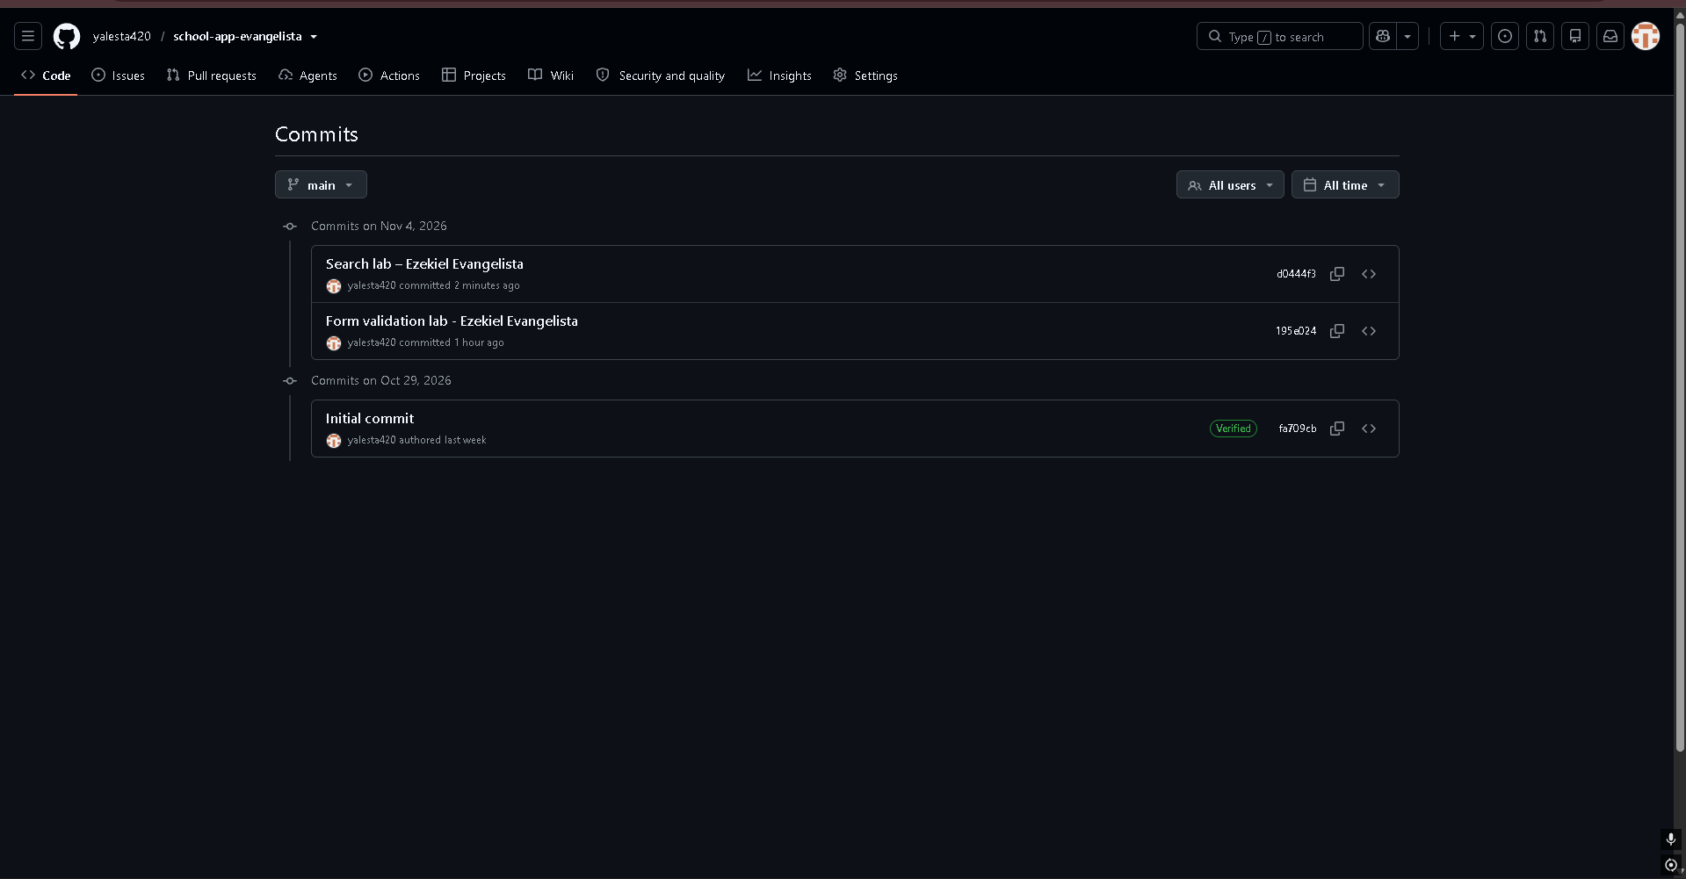Submission checklist
- ☐ Student details and Your unique values are filled in
- ☐ Every Answer box in Tasks 11 to 14 is filled in
- ☐ Screenshots 11, 12, 13 and 14 are attached, and your name is visible in the menu bar
- ☐ The search box placeholder has your first name
- ☐ Your code is pushed to the same repository as the Form Validation lab

What your teacher will check
Check | Where
Index(string? searchString) searching Name, Student No. and Email | Controllers/StudentsController.cs
The live search script and id="studentRows" | Views/Students/Index.cshtml
Your first name in the placeholder | Views/Students/Index.cshtml and Screenshot 13
Your own row found by your student number | Screenshot 12
Two commits with your full name, in the same repository | Your repository's commit history

